**DATE OF PRACTICAL – 30 AUGUST 2022**

**PROBLEM STATEMENT:** Create an Android Application to print a Simple Text on Screen.

**OBJECTIVE:** To print a Simple Text On Screen.

**(activity_main.xml)**

**CODE:**

<?xml version="1.0" encoding="utf-8"?>

<LinearLayout xmlns:android="[http://schemas.android.com/apk/res/android"](http://schemas.android.com/apk/res/android) xmlns:app="<http://schemas.android.com/apk/res-auto>" xmlns:tools="<http://schemas.android.com/tools>" android:layout_width="match_parent" android:layout_height="match_parent"

tools:context=".MainActivity" android:padding="50dp" android:background="@color/purple_700"

>

<TextView

android:layout_width="wrap_content" android:layout_height="wrap_content" android:text="Hello World!" android:textSize="50dp" android:layout_gravity="center_vertical" android:background="@color/purple_200" android:textStyle="bold" android:textColor="@color/white"

/>

</LinearLayout>

**(AndroidManifest.xml)**

**CODE:**

<?xml version="1.0" encoding="utf-8"?>

<manifest xmlns:android="[http://schemas.android.com/apk/res/android"](http://schemas.android.com/apk/res/android) xmlns:tools="<http://schemas.android.com/tools>">

<application

android:allowBackup="true" android:dataExtractionRules="@xml/data_extraction_rules" android:fullBackupContent="@xml/backup_rules" android:icon="@mipmap/ic_launcher" android:label="@string/app_name" android:roundIcon="@mipmap/ic_launcher_round" android:supportsRtl="true" android:theme="@style/Theme.Simple_Text" tools:targetApi="31">

<activity android:name=".MainActivity" android:exported="true">

<intent-filter>

<action android:name="android.intent.action.MAIN" />

<category android:name="android.intent.category.LAUNCHER" />

</intent-filter>

<meta-data

android:name="android.app.lib_name" android:value="" />

</activity>

</application>

</manifest>

**(MainActivity.java)**

**CODE:**

package com.example.simple_text;

import androidx.appcompat.app.AppCompatActivity; import android.os.Bundle;

public class MainActivity extends AppCompatActivity { @Override

protected void onCreate(Bundle savedInstanceState) { super.onCreate(savedInstanceState); setContentView(R.layout.activity_main);

}

}

**(Strings.xml)**

**CODE:**

<resources>

<string name="app_name">Simple_Text</string>

</resources>

**(Colors.xml)**

**CODE:**

<?xml version="1.0" encoding="utf-8"?>

<resources>

<color name="purple_200">#FFBB86FC</color>

<color name="purple_700">#FF3700B3</color>

<color name="white">#FFFFFFFF</color>

</resources>

**OUTPUT**

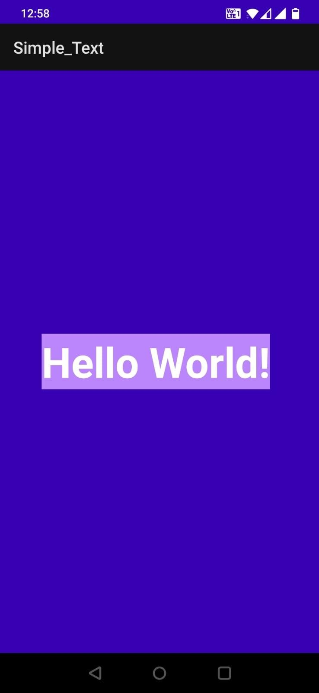

**DATE OF PRACTICAL – 30 AUGUST 2022**

**PROBLEM STATEMENT:** Create an Android Application to change the Background Color on Button Click.

**OBJECTIVE-** To Make a Button clickable to change Background Color of Layout.

**(activity_main.xml)**

**CODE:**

<?xml version="1.0" encoding="utf-8"?>

<LinearLayout xmlns:android="[http://schemas.android.com/apk/res/android"](http://schemas.android.com/apk/res/android) xmlns:app="[http://schemas.android.com/apk/res-auto"](http://schemas.android.com/apk/res-auto) xmlns:tools="[http://schemas.android.com/tools"](http://schemas.android.com/tools) android:layout_width="match_parent" android:layout_height="match_parent"

tools:context=".MainActivity" android:padding="50dp" android:id="@+id/l1"

>

<Button

android:layout_width="wrap_content" android:layout_height="wrap_content" android:text="click" android:textStyle="bold" android:textSize="40dp" android:layout_gravity="center_vertical" android:layout_margin="55dp" android:id="@+id/b1"/>

</LinearLayout>

**(AndroidManifest.xml)**

**CODE:**

<?xml version="1.0" encoding="utf-8"?>

<manifest xmlns:android="<http://schemas.android.com/apk/res/android>" xmlns:tools="[http://schemas.android.com/tools"](http://schemas.android.com/tools)>

<application android:allowBackup="true"

android:dataExtractionRules="@xml/data_extraction_rules" android:fullBackupContent="@xml/backup_rules" android:icon="@mipmap/ic_launcher" android:label="@string/app_name" android:roundIcon="@mipmap/ic_launcher_round" android:supportsRtl="true" android:theme="@style/Theme.Background_Color_Change" tools:targetApi="31">

<activity android:name=".MainActivity" android:exported="true">

<intent-filter>

<action android:name="android.intent.action.MAIN" />

<category android:name="android.intent.category.LAUNCHER" />

</intent-filter>

<meta-data android:name="android.app.lib_name" android:value="" />

</activity>

</application>

</manifest>

**(MainActivity.java)**

**CODE:**

package com.example.background_color_change;

import androidx.appcompat.app.AppCompatActivity; import android.graphics.Color;

import android.os.Bundle; import android.view.View; import android.widget.Button;

import android.widget.LinearLayout;

public class MainActivity extends AppCompatActivity { Button bt1;

LinearLayout lt1; @Override

protected void onCreate(Bundle savedInstanceState) { super.onCreate(savedInstanceState); setContentView(R.layout.activity_main); bt1=findViewById(R.id.b1); lt1=findViewById(R.id.l1);

bt1.setOnClickListener(new View.OnClickListener() { @Override

public void onClick(View view) { lt1.setBackgroundColor(Color.GREEN);

}

});

}

}

**(Strings.xml)**

**CODE:**

<resources>

<string name="app_name">Background_Color_Change</string>

</resources>

**(Colors.xml)**

**CODE:**

<?xml version="1.0" encoding="utf-8"?>

<resources>

<color name="green">#00FF00</color>

</resources>

**OUTPUT**

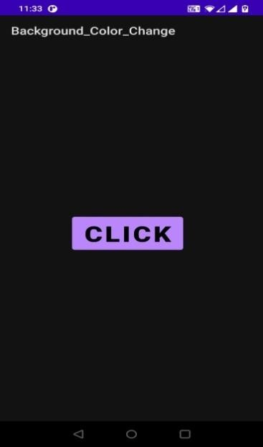 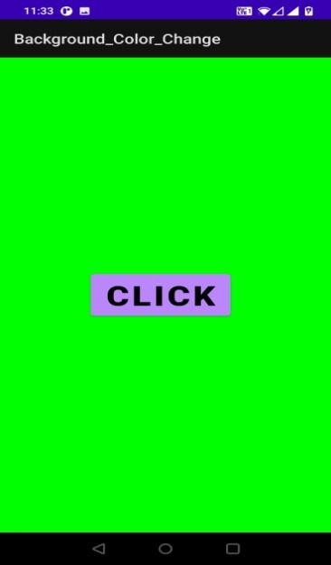

**DATE OF PRACTICAL – 06 SEPTEMBER 2022**

**PROBLEM STATEMENT:** Create a Simple Application in Android to change the Colors of the Background of a Text Box with the Click of a Button.

**OBJECTIVE:** To Make Buttons clickable to change Background Colors of Text Box.

**(activity_main.xml)**

**CODE:**

<?xml version="1.0" encoding="utf-8"?>

<RelativeLayout xmlns:android="[http://schemas.android.com/apk/res/android"](http://schemas.android.com/apk/res/android) xmlns:app="[http://schemas.android.com/apk/res-auto"](http://schemas.android.com/apk/res-auto) xmlns:tools="[http://schemas.android.com/tools"](http://schemas.android.com/tools) android:layout_width="match_parent" android:layout_height="wrap_content"

tools:context=".MainActivity" android:padding="50dp"

>

<EditText android:id="@+id/et"

android:layout_marginTop="80dp" android:layout_width="match_parent" android:layout_height="wrap_content" android:textSize="50dp"

/>

<Button

android:id="@+id/b1" android:layout_width="137dp" android:layout_height="74dp" android:layout_below="@+id/et" android:layout_marginTop="180dp" android:backgroundTint="@color/red" android:text="Red" />

<Button

android:id="@+id/b2" android:layout_width="137dp" android:layout_height="74dp" android:layout_below="@+id/et" android:layout_marginLeft="20dp" android:layout_marginTop="180dp" android:layout_toRightOf="@+id/b1" android:backgroundTint="@color/purple_500" android:text="Purple" />

<Button

android:id="@+id/b3" android:layout_width="137dp" android:layout_height="74dp" android:layout_below="@+id/b1" android:layout_marginTop="67dp" android:backgroundTint="@color/teal_700" android:text="Teal" />

<Button

android:id="@+id/b4" android:layout_width="137dp" android:layout_height="74dp" android:layout_below="@+id/b2" android:layout_marginLeft="20dp" android:layout_marginTop="67dp" android:layout_toRightOf="@+id/b3" android:backgroundTint="@color/orange" android:text="Orange" />

</RelativeLayout>

**(AndroidManifest.xml)**

**CODE:**

<?xml version="1.0" encoding="utf-8"?>

<manifest xmlns:android="<http://schemas.android.com/apk/res/android>" xmlns:tools="[http://schemas.android.com/tools"](http://schemas.android.com/tools)>

<application android:allowBackup="true"

android:dataExtractionRules="@xml/data_extraction_rules" android:fullBackupContent="@xml/backup_rules" android:icon="@mipmap/ic_launcher" android:label="@string/app_name" android:roundIcon="@mipmap/ic_launcher_round" android:supportsRtl="true" android:theme="@style/Theme.Background_Color_Change" tools:targetApi="31">

<activity android:name=".MainActivity" android:exported="true">

<intent-filter>

<action android:name="android.intent.action.MAIN" />

<category android:name="android.intent.category.LAUNCHER" />

</intent-filter>

<meta-data android:name="android.app.lib_name" android:value="" />

</activity>

</application>

</manifest>

**(MainActivity.java)**

**CODE:**

package com.example.background_color_change; import androidx.appcompat.app.AppCompatActivity;

import android.graphics.Color; import android.os.Bundle; import android.view.View; import android.widget.Button; import android.widget.EditText;

public class MainActivity extends AppCompatActivity { EditText et;

Button b1,b2,b3,b4; @Override

protected void onCreate(Bundle savedInstanceState) { super.onCreate(savedInstanceState); setContentView(R.layout.activity_main); et=findViewById(R.id.et); b1=findViewById(R.id.b1); b2=findViewById(R.id.b2); b3=findViewById(R.id.b3); b4=findViewById(R.id.b4); b1.setOnClickListener(new View.OnClickListener() {

@Override

public void onClick(View view) { et.setBackgroundColor(getResources().getColor(R.color.red));

}

});

b2.setOnClickListener(new View.OnClickListener() { @Override

public void onClick(View view) { et.setBackgroundColor(getResources().getColor(R.color.purple_500));

}

});

b3.setOnClickListener(new View.OnClickListener() { @Override

public void onClick(View view) { et.setBackgroundColor(getResources().getColor(R.color.teal_700));

}

});

b4.setOnClickListener(new View.OnClickListener() { @Override

public void onClick(View view) { et.setBackgroundColor(getResources().getColor(R.color.orange));

}

});

}

}

**(Strings.xml)**

**CODE:**

<resources>

<string name="app_name">Background_Color_Change</string>

</resources>

**(Colors.xml)**

**CODE:**

<?xml version="1.0" encoding="utf-8"?>

<resources>

<color name="purple_500">#FF6200EE</color>

<color name="teal_700">#FF018786</color>

<color name="red">#FF0000</color>

<color name="orange">#FFA500</color>

</resources>

**OUTPUT**

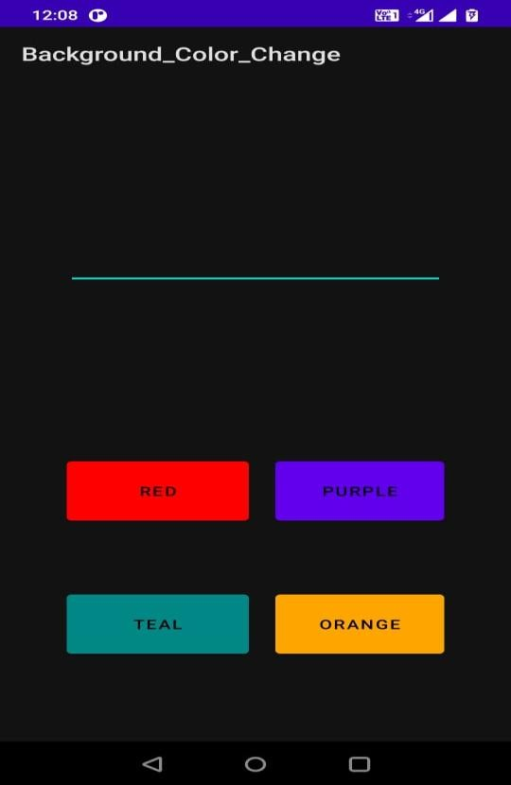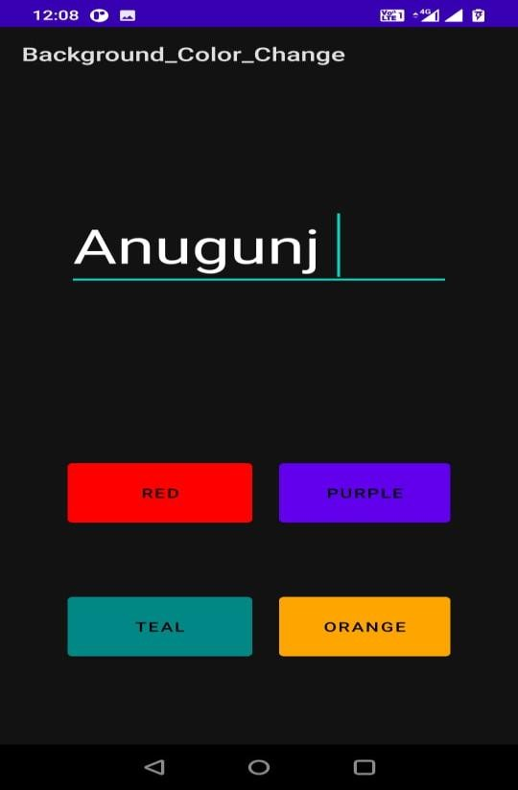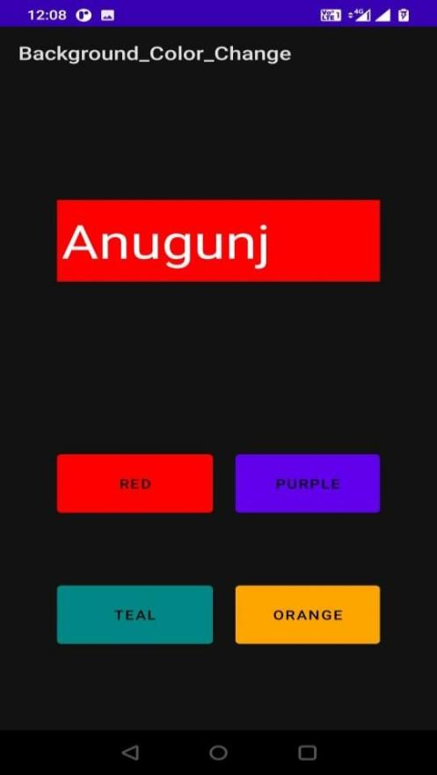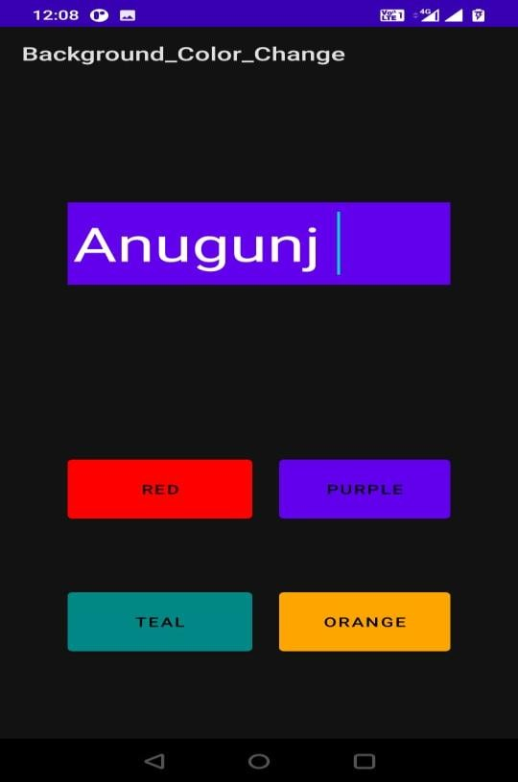

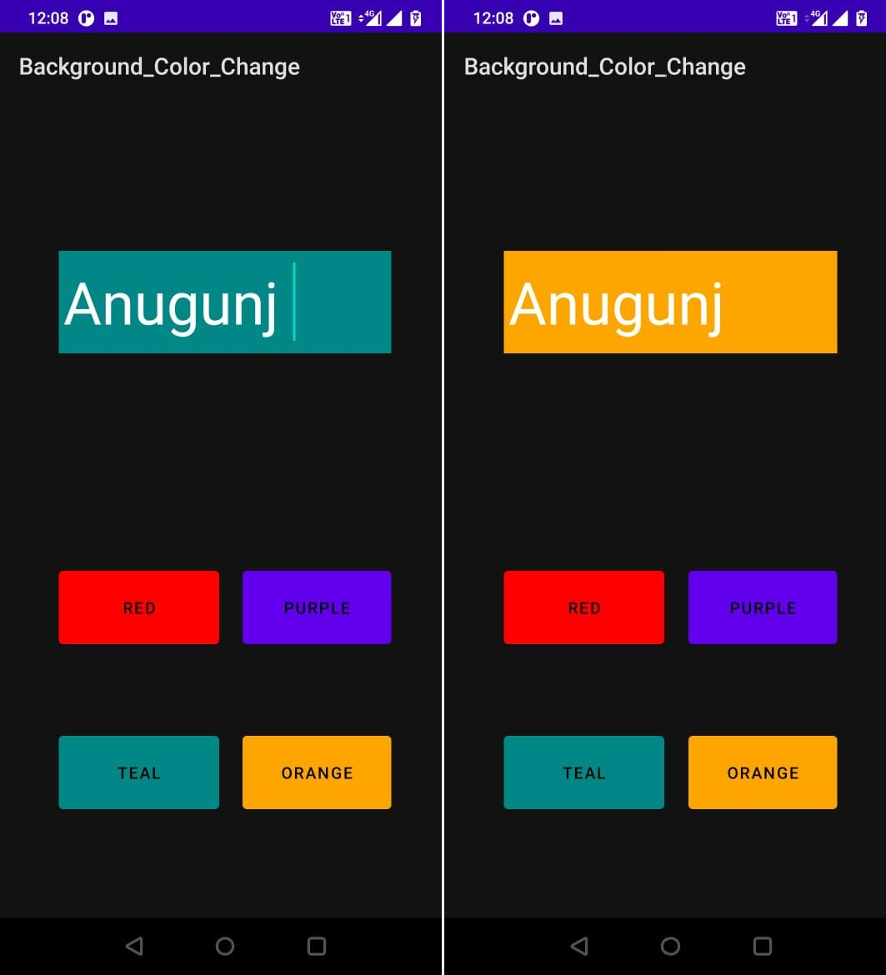

**DATE OF PRACTICAL – 06 SEPTEMBER 2022**

**PROBLEM STATEMENT:** Create an Android Application to Show the Significance of Activity LifeCycle.

**OBJECTIVE:** To See The Use Of Different Instances Of Android Life Cycle.

**(activity_main.xml)**

**CODE:**

<?xml version="1.0" encoding="utf-8"?>

<RelativeLayout xmlns:android="[http://schemas.android.com/apk/res/android"](http://schemas.android.com/apk/res/android) xmlns:app="[http://schemas.android.com/apk/res-auto"](http://schemas.android.com/apk/res-auto) xmlns:tools="[http://schemas.android.com/tools"](http://schemas.android.com/tools) android:layout_width="match_parent" android:layout_height="match_parent" android:background="@color/teal_200"

tools:context=".MainActivity" android:padding="50dp">

<TextView android:layout_width="match_parent" android:layout_height="match_parent" android:text="Activity LifeCycle" android:textStyle="bold" android:textSize="30dp" android:textColor="@color/white" android:gravity="center"

/>

</RelativeLayout>

**(AndroidManifest.xml)**

**CODE:**

<?xml version="1.0" encoding="utf-8"?>

<manifest xmlns:android="<http://schemas.android.com/apk/res/android>" xmlns:tools="[http://schemas.android.com/tools"](http://schemas.android.com/tools)>

<application

android:allowBackup="true" android:dataExtractionRules="@xml/data_extraction_rules" android:fullBackupContent="@xml/backup_rules" android:icon="@mipmap/ic_launcher" android:label="@string/app_name" android:roundIcon="@mipmap/ic_launcher_round" android:supportsRtl="true" android:theme="@style/Theme.LifeCycle" tools:targetApi="31">

<activity android:name=".MainActivity" android:exported="true">

<intent-filter>

<action android:name="android.intent.action.MAIN" />

<category android:name="android.intent.category.LAUNCHER" />

</intent-filter>

<meta-data android:name="android.app.lib_name" android:value="" />

</activity>

</application>

</manifest>

**(MainActivity.java)**

**CODE:**

package com.example.lifecycle;

import androidx.appcompat.app.AppCompatActivity; import android.os.Bundle;

import android.widget.Toast;

public class MainActivity extends AppCompatActivity { @Override

protected void onCreate(Bundle savedInstanceState) {

super.onCreate(savedInstanceState); setContentView(R.layout.activity_main);

Toast.makeText(MainActivity.this,"onCreate invoked",Toast.LENGTH_LONG).show();

}

@Override

protected void onStart() { super.onStart();

Toast.makeText(MainActivity.this,"onStart invoked",Toast.LENGTH_LONG).show();

}

@Override

protected void onResume() { super.onResume();

Toast.makeText(MainActivity.this,"onResume invoked",Toast.LENGTH_LONG).show();

}

@Override

protected void onPause() { super.onPause();

Toast.makeText(MainActivity.this,"onPause invoked",Toast.LENGTH_LONG).show();

}

@Override

protected void onStop() { super.onStop();

Toast.makeText(MainActivity.this,"onStop invoked",Toast.LENGTH_LONG).show();

}

@Override

protected void onRestart() { super.onRestart();

Toast.makeText(MainActivity.this,"onRestart invoked",Toast.LENGTH_LONG).show();

}

@Override

protected void onDestroy() {

super.onDestroy();

Toast.makeText(MainActivity.this,"onDestroy

invoked",Toast.LENGTH_LONG).show();

}

}

**(Strings.xml)**

**CODE:**

<resources>

<string name="app_name">LifeCycle</string>

</resources>

**(Colors.xml)**

**CODE:**

<?xml version="1.0" encoding="utf-8"?>

<resources>

<color name="teal_200">#FF018786</color>

<color name="white">#FFFFFFFF</color>

</resources>

**OUTPUT**

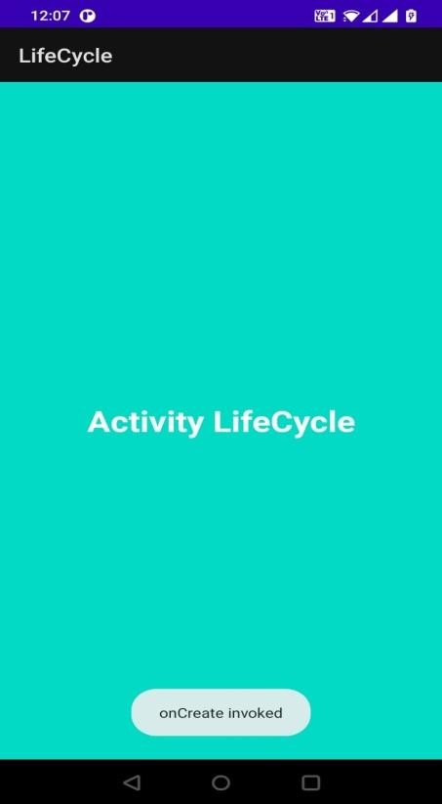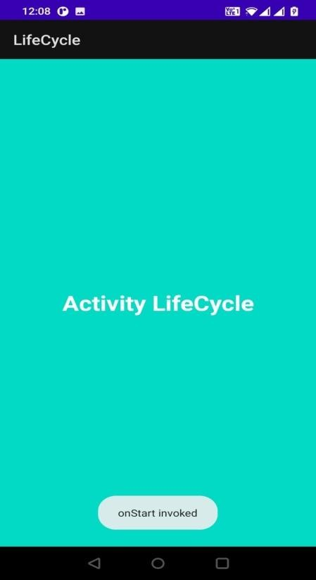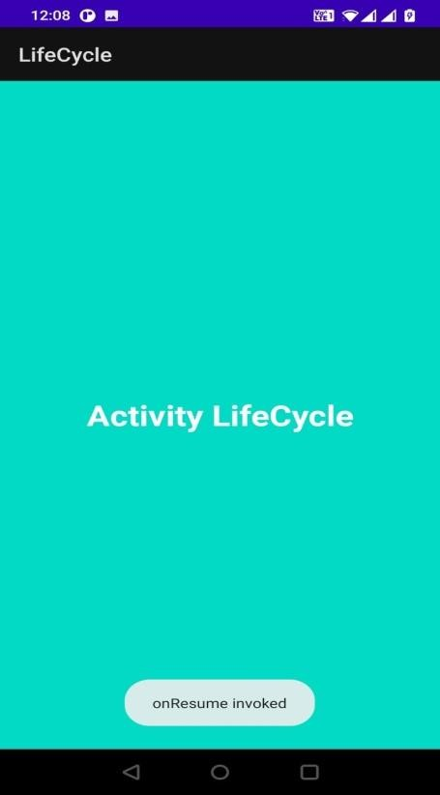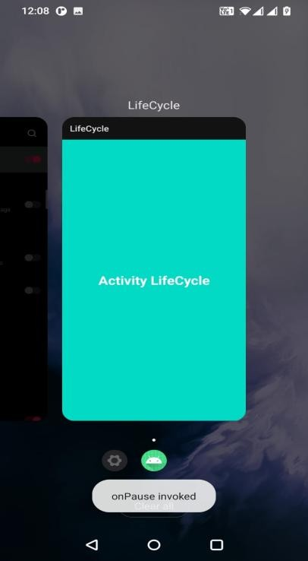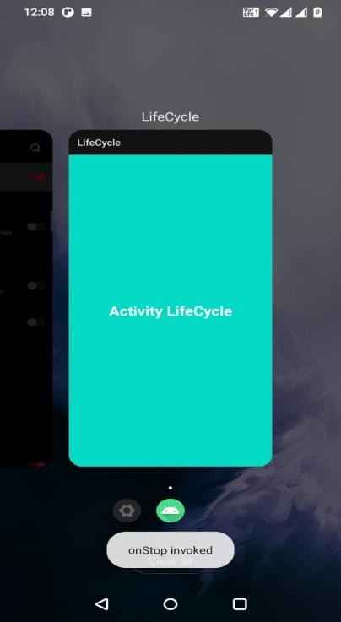

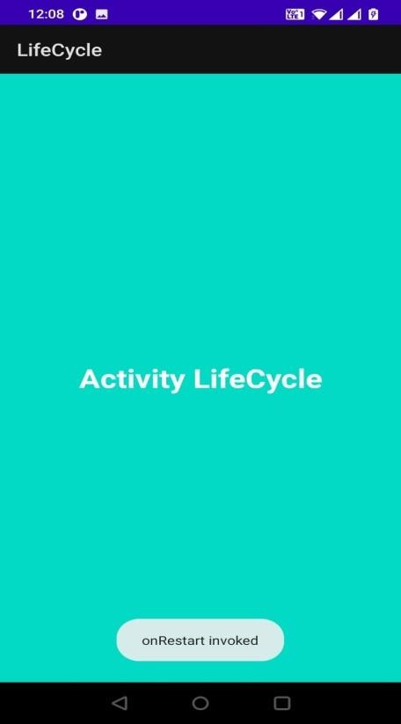  

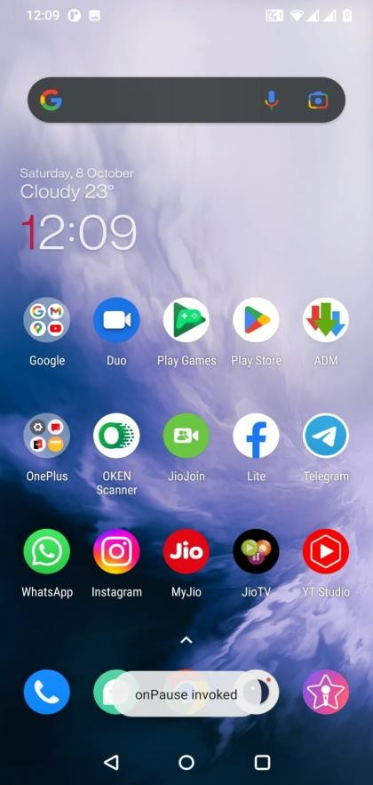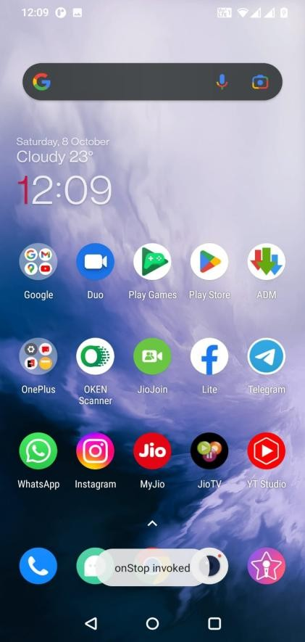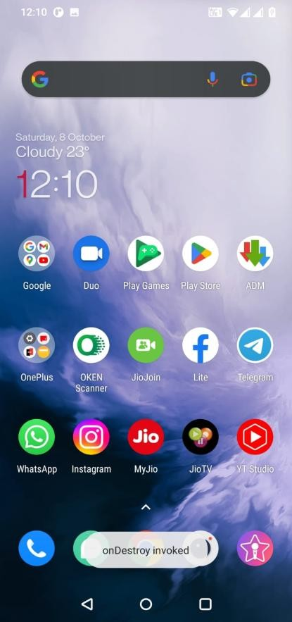

**DATE OF PRACTICAL – 13 SEPTEMBER 2022**

**PROBLEM STATEMENT:** Create an Android Application to Depict Basic Calculator.

**OBJECTIVE**: To Create A calculator for Basic Calculation like Addition Subtraction Multiplication and Division.

**(activity_main.xml)**

**CODE:**

<?xml version="1.0" encoding="utf-8"?>

<RelativeLayout xmlns:android="[http://schemas.android.com/apk/res/android"](http://schemas.android.com/apk/res/android) xmlns:app="[http://schemas.android.com/apk/res-auto"](http://schemas.android.com/apk/res-auto) xmlns:tools="[http://schemas.android.com/tools"](http://schemas.android.com/tools) android:layout_width="match_parent" android:layout_height="match_parent" android:background="@color/black"

tools:context=".MainActivity" android:padding="50dp">

<EditText android:layout_width="match_parent" android:layout_height="wrap_content" android:id="@+id/et1" android:layout_margin="20dp"

/>

<EditText android:layout_width="match_parent" android:layout_height="wrap_content" android:layout_below="@+id/et1" android:id="@+id/et2" android:layout_margin="20dp"

/>

<Button

android:layout_width="130dp" android:layout_height="130dp" android:layout_below="@+id/tv1" android:layout_margin="10dp"

android:text="+" android:textSize="70dp" android:id="@+id/bt1"

/>

<Button

android:layout_width="130dp" android:layout_height="130dp" android:layout_toRightOf="@+id/bt1" android:layout_below="@+id/tv1" android:layout_margin="10dp" android:text="-" android:textSize="70dp" android:id="@+id/bt2"

/>

<Button

android:layout_width="130dp" android:layout_height="130dp" android:layout_below="@+id/bt1" android:layout_margin="10dp" android:text="*" android:textSize="70dp" android:id="@+id/bt3"

/>

<Button

android:layout_width="130dp" android:layout_height="130dp" android:layout_below="@+id/bt2" android:layout_toRightOf="@+id/bt3" android:layout_margin="10dp" android:text="/" android:textSize="70dp" android:id="@+id/bt4"

/>

<TextView android:layout_width="match_parent"

android:layout_height="wrap_content" android:layout_below="@+id/et2" android:layout_margin="30dp" android:text="0"

android:textSize="50dp" android:id="@+id/tv1"

/>

</RelativeLayout>

**(AndroidManifest.xml)**

**CODE:**

<?xml version="1.0" encoding="utf-8"?>

<manifest xmlns:android="<http://schemas.android.com/apk/res/android>" xmlns:tools="[http://schemas.android.com/tools"](http://schemas.android.com/tools)>

<application android:allowBackup="true"

android:dataExtractionRules="@xml/data_extraction_rules" android:fullBackupContent="@xml/backup_rules" android:icon="@mipmap/ic_launcher" android:label="@string/app_name" android:roundIcon="@mipmap/ic_launcher_round" android:supportsRtl="true" android:theme="@style/Theme.Calculator" tools:targetApi="31">

<activity android:name=".MainActivity" android:exported="true">

<intent-filter>

<action android:name="android.intent.action.MAIN" />

<category android:name="android.intent.category.LAUNCHER" />

</intent-filter>

<meta-data android:name="android.app.lib_name"

android:value="" />

</activity>

</application>

</manifest>

**(MainActivity.java)**

**CODE:**

package com.example.calculator;

import androidx.appcompat.app.AppCompatActivity;

import android.os.Bundle; import android.view.View; import android.widget.Button; import android.widget.EditText;

import android.widget.TextView;

public class MainActivity extends AppCompatActivity { Button bt1, bt2, bt3, bt4;

EditText et1, et2;

TextView tv1;

@Override

protected void onCreate(Bundle savedInstanceState) { super.onCreate(savedInstanceState); setContentView(R.layout.activity_main);

bt1 = findViewById(R.id.bt1); bt2 = findViewById(R.id.bt2); bt3 = findViewById(R.id.bt3); bt4 = findViewById(R.id.bt4); et1 = findViewById(R.id.et1); et2 = findViewById(R.id.et2); tv1 = findViewById(R.id.tv1);

bt1.setOnClickListener(new View.OnClickListener() { @Override

public void onClick(View view) {

if (et1.getText().toString().length() == 0) { et1.setText("0");

}

if (et2.getText().toString().length() == 0) { et2.setText("0");

}

int num1, num2, sum;

num1 = Integer.parseInt(et1.getText().toString()); num2 = Integer.parseInt(et2.getText().toString()); sum = num1 + num2; tv1.setText(String.valueOf(sum));

bt2.setOnClickListener(new View.OnClickListener() { @Override

public void onClick(View view) {

if (et1.getText().toString().length() == 0) { et1.setText("0");

}

if (et2.getText().toString().length() == 0) { et2.setText("0");

}

});

}

int num1, num2, difference;

num1 = Integer.parseInt(et1.getText().toString()); num2 = Integer.parseInt(et2.getText().toString()); difference = num1 - num2; tv1.setText(String.valueOf(difference));

bt3.setOnClickListener(new View.OnClickListener() { @Override

public void onClick(View view) {

if (et1.getText().toString().length() == 0) { et1.setText("0");

}

if (et2.getText().toString().length() == 0) {

et2.setText("0");

}

int num1, num2, product;

num1 = Integer.parseInt(et1.getText().toString()); num2 = Integer.parseInt(et2.getText().toString()); product = num1 * num2; tv1.setText(String.valueOf(product));

}

});

bt4.setOnClickListener(new View.OnClickListener() { @Override

public void onClick(View view) {

if (et1.getText().toString().length() == 0) { et1.setText("0");

}

if (et2.getText().toString().length() == 0) { et2.setText("0");

}

});

}

}

}

});

}

int num1, num2, quotient;

num1 = Integer.parseInt(et1.getText().toString()); num2 = Integer.parseInt(et2.getText().toString()); quotient = num1 / num2; tv1.setText(String.valueOf(quotient));

**(Strings.xml)**

**CODE:**

<resources>

<string name="app_name">Calculator</string>

</resources>

**(Colors.xml)**

**CODE:**

<?xml version="1.0" encoding="utf-8"?>

<resources>

<color name="black">#FF000000</color>

</resources>

**OUTPUT**

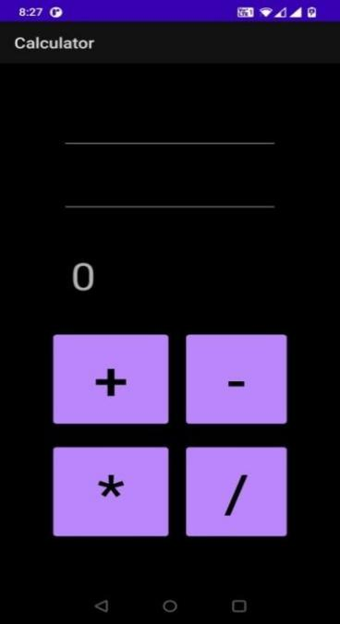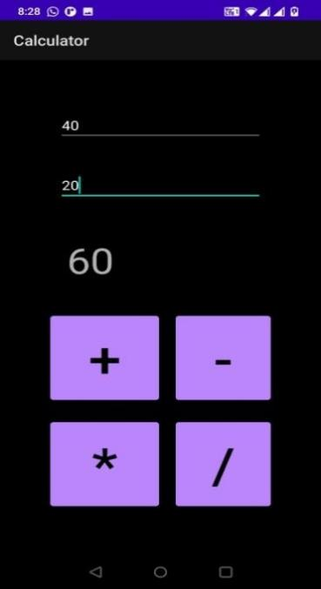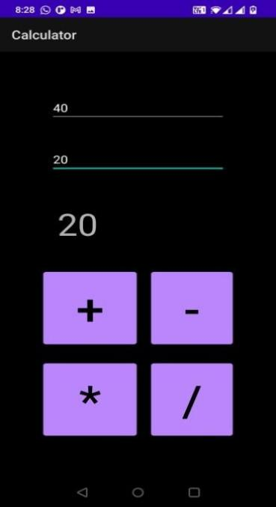

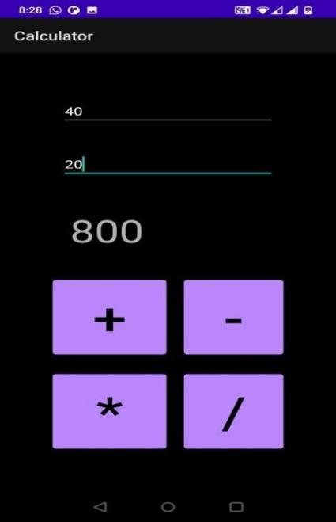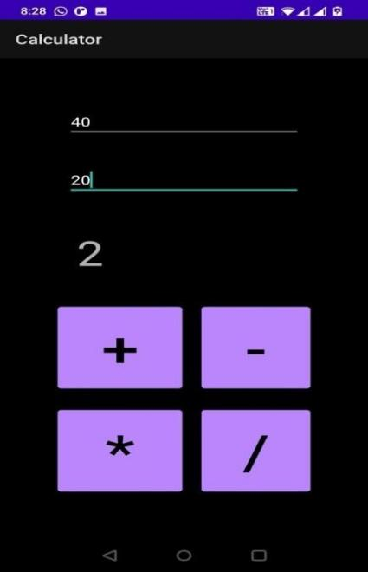

**DATE OF PRACTICAL – 13 SEPTEMBER 2022**

**PROBLEM STATEMENT:** Create an Android Application to Design the following xml Activity.

Name: Age: Address: Phno:

**Submit**

Generate a Toast Message when submit message (button) is pressed.

**OBJECTIVE:** To Collect Basic Data ( Name, Age, Address, Phno ) from User and then Print a Toast Message **“Information Successfully Submitted”.**

**(activity_main.xml)**

**CODE:**

<?xml version="1.0" encoding="utf-8"?>

<RelativeLayout xmlns:android="[http://schemas.android.com/apk/res/android"](http://schemas.android.com/apk/res/android) xmlns:app="[http://schemas.android.com/apk/res-auto"](http://schemas.android.com/apk/res-auto) xmlns:tools="[http://schemas.android.com/tools"](http://schemas.android.com/tools) android:layout_width="match_parent" android:layout_height="match_parent"

tools:context=".MainActivity" android:padding="50dp">

<EditText android:layout_width="match_parent" android:layout_height="wrap_content" android:inputType="textPersonName" android:text="Name:" android:id="@+id/e1" android:layout_margin="20dp"

/>

<EditText android:layout_width="match_parent" android:layout_height="wrap_content" android:inputType="number"

android:text="Age:" android:layout_below="@+id/e1" android:id="@+id/e2" android:layout_margin="20dp"

/>

<EditText android:layout_width="match_parent" android:layout_height="wrap_content" android:inputType="text" android:text="Address:" android:layout_below="@+id/e2" android:id="@+id/e3" android:layout_margin="20dp"

/>

<EditText android:layout_width="match_parent" android:layout_height="wrap_content" android:inputType="number" android:text="Phone-no:" android:layout_below="@+id/e3" android:id="@+id/e4" android:layout_margin="20dp"

/>

<Button android:layout_width="wrap_content" android:layout_height="wrap_content" android:layout_centerHorizontal="true" android:backgroundTint="@color/Red" android:layout_below="@+id/e4" android:text="Submit" android:textSize="40dp" android:textStyle="bold" android:layout_margin="30dp" android:id="@+id/b1"

/>

</RelativeLayout>

**(AndroidManifest.xml)**

**CODE:**

<?xml version="1.0" encoding="utf-8"?>

<manifest xmlns:android="<http://schemas.android.com/apk/res/android>" xmlns:tools="[http://schemas.android.com/tools"](http://schemas.android.com/tools)>

<application android:allowBackup="true"

android:dataExtractionRules="@xml/data_extraction_rules" android:fullBackupContent="@xml/backup_rules" android:icon="@mipmap/ic_launcher" android:label="@string/app_name" android:roundIcon="@mipmap/ic_launcher_round" android:supportsRtl="true" android:theme="@style/Theme.ToastProject" tools:targetApi="31">

<activity android:name=".MainActivity" android:exported="true">

<intent-filter>

<action android:name="android.intent.action.MAIN" />

<category android:name="android.intent.category.LAUNCHER" />

</intent-filter>

<meta-data android:name="android.app.lib_name" android:value="" />

</activity>

</application>

</manifest>

**(MainActivity.java)**

**CODE:**

package com.example.toastproject;

import androidx.appcompat.app.AppCompatActivity;

import android.os.Bundle; import android.view.View; import android.widget.Button; import android.widget.EditText; import android.widget.Toast;

public class MainActivity extends AppCompatActivity { Button b1;

@Override

protected void onCreate(Bundle savedInstanceState) { super.onCreate(savedInstanceState); setContentView(R.layout.activity_main); b1=findViewById(R.id.b1); b1.setOnClickListener(new View.OnClickListener() {

@Override

public void onClick(View view) { Toast.makeText(getApplicationContext(),"Information Successfully Submitted",

Toast.LENGTH_LONG).show();

}

});

}

}

**(Strings.xml)**

**CODE:**

<resources>

<string name="app_name">ToastProject</string>

</resources>

**(Colors.xml)**

**CODE:**

<?xml version="1.0" encoding="utf-8"?>

<resources>

<color name="Red">#ff0000</color>

</resources>

**OUTPUT**

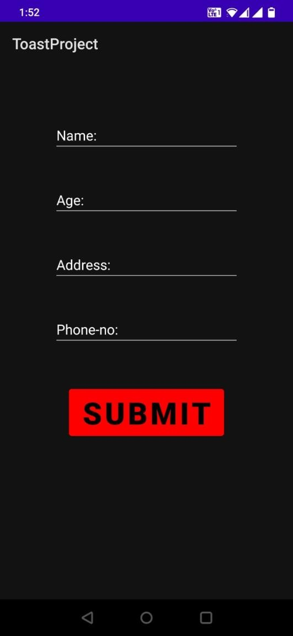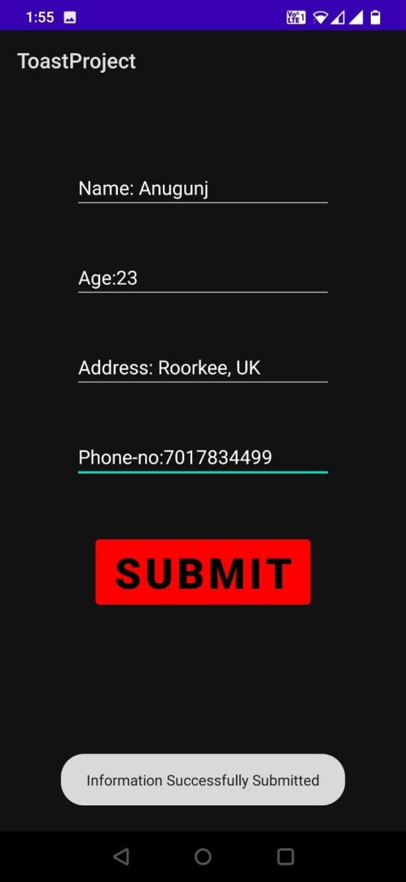

**DATE OF PRACTICAL – 20 SEPTEMBER 2022**

**PROBLEM STATEMENT:** Create an Android Application to Change the Image on an Activity on Button Click.

**OBJECTIVE:** To Change The Images On The Activity after Clicking On Buttons.

**(activity_main.xml)**

**CODE:**

<?xml version="1.0" encoding="utf-8"?>

<RelativeLayout xmlns:android="[http://schemas.android.com/apk/res/android"](http://schemas.android.com/apk/res/android) xmlns:app="[http://schemas.android.com/apk/res-auto"](http://schemas.android.com/apk/res-auto) xmlns:tools="[http://schemas.android.com/tools"](http://schemas.android.com/tools) android:layout_width="match_parent" android:layout_height="match_parent"

tools:context=".MainActivity">

<Button

android:id="@+id/b1" android:layout_width="294dp" android:layout_height="wrap_content" android:layout_centerHorizontal="true" android:layout_marginTop="20dp" android:backgroundTint="@color/teal_200" android:textColor="@color/white" android:text="NEXT" android:textSize="50dp" />

<ImageView android:id="@+id/iv" android:layout_width="364dp" android:layout_height="371dp"

android:layout_below="@+id/b1" android:layout_marginStart="26dp" android:layout_marginTop="60dp"

android:layout_marginBottom="60dp" android:layout_marginEnd="26dp" />

<Button

android:id="@+id/b2" android:layout_width="wrap_content" android:layout_height="wrap_content" android:layout_below="@+id/iv" android:layout_centerHorizontal="true" android:backgroundTint="@color/purple_200" android:textColor="@color/white" android:text="Previous" android:textSize="50dp" />

</RelativeLayout>

**(AndroidManifest.xml)**

**CODE:**

<?xml version="1.0" encoding="utf-8"?>

<manifest xmlns:android="<http://schemas.android.com/apk/res/android>" xmlns:tools="[http://schemas.android.com/tools"](http://schemas.android.com/tools)>

<application android:allowBackup="true"

android:dataExtractionRules="@xml/data_extraction_rules" android:fullBackupContent="@xml/backup_rules" android:icon="@mipmap/ic_launcher" android:label="@string/app_name" android:roundIcon="@mipmap/ic_launcher_round" android:supportsRtl="true" android:theme="@style/Theme.Image_Changer" tools:targetApi="31">

<activity android:name=".MainActivity" android:exported="true">

<intent-filter>

<action android:name="android.intent.action.MAIN" />

<category android:name="android.intent.category.LAUNCHER" />

</intent-filter>

<meta-data android:name="android.app.lib_name" android:value="" />

</activity>

</application>

</manifest>

**(MainActivity.java)**

**CODE:**

package com.example.image_changer;

import androidx.appcompat.app.AppCompatActivity; import android.os.Bundle;

import android.view.View; import android.widget.Button;

import android.widget.ImageView;

public class MainActivity extends AppCompatActivity { Button b1, b2;

ImageView iv1; int a = 0;

@Override

protected void onCreate(Bundle savedInstanceState) { super.onCreate(savedInstanceState); setContentView(R.layout.activity_main);

b1 = findViewById(R.id.b1); b2 = findViewById(R.id.b2); iv1 = findViewById(R.id.iv);

b1.setOnClickListener(new View.OnClickListener() { @Override

public void onClick(View view) { iv1.setImageResource(R.drawable.maldives);

}

});

b2.setOnClickListener(new View.OnClickListener() { @Override

public void onClick(View view) { iv1.setImageResource(R.drawable.lake);

}

});

}

}

**(Strings.xml)**

**CODE:**

<resources>

<string name="app_name">Image_Changer</string>

</resources>

**(Colors.xml)**

**CODE:**

<?xml version="1.0" encoding="utf-8"?>

<resources>

<color name="purple_200">#FFBB86FC</color>

<color name="teal_200">#FF03DAC5</color>

<color name="white">#FFFFFFFF</color>

</resources>

**OUTPUT**

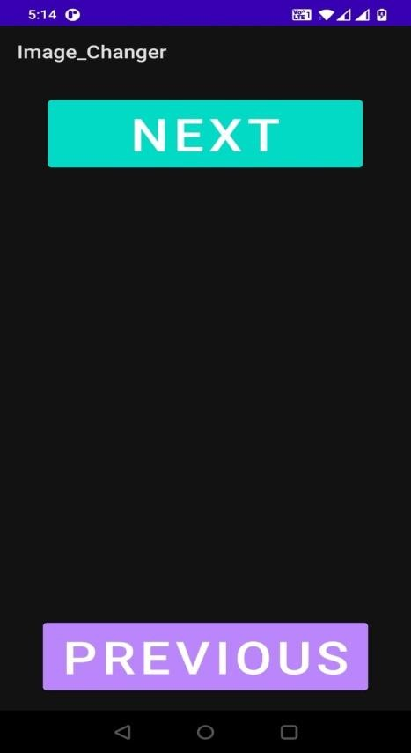

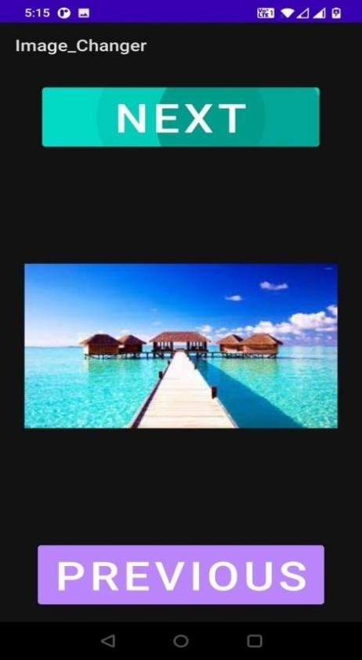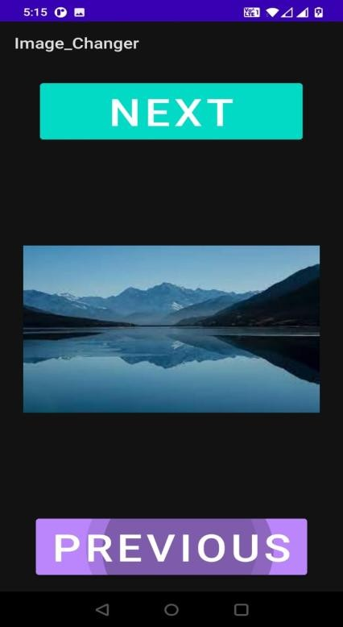

**DATE OF PRACTICAL – 20 SEPTEMBER 2022**

**PROBLEM STATEMENT:** Create an Android Application to Design the following xml File and Show the Concept of Array Adapter.

Name: RollNo:

**OBJECTIVE:** To Create Two Lists – ‘Name’ and ‘RollNo’ and then Adding Data into them Using Array Adapter.

**(activity_main.xml)**

**CODE:**

<?xml version="1.0" encoding="utf-8"?>

<RelativeLayout xmlns:android="[http://schemas.android.com/apk/res/android"](http://schemas.android.com/apk/res/android) xmlns:app="[http://schemas.android.com/apk/res-auto"](http://schemas.android.com/apk/res-auto) xmlns:tools="[http://schemas.android.com/tools"](http://schemas.android.com/tools) android:layout_width="match_parent" android:layout_height="match_parent" android:background="@color/purple"

tools:context=".MainActivity">

<ListView android:layout_width="195dp" android:layout_height="wrap_content" android:id="@+id/l1"

android:background="@color/purple_700"

/>

<ListView android:layout_width="200dp" android:layout_height="wrap_content" android:id="@+id/l2" android:layout_toRightOf="@+id/l1"

android:background="@color/purple_500"

/>

</RelativeLayout>

**(AndroidManifest.xml)**

**CODE:**

<?xml version="1.0" encoding="utf-8"?>

<manifest xmlns:android="<http://schemas.android.com/apk/res/android>" xmlns:tools="[http://schemas.android.com/tools"](http://schemas.android.com/tools)>

<application android:allowBackup="true"

android:dataExtractionRules="@xml/data_extraction_rules" android:fullBackupContent="@xml/backup_rules" android:icon="@mipmap/ic_launcher" android:label="@string/app_name" android:roundIcon="@mipmap/ic_launcher_round" android:supportsRtl="true" android:theme="@style/Theme.ArrayAdapter" tools:targetApi="31">

<activity android:name=".MainActivity" android:exported="true">

<intent-filter>

<action android:name="android.intent.action.MAIN" />

<category android:name="android.intent.category.LAUNCHER" />

</intent-filter>

<meta-data android:name="android.app.lib_name" android:value="" />

</activity>

</application>

</manifest>

**(MainActivity.java)**

**CODE:**

package com.example.arrayadapter;

import androidx.appcompat.app.AppCompatActivity;

import android.os.Bundle;

import android.widget.ArrayAdapter; import android.widget.ListView;

public class MainActivity extends AppCompatActivity { ListView lv1,lv2;

@Override

protected void onCreate(Bundle savedInstanceState) { super.onCreate(savedInstanceState); setContentView(R.layout.activity_main);

lv1 = findViewById(R.id.l1); lv2 = findViewById(R.id.l2);

String list1[] = {"Name:","Anugunj","Vivek","Mohan","Ajay","Saloni","Priyansh"};

String list2[] ={"RollNo:","11","22","33","44","50","60"};

ArrayAdapter<String> ad1= new ArrayAdapter<String>(MainActivity.this,android.R.layout.simple_list_item_1,list1) ;

lv1.setAdapter(ad1);

ArrayAdapter<String> ad2 = new ArrayAdapter<String>(MainActivity.this, android.R.layout.simple_list_item_1,list2);

lv2.setAdapter(ad2);

}

}

**(Strings.xml)**

**CODE:**

<resources>

<string name="app_name">Array Adapter</string>

</resources>

**(Colors.xml)**

**CODE:**

<?xml version="1.0" encoding="utf-8"?>

<resources>

<color name="purple_500">#FF6200EE</color>

<color name="purple_700">#FF3700B3</color>

<color name="purple">#3e1468</color>

</resources>

**OUTPUT**

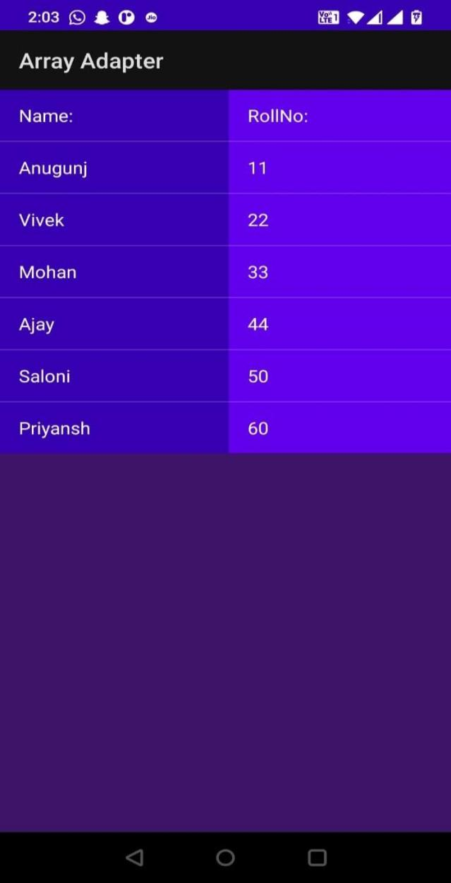

**DATE OF PRACTICAL – 27 SEPTEMBER 2022**

**PROBLEM STATEMENT:** Create an Android Application to Take Four Radio Buttons of Different Colors. When User Select any Radio Button, Background Color of Text View should be Changed.

**OBJECTIVE:** To Change the Text View Colors by Clicking on Radio Button Names Respectively.

**(activity_main.xml)**

**CODE:**

<?xml version="1.0" encoding="utf-8"?>

<RelativeLayout xmlns:android="[http://schemas.android.com/apk/res/android"](http://schemas.android.com/apk/res/android) xmlns:app="[http://schemas.android.com/apk/res-auto"](http://schemas.android.com/apk/res-auto) xmlns:tools="[http://schemas.android.com/tools"](http://schemas.android.com/tools) android:layout_width="match_parent" android:layout_height="match_parent" android:background="@color/purple_200"

tools:context=".MainActivity">

<RadioGroup android:layout_width="match_parent" android:layout_height="510dp" android:id="@+id/rg">

<RadioButton android:layout_width="wrap_content" android:layout_height="wrap_content" android:text="RED" android:textSize="50dp" android:id="@+id/rb1"

/>

<RadioButton android:layout_width="wrap_content" android:layout_height="wrap_content" android:text="BLUE" android:textSize="50dp"

android:id="@+id/rb2"

/>

<RadioButton

android:layout_width="wrap_content" android:layout_height="wrap_content" android:text="GREEN" android:textSize="50dp" android:id="@+id/rb3"

/>

<RadioButton android:layout_width="wrap_content" android:layout_height="wrap_content" android:text="MAGENTA" android:textSize="50dp" android:id="@+id/rb4"

/>

</RadioGroup>

<TextView android:layout_width="wrap_content" android:layout_height="wrap_content" android:id="@+id/tv" android:text="ANDROID" android:textStyle="bold" android:textSize="80dp" android:layout_centerHorizontal="true" android:layout_marginTop="550dp"

/>

</RelativeLayout>

**(AndroidManifest.xml)**

**CODE:**

<?xml version="1.0" encoding="utf-8"?>

<manifest xmlns:android="<http://schemas.android.com/apk/res/android>" xmlns:tools="[http://schemas.android.com/tools"](http://schemas.android.com/tools)>

<application android:allowBackup="true"

android:dataExtractionRules="@xml/data_extraction_rules" android:fullBackupContent="@xml/backup_rules"

android:icon="@mipmap/ic_launcher" android:label="@string/app_name" android:roundIcon="@mipmap/ic_launcher_round" android:supportsRtl="true" android:theme="@style/Theme.RadioButtons" tools:targetApi="31">

<activity android:name=".MainActivity" android:exported="true">

<intent-filter>

<action android:name="android.intent.action.MAIN" />

<category android:name="android.intent.category.LAUNCHER" />

</intent-filter>

<meta-data android:name="android.app.lib_name" android:value="" />

</activity>

</application>

</manifest>

**(MainActivity.java)**

**CODE:**

package com.example.radiobuttons;

import androidx.appcompat.app.AppCompatActivity;

import android.graphics.Color; import android.os.Bundle;

import android.widget.RadioButton; import android.widget.RadioGroup; import android.widget.TextView;

public class MainActivity extends AppCompatActivity { RadioGroup rg;

RadioButton rb1,rb2,rb3,rb4; TextView tv;

@Override

protected void onCreate(Bundle savedInstanceState) { super.onCreate(savedInstanceState); setContentView(R.layout.activity_main); rg=findViewById(R.id.rg); tv=findViewById(R.id.tv); rb1=findViewById(R.id.rb1); rb2=findViewById(R.id.rb2); rb3=findViewById(R.id.rb3); rb4=findViewById(R.id.rb4);

rg.setOnCheckedChangeListener(new RadioGroup.OnCheckedChangeListener() { @Override

public void onCheckedChanged(RadioGroup radioGroup, int i) { switch (i){

case R.id.rb1: tv.setBackgroundColor(Color.RED); break;

}

switch (i){

case R.id.rb2: tv.setBackgroundColor(Color.BLUE); break;

}

switch (i){

case R.id.rb3: tv.setBackgroundColor(getResources().getColor(R.color.green)); break;

}

switch (i){

case R.id.rb4: tv.setBackgroundColor(Color.MAGENTA); break;

}

}

});

}

}

**(Strings.xml)**

**CODE:**

<resources>

<string name="app_name">Radio Buttons</string>

</resources>

**(Colors.xml)**

**CODE:**

<?xml version="1.0" encoding="utf-8"?>

<resources>

<color name="purple_200">#FFBB86FC</color>

<color name="green">#057206</color>

</resources>

**OUTPUT**

