Task:

[Queryable Earth: combining satellite imagery and next-gen AI (planet.com)](https://www.planet.com/pulse/queryable-earth-combining-satellite-imagery-and-next-gen-ai/)

- Develop a queryable interface for Planet Labs real-time satellite data. For example, someone should be able to ask "How many ships were there in the Bab al Mandab strait on 2/15/23?" or "How much more forest has burnt down in the past month in Peru?" and

get an answer with clear evidence (ships highlighted for example 1, 2 comparison images for before and after for example 2)

- It might be helpful to use Meta's Segment Anything, Daniel Kang's AIDB, or Yolov8 for object detection and segmentation.

Solution

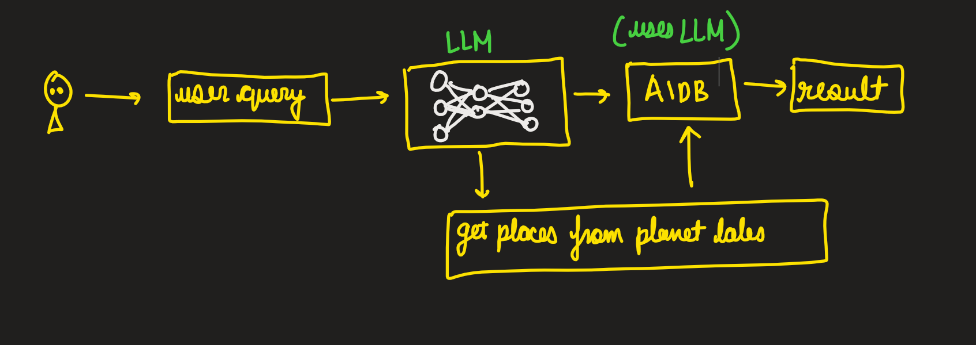

1. Automating the Planet Labs API
2. Make AIDB do calculations
3. Processing AIDB calculations
4. Coordination of AIDB and ML models