**Project Summary**

The Nursing Department at Texas A&M Corpus Christi relies on proper allocation and preparation for classrooms, labs, and lab equipment. Instructors of the Nursing Department must have the proper room with the proper equipment set-up in order to proceed with their intended lesson. If essential scheduling and equipment set-up are not satisfied then we are inefficiently using our educational resources and hindering our developing nurses. This resource management lies under the responsibility of Ms. Eloisa Beltran the Lab Coordinator. Currently, the scheduling process consists of a single meeting between instructors who negotiate on dates, times, and rooms for the their curriculum that semester. The scheduling during this day is done through the means of a physical calendar and sticky notes. This calendar with its sticky notes is eventually given to Ms. Eloisa Beltran who will then transfer this information to Astra. However, after this scheduling day Ms. Eloisa Beltran will have to account for occasional schedule request and cancelations from instructors throughout the rest of the semester and must allocate resources accordingly so that no conflicts occur. Additionally, she must make sure that the proper equipment is set up for the specific lesson. However, instructors often do not provide sufficient information as to exactly what equipment is needed for their lab and thus providing the proper equipment is handled through *experience* or the “Lab bible”. Ms. Eloisa Beltran often passes lab-prep duties to her student workers who do not have as much lab-prep *experience* as she does and thus *experience* cannot be a reliable tool. Subsequently these student workers proceed to use the “Skill Lab Bible” (an enormous binder), which abstractly defines the requirements for hundreds of different types of labs. The scheduling system for the nursing department is clearly cumbersome with many moving parts. The computer science department is proposing a capstone project that will develop a system to help alleviate some of the scheduling disorder and in turn benefit the Nursing Program.

This development will be a calendar oriented scheduling system that will replace the physical calendar and sticky notes and give an interface that will allow scheduling to be organized in a concise manner for Ms. Eloisa Beltran. This system will be viewable through two different types of users, the regular “user“ and “admin” user. The regular user will be able to view the calendar that displays all scheduled Labs as well their details. The user will also be allowed to request a lab time by filled out a request form. These forms will have different sections providing information like the room number, how many expected students, etc. Additionally there will be a section for notes that will hopefully provide information identifying what equipment the instructor demands for their scheduled lab. See diagrams below:

Macintosh HD:Users:Isaac:Desktop:CS_Capstone:Use Case Diagrams:Main Menu.pdf

Macintosh HD:Users:Isaac:Desktop:CS_Capstone:FlowCharts:ViewableViewCalendar.pdf

The “Admin” user will be able to not only do everything that the regular user can do but will be able to approve pending request from regular users for specific dates as well as deny requests. If a request is denied then a notification (email) will alert the associated user so that they may choose a different date. If the appointment is approved then it will be added to the viewable calendar. Additionally the admin user will be free to simply add or delete appointments that are already on the calendar. Lastly the Admin User will have the ability to manage the available rooms that regular users can schedule with and manipulate the request-form that regular users fill out to request a lab and create other admin users (This system will begin with one admin user). These features will make the system adaptable for the cases that a room becomes unavailable or an improvement in the request-form is made or giving access to student workers if need be. See diagrams below:

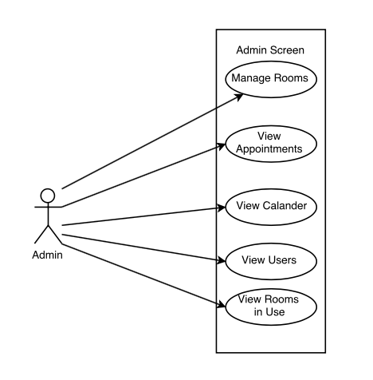

Macintosh HD:Users:Isaac:Desktop:CS_Capstone:FlowCharts:AdminViewCalendar.pdf

Macintosh HD:Users:Isaac:Desktop:CS_Capstone:FlowCharts:AdminViewAppointments.pdf

Computer Science students at Texas A&M Corpus Christi (Mark Flores, Josh Lopez, Marcelo Garza, Spencer Ellisor, and Isaac Delgado) will develop this capstone project. Additionally continuous meetings with Ms. Eloisa Beltran we be conducted to insure beneficial software is delivered to Ms. Eloisa Beltran and the Nursing Department.