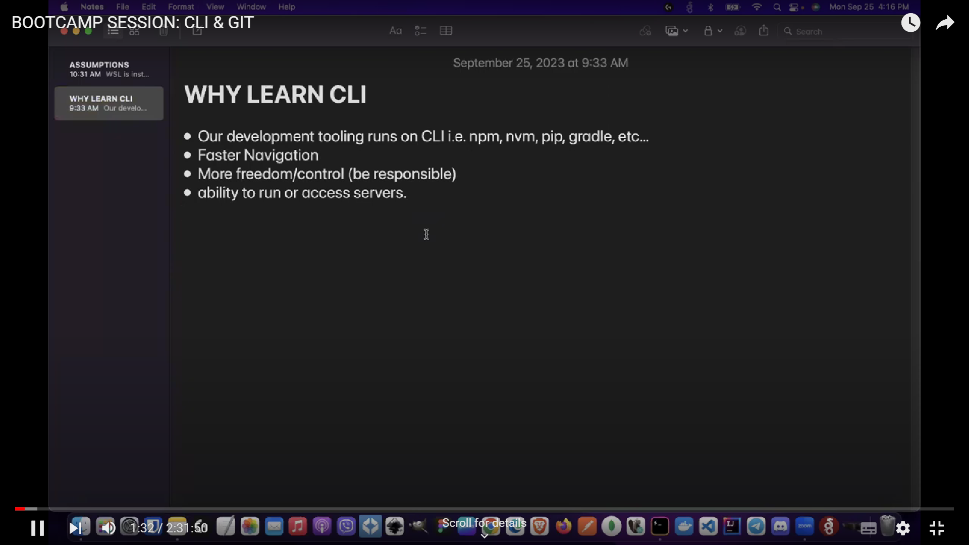

**Command Line Input (CLI)**

CLI is a command line program that accepts text input to execute operating system functions.

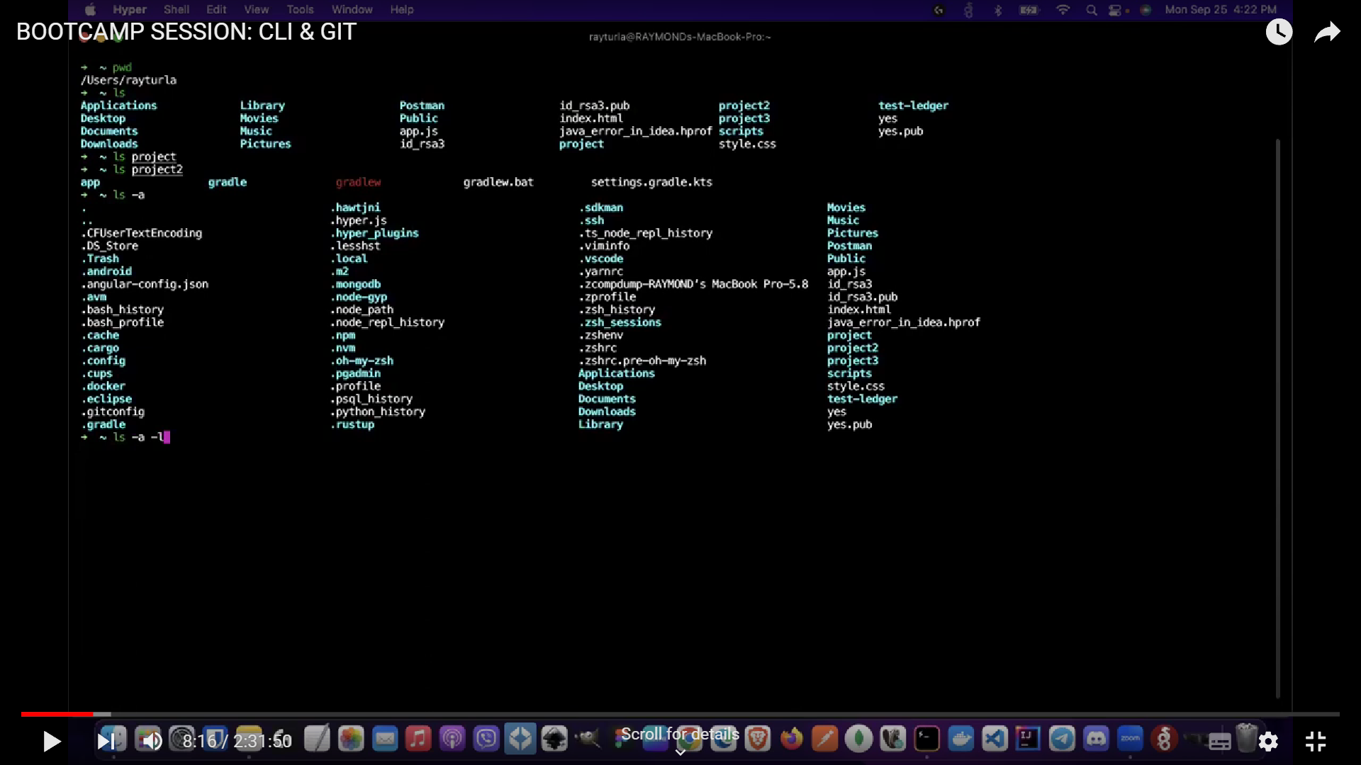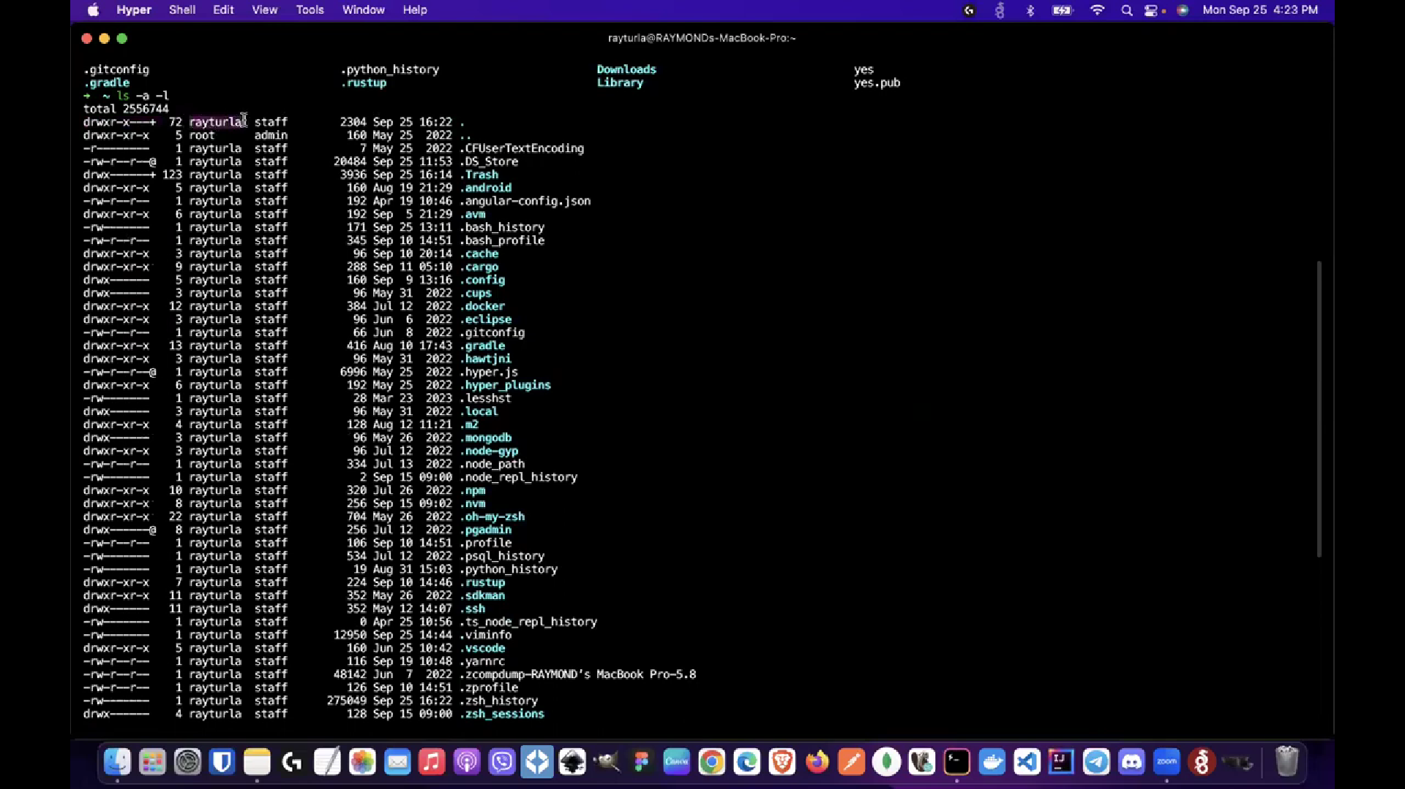

Pwd = current directory

Ls = content of that location

Ls (folder_name) = open the content of the folder

Ls -a = detailed view of the directory

Ls -a -l = detailved view of the directory with the hidden files included

Clear = clears the printed content

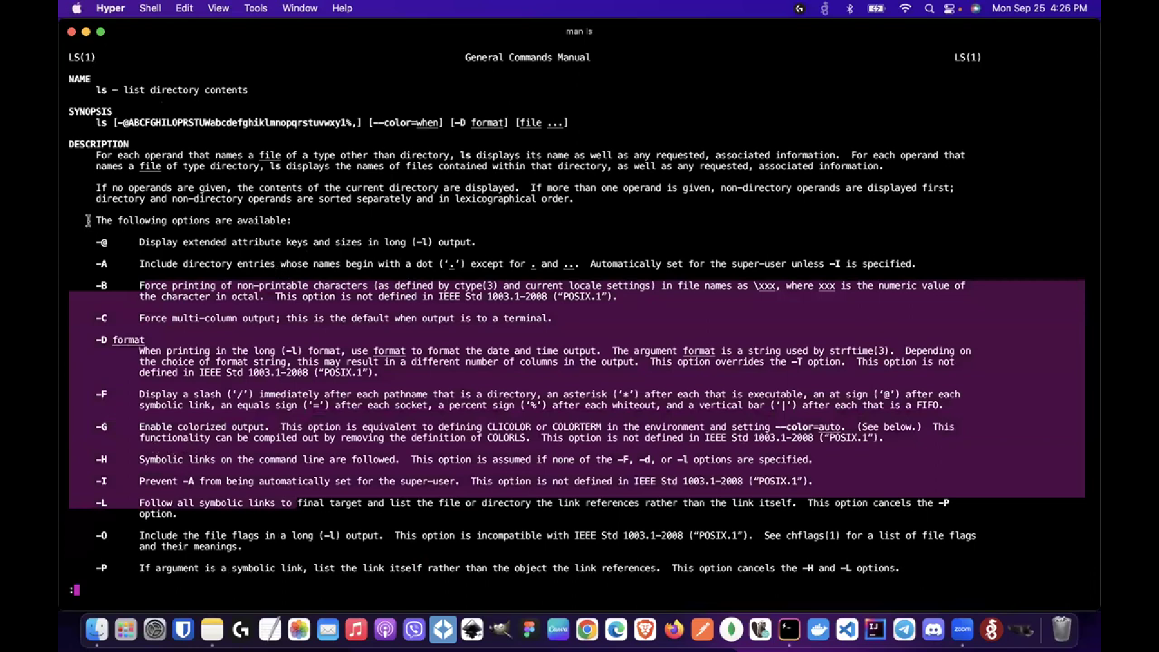

Mas ls = opens user manual for commands

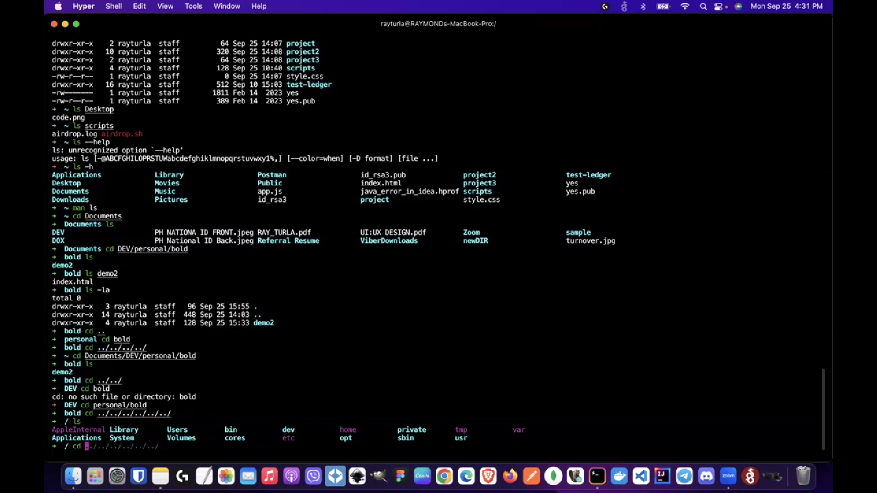

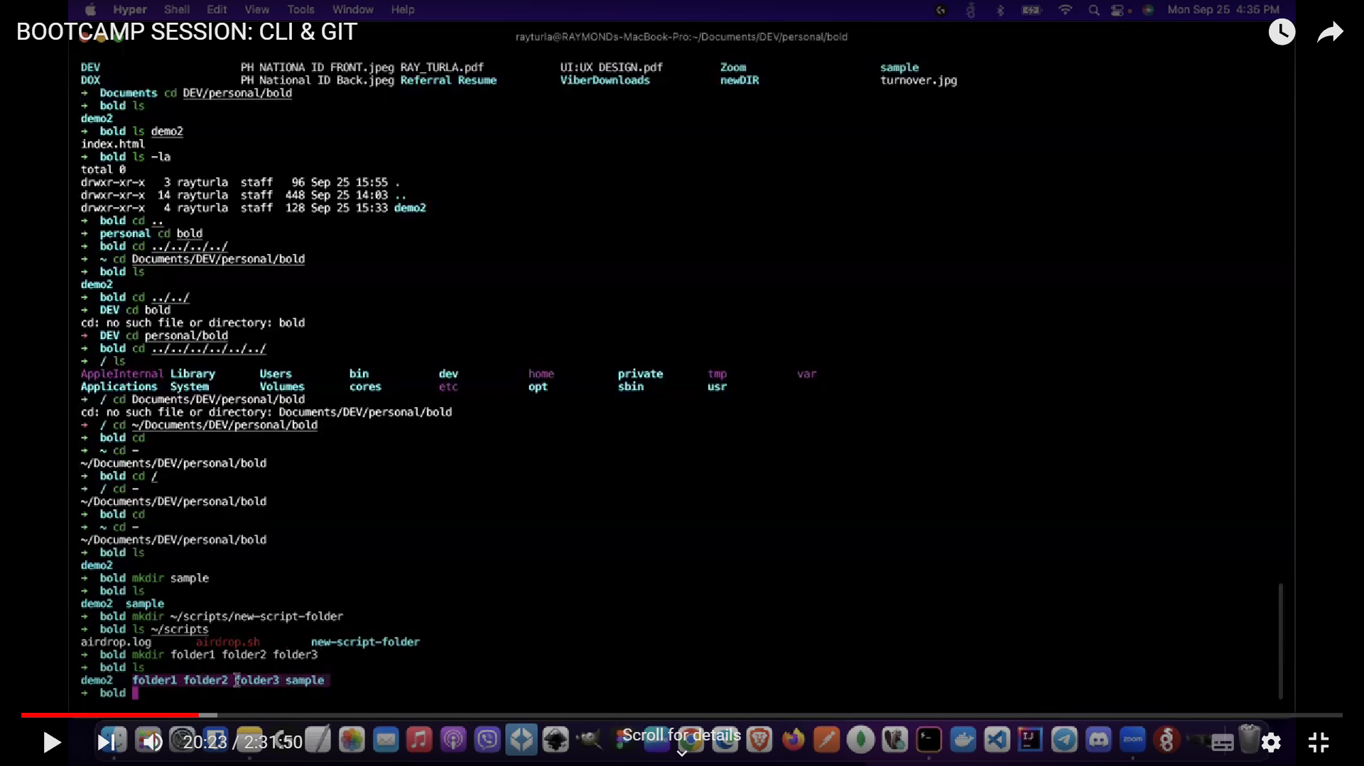

Mkdir = make directory (folder)

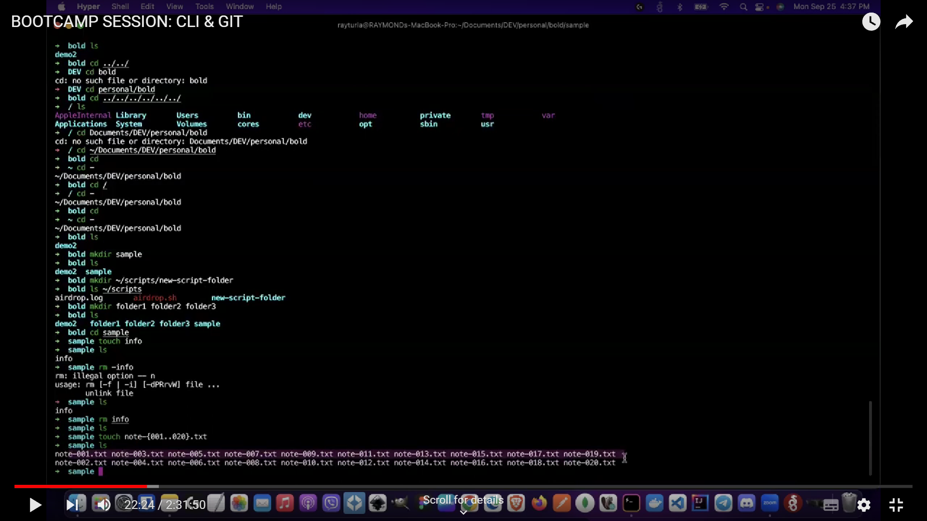

Touch file_name-{001..020}.txt = creates multiple files with names ranging from 1 to 20

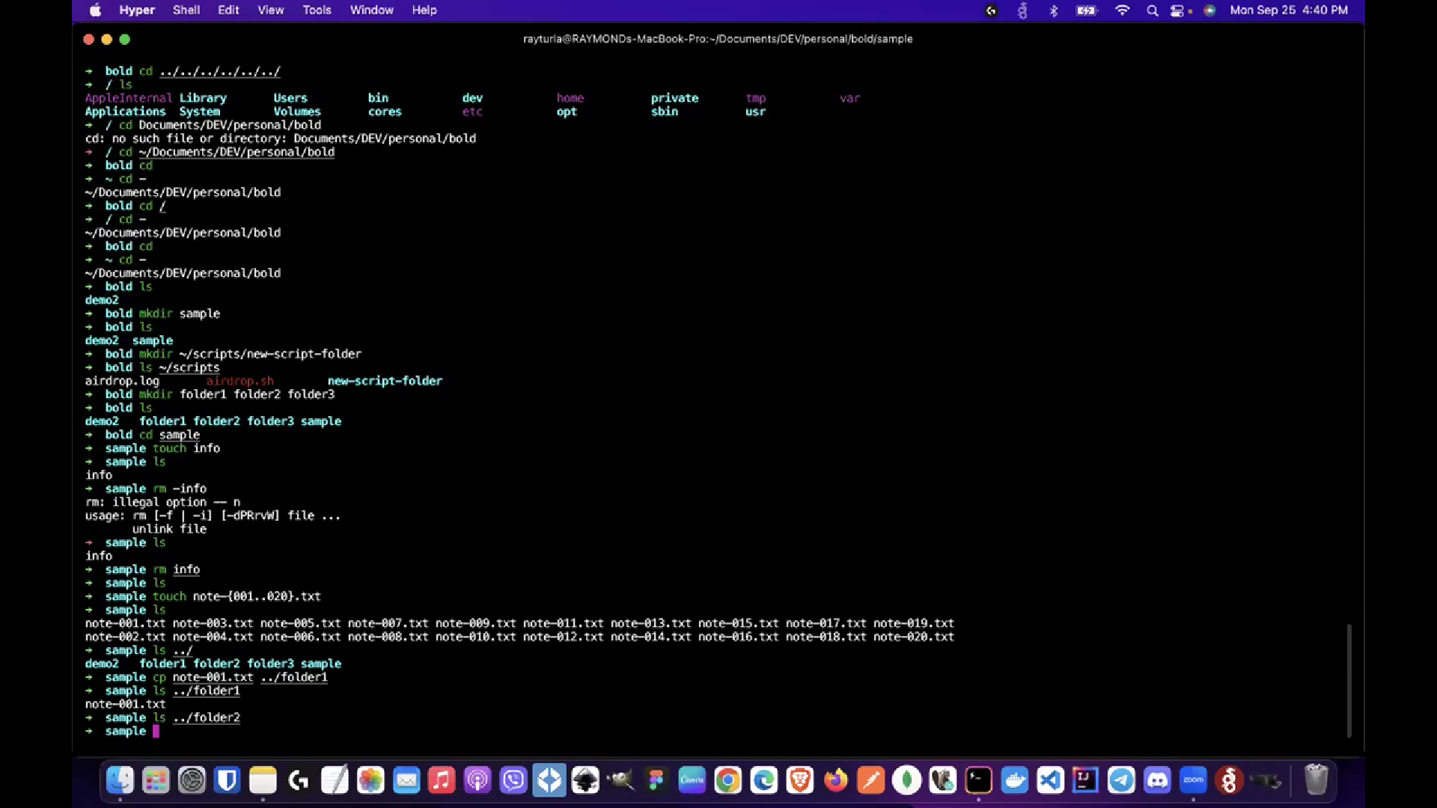

Cp = copies file from <file name> to <target destination>

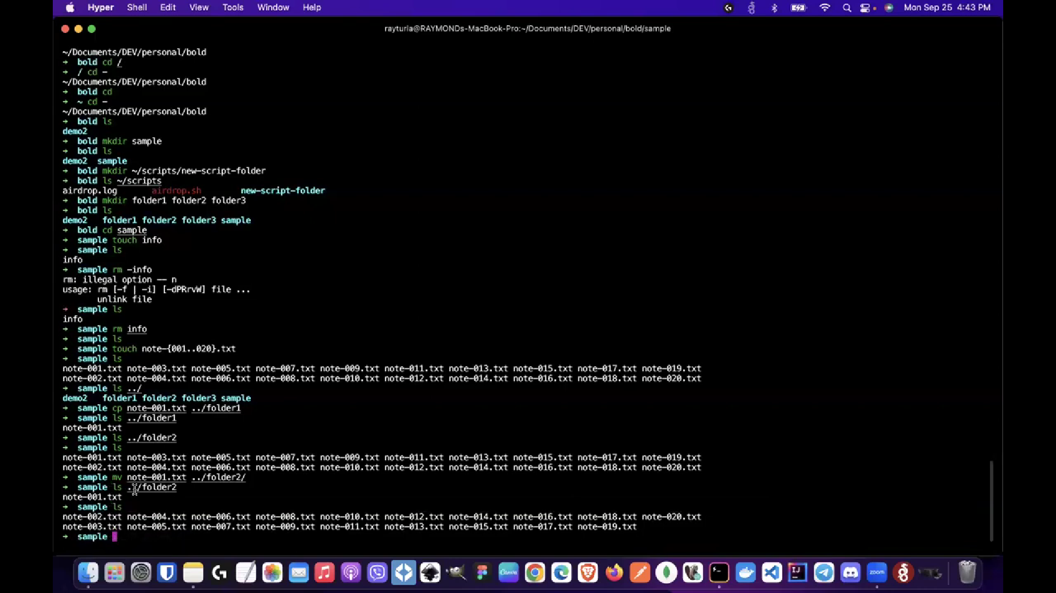

Mv = cut and paste <file name> to <target destination>

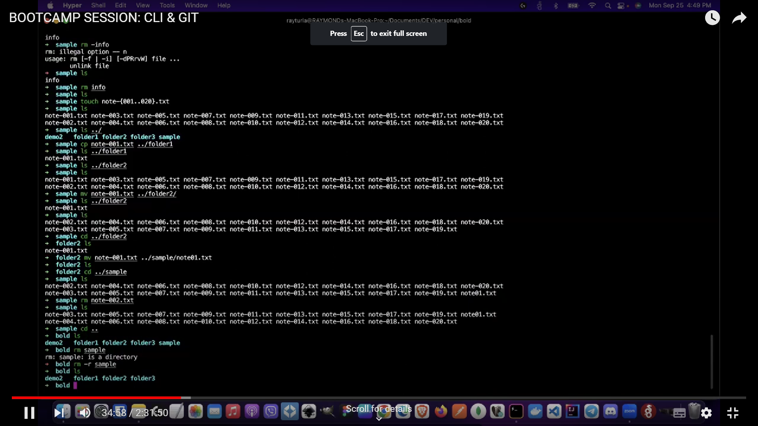

Rm file_name = remove objects (Delete)

Rm -r directory_name = remove directories (Folders)