RUST prerequesite: Own a Linux System.

Download WSL (windows system for linux) if using Windows.

Just type in Cargo in the command line to check if Rust is already installed in the computer.

CREATING A NEW RUST PROJECT

*cargo init guess_game* (creates a program with the name guess_game)

*code guess_game/* (opens guess_game file in the code editor with the src at main.rs).

In the Code Editor, type

*cargo build* (to compile the file)

*cargo run* (to run the program).

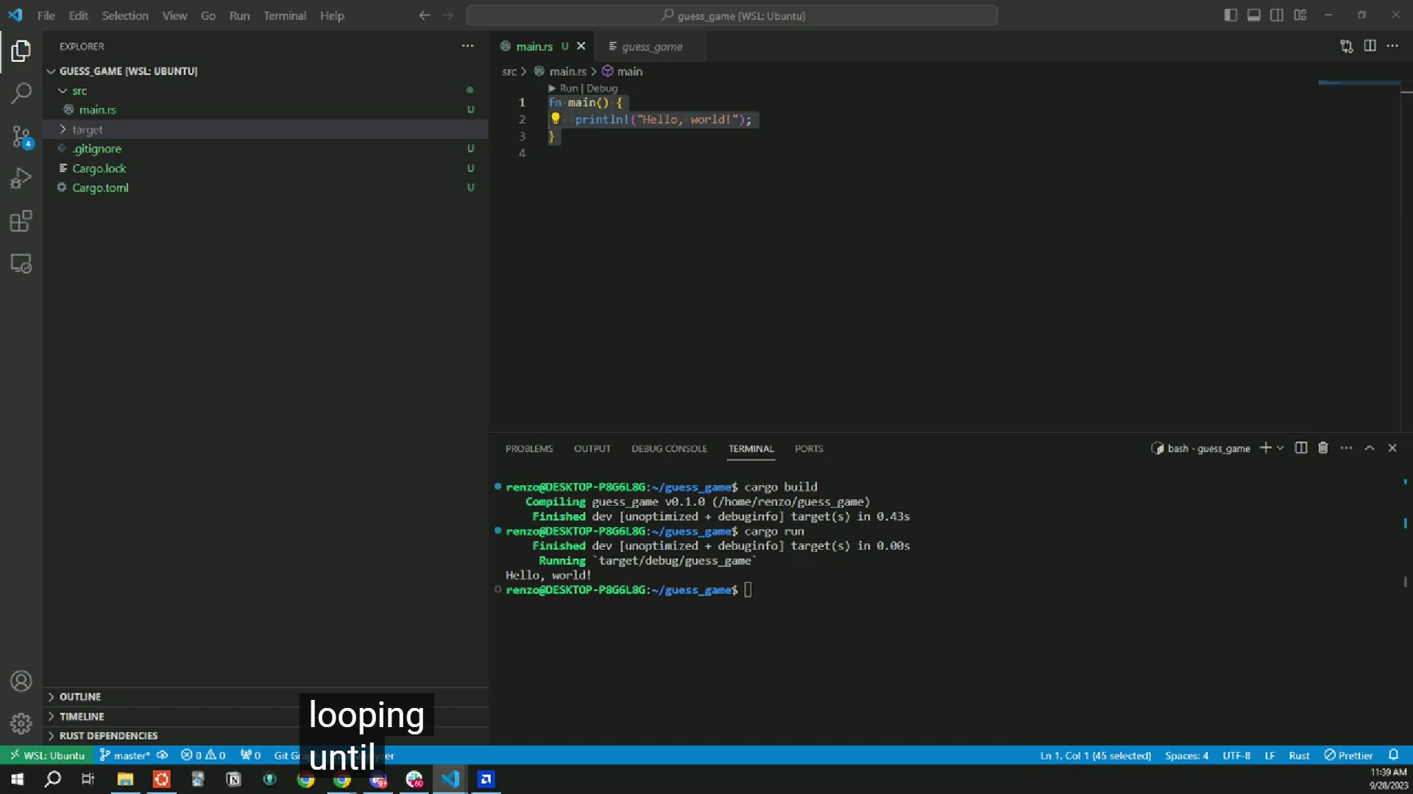

Guess the Game Program

*use std::io;* (uses a library for input/output)

*fn main() {}* (this is a function)

*mutable variables* (dynamic variables whose values we can change)

*let variable_name: data_type* (declaration of variable)

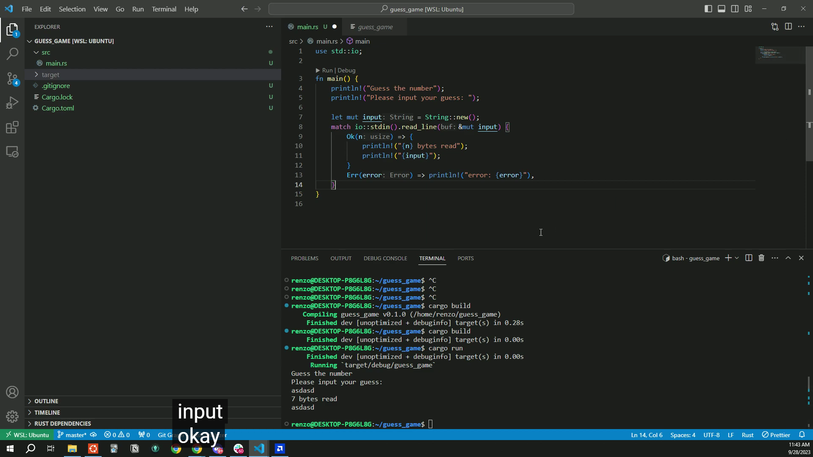

*u32* (unsigned integer variable)

PARSING THE INPUT STRING TO MATCH (COMPARE) IT WITH THE UNSIGNED INTEGER

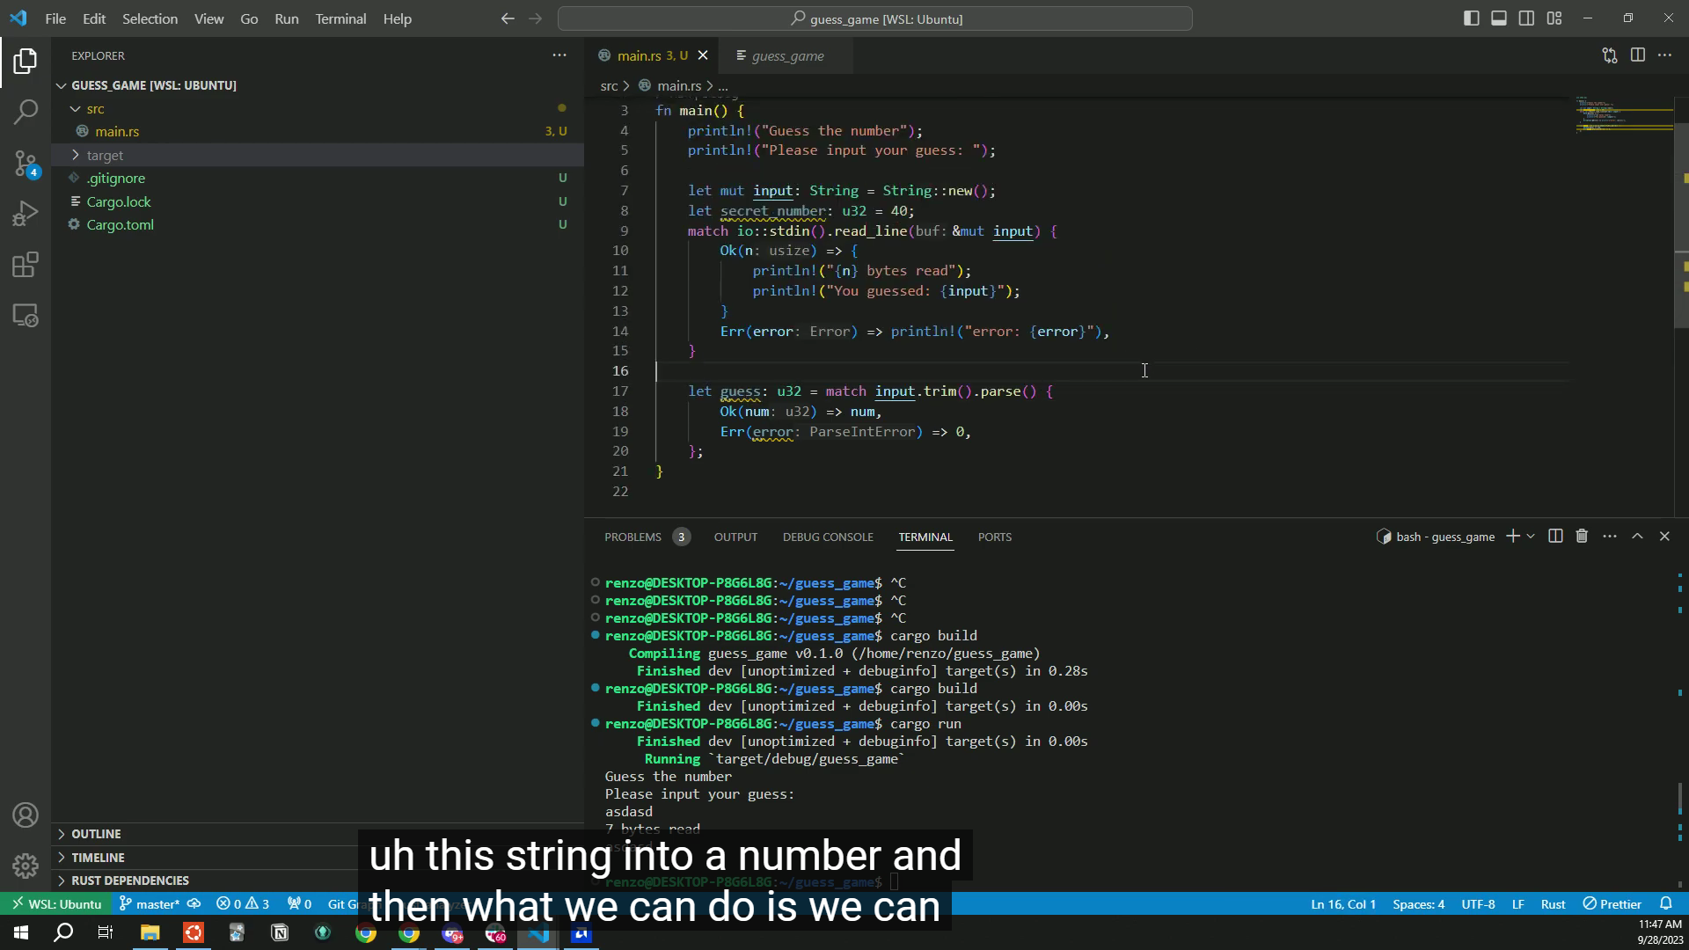

COMPARING THE GUESS VARIABLE WITH THE HIDDEN NUMBER USING A SWITCH CASE (Match)

*use std::cmp::Ordering* (Library for using switch cases)

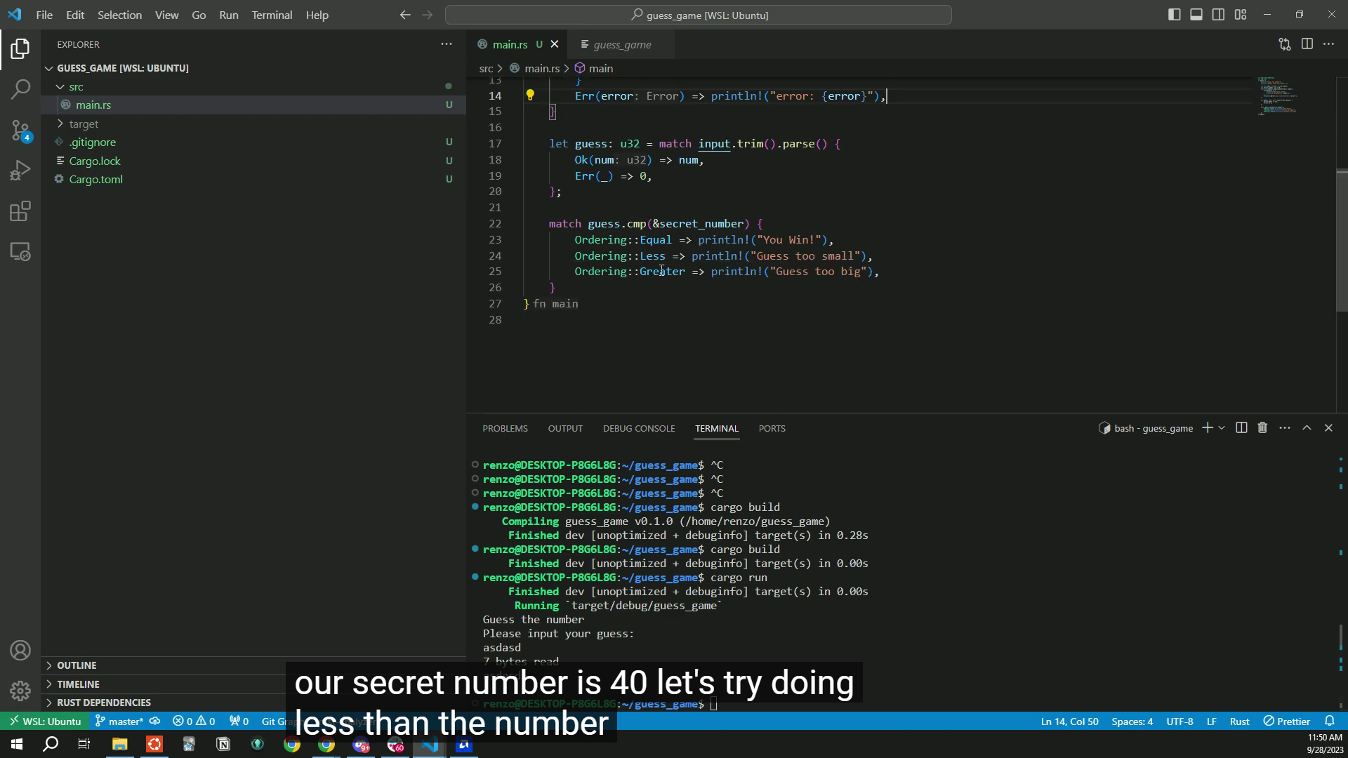

ADD PROGRAM FUNCTIONALITIES SUCH AS LOOPING THE GAME.

*use rand::Rng;* (RNG means range)

--rand is a dependency that needs installing. To do that, type “cargo add rand” in the terminal)

--rand is used for randomizing things. Used in the program to create dynamic secret numbers

