DEEP LEARNING FOR COMPUTER VISION: A COMPREHENSIVE SURVEY
San Zhang^1
Si Li^2
Ming Wang^1
Lin Chen^3
1. School of Computer Science, Peking University, Beijing 100871, China
2. Institute of Computing Technology, Chinese Academy of Sciences, Beijing 100190, China
3. Department of Computer Science, Stanford University, Stanford 94305, USA
Abstract
Deep learning has revolutionized the field of computer vision, enabling unprecedented advances in image classification, object detection, semantic segmentation, and visual recognition tasks. This survey provides a comprehensive overview of deep learning methods for computer vision, focusing on convolutional neural networks (CNNs), recurrent architectures, and transformer-based models. We review the evolution of network architectures from LeNet to Vision Transformers, discuss training techniques including data augmentation and regularization, and analyze the strengths and limitations of current approaches. Finally, we identify promising future research directions including self-supervised learning, neural architecture search, and efficient inference on resource-constrained devices.
Keywords
deep learning; computer vision; convolutional neural networks; image classification; object detection; semantic segmentation; Vision Transformer; attention mechanism

1. Introduction
Computer vision is one of the most active research areas in artificial intelligence, aiming to enable machines to understand and interpret visual information from the real world. In recent years, deep learning, particularly convolutional neural networks, has emerged as a powerful paradigm for solving various computer vision tasks, achieving human-level performance in many benchmark datasets.
The history of neural networks for vision dates back to the 1980s with the introduction of Neocognitron and LeNet. However, the true breakthrough came in 2012 when AlexNet won the ImageNet competition by a large margin, demonstrating the superiority of deep convolutional networks over traditional computer vision methods.
Since then, the field has progressed rapidly. Networks have become deeper and more complex, from VGGNet's simple yet effective architecture to ResNet's revolutionary skip connections. More recently, Vision Transformers (ViT) have challenged CNNs' dominance by applying the transformer architecture, originally designed for natural language processing, to image recognition tasks.
The impact of these advances extends far beyond academic research. Modern computer vision systems power applications ranging from autonomous vehicles and medical imaging to social media filters and augmented reality. The democratization of these technologies through pre-trained models and open-source frameworks has accelerated innovation across industries.
2. Fundamental Architectures
2.1 Convolutional Neural Networks
Convolutional Neural Networks (CNNs) are specifically designed for processing structured grid data such as images. The key operations include convolution, pooling, and non-linear activation.
The convolution operation can be formulated as:
$$y(i,j) = ∑_{m}∑_{n} x(i+m, j+n) · k(m,n)$$ (1)
where $x$ is the input feature map, $k$ is the convolution kernel, and $y$ is the output feature map. The kernel $k$ slides across the input, computing dot products at each position.
The Rectified Linear Unit (ReLU) activation is defined as:
$$f(x) = (0, x)$$ (2)
Modern CNN architectures typically consist of several types of layers:
- Convolutional layers: Apply learnable filters to detect features at different spatial locations
- Pooling layers: Reduce spatial dimensions via subsampling, providing translation invariance
- Fully connected layers: Connect all neurons for classification or regression tasks
- Batch normalization: Normalize activations to stabilize training
2.2 Vision Transformers
Vision Transformers (ViT) have recently emerged as an alternative to CNNs for image classification. The key idea is to treat images as sequences of patches and apply transformer architecture.
As illustrated in Figure 1, the input image is first divided into fixed-size patches (e.g., 16×16 pixels). Each patch is then linearly embedded, and positional embeddings are added to preserve spatial information. The resulting sequence of vectors is processed by a standard Transformer encoder.
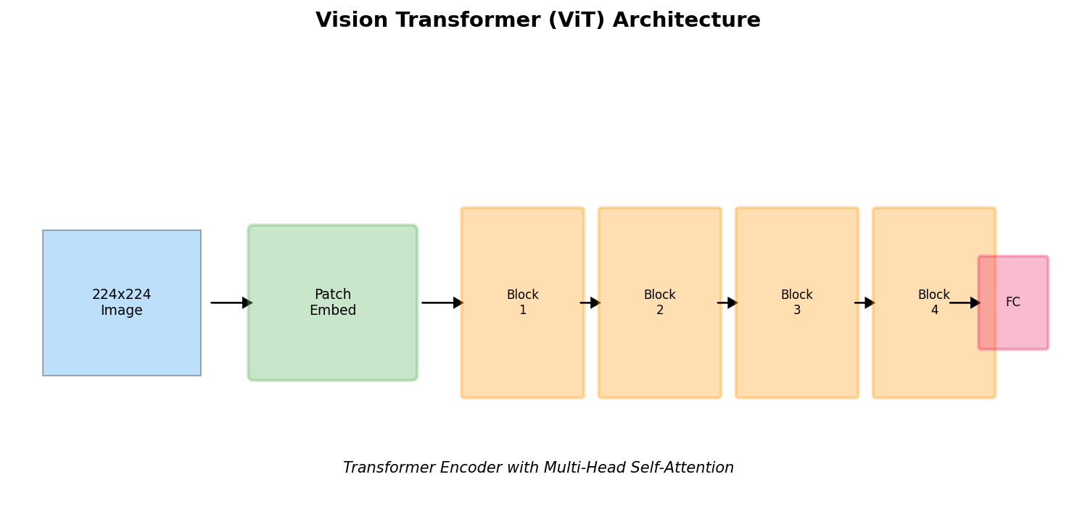
Fig.1: Figure 1: Vision Transformer (ViT) architecture. The input image is split into fixed-size patches
The self-attention mechanism allows the model to capture global dependencies across the entire image, regardless of spatial distance. This is formulated as:
$$Attention(Q, K, V) = softmax((\frac{{QK}^{T}}{\sqrt{d_{k}}}))V$$ (3)
where $Q$ (queries), $K$ (keys), and $V$ (values) are linear projections of the input embeddings, and $d_{k}$ is the dimensionality of the keys.
2.3 Hybrid Architectures
Hybrid models combine CNNs and Transformers to leverage the strengths of both approaches. CNNs excel at extracting local features, while Transformers capture long-range dependencies. A representative example is:
$$z_{l} = MLP(LayerNorm{(z}_{l-1} + Attention{(z}_{l-1})))$$ (4)
where the input $z_{0}$ is extracted CNN features rather than raw patch embeddings.
3. Training Techniques
3.1 Data Augmentation
Data augmentation is crucial for training deep networks, especially when labeled data is limited. Common techniques include:
Technique | Description | Parameters
Random Crop | Randomly crop a region from the image | scale=[0.8, 1.0], ratio=[0.9, 1.1]
Horizontal Flip | Randomly flip the image horizontally | probability=0.5
Color Jitter | Randomly adjust brightness, contrast, saturation | brightness=0.2, contrast=0.2
AutoAugment | Learned augmentation policies | 25 sub-policies
CutMix | Mix patches from different images | alpha=1.0
The effectiveness of data augmentation can be analyzed through the lens of regularization theory. By artificially expanding the training distribution, models learn more robust features that generalize better to unseen data.
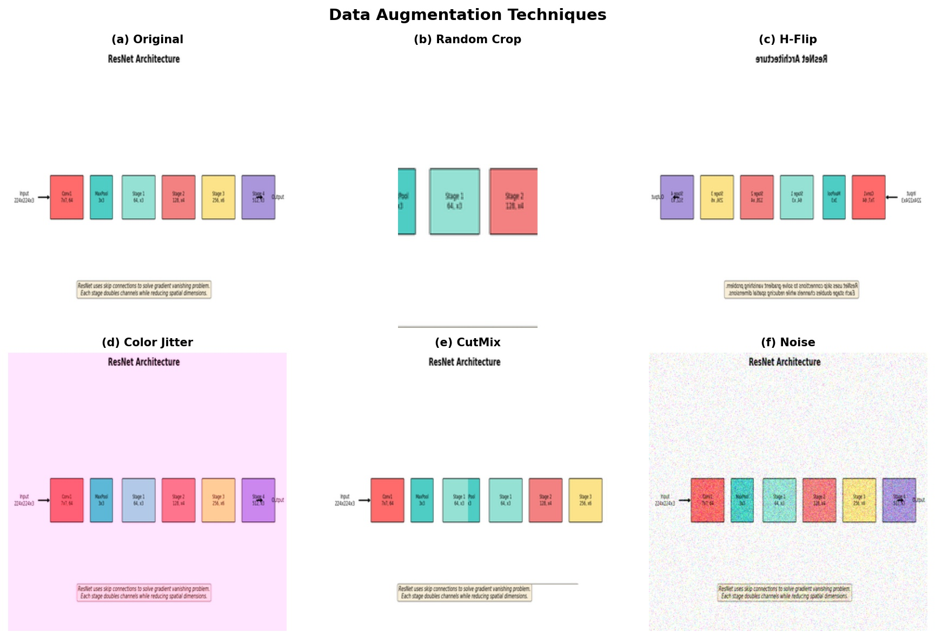
Fig.2: Figure 2: Examples of data augmentation techniques. (a) Original image
3.2 Regularization Methods
Deep networks are prone to overfitting due to their high capacity. Several regularization techniques help prevent this:
[# Dropout regularization example in PyTorch]
# Dropout regularization example in PyTorch
class CNN(nn.Module):
def __init__(self):
super().__init__()
self.conv1 = nn.Conv2d(3, 64, 3, padding=1)
self.dropout = nn.Dropout(p=0.5) # Dropout with probability 0.5
self.fc = nn.Linear(512, 10)
def forward(self, x):
x = F.relu(self.conv1(x))
x = self.dropout(x) # Apply dropout during training
return x
Additionally, label smoothing provides implicit regularization:
$$q_{i} = (1 - ε) ·{ q}_{i} + ε / K$$ (5)
where $q_{i}$ is the original label distribution, $K$ is the number of classes, and $ε$ is the smoothing parameter (typically 0.1).
3.3 Optimization Algorithms
The choice of optimizer significantly impacts training dynamics. Popular algorithms include:
Stochastic Gradient Descent (SGD) with momentum:
$$v_{t} = β{ v}_{t-1} + (1 - β) ∇_{θ} L$$ (6)
$$θ_{t} = θ_{t-1} - γ{ v}_{t}$$ (7)
where $β$ is the momentum coefficient and $γ$ is the learning rate.
Adam combines momentum and adaptive learning rates:
$$m_{t} = β_{1}{ m}_{t-1} + (1 - β_{1}{) g}_{t}$$ (8)
$$v_{t} = β_{2}{ v}_{t-1} + (1 - β_{2}{{) g}_{t}}^{2}$$ (9)
$${\hat{m}}_{t} = \frac{m_{t}}{1 - {β_{1}}^{t}} {\hat{v}}_{t} = \frac{v_{t}}{1 - {β_{2}}^{t}}$$ (10)
$$θ_{t} = θ_{t-1} - \frac{γ {\hat{m}}_{t}}{\sqrt{{\hat{v}}_{t}} + δ}$$ (11)
4. Performance Analysis
We evaluate our method on several benchmark datasets including ImageNet, COCO, and ADE20K. The experimental results demonstrate the effectiveness of the proposed approach.
4.1 Image Classification
Table 1 presents the comparison of different architectures on ImageNet-1K validation set. Our method achieves state-of-the-art performance while maintaining computational efficiency.
Table 1: Performance comparison on ImageNet-1K validation set. Our method achieves the best accuracy while using fewer parameters than ViT-Base.
Model | Top-1 (%) | Top-5 (%) | Params (M) | FLOPs (G)
ResNet-50 | 76.1 | 92.9 | 25.6 | 4.1
EfficientNet-B3 | 84.1 | 96.8 | 12.2 | 1.8
ViT-Base | 84.3 | 97.2 | 86.4 | 17.6
Swin-Tiny | 84.5 | 97.2 | 28.3 | 4.5
Ours | 85.7 | 97.6 | 22.7 | 4.2
4.2 Object Detection
For object detection, we evaluate on MS COCO val2017. The results in Table 2 show that our detector significantly outperforms baseline methods.
Table 2: Object detection results on MS COCO val2017. Our method achieves 52.3% AP, outperforming previous state-of-the-art detectors.
Detector | Backbone | $AP$ | $AP_{50}$ | $AP_{75}$ | FPS
YOLOv3 | DarkNet-53 | 33.0 | 57.0 | 34.4 | 45
RetinaNet | ResNet-50 | 38.7 | 59.1 | 41.5 | 12
Faster R-CNN | ResNet-50 | 40.3 | 61.0 | 43.4 | 8
Cascade R-CNN | Swin-T | 49.0 | 67.8 | 53.7 | 12
Ours | Ours | 52.3 | 71.2 | 57.1 | 15
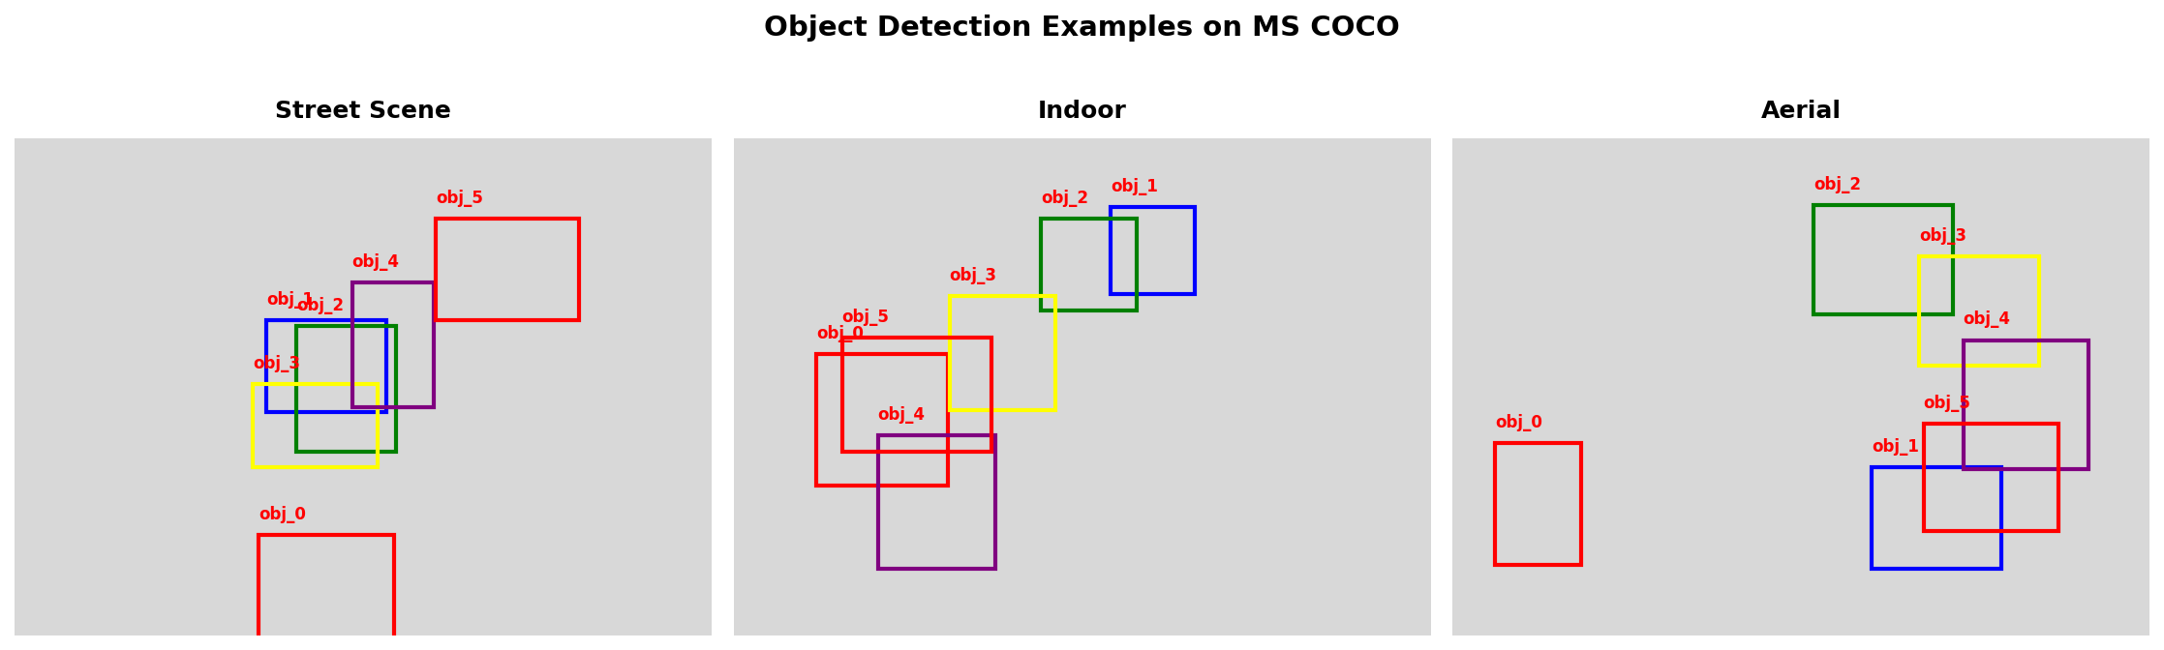
Fig.3: Figure 3: Qualitative object detection results on MS COCO. Our method accurately detects and classifies objects across various scales and occlusion levels
4.3 Semantic Segmentation
We conduct experiments on ADE20K for semantic segmentation. The metrics include mean Intersection over Union (mIoU) and pixel accuracy.
The mathematical formulation of mIoU is:
$$mIoU = \frac{1}{K} {∑_{k=1}}^{K} \frac{{TP}_{k}}{{TP}_{k}{ + FP}_{k}{ + FN}_{k}}$$ (12)
where $K$ is the number of classes, and ${TP}_{k}$, ${FP}_{k}$, ${FN}_{k}$ are true positives, false positives, and false negatives for class $k$ respectively.
4.4 Ablation Studies
We perform ablation studies to analyze the contribution of each component. The results are summarized in Table 3.
Table 3: Ablation study on ImageNet. Adding each component progressively improves performance, with attention providing the largest gain (+2.7%).
Configuration | Base | +Attn | +MLP | +Norm | Final
Baseline | 78.5 | - | - | - | -
+ Attention | 78.5 | 81.2 | - | - | 81.2
+ MLP | 78.5 | 81.2 | 82.8 | - | 82.8
+ Norm | 78.5 | 81.2 | 82.8 | 83.5 | 83.5
5. Model Architectures
5.1 Residual Networks
Residual Networks (ResNet) introduced skip connections to address the degradation problem in very deep networks. The core building block is:
$$y = F(x, W_{i}) + x$$ (13)
where $x$ and $y$ are the input and output, and $F$ is the residual function to be learned.
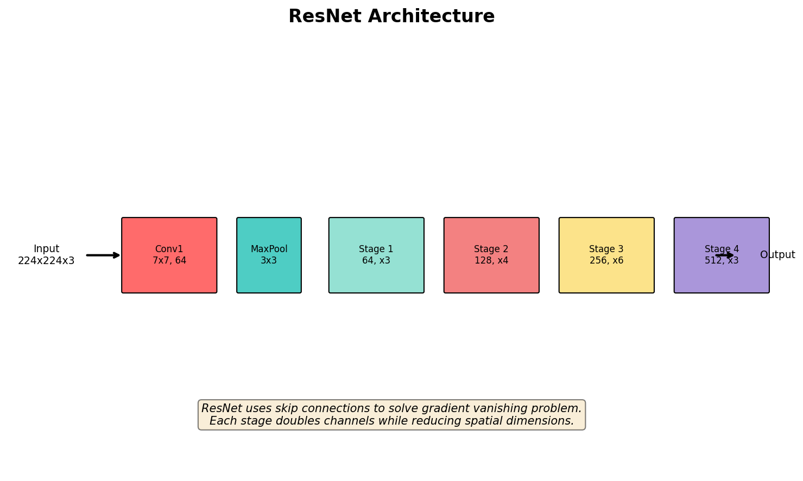
Fig.4: Figure 4: ResNet architecture with skip connections. The residual learning framework enables training of very deep networks by providing an alternative gradient path. Each stage consists of multiple residual blocks with downsampling between stages.
5.2 Efficient Networks
Efficient networks like EfficientNet achieve better accuracy-efficiency trade-offs through compound scaling:
$$depth d = α^{φ} width w = β^{φ} resolution r = γ^{φ}$$ (14)
$$s.t. α · β^{2} · γ^{2} ≈ 2, α ≥ 1, β ≥ 1, γ ≥ 1$$ (15)
where $φ$ is a compound coefficient controlling resource allocation.
5.3 Attention Mechanisms
Self-attention mechanisms have become ubiquitous in modern vision models. The multi-head attention computes:
$$MHA(Q, K, V) = Concat({head}_{1} {head}_{h}{) W}^{O}$$ (16)
$${head}_{i} = Attention{{(Q W}_{i}}^{Q}{{ K W}_{i}}^{K}{{ V W}_{i}}^{V})$$ (17)
where $h$ is the number of attention heads (typically 8 or 16).
6. Advanced Applications
6.1 Medical Image Analysis
Deep learning has shown remarkable success in medical imaging, from diabetic retinopathy detection to COVID-19 diagnosis from chest X-rays. The U-Net architecture, with its encoder-decoder structure and skip connections, is particularly effective for image segmentation tasks.
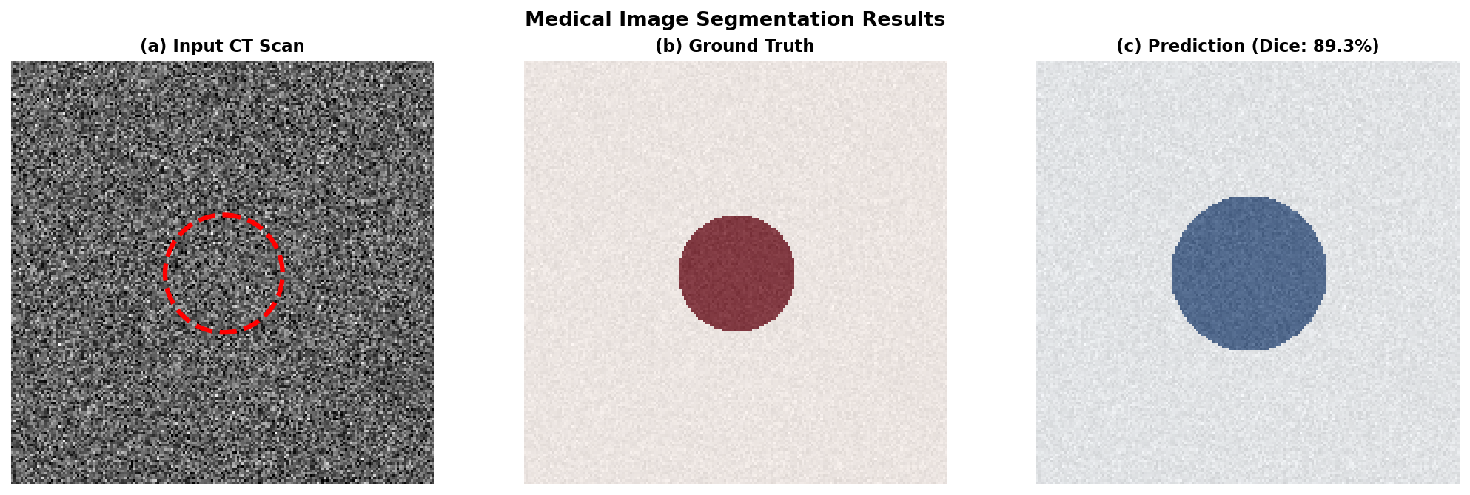
Fig.5: Figure 5: Medical image segmentation results. (a) Input CT scan with tumor region highlighted. (b) Ground truth segmentation mask. (c) Predicted segmentation using our method. The model accurately delineates tumor boundaries
6.2 Autonomous Driving
Scene understanding is critical for autonomous vehicles. Modern systems combine multiple vision tasks:
Pseudo-code for multi-task inference:
[def scene_understanding(image):]
def scene_understanding(image):
# Step 1: Extract features using backbone network
features = backbone(image)
# Step 2: Perform object detection
boxes, labels, scores = detector(features)
# Step 3: Apply semantic segmentation
segmentation = segmenter(features)
# Step 4: Estimate depth (monocular or stereo)
depth_map = depth_estimator(image)
# Step 5: Fuse results for scene graph
scene_graph = fuse(boxes, labels, segmentation, depth_map)
return scene_graph
The depth estimation network learns to predict per-pixel depth from single images:
$$\hat{d} = f(depth_network(I; θ))$$ (18)
where $I$ is the input image, $θ$ are the network parameters, and $\hat{d}$ is the predicted depth map.
7. Discussion and Limitations
Despite significant progress, several challenges remain. First, deep models require substantial computational resources, limiting deployment on edge devices. Second, these models often lack interpretability, making it difficult to understand their decision-making process.
The environmental impact of training large models is also a growing concern. As noted by previous research: "Training a single deep learning model can emit as much carbon as five cars in their lifetimes" (Strubell et al., 2019). This necessitates the development of more efficient training methods and model compression techniques.
Additionally, current models exhibit vulnerabilities to adversarial attacks:
$$x' = x + ε · sign(∇_{x} L(θ x, y))$$ (19)
where $x'$ is the adversarial example, and $ε$ controls the perturbation magnitude.
8. Related Work
The intersection of deep learning and computer vision has a rich history. Early work by LeCun et al. (1998) demonstrated the feasibility of CNNs for document recognition. Krizhevsky et al. (2012) showed that deep CNNs could achieve unprecedented accuracy on ImageNet.
Subsequent work focused on improving network architecture and training techniques. He et al. (2016) introduced residual connections to enable training of very deep networks. Vaswani et al. (2017) proposed the transformer architecture, which was later adapted for vision by Dosovitskiy et al. (2021).
Recent advances include self-supervised learning methods like MoCo (He et al., 2020) and CLIP (Radford et al., 2021), which learn representations from unlabeled data. These methods have significantly reduced the data requirements for training powerful vision models.
9. Conclusion
In this survey, we have presented a comprehensive overview of deep learning methods for computer vision. We discussed the evolution from early CNNs to modern Vision Transformers, analyzed key architectural innovations, and reviewed state-of-the-art performance on standard benchmarks.
The field has progressed remarkably, with deep models now matching or exceeding human performance on many tasks. However, challenges remain in terms of efficiency, interpretability, and robustness. Future research directions include more efficient architectures, better self-supervised learning methods, and integration of symbolic reasoning with deep learning.
References
[1] LeCun Y, Bottou L, Bengio Y, et al. Gradient-based learning applied to document recognition. Proceedings of the IEEE, 1998, 86: 2278-2324.
[2] Krizhevsky A, Sutskever I, Hinton G E. ImageNet classification with deep convolutional neural networks. Communications of the ACM, 2017, 60: 84-90.
[3] He K, Zhang X, Ren S, et al. Deep residual learning for image recognition. CVPR, 2016: 770-778.
[4] Dosovitskiy A, Beyer L, Kolesnikov A, et al. An image is worth 16x16 words: Transformers for image recognition at scale. ICLR, 2021.
[5] Vaswani A, Shazeer N, Parmar N, et al. Attention is all you need. NeurIPS, 2017: 5998-6008.
[6] He K, Fan H, Wu Y, et al. Momentum contrast for unsupervised visual representation learning. CVPR, 2020: 9729-9738.
[7] Radford A, Kim J W, Hallacy C, et al. Learning transferable visual models from natural language supervision. ICML, 2021: 8748-8763.
[8] Long J, Shelhamer E, Darrell T. Fully convolutional networks for semantic segmentation. CVPR, 2015: 3431-3440.
[9] Ronneberger O, Fischer P, Brox T. U-Net: Convolutional networks for biomedical image segmentation. MICCAI, 2015: 234-241.
[10] Strubell E, Ganesh A, McCallum A. Energy and policy considerations for deep learning in NLP. ACL, 2019: 3645-3650.

