# Documentation

*Developed by* Iderkhangai Amarkhuu (iderhangai2014@gmail.com)

Description:   
Design and implement a back-end Java application that simulates a vending machine: the user provides the amount of change and the available coins in the vending machine. Then the vending machine gives back the change. The number of the coins of the change should be as few as possible. If there are not enough coins in the vending machine, error should be given back instead. The valid coins are: 5, 10, 20, 50, 100 and 200.

## Technologies used

* Spring Boot – Back-End
* ReactJS –Front-End (Material UI)

## Architecture:

Spring Boot (Java 11) :

* **Controller** – Main rest controller resides here
* **Exception** – Global exception handler which handles errors.
* **Model** – Service parameters (request and response)
* **Util** – Helper classes
* **Service** – Service that does main functionality
* **Config** – Configuration class (CORS handling)

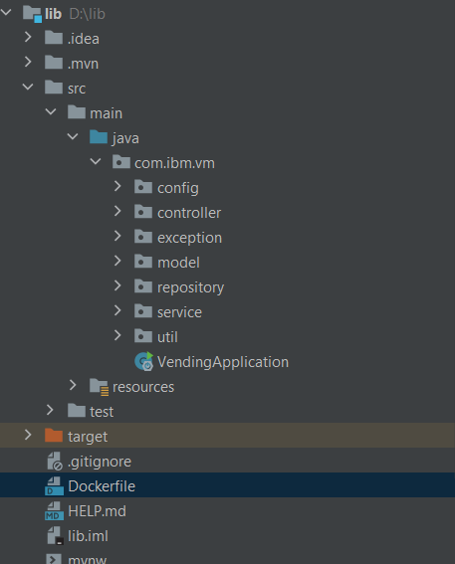 File structure

## ReactJS

* **App.js** – Main functionality that calls API and render UI elements.
* **App.css** – Styles

## API (Spring Boot) – mvn install (port:8080)

URL: <http://localhost:8080/api/v1/vm>

Request:

{

    "amount": "500"

}

Successful response:

{

    "code": 0,

    "timestamp": "2021-05-17 12:28:21",

    "changes": [

        200,

        200,

        100

    ]

}

Request 2:

{

    "amount": ""

}

--------------------------------------------------------------------------------------

{

    "amount": "11"

}

Error Response:

{

    "code": 422,

    "message": "Validation error. Check 'errors' field and Try again.",

    "timestamp": "2021-05-17 12:35:41",

    "errors": [

        {

            "field": "amount",

            "message": "must be greater than or equal to 10"

        }

    ]

}

--------------------------------------------------------------------------------------

{

    "code": 500,

    "message": "Invalid Coin Please Enter Valid Coin!",

    "timestamp": "2021-05-17 12:36:03"

}

### Front-End (ReactJS)

To run the file: npm start (port:3000)

Insert a one of the following coins in the input then submit

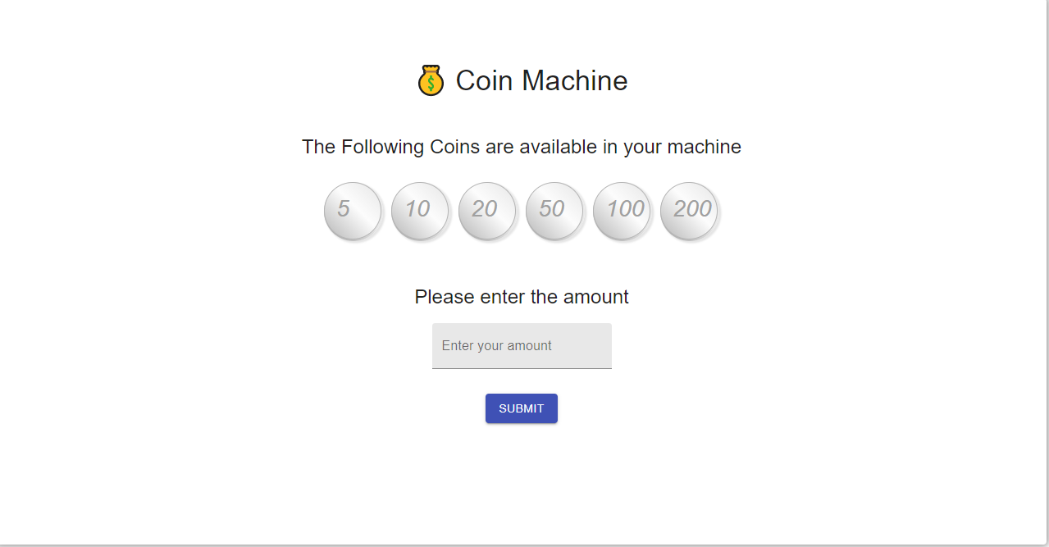

Server returns possible minimum number of available coins in the machine:

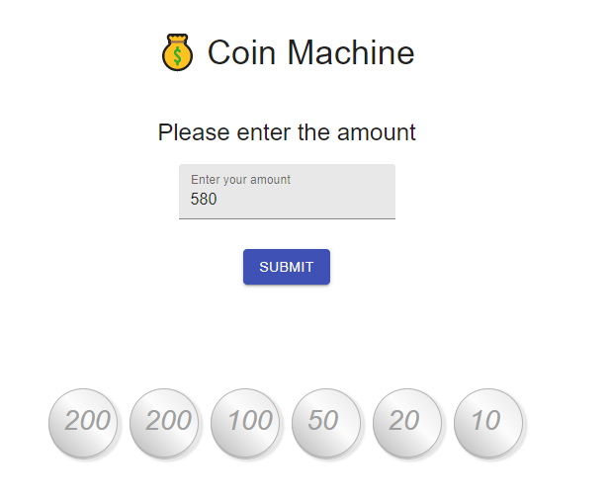

Testing with invalid coins

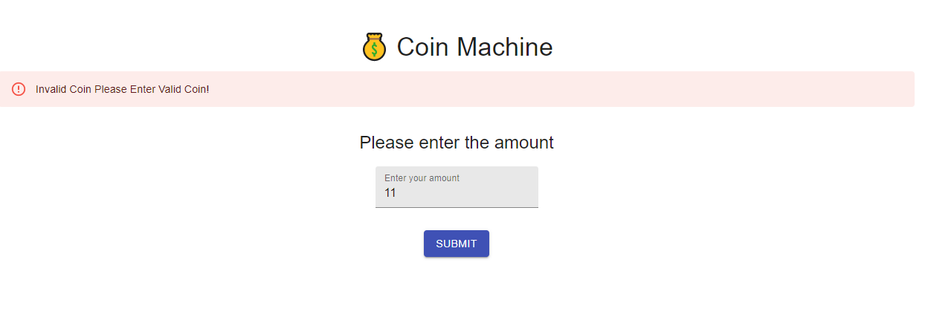

## Creating docker image for the project

FROM java:11  
EXPOSE 8080  
ADD target/ibm-vm.jar ibm-vm.jar  
ENTRYPOINT ["java", "-jar", "ibm-vm.jar"]