Inventory management system

Developed by Iderkhangai Amarkhuu/DQC3OM/

Contents

Overview 1

Used technologies 1

ERD 2

Class Diagram 3

Database 5

File Structure 6

User interface 6

# Overview

An **inventory management system** (or **inventory system**) is the process by which you manage your goods, categories, brands throughout your entire supply chain, from purchasing to end sales. It governs how you approach **inventory management** for your business.

# Used technologies

* Spring Boot
* MongoDB
* Thymeleaf-3
* Javascript Ajax and Jquery
* Bootstrap 4

# 

# ERD

Here is illustrating the database design and table, fields and their relations of each other.

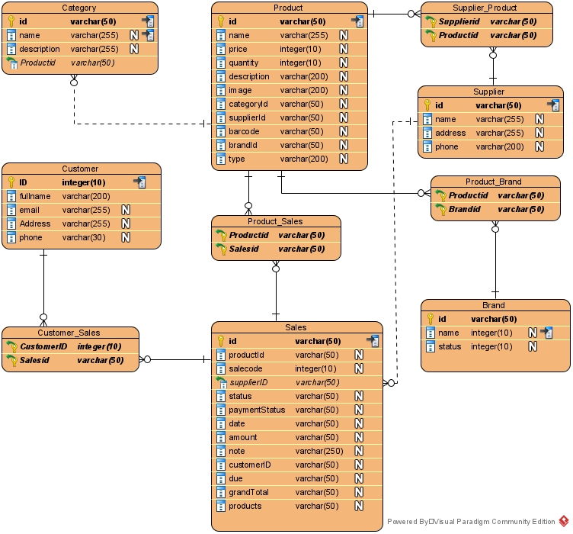

# Class Diagram

Here is class diagram of the system consist of properties, dependencies and relations

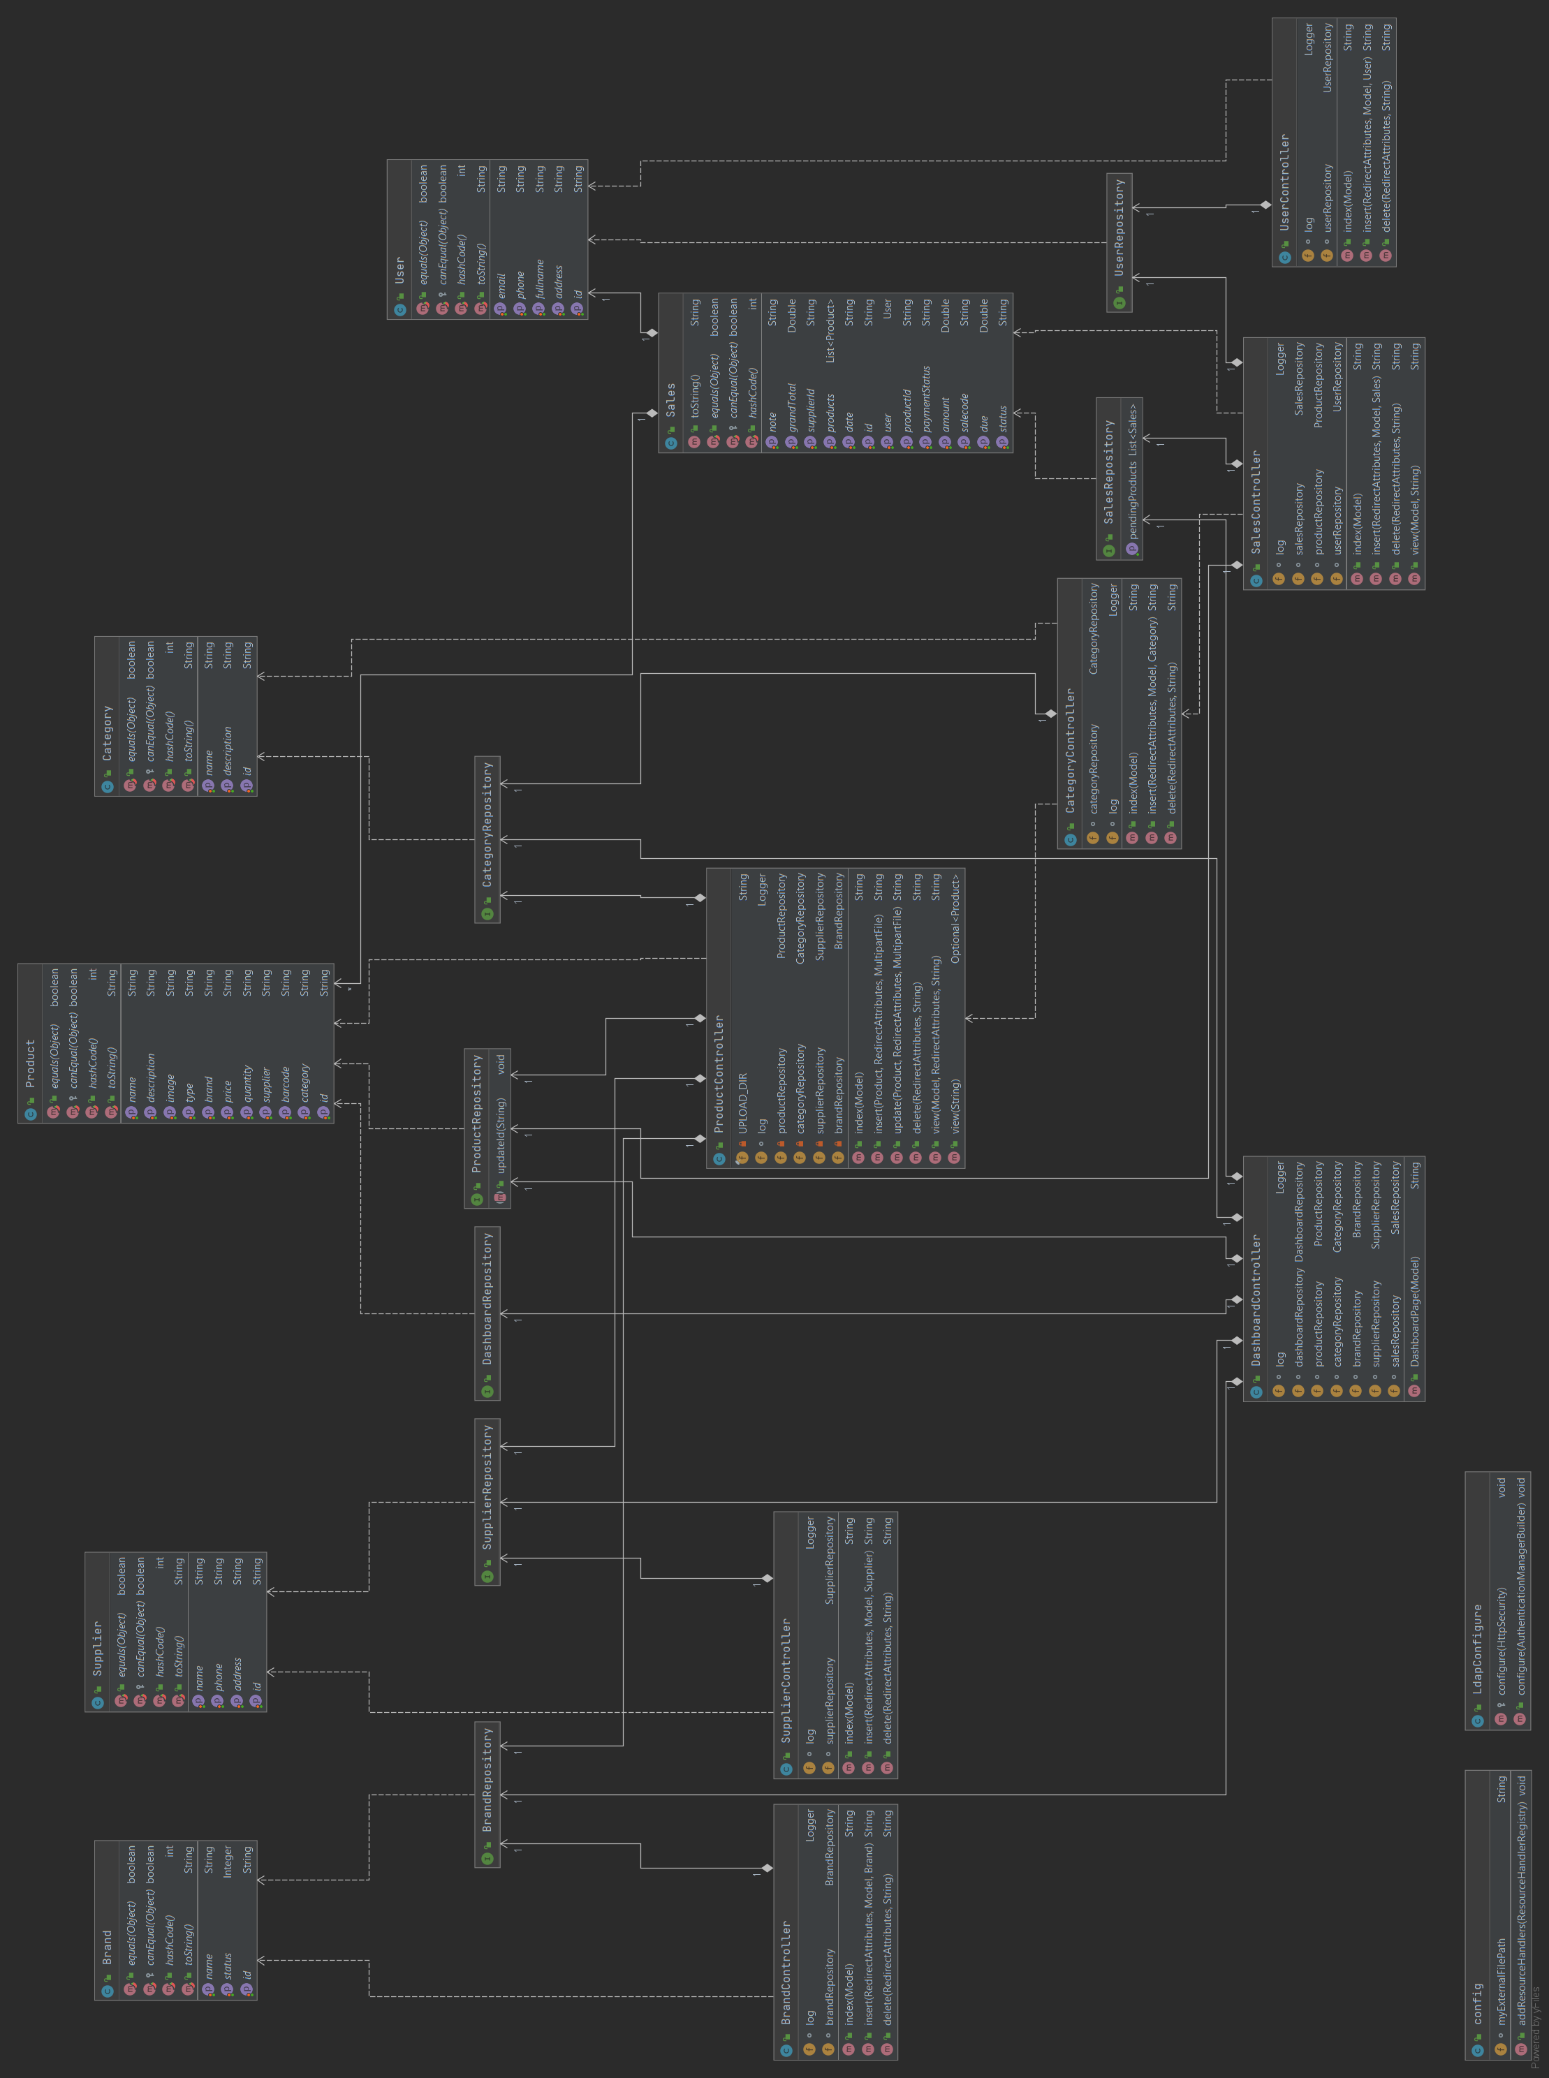



Click the link to download the Class diagram as image.

# Database

Here are showing documents of our main collection named Inventory

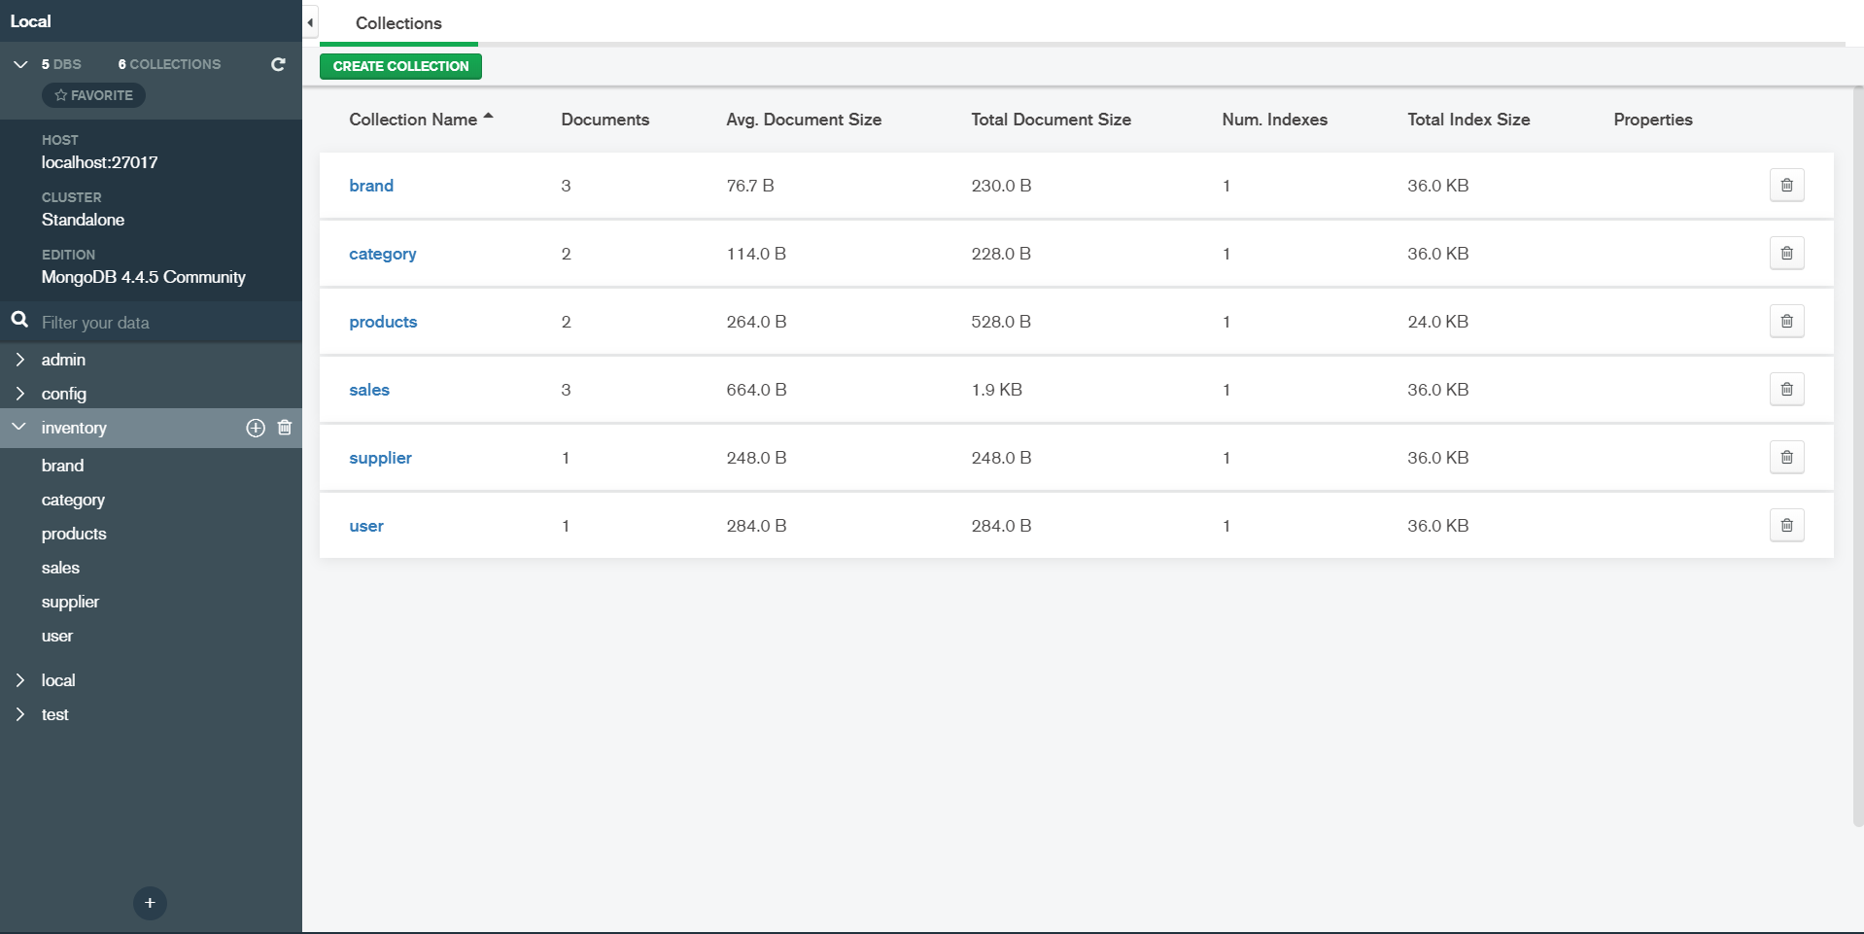

# File Structure

* **Config –** Configuration files and LDAP server implemented **.**
* **Controller –** Controller, Restful APIs.
* **Model –** Entity Bean classes.
* **Repository –** DAO class where we handle database operation with MongoRepository.

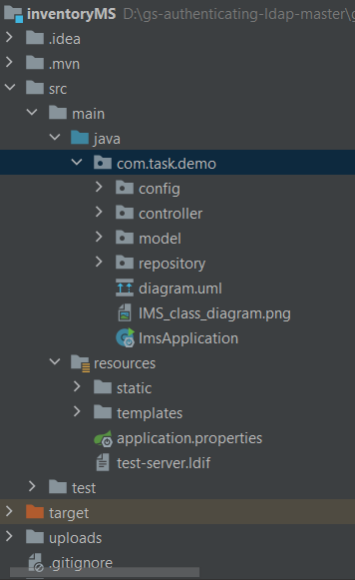

# User interactions

Figure 1: User login section which authenticated with LDAP server.

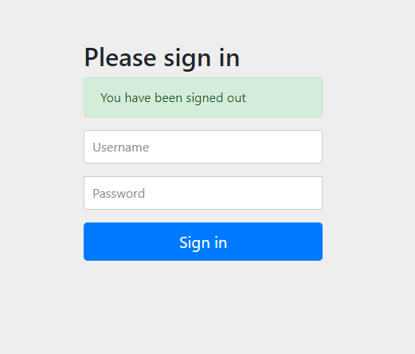

Figure 2: Main dashboard where user can track every modules of the system

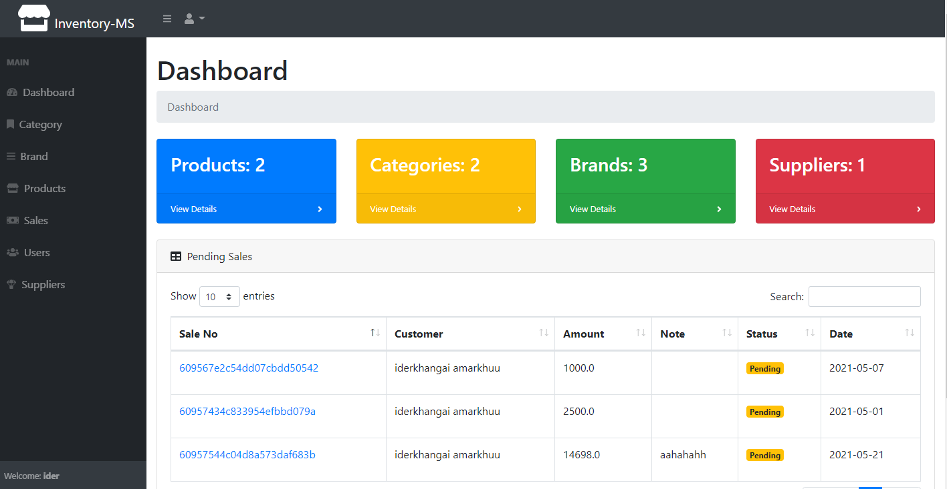

Figure 3: Brands List, U can insert, update and delete brands

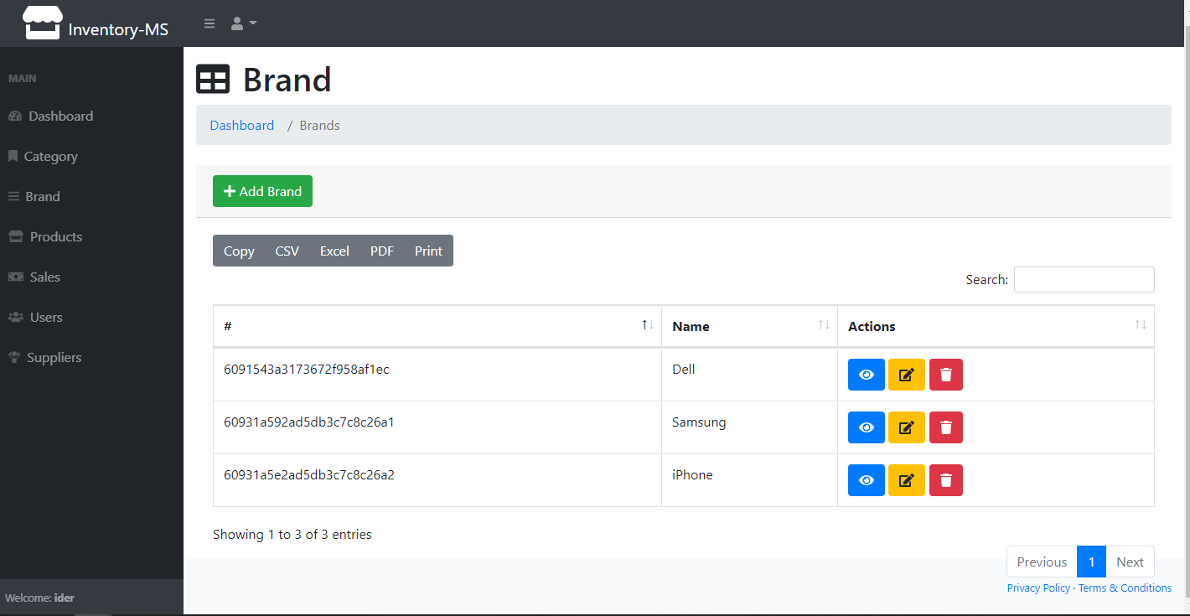

Figure 4: Product page where we can manage products

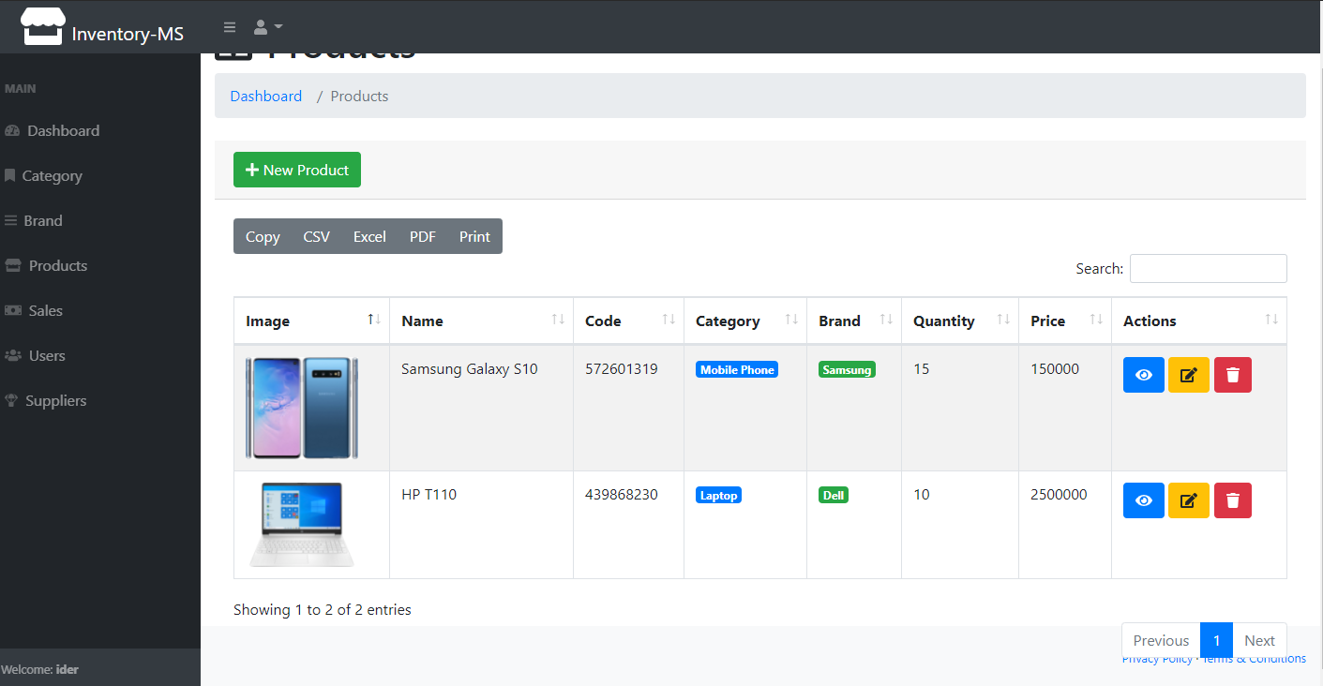

Figure 5: Sales page to manage sales of products to customer

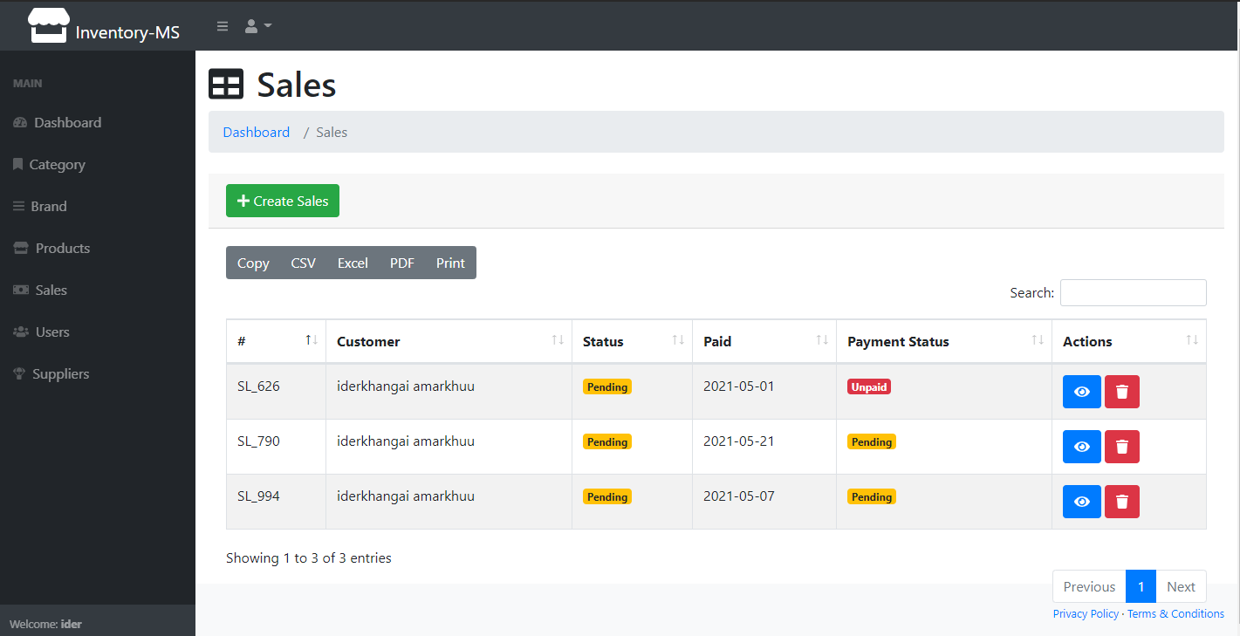

Figure 6: Displaying the sale’s details and print them and send them to customer.

