Hi Aaron, I'd like to send you more details, and hear your estimate for the first stage of the project. Full disclosure, I have hired someone outside the US to develop a demo, but I can't be sure if its a good fit at this point
The project is named ‘UFC Survivor.’
The website will be a game where users choose which UFC fighters will win at an upcoming event.
Contests will be generated from this source: http://ufcstats.com/statistics/events/completed
The top link is always the next upcoming event, and this is what our contests will be based off of. The website should scrape this link to find the relevant fighters for the contest.

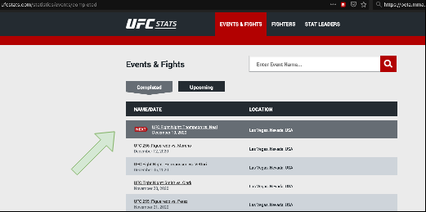

When the actual event happens, we should scrape the results from this same page, as they happen. To check if the fight is happened, the scraper should check the event page for what fights have completed. If a fight has completed, it looks like http://ufcstats.com/fight-details/33d52ac2d70b8415 but if it has not happened yet, it looks like http://ufcstats.com/fight-details/6c151e9c1b3501a9
The user will see a page like this for the contest.

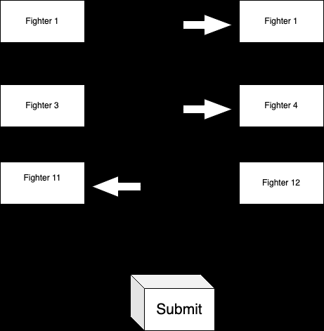

The user must select 1 fighter for each fight (sometimes up to 14 fights, sometimes as little as 5), then can submit. The entry should be saved with each fighter selection, and the user who made them.
Every contest has a date and time that it stops accepting new entries. A user can enter a contest multiple times.
Once a contest begins, and new entries are no longer accepted, the contest will be able to be viewed by anyone.
While viewing a “live” contest, users are displayed in a list next to each fighter they chose.

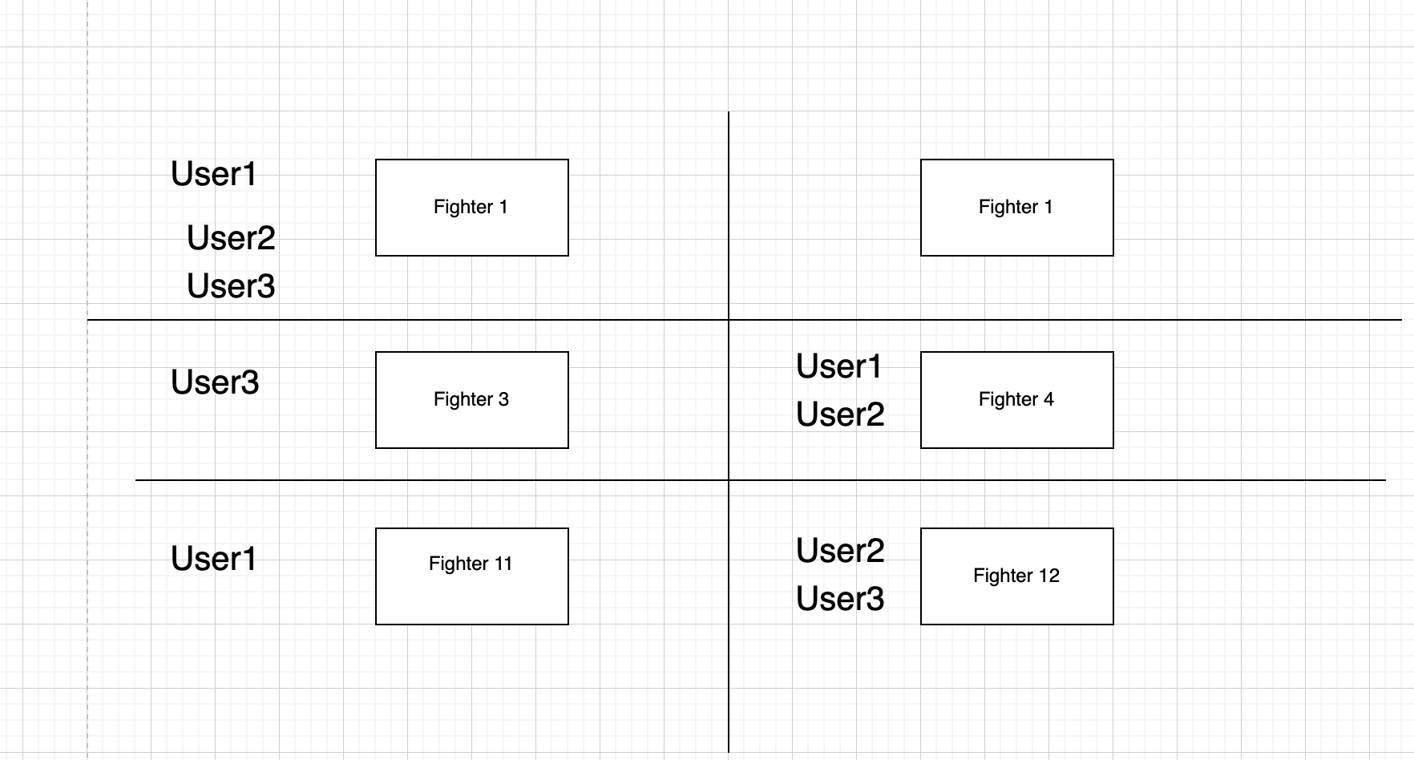

As the event unfolds, and results are collected, fighters will either win or lose. The contest should update and show this. In this example, I used red to mean a fighter lost, and green to mean they won

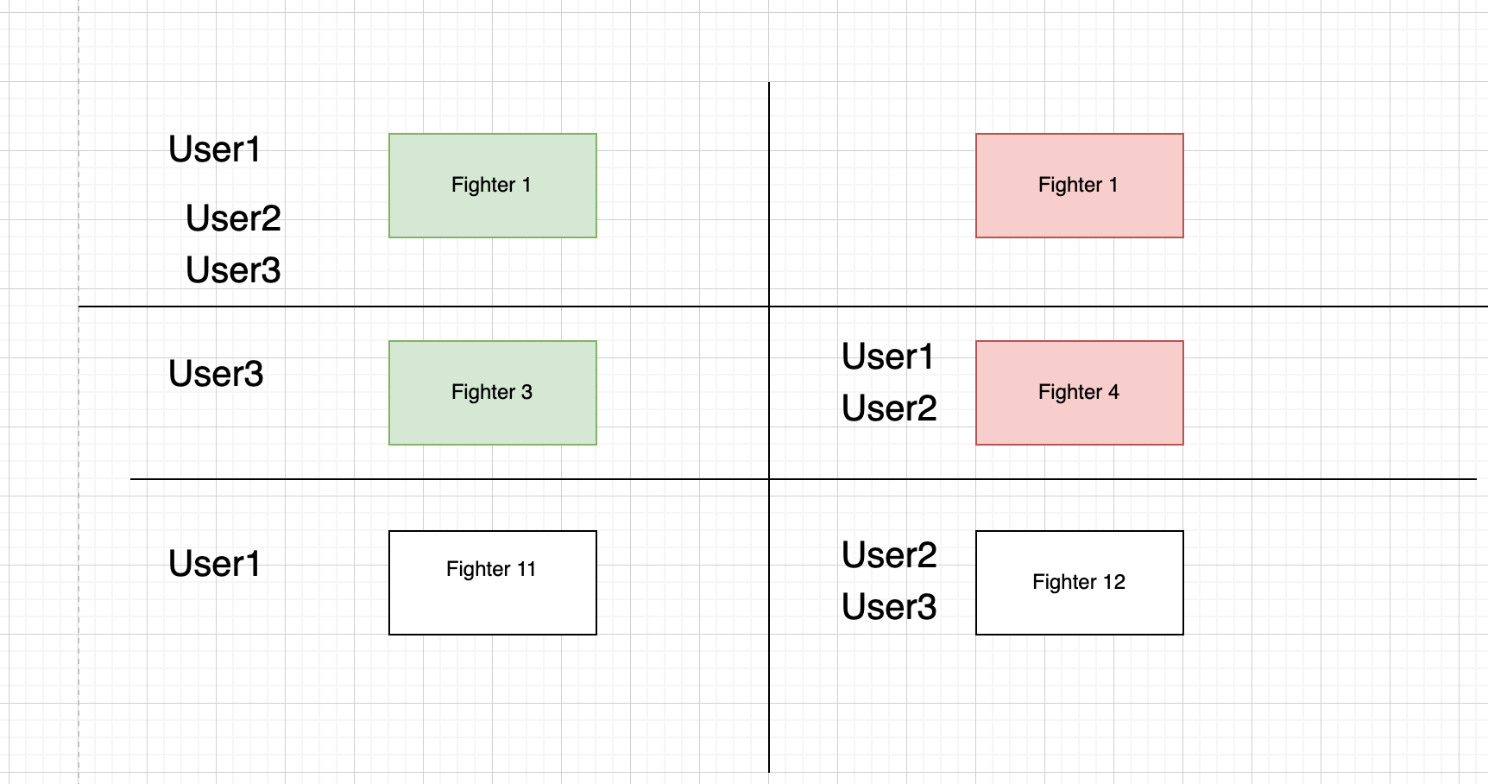

Any user who is on a fighter who loses, is no longer active in the contest and their name should be grayed out.
The winner of the contest is the one who “survives” the longest. In this example, User 3 survived the second fight, but the other entries lost, so User 3 is declared the winner.

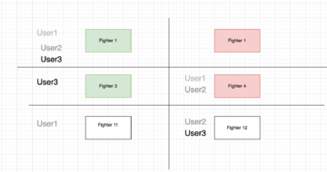

All pages should be viewed without logging in. The homepage should contain interface for choosing an entry. If a user submits an entry and is not logged in, the website will ask them to login or create account. A user should be able to create an account here with their Twitter.

On this page http://ufcstats.com/statistics/events/completed the top event is the next upcoming event. As soon as the event starts on Saturday, this event will be moved down to the 2nd row in the table.

Once the event starts, the event page (like http://ufcstats.com/event-details/e49c2db95e572dc8 ) will updates bouts one by one, as they happen
So as an example, after a few fights it will look like this

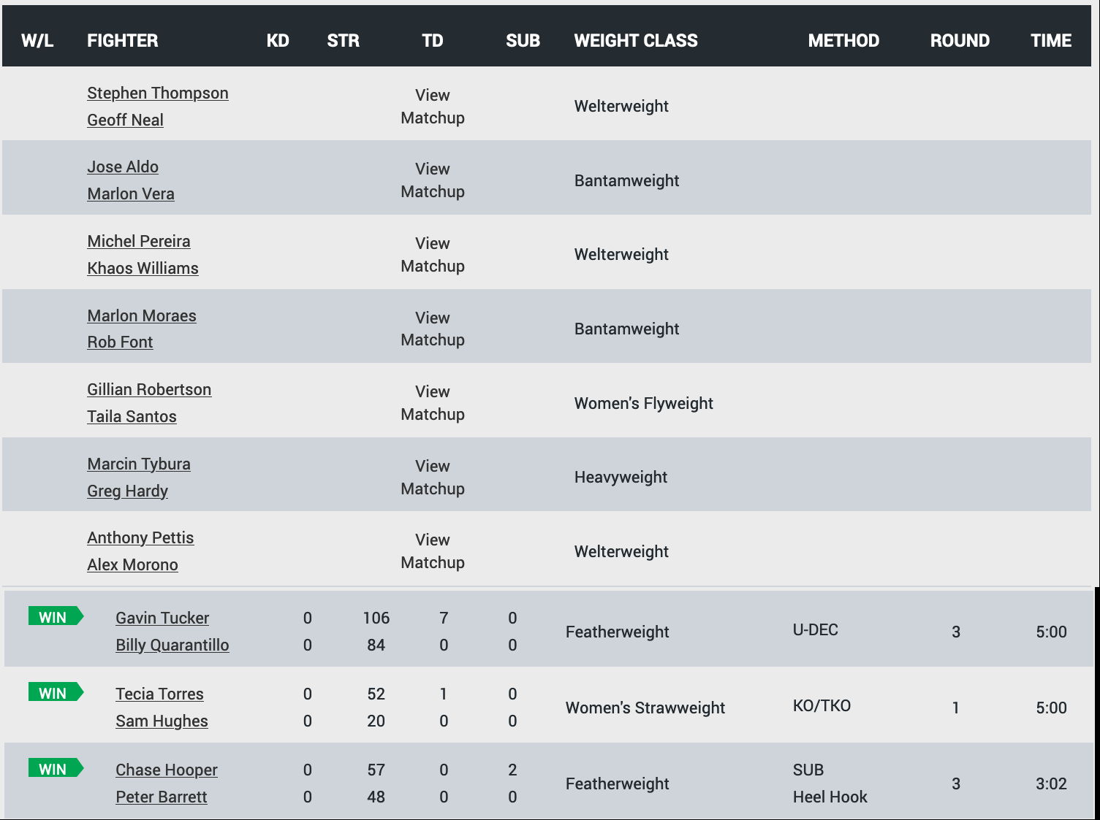

So the code does not need to scrape this "event page", until the event has started. And we know it has started because it is not the top row on this page http://ufcstats.com/event-details/e49c2db95e572dc8

Sign-in URL: https://477407784288.signin.aws.amazon.com/console
User name: AC
Password: Survivor11

