SRS for Programming Contest Platform

1. Introduction

1.1 Purpose
The purpose of this document is to define the functional, non-functional, and technical requirements for the Programming Contest Platform. This platform will allow three types of users — Participants, Judges, and Organisers — to interact within a secure environment, host contests, submit solutions, evaluate results, and manage problem sets.

1.2 Scope
The platform will:
- Allow Participants to register, create profiles, practice problems, and participate in contests.
- Allow Judges to create problems, upload solutions, and evaluate participant submissions (manual or auto).
- Allow Organisers to schedule contests, manage participants, and oversee judges.
- Provide automatic scoring and leaderboards.
- It will be built with Laravel (backend), Vue.js (frontend), and MySQL as the database.

1.3 Definitions
- RBAC – Role-Based Access Control
- UI – User Interface
- CRUD – Create, Read, Update, Delete

2. Overall Description

2.1 Product Perspective
This is a web-based platform. It will have:
- A frontend for all users (Vue.js, responsive, secure UI)
- A backend with APIs for authentication, contest management, and scoring
- A database storing users, problems, submissions, and results

2.2 User Characteristics
- Participants: Students under 16 years, basic computer literacy, and the ability to solve problems online
- Judges: Problem setters with programming knowledge
- Organisers: Admin-level users, technically competent to manage contests

2.3 Constraints
- Participants must be under 16 years (validated during registration).
- Secure authentication (JWT/session-based).
- Role-based access (RBAC) is enforced.

3. System Features and Requirements

3.1 Functional Requirements
ID | Feature | Description
FR-01 | User Authentication | Users can register/login/logout. Age validation enforced.
FR-02 | Role-Based Access Control | Different dashboards for Participant, Judge, Organiser.
FR-03 | Profile Management | Users can edit their profile, view progress, and track submissions.
FR-04 | Problem Management | Judges can create, update, and delete problems with test cases.
FR-05 | Contest Management | Organisers can create contests, schedule start/end times, and assign problems.
FR-06 | Practice Section | Participants can solve problems outside contests for learning.
FR-07 | Submission & Evaluation | Participants can submit code; the system compiles & runs against test cases.
FR-08 | Scoring | Automatic (based on test cases) or manual (judge evaluation).
FR-09 | Leaderboards | Display contest rankings based on scores.
FR-10 | Security | Secure UI, input sanitisation, and CSRF protection.

4. Non-Functional Requirements
Category | Requirement
Performance | The system must handle at least 100 concurrent participants.
Security | RBAC, password hashing, input sanitisation, SQL injection/XSS prevention.
Usability | UI must be responsive and mobile-friendly.
Reliability | 99.5% uptime for contests.
Scalability | Should support adding more contests and users without major code changes.

5. External Interface Requirements
- UI: Responsive, built with Vue.js, TailwindCSS
- API: RESTful API endpoints for CRUD operations
- Database: MySQL schema with tables: Users, Contests, Problems, Submissions, Scores

6. System Design (High-Level)

6.1 Architecture
- Frontend (Vue.js): Handles UI, communicates with backend via API
- Backend (Laravel): Business logic, authentication, RBAC, scoring engine
- Database (MySQL): Stores persistent data

6.2 ER Diagram (Conceptual)
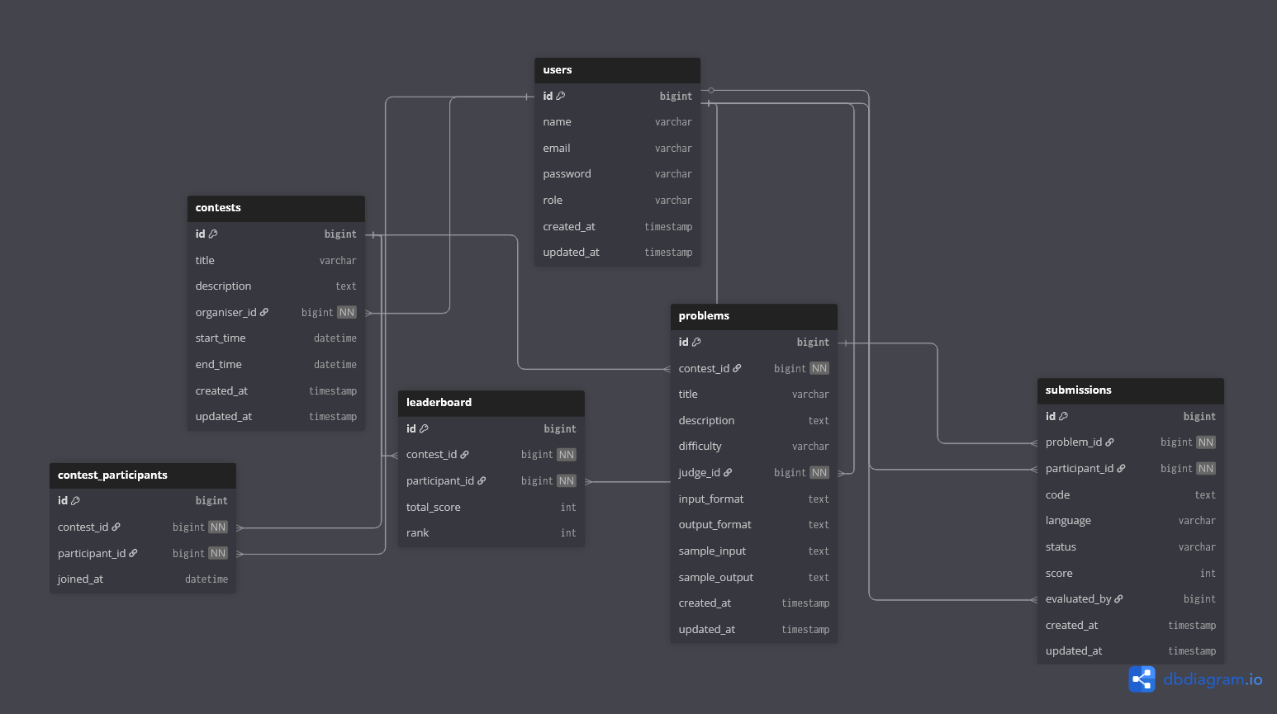

7. Other Requirements
- Must use HTTPS for deployment.
- Must log all user actions for auditing.

