**Percentage of children under 5 impacted by malnutrition and infant mortality rate (per 1000) in 2015**

Isabelle Devaux, 22/05/2025

From Julius: First, we loaded the two CSVs into R, selected only the 2015 column for each indicator, and then prepared world-map polygons via the built-in “maps” package.

Next, we merged country-level data onto the world map and plotted:

Data related to malnutrition (% weight-for-age under 5) is not available globally. S displayed on the map below, countries affected include sub-Sahara African countries and India.

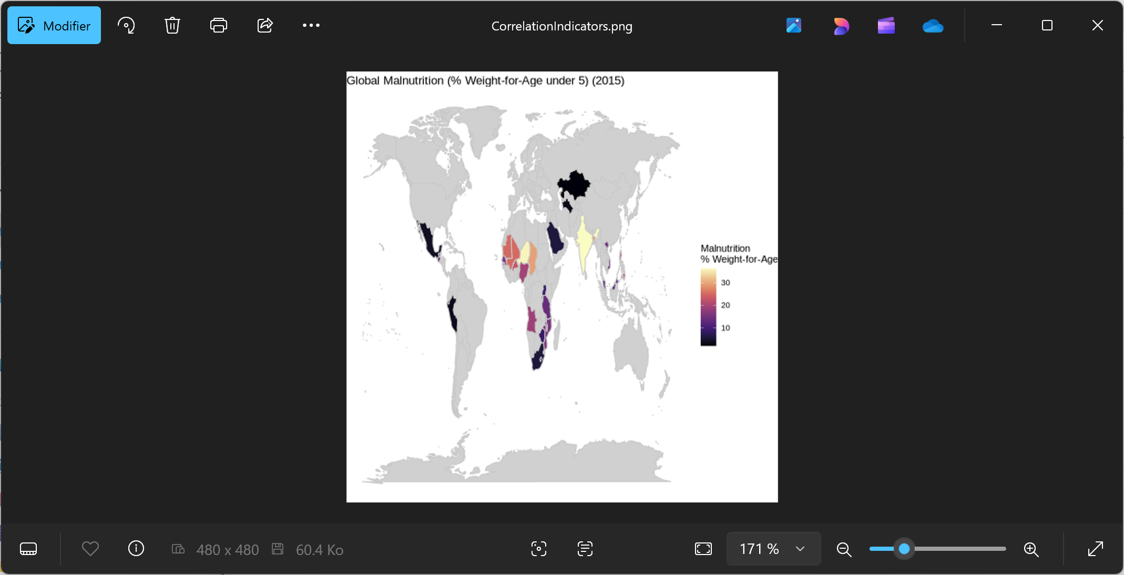

Infant mortality rate (per 1000 birth) is high in sub-Sahara Africa, East Africa and South-East Asia.

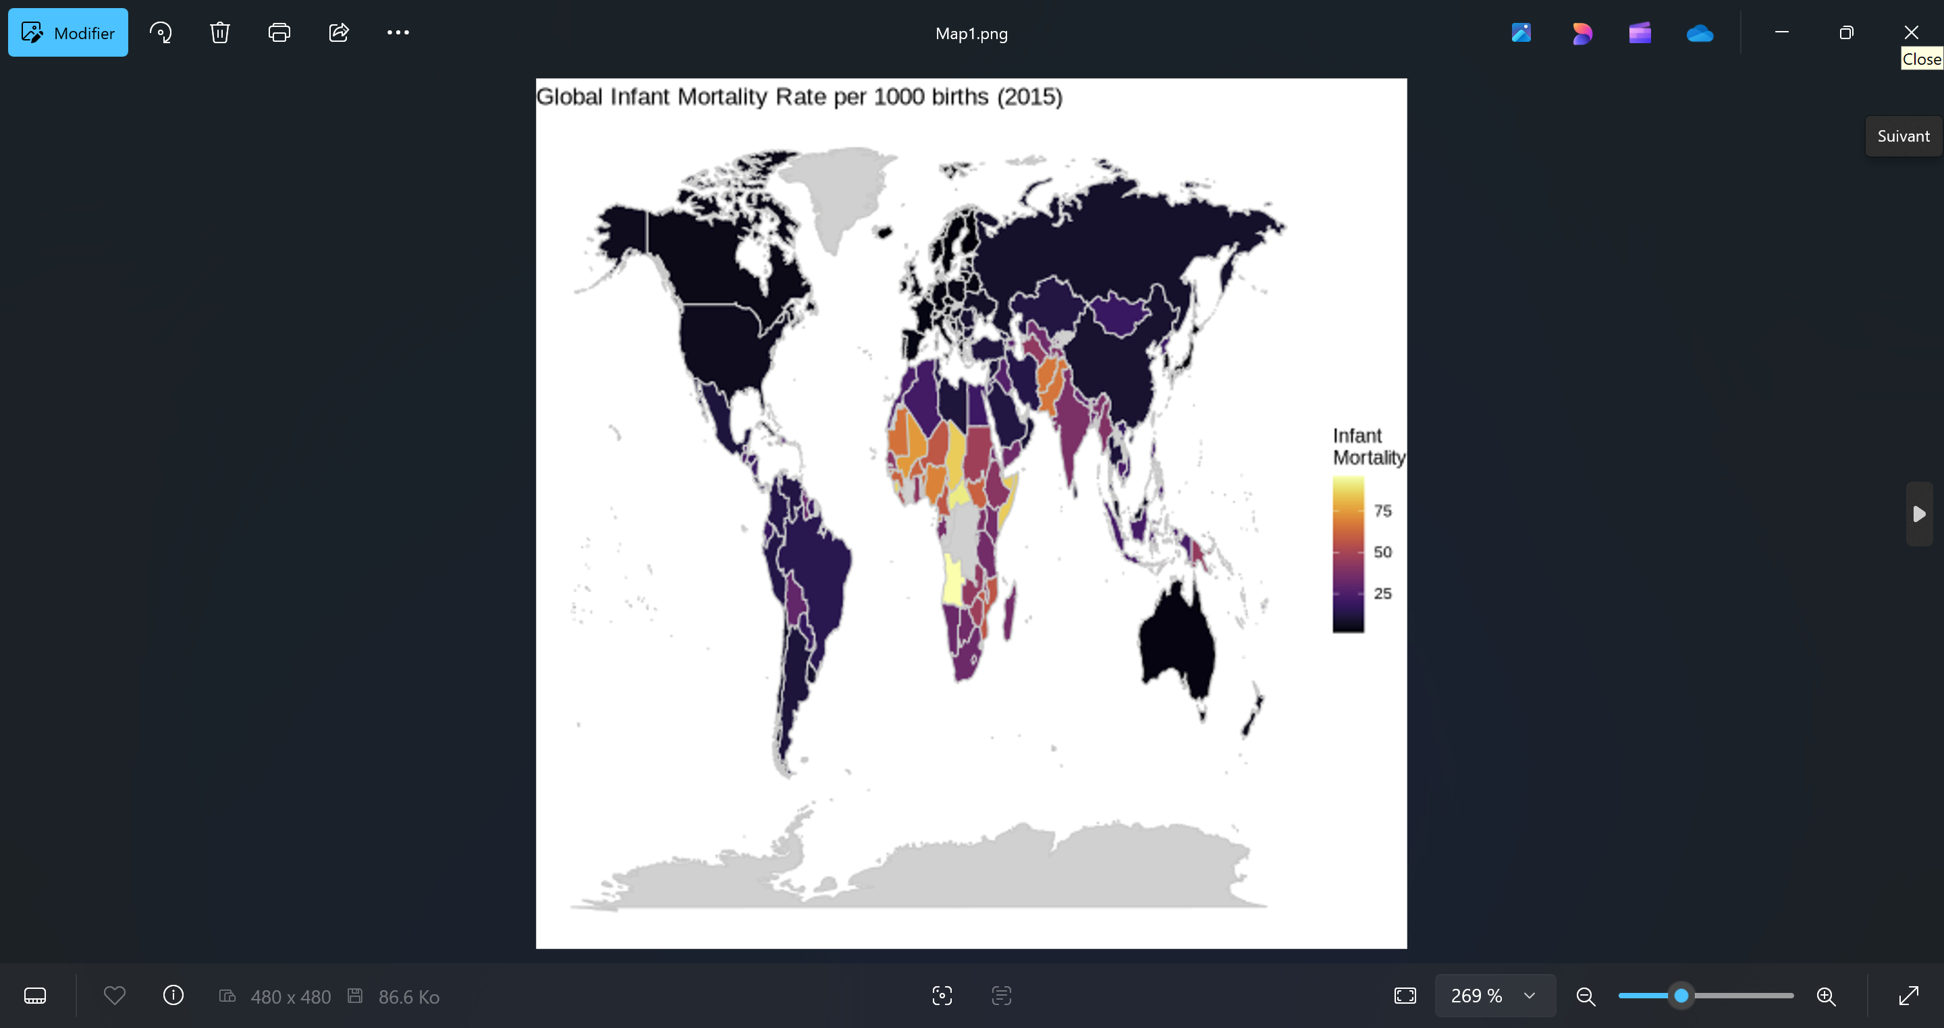

From Julius: Finally, we inner-joined the two indicator datasets (dropping any missing values), plotted a scatter with a linear fit, and computed the Pearson correlation:

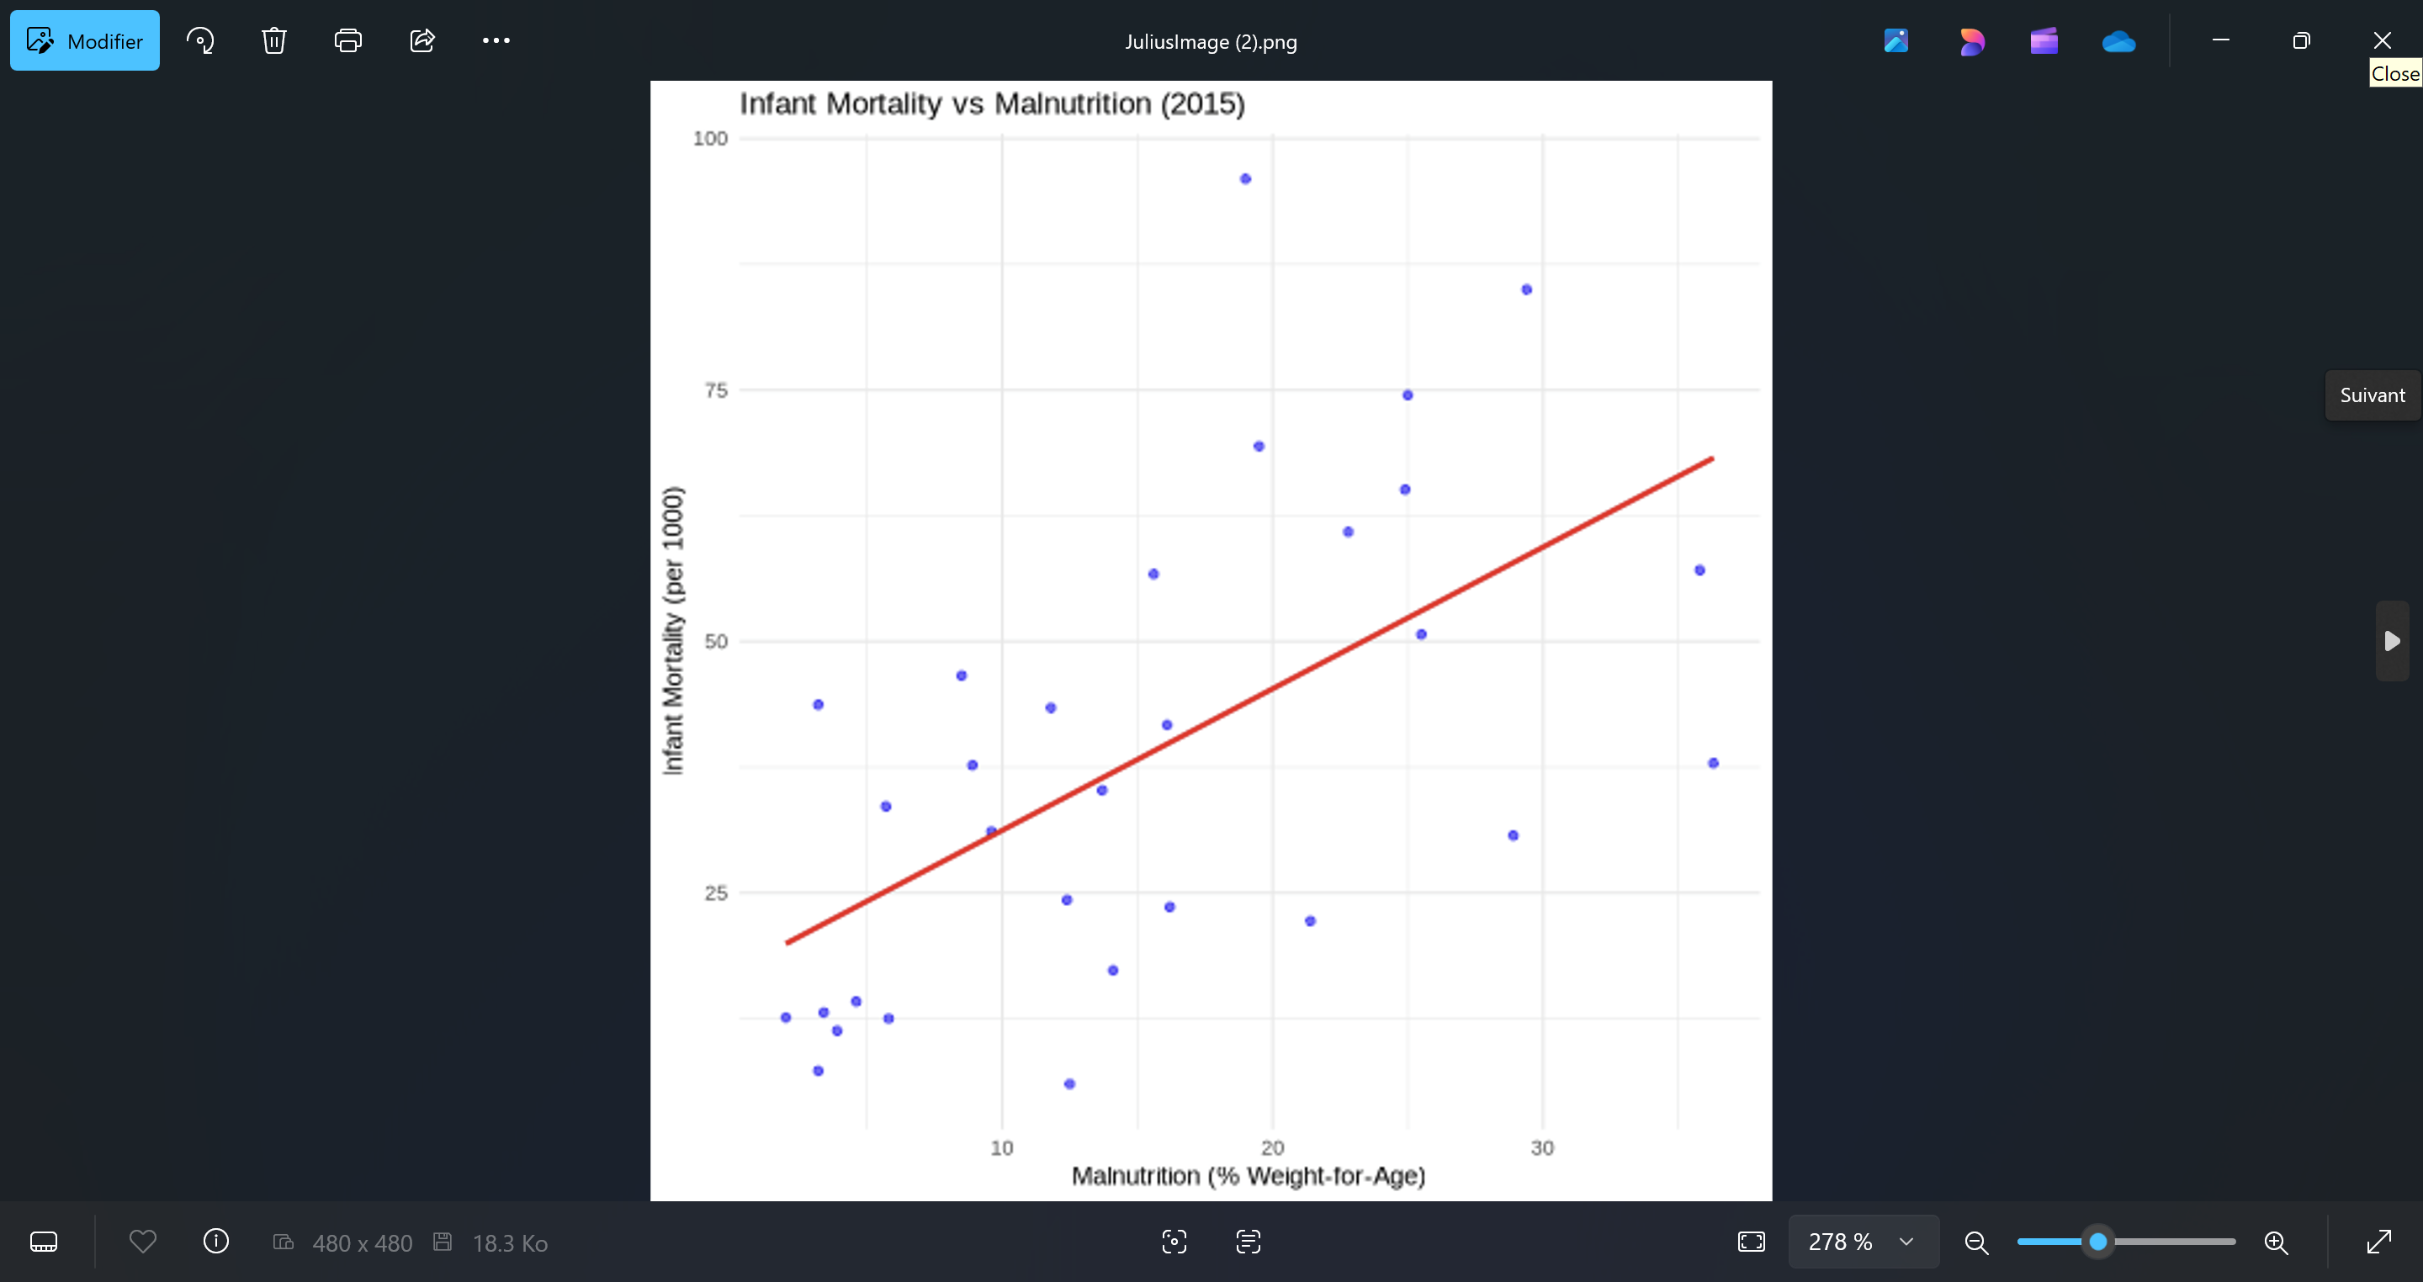

Pearson r: 0.585

Interpretation: There is a moderate positive relationship ($r\approx0.59$) between under-5 malnutrition rates and infant mortality rates across countries in 2015—higher malnutrition prevalence tends to coincide with higher infant mortality.