What is Q learning?

What if we had a cheat sheet for our agent – where we know the “expected reward” of each action at every step. This means that our agent would know exactly which “sequence of actions” to perform – that would eventually generate the maximum total reward. This total reward is called as the Q-value.

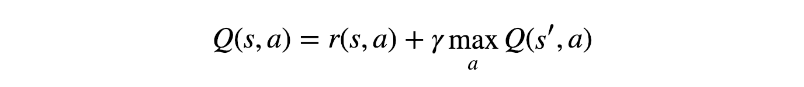

The above equation states that the Q-value for the agent at state a and performing action a Q(s,a) would be the immediate reward for that state and action – r(s,a) plus the highest Q-value possible from next state s’. The Gamma () is the discount factor which gives more importance to the contribution of the reward in near future than the ones in the far future.

As this is a recursive equation, we can start with making arbitrary assumptions for all the Q-values, and as it learns it would converge to the optimal policy.

A recursive formula is a formula that defines any term of a sequence in terms of its preceding term(s)

Practically we can express it as –

The alpha here is the learning rate (or step-size). The above expression determines to what extent newly acquired information overrides old information.

Why Deep Q-Learning?

What if the cheat sheet is long? One would not have resources (memory and time) enough to store each and every possible state action combination. The trick here would be to “approximate” Q-values with neural networks (or other machine learning models).

Deep Q network acts as a function approximator. For example you pass images of video game one screen at a time, and it produces a vector of action values – with the max value indicating the action to take. As a reinforcement signal it is fed back in the game at each time step. In the beginning when the neural network is initialized with random values – the actions taken are all over the place. Overtime it begins to associate situations and sequences in the game with appropriate actions and learns to play the game. In order to give the agent access to sequence of frames, one can stack say 4 frames together. There can be multiple strategies to deal with sequential data. This stacking of sequence was used by Deep Mind to train an agent to play Atari game, and it worked well.

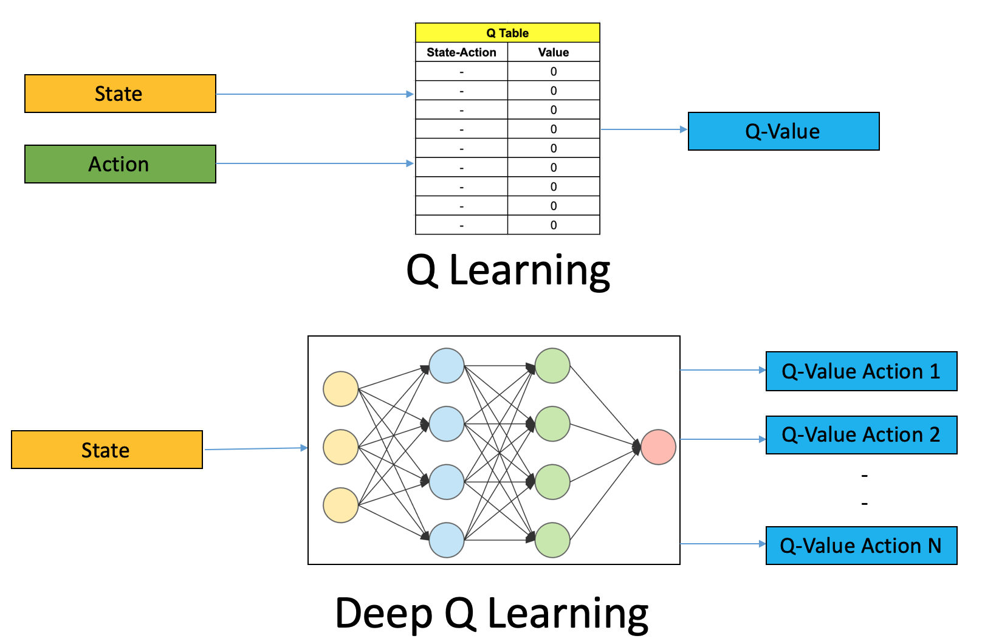

Unline the traditional reinforcement learning setup, where only one Q-value is produced at a time, the Deep Q network is designed to produces Q-value for every possible action in a single forward pass. Without this you would have to run the network individually for every action. Now we have a vector of all possible actions, and from it we can choose an action – either stochastically or choosing one with the maximum value.

These input and output transformations support results in a simple neural network architecture. The screen images are first processed by the convolutional layers, which allows the system to exploit spatial relationship and exploit spatial rule space. Since 4 sequences were stack the convolutional layers also extract temporal properties across the frames. The original DQN agent used three such convolutional layers with ReLU (regularized linear units) activation. They were followed by one fully connected hidden layer with ReLU activation, and one fully connected linear output layer that produced the vector of action values.

Steps involved in reinforcement –

All the past experience is stored by the user in the memory.
The next action is determined by the maximum output of the Q-network
The loss function is the mean squared error of the predicted Q-value and the target Q-value (Q*). However we do not know the target or actual value.

From the Bellman equation we have -

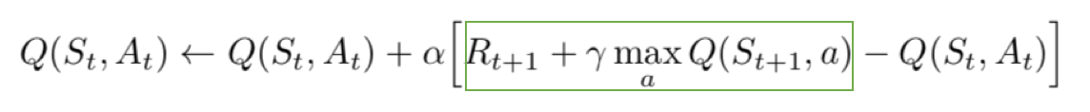
The part of the equation in the green box represents the target. One can say that it is predicting its own value, but as R is an unbiased true reward, the network is going to update its gradient using backpropagation to finally converge.

Challenges
Training such a network requires lot of data. It is not guaranteed to converge on optimal value function as in situations the network weights can oscillate or diverge due to high correlation between actions and states. This can result in unstable and ineffective policy.

Experience Replay
Make efficient use of observed experiences. The basic Q-learning algorithm where we interact with the environment and at each time stamp we obtain a state action reward and next state as tuple, learn from it and discard it – moving on to next tuple in the following time stamp. However if we are able to store these tuples we can possibly learn more. Some states are pretty rare to come by and some actions can be very costly. It helps if we can recall such experiences. That is what the “replay buffer” allow us to do. We store each experience tuple in the buffer as we are interacting with the environment.

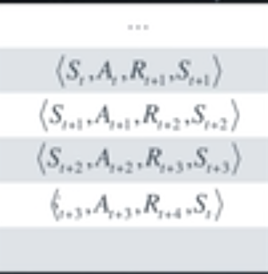

Then we would sample a small batch of tuples from it in order to learn. Thus we are able to learn from individual tuples multiple times, and recall rare occurrences.

Also think about it this way – for every experiences obtained every action At effects the next state St in some way. This means a sequence of experienced tuples can be highly correlated. A basic (naive0 Q-learning algorithm that learns from each of these experiences in sequential order runs the risk of being misled by the effects of the correlation. With experience replay we can sample the buffer at random 0 it does not have to be in the same sequence as we stored the tuples. This helps break the correlation, which prevents action value from oscillating or diverging.

Experience Replay can be seen as building a database of samples and then learning a mapping from them. In that sense Experience replay can help us reduce the reinforcement learning problem or at least value learning portion of it to a supervised learning scenario.

Fixed Q targets
The Experience Replay help us address one type of correlation – between consecutive experience tuples. There is another kind of correlation Q-learning is suspectible to. Q-learning is form of Temporal Difference or TD learning. Here R + gamma times the maximum possible value from the next state is called the TD target. Our goal is to reduce the difference between this target and currently predicted Q-value. This difference is the TD error. The TD target is supposed to be a replacement for true value function qpi(S, A) which is unknown to us. We originally used Qpi to define a squared error loss. Then we differentiated it with respect to w, to get our gradient descent update rule. Now qpi is not dependent on our function approximation or its parameters. Thus resulting in a simple derivative, an update rule. But our TD target is dependent on these parameters which means simply replacing the true value function qpi with a target like this is mathematically incorrect.

Each action affects the next position of the target in an unpredictable manner. You have to decouple the target from action giving it a more stable learning environment. In Q-learning we can fix the function parameters used to generate our target. The fixed parameters are indicated by a w minus are copy of w that we don’t change during the learning step. In practice we copy w into w-, used it to generate targets, while changing w from a certain number of learning steps. Then we update w- with the latest w, again learn for a number of steps, and so on. 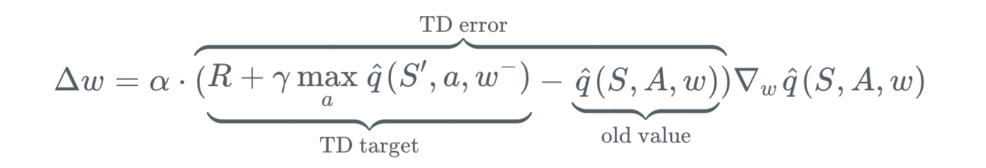

The target Q-network’s weight are updated less often (or slowly) than that of primary Q-Network.

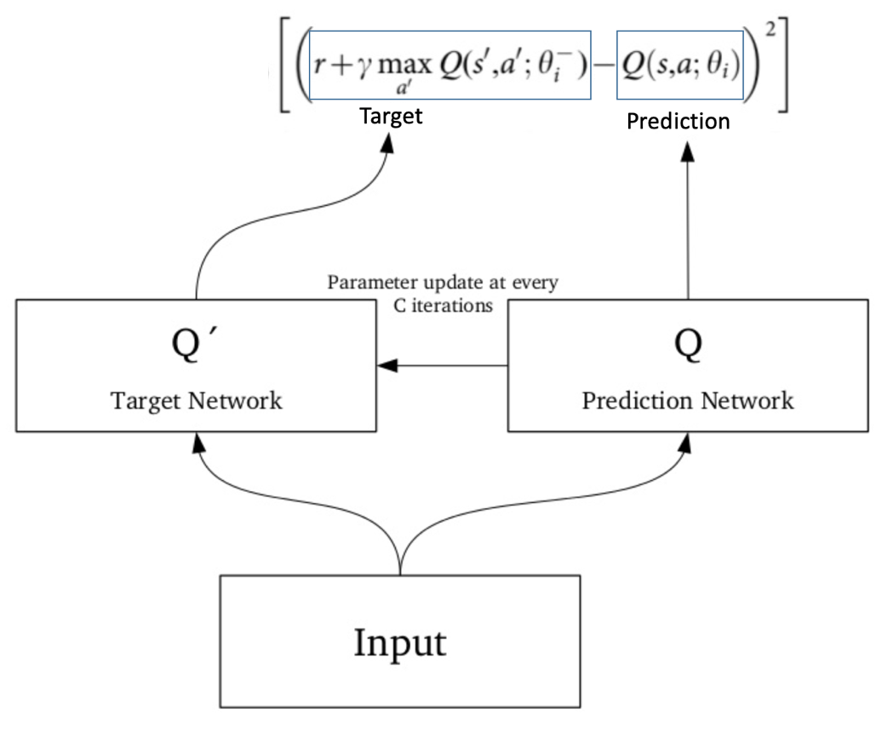

Algorithm

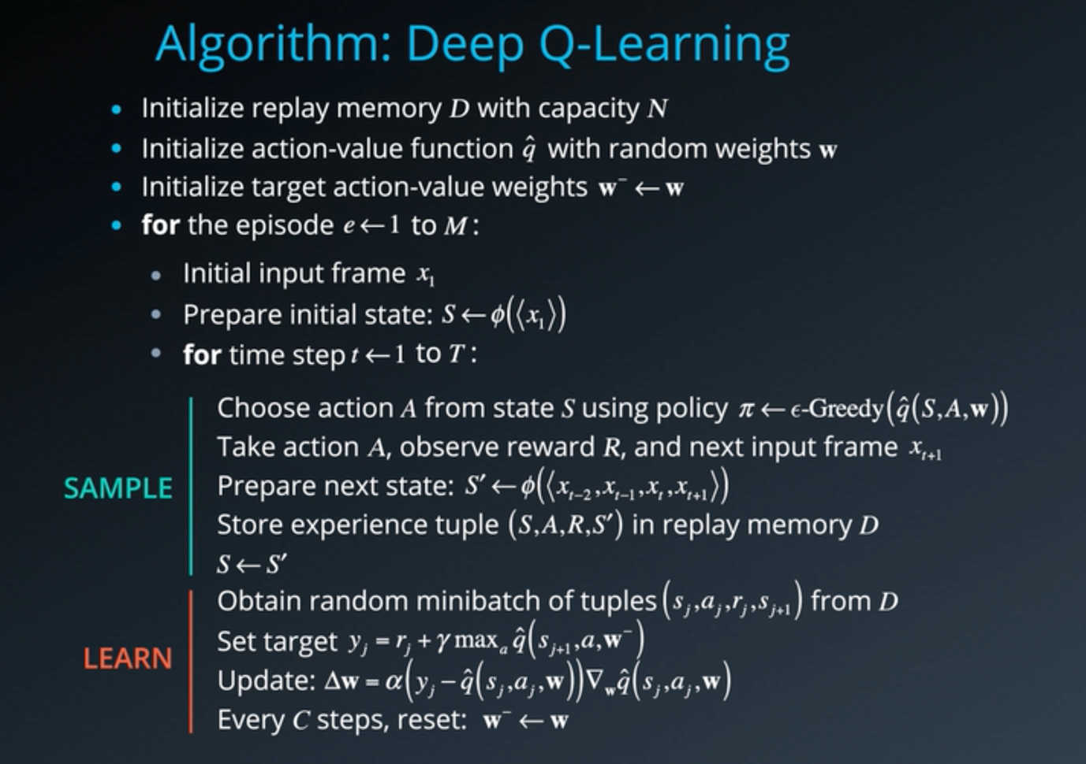

There are two main processes that are interleaved in this algorithm. One, is where we sample the environment by performing actions and store away the observed experienced tuples in a replay memory. The other is where we select the small batch of tuples from this memory, randomly, and learn from that batch using a gradient descent update step.

These two processes are not directly dependent on each other. So, you could perform multiple sampling steps then one learning step, or even multiple learning steps with different random batches.

The rest of the algorithm is designed to support these steps.
- In the beginning you need to initialize an empty replay memory D. Note that memory is finite, so you may want to use something like a circular Q that retains the N most recent experience tuples.
- Then, you also need to initialize the parameters or weights of your neural network. There are certain best practices that you can use, for instance, sample the weights randomly from a normal distribution with variance equal to two by the number of inputs to each neuron. These initialization methods are typically available in modern deep learning libraries like Keras and TensorFlow, so you won't need to implement them yourself.
- To use the fixed Q targets technique, you need a second set of parameters w- which you can initialize to w.

Now, remember that the specific algorithm was designed to work with video games. So, for each episode and each time step t within that episode you observe a raw screen image or input frame xt which you need to convert to grayscale crop to a square size, etc.. Also, in order to capture temporal relationships you can stack a few input frames to build each state vector.

Let's denote this pre-processing and stacking operation by the function phi, which takes a sequence of frames and produces some combined representation. Note that if we want to stack say four frames will have to do something special for the first, three time steps. For instance, we can treat those missing frames as blank, or just used copies of the first frame, or we can just skip storing the experience tuples till we get a complete sequence.

In practice, you won't be able to run the learning step immediately. You will need to wait till you have sufficient number of tuples in memory. Note that we do not clear out the memory after each episode, this enables us to recall and build batches of experiences from across episodes. There are many other techniques and optimizations that are used in the DQN paper, such as reward clipping, error clipping, storing past actions as part of the state vector, dealing with terminal states, digging epsilon over time, et cetera.

