 | COMSATS University Islamabad, Pakistan
Campaignly.AI
Software Requirements Specification
by
Majid Farooq Qureshi CIIT/FA23 BCS 045/ISB
Habib Ur Rehman CIIT/FA23 BCS 116/ISB


Supervisor
Ms. Saadia Maqbool
Bachelor of Science in Computer Science
2023 to 2027
The candidate confirms that the work submitted is their own and appropriate credit has been given where reference has been made to the work of others.

COMSATS University Islamabad, Pakistan
Campaignly.AI
Software Requirements Specification
A requirements specification report presented to
COMSATS University Islamabad
In partial fulfillment of the requirements for the degree of
Bachelor of Science in Computer Science
2023 to 2027
By
Majid Farooq Qureshi CIIT/FA23 BCS 045/ISB
Habib Ur Rehman CIIT/FA23 BCS 116/ISB
Supervisor Ms. Saadia Maqbool
25 October 2026
Abstract
Campaignly.AI is proposed because small and medium businesses find it difficult to turn a business offer into a Meta advertising campaign and then follow up the resulting leads. Today such a business typically combines Meta Ads Manager, a separate copywriting or design tool and manual WhatsApp replies. Integrated marketing platforms exist, but they are aimed at agencies and marketers and expect the user to understand objectives, targeting and automation. The targeted challenges are configuring compliant campaigns without specialist knowledge and responding to every lead quickly enough to keep it interested. Disconnected tools also make it hard to see whether a campaign, its leads and its conversations are in a healthy state. The gap is a single guided workflow for non-specialists that connects business setup, policy-aware creative preparation, Meta deployment, lead management and WhatsApp nurturing under one subscription. The system aims to capture a reusable business profile and generate editable, industry-aware ad copy and media checked by an internal Meta-rules filter. It aims to deploy and monitor Facebook and Instagram campaigns through the Meta Marketing API and to synchronise lead-form leads into a protected, tenant-isolated workspace. It also aims to nurture leads through an AI WhatsApp assistant with intent scoring and human takeover, governed by Stripe subscriptions and an administration console. The expected result is a coherent, auditable path from business setup to a ready lead that a business owner can operate without an agency.
Abbreviations
AI | Artificial Intelligence
API | Application Programming Interface
AUD | Australian Dollar
BR | Business Rule
CON | Design and Implementation Constraint
CTA | Call to Action
DEP | Operational or Integration Dependency
DNC | Do Not Contact
EV | Backend Event
FE | Scope Feature
FR | Functional Requirement
GST | Goods and Services Tax
JWT | JSON Web Token
LI | Limitation
LLM | Large Language Model
NFR | Non-Functional Requirement
OAuth | Open Authorization
OE | Operating Environment
OIDC | OpenID Connect
PII | Personally Identifiable Information
RAG | Retrieval-Augmented Generation
RBAC | Role-Based Access Control
RLS | Row-Level Security
SaaS | Software as a Service
SMB | Small and Medium Business
SRS | Software Requirements Specification
TLS | Transport Layer Security
UC | Use Case
UI | User Interface
UML | Unified Modeling Language
WCAG | Web Content Accessibility Guidelines
Table of Contents
Chapter 1 Introduction and Problem Definition 1
1.1 Overview of the Project 1
1.2 Vision Statement 1
1.3 Problem Statement 1
1.4 Problem Solution 2
1.5 Objectives of the Proposed System 2
1.6 Scope 3
1.6.1 Limitations and Constraints 3
1.7 Modules 4
1.7.1 Module M01 Business Onboarding and Brand Setup 4
1.7.2 Module M02 AI Advertisement and Content Generation 5
1.7.3 Module M03 AI Media Editing and Creative Automation 5
1.7.4 Module M04 Meta Campaign Automation 6
1.7.5 Module M05 Lead Management 6
1.7.6 Module M06 AI WhatsApp Lead Nurturing 6
1.7.7 Module M07 Subscription and Billing 7
1.7.8 Module M08 Admin Dashboard and Platform Operations 7
1.7.9 Module M09 Marketing Website and Customer Acquisition 8
1.7.10 Module M10 Authentication and User Management 8
1.8 Related System Analysis and Literature Review 8
1.8.1 Literature Review 8
1.8.2 Related System Analysis 9
1.9 Tools and Technologies 10
1.10 Project Contribution 11
1.11 Relevance to Course Modules 12
Chapter 2 Requirement Analysis 13
2.1 User Classes and Characteristics 13
2.2 Operating Environment 13
2.3 Design and Implementation Constraints 15
2.3.1 Business Rules 16
2.3.2 Operational Policies and Integration Dependencies 18
2.4 Use Case Diagram 18
2.5 Requirement Identifying Technique 27
2.6 Functional Requirements 53
2.6.1 Module M01 Business Onboarding and Brand Setup 53
2.6.2 Module M02 AI Advertisement and Content Generation 54
2.6.3 Module M03 AI Media Editing and Creative Automation 56
2.6.4 Module M04 Meta Campaign Automation 57
2.6.5 Module M05 Lead Management 59
2.6.6 Module M06 AI WhatsApp Lead Nurturing 60
2.6.7 Module M07 Subscription and Billing 61
2.6.8 Module M08 Admin Dashboard and Platform Operations 62
2.6.9 Module M09 Marketing Website and Customer Acquisition 64
2.6.10 Module M10 Authentication and User Management 65
2.6.11 Requirements Traceability 66
2.7 Non Functional Requirements 66
2.7.1 Reliability 67
2.7.2 Usability 68
2.7.3 Performance 69
2.7.4 Security 70
2.8 External Interface Requirements 71
2.8.1 User Interfaces 71
2.8.2 Software Interfaces 72
2.8.3 Hardware Interfaces 73
2.8.4 Communications Interfaces 73
References 75
Plagiarism Report 76

List of Figures
Figure 2.1 System-level use case diagram of Campaignly.AI 19
Figure 2.2 Use case diagram for access, onboarding and account management 20
Figure 2.3 Use case diagram for ad generation and creative media 21
Figure 2.4 Use case diagram for Meta campaign deployment and control 22
Figure 2.5 Use case diagram for leads and WhatsApp nurturing 23
Figure 2.6 Use case diagram for subscription and billing 24
Figure 2.7 Use case diagram for administration and the public website 25
Figure 2.8 Module M01 Business Onboarding and Brand Setup mockup M01-S01 Business Onboarding Wizard 29
Figure 2.9 Module M02 AI Advertisement and Content Generation mockup M02-S01 AI Ad Generator 30
Figure 2.10 Module M02 AI Advertisement and Content Generation mockup M02-S02 Industry Campaign Templates 31
Figure 2.11 Module M03 AI Media Editing and Creative Automation mockup M03-S01 Media Studio and Editor 32
Figure 2.12 Module M04 Meta Campaign Automation mockup M04-S01 Meta Connection and Campaign Review 33
Figure 2.13 Module M04 Meta Campaign Automation mockup M04-S02 Campaign List and Controls 34
Figure 2.14 Module M04 Meta Campaign Automation mockup M04-S03 Campaign Detail and Metrics 35
Figure 2.15 Module M04 Meta Campaign Automation mockup M04-S04 Settings: Integrations, Brand Kit and Security 36
Figure 2.16 Module M05 Lead Management mockup M05-S01 Leads Workspace 37
Figure 2.17 Module M05 Lead Management mockup M05-S02 Lead Detail and Activity Timeline 38
Figure 2.18 Module M05 Lead Management mockup M05-S03 Campaign Analytics 39
Figure 2.19 Module M06 AI WhatsApp Lead Nurturing mockup M06-S01 WhatsApp AI Agent and Takeover 40
Figure 2.20 Module M07 Subscription and Billing mockup M07-S01 Billing and Subscription 41
Figure 2.21 Module M07 Subscription and Billing mockup M07-S02 Public Pricing 42
Figure 2.22 Module M08 Admin Dashboard and Platform Operations mockup M08-S01 Administration Overview 43
Figure 2.23 Module M08 Admin Dashboard and Platform Operations mockup M08-S02 Knowledge Base, Referrals and Enquiries 44
Figure 2.24 Module M09 Marketing Website and Customer Acquisition mockup M09-S01 Marketing Website 45
Figure 2.25 Module M09 Marketing Website and Customer Acquisition mockup M09-S02 Campaign Diagnostic and Enquiry 46
Figure 2.26 Module M10 Authentication and User Management mockup M10-S01 Sign In, Registration and Password Reset 47
Figure 2.27 Module M10 Authentication and User Management mockup M10-S02 Owner Overview Dashboard 48
Figure 2.28 Module M10 Authentication and User Management mockup M10-S03 Notification Centre 49

List of Tables
Table 1.1 Campaignly.AI module inventory 4
Table 1.2 Related system comparison 9
Table 1.3 Planned tools and technologies 10
Table 2.1 User classes and characteristics 13
Table 2.2 Design and implementation constraints 15
Table 2.3 Business rule register 16
Table 2.4 Subscription plan catalogue 17
Table 2.5 Subscription access matrix 17
Table 2.6 Operational policies and external dependencies 18
Table 2.7 Use case summary 26
Table 2.8 Screen inventory and scope traceability 28
Table 2.9 Backend event-response analysis 49
Table 2.10 Module M01 functional requirements 53
Table 2.11 Module M02 functional requirements 54
Table 2.12 Module M03 functional requirements 56
Table 2.13 Module M04 functional requirements 57
Table 2.14 Module M05 functional requirements 59
Table 2.15 Module M06 functional requirements 60
Table 2.16 Module M07 functional requirements 61
Table 2.17 Module M08 functional requirements 62
Table 2.18 Module M09 functional requirements 64
Table 2.19 Module M10 functional requirements 65
Table 2.20 Objective to requirement traceability 66
Table 2.21 Reliability acceptance requirements 67
Table 2.22 Usability acceptance requirements 68
Table 2.23 Performance acceptance requirements 69
Table 2.24 Security acceptance requirements 70
Table 2.25 User interface requirements 71
Table 2.26 Software interface requirements 72
Table 2.27 Hardware interface requirements 73
Table 2.28 Communications interface requirements 73

Chapter 1 Introduction and Problem Definition
This chapter introduces Campaignly.AI, defines the problem it addresses and the proposed solution, and fixes the objectives, scope and modules of the Phase 1 release. It then positions the product against literature and existing systems and records the selected technologies, the contribution of the project and its relevance to the degree programme. The project proposal and the Phase 1 requirements register are the primary sources; this SRS is the confirmed final Phase 1 baseline for the development team.

1.1 Overview of the Project
Campaignly.AI is a web-based, AI-powered Software-as-a-Service platform that automates Facebook and Instagram advertising for businesses in every industry. A business owner signs up, completes a short onboarding wizard that captures the business name, industry, offer, audience, tone and location, and then uses that profile to generate ad copy, images and short videos. Every draft passes an internal Meta-rules check called the Bradley Filter before the owner reviews and confirms deployment through the Meta Marketing API.
After launch, the platform synchronises campaign status, metrics and Meta lead-form submissions into a lead workspace that only the owning business can see. An AI WhatsApp assistant answers new leads, follows up within WhatsApp rules, scores intent from 0 to 100 and alerts the owner when a lead becomes ready, while the owner can take over any conversation. Access is governed by Stripe subscriptions priced in Australian dollars. The product consists of four applications: the user dashboard, the administrator dashboard, the public marketing website and the backend API.

1.2 Vision Statement
For small and medium business owners who want customers from Facebook and Instagram but do not have marketing expertise or an agency, Campaignly.AI is a guided advertising assistant that takes them from a business description to a ready-to-buy lead in one place. Unlike Meta Ads Manager or general marketing suites, Campaignly.AI hides campaign complexity behind a step-by-step workflow, checks content before it reaches Meta, and keeps every lead conversation moving with an AI assistant the owner can override at any time.

1.3 Problem Statement
Small and medium businesses depend on social media advertising, yet running a Meta campaign requires choosing an objective, defining an audience, writing compliant copy, preparing media for several placements, setting a budget and monitoring results. Owners without this knowledge either overspend on boosted posts, pay an agency, or have ads rejected for policy reasons they did not anticipate .
The work does not end when an ad runs. Leads from Meta lead forms arrive in a separate system, and follow-up usually happens manually on WhatsApp, often hours later. Because ad tools, content tools and messaging are disconnected, an owner cannot easily tell whether a campaign is delivering, whether its leads were synchronised or whether anyone replied to them. The problem is therefore the absence of a single, understandable workflow that connects campaign creation, policy awareness, lead capture and timely follow-up for non-specialist business owners.

1.4 Problem Solution
Campaignly.AI replaces the disconnected tools with one guided workflow. The onboarding wizard stores a reusable business profile so the owner never has to re-explain the business. The AI Ad Generator and media library turn that profile into editable ad variations and placement-ready media, grounded in a managed dataset of Meta policies and approved examples through retrieval-augmented generation. The Bradley Filter flags policy risks before deployment while making clear that Meta still makes the final approval decision.
A campaign builder collects only the decisions Meta requires, previews the ad per placement and submits it after explicit confirmation. Background jobs synchronise status, metrics and leads and keep the last good data when a provider fails. New leads are answered on WhatsApp by an assistant that respects opt-in, the 24-hour service window and owner takeover, and that notifies the owner once a lead reaches the readiness threshold. Stripe subscriptions, server-side tenant isolation and an administrator console complete a solution that a business can operate on its own.

1.5 Objectives of the Proposed System
The objectives of the Phase 1 release are listed below with the functional requirements that realise each one; detailed traceability is given in Section 2.6.11.
BO-1: Enable a non-marketer in any industry to complete business setup and prepare a campaign through a guided workflow. Realised by FR-001, FR-005, FR-087, FR-008, FR-026, FR-028.
BO-2: Generate editable, industry-aware ad copy and media with visible policy concerns and human review. Realised by FR-008, FR-011, FR-012, FR-015, FR-082.
BO-3: Deploy and control Facebook and Instagram campaigns through a reviewed Meta Marketing API integration. Realised by FR-026, FR-027, FR-028, FR-029, FR-030, FR-033, FR-086, FR-089.
BO-4: Synchronise Meta lead-form leads and protect them for their owning business only. Realised by FR-037, FR-039, FR-040, FR-041, FR-080.
BO-5: Offer a card-backed 14-day trial and monthly or annual AUD subscriptions through Stripe. Realised by FR-053, FR-054, FR-056, FR-058, FR-083.
BO-6: Keep campaign status, metrics, lead totals and alerts visible with their freshness. Realised by FR-031, FR-034, FR-035, FR-043, FR-081, FR-088.
BO-7: Give administrators oversight of users, AI usage, Meta integration health and background jobs. Realised by FR-060, FR-061, FR-062, FR-063, FR-064, FR-065.
BO-8: Ground generation in a managed retrieval dataset and apply the Bradley Filter before deployment. Realised by FR-014, FR-015, FR-067.
BO-9: Nurture leads on WhatsApp with intent scoring, readiness alerts and human takeover. Realised by FR-044, FR-046, FR-050, FR-052, FR-084, FR-085.

1.6 Scope
Phase 1 delivers a complete, single-region SaaS release for businesses in every industry: fitness, ecommerce, restaurants, beauty, real estate, coaching, healthcare, education, local services and Other. Users register with email or Google, onboard their business, create and check ads, manage media, deploy and monitor Meta campaigns, manage leads, nurture them on WhatsApp and pay for a subscription. Administrators operate the platform, and visitors evaluate it through the marketing website and a free campaign diagnostic. The release boundary is as follows.
In scope: the ten modules listed in Section 1.7 across the user dashboard, administrator dashboard, marketing website and backend API; Facebook and Instagram campaigns with six Meta objectives (Awareness, Traffic, Engagement, Leads, App promotion and Sales); Meta lead-form leads, WhatsApp nurturing, scoring and takeover; Stripe Trial, Starter, Growth and Pro plans in AUD including GST; and the administrator console, retrieval dataset management and referrals.
Out of scope: Google, TikTok, LinkedIn or any non-Meta advertising network; automated budget optimisation, A/B tests and creative experiments run without the owner; native Android or iOS applications; agency, staff or multi-user team roles inside one business; and the education page, help chat, campaign export, ad-spend cap and seven-day companion automation.

1.6.1 Limitations and Constraints
LI-1: Only Facebook and Instagram are supported, and only through Meta-approved APIs and permissions.
LI-2: Meta makes the final approval and delivery decision. A Bradley Filter pass reduces risk but never guarantees approval.
LI-3: Location targeting depends on a geocoder resolving the address and on Meta special ad category rules.
LI-4: Campaign recommendations are advisory; the system never changes budgets or runs experiments automatically.
LI-5: Meta tokens, app review, WhatsApp template approval, rate limits and provider outages can delay or block external actions.
LI-6: WhatsApp business-initiated messages outside the 24-hour service window require Meta-approved templates.
LI-7: Data retention and deletion schedules must be approved before production release (dependency DEP-01).

1.7 Modules
The ten modules in Table 1.1 preserve the structure of the project scope . M01 to M07 support the business owner through the user dashboard and shared backend services, M08 provides the administrator dashboard, M09 the public marketing website and M10 the identity, session and account services used by all applications. Each feature retains its original FE number within its module, so M01 FE-01 and M02 FE-01 are distinct references. Requirements added during Phase 1 baselining are listed after the scope features of their module.
Table 1.1 Campaignly.AI module inventory
Module | Scope responsibility
M01 | Business Onboarding and Brand Setup
M02 | AI Advertisement and Content Generation
M03 | AI Media Editing and Creative Automation
M04 | Meta Campaign Automation
M05 | Lead Management
M06 | AI WhatsApp Lead Nurturing
M07 | Subscription and Billing
M08 | Admin Dashboard and Platform Operations
M09 | Marketing Website and Customer Acquisition
M10 | Authentication and User Management

1.7.1 Module M01 Business Onboarding and Brand Setup
A guided multi-step wizard captures the business identity, industry, offer, audience, tone and location, saves progress and builds the profile used for personalisation.
FE-01: Multi-step business onboarding and setup wizard.
FE-02: Configure brand tone and communication style.
FE-03: Select business industry and service category.
FE-04: Store onboarding data for AI personalization.
FE-05: Resume incomplete onboarding process anytime.
FE-06: Edit business profile and branding settings.
FE-07: AI onboarding recommendations based on industry.

1.7.2 Module M02 AI Advertisement and Content Generation
Generates Meta ad copy, variations, images and videos from the business profile and industry templates, grounded in a retrieval dataset and checked by the Bradley Filter.
FE-01: Generate AI-powered Meta advertisement content.
FE-02: Access industry-specific campaign templates library.
FE-03: Configure demographics and audience targeting settings.
FE-04: Optimize content readability and compliance automatically.
FE-05: Generate multiple ad variations simultaneously.
FE-06: Store and manage generated advertisements.
FE-07: Retrieve high-performing ads using RAG.
FE-08: Validate ads against Meta advertising policies.
FE-09: Generate AI campaign recommendations automatically.

1.7.3 Module M03 AI Media Editing and Creative Automation
Uploads, edits and resizes images and videos for Meta placements, adds captions and brand elements, and keeps a reusable media library with versions.
FE-01: Upload advertising images and videos securely.
FE-02: Edit videos using AI-powered automation tools.
FE-03: Generate captions and animated subtitles automatically.
FE-04: Resize media for Meta advertising placements.
FE-05: Apply brand colors, fonts, and logos.
FE-06: Create short-form promotional video snippets.
FE-07: Manage reusable uploaded and generated media.
FE-08: Enhance images and optimize media quality.
FE-09: Manually edit AI-generated media assets.

1.7.4 Module M04 Meta Campaign Automation
Connects the Meta account, builds and reviews campaigns for six objectives, deploys them, previews placements and controls and synchronises their lifecycle and metrics.
FE-01: Connect Meta accounts using secure OAuth.
FE-02: Select Facebook Pages and Ad Accounts.
FE-03: Automate campaign creation using Meta APIs.
FE-04: Upload media for advertising campaigns.
FE-05: Configure geographic and radius-based targeting.
FE-06: Track campaign lifecycle and statuses.
FE-07: Duplicate campaigns and advertisements easily.
FE-08: Pause, activate, or stop campaigns.
FE-09: Retrieve impressions, clicks, and conversion analytics.
FE-10: Synchronize campaign data with Meta automatically.

1.7.5 Module M05 Lead Management
Synchronises Meta lead-form leads, protects them, and lets the owner search, filter, categorise and follow their engagement and conversion.
FE-01: Synchronize leads from Meta lead forms.
FE-02: Refresh lead data manually anytime.
FE-03: Encrypt and securely store lead information.
FE-04: Display lead details within dashboard interface.
FE-05: Filter, search, and categorize leads easily.
FE-06: Track lead engagement and activities.
FE-07: View campaign-based lead conversion analytics.

1.7.6 Module M06 AI WhatsApp Lead Nurturing
Connects the business WhatsApp number, replies to and follows up leads, scores their intent, alerts the owner and supports manual takeover.
FE-01: Automate WhatsApp lead follow-up conversations.
FE-02: Handle enquiries using AI conversation workflows.
FE-03: Score leads using sentiment and intent.
FE-04: Automate follow-up timing and escalation decisions.
FE-05: Process conversations using scheduled background jobs.
FE-06: Capture inbound WhatsApp replies instantly.
FE-07: Notify businesses about conversion-ready leads.
FE-08: Store conversation histories and lead scores.
FE-09: Allow manual takeover of AI conversations.

1.7.7 Module M07 Subscription and Billing
Provides the AUD plan catalogue, Stripe Checkout, a card-backed trial, the billing portal, verified webhooks, reminders and access control by subscription status.
FE-01: Create Stripe subscription checkout sessions.
FE-02: Support free trial subscription onboarding.
FE-03: Manage subscriptions through billing portal.
FE-04: Handle Stripe payment webhook events.
FE-05: Restrict features based on subscription status.
FE-06: Display pricing and subscription plans.
FE-07: Send billing and trial reminder notifications.

1.7.8 Module M08 Admin Dashboard and Platform Operations
Lets administrators manage users, view platform analytics and AI usage, monitor Meta integration health and jobs, and manage referrals and the retrieval dataset.
FE-01: Secure administrator authentication and access control.
FE-02: Manage users and subscription statuses centrally.
FE-03: Display platform-wide analytics and metrics.
FE-04: Monitor AI usage and campaign generation.
FE-05: Monitor Meta API integration health.
FE-06: Manage queues and scheduled background jobs.
FE-07: Create and track referral campaigns.
FE-08: Manage high-performing advertisement datasets.

1.7.9 Module M09 Marketing Website and Customer Acquisition
Public landing, pricing, diagnostic, enquiry, proof content, blog and legal pages that attract and convert visitors.
FE-01: Display public landing pages and pricing.
FE-02: Provide AI-powered campaign diagnostic assessments.
FE-03: Capture prospective customer enquiries and leads.
FE-04: Showcase testimonials, portfolios, and case studies.
FE-05: Display About, Contact, Privacy, and Terms pages.
FE-06: Publish SEO-optimized educational blog content.

1.7.10 Module M10 Authentication and User Management
Email and Google sign-in, sessions, password reset, account settings, role-based permissions, tenant isolation, the overview and the notification centre.
FE-01: Register users using email authentication.
FE-02: Support Google OAuth login authentication.
FE-03: Manage sessions using JWT authentication tokens.
FE-04: Reset passwords using secure email links.
FE-05: Update account profile and credentials securely.
FE-06: Enforce role-based user access permissions.

1.8 Related System Analysis and Literature Review
This section reviews literature and standards that shape the requirements and compares Campaignly.AI with existing systems.

1.8.1 Literature Review
Lewis et al. introduced retrieval-augmented generation, in which a language model is conditioned on documents retrieved from an external index rather than relying only on its parameters . Their results showed more specific and factual output on knowledge-intensive tasks, and the index can be updated without retraining. Campaignly.AI applies this idea by retrieving published Meta policy rules and approved ad examples before generating copy, so the dataset can change when Meta policies change. The study does not measure advertising performance, so this SRS does not claim higher conversion from generated ads; instead it requires versioned datasets and human review.
Accessibility, security and payment literature set further requirements. WCAG 2.2 defines testable success criteria for perceivable, operable, understandable and robust interfaces . NIST SP 800-63B recommends long passwords without composition rules and bounded session lifetimes , which informs the 15-character password and 12-hour idle, 7-day absolute session limits. Stripe documents that webhook events can arrive more than once and out of order and must be verified by signature ; the Meta Marketing API and WhatsApp Cloud API documentation define permissions, objectives, lead retrieval, message templates and the 24-hour customer service window , . The OWASP Top 10 lists the most critical web application risks, including broken access control , which motivates server-side tenant isolation.

1.8.2 Related System Analysis
Table 1.2 compares Campaignly.AI with four existing systems using their public product descriptions accessed on 25 October 2026; it is a positioning comparison, not a usability benchmark.
Table 1.2 Related system comparison
System | Main capabilities | Fit for target users | Campaignly.AI response
Meta Ads Manager | Native campaign creation, targeting, budgets, lead forms and reporting for Facebook and Instagram. | Complete but expert-oriented; no copy generation or WhatsApp follow-up of leads. | Uses the same Meta APIs behind a guided builder and adds generation, checks and nurturing.
AdEspresso | Campaign creation, management, analytics and split testing for Meta and Google ads. | Aimed at marketers who plan experiments; lead follow-up is outside the product. | Keeps the guided flow and excludes automated split testing (LI-4).
Jasper | AI marketing content with brand voice, templates and workflows. | Strong on content; no campaign deployment, lead sync or messaging. | Generation is one step of an end-to-end workflow tied to Meta deployment.
HighLevel | CRM, funnels, conversations, automation and ad reporting for agencies. | Broad agency platform requiring setup of workflows and integrations. | Narrow, opinionated SMB workflow from profile to ready lead.

No single reviewed system combines business onboarding, policy-aware generation, Meta deployment, lead synchronisation and AI WhatsApp nurturing for non-specialist owners. Campaignly.AI is evaluated against its own acceptance criteria in Chapter 2 rather than by claiming that competitors lack unlisted features.

1.9 Tools and Technologies
Table 1.3 lists the selected technology for each layer with an alternative option, so the team can still choose before design freeze. Status shows whether the choice is already used in the prototype or planned. The original proposal listed MongoDB and AWS S3 ; the deployed prototype uses Prisma with SQLite and keeps AWS S3 for media, and PostgreSQL is the recorded production alternative.
Table 1.3 Planned tools and technologies
Tool/Technology (status) | Alternative option | Purpose | Rationale
Next.js 15 App Router, React 19, TypeScript, Tailwind CSS 3, lucide-react | Vite + React | User dashboard, admin dashboard and marketing website | One codebase for three web apps; server rendering for public pages
Next.js API route handlers with Zod validation | Separate Node.js Express or NestJS API | Backend REST API, validation and provider adapters | One deployable for interface and API; same language and types on both sides
Prisma ORM 5 with SQLite | PostgreSQL (Supabase or Neon) through the same Prisma schema; MongoDB Atlas | Users, business profiles, ads, media, campaigns, leads, conversations, subscriptions | Type-safe schema and queries; unique constraints support deduplication; the database provider changes by configuration
JWT sessions signed with jose in an HTTP-only cookie, bcrypt password hashes (implemented); Google OAuth 2.0 / OIDC | Auth.js (NextAuth) | Registration, sign-in, sessions and password reset | Few dependencies and full control of idle and absolute session limits
Vercel Cron calling job routes | Redis + BullMQ worker | Sync, nurturing, reminder and media jobs | Scheduling without extra infrastructure on the existing host
Google Gemini API primary, Groq secondary, mock mode for demonstrations | OpenAI API | Ad copy, compliance scoring, WhatsApp replies and lead scoring | A second provider keeps generation available when the first fails
Approved ad examples and policy records retrieved from the database ; vector index | Pinecone or pgvector | Retrieval dataset for RAG and the Bradley Filter | Starts simple with the existing database; a vector index can be added without changing callers
AWS S3 with local storage fallback, sharp for images, FFmpeg through fluent-ffmpeg for video | Cloudinary | Private media storage, image editing and video editing | S3 is durable and low cost; sharp and FFmpeg are free and scriptable
Meta Marketing API and Lead Ads, Graph API v18+ | None in Phase 1 | Campaign deployment, status, metrics and leads | Required by the Facebook and Instagram scope
WhatsApp Cloud API | Twilio or 360dialog WhatsApp | Inbound and outbound lead conversations | Direct Meta API without a reseller fee
Stripe Checkout, Billing and Customer Portal | Paddle | Trials, subscriptions, invoices and payment methods | Supports AUD, GST-inclusive prices and verified webhooks
Google Geocoding API; Resend email | OpenStreetMap Nominatim; SendGrid | Location resolution; reset, reminder and readiness emails | Reliable address resolution and transactional email
Vercel, Docker, GitHub, GitHub Actions | AWS EC2 for all services | Hosting, containers, version control and CI | Low-cost managed hosting with repeatable builds
Cursor/VS Code, Postman, Playwright | Figma for mockups | Development, API testing and mockup capture | Mockups are produced in the product design system itself

1.10 Project Contribution
Campaignly.AI introduces several technical and conceptual contributions compared to existing advertising tools such as Meta Ads Manager, AdEspresso, Jasper and HighLevel. Its main innovation is a single guided profile-to-lead workflow. A business owner moves from describing their business to receiving a ready-to-buy lead in one system, instead of combining separate ad, content and messaging tools. Ad copy is generated through retrieval-augmented generation, grounded in a versioned dataset of Meta policies and approved ads. Every draft is then checked by an internal Bradley Filter, which flags policy risks before deployment and so reduces ad rejections. A simplified campaign builder asks only for the decisions Meta requires and shows a preview for each placement. It submits to Meta only after the owner confirms, which hides the complexity of Ads Manager from non-specialist users.
The system also closes the gap between running an ad and converting a lead. Meta leads are synchronised automatically and answered on WhatsApp by an AI assistant that scores each lead's intent from 0 to 100. The assistant alerts the owner once a lead is ready and stops immediately when the owner takes over or the prospect opts out. All integrations are designed to be reliable: duplicate or failed webhooks and jobs never create duplicate leads, messages or charges, and the last good data is kept whenever a provider fails. Stripe subscriptions in AUD and usage credits are enforced on the server, failed work refunds its credit, and unpaid accounts become read-only instead of losing data. Generation stays available through a fallback from Gemini to Groq. Strict tenant isolation and encrypted lead data ensure that each business sees only its own information, while administrators monitor the platform without access to lead personal data. A free campaign diagnostic on the public website also gives visitors instant findings and a suggested Meta objective before they register.
By combining AI generation, compliance checking, Meta automation, WhatsApp nurturing and Stripe billing in one secure platform, Campaignly.AI lets small business owners run effective Meta advertising without an agency. It improves usability, reliability and lead conversion compared to conventional advertising tools.Contribution impact: by integrating generation, compliance checks, Meta deployment and conversational follow-up, the system lets a business owner run and maintain Meta advertising without an agency while keeping every automated step reviewable.

1.11 Relevance to Course Modules
• Software Engineering: requirements elicitation, mockup-based analysis, use case modelling and traceability.
• Database Systems: relational schema with tenant keys, unique constraints and indexes defined in Prisma.
• Web Technologies: Next.js and React user interfaces and a REST API built with Next.js route handlers.
• Artificial Intelligence: prompting, retrieval-augmented generation and intent scoring with language models.
• Computer Networks: HTTPS, OAuth 2.0 redirects and webhook communication with external services.
• Information Security: authentication, role-based access, tenant isolation, signature verification and secret handling.
• Human-Computer Interaction: guided workflows, error recovery and WCAG 2.2 accessibility.
• Cloud Computing: containerised deployment and managed database, storage and hosting services.

Chapter 2 Requirement Analysis
This chapter specifies who uses Campaignly.AI, where it runs and which constraints apply, then models the system with use case diagrams. Functional requirements are derived from 21 user interface mockups and from an event-response analysis of backend processes, following the technique prescribed by the template. Measurable non-functional requirements and external interface requirements complete the specification.

2.1 User Classes and Characteristics
Table 2.1 User classes and characteristics
User class | Description
Business user (owner) | The owner or manager of a small or medium business in any industry, usually without marketing training. Uses the dashboard several times a week on a laptop or phone to create ads, check campaigns and respond to leads. Sees only the data of their own business and is limited by the subscription plan.
Administrator | A Campaignly.AI operator who manages users, monitors AI usage, Meta integration health and background jobs, handles referrals and enquiries and publishes the retrieval dataset. Uses the separate administrator dashboard and cannot read lead personal data or conversations by default.
Public visitor | A prospective customer who browses the marketing website, views pricing, runs the free campaign diagnostic, submits an enquiry or registers. Has no access to any dashboard.
WhatsApp prospect | A person who submitted a Meta lead form or messaged the business number. Interacts only through WhatsApp, has no account and can opt out at any time.
External systems | Meta Platform, WhatsApp Cloud API, Stripe, Google Identity, the AI service (Gemini and Groq), a geocoding service and an email service, plus the job scheduler that triggers timed processing. They exchange authenticated API calls and webhooks and are modelled as non-human actors.

2.2 Operating Environment
OE-1: The web applications shall operate correctly in the current and previous major versions of Google Chrome, Microsoft Edge, Mozilla Firefox and Apple Safari at the release date.
OE-2: The interfaces shall be responsive from 360 to 1920 CSS pixels wide so that owners can use mobile browsers on Android and iOS; no native mobile application is provided.
OE-3: The user dashboard, administrator dashboard and marketing website shall be served by a Next.js application hosted on Vercel; the backend API shall run as a Docker container on Node.js 20 LTS.
OE-4: Application data shall be stored in a relational database accessed through Prisma (SQLite in the prototype, PostgreSQL in production) and media in private AWS S3 storage, in one cloud region selected before production, preferably near the Australian customer base.
OE-5: Subscriptions are sold in Australia in AUD; Meta ad accounts may use any Meta-supported currency and time zone, which the system displays as returned by Meta.
OE-6: Performance targets assume a client connection of at least 20 Mbps; the system shall remain usable, with slower responses, on slower connections.

2.3 Design and Implementation Constraints
Table 2.2 lists the technology, platform and policy constraints that bound the design. They are fixed for Phase 1 unless a recorded scope change replaces them.
Table 2.2 Design and implementation constraints
ID | Constraint | Basis
CON-001 | The front end shall be built with Next.js, React and TypeScript using the Campaignly design system of the deployed prototype shown in the mockups. | Deployed prototype and Section 2.5 mockups
CON-002 | All business logic, validation, authorisation and entitlement checks shall run in the server-side Next.js API route handlers, never only in the browser. | Broken access control risk
CON-003 | The relational database defined by the Prisma schema shall be the system of record; the prototype uses SQLite, and the Prisma provider shall be switched to PostgreSQL before production release. | Prototype stack, Table 1.3
CON-004 | Advertising shall use only the Meta Marketing API and Lead Ads (Graph API v18 or later), which require Meta app review for the needed permissions. | LI-1; Meta documentation
CON-005 | WhatsApp messaging shall use the WhatsApp Cloud API; messages outside the 24-hour customer service window shall use approved templates only. | LI-6; WhatsApp documentation
CON-006 | Payments shall be processed only by Stripe Checkout, Billing and the Customer Portal; the system shall never store card details. | Stripe documentation
CON-007 | Text generation shall use the Google Gemini API as the primary model and the Groq API as the secondary model; prompts shall contain only the owning tenant's data. | Prototype AI adapters; BR-010
CON-008 | Provider secrets and service-role keys shall exist only in server configuration and never in browser bundles or public environment variables. | Secret handling; NFR-SEC-006
CON-009 | The marketing website, billing and Meta client shall be separate modules so that each can change without modifying the others. | Phase 1 register NFR-14

2.3.1 Business Rules
The functional requirements in Section 2.6 refer to the business rules in Table 2.3. BR-013 is a proposed rule pending dependency DEP-02.
Table 2.3 Business rule register
Rule | Subject | Required behaviour
BR-001 | Advertising platforms | Facebook and Instagram only; special ad categories constrain targeting; political ads excluded.
BR-002 | Bradley Filter | Bradley Filter is an internal check and never a Meta approval.
BR-003 | Location targeting | Location targeting requires a resolved and confirmed location.
BR-004 | Campaign optimisation | No automated budget optimisation, A/B or creative experimentation.
BR-005 | Meta tokens | An unusable Meta token blocks Meta writes until reconnect.
BR-006 | Entitlements | Subscription status and package limits control chargeable actions.
BR-007 | Pricing | Plans are priced in AUD including GST; Meta ad spend is separate.
BR-008 | Lead privacy | Lead personal data and transcripts are visible to the owning business only.
BR-009 | Owner control | Recommendations and duplicates never publish or change a campaign without owner action.
BR-010 | Tenant ownership | Every record, file, job and callback belongs to exactly one tenant.
BR-011 | Automation stop | Takeover, opt-out and Do not contact stop autonomous WhatsApp replies.
BR-012 | Generation grounding | Generation uses the owning business profile and the published dataset.
BR-013 | Credits | One successful output consumes one credit; failed work refunds its credit.

Table 2.4 defines the confirmed plan catalogue. Annual prices equal ten monthly payments, paid allowances refresh monthly and trial allowances cover the trial period.
Table 2.4 Subscription plan catalogue
Plan and price (AUD incl. GST) | Copy | Images | Videos | Active campaigns
Trial: A$0 for 14 days, card required | 20 | 5 | 1 | 1
Starter: A$49 per month or A$490 per year | 40 | Upload and edit only | None | 3
Growth: A$99 per month or A$990 per year | 150 | 40 | 8 | 10
Pro: A$179 per month or A$1,790 per year | 400 | 120 | 25 | 30

Table 2.5 shows which actions each subscription state allows. Blocking changes does not pause ads already running in Meta; the interface tells the owner to use Meta for urgent control.
Table 2.5 Subscription access matrix
Subscription state | Generate | Deploy or change campaigns | Send WhatsApp | View own data
Trial within dates and credits | Yes | Yes | Yes | Yes
Active paid plan within limits | Yes | Yes | Yes | Yes
Past due, first 7 days | No | No | No | Yes
Cancelled, unpaid or trial ended | No | No | No | Yes, with subscribe prompt

2.3.2 Operational Policies and Integration Dependencies
Table 2.6 identifies decisions that require product, provider or policy authority. They are deployment prerequisites rather than evidence of an existing agreement; the development team shall assume the stated default until each one is confirmed.
Table 2.6 Operational policies and external dependencies
ID | Owner and dependency | Proposed default until confirmed
DEP-01 | Product owner and privacy adviser, before production: retention, deletion, backup purge and account-closure periods. | Periods shall be approved and recorded before production release (LI-7).
DEP-02 | Product owner, before billing build: credit accounting. | One successful output uses one credit; failed work refunds; no rollover; editing is free.
DEP-03 | Product owner: active-campaign count. | Pending plus active campaigns count, stopped ones do not; excess deployment is blocked after downgrade.
DEP-04 | Product owner and operations: timing policies. | Reset link valid 30 minutes; trial reminders at 3 days and 1 day; retries after 1, 5 and 15 minutes.
DEP-05 | Product owner: follow-up schedule and attempt limit. | First follow-up after 24 hours, maximum three, then human review.
DEP-06 | Technical lead, before design freeze: database, job queue, geocoder, email and media providers and hosting region. | The selected options in Table 1.3.
DEP-07 | Product owner: referral terms for annual plans, refunds and repeated referrals. | One free month per qualified referral; refunds and repeats go to administrator review.

2.4 Use Case Diagram
The use case model follows the notation in Appendix A of the template. Figure 2.1 shows the system-level view: the four human actors and the fourteen use cases they initiate. Figures 2.2 to 2.7 refine each area and add the external systems as «actor» rectangles; the Job scheduler represents the time-triggered processing listed in the event-response table. In the detailed diagrams each oval carries the identifier of the system-level use case it belongs to, while unlabelled ovals are reusable or optional behaviour of that use case.
An «include» relationship is used only where the base use case always performs the included behaviour, and its arrow points from the base use case to the included one. An «extend» relationship is used only for behaviour added under a condition, and its arrow points from the extension to the base use case. The extension conditions are: the user chooses Google sign-in or has forgotten the password; the owner asks for onboarding suggestions; the owner selects an industry template; the plan permits image or video generation and credits remain; the owner edits a media asset; and a lead's intent score first reaches 70.
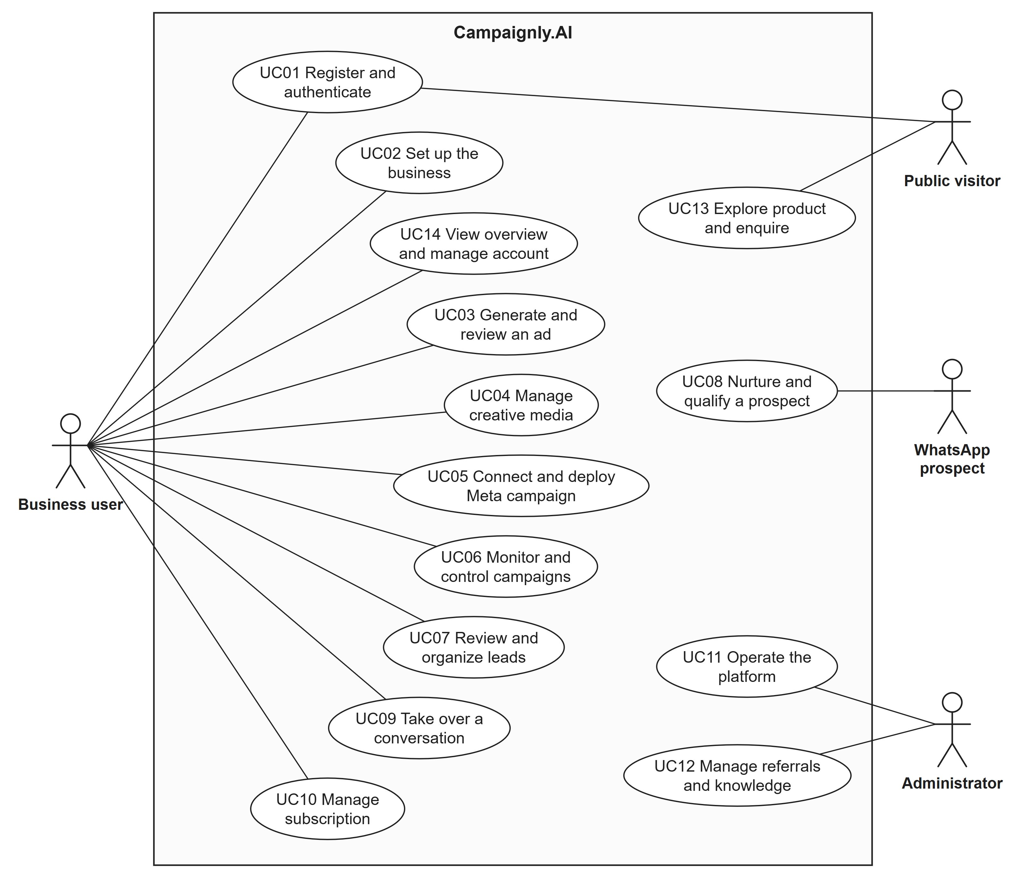
Figure 2.1 System-level use case diagram of Campaignly.AI
Figure 2.2 covers registration, sign-in with its optional Google and password reset paths, business onboarding, which always resolves the business location, and the overview and account settings.
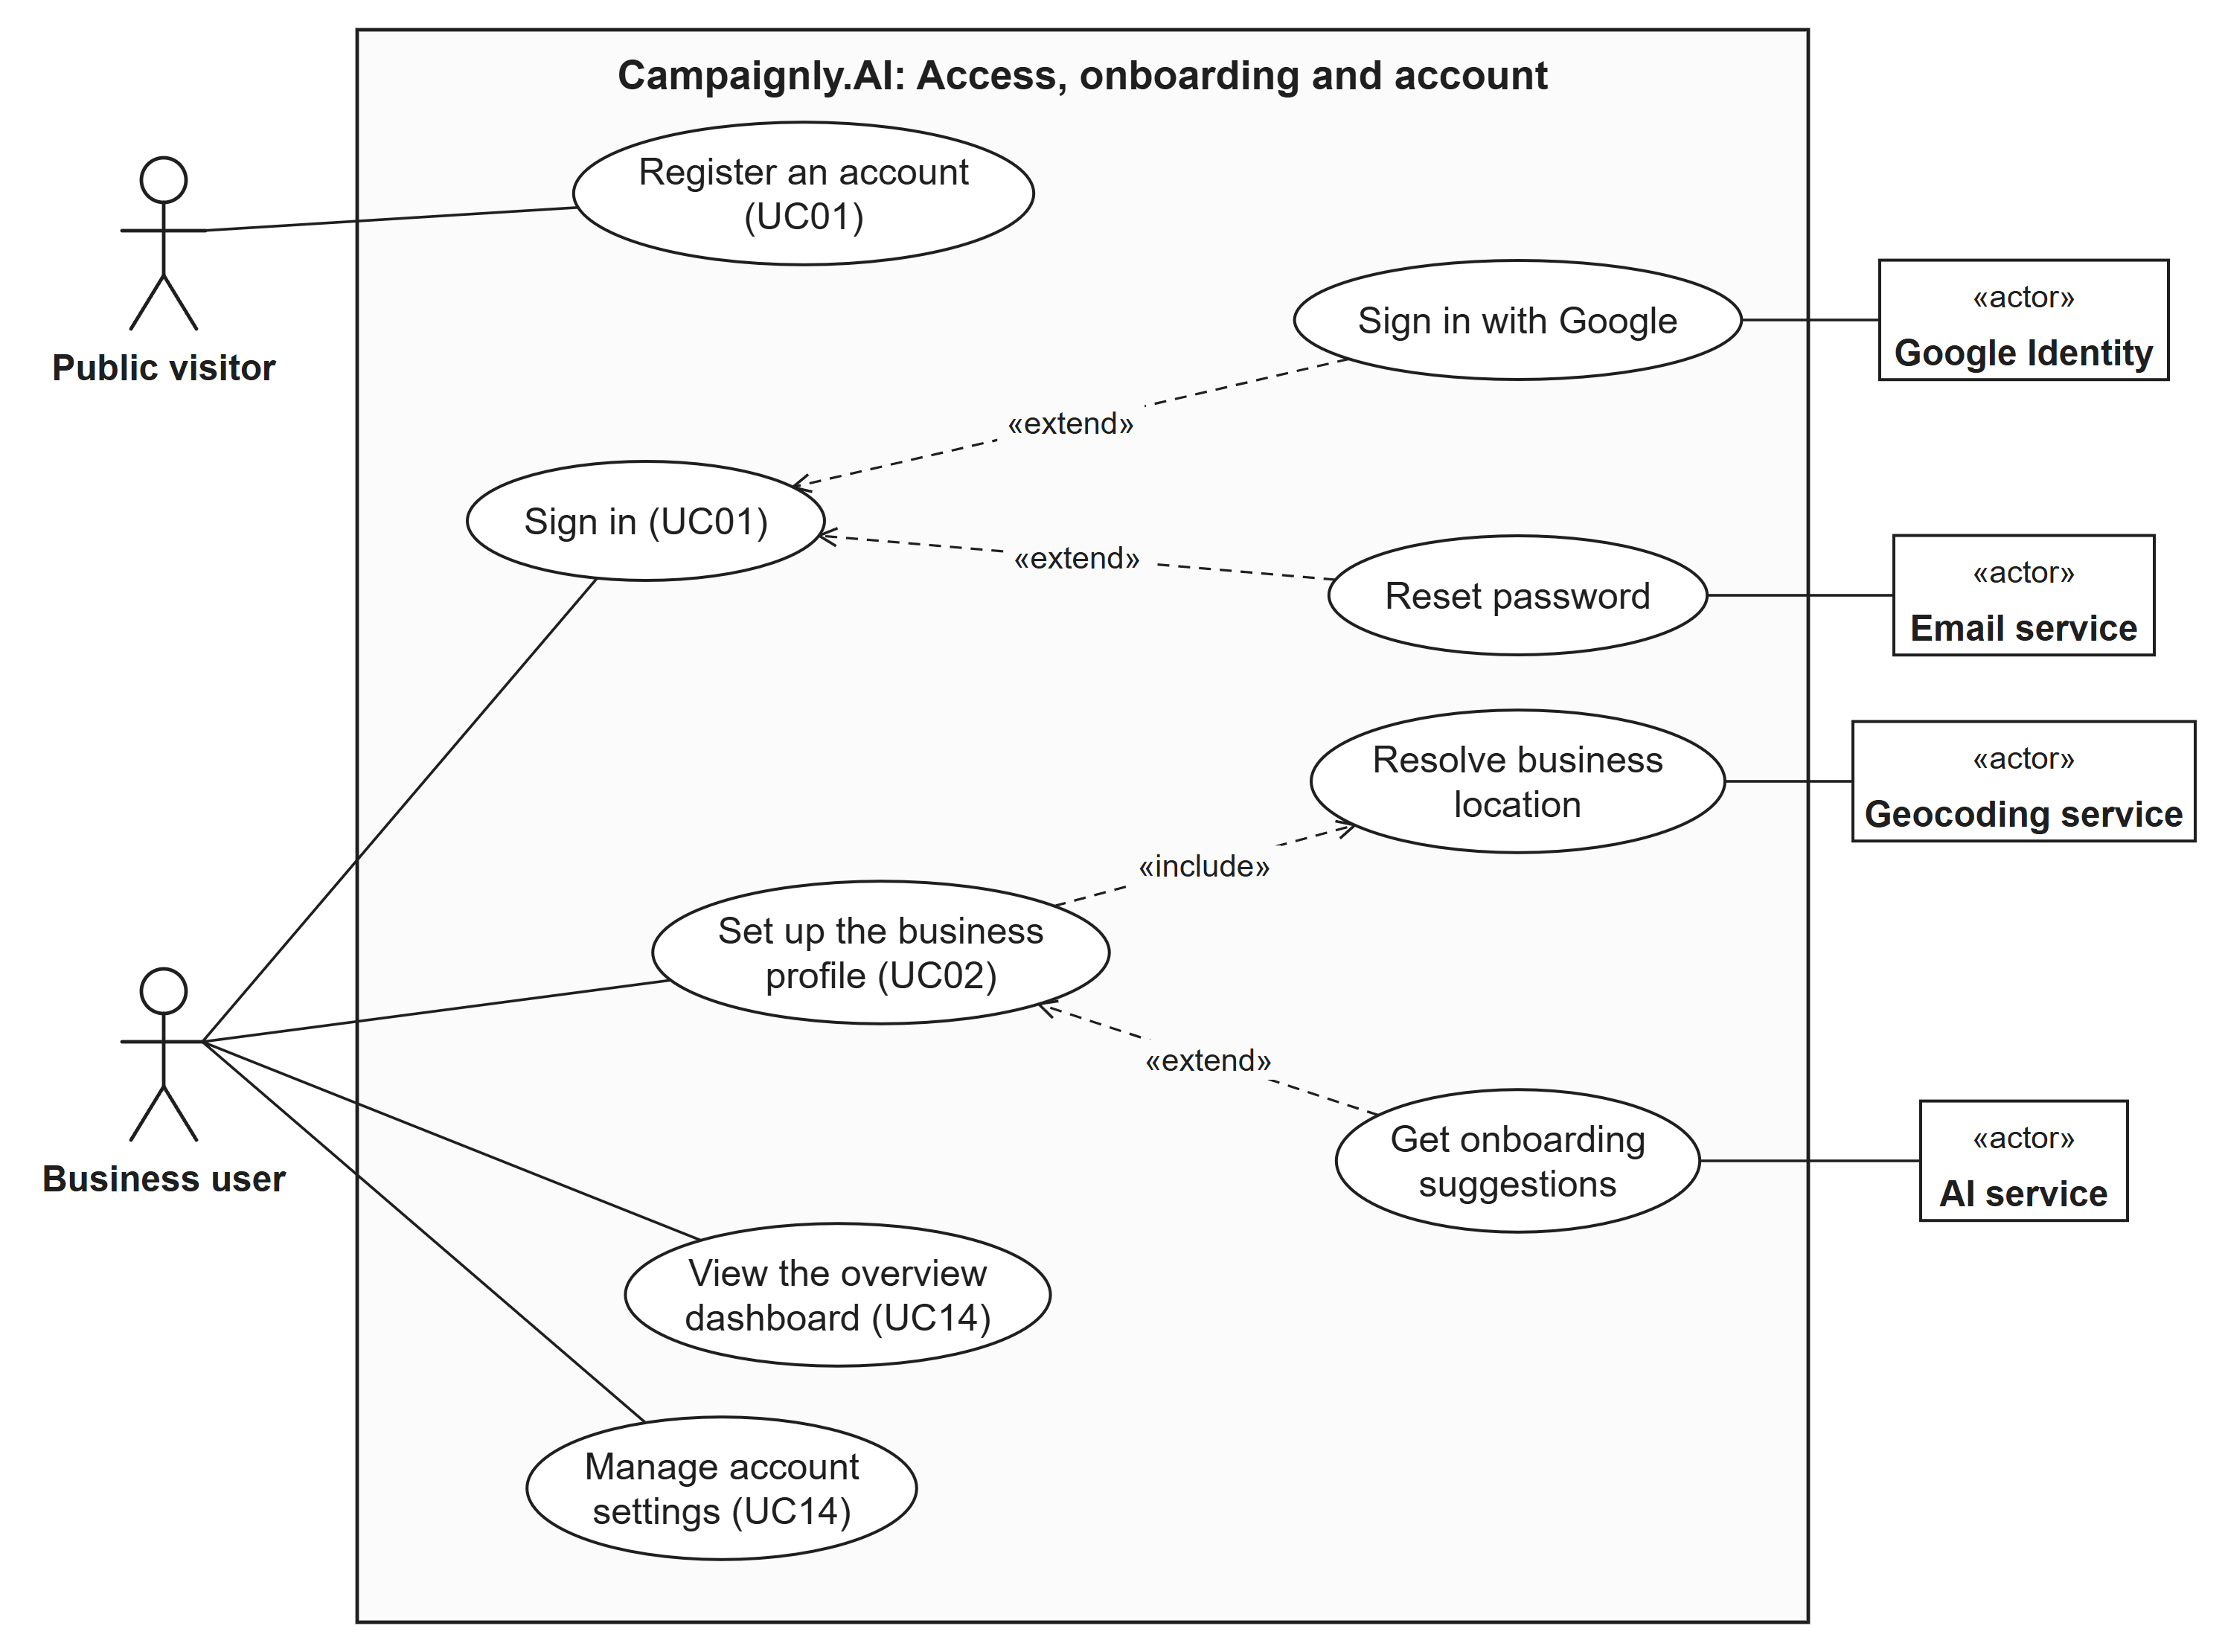
Figure 2.2 Use case diagram for access, onboarding and account management
Figure 2.3 covers ad generation, which always runs the Bradley Filter check and may start from a template or add image and video drafts, and the media library with versioned editing.
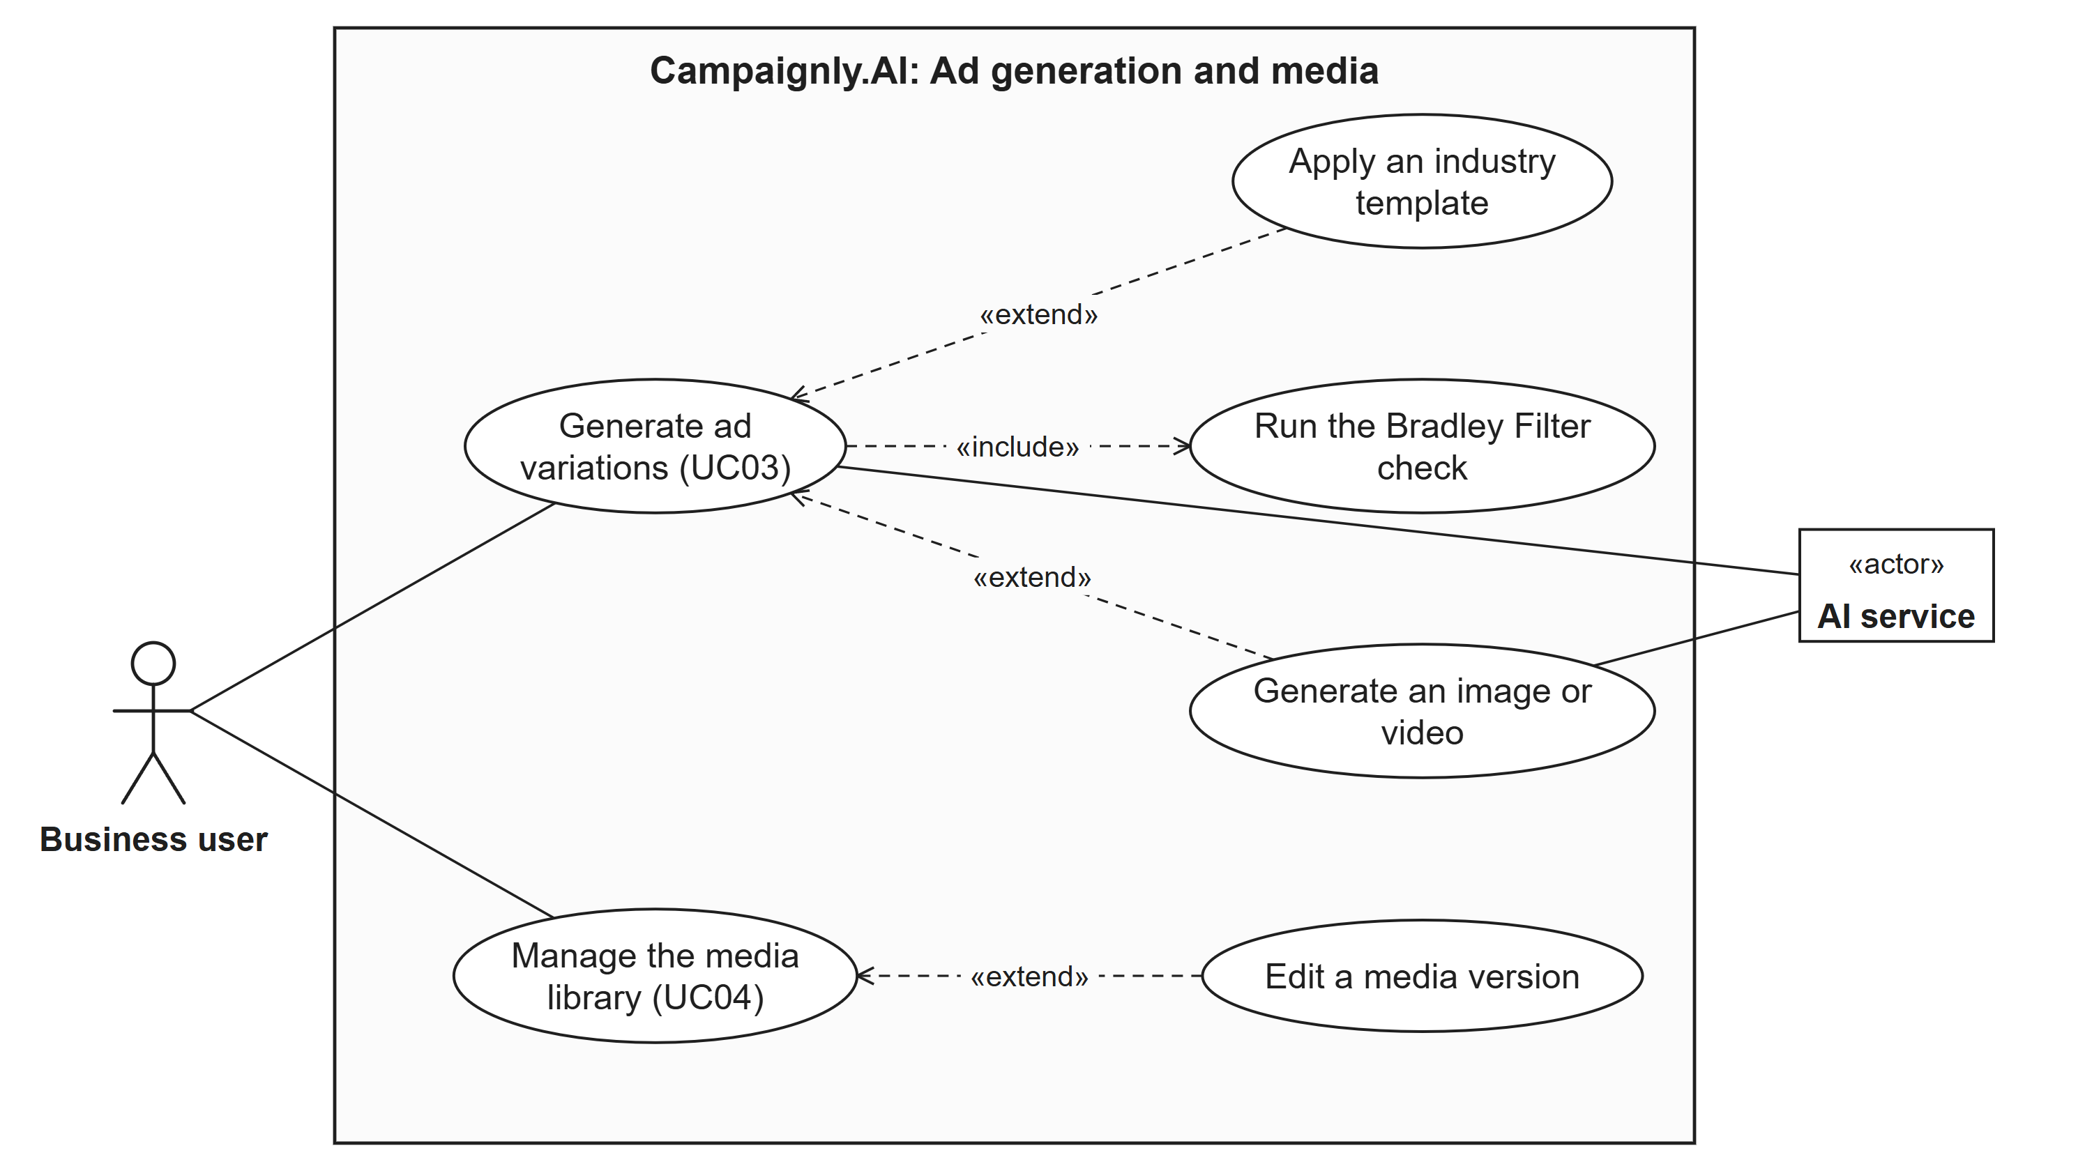
Figure 2.3 Use case diagram for ad generation and creative media
Figure 2.4 covers the Meta connection, deployment, which always reruns the Bradley Filter check and confirms location targeting, campaign control and duplication, and scheduled synchronisation of status and metrics.
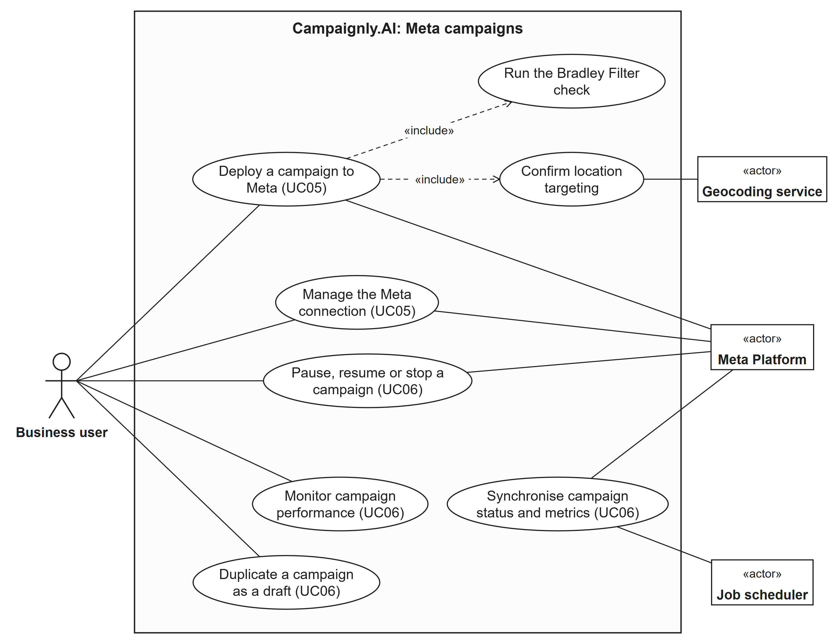
Figure 2.4 Use case diagram for Meta campaign deployment and control
Figure 2.5 covers lead synchronisation and review, the WhatsApp business number, owner takeover, notifications, and prospect nurturing, which always scores intent and notifies the owner once a lead becomes ready.
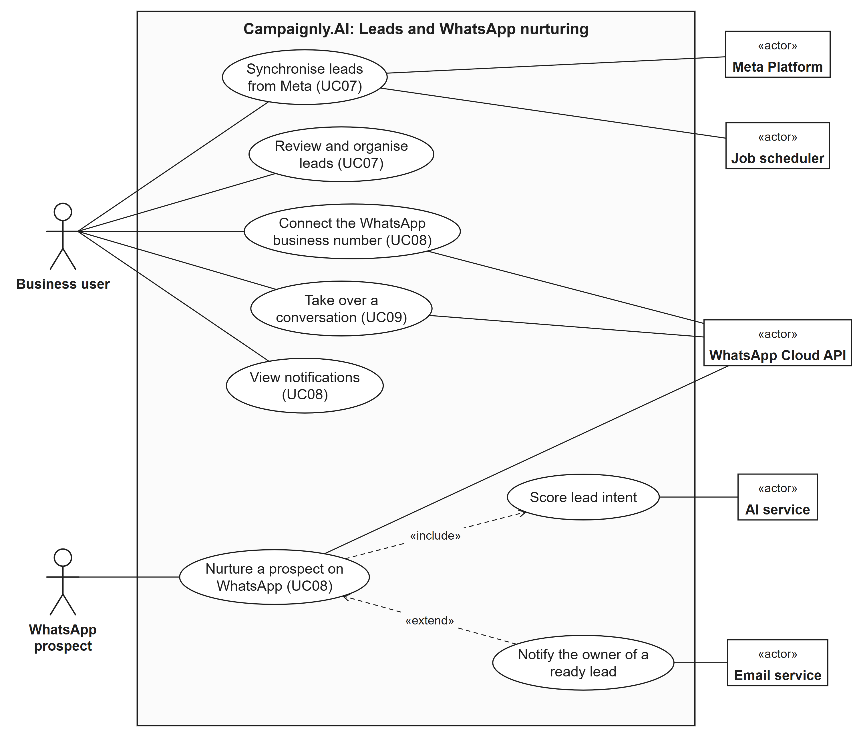
Figure 2.5 Use case diagram for leads and WhatsApp nurturing
Figure 2.6 covers the card-backed trial and subscription, the Stripe billing portal, plan usage, verified billing events from Stripe and scheduled billing reminders.
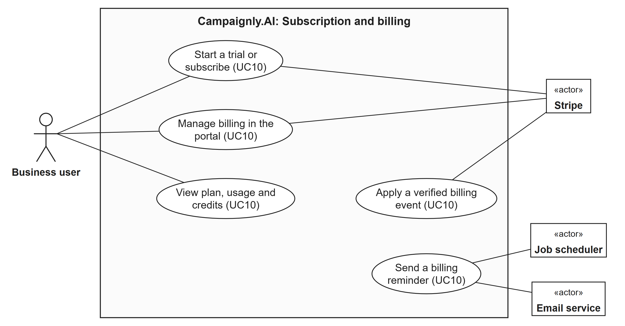
Figure 2.6 Use case diagram for subscription and billing
Figure 2.7 covers platform operations, dataset publication and referrals for the administrator, referral rewards triggered by Stripe, and the public website, pricing, diagnostic and enquiry for visitors.
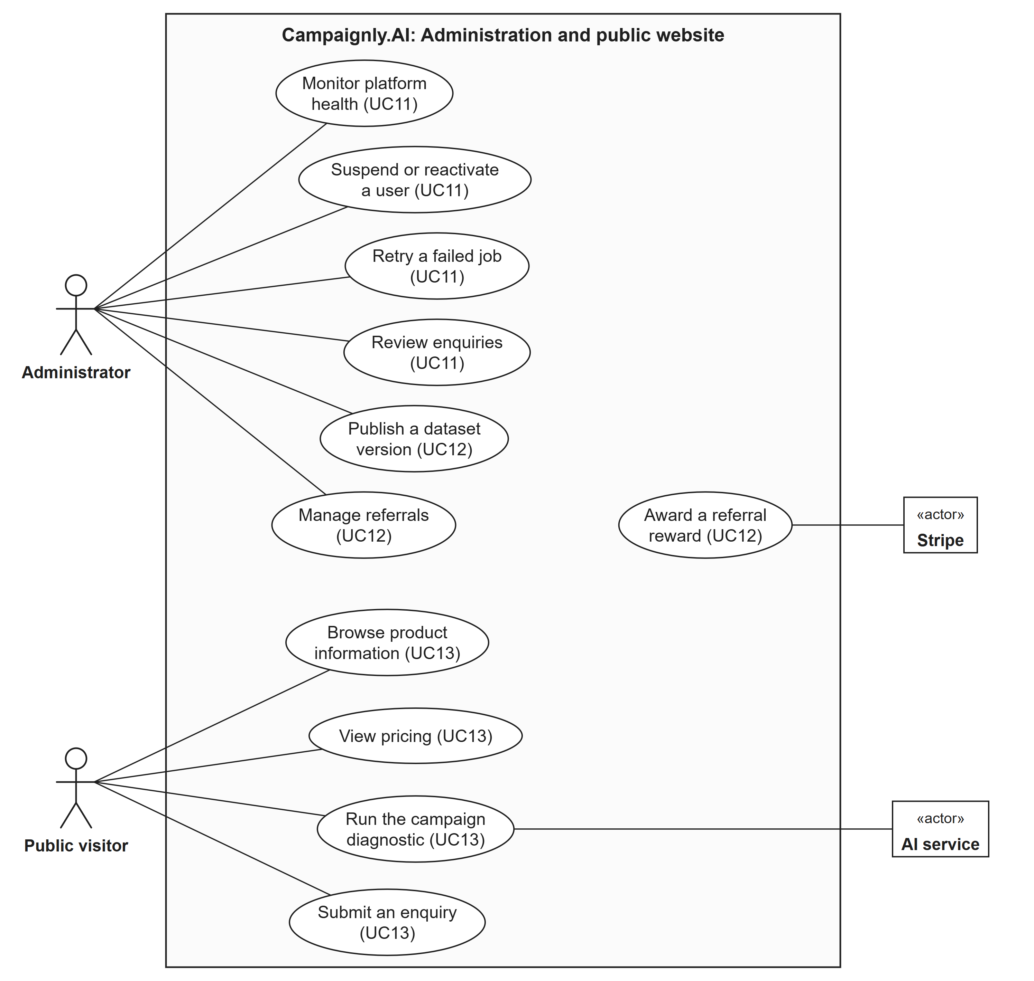
Figure 2.7 Use case diagram for administration and the public website
Table 2.7 links every use case to its actors, the screens that realise it and its functional requirements.
Table 2.7 Use case summary
UC | Use case | Primary actor | Supporting actors | Screens | Requirements
UC01 | Register and authenticate | Public visitor / Business user | Google Identity, Email service | M10-S01 | FR-074, FR-075, FR-076, FR-077, FR-079, FR-080
UC02 | Set up the business | Business user | Geocoding service, AI service | M01-S01 | FR-001, FR-002, FR-003, FR-004, FR-005, FR-006, FR-007, FR-087
UC03 | Generate and review an ad | Business user | AI service | M02-S01, M02-S02 | FR-008, FR-009, FR-010, FR-011, FR-012, FR-013, FR-014, FR-015, FR-016, FR-082
UC04 | Manage creative media | Business user | None | M03-S01 | FR-017, FR-018, FR-019, FR-020, FR-021, FR-022, FR-023, FR-024, FR-025
UC05 | Connect and deploy Meta campaign | Business user | Meta Platform, Geocoding service | M04-S01 | FR-026, FR-027, FR-028, FR-029, FR-030, FR-036, FR-086, FR-089
UC06 | Monitor and control campaigns | Business user | Meta Platform, Job scheduler | M04-S02, M04-S03, M05-S03 | FR-031, FR-032, FR-033, FR-034, FR-035
UC07 | Review and organize leads | Business user | Meta Platform, Job scheduler | M05-S01, M05-S02 | FR-037, FR-038, FR-039, FR-040, FR-041, FR-042, FR-043
UC08 | Nurture and qualify a prospect | WhatsApp prospect | WhatsApp Cloud API, AI service, Email service | M06-S01, M10-S03 | FR-044, FR-045, FR-046, FR-047, FR-048, FR-049, FR-050, FR-051, FR-084, FR-085, FR-088
UC09 | Take over a conversation | Business user | WhatsApp Cloud API | M05-S02, M06-S01 | FR-052
UC10 | Manage subscription | Business user | Stripe, Job scheduler, Email service | M07-S01, M07-S02 | FR-053, FR-054, FR-055, FR-056, FR-057, FR-058, FR-059, FR-083
UC11 | Operate the platform | Administrator | None | M08-S01 | FR-060, FR-061, FR-062, FR-063, FR-064, FR-065, FR-070
UC12 | Manage referrals and knowledge | Administrator | Stripe | M08-S02 | FR-066, FR-067
UC13 | Explore product and enquire | Public visitor | AI service | M09-S01, M07-S02, M09-S02 | FR-068, FR-069, FR-070, FR-071, FR-072, FR-073
UC14 | View overview and manage account | Business user | None | M10-S02, M04-S04 | FR-078, FR-081

2.5 Requirement Identifying Technique
Mockup-based analysis identifies visible controls, validation and outcomes, while event-response analysis captures backend actions. Figures 2.8 to 2.28 show the interface mockups grouped under their respective modules. Each screen has a reference ID Mxx-Snn for traceability, where Mxx is the module of Section 1.7 and Snn the screen number within that module. The steps were: break each module into the screens a user needs; assign a screen ID to each screen; design the screen in the Campaignly design system; identify its interactive elements; and derive a feature-level functional requirement from each element. Backend-only behaviour, such as webhooks from Meta, WhatsApp and Stripe, scheduled synchronisation, nurturing jobs, reminders and security events, is linked to an event in the event-response table at the end of this section.
The mockups use the design system of the deployed Campaignly.AI prototype (campaignly-ai.vercel.app) rather than the rough mockups in the scope document: DM Sans body text, Fraunces display headings, primary teal #0F766E, orange accent #EA580C and a light grey-green surface #F4F7F6 with card-based layouts. All 21 screens were built in the prototype codebase with its own navigation shell, cards, buttons, inputs and badges, refining the corresponding prototype screen so that it shows the confirmed requirements; M04-S03, M05-S03 and M10-S03 are new screens. Sample data such as Pulse Fit Studio is illustrative only. The mockups illustrate the required behaviour and are not committed final designs; the written requirements govern system behaviour.
Table 2.8 inventories the screens. A functional requirement is validated by checking its successful outcome and its rejection, failure or unavailable state against the related screen or backend event. The 78 scope features and 11 baseline additions are covered by FR-001 to FR-089.
Table 2.8 Screen inventory and scope traceability
Module | Screen ID | Screen and purpose | Prototype screen refined
M01 | M01-S01 | Business Onboarding Wizard | /onboarding
M02 | M02-S01 | AI Ad Generator | /dashboard/ads
M02 | M02-S02 | Industry Campaign Templates | /dashboard/ads
M03 | M03-S01 | Media Studio and Editor | /dashboard/media
M04 | M04-S01 | Meta Connection and Campaign Review | /dashboard/meta, /dashboard/campaigns
M04 | M04-S02 | Campaign List and Controls | /dashboard/campaigns
M04 | M04-S03 | Campaign Detail and Metrics | New screen
M04 | M04-S04 | Settings: Integrations, Brand Kit and Security | /dashboard/settings
M05 | M05-S01 | Leads Workspace | /dashboard/leads
M05 | M05-S02 | Lead Detail and Activity Timeline | /dashboard/leads
M05 | M05-S03 | Campaign Analytics | New screen
M06 | M06-S01 | WhatsApp AI Agent and Takeover | /dashboard/whatsapp
M07 | M07-S01 | Billing and Subscription | /dashboard/billing
M07 | M07-S02 | Public Pricing | /pricing
M08 | M08-S01 | Administration Overview | /admin
M08 | M08-S02 | Knowledge Base, Referrals and Enquiries | /admin
M09 | M09-S01 | Marketing Website | /
M09 | M09-S02 | Campaign Diagnostic and Enquiry | /diagnostic
M10 | M10-S01 | Sign In, Registration and Password Reset | /login, /register, /forgot-password
M10 | M10-S02 | Owner Overview Dashboard | /dashboard
M10 | M10-S03 | Notification Centre | New screen
M01-S01
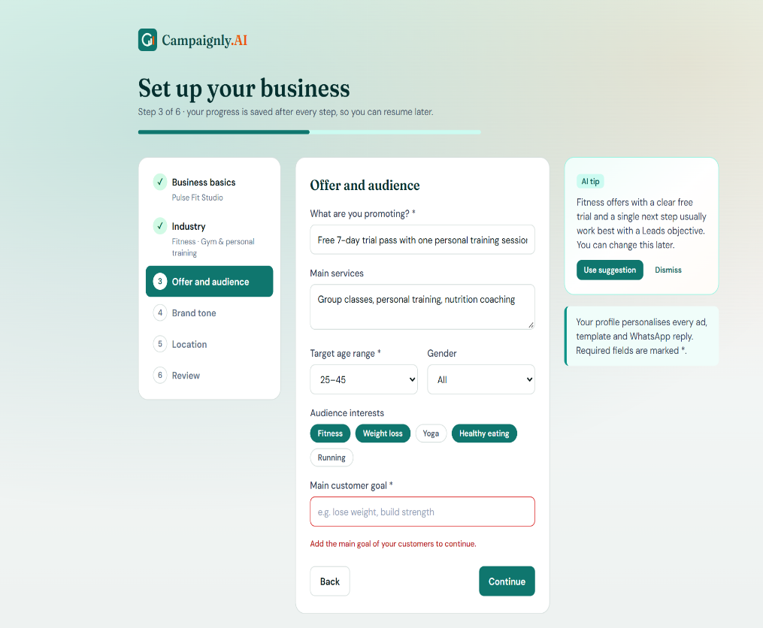
Figure 2.8 Module M01 Business Onboarding and Brand Setup
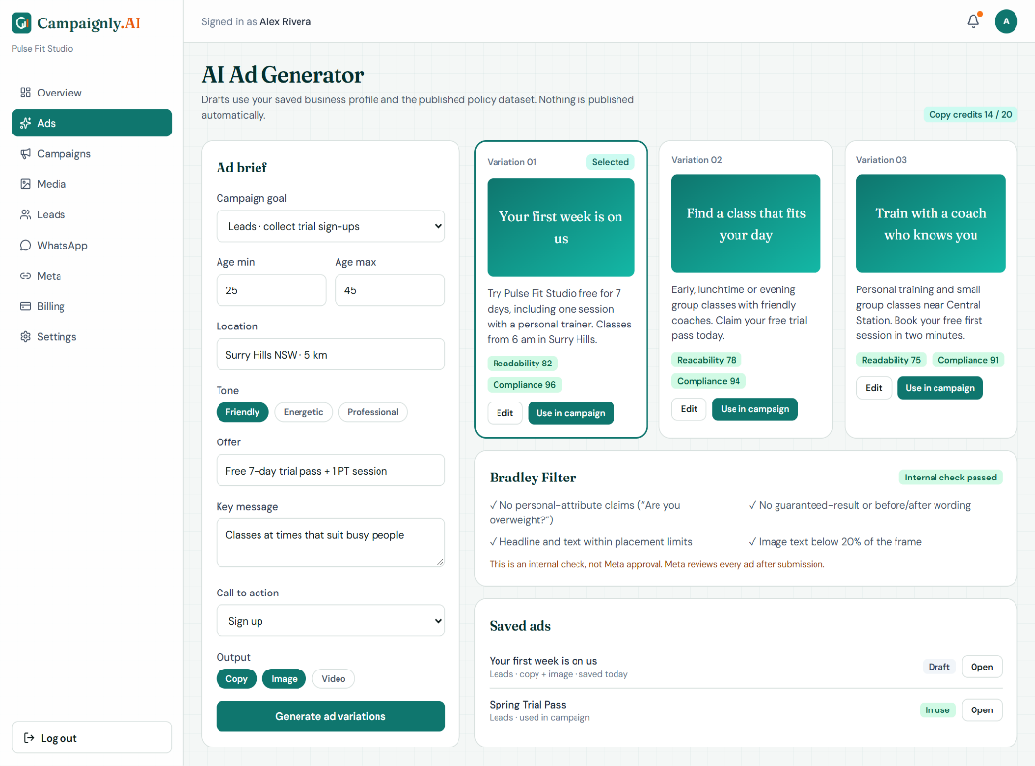
M02-S01

Figure 2.9 Module M02 AI Advertisement and Content Generation mockup
M02-S02
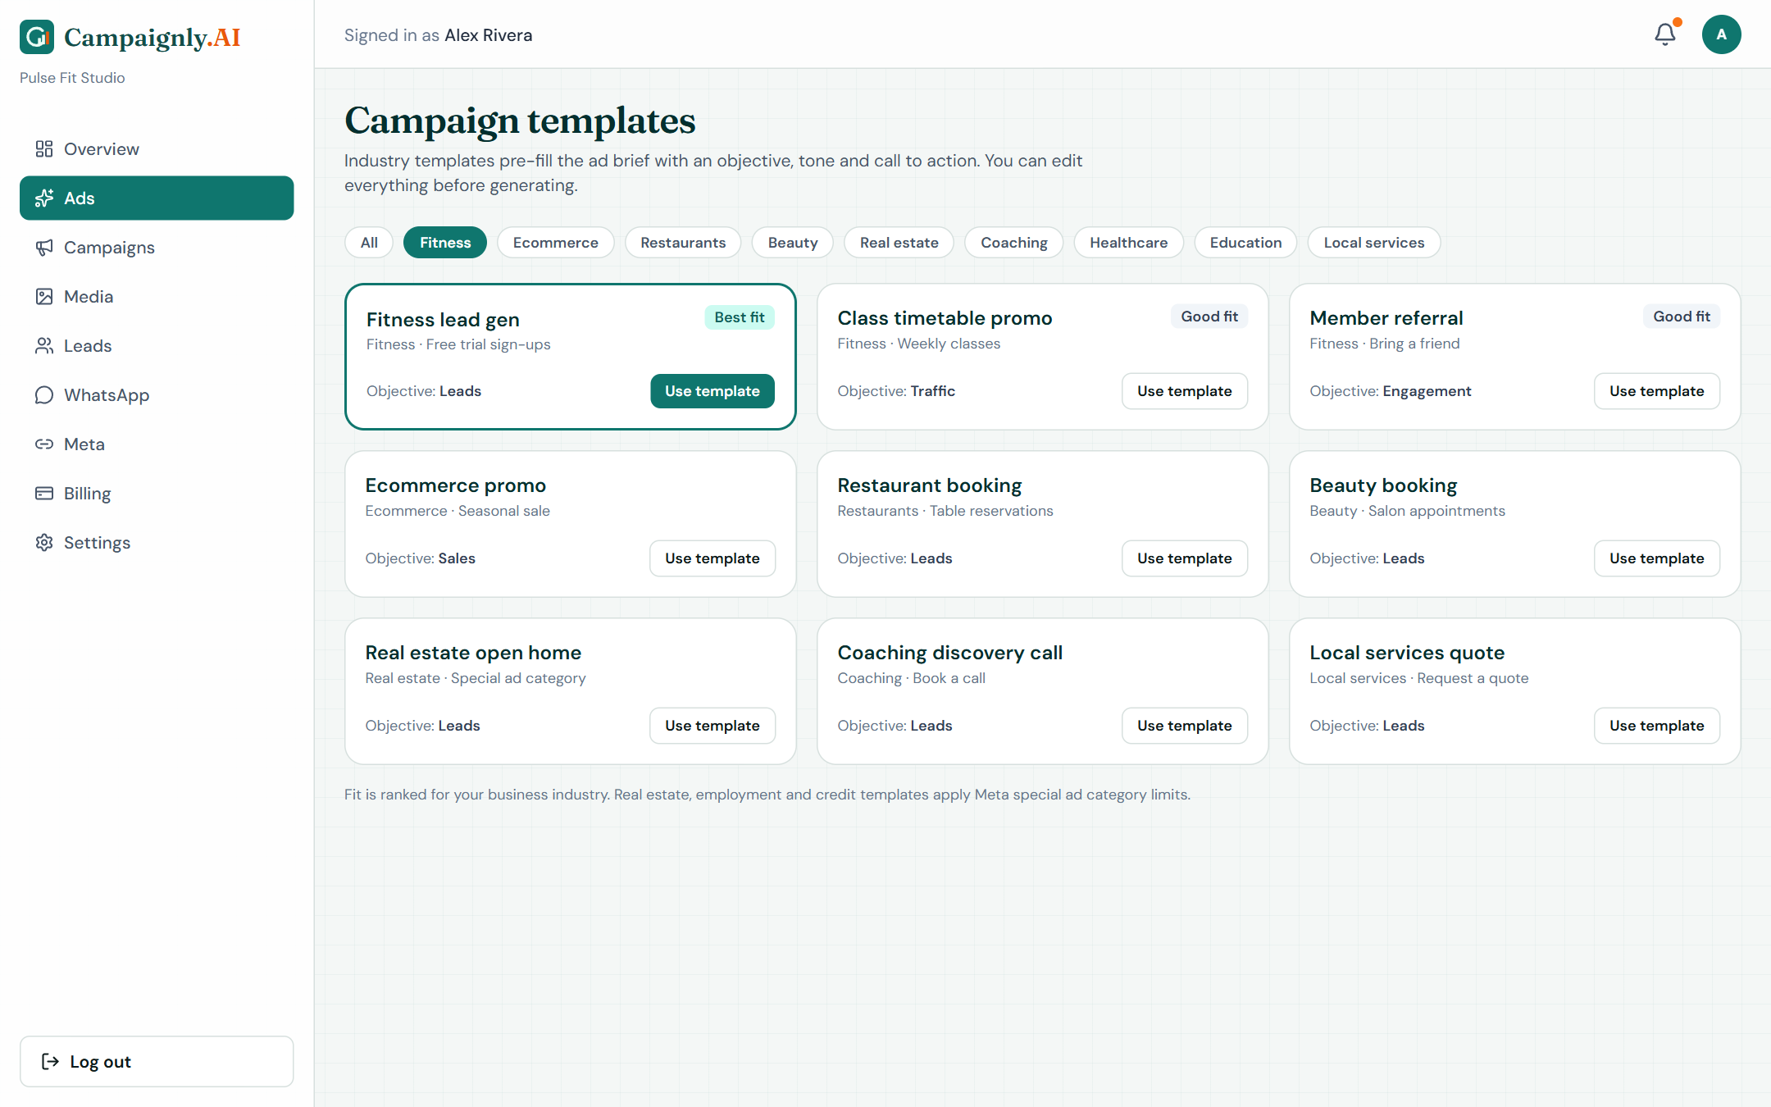
Figure 2.10 Module M02 AI Advertisement and Content Generation mockup
M03-S01
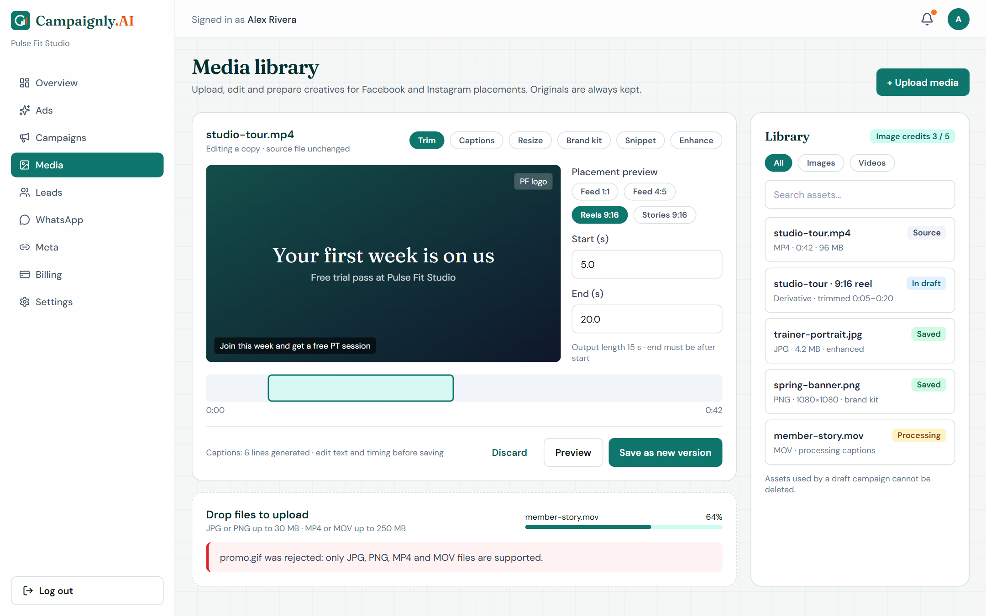
Figure 2.11 Module M03 AI Media Editing and Creative Automation
M04-S01
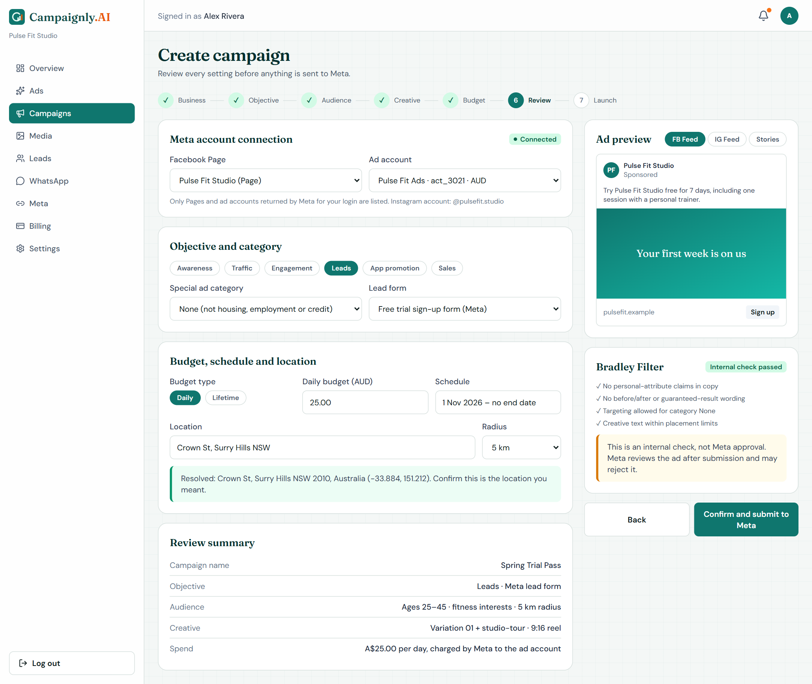
Figure 2.12 Module M04 Meta Campaign Automation mockup
M04-S02
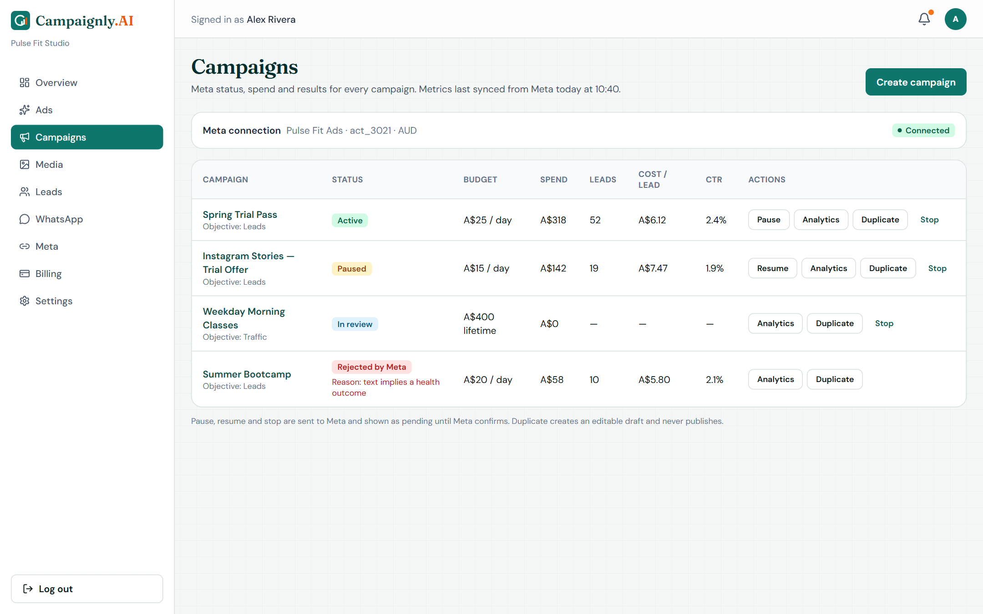
Figure 2.13 Module M04 Meta Campaign Automation
M04-S03
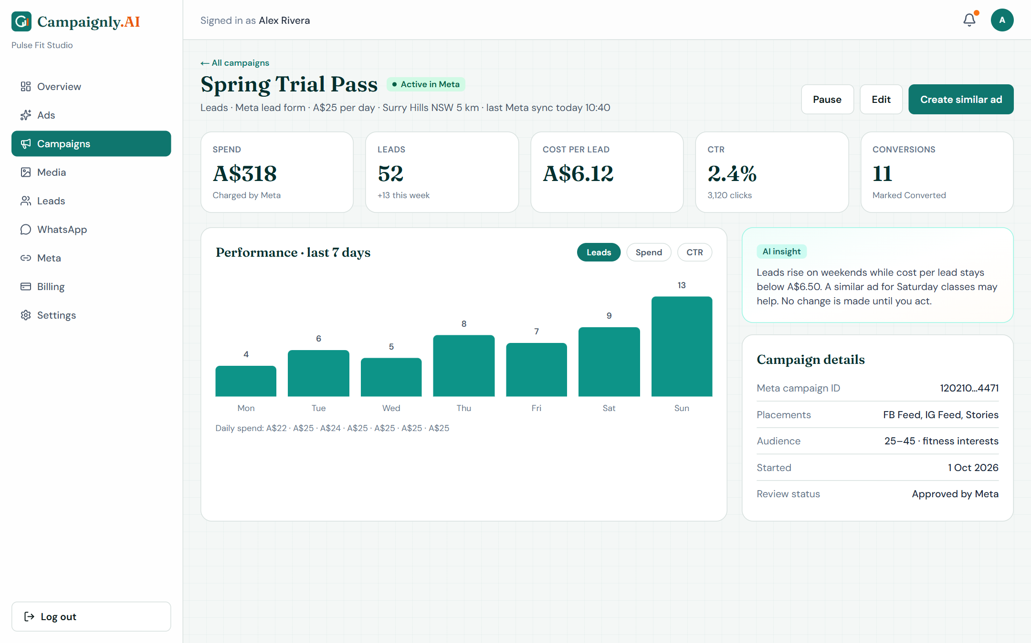
Figure 2.14 Module M04 Meta Campaign Automation mockup

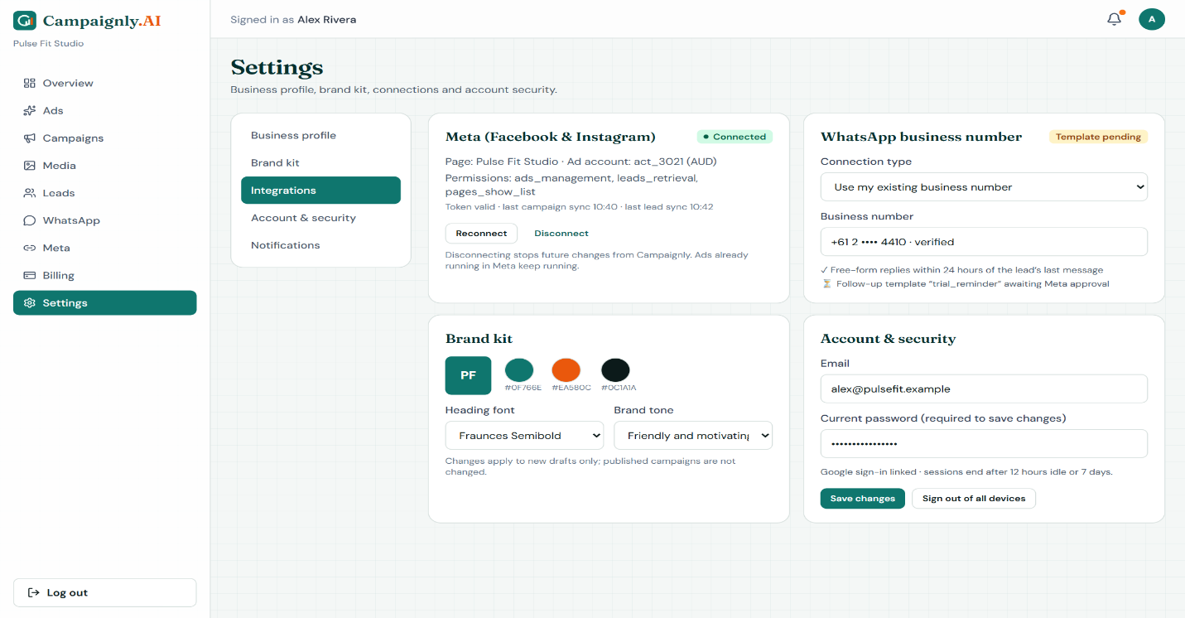
M04-S04
Figure 2.15 Module M04 Meta Campaign Automation mockup
M05-S01
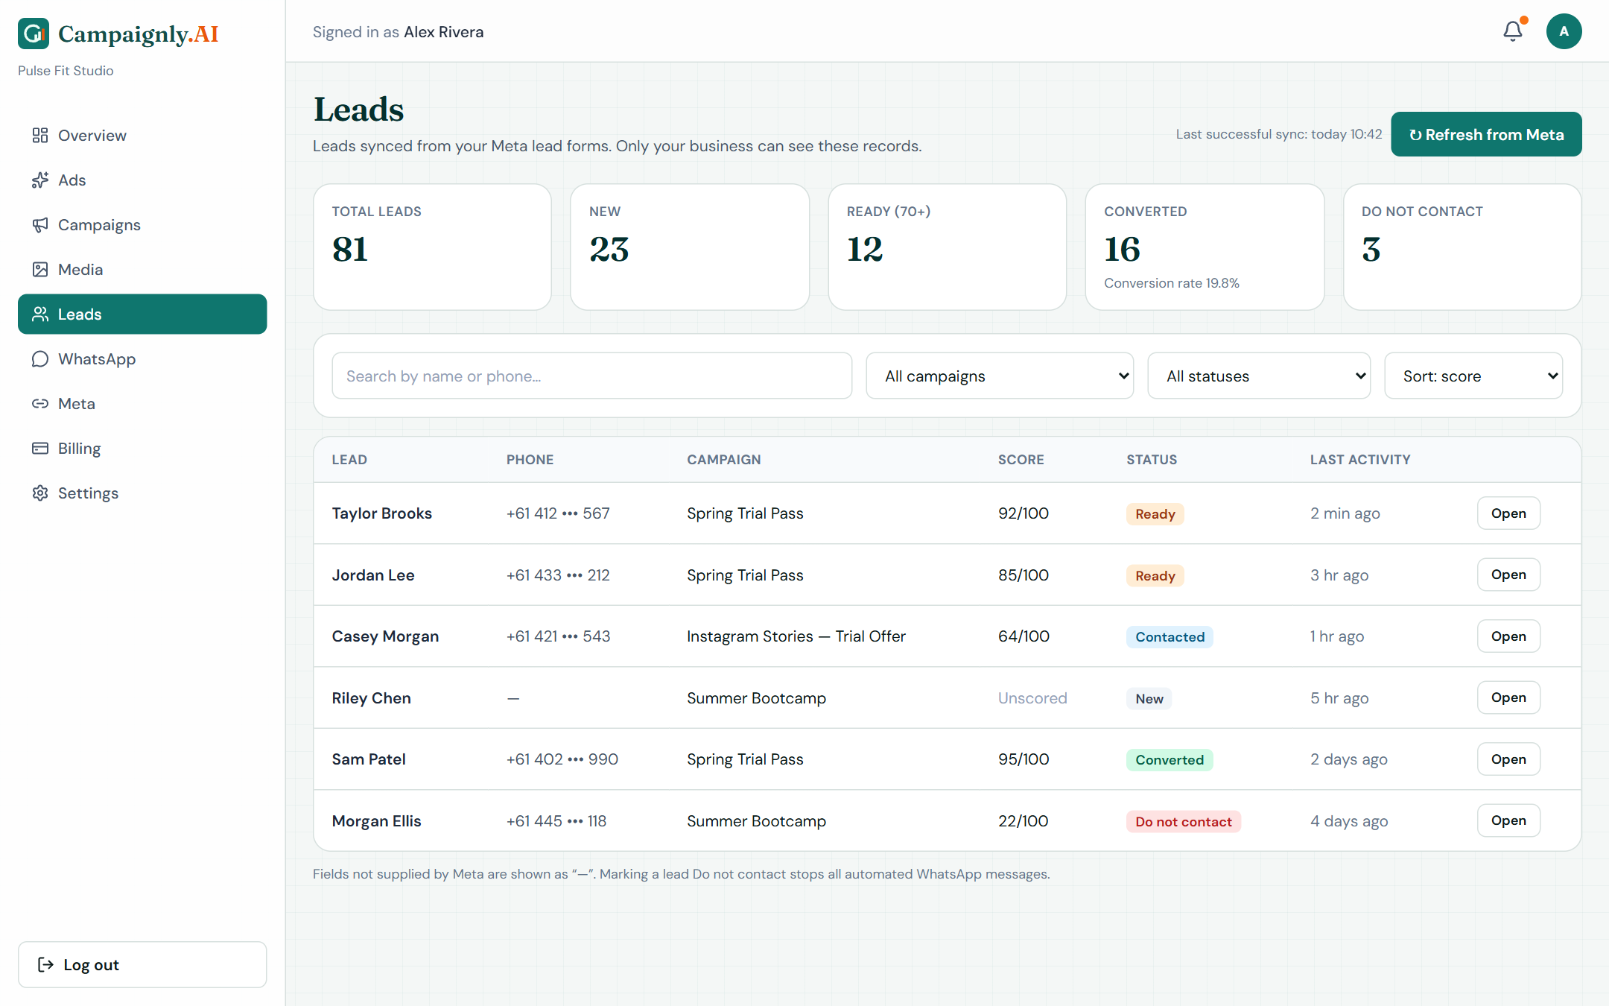
Figure 2.16 Module M05 Lead Management mockup
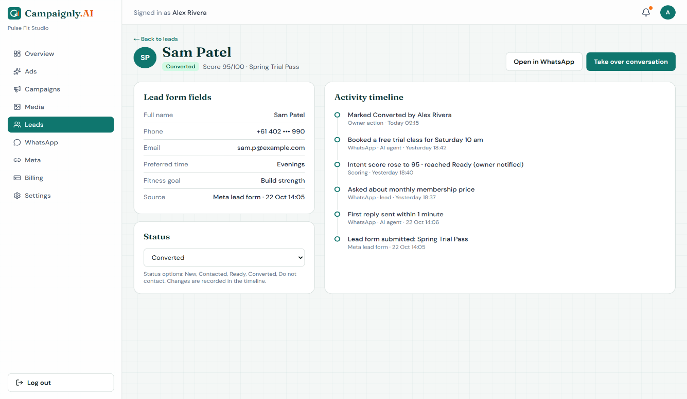
M05-S02

Figure 2.17 Module M05 Lead Management mockup
M05-S03
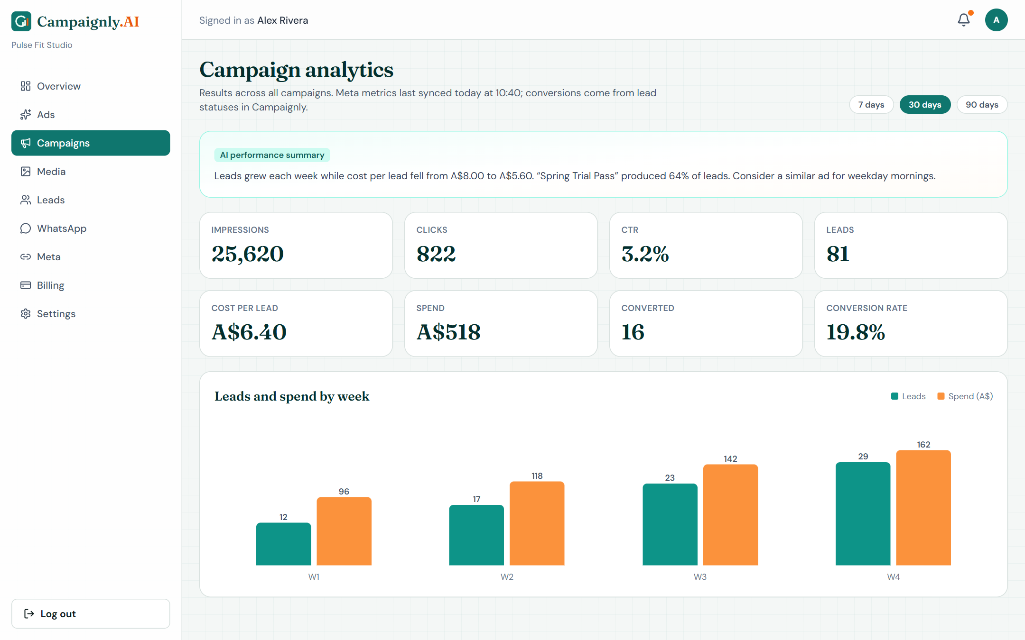
Figure 2.18 Module M05 Lead Management mockup
M06-S01
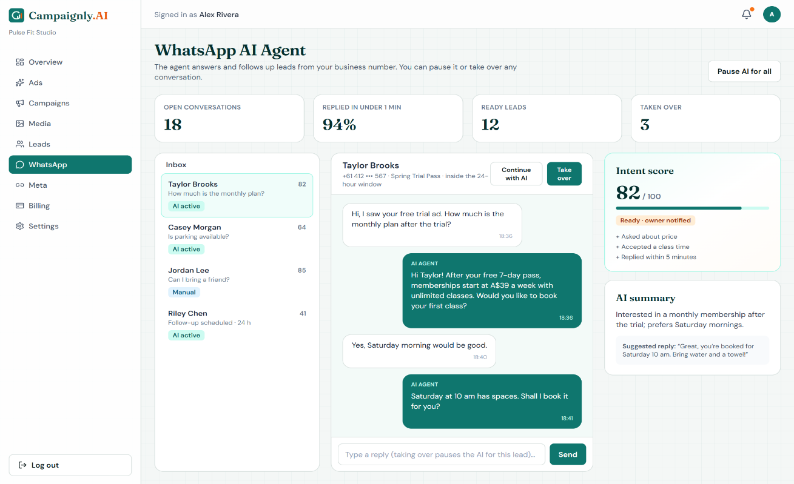
Figure 2.19 Module M06 AI WhatsApp Lead Nurturing mockup
M07-S01
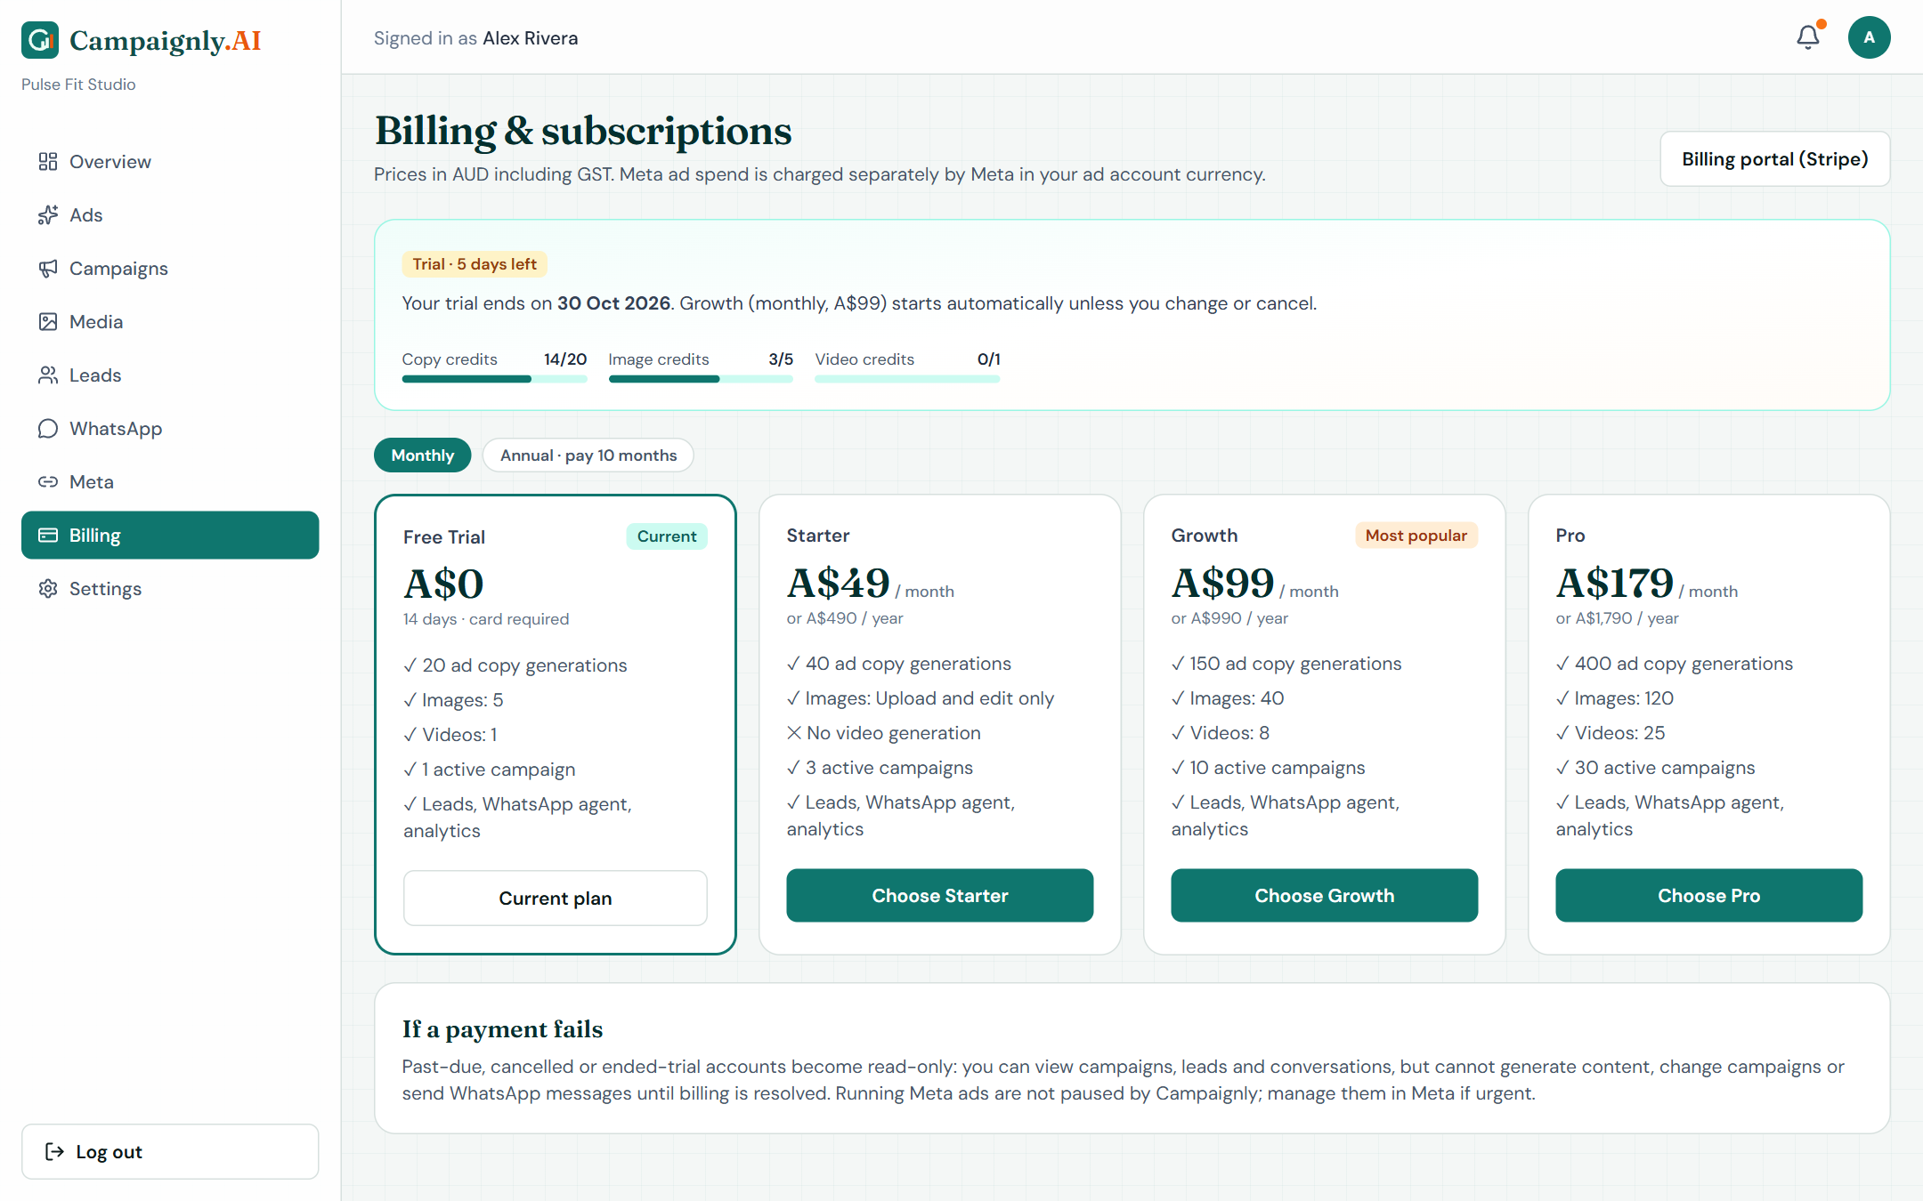
Figure 2.20 Module M07 Subscription and Billing mockup
M07-S02
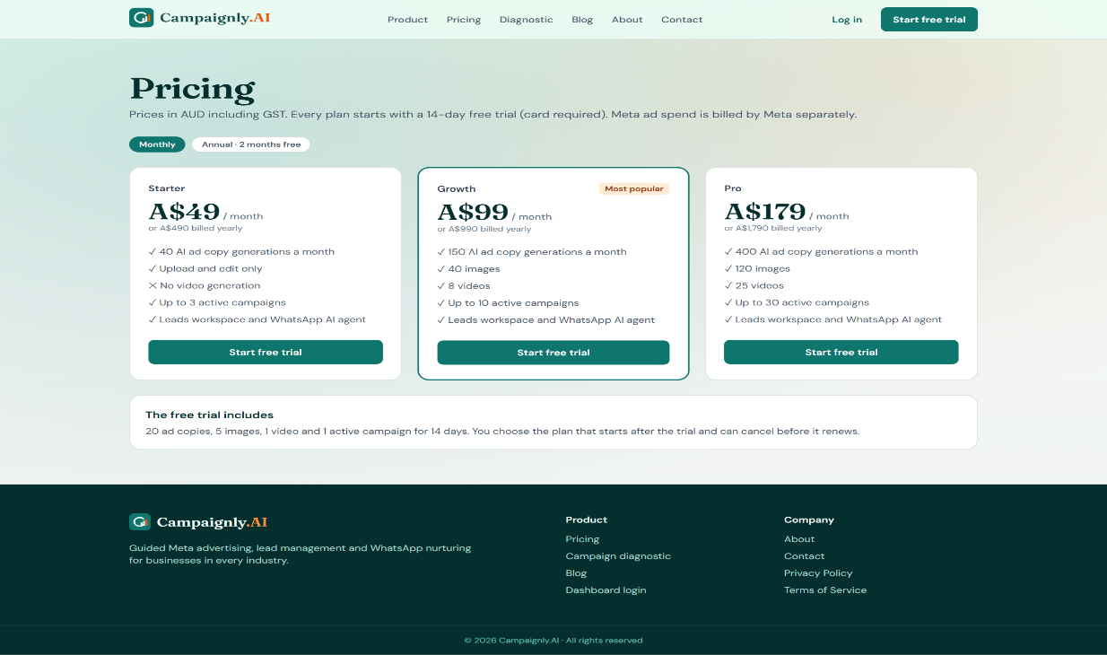
Figure 2.21 Module M07 Subscription and Billing mockup
M08-S01
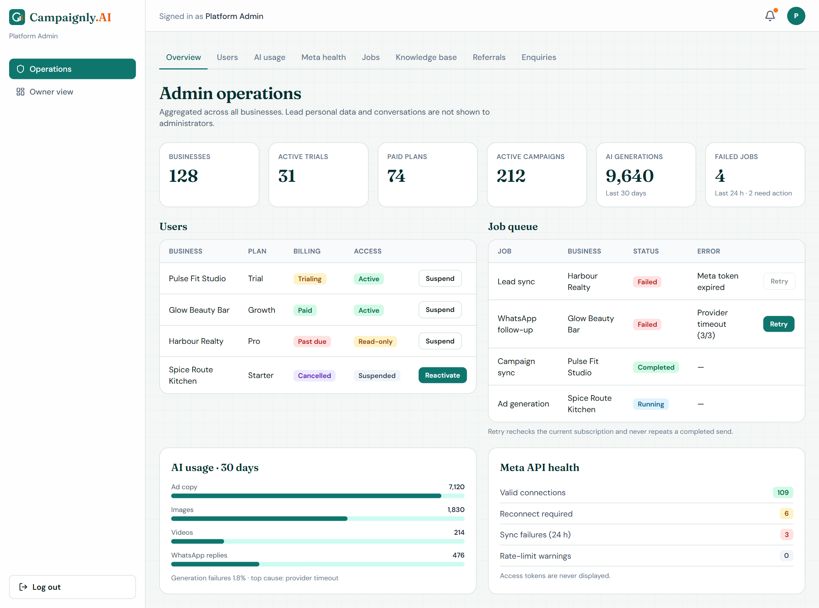
Figure 2.22 Module M08 Admin Dashboard and Platform Operations
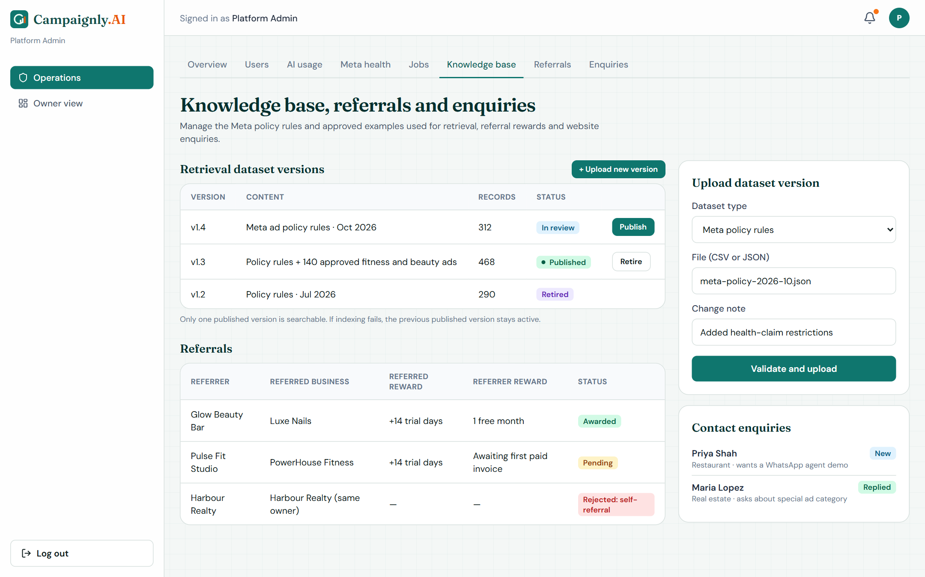
M08-S02

Figure 2.23 Module M08 Admin Dashboard and Platform Operations mockup
M09-S01
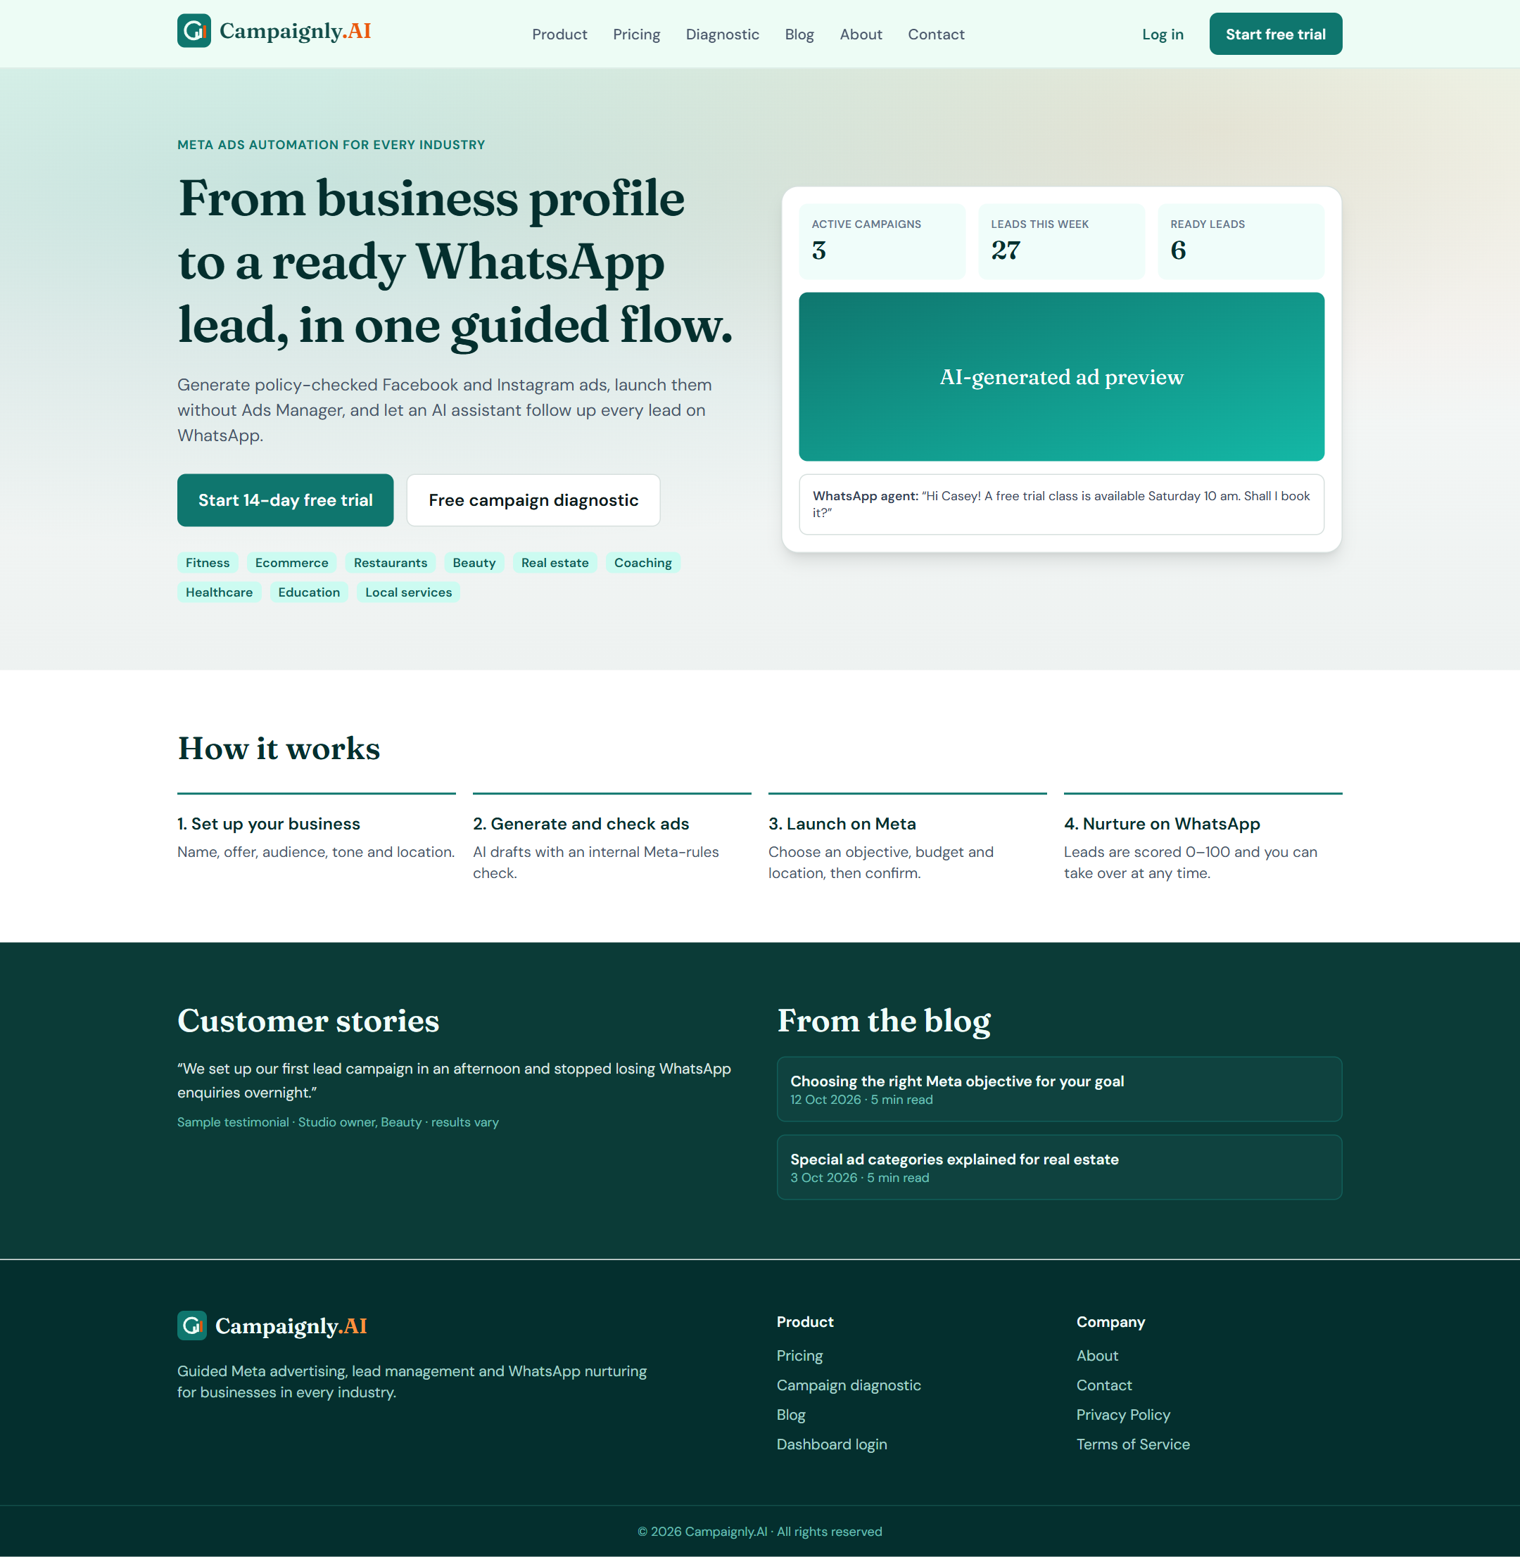
Figure 2.24 Module M09 Marketing Website and Customer Acquisition
M09-S02
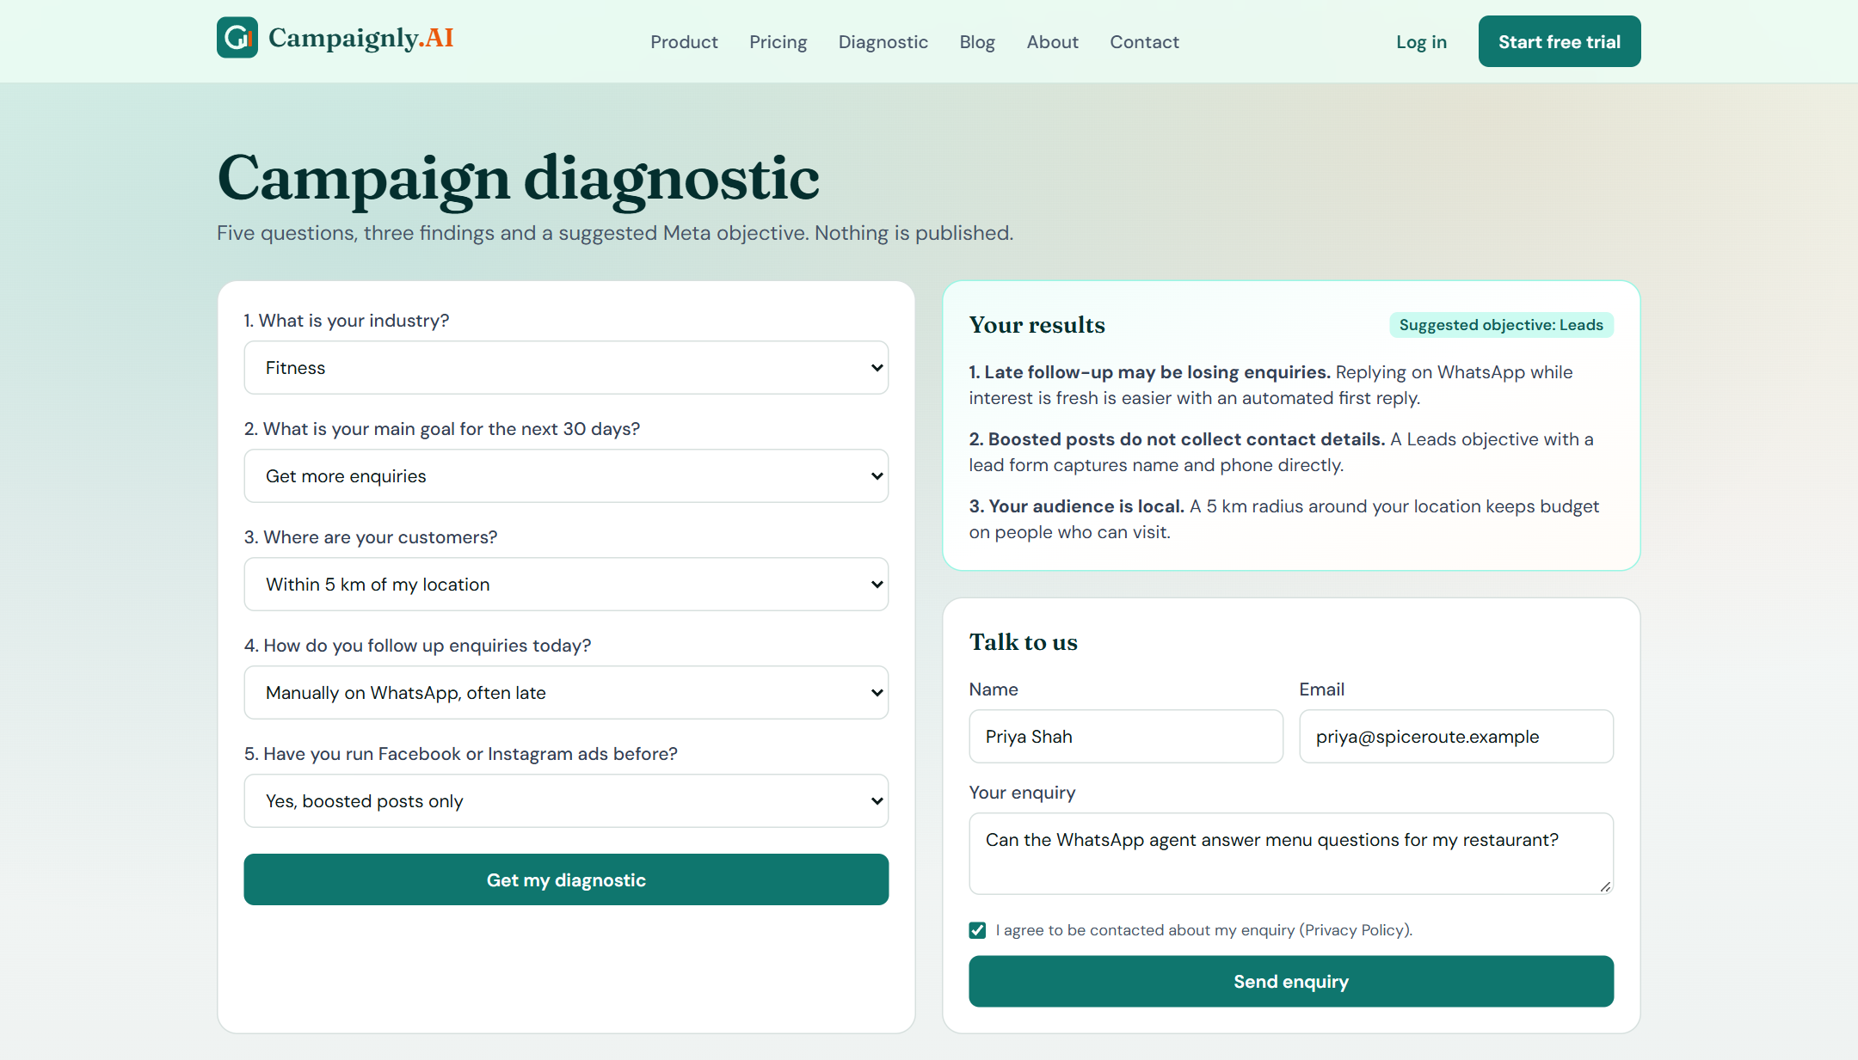
Figure 2.25 Module M09 Marketing Website and Customer Acquisition
M10-S01
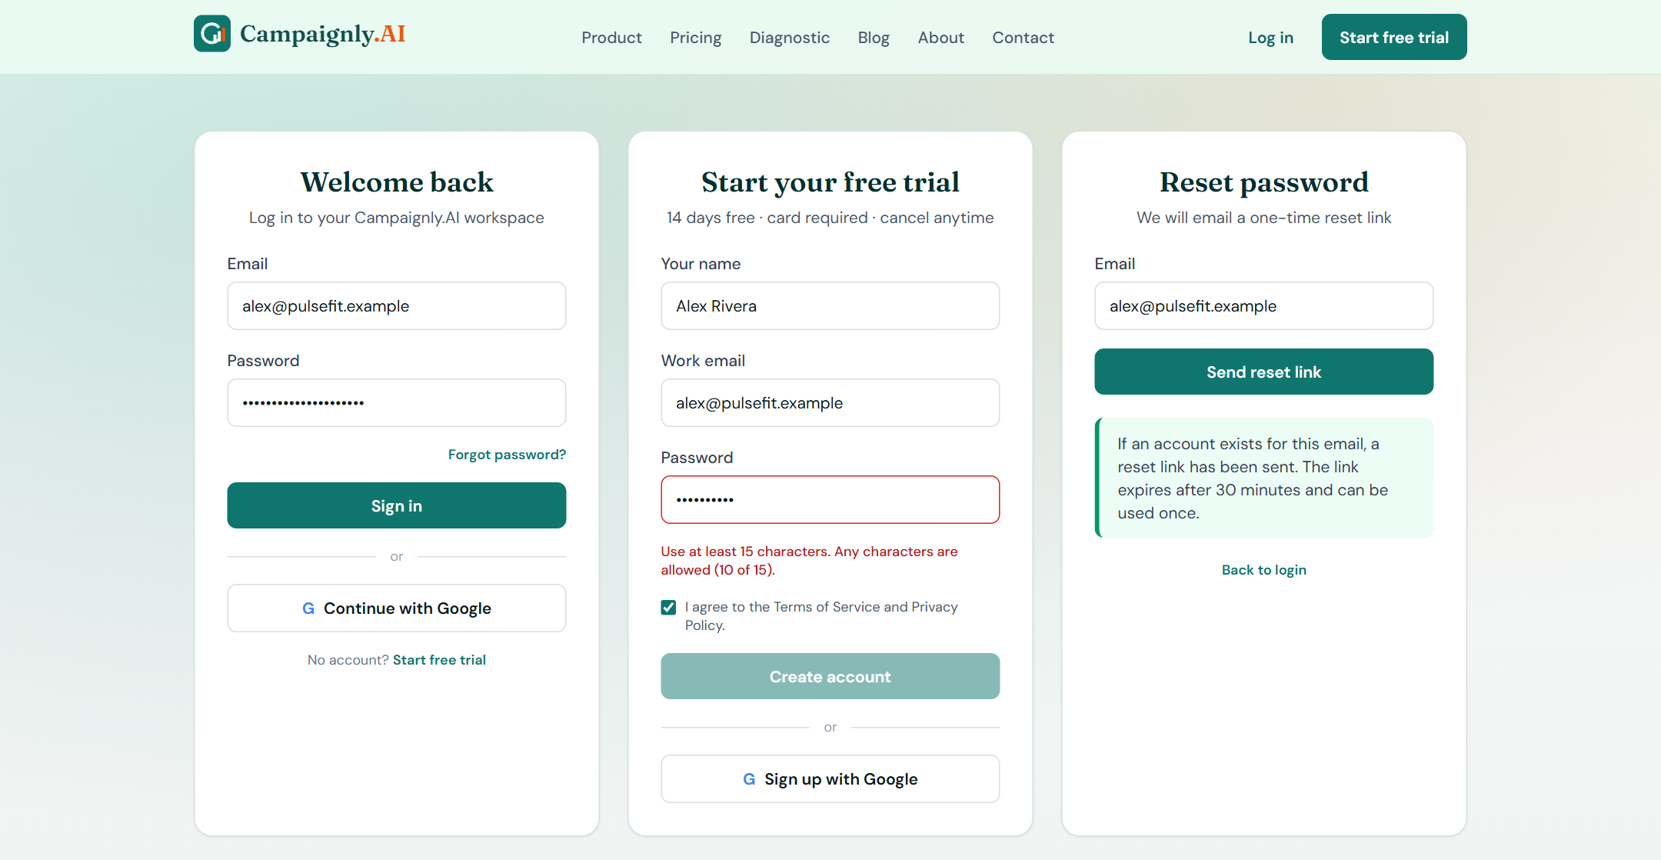
Figure 2.26 Module M10 Authentication and User Management mockup
M10-S02
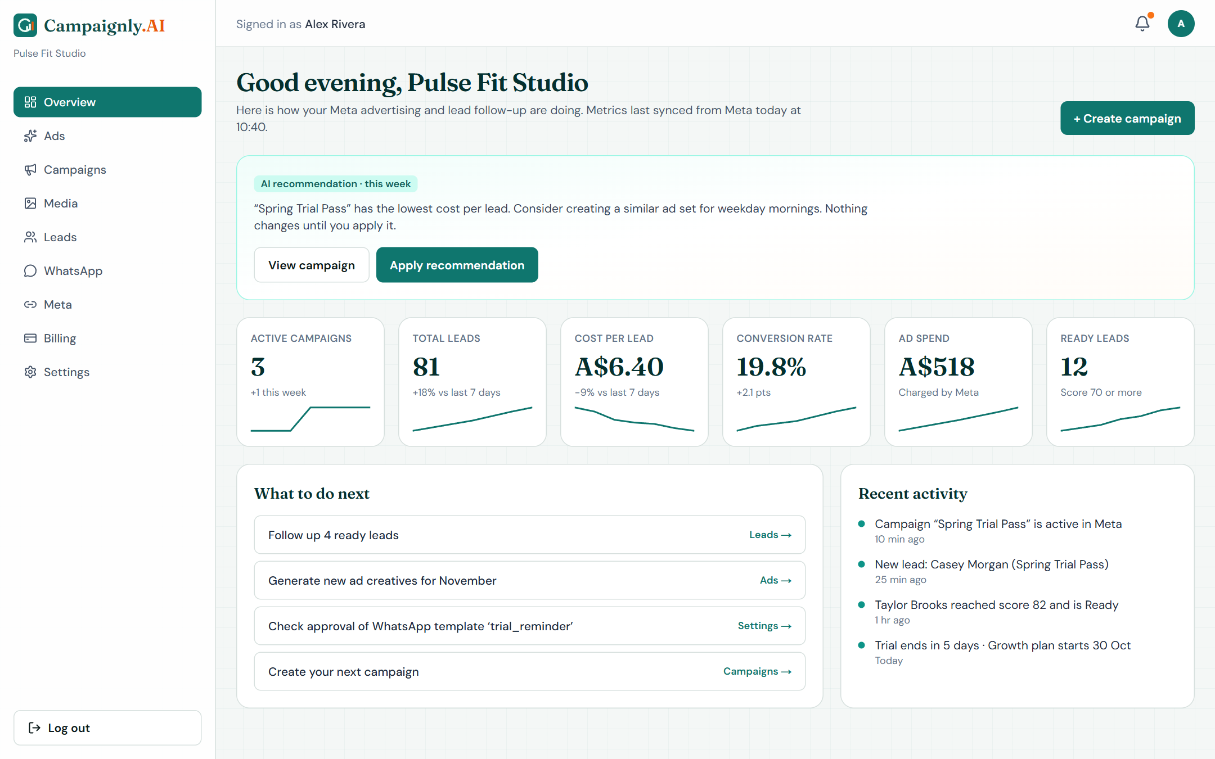
Figure 2.27 Module M10 Authentication and User Management mockup
M10-S03
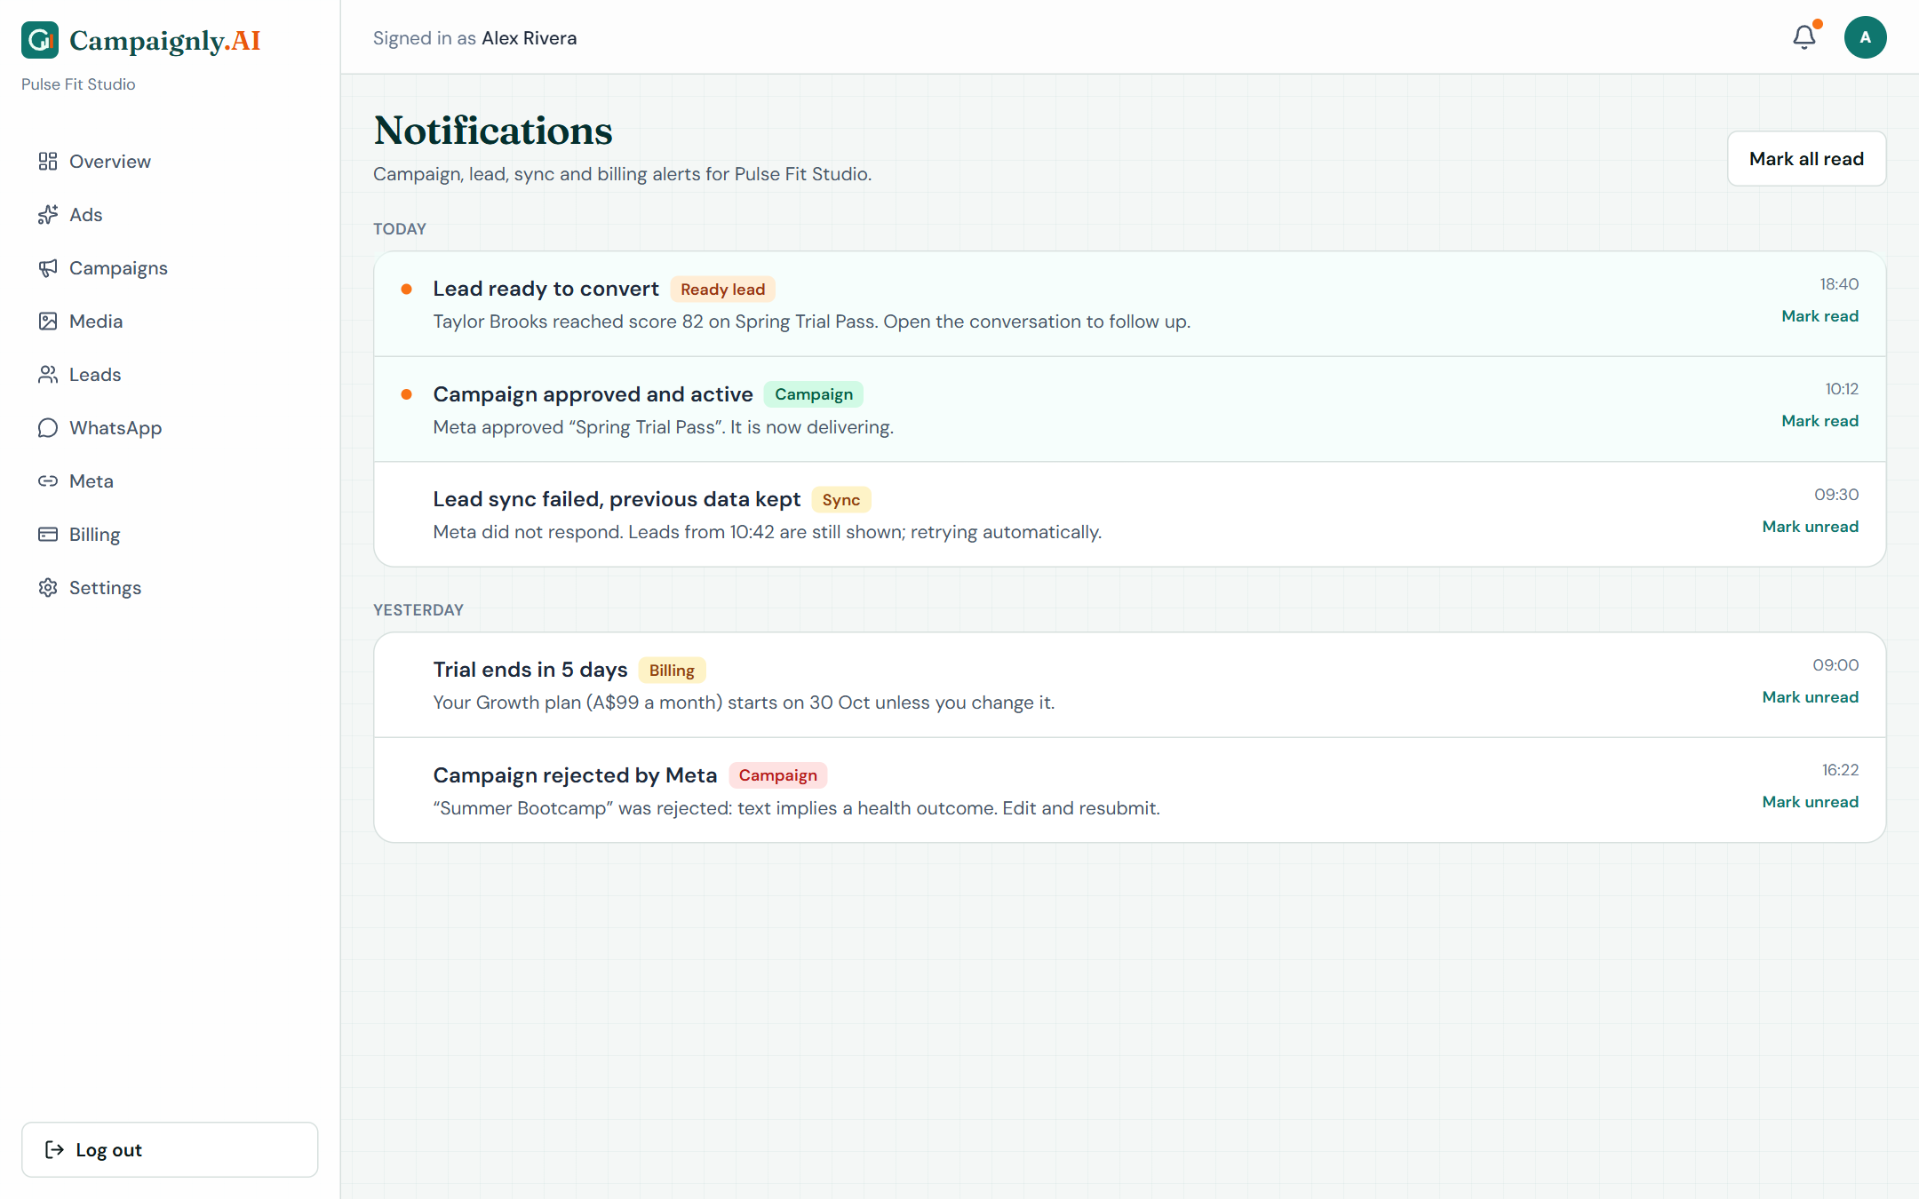
Figure 2.28 Module M10 Authentication and User Management mockup
Table 2.9 records the initiating event, its source and prior state, the nominal response with the resulting state, and the exception boundary for each backend workflow. These event IDs supplement the screen references in the functional requirements, and the Related line names the requirements each event exercises.
Table 2.9 Backend event-response analysis
Event | Trigger | System response | Exception handling
EV-01  Generation requested | Owner selects Generate in M02-S01 or M03-S01  Source: Business user  Before: Brief saved; profile complete | 1. Check subscription status and credits  2. Reserve one credit  3. Retrieve published dataset context  4. Call the AI provider  5. Run readability and policy checks  6. Save the draft version  After: Editable draft saved with check results; credit consumed | On timeout or provider error release the credit, keep the brief and show a retryable error; never publish  Related: FR-008, FR-011, FR-012, FR-014, FR-015, FR-082
EV-02  Media upload or edit completed | Upload finishes or edit job ends  Source: Business user / media processor  Before: Upload in progress or edit queued | 1. Verify type, size and file signature  2. Store the source privately  3. Save the edited output as a new version  4. Update the library  After: New asset or version listed; source unchanged | Reject invalid files with the reason; on processing failure keep the source and mark the job failed  Related: FR-017, FR-018, FR-019, FR-020, FR-021, FR-022, FR-023, FR-024, FR-025
EV-03  Meta OAuth callback received | Meta redirects after consent  Source: Meta Platform  Before: Connection pending with stored state token | 1. Validate state and tenant binding  2. Exchange the code on the server  3. Store the token encrypted  4. Fetch permitted Pages and ad accounts  After: Meta connected; permitted assets selectable | Denied consent or invalid state leaves the account disconnected with a reason; the token never reaches the browser  Related: FR-026, FR-027, FR-036
EV-04  Campaign submit or control request | Owner confirms deploy, pause, activate or stop  Source: Business user  Before: Draft with current Bradley Filter pass, or existing campaign | 1. Recheck entitlement, token, category and inputs  2. Store a request ID  3. Create or update Meta objects  4. Record provider IDs and acknowledgement  After: Campaign shows the requested state or In review; IDs stored | Keep the last known state and show an actionable error; reconcile partial creation using stored IDs before any retry  Related: FR-028, FR-029, FR-030, FR-031, FR-033, FR-086, FR-089
EV-05  Campaign sync due | Scheduled interval reached  Source: Job scheduler  Before: Last good snapshot stored | 1. Queue one job per campaign and interval  2. Fetch status, review reason and metrics  3. Commit the snapshot and sync time  After: Fresh status and metrics with a timestamp | Keep the previous snapshot and record a failure visible to owner and administrator; an expired token sets Reconnect required  Related: FR-031, FR-034, FR-035, FR-064
EV-06  Lead sync due or Refresh selected | Schedule reached or owner selects Refresh in M05-S01  Source: Job scheduler / business user  Before: Last cursor and stored leads | 1. Fetch new lead-form submissions page by page  2. Upsert by tenant and Meta lead ID  3. Encrypt personal fields  4. Preserve owner status and notes  5. Update the last successful sync time  After: New leads listed without duplicates | On partial failure keep the cursor and existing records and do not advance the success time  Related: FR-037, FR-038, FR-039, FR-040
EV-07  Inbound WhatsApp message | Prospect sends a message  Source: WhatsApp Cloud API  Before: Conversation exists or a new lead is identified | 1. Verify the webhook signature  2. Map the number to its tenant  3. Deduplicate the message ID  4. Store the message  5. Open the 24-hour service window  6. Queue a reply job if eligible  After: Message stored; reply queued or owner notified | Invalid signature or unknown number changes nothing and is logged; a duplicate is acknowledged once  Related: FR-049, FR-051, FR-080
EV-08  Outbound nurturing job due | Reply or follow-up job reaches its due time  Source: Job scheduler  Before: Job queued with a unique lead and event key | 1. Recheck opt-in, takeover, Do not contact and subscription  2. Use free-form text inside 24 hours or an approved template outside it  3. Generate a grounded answer  4. Send and store the provider message ID  After: Message sent and shown as Sent | Cancel ineligible jobs with the reason; hold and flag the owner when no template exists; retry transient errors after 1, 5 and 15 minutes; reconcile unknown outcomes before resending  Related: FR-044, FR-045, FR-047, FR-048, FR-052, FR-084
EV-09  Delivery status callback | WhatsApp reports sent, delivered, read or failed  Source: WhatsApp Cloud API  Before: Message with provider ID stored | 1. Verify the callback  2. Deduplicate  3. Apply the status only in forward order  After: Delivery status visible in the thread | Ignore older out-of-order statuses; show the failure reason when delivery fails  Related: FR-042, FR-049, FR-051
EV-10  Lead score updated | Scoring finishes after a message  Source: AI service  Before: Lead scored or unscored | 1. Validate an integer from 0 to 100  2. Store the score and reason  3. Set Ready at 70 or above unless Converted or Do not contact  4. Create one dashboard notification  5. Queue one email  After: Lead marked Ready and owner notified once | Discard out-of-range results; retry a failed email without a second dashboard alert  Related: FR-046, FR-050, FR-085, FR-088
EV-11  Takeover or opt-out | Owner selects Take Over or prospect replies STOP  Source: Business user / WhatsApp prospect  Before: Automation active for the lead | 1. Save the conversation mode or Do not contact first  2. Cancel queued automated jobs  3. Confirm the change in the thread  After: Automation paused for that lead | A message already in flight is shown with its real status; resuming requires owner action and rechecks eligibility  Related: FR-041, FR-048, FR-052
EV-12  Stripe subscription or invoice event | Stripe webhook delivered  Source: Stripe  Before: Subscription trialing, active or past due | 1. Verify the signature on the raw body  2. Deduplicate the event ID  3. Retrieve the authoritative subscription  4. Update status, period and credits  5. Evaluate referral rewards  After: Access matches the verified Stripe state | Reject invalid signatures without change; stale or out-of-order events cannot roll the state back  Related: FR-053, FR-054, FR-055, FR-056, FR-057, FR-083
EV-13  Billing period renews or trial ends | Period boundary in verified Stripe state  Source: Stripe / job scheduler  Before: Credits used in the current period | 1. Reset allowances once per period  2. Set read-only access when a trial ends unpaid  3. Keep the usage ledger  After: New period credits or read-only access | Ignore duplicate renewals using the period key  Related: FR-054, FR-057, FR-082
EV-14  Reminder due | Three days and one day before trial end, or payment failure  Source: Job scheduler  Before: Reminder not yet sent | 1. Check eligibility  2. Send the email and in-app notification  3. Record the reminder key as sent  After: One reminder delivered per key | Retry failed emails; exhausted retries are visible to administrators  Related: FR-059, FR-088
EV-15  Password reset requested or redeemed | Owner submits the reset form or opens the link  Source: Business user  Before: Account may or may not exist | 1. Always return the same acknowledgement  2. Email a single-use link valid for 30 minutes  3. On redemption validate the token, change the password and end other sessions  After: Password changed; other sessions ended | Expired, reused or altered tokens change nothing  Related: FR-074, FR-076, FR-077
EV-16  Session expires or sign-out | 12 hours idle, 7 days absolute, or sign-out  Source: System clock / business user  Before: Session active | 1. Invalidate the session on the server  2. Reject later protected requests  After: User signed out | Keep unsaved form input in the browser where possible  Related: FR-076, FR-079
EV-17  Dataset publication requested | Administrator selects Publish in M08-S02  Source: Administrator  Before: Dataset version In review | 1. Validate records  2. Index the version in the retrieval store  3. Switch the published version after indexing succeeds  After: New version used for later generations | On indexing failure the previous version stays published and the error is shown  Related: FR-014, FR-067
EV-18  User suspended or job retried | Administrator action in M08-S01  Source: Administrator  Before: User active or job failed | 1. Require a reason  2. Write an audit entry  3. Block protected writes for a suspended user  4. Recheck entitlement and idempotency before a retry  After: Audited change applied | Refuse to repeat an external effect that already completed  Related: FR-061, FR-065, FR-079, FR-080
EV-19  Diagnostic or enquiry submitted | Visitor submits M09-S02  Source: Public visitor  Before: No account required | 1. Validate five answers, or name, email and consent  2. Apply rate limiting  3. Return three findings and an objective, or store one enquiry and notify operations  After: Result or acknowledgement shown | Keep entered values on validation errors; ignore a repeat submission within 60 seconds  Related: FR-069, FR-070
EV-20  Referral qualifies | First paid invoice of a referred account  Source: Stripe (through EV-12)  Before: Referral pending | 1. Reject self-referrals and earlier awards  2. Grant the referrer one free month  3. Record the audit entry  After: Referral marked Awarded | Flag refunds or duplicate qualification for administrator review instead of awarding again  Related: FR-054, FR-056, FR-066

2.6 Functional Requirements
This section specifies 89 feature-level functional requirements, FR-001 to FR-089, organised by the modules of Section 1.7. Seventy-eight realise the scope features and eleven were added during Phase 1 baselining; 77 are derived from the mockups and 12 from backend events. Each FR number is the number of the Phase 1 register requirement it confirms .
Each table has three columns. The feature and trace cell names the feature, its scope feature (Mxx FE-yy) or Phase 1 baseline addition, the screen and events that exercise it, and its priority. The requirement cell states the required behaviour and ends with a testable acceptance check, and the rules cell lists the business rules of Table 2.3 that constrain it. Priority Must means required for release acceptance; Should means in scope but deferrable through a recorded scope change. FR-018, FR-019 and FR-022 (video trim, captions and short snippets) are explicitly deferrable to a later release if time is short.

2.6.1 Module M01 Business Onboarding and Brand Setup
Table 2.10 Module M01 functional requirements
Feature and trace | Functional requirement | Rules
Guided onboarding wizard  M01 FE-01  M01-S01  Priority: Must | FR-001: The system shall guide a business user through business identity, offer, audience, tone and location steps; validate each step and show progress.  Acceptance: A valid step advances; an invalid step retains entries and identifies each error. | BR-012
Brand tone  M01 FE-02  M01-S01  Priority: Must | FR-002: The system shall save the selected tone and communication style in the owning business profile for later generation.  Acceptance: A saved tone appears after reload and is supplied to the next generation request. | BR-012
Industry selection  M01 FE-03  M01-S01  Priority: Must | FR-003: The system shall offer Fitness, Ecommerce, Restaurants, Beauty, Real estate, Coaching, Healthcare, Education, Local services and Other; require a description for Other.  Acceptance: Each listed choice saves; Other without a description fails validation. | BR-012
Personalisation profile  M01 FE-04  M01-S01  Priority: Must | FR-004: The system shall persist business onboarding data against the authenticated tenant and use that version for content personalization.  Acceptance: Two businesses generating the same prompt receive their own profile context only. | BR-010  BR-012
Resume onboarding  M01 FE-05  M01-S01  Priority: Must | FR-005: The system shall save completed wizard steps and resume the latest incomplete step after a later sign-in.  Acceptance: After leaving at step three, sign-in restores the previously saved fields and step. | BR-010
Edit brand profile  M01 FE-06  M04-S04  Priority: Must | FR-006: The system shall allow the owner to edit business details, colors, fonts and logo without changing already deployed campaigns.  Acceptance: Reload shows the new profile; existing published campaigns remain unchanged. | BR-009  BR-012
Onboarding suggestions  M01 FE-07  M01-S01  Priority: Should | FR-007: The system shall present industry-based setup recommendations that the user may accept, edit or dismiss.  Acceptance: Dismissing a recommendation does not replace any entered value. | BR-009
Required profile fields  Phase 1 baseline addition  M01-S01  Priority: Must | FR-087: The system shall require business name, industry, offer, audience, tone and resolvable location before completing onboarding.  Acceptance: Submitting any missing required field fails; all valid fields allow completion. | BR-003  BR-012

2.6.2 Module M02 AI Advertisement and Content Generation
Table 2.11 Module M02 functional requirements
Feature and trace | Functional requirement | Rules
Generate ad copy  M02 FE-01  M02-S01 / EV-01  Priority: Must | FR-008: The system shall generate an editable Meta ad draft from the selected brief and saved business profile after an entitlement check.  Acceptance: Success returns editable text; failure preserves the brief; generation never publishes an ad. | BR-002  BR-006  BR-012
Industry templates  M02 FE-02  M02-S02  Priority: Should | FR-009: The system shall allow the user to select an industry template and edit its brief before generation.  Acceptance: Selecting a template populates the brief without changing a saved campaign. | BR-012
Audience settings  M02 FE-03  M02-S01  Priority: Must | FR-010: The system shall accept permitted demographic and audience settings and reject settings incompatible with the chosen special ad category.  Acceptance: Valid settings persist; an incompatible setting blocks submission with an explanation. | BR-001
Readability and compliance scores  M02 FE-04  M02-S01 / EV-01  Priority: Must | FR-011: The system shall return readable copy with detected policy concerns and suggested corrections for review.  Acceptance: Flagged text is identifiable and remains editable; correcting it permits a new check. | BR-002
Ad variations  M02 FE-05  M02-S01 / EV-01  Priority: Should | FR-012: The system shall generate the requested number of distinct copy variations, bounded by remaining copy credits, and let the user select one.  Acceptance: Requesting more than available credits is rejected before work starts; selection is saved. | BR-006
Saved ads  M02 FE-06  M02-S01  Priority: Must | FR-013: The system shall let the owner list, view, rename, edit, save and delete draft ads, with confirmation before deletion.  Acceptance: A saved draft can be reopened; another tenant cannot read or modify it. | BR-010
RAG retrieval  M02 FE-07  EV-01, EV-17  Priority: Must | FR-014: The system shall retrieve relevant approved campaign examples and policy context from Pinecone and associate the dataset version with the generation job.  Acceptance: Only published dataset content is retrieved; retrieval failure returns a visible failure without publishing. | BR-002  BR-012
Bradley Filter check  M02 FE-08  M04-S01 / EV-01  Priority: Must | FR-015: The system shall check the final copy, media and targeting against the configured Meta-rule set before deployment; block a failed check and explain corrections.  Acceptance: A failing check blocks deployment; editing the draft invalidates its prior check result. | BR-002
Campaign recommendations  M02 FE-09  M10-S02  Priority: Should | FR-016: The system shall display suggested campaign improvements with a reason and require the owner to apply any change explicitly.  Acceptance: A recommendation alone cannot publish, pause, change a budget or start an experiment. | BR-004  BR-009
Image and video generation  Phase 1 baseline addition  M02-S01 / EV-01, EV-13  Priority: Must | FR-082: The system shall generate image or video drafts only when the package permits the media type and sufficient credits remain.  Acceptance: Starter cannot generate images or videos; Growth with credits can create a media draft. | BR-006

2.6.3 Module M03 AI Media Editing and Creative Automation
Table 2.12 Module M03 functional requirements
Feature and trace | Functional requirement | Rules
Media upload  M03 FE-01  M03-S01 / EV-02  Priority: Must | FR-017: The system shall accept JPG or PNG up to 30 MB and MP4 or MOV up to 250 MB, validate content and show upload progress and errors.  Acceptance: A valid boundary-size file is accepted; an oversized, unsupported or disguised file is rejected. | BR-010
Video trim  M03 FE-02  M03-S01 / EV-02  Priority: Should, deferrable | FR-018: The system shall produce an edited video from user-selected trim instructions while retaining the original.  Acceptance: A valid trim creates a new version; start time at or after end time is rejected. | BR-010
Captions and subtitles  M03 FE-03  M03-S01 / EV-02  Priority: Should, deferrable | FR-019: The system shall generate editable captions or subtitles for a selected video and preview the timing before saving.  Acceptance: The owner can correct text and timing; export/save retains the corrected subtitle version. | BR-010
Placement resizing  M03 FE-04  M03-S01 / EV-02  Priority: Should | FR-020: The system shall resize a media derivative for a selected Facebook or Instagram placement and preview cropping.  Acceptance: Changing placement updates the preview; the source file remains intact. | BR-001
Brand application  M03 FE-05  M03-S01 / EV-02  Priority: Should | FR-021: The system shall apply the saved or selected logo, font and colors to a derivative with a preview before saving.  Acceptance: Saved output reflects the chosen branding while the original remains available. | BR-012
Short snippets  M03 FE-06  M03-S01 / EV-02  Priority: Should, deferrable | FR-022: The system shall create a promotional snippet from a chosen source segment and allow preview and save as a derivative.  Acceptance: An invalid time range is rejected; a valid snippet is separately listed in the library. | BR-010
Media library  M03 FE-07  M03-S01 / EV-02  Priority: Must | FR-023: The system shall list, search, preview, rename and delete owned uploaded/generated assets; block removal while an asset is referenced by a deployable draft.  Acceptance: A referenced asset shows its dependency; an unreferenced asset is removed after confirmation. | BR-010
Image enhancement  M03 FE-08  M03-S01 / EV-02  Priority: Should | FR-024: The system shall offer image enhancement as a previewable derivative that the user may accept or discard.  Acceptance: Discarding an enhancement keeps the source unchanged; accepting saves a new version. | BR-010
Manual media changes  M03 FE-09  M03-S01 / EV-02  Priority: Should | FR-025: The system shall let the user adjust AI media output and save the accepted revision before it is attached to an ad.  Acceptance: The campaign preview shows the saved revision, not a discarded edit. | BR-002  BR-010

2.6.4 Module M04 Meta Campaign Automation
Table 2.13 Module M04 functional requirements
Feature and trace | Functional requirement | Rules
Connect Meta account  M04 FE-01  M04-S01 / EV-03  Priority: Must | FR-026: The system shall initiate Meta OAuth, validate the callback state, and store the resulting connection for the owning tenant.  Acceptance: Success shows connection status; denial or invalid state leaves the account disconnected. | BR-005  BR-010
Page and ad account selection  M04 FE-02  M04-S01 / EV-03  Priority: Must | FR-027: The system shall list and select only Pages and ad accounts returned for the connected Meta identity.  Acceptance: A forged Page or account identifier is rejected server-side. | BR-005  BR-010
Campaign objective, budget and schedule  M04 FE-03  M04-S01 / EV-04  Priority: Must | FR-028: The system shall collect a name, one of six objectives, budget, schedule, targeting and objective-specific assets; review and confirm before creating the campaign through Meta.  Acceptance: Daily is the default; lifetime requires an end date; invalid prerequisites block deployment. | BR-001  BR-003  BR-005  BR-006
Attach media and copy  M04 FE-04  M04-S01 / EV-04  Priority: Must | FR-029: The system shall attach an owned compatible media revision and ad copy to the reviewed campaign payload.  Acceptance: An asset from another tenant or incompatible placement is rejected before the Meta request. | BR-001  BR-010
Location targeting  M04 FE-05  M04-S01 / EV-04  Priority: Must | FR-030: The system shall resolve location or postcode through a geocoder, show the resolved location and permitted radius, and require user confirmation.  Acceptance: An unresolved or ambiguous location blocks deploy until resolved and confirmed. | BR-003
Campaign lifecycle status  M04 FE-06  M04-S02 / EV-04, EV-05  Priority: Must | FR-031: The system shall show the last known Meta lifecycle status, review/rejection reason where supplied, and last synchronization time separately from local draft/job status.  Acceptance: A Meta rejection is shown as rejected even when the internal policy check passed. | BR-002
Duplicate to draft  M04 FE-07  M04-S02  Priority: Should | FR-032: The system shall copy a selected campaign or ad into a new editable local draft without publishing it or reusing its external campaign identifier.  Acceptance: Duplication creates a new draft ID and no Meta write. | BR-009  BR-010
Pause, activate and stop  M04 FE-08  M04-S02 / EV-04  Priority: Must | FR-033: The system shall allow the owner to request pause, activation or stop, confirm the target and show success only after provider acknowledgement.  Acceptance: A failed request leaves the last known status and shows an actionable error. | BR-005  BR-006
Campaign metrics  M04 FE-09  M04-S03 / EV-05  Priority: Must | FR-034: The system shall retrieve and display impressions, clicks and provider-reported conversions for the selected campaign and date range.  Acceptance: Unavailable values show unavailable rather than zero; all displayed totals match the returned fixture. | BR-010
Automatic campaign sync  M04 FE-10  EV-05  Priority: Must | FR-035: The system shall schedule campaign synchronization and update the last successful snapshot only after a successful provider response.  Acceptance: A failed sync leaves the previous metrics intact and records a visible failure. | BR-005
Reconnect and disconnect Meta  Phase 1 baseline addition  M04-S04 / EV-03  Priority: Must | FR-036: The system shall let the owner reconnect an expired Meta connection or disconnect it with an explanation that existing Meta ads may continue running.  Acceptance: Disconnect clears usable local credentials and disables future Meta writes until reconnect. | BR-005
Special ad category  Phase 1 baseline addition  M04-S01 / EV-04  Priority: Must | FR-086: The system shall require housing, employment or credit declarations when applicable, constrain targeting accordingly and reject political-ad deployment.  Acceptance: A housing campaign cannot bypass category restrictions; political content cannot deploy. | BR-001  BR-002
Placement preview  Phase 1 baseline addition  M04-S01 / EV-04  Priority: Should | FR-089: The system shall show a preview of the selected ad copy and media for each chosen Facebook and Instagram placement before the campaign is submitted.  Acceptance: Switching placement updates the preview without changing the saved draft; a creative that exceeds a placement limit is flagged. | BR-001  BR-002

2.6.5 Module M05 Lead Management
Table 2.14 Module M05 functional requirements
Feature and trace | Functional requirement | Rules
Lead synchronisation  M05 FE-01  EV-06  Priority: Must | FR-037: The system shall retrieve permitted lead-form submissions and upsert them by tenant and Meta lead identifier.  Acceptance: Processing the same lead twice produces one lead; existing owner annotations survive refresh. | BR-008  BR-010
Manual lead refresh  M05 FE-02  M05-S01 / EV-06  Priority: Must | FR-038: The system shall let the owner request a lead refresh, show progress and display the last successful synchronization timestamp.  Acceptance: A failed refresh shows an error and does not advance the success timestamp. | BR-005
Protect lead records  M05 FE-03  EV-06  Priority: Must | FR-039: The system shall protect lead personal data and conversation content at rest and restrict decryption to authorized processing.  Acceptance: Stored fixture values are not plaintext; an unauthorized read reveals no lead fields. | BR-008  BR-010
Lead details  M05 FE-04  M05-S02 / EV-06  Priority: Must | FR-040: The system shall show available lead fields, originating campaign, source and timestamps to the owning business only.  Acceptance: Missing provider fields remain blank or marked unavailable and are never fabricated. | BR-008  BR-010
Lead search, filter and status  M05 FE-05  M05-S01 / EV-11  Priority: Must | FR-041: The system shall search owned leads and filter by campaign and status; support New, Contacted, Ready, Converted and Do not contact.  Acceptance: Changing to Do not contact suppresses future nurturing; filters return only matching owned leads. | BR-008  BR-011
Engagement history  M05 FE-06  M05-S02 / EV-09  Priority: Should | FR-042: The system shall display a chronological timeline of received/sent messages, status changes and readiness notifications for a lead.  Acceptance: Each recorded activity has its type and timestamp and is ordered consistently. | BR-008
Conversion analytics  M05 FE-07  M05-S03  Priority: Must | FR-043: The system shall show campaign lead counts and owner-marked Converted counts separately from Meta-reported conversions.  Acceptance: For 2 converted of 10 leads, the local lead conversion rate is 20%; zero leads yields unavailable. | BR-010

2.6.6 Module M06 AI WhatsApp Lead Nurturing
Table 2.15 Module M06 functional requirements
Feature and trace | Functional requirement | Rules
Automated follow-up  M06 FE-01  M06-S01 / EV-08  Priority: Must | FR-044: The system shall send follow-up only for a connected number, valid entitlement, recorded opt-in and an eligible lead not under manual takeover.  Acceptance: A missing opt-in or Do not contact state prevents any outbound call. | BR-006  BR-011
Answer enquiries  M06 FE-02  M06-S01 / EV-08  Priority: Must | FR-045: The system shall generate answers using the owning business offer and profile; route unsupported enquiries to human review.  Acceptance: A known offer question receives a grounded draft/answer; unknown claims are not invented. | BR-011  BR-012
Lead intent score  M06 FE-03  M06-S01 / EV-10  Priority: Must | FR-046: The system shall derive an integer intent/sentiment score from 0 to 100 with an explanation and timestamp from conversation evidence.  Acceptance: Out-of-range output is rejected; insufficient evidence is marked unscored. | BR-008
Follow-up timing and escalation  M06 FE-04  EV-08  Priority: Must | FR-047: The system shall apply the configured follow-up schedule and escalation conditions; outside the 24-hour customer-service window use an approved template only.  Acceptance: A due follow-up with no eligible template is withheld and shows an action required. | BR-011
Conversation jobs  M06 FE-05  EV-08, EV-11  Priority: Must | FR-048: The system shall queue nurturing jobs with a unique lead/event key and recheck eligibility immediately before sending.  Acceptance: A duplicated job or takeover occurring while queued cannot cause an extra autonomous reply. | BR-006  BR-011
Inbound WhatsApp webhook  M06 FE-06  EV-07, EV-09  Priority: Must | FR-049: The system shall verify inbound WhatsApp events, map the sender to the owning business conversation and deduplicate provider message IDs.  Acceptance: Invalid signatures cause no mutation; duplicate valid events create one message. | BR-008  BR-010
Ready-lead notification  M06 FE-07  M10-S03 / EV-10  Priority: Must | FR-050: The system shall create an owner notification when a lead first becomes conversion-ready and link it to the lead detail.  Acceptance: The correct tenant receives one readiness notification for the lead. | BR-008
Conversation record  M06 FE-08  M06-S01 / EV-07, EV-09  Priority: Must | FR-051: The system shall persist message direction, provider ID, delivery state, time, score history and takeover state securely.  Acceptance: Reload reproduces the saved conversation in order without exposing another tenant's history. | BR-008  BR-010
Manual takeover  M06 FE-09  M06-S01 / EV-08, EV-11  Priority: Must | FR-052: The system shall allow the owner to take control, suppress queued/autonomous replies and explicitly resume automation later.  Acceptance: After takeover, simulated inbound messages do not trigger AI sends; resume rechecks all eligibility rules. | BR-011
WhatsApp business number  Phase 1 baseline addition  M04-S04 / EV-08  Priority: Must | FR-084: The system shall guide connection of the business WhatsApp number, allow a new business number as fallback and show connection/template readiness.  Acceptance: An unconnected or invalid number cannot send; a verified connection is shown to its owner. | BR-010  BR-011
Ready threshold  Phase 1 baseline addition  EV-10  Priority: Must | FR-085: The system shall mark a scored lead Ready at 70 or above unless Converted or Do not contact, and notify dashboard plus email once per lead.  Acceptance: Scores 69 and 70 exercise the boundary; reprocessing 70 does not send another readiness email. | BR-008  BR-011

2.6.7 Module M07 Subscription and Billing
Table 2.16 Module M07 functional requirements
Feature and trace | Functional requirement | Rules
Stripe Checkout  M07 FE-01  M07-S01 / EV-12  Priority: Must | FR-053: The system shall create a Stripe Checkout session for the authenticated tenant and selected catalog plan and interval.  Acceptance: The client cannot substitute a price; the return page shows pending until verified billing state arrives. | BR-006  BR-007
Card-backed free trial  M07 FE-02  M07-S01 / EV-12, EV-13, EV-20  Priority: Must | FR-054: The system shall offer a 14-day free trial with a card and display the renewal date and selected post-trial price before checkout.  Acceptance: An eligible account receives trial dates and Trial credits; incomplete checkout grants no entitlement. | BR-006  BR-007
Billing portal  M07 FE-03  M07-S01 / EV-12  Priority: Must | FR-055: The system shall open a Stripe billing portal session for the owner to manage payment method, plan and cancellation.  Acceptance: A tenant cannot open another tenant's portal; cancellation timing follows verified Stripe state. | BR-006
Verified billing webhooks  M07 FE-04  EV-12, EV-20  Priority: Must | FR-056: The system shall verify Stripe signatures, deduplicate event IDs and reconcile subscription status before changing access.  Acceptance: Invalid or repeated events create no extra entitlement or reward; stale events cannot roll state backward. | BR-006
Feature access by subscription status  M07 FE-05  M07-S01 / EV-12, EV-13  Priority: Must | FR-057: The system shall enforce the subscription access matrix and package limits on both API operations and queued work.  Acceptance: Past-due, canceled, unpaid and ended-trial accounts can view data but cannot generate, deploy/change or send. | BR-006
Plan display  M07 FE-06  M07-S02  Priority: Must | FR-058: The system shall display Trial, Starter, Growth and Pro with monthly/annual prices, credits, campaign limits and renewal information.  Acceptance: The displayed selected price and interval match the server-selected Checkout catalog entry. | BR-007
Billing and trial reminders  M07 FE-07  EV-14  Priority: Should | FR-059: The system shall notify the owner of trial expiry and billing issues using deduplicated scheduled reminders.  Acceptance: Each configured reminder is delivered once; a failure is visible to operations for retry. | BR-006
Australian plan catalogue  Phase 1 baseline addition  M07-S01 / EV-12  Priority: Must | FR-083: The system shall use AUD GST-inclusive subscription prices and annual charges equal to ten monthly charges, distinct from Meta ad-spend currency.  Acceptance: Starter shows A$49/month or A$490/year; Meta budget remains in the selected ad account currency. | BR-007

2.6.8 Module M08 Admin Dashboard and Platform Operations
Table 2.17 Module M08 functional requirements
Feature and trace | Functional requirement | Rules
Administrator access  M08 FE-01  M08-S01  Priority: Must | FR-060: The system shall restrict the administration area and APIs to an authenticated administrator.  Acceptance: A business account receives access denied and no operational data. | BR-010
User operations  M08 FE-02  M08-S01 / EV-18  Priority: Must | FR-061: The system shall let an administrator find users, inspect billing status and suspend/reactivate platform access, recording actor, reason and time.  Acceptance: Suspension blocks privileged operations; it does not fabricate a Stripe payment or expose lead PII. | BR-006  BR-008
Aggregate analytics  M08 FE-03  M08-S01  Priority: Must | FR-062: The system shall display platform user, campaign and subscription aggregates without lead personal data or transcripts.  Acceptance: Aggregate fixtures reconcile with eligible records and contain no prospect contact details. | BR-008
AI usage monitoring  M08 FE-04  M08-S01  Priority: Must | FR-063: The system shall show generation counts, credit consumption and failures by period and tenant without conversation content.  Acceptance: Repeated job processing does not double-count successful generation usage. | BR-008
Meta integration health  M08 FE-05  M08-S01 / EV-05  Priority: Must | FR-064: The system shall show connection validity, recent sync failures and provider error summaries without exposing tokens.  Acceptance: An expired token appears as reconnect required and the token value is absent. | BR-005
Job queue operations  M08 FE-06  M08-S01 / EV-18  Priority: Must | FR-065: The system shall list job status and sanitized failures, and allow an authorized retry of failed jobs with an audit entry.  Acceptance: Retry rechecks current entitlement and idempotency; a completed send is not repeated. | BR-006  BR-011
Referral management  M08 FE-07  M08-S02 / EV-20  Priority: Should | FR-066: The system shall let administrators manage and track referrals; grant a referred trial 14 extra days and reward the referrer one month after the first paid invoice.  Acceptance: A duplicate paid-invoice event cannot award a second reward; self-referrals are rejected. | BR-006  BR-007
Retrieval dataset management  M08 FE-08  M08-S02 / EV-17  Priority: Must | FR-067: The system shall allow authorized upload, review, versioning, publication and retirement of policy/examples used for retrieval.  Acceptance: Only a published version is searchable; retired content is excluded from new generation jobs. | BR-002  BR-008

2.6.9 Module M09 Marketing Website and Customer Acquisition
Table 2.18 Module M09 functional requirements
Feature and trace | Functional requirement | Rules
Public landing page  M09 FE-01  M09-S01  Priority: Must | FR-068: The system shall let a visitor view product capabilities, pricing and registration links without authentication.  Acceptance: Each plan CTA opens the matching registration/plan path and no private data is present. | BR-007
Campaign diagnostic  M09 FE-02  M09-S02 / EV-19  Priority: Must | FR-069: The system shall collect five diagnostic answers and return three findings and one suggested objective without publishing a campaign.  Acceptance: Incomplete answers show validation; a completed set yields exactly three findings and one objective. | BR-009
Enquiry form  M09 FE-03  M09-S02 / EV-19  Priority: Must | FR-070: The system shall capture a visitor's name, email, enquiry and consent; validate input, prevent duplicate submissions and make the enquiry available to operations.  Acceptance: Invalid email is rejected; successful submission shows acknowledgement and one enquiry record. | BR-008
Proof content  M09 FE-04  M09-S01  Priority: Should | FR-071: The system shall display approved testimonials, portfolio items and case studies with their attribution.  Acceptance: Unpublished material is absent; displayed outcomes are attributed and not presented as guaranteed results. | BR-002
Information and legal pages  M09 FE-05  M09-S01  Priority: Must | FR-072: The system shall provide About, Contact, Privacy and Terms pages linked from public navigation/footer.  Acceptance: Each page is reachable without sign-in and shows its applicable content/version. | BR-008
Educational blog  M09 FE-06  M09-S01  Priority: Should | FR-073: The system shall display published educational articles with titles, dates, readable URLs and metadata.  Acceptance: A published article opens directly; an unpublished article is not publicly retrievable. | BR-001

2.6.10 Module M10 Authentication and User Management
Table 2.19 Module M10 functional requirements
Feature and trace | Functional requirement | Rules
Email registration and sign-in  M10 FE-01  M10-S01 / EV-15  Priority: Must | FR-074: The system shall register and sign in users with email and a password of at least 15 characters without a composition rule; reject duplicate accounts safely.  Acceptance: A 14-character password fails; a valid 15-character password may pass; bad credentials reveal no account details. | BR-010
Google sign-in  M10 FE-02  M10-S01  Priority: Must | FR-075: The system shall authenticate through Google OIDC, validate callback state and identity, and safely resolve an existing account.  Acceptance: An invalid callback is rejected; matching email alone cannot silently link an unverified identity. | BR-010
Session control and sign-out  M10 FE-03  M04-S04 / EV-15, EV-16  Priority: Must | FR-076: The system shall expire sessions after 12 hours idle or 7 days absolute and invalidate the session on sign-out.  Acceptance: Requests after either boundary or sign-out are rejected even if a client retains an old token. | BR-010
Password reset  M10 FE-04  M10-S01 / EV-15  Priority: Must | FR-077: The system shall issue an expiring one-time reset link by email with a generic acknowledgement and invalidate it after use.  Acceptance: Reusing or altering the token fails; the new password must meet FR-074. | BR-010
Account settings  M10 FE-05  M04-S04  Priority: Must | FR-078: The system shall let the owner update profile and credentials after required identity checks, show validation and confirm persistence.  Acceptance: Invalid fields do not overwrite saved values; sensitive changes require reauthentication. | BR-010
Role permissions  M10 FE-06  EV-16, EV-18  Priority: Must | FR-079: The system shall enforce visitor, business-user and administrator privileges at every protected route and API.  Acceptance: A business user calling an admin endpoint is denied even if the control is hidden in the browser. | BR-008  BR-010
Tenant isolation  Phase 1 baseline addition  EV-07, EV-18  Priority: Must | FR-080: The system shall derive tenant context from the authenticated session and check ownership for records, files, jobs and callbacks.  Acceptance: Changing a submitted tenant or record ID yields no access to another business's data. | BR-010
Overview summary  Phase 1 baseline addition  M10-S02  Priority: Must | FR-081: The system shall show owned campaign summary, leads, credit balance, subscription state, connection status and recent alerts with clear empty/error states.  Acceptance: A new tenant sees setup actions; an existing tenant sees only its own totals and timestamps. | BR-006  BR-010
Notification centre  Phase 1 baseline addition  M10-S03 / EV-10, EV-14  Priority: Must | FR-088: The system shall list in-app notifications for campaign status changes, ready leads, sync failures and billing reminders, let the owner mark them read individually or all together, and link each notification to its source record.  Acceptance: Each notification opens its linked record; marking all read clears the unread count without deleting history. | BR-008  BR-010

2.6.11 Requirements Traceability
Table 2.20 Objective to requirement traceability
Objective | Functional requirements | Use cases
BO-1 | FR-001, FR-005, FR-087, FR-008, FR-026, FR-028 | UC02, UC03, UC05
BO-2 | FR-008, FR-011, FR-012, FR-015, FR-082 | UC03
BO-3 | FR-026, FR-027, FR-028, FR-029, FR-030, FR-033, FR-086, FR-089 | UC05, UC06
BO-4 | FR-037, FR-039, FR-040, FR-041, FR-080 | UC01, UC07
BO-5 | FR-053, FR-054, FR-056, FR-058, FR-083 | UC10
BO-6 | FR-031, FR-034, FR-035, FR-043, FR-081, FR-088 | UC06, UC07, UC08, UC14
BO-7 | FR-060, FR-061, FR-062, FR-063, FR-064, FR-065 | UC11
BO-8 | FR-014, FR-015, FR-067 | UC03, UC12
BO-9 | FR-044, FR-046, FR-050, FR-052, FR-084, FR-085 | UC08, UC09

2.7 Non Functional Requirements
The quality requirements below are specific and verifiable. Each states a measurable target, why the target was chosen and how the architecture supports it; the baseline NFR identifier from the Phase 1 register is given where one exists . Targets are acceptance criteria for testing, not measured results. Performance tests use the agreed fixture of 10 tenants, each with 100 campaigns and 1,000 leads, and 20 concurrent signed-in sessions.
The architecture is layered: Next.js pages call authenticated Next.js API route handlers; the handlers apply validation, role and tenant checks and subscription entitlement, store data through Prisma with a tenant key on every row, and places slow work on background jobs; provider adapters isolate Meta, WhatsApp, Stripe and AI services; and workers recheck eligibility before every external action. Maintainability (Phase 1 register NFR-14) is addressed by constraint CON-009. Each requirement below states its measure, followed by its justification and architectural support.

2.7.1 Reliability
Table 2.21 Reliability acceptance requirements
ID | Requirement
NFR-REL-001 | In a fault-injection suite of 30 failed sync and AI jobs, 100% keep the last successful data and show a failure to the owner and administrator within 1 minute.  Justification: Provider failures are expected; correct older data is safer than empty screens.  Architectural support: Snapshots are committed only after a successful provider response; job state is persisted.  Phase 1 register: NFR-10
NFR-REL-002 | During a 10-minute simulated outage of each provider, no stored lead, draft, media or campaign record is lost, and every pending action reaches success, failure or retry within 15 minutes of recovery.  Justification: External availability is outside the system's control.  Architectural support: Adapters isolate providers; bounded retries after 1, 5 and 15 minutes; reconciliation by stored IDs.  Phase 1 register: NFR-11
NFR-REL-003 | Replaying every webhook and job fixture 10 times produces exactly one lead, message, entitlement change or referral reward (zero duplicates).  Justification: Meta, WhatsApp and Stripe may deliver events more than once .  Architectural support: Unique constraints on tenant and provider event IDs; idempotency keys on jobs.
NFR-REL-004 | Mean time between failures of at least 720 hours over the first 90 days after release, where a failure is any period over 5 minutes in which signed-in users cannot load the Overview.  Justification: Owners check leads daily; one failure a month is the tolerable ceiling for a small-business SaaS.  Architectural support: Managed hosting and database, health checks and container restart on failure.
NFR-REL-005 | Monthly availability of the user dashboard and API of at least 99.5%, excluding announced maintenance under 2 hours per month.  Justification: Allows about 3.6 hours of downtime a month while keeping the service dependable for daily use.  Architectural support: Stateless API containers behind the host load balancer; uptime monitoring with alerts.

2.7.2 Usability
Table 2.22 Usability acceptance requirements
ID | Requirement
NFR-USE-001 | At least 4 of 5 first-time participants without marketing training complete onboarding and reach a reviewable ad draft within 15 minutes, without Ads Manager or help.  Justification: The target user is a non-specialist owner.  Architectural support: Guided wizard (M01-S01), saved progress, field-level validation and AI tips.  Phase 1 register: NFR-07
NFR-USE-002 | From any dashboard page, every primary module is reachable in one click.  Justification: Frequent tasks must be fast to reach.  Architectural support: Persistent sidebar navigation (M10-S02).
NFR-USE-003 | Every external operation shows a pending state within 1 second and a final success or failure state; no progress indicator lasts longer than 30 seconds without an explanation.  Justification: Owners must distinguish accepted work from completed work.  Architectural support: Job IDs with status polling; explicit provider timeouts.  Phase 1 register: NFR-08
NFR-USE-004 | The release meets WCAG 2.2 Level AA: zero critical automated violations, keyboard-only completion of M01, M02, M04 and M07, and text contrast of at least 4.5:1.  Justification: Accessibility is required for all users .  Architectural support: Shared accessible components with labels, focus rings and the teal colour palette.  Phase 1 register: NFR-09
NFR-USE-005 | In all 21 forms, validation errors name the field and the correction and keep the values already entered.  Justification: Error recovery must not cost the user their work.  Architectural support: Client and server validation with the same Zod schemas.
NFR-USE-006 | 100% of screens that show a Bradley Filter result label it as an internal check, separate from the Meta review status.  Justification: Users must not mistake an internal pass for Meta approval.  Architectural support: Separate policy-check and Meta-status fields (M02-S01, M04-S01, M04-S02).  Phase 1 register: NFR-16

2.7.3 Performance
Table 2.23 Performance acceptance requirements
ID | Requirement
NFR-PER-001 | 95% of dashboard pages show usable content within 4 seconds of the request over a 20 Mbps or faster connection, with the agreed fixture.  Justification: Baseline target; keeps routine checks quick.  Architectural support: Paginated queries, tenant indexes and cached snapshots instead of live provider calls.
NFR-PER-002 | 95% of API read requests complete within 500 ms at 20 concurrent sessions.  Justification: Leaves most of the NFR-PER-001 budget for rendering.  Architectural support: Indexed reads by tenant, 50-row pages and no provider calls on read paths.
NFR-PER-003 | 95% of ad copy requests return a draft within 30 seconds; 100% return a draft or a visible failure by 30 seconds.  Justification: Generation is slower than page loads but must end predictably.  Architectural support: Asynchronous generation job with a 30-second provider timeout.
NFR-PER-004 | 99% of lead sync jobs start within 2 minutes of their due time.  Justification: Leads should reach the assistant while they are fresh.  Architectural support: Dedicated job workers with due-time metrics and backlog alerts.
NFR-PER-005 | 99% of inbound WhatsApp and Stripe webhooks are acknowledged within 2 seconds.  Justification: Providers retry slow webhooks, causing duplicates.  Architectural support: Verify, store durably, acknowledge, then process on a job.
NFR-PER-006 | 95% of eligible inbound WhatsApp messages receive an AI reply within 60 seconds.  Justification: A fast first reply keeps the lead engaged.  Architectural support: Reply job queued on receipt; streaming model calls with timeout.

2.7.4 Security
Table 2.24 Security acceptance requirements
ID | Requirement
NFR-SEC-001 | No lead personal data or conversation text appears in plaintext in database, storage or backup samples.  Justification: Lead data is personal information.  Architectural support: Field-level encryption with server-held keys; encrypted backups.  Phase 1 register: NFR-01
NFR-SEC-002 | All browser, API and webhook traffic uses HTTPS with TLS 1.2 or later; plain HTTP requests are redirected or refused.  Justification: Protects data in transit.  Architectural support: TLS termination at the hosting provider; HSTS.  Phase 1 register: NFR-02
NFR-SEC-003 | In a two-tenant test suite covering every protected endpoint, file and job, zero records of one tenant are read or changed by the other.  Justification: Broken access control is the top web risk .  Architectural support: Tenant derived from the session; every Prisma query is filtered by the owning account.  Phase 1 register: NFR-03
NFR-SEC-004 | Webhooks with an invalid or missing Stripe or WhatsApp signature cause zero business-state changes.  Justification: Callbacks are untrusted input.  Architectural support: Signature verification on the raw body before any processing.  Phase 1 register: NFR-04
NFR-SEC-005 | A scan of browser bundles, API responses and logs finds zero provider secrets or access tokens.  Justification: Browsers and logs are not secret stores.  Architectural support: Server-only configuration (CON-008) and log redaction.  Phase 1 register: NFR-05
NFR-SEC-006 | Sessions are rejected after 12 hours idle, 7 days absolute, and immediately after sign-out.  Justification: Limits misuse of unattended or stolen sessions .  Architectural support: Server-side session records checked on every request.  Phase 1 register: NFR-06
NFR-SEC-007 | Administrator views expose zero lead contact details or transcripts, and missing lead fields are never fabricated.  Justification: Least privilege for operators.  Architectural support: Separate sanitised admin queries and role checks.  Phase 1 register: NFR-15
NFR-SEC-008 | An OWASP ZAP baseline scan before release reports zero high-risk findings.  Justification: Independent check against common web vulnerabilities .  Architectural support: Input validation, output encoding and security headers.
NFR-SEC-009 | After 10 failed sign-in attempts for one account within 15 minutes, further attempts are delayed for 15 minutes.  Justification: Slows password guessing while keeping lockouts short .  Architectural support: Attempt counter per account and IP address.

2.8 External Interface Requirements
This section defines how Campaignly.AI communicates with its users and with external software and hardware.

2.8.1 User Interfaces
Table 2.25 User interface requirements
ID | Interface | Required interaction
UI-001 | Design system | All screens shall follow the Campaignly design system shown in the mockups: DM Sans body text, Fraunces display headings, primary teal #0F766E, orange accent #EA580C, success #15803D, warning #B45309, danger #B91C1C, surface #F4F7F6, rounded cards and the Campaignly.AI logo mark.
UI-002 | Dashboard navigation | Every dashboard screen shall show the left sidebar (Overview, Ads, Campaigns, Media, Leads, WhatsApp, Meta, Billing, Settings, Log out) with the business name under the logo, and a top bar with the signed-in user, the notifications bell and the profile avatar. On screens narrower than 768 pixels the sidebar is replaced by a scrollable row of navigation pills.
UI-003 | Administrator dashboard | The administrator dashboard shall be visually separate, with its own sidebar (Operations, Owner view) and tabs (M08-S01, M08-S02), and shall not show lead personal data.
UI-004 | Status badges | Status shall be shown by labelled badges (for example Active, Paused, In review, Ready, Do not contact) and never by colour alone.
UI-005 | Messages and notices | Messages shall follow one convention: inline field errors in red under the field, success and warning notices as coloured left-border banners, and toast confirmations for completed actions.
UI-006 | Buttons and confirmations | Buttons shall use verb labels (Generate ad variations, Confirm and submit to Meta, Take over conversation); destructive or external actions (disconnect, stop campaign, submit to Meta, delete media) shall require confirmation.
UI-007 | Currency, units and dates | Currency and units shall always be labelled: AUD for subscriptions and the ad-account currency for budgets and spend; dates shall use the user's time zone.
UI-008 | Keyboard behaviour | Pressing Enter shall submit the active form, Escape shall close dialogs and return focus to the control that opened them, and all controls shall be reachable with the Tab key in visual order.
UI-009 | Localisation | Screen text shall be stored outside the components so that the interface can be localised later; Phase 1 ships in English.

2.8.2 Software Interfaces
Table 2.26 defines the logical responsibilities of each external software interface. The selected providers are those of Table 1.3.
Table 2.26 Software interface requirements
ID | Interface | Required interaction
SI-001 | Meta Marketing API and Lead Ads (Graph API v18 or later) | The system shall create, update, pause, activate and stop campaigns, ad sets and ads and read their status, review feedback and insights.  The system shall retrieve lead-form submissions for permitted Pages and forms and shall request only the permissions it uses.
SI-002 | WhatsApp Cloud API | The system shall send text and approved template messages from the connected business number and receive inbound messages and delivery statuses by verified webhook.
SI-003 | Stripe Checkout, Billing and Customer Portal | The system shall create Checkout and portal sessions from server-side price IDs and receive subscription and invoice events by signed webhook.
SI-004 | Google Identity (OAuth 2.0 / OpenID Connect) | The system shall authenticate users through the authorisation code flow and validate the state, nonce, issuer and audience of the returned token.
SI-005 | AI services (Google Gemini and Groq APIs) | The system shall send prompts containing only the owning tenant's profile and published dataset context, and shall validate the structure and ranges of returned drafts and scores.
SI-006 | Geocoding, email and media processing services | The system shall resolve locations to candidates the user confirms, send transactional emails (reset, readiness, reminders), and process media into new versions without altering the source.
SI-007 | Database and object storage (Prisma with SQLite or PostgreSQL; AWS S3) | The system shall store all tenant data with a tenant key, access it only through parameterised Prisma queries on the server, and keep database and storage credentials in server-side environment variables only.

2.8.3 Hardware Interfaces
Table 2.27 Hardware interface requirements
ID | Interface | Required interaction
HI-001 | User devices | Campaignly.AI has no direct hardware interfaces. Users need a computer, tablet or smartphone with a supported browser and an internet connection; file selection, the camera roll and the keyboard are accessed only through standard browser controls.
HI-002 | Server hardware | Server hardware is provided by the hosting services in OE-3 and OE-4, and its capacity shall be sized to meet the performance acceptance requirements in Section 2.7.3.

2.8.4 Communications Interfaces
Table 2.28 Communications interface requirements
ID | Interface | Required interaction
CI-001 | Transport protocol | All communication between browsers, the API and external services shall use HTTPS with TLS 1.2 or later, and JSON request and response bodies.
CI-002 | Email notifications | The system shall send an email to the business owner when a lead first becomes Ready, when a trial is 3 days and 1 day from ending, when a payment fails, and when a password reset is requested.
CI-003 | In-app notifications | The system shall show in-app notifications (M10-S03) for the same events and for campaign status changes and sync failures.
CI-004 | WhatsApp messaging | The system shall communicate with WhatsApp prospects only through the connected business number, honouring opt-out keywords such as STOP.
CI-005 | Webhook acknowledgement | Webhook endpoints shall return a success response only after the event is verified and stored, so that providers retry undelivered events.
CI-006 | API error format | API errors shall return a stable error code, a safe message, a retry indicator and a correlation ID, without credentials or lead content.

References
P. Lewis, E. Perez, A. Piktus, F. Petroni, V. Karpukhin, N. Goyal, H. Küttler, M. Lewis, W. Yih, T. Rocktäschel, S. Riedel and D. Kiela, "Retrieval-Augmented Generation for Knowledge-Intensive NLP Tasks," Advances in Neural Information Processing Systems, vol. 33, pp. 9459-9474, 2020. https://doi.org/10.48550/arXiv.2005.11401.
World Wide Web Consortium, Web Content Accessibility Guidelines (WCAG) 2.2, W3C Recommendation, 5 October 2023, updated 12 December 2024. https://www.w3.org/TR/WCAG22/.
National Institute of Standards and Technology, Digital Identity Guidelines: Authentication and Authenticator Management, NIST Special Publication 800-63B. https://pages.nist.gov/800-63-4/sp800-63b.html.
Stripe, Receive Stripe events in your webhook endpoint, Stripe Documentation. https://docs.stripe.com/webhooks.
Meta Platforms, Marketing API, Meta for Developers Documentation. https://developers.facebook.com/docs/marketing-api.
Meta Platforms, WhatsApp Cloud API, Meta for Developers Documentation. https://developers.facebook.com/docs/whatsapp/cloud-api.
OWASP Foundation, OWASP Top 10:2021, Open Worldwide Application Security Project, 2021. https://owasp.org/Top10/ .
Meta Platforms, Meta Ads Manager, advertising management tool for Facebook and Instagram. https://www.facebook.com/business/tools/ads-manager .
AdEspresso, Digital advertising made easy, campaign creation and management platform for Meta and Google ads. https://adespresso.com/ .
Jasper, AI marketing platform, AI content generation tool for marketing teams. https://www.jasper.ai/ .
[13] HighLevel, All-in-one marketing platform, CRM, automation and marketing platform for agencies. https://www.gohighlevel.com/ .

Plagiarism Report
