**Advertisement Section Don’t showing**

In front International health page , Mims Learning, E book, this section do not exist, so why is it coming in position

I Hope Compare to the position that is in font there will be position of ads in Back.

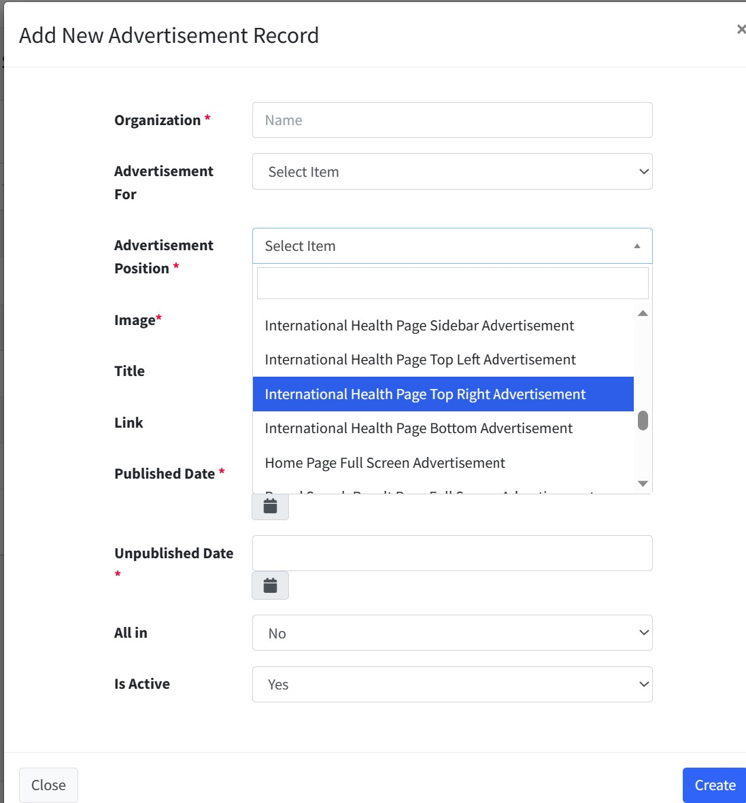

**Job Section**

In Description and Education section: please add font size option and create bullet point

Number of vacancy section : if I do not fill, so that frontend show null, if do not fill this section, so frontend show not specific

Job source, job type employment type, job nature: If we fill it then it will show in front, if we are not fill this, so this option will not show in front.

Note: Every description section in this website create bullet point and Font size

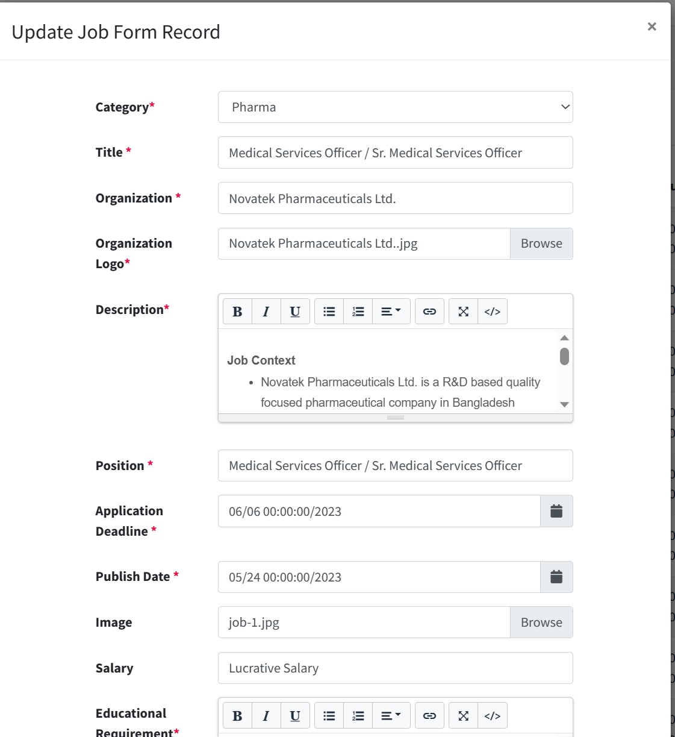

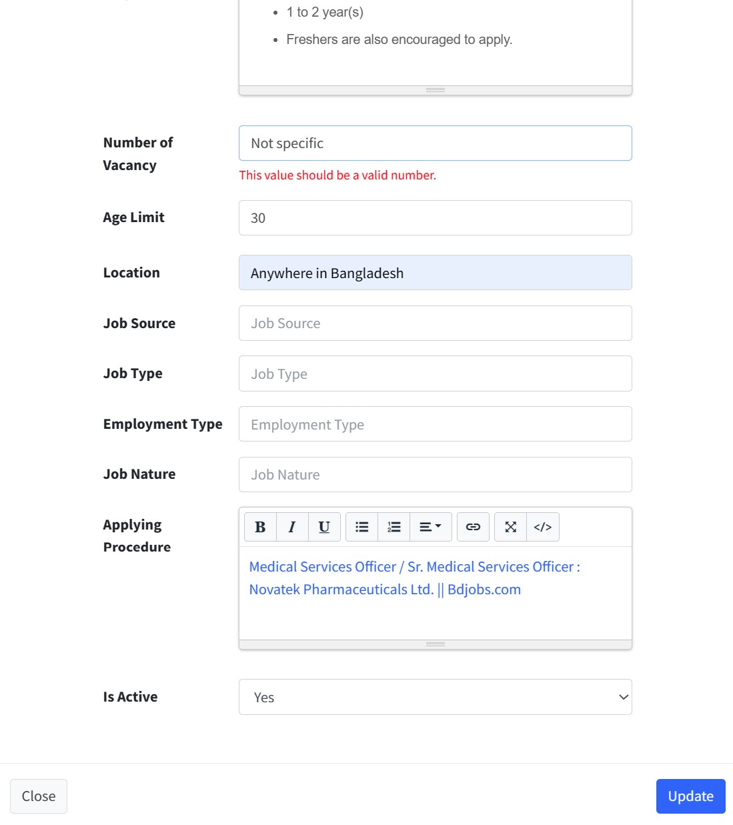

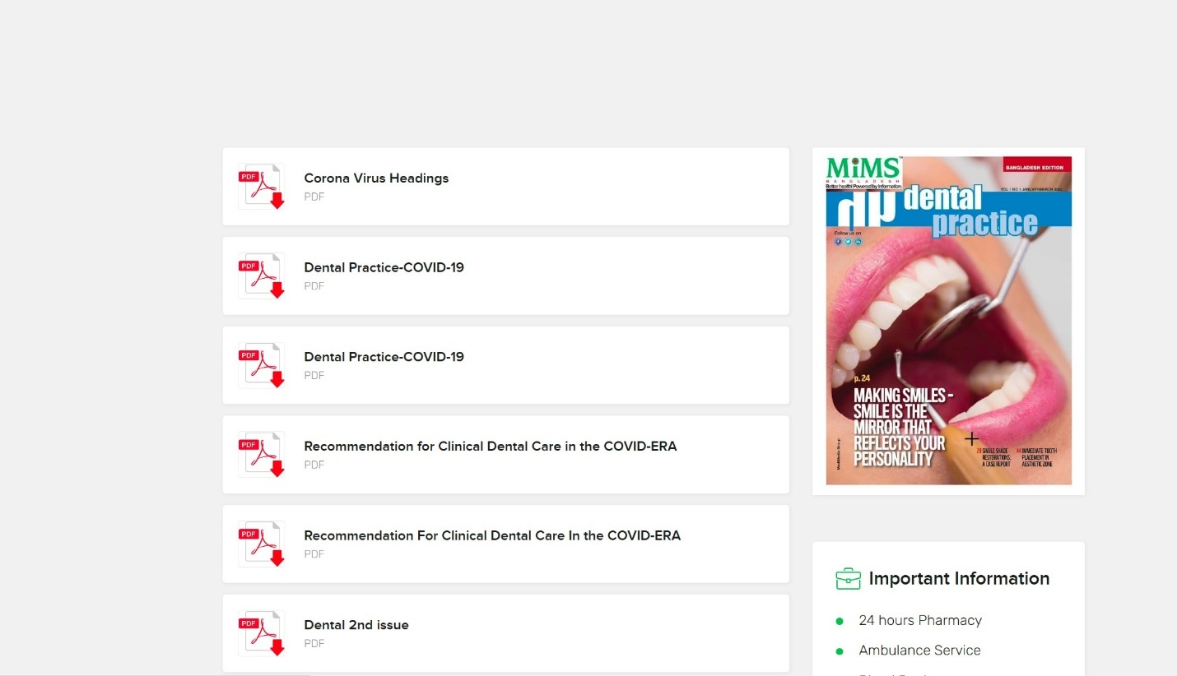

Mims dental practice this image cannot change I uplode new pdf Dental 2nd issue , second issue pdf. I am not getting the option to sshow the pdf image of 2nd issue here.

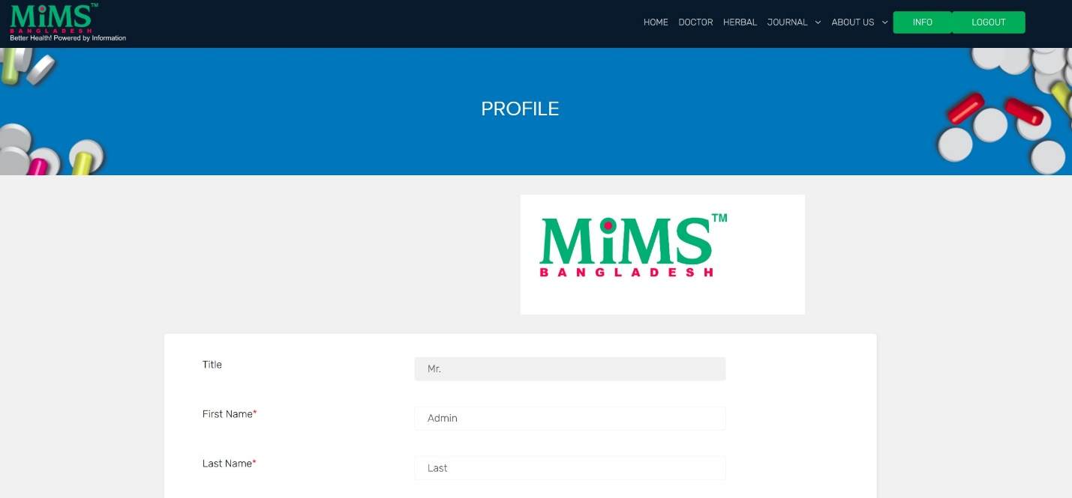

Info section : Why mims logo here?

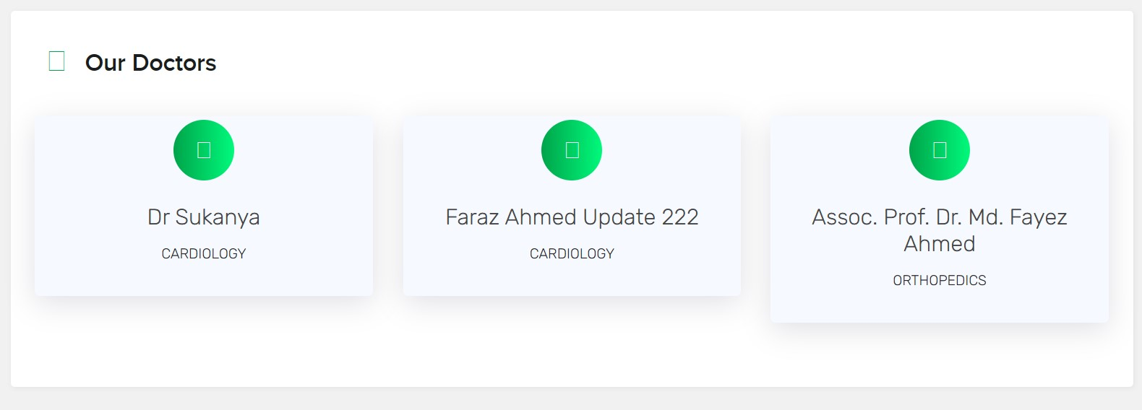

In Doctor section : 3 doctor are showing , But see the size, size are not same and symbol are nor showing

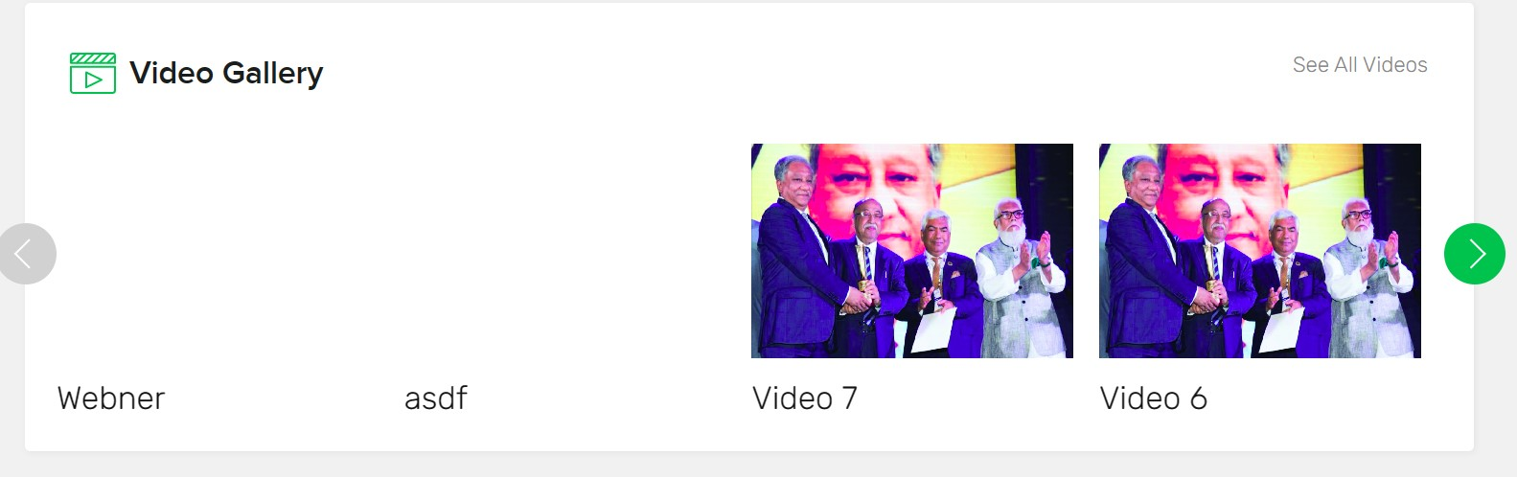

Video gallery Section: Image Are not showing

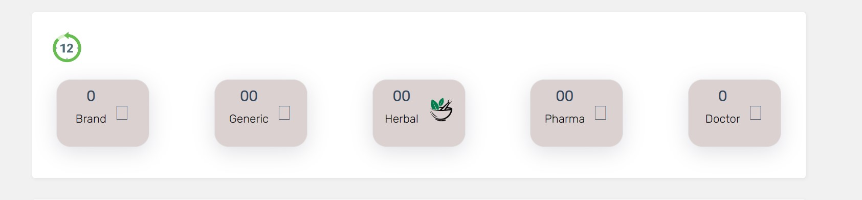

This Section : Number and Symbol are not showing