Laboratorium 12
Artem Buhera  GĆ01 135678 | 31.05.2021

W danym laboratorium musieliśmy zaimplementować program, demonstrujący zjawisko Rungego w interpolacji wielomianowej Lagrange'a na przykładzie funkcji
dla x ∈ [-1, 1]
Program stosuje bazę Newtona do obliczenia wielomianu interpolacyjnego w postaci

gdzie współczynniki c_{i} - ilorazy różnicowe, obliczone na podstawie siatki węzłów funkcji interpolowanej
Używamy dwów rodzajów siatki:
- węzły równoodległe
- węzły Czebyszewa, gdzie
Dla optymalizacji obliczeń p_{n}(x) używamy modyfikację algorytmu Hornera

Kod programu:
#include <cmath>
#include <iostream>
#include <fstream>
#include <vector.h>
using namespace std;
double exact(double x) {
return 1.0 / (1.0 + 10.0 * std::pow(x, 6));
}
Vector calculateExact(Vector &args, double (*f)(double)) {
Vector values(args.n());
for (int i = 0; i < args.n(); i++)
values[i] = f(args[i]);
return values;
}
Vector equidistant(double left_bound, double right_bound, int n) {
Vector result(n);
double x = left_bound;
double step = (right_bound - left_bound) / (n - 1);
for (int i = 0; i < n; i++) {
result[i] = x;
x += step;
}
return result;
};
Vector chebyshev(double left_bound, double right_bound, int n) {
Vector result(n+1, (right_bound + left_bound) / 2.0);
for (int i = 0; i < n+1; i++) {
double xi = cos((2.0*i + 1.0) / (2.0*n + 2.0) * M_PI);
result[i] += (right_bound - left_bound) / 2.0 * xi;
}
return result;
};
Vector NewtonBasis(Vector &args, Vector &values) {
int n = args.n();
Vector result = values;
for (int i = 1; i < n; i++) {
Vector temp = result;
int count = 0;
for (int j = i; j < n; j++) {
temp[j] = (result[j] - result[j-1]) / (args[j] - args[count]);
count++;
}
result = temp;
}
return result;
}
double interpolate(Vector &x, Vector &c, double arg) {
int n = c.n() - 1;
double result = c[n] * (arg - x[n-1]) + c[n-1];
for (n--; n >= 1; n--) {
result *= arg - x[n-1];
result += c[n-1];
}
return result;
}
void calculate(double left_bound, double right_bound, int n) {
ofstream out, nodes_equi, nodes_chebyshev;
stringstream filename;
filename << "../lab12/n" << to_string(n) << ".csv";
out.open(filename.str());
stringstream filename_nodes_equi;
filename_nodes_equi << "../lab12/n" << to_string(n) << "_nodes_equi.csv";
nodes_equi.open(filename_nodes_equi.str());
stringstream filename_nodes_chebyshev;
filename_nodes_chebyshev << "../lab12/n" << to_string(n) << "_nodes_chebyshev.csv";
nodes_chebyshev.open(filename_nodes_chebyshev.str());
Vector args_equi = equidistant(left_bound, right_bound, n);
Vector values_equi = calculateExact(args_equi, exact);
Vector coefficients_equi = NewtonBasis(args_equi, values_equi);
nodes_equi << "x,y" << endl;
for (int i = 0; i < args_equi.n(); i++)
nodes_equi << args_equi[i] << "," << values_equi[i] << endl;
Vector args_chebyshev = chebyshev(left_bound, right_bound, n);
Vector values_chebyshev = calculateExact(args_chebyshev, exact);
Vector coefficients_chebyshev = NewtonBasis(args_chebyshev, values_chebyshev);
nodes_chebyshev << "x,y" << endl;
for (int i = 0; i < args_chebyshev.n(); i++)
nodes_chebyshev << args_chebyshev[i] << "," << values_chebyshev[i] << endl;
out << "x,equidistant,Chebyshev" << endl;
for (double arg = left_bound; arg < right_bound; arg += 0.01) {
double interpolated_equidistant =
interpolate(args_equi, coefficients_equi, arg);
double interpolated_chebyshev =
interpolate(args_chebyshev, coefficients_chebyshev, arg);
out << arg << ","
<< interpolated_equidistant << ","
<< interpolated_chebyshev << endl;
}
out.close();
nodes_equi.close();
nodes_chebyshev.close();
}
int main() {
double left_bound = -1.0, right_bound = 1.0;
calculate(left_bound, right_bound, 5);
calculate(left_bound, right_bound, 10);
calculate(left_bound, right_bound, 12);
calculate(left_bound, right_bound, 15);
}

Vector.h:

#include <vector>
#include <algorithm>
#include <ostream>
#include <iostream>
#include <iomanip>
#ifndef VECTOR_H
#define VECTOR_H
using namespace std;
class Vector {
int size;
double* m_points;
public:
Vector(int size, double default_value) : size(size) {
m_points = new double[size];
for (int i = 0; i < size; i++) {
m_points[i] = default_value;
}
}
Vector(int size) : size(size) {
m_points = new double[size];
}
Vector(std::initializer_list<double> input) : size(input.size()) {
m_points = new double [size];
auto begin = input.begin();
for (int i = 0; i < size; i++) {
m_points[i] = *begin;
begin++;
}
}
Vector(const Vector &vect) : size(vect.size) {
m_points = new double[size];
for (int i = 0; i < size; i++) {
m_points[i] = vect.m_points[i];
}
}
~Vector() {
delete[] m_points;
m_points = nullptr;
}
double &operator[](int i) const {
return m_points[i];
}
double &operator[](int i) {
return m_points[i];
}
void operator=(Vector &vect) {
delete[] m_points;
size = vect.size;
m_points = new double[vect.size];
for (int i = 0; i < size; i++) {
m_points[i] = vect.m_points[i];
}
}
void print(int width = 8) {
cout << left;
for (int i = 0; i < size; i++) {
cout << setw(width) << m_points[i] << endl;
}
cout << endl << endl;
}
const int n() {
return int(size);
}
};
#endif

Otrzymane wykresy funkcji interpolowanej oraz interpolujących na węzłach równoodległych i Czebyszewa w zależności od ilości węzłów:
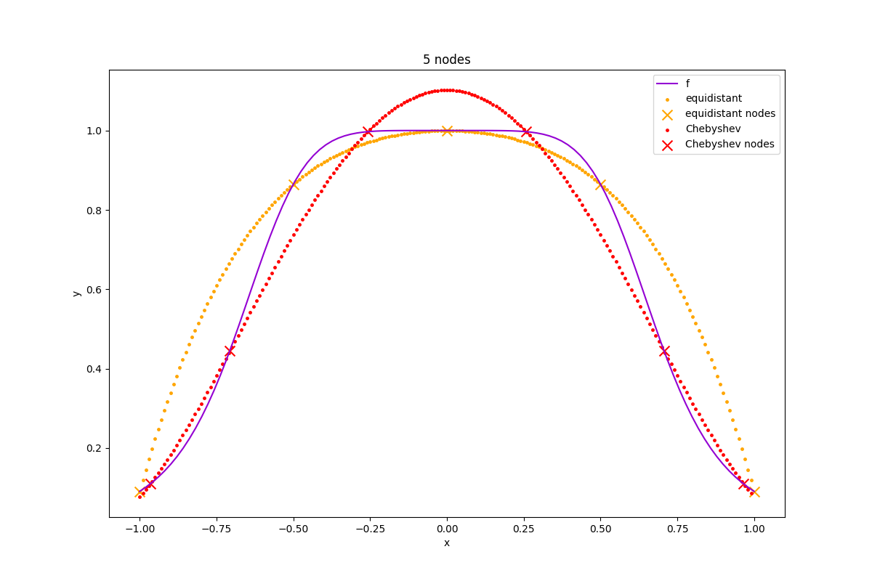
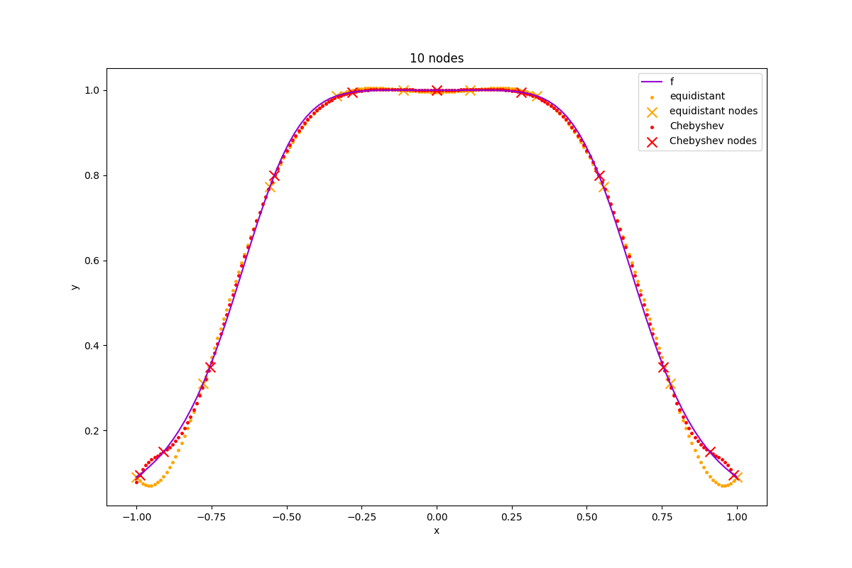
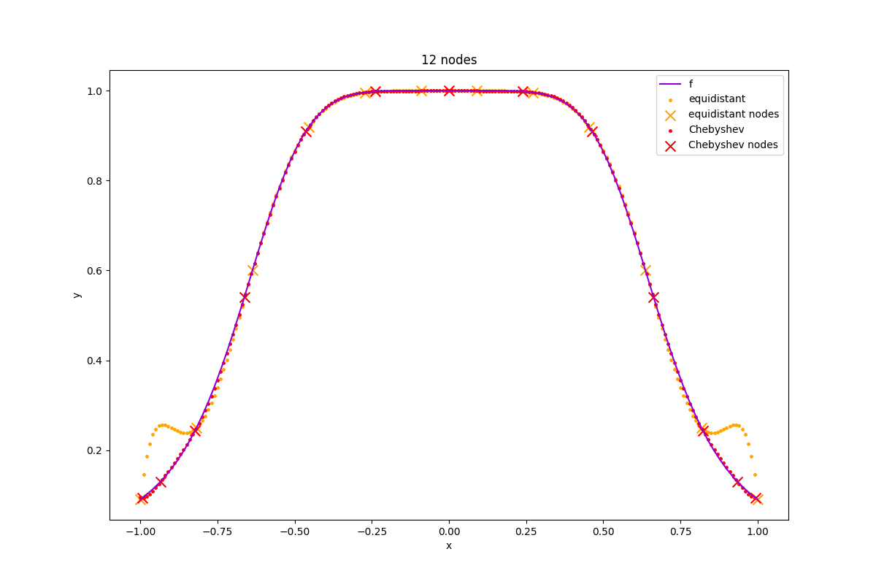
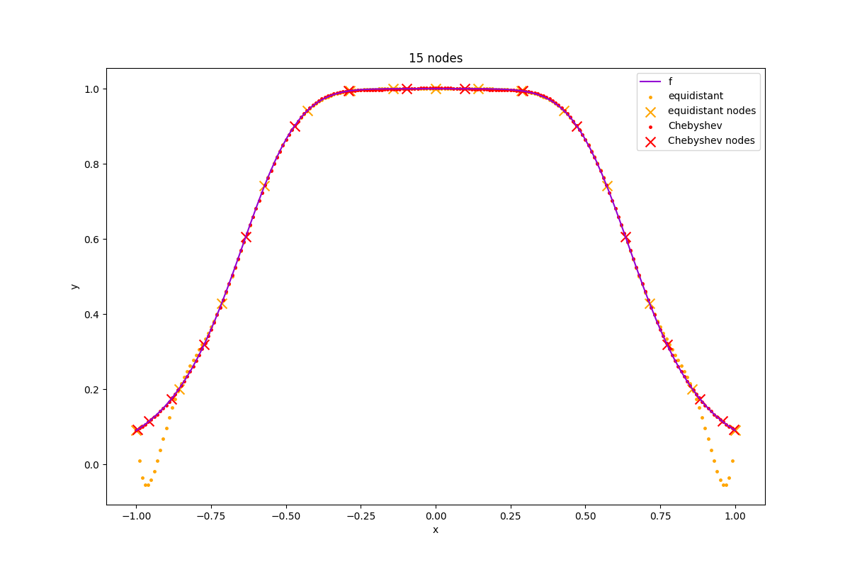
Dla węzłów równoodległych możemy łatwo zaobserwować zjawisko Rungego na końcach wykresów.

Natomiast dla węzłów Czebyszewa wartości pozostają zbliżone do faktycznych na całym zakresie.

