What is Boundary Testing?
- Boundary testing is the process of testing between extreme ends or boundaries between partitions' of the input values.
- So these extreme ends like Start- End, Lower- Upper, Maximum-Minimum, Just Inside-Just Outside values are called boundary values and the testing is called "boundary testing".
- The basic idea in boundary value testing is to select input variable values at their:
1. Minimum
2. Just above the minimum
3. A nominal value
4. Just below the maximum
5. Maximum
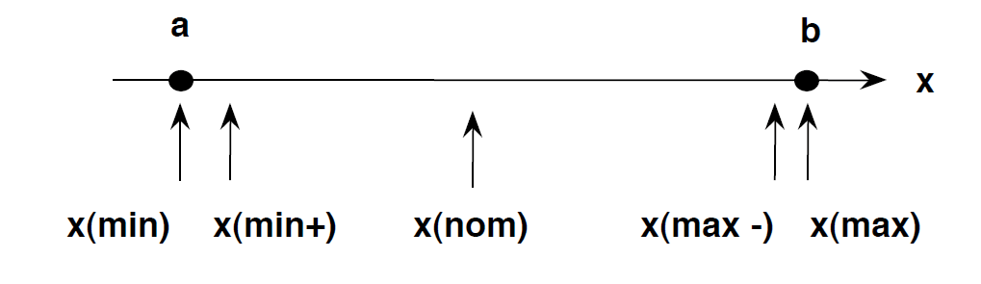

What is Equivalent Class Partitioning?
- It is a black box technique (code is not visible to tester) which can be applied to all levels of testing like unit, integration, system, etc. In this technique, you divide the set of test condition into a partition that can be considered the same.
- It divides the input data of software into different equivalence data classes.
- We apply this technique, where there is a range in input field.

Example 1: Equivalence and Boundary Value
- Let's consider the behavior of tickets in the Flight reservation application, while booking a new flight.
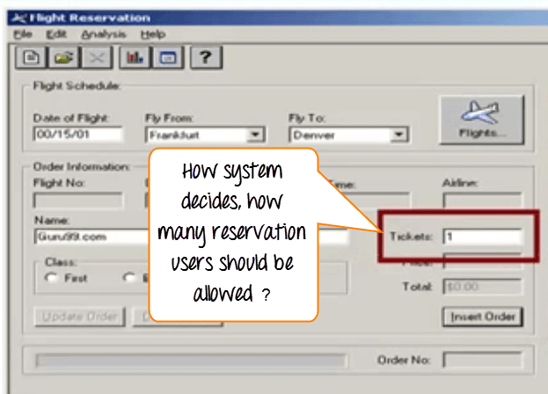
- Ticket values 1 to 10 are considered valid & ticket is booked. While value 11 to 99 are considered invalid for reservation and error message will appear, "Only ten tickets may be ordered at one time."
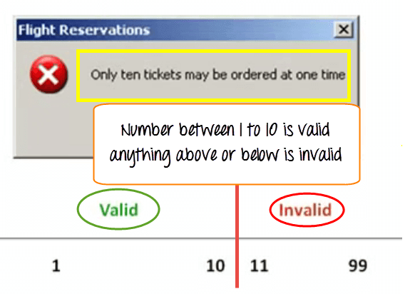
Here is the test condition
- Any Number greater than 10 entered in the reservation column (let say 11) is considered invalid.
- Any Number less than 1 that is 0 or below, then it is considered invalid.
- Numbers 1 to 10 are considered valid
- Any 3 Digit Number say -100 is invalid.
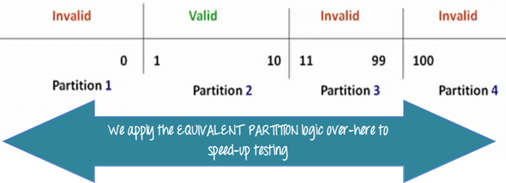
Boundary Value Analysis- in Boundary Value Analysis, you test boundaries between equivalence partitions
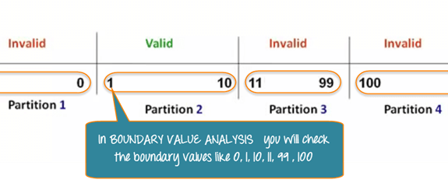

Cause and effect graph based on a situation
Situation:
The “Print message” is software that read two characters and, depending of their values, messages must be printed.
- The first character must be an “A” or a “B”.
- The second character must be a digit.
- If the first character is an “A” or “B” and the second character is a digit, the file must be updated.
- If the first character is incorrect (not an “A” or “B”), the message X must be printed.
- If the second character is incorrect (not a digit), the message Y must be printed.
Solution:
The causes for this situation are:
C1 – First character is A
C2 – First character is B
C3 – Second character is a digit
The effects (results) for this situation are
E1 – Update the file
E2 – Print message “X”
E3 – Print message “Y”

First draw the causes and effects as shown below:
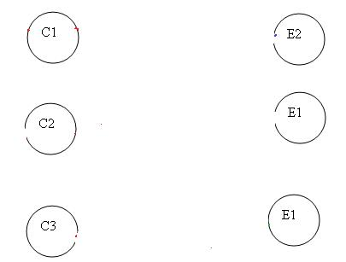

let’s start with Effect E1.
Effect E1 is to update the file. The file is updated when
– First character is “A” and second character is a digit
– First character is “B” and second character is a digit
– First character can either be “A” or “B” and cannot be both.
Now let’s put these 3 points in symbolic form:
For E1 to be true – following are the causes:
– C1 and C3 should be true
– C2 and C3 should be true
– C1 and C2 cannot be true together. This means C1 and C2 ae mutually exclusive.

Now let’s draw this:
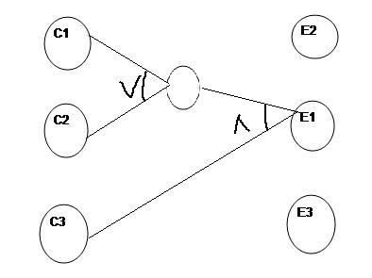
Let’s move to Effect E2:
E2 states to print message “X”. Message X will be printed when First character is neither A nor B.
Which means Effect E2 will hold true when either C1 OR C2 is invalid. So the graph for Effect E2 is shown as (In blue line)
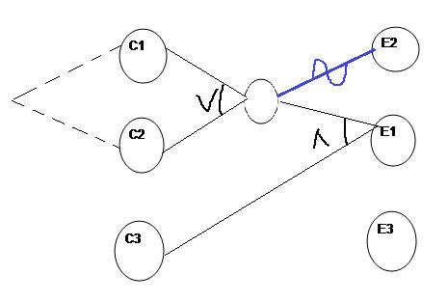
For Effect E3.
E3 states to print message “Y”. Message Y will be printed when Second character is incorrect.
Which means Effect E3 will hold true when C3 is invalid. So the graph for Effect E3 is shown as (In Green line)
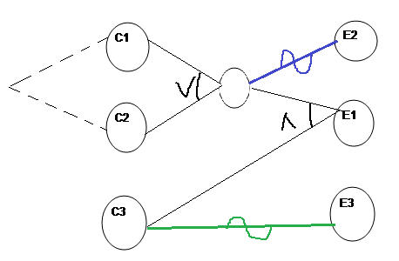
This completes the Cause and Effect graph for the above situation.

