**Dt:13/2/17 C#.Net**

**Topics : Constructor ,Destructor ,Array, and Inheritance**

**1 :**Write a constructor destructor program in which you make 3 constructors. One is for default constructors with default message, next is parameterized constructor which accept a string value and last one is also parameterized constructor which accept two numerical value and shows add of them. Initialize all constructors and shows output.

**2:Correct the program and execute**

using System;

using System.Collections.Generic;

using System.Linq;

using System.Text;

namespace params_array

{

    class Program

    {

        static int add(params int allnumber)

        {

            int sum = 0;

            foreach (int n in allnumber)

            {

                sum = sum + n;

            }

            return sum;

        }

        static void Main(string[] args)

        {

            int sum;

            // passing three parameters

            sum = Program.add(1, 2, 3);

            Console.WriteLine("Sum of 1,2,3 is:\t{0}", sum);

            // passing five parameters

            sum = Program.add(3, 5, 2, 6, 2);

            Console.WriteLine("Sum of 3,5,2,6,2 is:\t{0}", sum);

            Console.ReadLine();

        }

    }

}

Output:-

3. **Qu1:** Write a program to copy one array’s elements to another array without using array function.

4. **Qu2:** Reverse a string using array.

**Hint:** accept string value and store in a string variable str. Then convert str into array as follow:

char[] ch=str.ToCharArray;

5. Inheritance :

namespace Basic_Example

{

    class Program

    {

        static void Main(string[] args)

        {

            Scooter sc = new Scooter();

            sc.ScooterType();

            Car c = new Car();

            c.CarType();

            Console.ReadKey();

        }

    }

    //Creating Base Class

    class Tyre

    {

        protected void TyreType()

        {

            Console.WriteLine("This is Tubeless Tyre");

        }

    }

    //Creating Child Class

    class Scooter : Tyre

    {

        public void ScooterType()

        {

            Console.WriteLine("Scooter Color is Red");

            TyreType();

        }

    }

    //Creating Child Class

    class Car : Tyre

    {

        public void CarType()

        {

            Console.WriteLine("Car Type : Ferrari");

            TyreType();

        }

    }

}

#### Output?

#### ?

#### 6.Qu 1: You are assigning to develop a project in which you have to achieve following goals.

1. Write a program for creating Laptop.
2. Name, Price, Processor, Ram and Hard drive should be defined in base class as constant.
3. You need to inherit these functionalities in your program and Print Details.
4. All the laptop should have different **name, price, processor, ram and hard drive**.

Expected Output:

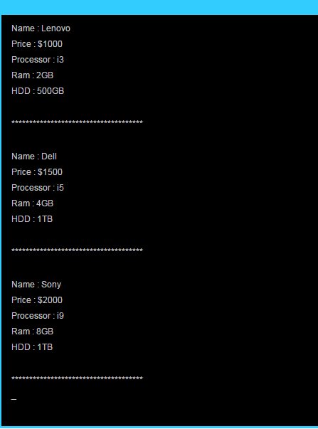

|  |
| --- |
| Correct the program and execute the program  7. namespace Abstract_Method  {      class Program      {          static void Main(string[] args)          {              childclass ch = new childclass();              ch.sum();              Console.ReadKey();          }      }  }    abstract class baseclass  {      public int num = 5;      public abstract void sum();  }  class childclass : baseclass  {      public void sum()      {          Console.WriteLine("Total Sum : " + num * num);      }  } |

**Output ?**