Feature System & Domain Model
Refactoring Design Document

Sub Team 5 – Apaties II

Executive Summary

This design document is concerned with the structural refactoring of the iDaVIE Feature Domain carried out by Sub-team 5. The main goal is to decompose the legacy monolithic classes (most notably the FeatureSetManager class) into a pure C# domain model decoupled from the Unity runtime.

Using Domain-Driven Design (DDD) patterns, SOLID principles, and GRASP design, we created a design-pure kernel that encapsulates domain logic. Additionally we improved modifiability and analysability of the system by separating domain objects from Unity components.

1. Unity Decoupling & First-Class Domain Aggregate Promotion

The most significant architectural shift that we did is the complete decoupling of Unity dependencies from the feature domain. In the initial repository, the concept of a "Feature" was tightly bound to the Unity engine which limited its reuse and testability.

1.1 The Legacy Coupling Patterns
In the original codebase, a feature was not a pure domain object and instead had direct ties to unity types:
- MonoBehaviour and GameObject Inheritance: Feature sets were represented directly by FeatureSetRenderer, which inherited from MonoBehaviour. This meant that creating a list of features required instantiating Unity GameObjects in a scene.
- Structural Engine Types: Bounding boxes and positions were represented using UnityEngine.Vector3. Rendering colors were defined via UnityEngine.Color.
- Lifecycle Entanglement: Business logic checking if a point lay inside a feature or updating a feature's properties was executed inside the Unity Update() loop, intermingling math calculations with graphics frame rates. This coupling made it impossible to run automated tests without starting the Unity engine, creating a significant bottleneck for CI/CD pipelines.

1.2 Decoupling Strategy & Value Object Isolation
To break the coupling, we replaced all UnityEngine dependencies with pure C# value objects:
- Voxel Space Coordinates (Vec3): We replaced UnityEngine.Vector3 with a custom struct Vec3. This struct holds immutable X, Y, and Z float values and provides basic distance and boundary logic.
- Unity-Free Colors (FeatureColor): We replaced UnityEngine.Color with a custom struct FeatureColor. This struct stores R, G, B, and A channels.
- Strict Adapter Boundary: The transformation from domain value types to Unity-specific graphics types is deferred to the infrastructure boundary in FeatureVisualiser.cs. For example, FeatureVisualiser maps FeatureColor to UnityEngine.Color at the point of rendering, keeping the domain pure.

1.3 Promoting Feature to a Kernel Domain Aggregate
We have removed all Unity dependencies and structured the feature system as a clean, hierarchical C# structure. Related objects are collected under one parent coordinator, FeatureSet (the Aggregate Root). This design introduces three main simplifications:
Controlled Data Updates
 | Initial Way | New Way
Controlled Data Updates | A script could directly add, delete, or modify individual features. This caused data errors where the UI, files, and graphics became out of sync. | The list of features is private. To add or remove a feature, external scripts must call FeatureSet.Add(Feature) or FeatureSet.Remove(Feature). This ensures that all additions or deletions are validated at a single entry point.

Automatic Parent-Child Links
 | Initial Way | New Way
Automatic Parent-Child Links | Developers had to manually write feature.FeatureSetParent = this in multiple files. If they forgot to do this the program crashed. | The parent property is locked (private set). The parent link is wired automatically inside FeatureSet.Add(feature). Developers can no longer make wiring mistakes.

Decoupled Change Notifications
 | Initial Way | New Way
Decoupled Change Notifications | The legacy code used dirty-flags to avoid constant coordinate polling, but the notification path was tightly coupled. The Feature class had to call FeatureSetRenderer (a Unity MonoBehaviour) directly to flag changes. This meant modifying a feature's bounds in a test suite or a non-Unity helper class crashed the application. | The notification chain is entirely decoupled. When a feature's bounds change, it notifies its pure C# parent FeatureSet in the domain layer. The FeatureSet raises a standard C# event, which the FeatureVisualiser adapter routes to the renderer. This retains the push-based performance optimization while allowing features to be modified and tested outside of Unity.

1.4 Architectural Benefits of the Pure Domain Aggregate
- Multi-platform portability: Because the core feature model has zero dependencies on UnityEngine or SteamVR, it can be compiled and executed on any platform supporting .NET.
- Fast unit testing: Tests targeting the domain do not require launching Unity, which allows the execution of unit and property-based test suites in milliseconds via a simple dotnet test runner.
- Migration stability: If the application undergoes a migration (such as upgrading from Unity 5 to Unity 6), the core business rules of the feature domain remain stable and untouched.

2. Domain-Driven Design (DDD) & SOLID/GRASP Analysis

To maximize maintainability and prepare the codebase for future extensions, we applied Domain-Driven Design (DDD) patterns alongside object-oriented design principles (GRASP and SOLID).

2.1 DDD Patterns Applied
Pattern | Class / Artifact | Notes
Aggregate Root | FeatureSet | A Feature cannot exist in isolation; its lifecycle is tied to its parent FeatureSet. Subscribing to modifications in individual features is routed through the aggregate root via the FeatureDirty event, preventing external objects from maintaining direct coupling to individual features.
Value Objects | Vec3, FeatureColor | Core mathematical structures are realized as immutable Value Objects. They do not have unique identities; they are defined solely by their values and are safe from side-effect mutations.
Repository / Registry | FeatureCatalog | Acts as an in-memory repository for FeatureSet aggregates. It manages their persistence boundaries, delegating implementation details to the infrastructure layer.

2.2 SOLID Principles Audit
During the audit, the team reviewed the codebase against each of the five SOLID principles and made targeted refactors throughout.
Single Responsibility Principle (SRP)
The existing FeatureSetManager was decomposed into three focused classes:
  - FeatureCatalog — changes only if the way feature sets are grouped changes.
  - FeatureSetService — changes only if core application workflows such as selection rules change.
  - FeatureVisualiser — changes only if visual representation in Unity is modified.
Open-Closed Principle (OCP)
The persistence and statistics features were redesigned to depend on interfaces (IFeaturePersistenceService and IFeatureStatisticsProvider), meaning the underlying database structure or statistics library can be swapped — for instance, using a mock stub in unit tests or a fast C++ DLL in production — without touching any domain code.
Liskov Substitution Principle (LSP)
All implementations of IFeature strictly preserve its base behaviour, allowing different feature categories such as Masked, Imported, and User-defined to be substituted transparently.
Interface Segregation Principle (ISP)
The broad IFeatureDirtyNotifier interface was replaced with a direct event on FeatureSet, so that the rendering layer only receives dirty updates rather than inheriting unnecessary management capabilities.
Dependency Inversion Principle (DIP)
High-level modules (domain and application logic) were decoupled from low-level modules (Unity rendering, C++ DLLs, file writers) by ensuring both sides depend on abstractions. The concrete persistence implementation, VoTableExportService, now lives in the Infrastructure layer and is injected into the domain at runtime.

2.3 GRASP Design Principles Audit
During the audit, the team also verified the codebase against the key GRASP design principles.
Information Expert
Behaviours were placed on the classes that hold the data needed to execute them. For example, the BoundsContains(Vec3) method, which checks whether a point falls within a feature, lives directly on Feature because that is the class that holds the bounding box limits.
Low Coupling & High Cohesion
The legacy FeatureSetManager was identified as highly coupled because it held references to almost every class in the project. The refactored FeatureCatalog resolves this by depending only on FeatureSet, Feature, and the IFeaturePersistenceService interface. All classes were made highly cohesive so that every method within a class relates closely to its core purpose.
Protected Variations
External libraries such as AstTool and native DLLs were wrapped behind stable interfaces — ICoordinateTransformer and IFeatureStatisticsProvider — shielding the application from instability or breaking changes in the underlying C and C++ libraries.

3. Worked Refactoring Case Studies

To demonstrate the viability of our refactoring proposal, we executed two worked refactoring examples, collecting metrics before and after the change.

3.1 Case Study 1: Moment-Map Generation
Moment maps (integrated emission maps along a velocity axis) were originally calculated by a monolithic Unity script (MomentMapRenderer.cs) which directly called native DLLs and managed textures.

Responsibility Split
Responsibility | Outcome
GPU Shader Dispatch | Moved from CalculateMomentMaps() in the monolith to MomentMapRendererAdapter.Compute().
Bounds Extraction | Moved to MomentMapCalculator.ComputeMinMaxBounds() in the domain layer.
Orchestration / Sequencing | Moved to MomentMapService.GenerateMomentMaps().
UI Update & Sprite Binding | Handled exclusively by MomentMapRendererAdapter.ApplyResultToUI().
Config Singleton Access | Removed; parameters are injected at the composition root.

3.2 Case Study 2: VOTable Export
Upstream iDaVIE saved catalogs via a static class VoTableSaver inside VoTable.cs. This helper directly accessed Unity MonoBehaviours (FeatureSetRenderer and VolumeDataSetRenderer), making it impossible to run headless exports or test the XML generation.
We introduced a plug-in seam: the domain defines IVoTableExporter, IAstFrame (an opaque handle replacing raw IntPtr), and ICoordinateTransformer. The persistence layer implements these interfaces in VoTableExportService.cs.

4. Before/After Metrics & Technical Debt Analysis

After our refactoring the average code health for feature data increased by 0.57 data points. We ran various metrics on our code using both understand and codescene in order to compare the initial and refactored code.

4.1 Line Breakdown
After refactoring the project grew in overall line count, but the comment-to-code ratio improved substantially. Before refactoring, 398 comment lines covered 2,318 code lines (~17%). After refactoring, 1,055 comment lines cover 2,987 code lines (~35%), more than doubling the ratio.
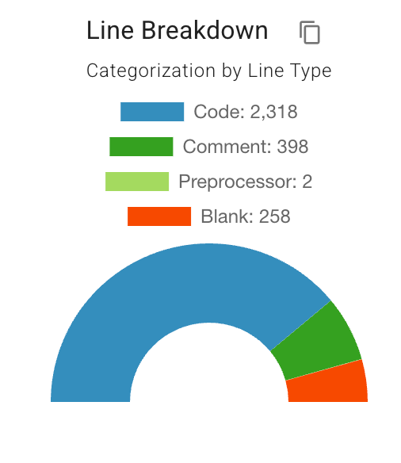  Before: Code 2,318 · Comment 398 | 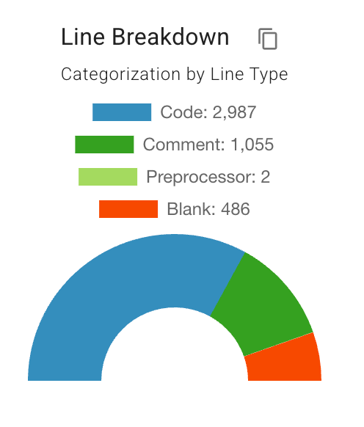  After: Code 2,987 · Comment 1,055

4.2 Technical Debt & Function Complexity
Both the before and after snapshots achieve an Overall grade of A for Function Complexity. After refactoring, the technical debt metric reports zero violations across the five monitored files (IFeatureSystemPort.cs, Vec3.cs, VoTable.cs, FeatureAnchor.cs, FeatureMenuCell.cs).
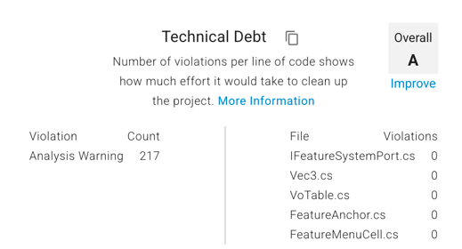
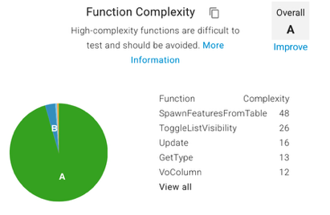
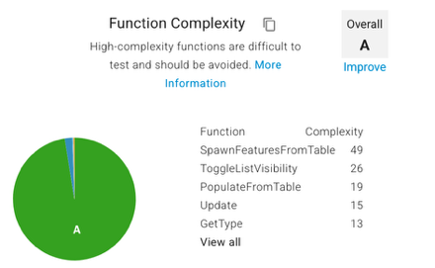

Before: Function Complexity
After: Function Complexity
After: Technical Debt

4.3 Most Complex Functions (McCabe Cyclomatic Metric)
The most complex function, SpawnFeaturesFromTable, remained the primary hotspot in both snapshots, rising marginally from a cyclomatic complexity of 48 to 49. All other highly-ranked functions either decreased or remained stable. ToggleListVisibility stayed at 26; Update improved from 16 to 15; GetType remained at 13.
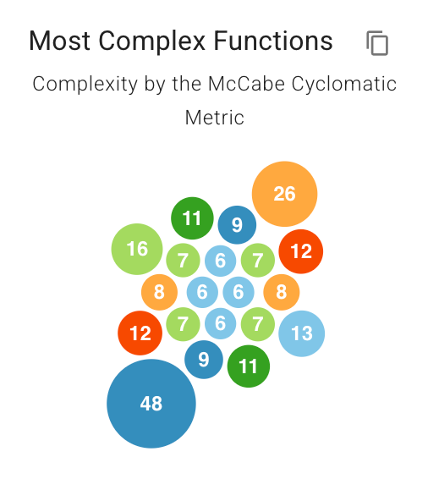  Before: Most Complex Functions | 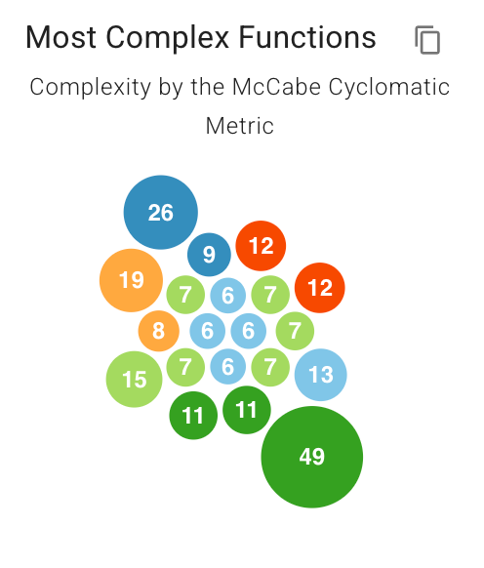  After: Most Complex Functions

4.4 Most Complex Classes (Average McCabe Cyclomatic Metric)
The decomposition of FeatureSetManager had a measurable effect on class-level complexity. Before refactoring the highest class complexity score was 9; after refactoring the highest score remains 9 but is now distributed across more, smaller classes with lower average complexity per class, reflecting the SRP decomposition described in Section 2.2.
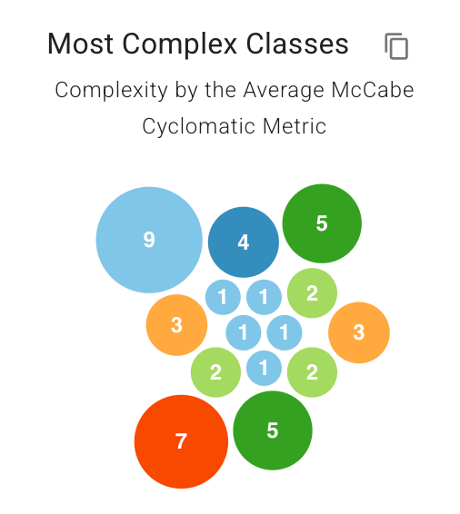  Before: Most Complex Classes | 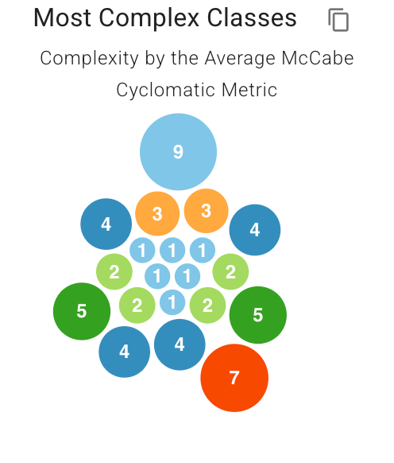  After: Most Complex Classes

4.5 Largest Functions & Largest Classes
Before refactoring the five largest functions were concentrated in FeatureSetManager and VoTable subsystems. After refactoring the largest function, SpawnFeaturesFromTable, grows slightly (~280 lines) as it consolidates import orchestration, but the other formerly large functions have been broken up. At the class level, the previously monolithic FeatureSetManager (~580 lines) has been replaced by FeatureSetRenderer (~540 lines) and FeatureSetService as the largest classes, reflecting a more even distribution of responsibilities.
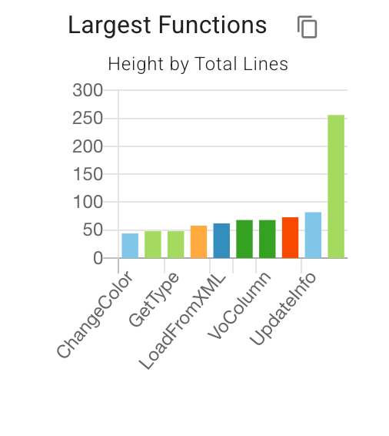  Before: Largest Functions | 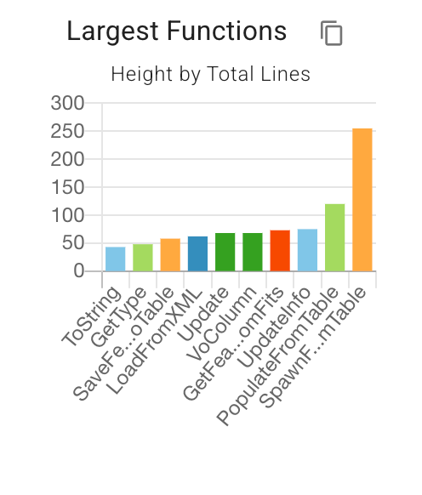  After: Largest Functions

4.6 Largest Files
After refactoring, VoTable.cs is the largest file at approximately 630 lines, followed by FeatureSetRenderer (~460 lines) and FeatureSetService (~440 lines). The new FeatureSet.cs and FeatureCatalog.cs are moderate in size, consistent with their focused single responsibilities.
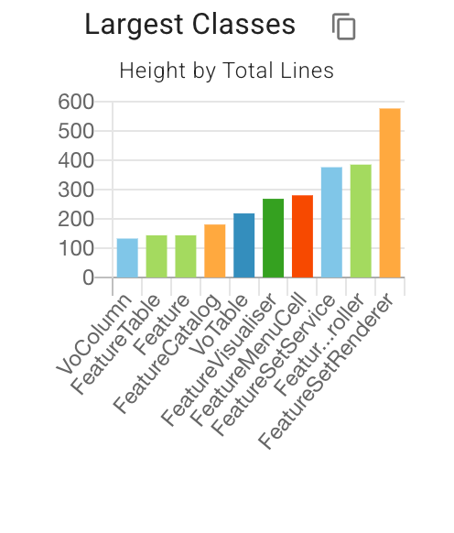  After: Largest Classes | 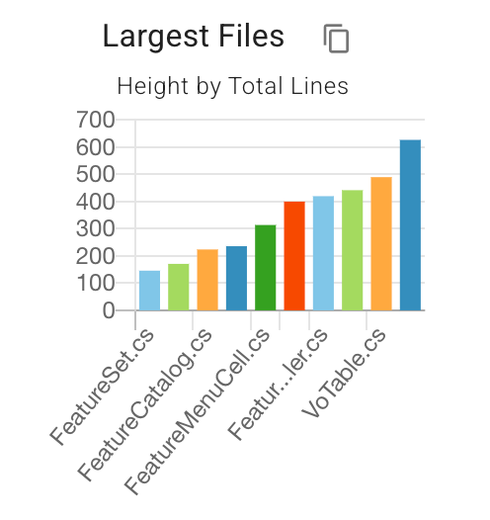  After: Largest Files

Appendix

Interface Contracts…………pg 10-12

UML diagrams…………………….pg 13-15

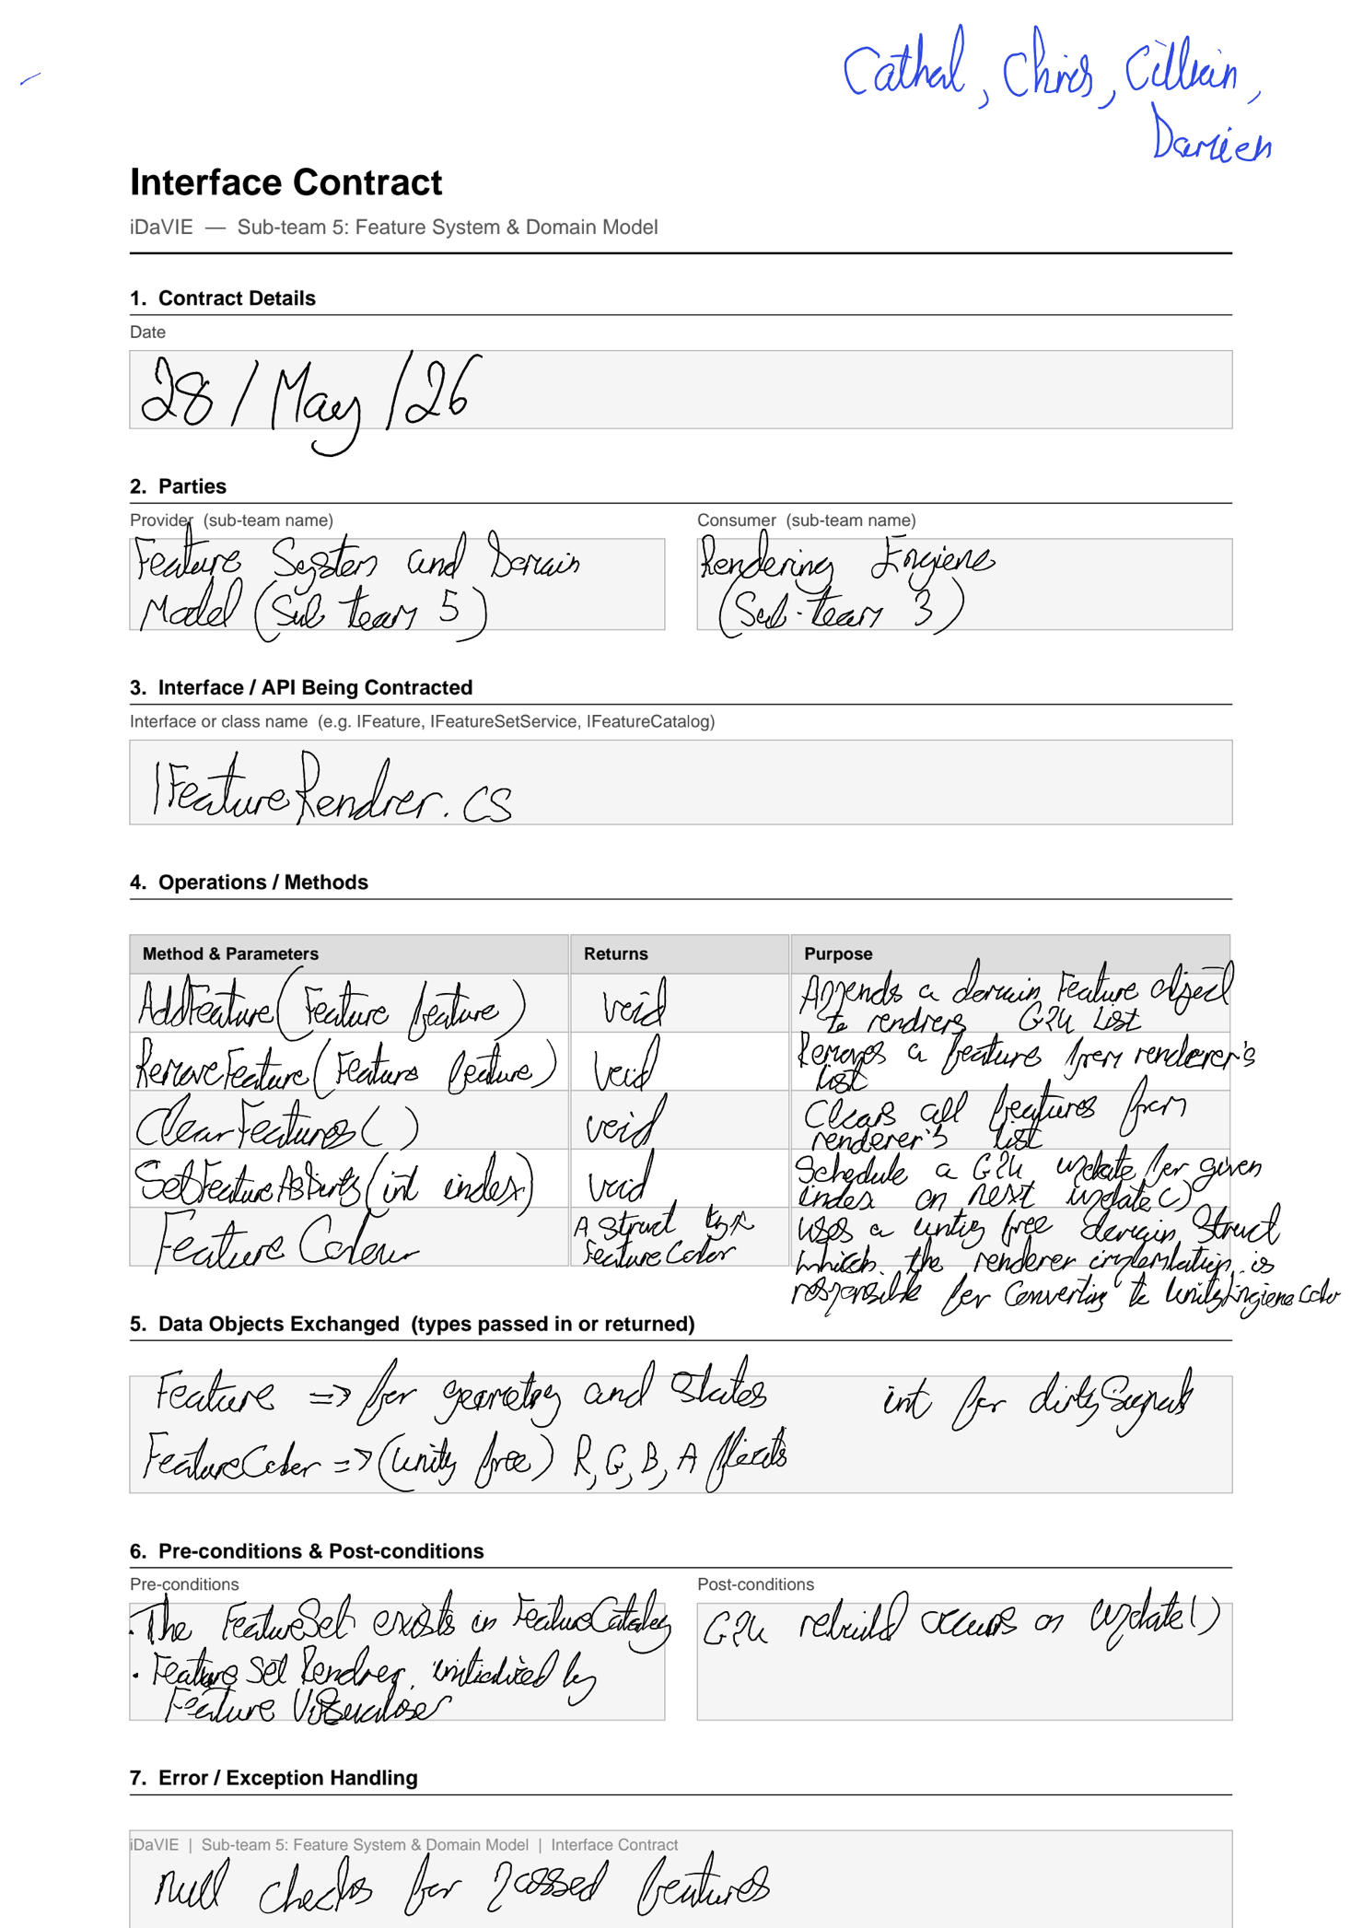





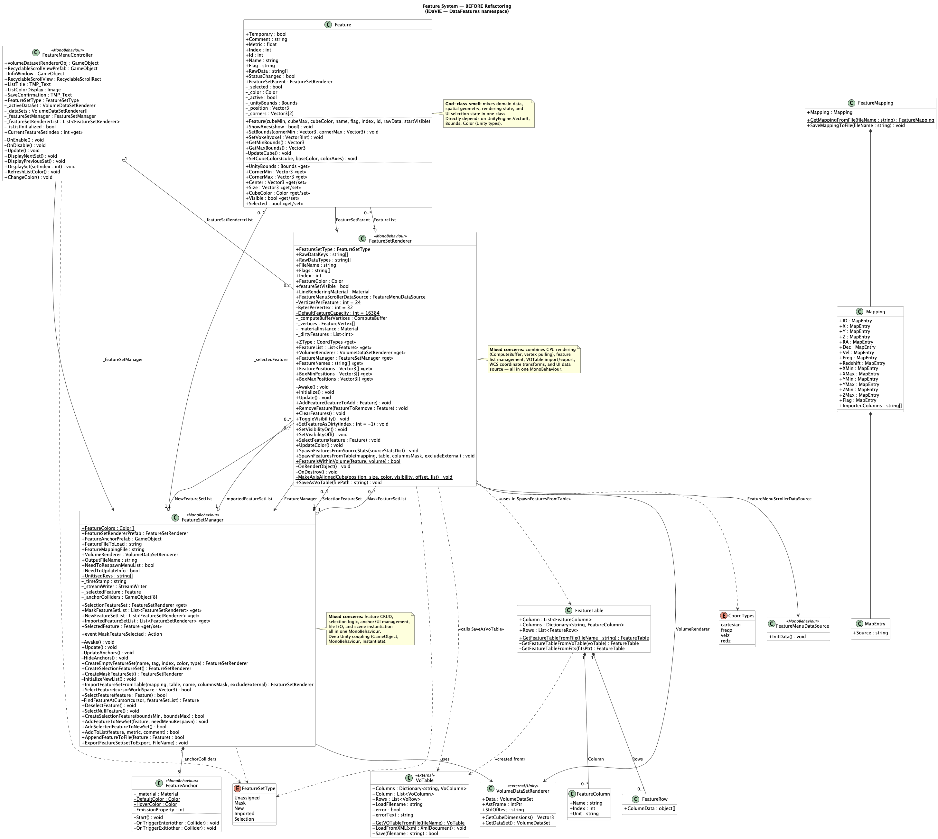

Feature Domain Before Refactoring

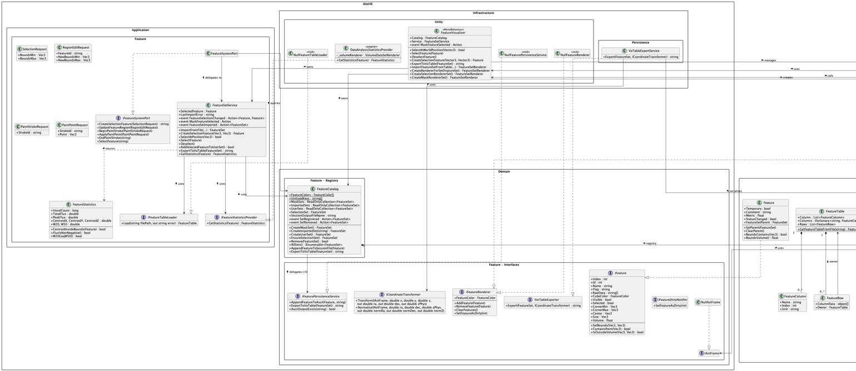

Feature Domain After Refactoring

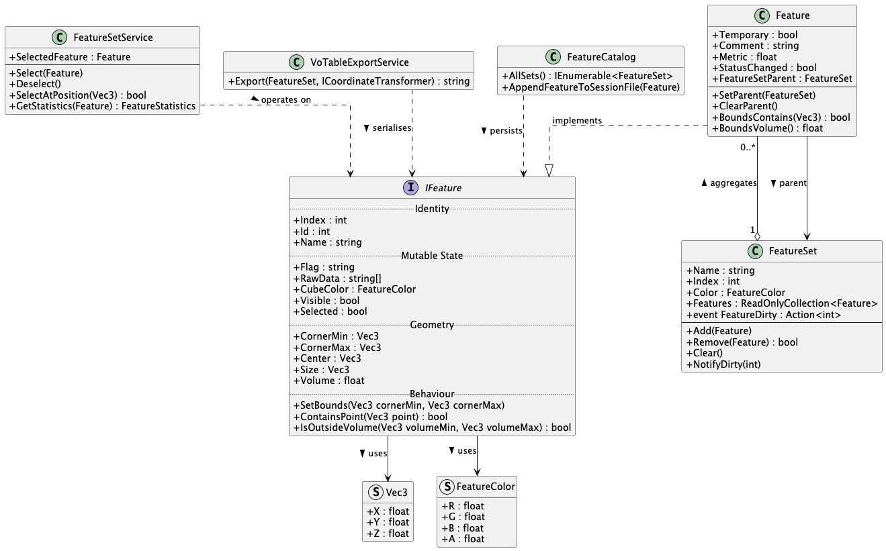

IFeature Interface
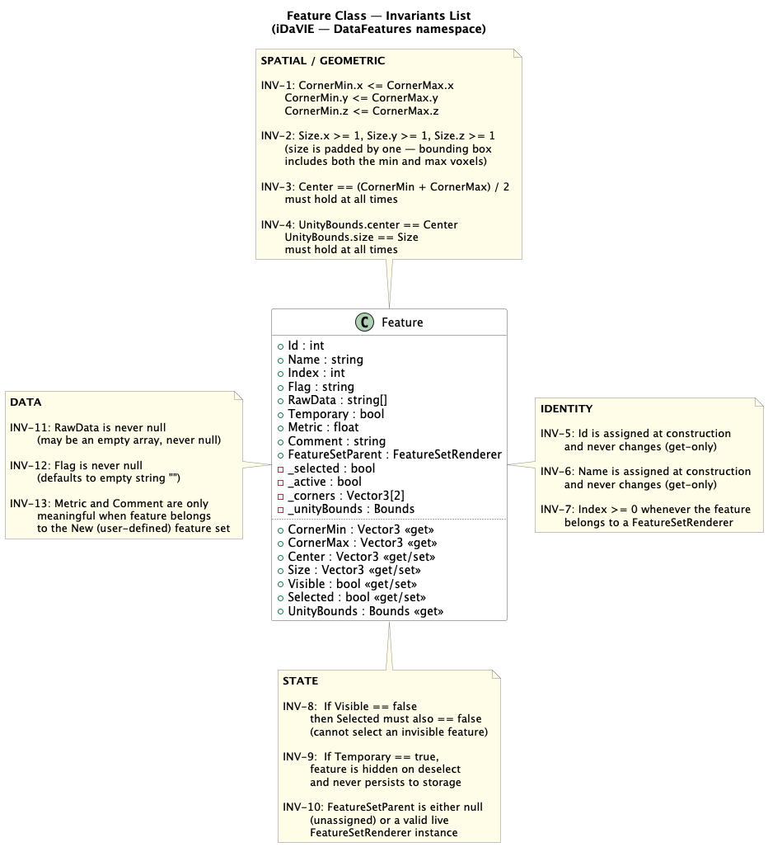

Invariants List

