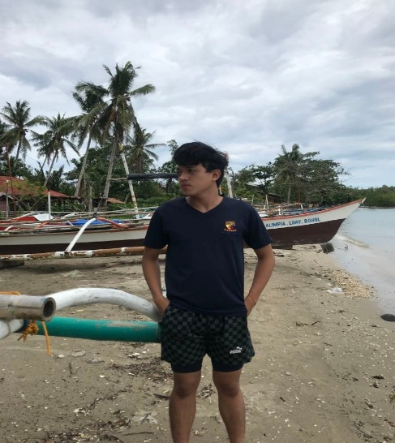

Hi I am Jhon Reynold Durang. I am currently living in Tagbilaran City, Bohol. I am the eldest son of my family, and my hobby is playing online games and playing basketball. My goal in life is to graduate in college and to have a stable job and to become a professional someday.

As a person, I strive to be kind, compassionate, and helpful to those around me. I believe in treating others with respect and empathy, and I try to be a positive force in the world by contributing to my community and helping those in need.

My guiding principle in living my life would be to pursue my passions and make a positive impact on the world. I believe that life is short, and it's important to make the most of the time we have by doing things that bring us joy and fulfillment while also making a difference in the lives of others.

Like everyone else, I am both alike and different from others in various ways. I share many common experiences and emotions with others, but I also have unique perspectives and traits that set me apart.

In terms of accomplishments, I would be proud of any small or big achievements that I have made, such as learning a new skill, or simply being there for my friends and family.

As for my dreams and future plans, they would likely involve continuing to learn and grow as a person while also contributing to the greater good. I might hope to travel the world, pursue a fulfilling career, and make a positive impact on the lives of those around me in whatever ways I can.