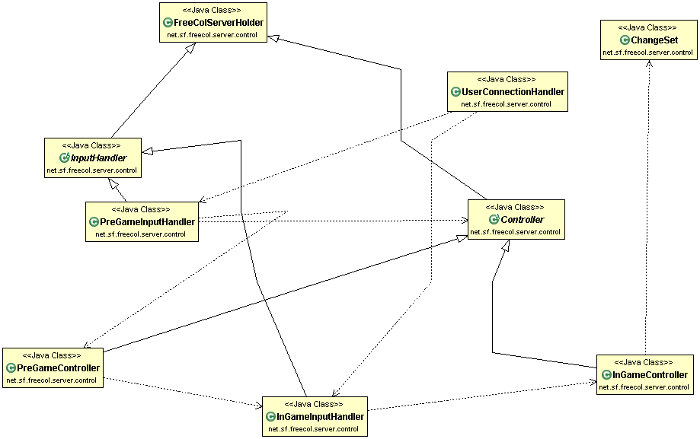

and have nine classes i.e. ChangeSet, Controller, FreeColServerHolder, InGameController, InGameInputHandler, InputHandler, PreGameController, PreGameInputHandler, UserConnectionHandler) they are connected with some associations. These associations are described as follows

- InputHandler and Controller are subclasses of FreeColServerHolder
- PreGameInputHandler and InGameInputHandler are subclasses of InputHandler
- PreGameController and InGameController are subclasses of Controller
- UserConnectionHandler Is depends on the PreGameInputHandler and InGameInputHandler
- PreGameInputHandler is depends on the Controller and PreGameController
- PreGameController Depends on InGameInputHandler which depends on InGameController which further depends on the ChangeSet.

