The Johns Hopkins Turbulence Databases (JHTDB)

FORCED MHD TURBULENCE DATA SET
Data provenance: H. Aluie^{1,2}, G. Eyink¹, E. Vishniac³, S. Chen^{1,4}
Database ingest and Web Services: K. Kanov¹, R. Burns¹, C. Meneveau¹, A. Szalay¹
¹Johns Hopkins University, Baltimore, MD 21218
²Los Alamos National Laboratory, Los Alamos, NM 87545
³McMaster University, Ontario L8S4L8, Canada
⁴Peking University, Beijing China

The data is from a direct numerical simulation on a 1024³ periodic grid of the incompressible MHD equations
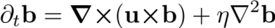
Here u is velocity, b = B/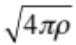 is the magnetic ﬁeld in Alfvén velocity units,
j = ∇×b is current, and p is pressure. The external stirring force was a Taylor-Green ﬂow
F ≡ f₀ [sin(k_{f} x) cos(k_{f} y) cos(k_{f} z )e_{x} −cos(k_{f} x) sin(k_{f} y) cos(k_{f} z )e_{y}] applied at modes
k_{f} = 2 with an amplitude f₀ = 0.25. The magnetic Prandtl number is unity, η= ν. The
simulation used a pseudo-spectral parallel code in an Elsasser variable formulation¹.
The time integration scheme was slaved 2nd-order Adams-Bashforth, with viscous and resistive terms solved analytically by an integrating factor. The simulation was de-aliased using phase-shift and a 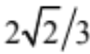 truncation^{2,3}. After the simulation reached a statistically stationary state, 1024 frames of data, which includes the 3 components of the velocity vector, 3 components of the magnetic field vector, and the pressure, were generated and ingested into the database. Also calculated and archived were the 3 components of the magnetic vector potential a=curl ⁻¹ b in the Coulomb gauge ∇·a =0. The duration of the stored data is about one large-eddy turnover time.

Simulation parameters:
Domain: 2 x 2 x 2 (i.e. range of x , y, and z is [0,2π])
Grid: 1024³ , Maximum wavenumber: 482
Viscosity, Resistivity: = η= 1.1 × 10⁻⁴
Simulation time-step 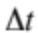 = 2.5 × 10⁻⁴
Data are stored separated by δt = 2.5 × 10⁻³ (i.e. every 10 DNS time-steps is stored)
Time stored: between t=0 and 2.56 (1024 time samples separated by δt)

Statistical characteristics of turbulence, time averaged over t=0 and 2.56:

Velocity (w=u) Magnetic (w=b)
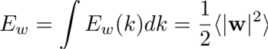
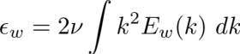
Total energy : E_{u}=7.7 × 10⁻ ² E_{b}=8.5 × 10⁻ ²
Dissipation, : = 1.1× 10⁻ ² = 2.2× 10⁻ ²
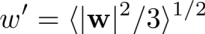
rms field component, : u′= 0.23 b′= 0.24
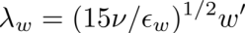
Taylor microscale : λ_{u}= 8.9× 10⁻ ² λ_{b}= 6.6× 10⁻ ²
Taylor-scale Reynolds #, : Re_{λu}= 186 Re_{λb}= 144
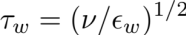
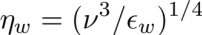
Kolmogorov time scale : τ_{u} =0.1 τ_{b} = 0.07
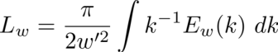
Kolmogorov length scale : η_{u}= 3.3× 10⁻ ³ η_{b}= 2.8× 10⁻ ³
Integral scale : L_{u}= 0.56 L_{b}= 0.35
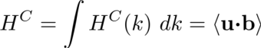
Large eddy turnover time : T_{u}=2.43 T_{b}=1.46
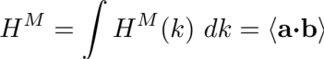
Cross Helicity : H^{C}= 1.3× 10⁻ ³
Magnetic Helicity : H^{M}= -0.7× 10⁻ ³

Figures 1, 2, and 3 below show the radial energy spectra, Elsasser spectra, and helicity cospectra, respectively. Figures 4, 5, and 6 show the time series of mean energies, dissipations, and helicities, respectively. Tables with the numerical data plotted in these figures is available in textfiles that can be downloaded from the website.

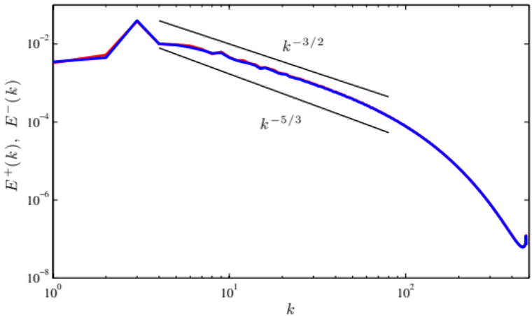
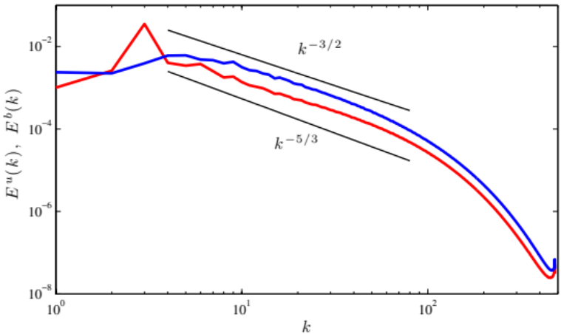

Figure 1: Spectra of velocity (red) Figure 2: Spectra of Elsasser variables,
and magnetic (blue) fields z⁺=u+b (red) and z⁻=u-b (blue)

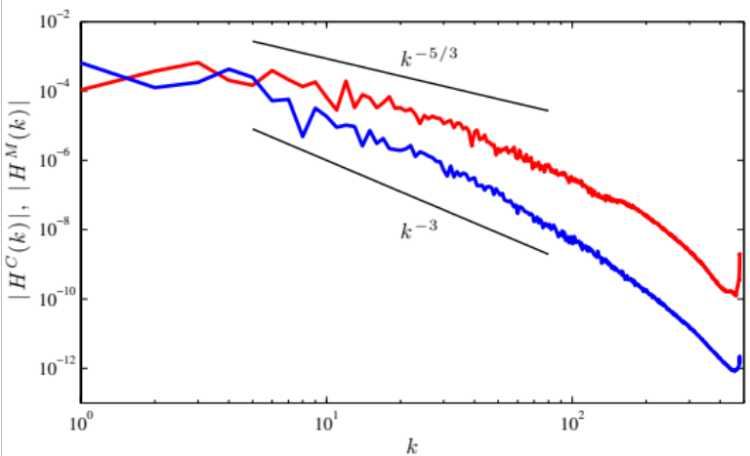

Figure 3: Co-spectra of cross (red) and magnetic (blue) helicity

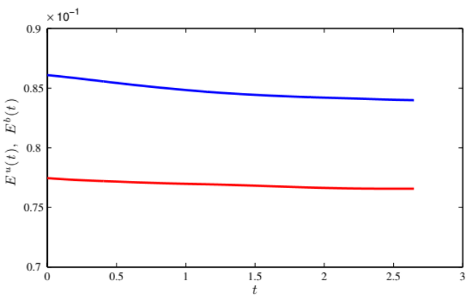
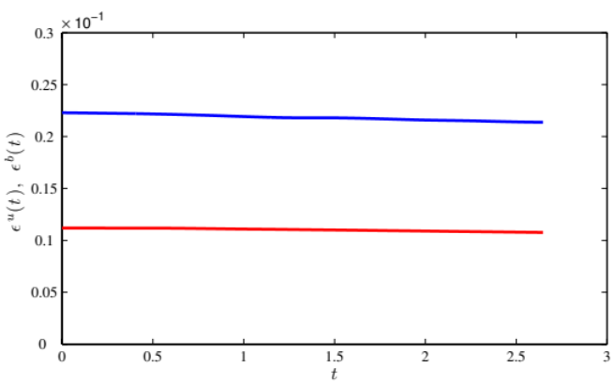

Figure 4: Time-series of kinetic (red) Figure 5: Time-series of kinetic (red)
and magnetic (blue) energy and magnetic (blue) dissipation

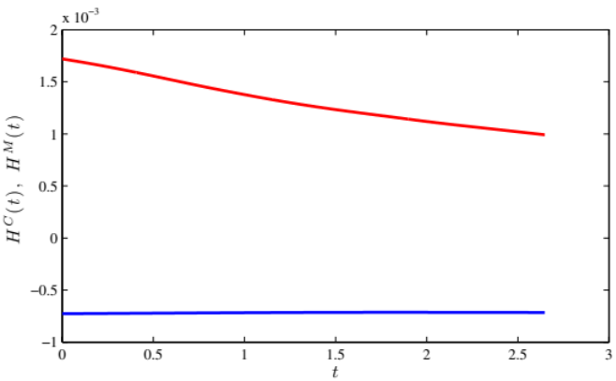

Figure 6: Time-series of cross (red)
and magnetic (blue) helicity

References:

1. H. Aluie. Hydrodynamic and Magnetohydrodynamic Turbulence: Invariants, Cascades, and Locality. PhD thesis, The Johns Hopkins University, Baltimore, 2009. http://search.proquest.com/docview/304916341
2. Patterson G.S. and Orszag S.A., “Spectral calculations of isotropic turbulence: efficient removal of aliasing interactions” Phys. Fluids. 14,2538-2541 (1971).
3. Note: The divergence-free condition in the simulation is enforced based on the spectral representation of the derivatives. The JHTDB analysis tools for gradients are based on finite differencing of various orders. Therefore, when evaluating the divergence using these spatially more localized derivative operators, a non-negligible error in the divergence is obtained, as expected.

