The Johns Hopkins Turbulence Databases (JHTDB)

FORCED ISOTROPIC TURBULENCE DATA SET

Data provenance: M. Wan¹, S. Chen^{1,2}, G. Eyink¹, C. Meneveau¹
Database ingest and Web Services: E. Perlman¹, R. Burns¹, Y. Li¹, A. Szalay¹
¹Johns Hopkins University, Baltimore, MD 21218
²Peking University, Beijing China
The data is from a direct numerical simulation of forced isotropic turbulence on a 1024³ periodic grid, using a pseudo-spectral parallel code. Time integration of the viscous term is done analytically using integrating factor. The other terms are integrated using a second-order Adams-Bashforth scheme and the nonlinear term is written in vorticity form¹. The simulation is de-aliased using phase-shift and a 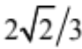 truncation^{2,3}. Energy is injected by keeping constant the total energy in modes such that their wave-number magnitude is less or equal to 2. After the simulation has reached a statistical stationary state, 1,024 frames of data, which includes the 3 components of the velocity vector and the pressure, are generated and ingested into the database. The duration of the stored data is about one large-eddy turnover time.

Simulation parameters:
Domain: 2 x 2 x 2 (i.e. range of x₁ , x₂ and x₃ is [0,2π])
Grid: 1024³
Viscosity () = 0.000185
Simulation time-step 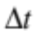 = 0.0002
Data are stored separated by δt = 0.002 (i.e. every 10 DNS time-steps is stored)
Time stored: between t=0 and 2.048 (1024 time samples separated by δt)

Statistical characteristics of turbulence, time averaged over t=0 and 2.048:
Total kinetic energy, 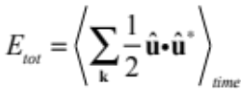: 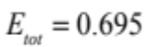
Dissipation, 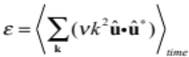: 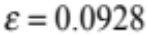
Rms velocity, 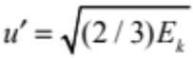: 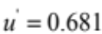
Taylor Micro. Scale 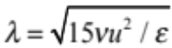: 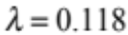
Taylor-scale Reynolds #, 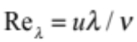: 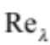=433
Kolmogorov time scale 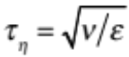: 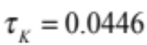
Kolmogorov length scale 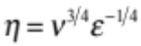: 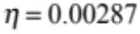
Integral scale: 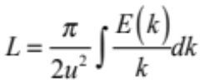: 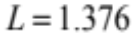
Large eddy turnover time: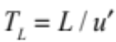: 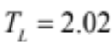
Figures 1 and 2 show radial spectrum and time-series of E_{tot} and Re_{λ}. The values corresponding to the data in the database are for t>0 and shown in solid lines.
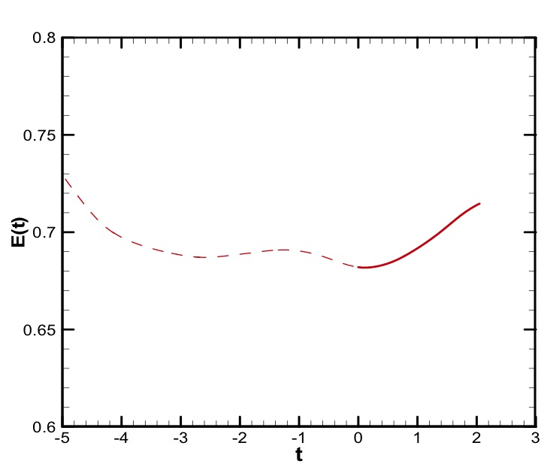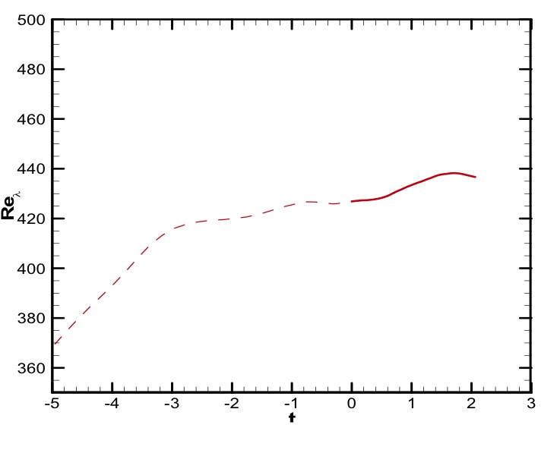
Figure 2: Total kinetic energy (left panel) and micro-scale Reynolds number (right panel) as function of time. Dashed line is times before ingestion into database. Data corresponding to the database is show using solid line between t=0 and 2.048.

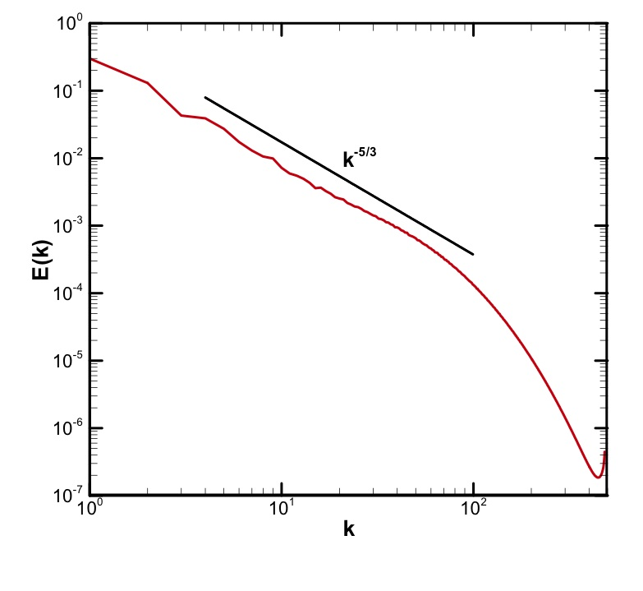
Figure 1: Radial kinetic energy spectrum, averaged in time between t=0 and 2.048.

References:
- Cao N.Z. and Chen S.Y., “Statistics and structures of pressure in isotropic turbulence”. Phys. Fluids. 11.2235-2250 (1999)
- Patterson G.S. and Orszag S.A., “Spectral calculations of isotropic turbulence: efficient removal of aliasing interactions” Phys. Fluids. 14,2538-2541 (1971).
- Note: The divergence-free condition in the simulation is enforced based on the spectral representation of the derivatives. The JHTDB analysis tools for gradients are based on finite differencing of various orders. Therefore, when evaluating the divergence using these spatially more localized derivative operators, a non-negligible error in the divergence is obtained, as expected.

