SQL Server vNext CTP1.3

Contents

Overview 2

What’s New in CTP 1.3 3

Setup 4

Setup Overview 4

Kubernetes Cluster Setup 4

Deploy on Minikube 4

Step 1: Pre-requisites 4

Step 3: Install Minikube 5

Step 4: Create a Minikube cluster 5

Step 5: Disable automatic checkpoint If Using Windows 10/Hyper-V 5

Deploy on Azure Container Services (ACS) 5

Step 1: Pre-Requisites 5

Step 2: Create SSH Keys 6

Step 3: Login to Azure 6

Step 4: Create a resource group 6

Step 5: Create a Service Principal 7

Step 6: Create a Kubernetes cluster 7

Step 7: Connect to the cluster 7

Step 8: Give cluster admin permission to default service account 8

Deploy SQL Server vNext CTP1.3 in Kubernetes cluster 8

Step 1: Verify K8S cluster Config 8

Step 2: Clone the Deployment Project from GitHub 8

Step 3: Deployment 9

Step 4: Getting the IP Address and Port to Connect To 11

SQL Server Big Data Tools 11

Install SQL Operations Studio 11

Install SQL Server Big Data Extension 11

Connect to Cluster 12

Manage your cluster 12

Scale-out Data Management 13

Code snippets to run queries faster 13

End-to-End Transact-SQL Sample 14

STEP 1: Initialize compute cluster 14

STEP 2: Derive table schema from sample file (using Spark) and create SQL Server table schema 15

STEP 3: Start/Stop Spark stream (submit Spark job to Resource Negotiator) 15

STEP 4: Query from the head node 16

STEP 5: Run a simple query against the head node to join high-value and high-volume data 16

Bring your own Data 17

Bring your own data into Compute Pool via opertaions Studio 17

Bring your own data into Compute Pool VIA CURL 17

Bring your high value data into Head Node 18

Troubleshooting 21

Dynamic Management Views 21

dm_compute_pools 21

dm_compute_pool_node_status 21

dm_compute_pool_jobs 21

dm_compute_pool_table_status 22

sp_compute_pool_log 22

Known Issues 22

Unable to connect to SQL Server Head Node in ACS cluster using external IP 22

Querying dm_compute_pools() without creating a compute pool will result in error 23

Latest versions of K8S Utilities 23

Clearning minikube State 23

Windows Only. Error: the systemctl restart crio failed while trying to start minikube 23

# Overview

SQL Server vNext CTP1.3 enables you to integrate your “**high-value**” relational data in SQL Server with your “**high-volume**” data in big data environments such as Hadoop.

CTP1.3 allows you to create and deploy a “**compute pool**” that consists of many “**SQL Server compute instances**” in your Hadoop cluster. You can then ingest your high-volume data from Spark streaming jobs into the SQL Server compute instances by partitioning the data and spreading the partitions across the SQL Server compute instances in the compute pool.

Once the high-volume data is stored in partitions in the SQL Server compute instances on the Hadoop cluster, you can create an “**external table**” in a “**SQL Server head node**” that represents the high-volume data that resides in the partitions stored in the SQL Server compute instances in your Hadoop cluster. This external table can be queried in the head node just like any other table, but in this case a “**fan-out query**” will be *simultaneously* executed against *each* of the SQL Server compute instances to query the partitioned data. The results of these queries will be brought back to the head node and you can optionally choose to join the results of the high-volume data fan-out query with the results of a high-value data query in the SQL Server head node.

The diagram below shows a 5-node configuration (1 head node + 4 compute instances) in a Hadoop cluster with SQL Server and Spark running on each of the instances.

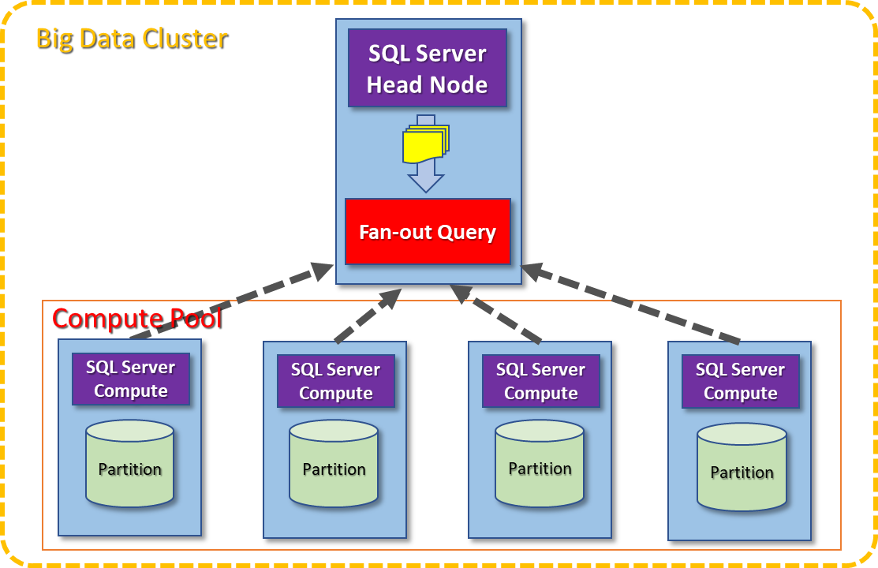

Partition

**SQL Server Compute**

**SQL Server Head Node**

**Fan-out Query**

Big Data Cluster

Compute Pool

This document will walk you through:

* Setup – deploy and configure SQL Server head node & compute pool on Kubernetes
* Stream – initiate Spark streaming jobs to write high-volume data into SQL Server compute pool
* Query – query high-volume data in SQL Server compute pool and combine with high-value data

# What’s New in CTP 1.3

SQL Server vNext CTP 1.3 has the following changes:

1. A new Python-based CLI “mssqlctl” to deploy the compute pool on Kubernetes
2. For ACS environment the minimum VM requirement is now Standard_DS3_V2 which contains 4 CPUs & 14 GB of memory
3. Hive meta-store integration for Spark Jobs
4. Hive metadata database is backed by SQL Server database named “metastore” on the head node
5. Data ingestion from Spark job into the compute pool will now create hive table, generate parquet files & insert data into the SQL tables
6. SQL Server Big Data Extension for SQL Operations Studio to manage the HDFS, Spark Jobs, and Scale-out Data environment
7. Code snippets in SQL Operations Studio for the end-to-end T-SQL sample

# Setup

## Setup Overview

SQL Server vNext CTP1.3 can be deployed as docker containers on a Kubernetes cluster. This is an overview of the setup and configuration steps:

* Setup Kubernetes cluster on a single VM, cluster of VMs or in Azure Container Service
* Deploy SQL Server vNext CTP1.3 in a Kubernetes cluster
* Configure SQL Server Head Node

## Kubernetes Cluster Setup

If you already have a Kubernetes cluster, then you can skip directly to the deployment step. This section assumes a basic understanding of Kubernetes concepts. For detailed information on Kubernetes, see the [Kubernetes documentation](https://kubernetes.io/docs/home/).

You can choose to deploy Kubernetes in any of three ways:

* Minikube – a single-node Kubernetes cluster in a VM
* Azure Container Services – a managed Kubernetes cluster in Azure
* Multiple VMs – Please refer to “**k8s-deployment-multiple-vms.docx**” document in GitHub for instructions

## Deploy on Minikube

**(Skip this section if you plan on using Azure Container Service or your own Kubernetes cluster)**

Minikube is a tool that makes it easy to run Kubernetes on a single machine like a laptop or a desktop. Minikube runs a single-node Kubernetes cluster inside a VM on your laptop for users looking to try out Kubernetes or develop with it day-to-day. **To run a Minikube cluster for CTP1.3, it is recommended that your machine have at least 32 GB of RAM**. If the machine has insufficient memory, then modify the cluster configuration such that only 3 instances are created – 1 head node & 2 compute instances.

### Step 1: Pre-requisites

* VT-x or AMD-v virtualization must be enabled in your computer’s BIOS.
* If you are on Windows, install [Git for Windows](https://git-for-windows.github.io/). If you are on Linux or Mac, install [git](https://git-scm.com/book/en/v2/Getting-Started-Installing-Git).
* Install [kubectl](https://kubernetes.io/docs/tasks/tools/install-kubectl/)
* Install Python 3
  + If pip is missing then download [get-pip.py](https://bootstrap.pypa.io/get-pip.py) and run python get-pip.py
  + Install requests package using python -m pip install requests
* If you do not already have a hypervisor installed, install one now.
* For OS X, install [xhyve driver](https://git.k8s.io/minikube/docs/drivers.md), [VirtualBox](https://www.virtualbox.org/wiki/Downloads), or [VMware Fusion](https://www.vmware.com/products/fusion).
* For Linux, install [VirtualBox](https://www.virtualbox.org/wiki/Downloads) or [KVM](http://www.linux-kvm.org/).
* For Windows, install [VirtualBox](https://www.virtualbox.org/wiki/Downloads) or [Hyper-V](https://msdn.microsoft.com/en-us/virtualization/hyperv_on_windows/quick_start/walkthrough_install).
  + If you do not have an external switch configured in hyper-v, then create one that has external network access. See how to [create external switch in hyper-v for minikube](https://blogs.msdn.microsoft.com/wasimbloch/2017/01/23/setting-up-kubernetes-on-windows10-laptop-with-minikube/).

### Step 3: Install Minikube

Install Minikube according to the instructions for the [v0.24.1 release](https://github.com/kubernetes/minikube/releases/tag/v0.24.1). CTP 1.3 release will work only with v0.24.1.

### Step 4: Create a Minikube cluster

The command below creates a minikube cluster in a Hyper-V VM with 8 CPUs, 28 GB memory, and disk size of 100GB. The disk size is not reserved space. It will grow to that size on disk as needed. We recommend not changing the disk space to something less than 100GB as we ran into problems with this in testing. This also specifies the hyper-v switch with external access explicitly.

**Change the parameters such as --memory as needed depending on your available hardware and which hypervisor you are using. Make sure the --hyper-v virtual-switch parameter value matches the name you used when creating your virtual switch.**

minikube start --vm-driver="hyperv" --cpus 8 --memory 28672 --disk-size 100g --hyperv-virtual-switch "External"

If you are using Minikube with VirtualBox the command would look like this:

minikube start --cpus 8 --memory 28672 --disk-size 100g

### Step 5: Disable automatic checkpoint If Using Windows 10/Hyper-V

On Windows 10, automatic checkpoint is enabled on a VM. Execute the command below in PowerShell to disable automatic checkpoint on the VM.

Set-VM -Name minikube -CheckpointType Disabled -AutomaticCheckpointsEnabled $false

## Deploy on Azure Container Services (ACS)

**(Skip this section if you plan on using Minikube or your own Kubernetes cluster)**

Azure Container Service makes it simple to create, configure, and manage a cluster of virtual machines that are preconfigured with a Kubernetes cluster to run containerized applications. This enables you to use your existing skills or draw upon a large and growing body of community expertise, to deploy and manage container-based applications on Microsoft Azure.

This section describes the steps to deploy Kubernetes on Azure Container Services using Azure CLI. If you don't have an Azure subscription, create a [free account](https://azure.microsoft.com/free/?WT.mc_id=A261C142F) before you begin.

### Step 1: Pre-Requisites

* If you are on Windows, install [Git for Windows](https://git-for-windows.github.io/). If you are on Linux or Mac, install [git](https://git-scm.com/book/en/v2/Getting-Started-Installing-Git).
* Install [kubectl](https://kubernetes.io/docs/tasks/tools/install-kubectl/)
* This section requires that you be running the Azure CLI version 2.0.4 or later. If you need to install or upgrade, see [Install Azure CLI 2.0](https://docs.microsoft.com/en-us/cli/azure/install-azure-cli). Run az --version to find the version if needed.

### Step 2: Create SSH Keys

#### Windows

If you are on Windows, follow these steps to create SSH keys:

Open the **Git Bash shell** from the Start menu.

Run the following commands

mkdir sqlvnextkeys

cd sqlvnextkeys

ssh-keygen -t rsa -b 2048 -f ./id_rsa -N youpassword

#### Linux

If you are on Linux or MacOS, follow these steps to create SSH keys:

Run the following commands at the terminal:

mkdir ~/sqlvnextkeys

cd ~/sqlvnextkeys

ssh-keygen -t rsa -b 2048 -f ./id_rsa -N yourpassword

### Step 3: Login to Azure

**For the remainder of these steps if you are on Windows please use PowerShell.**

At the command prompt run the following command and follow the prompts to login to your Azure subscription:

az login

### Step 4: Create a resource group

Create a resource group with the [az group create](https://docs.microsoft.com/en-us/cli/azure/group) command. An Azure resource group is a logical group in which Azure resources are deployed and managed. The following example creates a resource group named *sqlvnextgroup* in the *westus* location.

az group create --name **sqlvnextgroup** --location westus2

Note: We recommend using only the following locations: ukwest, uksouth, westcentralus, westus2, canadaeast, canadacentral, westindia, southindia, centralindia

### Step 5: Create a Service Principal

Create a service principal that Kubernetes will be used to interact with Azure APIs to manage resources within the service.

You will first need to determine your subscription ID:

az account show

Your subscription ID is the ID property value in the JSON that is returned by the above command. Copy that and replace the <subscriptionID> placeholder in the next command that is used to create the service principal. Make sure you create the service principal in the same resource group that you created above.

az ad sp create-for-rbac --role="Contributor" --scopes="/subscriptions**/<subscriptionID>**/resourceGroups/**sqlvnextgroup**"

**Save the JSON that is returned for future reference.**

### Step 6: Create a Kubernetes cluster

**Wait for 1 minute for the newly created service principal to be available for use in your resource group.**

Create a Kubernetes cluster in Azure Container Service with the [az acs create](https://docs.microsoft.com/en-us/cli/azure/acs) command. The following example creates a cluster named *sqlvnextcluster* with one Linux master node and three Linux agent nodes. Make sure you create the ACS cluster in the same resource group that you created above. You can increase or decrease the default agent count by adding --agent-count <n> to the [az acs create](https://docs.microsoft.com/en-us/cli/azure/acs) command where <n> is the number of agent nodes you want to have.

az acs create --orchestrator-type kubernetes --resource-group **sqlvnextgroup** --name **sqlvnextcluster** --ssh-key-value=**~/sqlvnextkeys/id_rsa.pub** --agent-vm-size=Standard_DS3_v2--master-vm-size=Standard_DS3_v2--master-storage-profile=ManagedDisks--agent-storage-profile**=**ManagedDisks --agent-count=2

After several minutes, the command completes and returns JSON-formatted information about the cluster.

**Save the JSON that is returned for future reference.**

### Step 7: Connect to the cluster

To manage a Kubernetes cluster, use [kubectl](https://kubernetes.io/docs/user-guide/kubectl/), the Kubernetes command-line client. To install it locally, you can use the [az acs kubernetes install-cli](https://docs.microsoft.com/en-us/cli/azure/acs/kubernetes) command.

To configure kubectl to connect to your Kubernetes cluster, run the [az acs kubernetes get-credentials](https://docs.microsoft.com/en-us/cli/azure/acs/kubernetes) command. This step downloads credentials and configures the Kubernetes CLI to use them.

az acs kubernetes get-credentials --resource-group=**sqlvnextgroup** --name **sqlvnextcluster** --ssh-key-file=**~/sqlvnextkeys/id_rsa**

You will be asked to enter the password that you used when you created the SSH keys above.

To verify the connection to your cluster, use the [kubectl get](https://kubernetes.io/docs/user-guide/kubectl/v1.6/) command to return a list of the cluster nodes.

kubectl get nodes

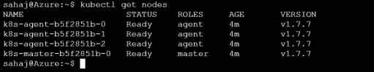

### Step 8: Give cluster admin permission to default service account

Before running the cluster deployment script, you need to grant cluster admin permission to the default service account. You can use the following kubectl command.

**(NOTE: This step is a workaround and recommended only on test clusters. In future CTP, we will have a service account for controller that will not require giving cluster admin permission to default service account.)**

kubectl create clusterrolebinding add-on-cluster-admin --clusterrole=cluster-admin --serviceaccount=default:default

# Deploy SQL Server vNext CTP1.3 in Kubernetes cluster

Now that there is a Kubernetes cluster setup using Minikube, ACS or VMs, you can proceed with the deployment for SQL Server vNext CTP1.3. This step can be repeated to recreate the environment if needed.

**Before starting the deployment, you need the credentials to the private docker registry containing SQL Server vNext CTP1.3 images. This should be provided to you by your PM buddy. If you have not already received them, please contact your PM buddy.**

### Step 1: Verify K8S cluster Config

Execute the below kubectl command to view the cluster configuration. Ensure that kubectl is pointed to the correct cluster context.

kubectl config view

### Step 2: Clone the Deployment Project from GitHub

First, in PowerShell or a cmd window, navigate to the directory that you want to contain the deployment project files.

Then, run the following command to clone the files from GitHub to your machine:

git clone https://github.com/annashres/sqleapvnext.git

### Step 3: Deployment

The deployment commands are slightly different if using Windows or Linux. Choose the steps below depending on which operating system you are using.

#### Windows

Using a **CMD** window (**not PowerShell**), navigate to the **ctp1.3\kube\deployment\mssql-compute-pool** folder. Initialize the following environment variables first. You can set the MSSQL passwords to whatever you like but make sure they are sufficiently complex and don’t use the ! & or ‘ characters. Enter the Docker username and password that are available in the EAP Portal.

SET CLUSTER_NAME=default

SET CLUSTER_PLATFORM=minikube or acs or aks

SET CLUSTER_NODE_REPLICAS=<number_of_nodes_excluding_master>

SET CONTROLLER_USERNAME=<controller_admin_name – can be anything>

SET CONTROLLER_PASSWORD=<controller_admin_password – can be anything>

SET DOCKER_REGISTRY=private-repo.microsoft.com

SET DOCKER_REPOSITORY=mssql-private-preview

SET DOCKER_USERNAME=<your_user_name>

SET DOCKER_PASSWORD=<your_password>

SET DOCKER_EMAIL=<your_email>

SET DOCKER_IMAGE_TAG=ctp-1.3

SET MSSQL_SA_PASSWORD=<sa_password_of_sql_instances>

SET MSSQL_IMPORT_PASSWORD=<import_account_password_of_sql_instances>

SET MSSQL_EXTERNAL_PASSWORD=<external_account_password_of_sql_instances>

NOTE: Characters ! & ' cannot be used in the MSSQL passwords.

Run this command:

python mssqlctl create

You can ignore the initial error messages about various resources not being found.

**This step can take several minutes to run.**

While the command window is showing the status, you can check the deployment status by running this command:

kubectl describe pod mssql-compute-pool-**master**-0

While the command window is showing the status, you can check the deployment status by running this command:

kubectl describe pod mssql-compute-pool-**node**-0

#### Linux

Navigate to the **ctp1.3/kube/deployment/mssql-compute-pool** folder. Initialize the following environment variables first. You can set the MSSQL passwords to whatever you like but make sure they are sufficiently complex and don’t use the ! & or ‘ characters. Enter the Docker username and password that are available in the EAP Portal.

export CLUSTER_NAME=default

export CLUSTER_PLATFORM=minikube or acs or aks

export CLUSTER_NODE_REPLICAS=<number_of_nodes_excluding_master>

export CONTROLLER_USERNAME=<controller_admin_name – can be anything>

export CONTROLLER_PASSWORD=<controller_admin_password – can be anything>

export DOCKER_REGISTRY=private-repo.microsoft.com

export DOCKER_REPOSITORY=mssql-private-preview

export DOCKER_USERNAME=<your_user_name>

export DOCKER_PASSWORD=<your_password>

export DOCKER_EMAIL=<your_email>

export DOCKER_IMAGE_TAG=ctp-1.3

export MSSQL_SA_PASSWORD=<sa_password_of_sql_instances>

export MSSQL_IMPORT_PASSWORD=<import_account_password_of_sql_instances>

export MSSQL_EXTERNAL_PASSWORD=<external_account_password_of_sql_instances>

NOTE: Characters ! & ' cannot be used in the MSSQL passwords.

Run this command:

python mssqlctl create

You can ignore the initial error messages about various resources not being found.

**This step can take several minutes to run.**

While the command window is showing the status, you can check the deployment status by running this command:

kubectl describe pod mssql-compute-pool-**master**-0

While the command window is showing the status, you can check the deployment status by running this command:

kubectl describe pod mssql-compute-pool-**node**-0

There will probably be multiple compute pool pods number 0-n. You can run the above command to see the status of each of them as they are deploying by changing the number at the end.

### Step 4: Getting the IP Address and Port to Connect To

After the deployment script has completed successfully, you can obtain the IP address of the SQL Server head node using the steps outlined below.

#### Using ACS/AKS

Azure provides Azure LoadBalancer service to ACS. Run following command:

kubectl get svc service-master-nodeport

Look for the **External-IP** value that is assigned to the service. Then, connect to the SQL Server head node instance using the IP address at port **31433** (Ex: <ip-address>,31433).

#### Using Minikube

If you are using **Minikube,** you need to run the following command to get the IP address you need to connect to.

minikube ip

You will use this IP address & port number **31433** to connect to the SQL Server head node (Ex: <ip-address>,31433).

# SQL Server Big Data Tools

## Install SQL Operations Studio

* Download the version of SQL Operations Studio for your OS from <https://github.com/annashres/sqleapvnext/releases>
* Unzip the file and run the application. We recommend using 7zip on Windows.

## Install SQL Server Big Data Extension

* Download the extension from <https://github.com/annashres/sqleapvnext/releases>
* In SQL Operations Studio hit F1 to open the action bar and type “Extensions: Install from VSIX”, then hit enter to select this action.
* Choose the VSIX file you just downloaded and click Install.
* You will be prompted to reload SQL Operations Studio – click the Reload button as requested.

### Connect to Cluster

* In SQL Operations Studio, hit F1 -> New Connection and you can connect to your SQL Server rest endpoint. (Example: ‘<IP Address>,31433’). **Connect to the high_value_data database.**

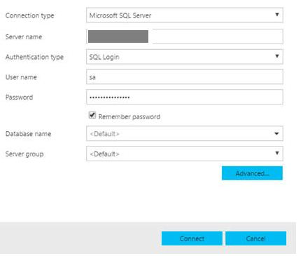

Click Connect, and the Server Dashboard will appear. You are now connected and can run queries etc.

### Manage your cluster

The Server Dashboard is set up to enable you to view built-in cluster manageability features. To see available features, click the “+” button beside HOME. Select all the features in the list and click OK.



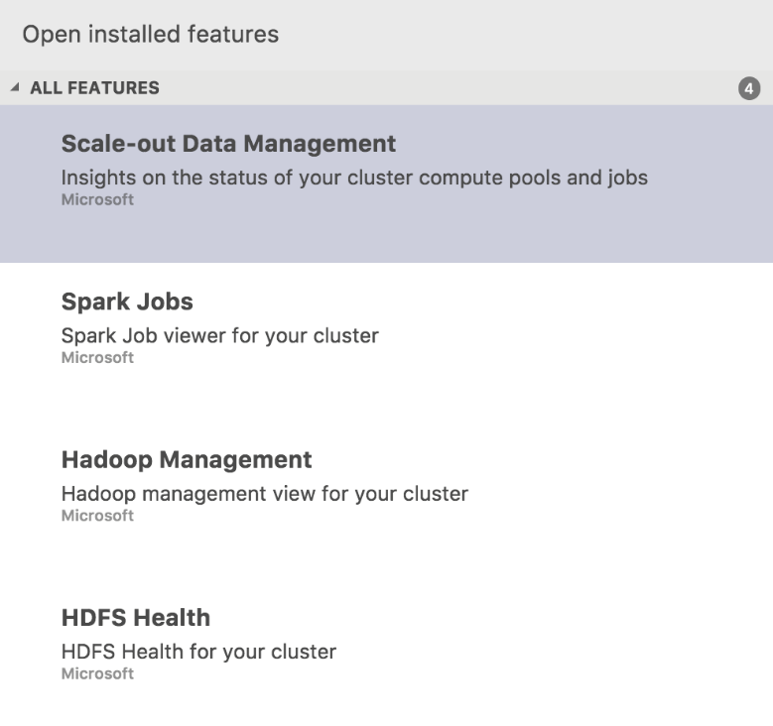

### Scale-out Data Management

The Scale-out Data Management feature shows information about Compute Pools and any Spark jobs you will be running by following this Getting Started guide. It will also show tabs with information about Hadoop and HDFS.

Click each of the tabs to see the information available.



### Code snippets to run queries faster

The next set of steps in the getting started guide will be run as T-SQL queries. For convenience we have created snippets that are now installed by the extension.

Typing “***compute”*** in the Query Editor window will show the following code snippets to choose from –

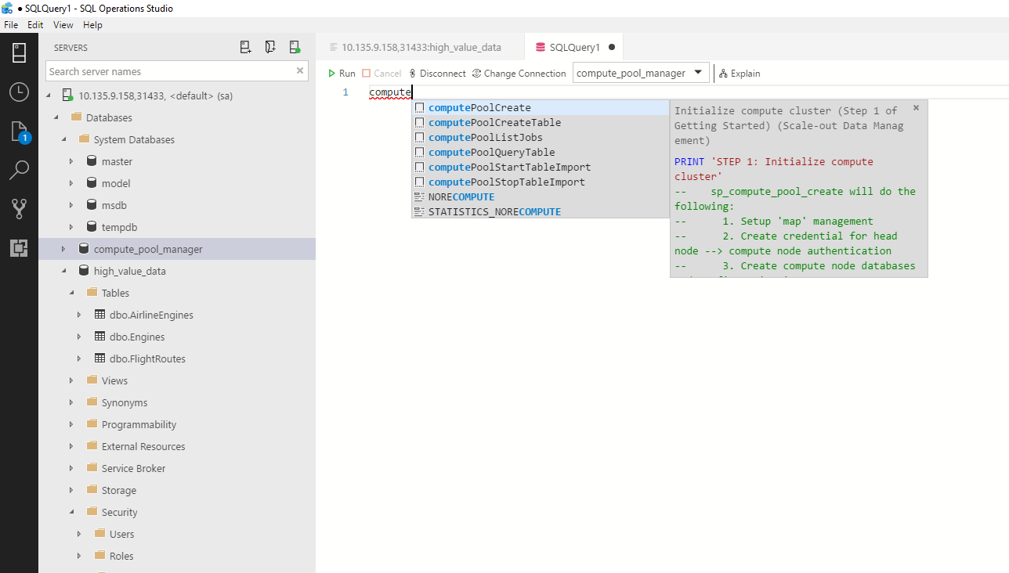

# End-to-End Transact-SQL Sample

## STEP 1: Initialize compute cluster

Connect to the head node using the IP address / port number (31433) obtained at the end of the deployment script. You can now create a compute pool on the head node. Execute the batch below to create a compute pool that consists of 2 instances. If you modified the number of compute instances in the ss-node.yml above, then change the value of **@cluster_node_count** variable to match.

Selecting the ***computePoolCreate*** Code snippet will auto populate the T-SQL script to create the compute pools in the cluster or you can copy/paste in the code.

USE high_value_data

GO

DECLARE @compute_pool_name NVARCHAR(max) = 'mssql-compute-pool'

DECLARE @cluster_node_count INT = 2

PRINT 'STEP 1: Initialize compute cluster'

--sp_compute_pool_create will do the following:

-- 1. setup up 'map' management

-- 2. create credential for head node --> compute node authentication

-- 3. create compute node databases and configure 'map'

-- 4. create EXTERNAL DATASOURCE on head node for compute cluster

--

EXEC sp_compute_pool_create @compute_pool_name, @cluster_node_count

GO

## STEP 2: Derive table schema from sample file (using Spark) and create SQL Server table schema

After successful creation of the compute pool, you can now configure the compute instances to receive data from a Spark streaming job and query the data from the head node. For this example, we will derive the schema of the table in SQL Server from a sample file that resides on an HDFS volume on the newly created cluster. Execute the batch below to create an external table (airlinedata) on the head node and tables on the compute instances to hold data from the Spark streaming job.

Selecting the ***computePoolCreateTable*** Code snippet will create Spark and SQL Server External Table from sample and will auto-fill the T-SQL statement or you can copy/paste in the code.

USE high_value_data

GO

PRINT 'STEP 2: Derive table schema from sample file (using Spark) and create SQL Server table schema'

-- sp_compute_pool_create_table will do the following:

--    1. Submit Resource Negotiator request to submit Spark job to derive T/SQL schema

--    2. Create TABLE on each compute node

--    3. Create EXTERNAL TABLE on the head node

--

DECLARE @compute_pool_name NVARCHAR(max) = 'mssql-compute-pool'

DECLARE @table_name NVARCHAR(max) = 'airlinedata'

DECLARE @sample_file_name NVARCHAR(max) = 'hdfs:///airlinedata/airlinedata_sample.csv'

EXEC sp_compute_pool_create_table @compute_pool_name, @table_name, @sample_file_name

GO

## STEP 3: Start/Stop Spark stream (submit Spark job to Resource Negotiator)

Now, you can start streaming data from a Spark streaming job into the compute instances. Execute the batch below to start a Spark streaming job that will stream data into the table airlinedata on each compute node.

Selecting the ***computePoolStartTableImport*** Code snippet will start data import via Spark job submission and will auto-fill the T-SQL statement.

USE high_value_data

GO

PRINT 'STEP 3: Start/Stop Spark stream (Submit Spark job to Resource Negotiator)'

--  Submit Spark job to ingest data from specified folder (files) into compute instances

--

DECLARE @compute_pool_name NVARCHAR(max) = 'mssql-compute-pool'

DECLARE @table_name NVARCHAR(max) = 'airlinedata'

DECLARE @source_folder NVARCHAR(max) = 'hdfs:///airlinedata'

EXEC sp_compute_pool_start_import @compute_pool_name, @table_name, @source_folder;

GO

## STEP 4: Query from the head node

After the streaming job has been successfully started, you can now query the data from the head node. Execute the batch below to run some sample queries. If you run the query a few times you should see that the number of rows in the results is increasing as the data is continuously ingested into the compute instances via the Spark streaming job.

Selecting the ***computePoolQueryTable*** Code snippet will run a simple query against the head node and will auto-fill the T-SQL statement.

**Note: it may take a few minutes to populate the data in the tables from the source data files.**

USE high_value_data

GO

-- View data via fan-out queries

--

SELECT count(*) FROM airlinedata

SELECT TOP 10 * FROM airlinedata

GO

## STEP 5: Run a simple query against the head node to join high-value and high-volume data

Now that you have populated the high-volume streaming data into the compute instances, you can execute the script “**prepare_high_value_db_view.sql**” script under the /**samples-tsql** folder to create some sample high-value data in the head node.

The last step is a to execute a query to join the high-volume data in the compute instances represented by the newly created view AirlineEngineSensorDataNorm with the high-value data in AirlineEngines, AircraftRegistration, and FlightRoutes.

USE high_value_data

GO

-- Join high-value data with the high-volume data in compute pool

--

SELECT E.AircraftRegistration, F.Origin, F.Destination, A.*

FROM AirlineEngineSensorDataNorm AS A

JOIN high_value_data.dbo.AirlineEngines AS E

ON E.EngineId = A.EngineId

JOIN high_value_data.dbo.FlightRoutes AS F

ON F.AircraftRegistration = E.AircraftRegistration AND F.EngineId = E.EngineId

WHERE A.EngineId IN (9, 48);

GO

# Bring your own Data

### Bring your own data into Compute Pool via opertaions Studio

You can view what files are in the cluster and upload files to get started analyzing data from inside SQL Operations Studio.

* + To get started, open the HDFS Health tab in the Dashboard which will automatically connect to the HDFS filesystem
  + Go to the Files view, and you’ll see a HDFS Files section with remote files
  + Right-click on a folder and choose “Upload files to HDFS” to select files & folders to be uploaded.
  + You can now access these files for use in Spark jobs and to create external tables over them

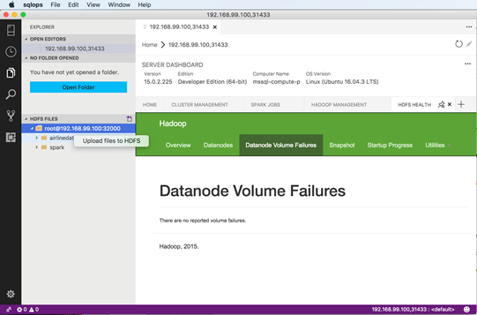

### Bring your own data into Compute Pool VIA CURL

Httpfs is started when deployment is completed. The service port is set at 32000 (default port 14000 but we mapped it to 32000). Once the deployment completes, we can use the following command to access hdfs.

To list file under hdfs:///airlinedata:

**curl "http://<host_ip_address>:32000/webhdfs/v1/airlinedata/?user.name=root&op=liststatus’** **http://<host_ip_address>:32000/webhdfs/v1/airlinedata/?user.name=root&op=liststatus’**

To put a new file ext1.csv from local directory to airlinedata directory (Content-Type parameter is required):

**curl -i -X PUT -T ext1.csv ‘http://<host_ip_address>:32000/webhdfs/v1/airlinedata/ext1.csv?user.name=root&op=create&data=true’ -H ‘Content-Type: application/octet-stream’**

To get a file from airlinedata directory:

**curl ‘**[**http://** **<host_ip_address>:32000/webhdfs/v1/airlinedata/ext1.csv?user.name=root&op=open**](http://10.135.9.28:32000/webhdfs/v1/airlinedata/ext1.csv?user.name=root&op=open)**’ > ext1.csv.cop0079**

To create a directory “test” under hdfs:///:

**curl -i -X PUT ‘http://<host_ip_address>:32000/webhdfs/v1/test?op=mkdirs&user.name=root’**

Possible commands that we can submit through httpfs are listed below:

    OPEN(HTTP_GET),

    GETFILESTATUS(HTTP_GET),

    LISTSTATUS(HTTP_GET),

    GETHOMEDIRECTORY(HTTP_GET),

    GETCONTENTSUMMARY(HTTP_GET),

    GETFILECHECKSUM(HTTP_GET),

    GETFILEBLOCKLOCATIONS(HTTP_GET),

    INSTRUMENTATION(HTTP_GET),

    GETACLSTATUS(HTTP_GET),

    APPEND(HTTP_POST),

    CONCAT(HTTP_POST),

    CREATE(HTTP_PUT),

    MKDIRS(HTTP_PUT),

    RENAME(HTTP_PUT),

    SETOWNER(HTTP_PUT),

    SETPERMISSION(HTTP_PUT),

    SETREPLICATION(HTTP_PUT),

    SETTIMES(HTTP_PUT),

    MODIFYACLENTRIES(HTTP_PUT),

    REMOVEACLENTRIES(HTTP_PUT),

    REMOVEDEFAULTACL(HTTP_PUT),

    REMOVEACL(HTTP_PUT),

    SETACL(HTTP_PUT),

    DELETE(HTTP_DELETE),

    SETXATTR(HTTP_PUT),

    GETXATTRS(HTTP_GET),

    REMOVEXATTR(HTTP_PUT),

    LISTXATTRS(HTTP_GET);

### Bring your high value data into Head Node

To bring an existing SQL Server database into the Head Node, we recommend backup and restore.

1. **Backup your existing SQL Server database**

$ sqlcmd -S <server_name> -U <username> -P <password> -Q "BACKUP DATABASE <db_name> TO DISK='<path>\<db_name>.bak'"

1. **Get list of pods from Kubernetes cluster**

Note the name of the pod with <compute_pool_name>-master-0. This is the SQL Server head node.

$ kubectl get pods

NAME READY STATUS RESTARTS AGE

mssql-compute-pool-master-0 2/2 Running 0 1h

mssql-compute-pool-node-0 2/2 Running 0 1h

mssql-compute-pool-node-1 2/2 Running 0 1h

mssql-compute-pool-node-2 2/2 Running 0 1h

mssql-compute-pool-node-3 2/2 Running 0 1h

mssql-compute-pool-node-4 2/2 Running 0 1h

mssql-compute-pool-node-5 2/2 Running 0 1h

mssql-compute-pool-node-6 2/2 Running 0 1h

mssql-compute-pool-node-7 2/2 Running 0 1h

1. **Copy backup file to the SQL Server container in the master pod of the Kubernetes cluster**

$kubectl cp <path>\<db_name>.bak mssql-compute-pool-master-0:/tmp/ -c mssql-compute-pool-data

1. **Verify that the backup file was copied to the pod container**

$ kubectl exec -it mssql-compute-pool-master-0 -c mssql-compute-pool-data -- bin/bash

root@mssql-compute-pool-master-0:/# cd tmp

root@mssql-compute-pool-master-0:/tmp# ls

<db_name>.bak

root@mssql-compute-pool-master-0:/tmp# exit

exit

1. **Find the Head node SQL Server IP address**

$ kubectl get services

NAME TYPE CLUSTER-IP EXTERNAL-IP PORT(S)

AGE

kubernetes ClusterIP 10.0.0.1 <none> 443/TCP

2d

service-master ClusterIP None <none> 8088/TCP,50070/TCP,50075/TCP,50020/TCP,9000/TCP,50010/TCP,8030/TCP,8031/TCP,8032/TCP,8033/TCP,8040/TCP,8042/TCP,8080/TCP,1433/TCP,9995/TCP,8090/TCP,14000/TCP 12m

service-master-nodeport LoadBalancer 10.0.111.236 40.84.230.63 31000:31912/TCP,30001:31035/TCP,30002:30723/TCP,31433:31651/TCP,30003:31311/TCP,30004:31219/TCP,32000:30335/TCP 12m

service-node ClusterIP None <none> 8088/TCP,50070/TCP,50075/TCP,50020/TCP,9000/TCP,50010/TCP,8030/TCP,8031/TCP,8032/TCP,8033/TCP,8040/TCP,8042/TCP,1433/TCP 8m

1. **Restore the database backup to Head node SQL Server**

$ sqlcmd -S <head_node_ip> -U <username> -P <password> -Q "RESTORE FILELISTONLY FROM DISK='/tmp/<db_name>.bak'"

LogicalName PhysicalName Type FileGroupName Size MaxSize FileId CreateLSN DropLSN UniqueId ReadOnlyLSN ReadWriteLSN BackupSizeInBytes SourceBlockSize FileGroupId LogGroupGUID DifferentialBaseLSN DifferentialBaseGUID IsReadOnly IsPresent TDEThumbprint SnapshotUrl

-------------------------------------------------------------------------------------------------------------------------------- ---------------------------------------------

FlightDemo C:\Demo\sqlservr\data\FlightDemo.mdf D PRIMARY 8388608 35184372080640 1 0 0 C5EABDE0-49D0-4FF5-A80A-BC50C45B5321 0 0 3604480 4096 1 NULL 0 00000000-0000-0000-0000-000000000000 0 1 NULL NULL

FlightDemo_log C:\Demo\sqlservr\data\FlightDemo_log.ldf L NULL 8388608 2199023255552 2 0 0 F45ABB16-1BDC-48F8-97C6-AE4B41347600 0 0 0 4096 0 NULL 0 00000000-0000-0000-0000-000000000000 0 1 NULL NULL

(2 rows affected)

$ sqlcmd -S <head_node_ip> -U <username> -P <password> -Q "RESTORE DATABASE <db_name> FROM DISK='/tmp/<db_name>.bak' WITH MOVE '<db_name>' TO '/tmp/<db_name>.mdf', MOVE '<db_name>_log' TO '/tmp/<db_name>.ldf'"

Processed 440 pages for database 'FlightDemo', file 'FlightDemo' on file 1.

Processed 3 pages for database 'FlightDemo', file 'FlightDemo_log' on file 1.

Converting database 'FlightDemo' from version 857 to the current version 888.

RESTORE DATABASE successfully processed 443 pages in 0.456 seconds (7.581 MB/sec).

1. **Setup compute pool stored procedures**

Execute “**high-value-db-configuration\compute_pool_ddl_install.SQL**” script

1. **Setup supportability stored procedures**

Execute “**high-value-db-configuration\supportability.SQL**” script

# Troubleshooting

## Dynamic Management Views

The sample database (high_value_data) created by the deployment script already contains the dynamic management views for troubleshooting. The following new dynamic management views are available for troubleshooting.

### dm_compute_pools

This DMV shows the number of nodes in the compute pool

|  |  |
| --- | --- |
| Column | Description |
| Name | Compute pool name |
| Nodes | Number of compute node in a compute pool |

Example usage

SELECT * FROM dm_compute_pools ()

### dm_compute_pool_node_status

This DMV returns the status of all compute nodes in the compute pool.

|  |  |
| --- | --- |
| Column | Description |
| Node_id | Computer node id |
| State | State of the compute node |
| Connection_time |  |
| version | Version of sql server running on the compute node |

Example usage

DECLARE @compute_pool_name NVARCHAR(max) = 'mssql-compute-pool'

SELECT * FROM dm_compute_pool_node_status (@compute_pool_name)

### dm_compute_pool_jobs

|  |  |
| --- | --- |
| This DMV returns information about the spark job that was submitted by T-SQL command. Column | Description |
| Duration | Duration that spark job ran |
| Class_path | Spark job class name |
| Start_time | Spark job execution start time |
| Context | Spark job context name |
| Status | Status of spark job |
| Job_id | Spark job id |
| Result_message | Spark job result message |

Example usage

DECLARE @compute_pool_name NVARCHAR(max) = 'mssql-compute-pool'

SELECT * FROM dm_compute_pool_jobs(@compute_pool_name)

### dm_compute_pool_table_status

This DMV returns number of rows in compute node external tables.

|  |  |
| --- | --- |
| Column | Description |
| Node_id | Compute node id |
| Rows | Number of row in an external table in the compute node |

Example usage

DECLARE @compute_pool_name NVARCHAR(max) = 'mssql-compute-pool'

DECLARE @table_name NVARCHAR(max) = 'airlinedata'

SELECT * FROM dm_compute_pool_table_status (@compute_pool_name, @table_name)

## sp_compute_pool_log

This store procedure shows the log of all the compute pool operations. You can use this stored procedure to troubleshoot the commands between head node & compute nodes and spark job server.

# Known Issues

## Unable to connect to SQL Server Head Node in ACS cluster using external IP

You may receive an error saying that the certificate authority cannot be trusted while trying to connect to the SQL Server head node in ACS cluster. Error message will look like below:

A connection was successfully established with the server, but then an error occurred during the login process. (provider: SSL Provider, error: 0 - The certificate chain was issued by an authority that is not trusted.) (.Net SqlClient Data Provider)

You can workaround by enabling the “Trust server certificate” option in the SSMS Connection Dialog box. (Click Options & option is on the Connection Properties tab)

## Querying dm_compute_pools() without creating a compute pool will result in error

The dm_compute_pools DMV should be executed only after running sp_compute_pool_create. If there are no compute pools defined, then you will get the error below which is expected:

Msg 6522, Level 16, State 1, Line 10

A .NET Framework error occurred during execution of user-defined routine or aggregate "dm_compute_pools":

System.Exception: ERROR: There are no external_data_sources in this database.  HINT: Run 'sp_compute_pool_create' which will create an EXTERNAL DATASOURCE to the 'compute_pool_manager' database

System.Exception:

   at Microsoft.SqlServer.ComputePoolManagement.Dmvs.ComputePoolDmvs.GetPools()

   at Microsoft.SqlServer.ComputePoolManagement.SqlClr.Supportabilty.<>c.<GetPools>b__7_0()

   at Microsoft.SqlServer.ComputePoolManagement.SqlClr.SqlClrAbstractBase.ExceptionInterceptor[T](Func`1 func)

   at Microsoft.SqlServer.ComputePoolManagement.SqlClr.Supportabilty.GetPools()

## Latest versions of K8S Utilities

Ensure that you have the latest version of minikube & kubectl utilities.

## Clearning minikube State

If you encounter issues with minikube related to stale docker images or unable to start the VM errors then run the following commands:

minikube stop

minikube delete

And remove the “%userprofile%\.minikube” or “$home/.minikube” directory before trying to start the VM again. This will ensure that you have a clean environment.

## Windows Only. Error: the systemctl restart crio failed while trying to start minikube

Depending on the resources on your machine, you might get error about some service restart “the systemctl restart crio failed” while trying to start a minikube cluster. This error can happen on Windows 10 since VMs by default will use dynamic memory and system may not be responsive enough. To switch off dynamic memory, use the following steps:

minikube stop

set-vm -Name minikube -StaticMemory

minikube start