# Zu Aufgabe 4

Bitte diese Seiten auf Folie ausdrucken.

|  |  |  |  |  |  |  |  |  |  |  |  |  |  |  |  |  |  |  |  |  |  |
| --- | --- | --- | --- | --- | --- | --- | --- | --- | --- | --- | --- | --- | --- | --- | --- | --- | --- | --- | --- | --- | --- |
|  |  |  |  |  |  |  |  |  |  |  |  |  |  |  |  |  |  |  |  |  |  |
|  |  |  |  |  |  |  |  |  |  |  |  |  |  |  |  |  |  |  |  |  |  |
|  |  |  |  |  |  |  |  |  |  |  |  |  |  |  |  |  |  |  |  |  |  |
|  |  |  |  |  |  |  |  |  |  |  |  |  |  |  |  |  |  |  |  |  |  |
|  |  |  |  |  |  |  |  |  |  |  |  |  |  |  |  |  |  |  |  |  |  |
|  |  |  |  |  |  |  |  |  |  |  |  |  |  |  |  |  |  |  |  |  |  |
|  |  |  |  |  |  |  |  |  |  |  |  |  |  |  |  |  |  |  |  |  |  |
|  |  |  |  |  |  |  |  |  |  |  |  |  |  |  |  |  |  |  |  |  |  |
|  |  |  |  |  |  |  |  |  |  |  |  |  |  |  |  |  |  |  |  |  |  |
|  |  |  |  |  |  |  |  |  |  |  |  |  |  |  |  |  |  |  |  |  |  |
|  |  |  |  |  |  |  |  |  |  |  |  |  |  |  |  |  |  |  |  |  |  |
|  |  |  |  |  |  |  |  |  |  |  |  |  |  |  |  |  |  |  |  |  |  |
|  |  |  |  |  |  |  |  |  |  |  |  |  |  |  |  |  |  |  |  |  |  |
|  |  |  |  |  |  |  |  |  |  |  |  |  |  |  |  |  |  |  |  |  |  |
|  |  |  |  |  |  |  |  |  |  |  |  |  |  |  |  |  |  |  |  |  |  |
|  |  |  |  |  |  |  |  |  |  |  |  |  |  |  |  |  |  |  |  |  |  |
|  |  |  |  |  |  |  |  |  |  |  |  |  |  |  |  |  |  |  |  |  |  |
|  |  |  |  |  |  |  |  |  |  |  |  |  |  |  |  |  |  |  |  |  |  |
|  |  |  |  |  |  |  |  |  |  |  |  |  |  |  |  |  |  |  |  |  |  |
|  |  |  |  |  |  |  |  |  |  |  |  |  |  |  |  |  |  |  |  |  |  |

# Zu Aufgabe 4

Bitte diese Seiten auf Folie ausdrucken.

|  |  |  |  |  |  |  |  |  |  |  |  |  |  |  |  |  |  |  |  |  |  |
| --- | --- | --- | --- | --- | --- | --- | --- | --- | --- | --- | --- | --- | --- | --- | --- | --- | --- | --- | --- | --- | --- |
|  |  |  |  |  |  |  |  |  |  |  |  |  |  |  |  |  |  |  |  |  |  |
|  |  |  |  |  |  |  |  |  |  |  |  |  |  |  |  |  |  |  |  |  |  |
|  |  |  |  |  |  |  |  |  |  |  |  |  |  |  |  |  |  |  |  |  |  |
|  |  |  |  |  |  |  |  |  |  |  |  |  |  |  |  |  |  |  |  |  |  |
|  |  |  |  |  |  |  |  |  |  |  |  |  |  |  |  |  |  |  |  |  |  |
|  |  |  |  |  |  |  |  |  |  |  |  |  |  |  |  |  |  |  |  |  |  |
|  |  |  |  |  |  |  |  |  |  |  |  |  |  |  |  |  |  |  |  |  |  |
|  |  |  |  |  |  |  |  |  |  |  |  |  |  |  |  |  |  |  |  |  |  |
|  |  |  |  |  |  |  |  |  |  |  |  |  |  |  |  |  |  |  |  |  |  |
|  |  |  |  |  |  |  |  |  |  |  |  |  |  |  |  |  |  |  |  |  |  |
|  |  |  |  |  |  |  |  |  |  |  |  |  |  |  |  |  |  |  |  |  |  |
|  |  |  |  |  |  |  |  |  |  |  |  |  |  |  |  |  |  |  |  |  |  |
|  |  |  |  |  |  |  |  |  |  |  |  |  |  |  |  |  |  |  |  |  |  |
|  |  |  |  |  |  |  |  |  |  |  |  |  |  |  |  |  |  |  |  |  |  |
|  |  |  |  |  |  |  |  |  |  |  |  |  |  |  |  |  |  |  |  |  |  |
|  |  |  |  |  |  |  |  |  |  |  |  |  |  |  |  |  |  |  |  |  |  |
|  |  |  |  |  |  |  |  |  |  |  |  |  |  |  |  |  |  |  |  |  |  |
|  |  |  |  |  |  |  |  |  |  |  |  |  |  |  |  |  |  |  |  |  |  |
|  |  |  |  |  |  |  |  |  |  |  |  |  |  |  |  |  |  |  |  |  |  |
|  |  |  |  |  |  |  |  |  |  |  |  |  |  |  |  |  |  |  |  |  |  |

# Zu Aufgabe 4

Bitte diese Seiten auf Folie ausdrucken.

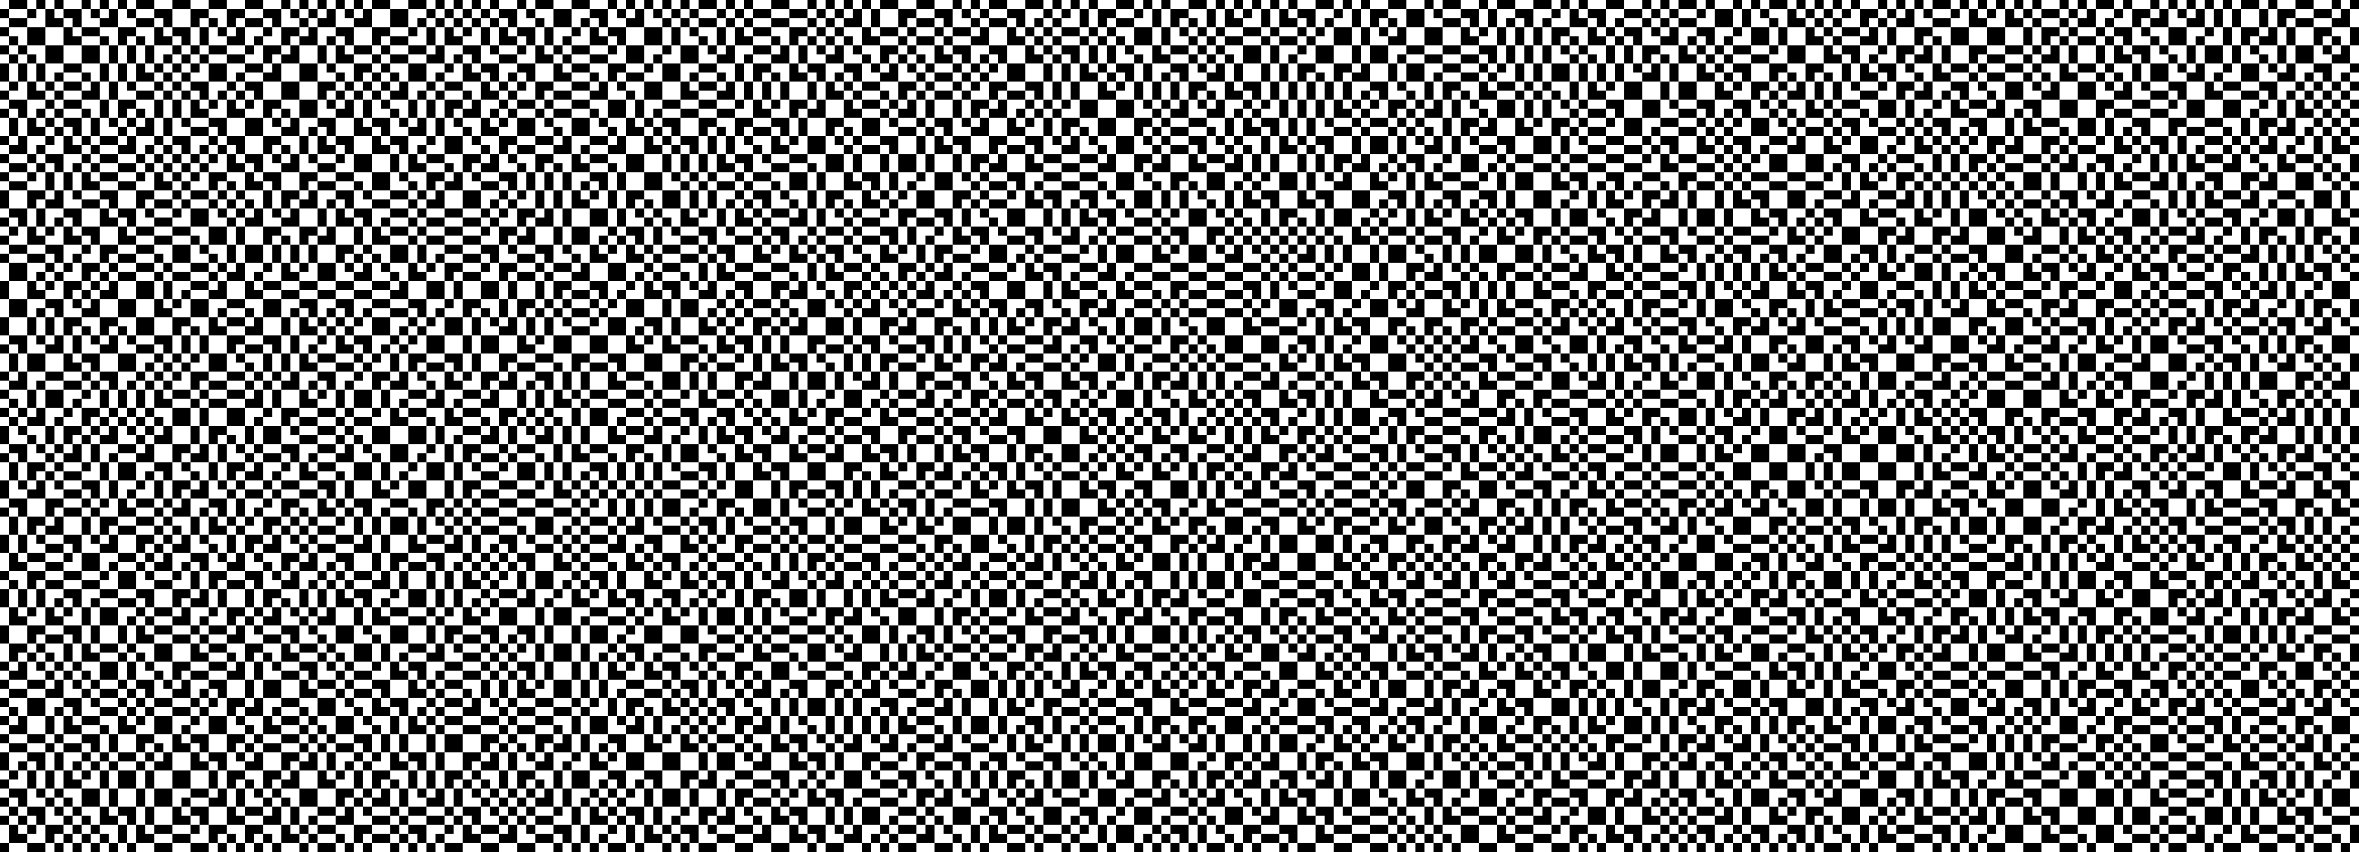

# Zu Aufgabe 4

Bitte diese Seiten auf Folie ausdrucken.

