DH Text Submission Guidelines
This is the template for abstract submissions to the annual Digital Humanities conference of ADHO. Please read and observe these guidelines closely in order to facilitate the file conversion for the edition of the Conference Proceedings. The guidelines included here are a subset of more complete instructions you can find online at the conference Web site.

The template consists of sections with light grey background that cannot be edited and will be processed automatically during the TEI-conversion. The other sections are where you insert the content of your submission.

Below, you will find the three editable main sections of this document:

- Subtitle: section for an optional subtitle
- Body: section for the chapters of your paper
- References: section for the bibliographic references.

Please avoid pasting richly-formatted text into these sections and only use the paragraph styles provided by this template named „DH-[Stylename]“:

- DH-Default
- DH-Subtitle
- DH-Heading1
- DH-Heading2
- DH-Heading3
- DH-Quotation

Also supported are links, lists and tables. Please avoid wide tables with lots of cell content. In addition, we support the following character level styles:

- Bold (to be used, sparingly, for emphasis)
- Italics (to be used for titles)

Please observe the following additional indications:

Images: Accepted image file formats are PNG, JPEG and SVG. For PNG and JPEG images the minimum image width is 1000 pixels.

Quotations of 5 or more lines should be in the "DH-Quotation" block quote format. For short quotations within the text, single quotation marks should be used.

Program code or mathematical formulae should appear as images.

Notes should be used only for comments, not for bibliographic citations.

Bibliographic references should be made inline using the author's name and year of publication, e.g. (Bloggs, 1990; Bloggs et al., 1991).

References section: The works cited should be listed in the "References" section at the end of the article. The list should be in alphabetical order by author. Where an author has more than one publication, they should be arranged in chronological order.

Citation style: Please follow the citation style of the DSH journal at:
http://dsh.oxfordjournals.org/for_authors/index.html. We provide a CSL file for use with reference managers such as Zotero. See the file and instructions here:
https://github.com/computationalstylistics/DHAbstracts_biblio_style.
Some examples are given below.

Biber, D. (1988). Variation Across Speech and Writing. Cambridge: Cambridge University Press.
Calzolari, N. (1989). A typology of English text. In Batori, I. S., Lenders, W. and Putschke, W. (eds), Computational Linguistics. New York: ACM Press, pp. 510-19.
Oostdijk, N. (1988). A corpus linguistic approach to linguistic variation. Literary and Linguistic Computing, 3: 12-25.
Richardson, S. D. and Braden-Harder, L. (1988). The experience of developing a large-scale natural language text processing system: CRITIQUE. Proceedings of the Second Conference on Applied Natural Language Processing, Austin, TX, February 1988.
Garfinkel, M. S. and Weiss, S. C. (1999). In the court of history, Ehlers v. Bush. Recent Science Newsletter, 1(1): 6-7, http://web.archive.org/web/20030604160332/recentscience.gwu.edu/RSN/ (accessed 27 February 2004).

The main title of your contribution – this field cannot be edited
Kugire Data Curation for the Kokinwakashu TEI/XML Data
Add a subtitle (optional):

Xudong Chen (w.iac25333@kurenai.waseda.jp), Waseda University, Japan
Bor Hodošček (hodoscek.bor.hmt@osaka-u.ac.jp), The University of Osaka, Japan
Hilofumi Yamamoto (yamamoto.h.al@m.titech.ac.jp), Institute of Science Tokyo, Japan
Author information – this field cannot be edited

Main body – enter your text and images here:

1 Introduction
Kugire — phrase breaks within waka poems — are well suited to studying the diversity of poetic interpretation. Translations of waka are practices of expert interpretation: they embed philological and literary knowledge into a reading of the text. Kugire is a latent structural property of every waka, and comparing where different experts locate kugire across the full anthology can serve as a measurable index of both the diversity and the stability of poetic interpretation. Analyzing such interpretive diversity in relation to poetic structure requires data.
One of the few existing kugire resources is a program that identifies kugire with a dataset for the Hyakuninisshu, later applied to the Kokinwakashu and compared against Asaoka (2008) and Kami (1985). The dataset, however, cannot capture the interpretive nature of kugire (see Kami, 1985), which admits no single correct answer. Asaoka (2007) proposes two criteria — semantic independence of core sentences (necessary) and a clear grammatical break (sufficient) — both of which remain open to interpretation. Across existing resources, kugire tends to be treated as a binary property, which cannot represent the certainty of individual judgements or the range of expert readings. A kugire dataset should therefore collect annotations from multiple sources, each with documented criteria.
This project adds kugire as an interpretive annotation layer to the TEI/XML data of the Kokinwakashu, using rule-based and translation-based methods. Keeping kugire as a separate layer preserves the annotation criteria and any competing interpretations.

2 Data sources
The base data is a lexically extended version of the TEI data of the Karoku second-year manuscript of the Kokinwakashu (Ikuura et al., 2023). The extended dataset maps tokenization from the Hachidaishu Vocabulary Dataset (Hodošček and Yamamoto, 2022) onto this segmented text, forming the basis for the kugire annotation.
For the rule-based method, we use the Hachidaishu Part-of-Speech Dataset (Yamamoto et al., 2024a), which provides conjugation and part-of-speech data for each token. For the translation-based method, we use the explanatory translation of the Kokinwakashu by (Kaneko, 1933), the earliest twentieth-century explanatory translation of the anthology, digitized and published on Zenodo (Yamamoto et al., 2024b).

3 Output Data
The output is a TEI/XML file derived from the base data by appending kugire annotations to each poem. The original text, segmentation, and all existing TEI markup are preserved without modification; the annotation layer is additive.
Each kugire position is encoded as a <k> element placed after the final <seg> child of the corresponding line element <l>:
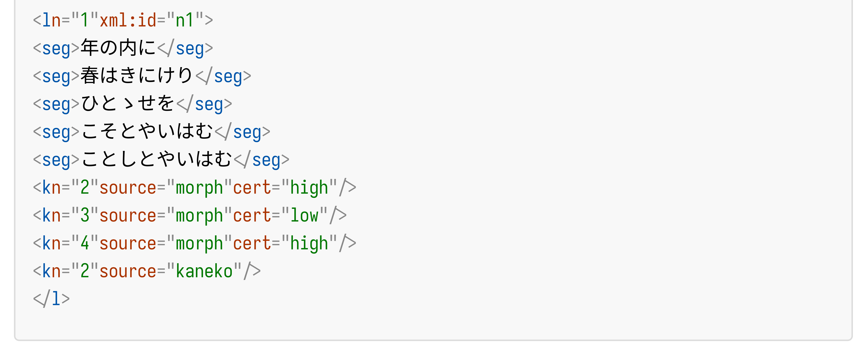
Fig. 1 Kugire annotation using <k> elements
The rule-based method identifies three candidate positions. The strongest (cert="high") is after the second segment, where keri appears in the conclusive form, ending the first complete sentence. A weaker candidate (cert="low") is also placed after the third segment. The LLM-assisted translation-based method, drawing on explanatory translation (Kaneko, 1933), identifies only the second segment as a kugire. The competing candidates are preserved independently.
The @n attribute is the 1-based segment index; @source is the evidence code; @cert (high / mid / low) grades morphological certainty for rule-based annotations and is omitted for translation-based ones.
The <k> element is a project-internal tag pending a decision on the target TEI encoding. A future revision will replace it with standard TEI mechanisms: <anchor> elements to mark break positions in the text, and <interpGrp><interp> in <standOff> to record the source and certainty of each annotation:
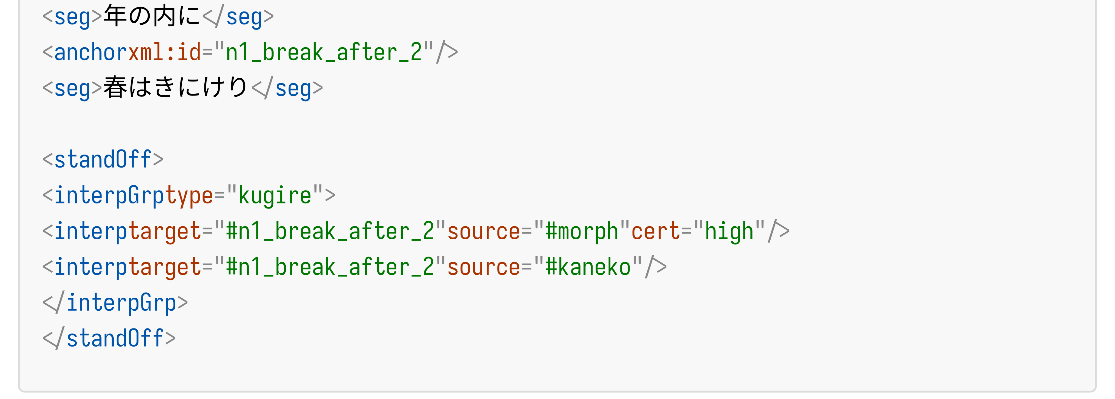
Fig. 2 Prospective encoding using <anchor> and <interpGrp> in <standOff>

4 Annotation pipeline
The annotation follows an LLM-assisted pipeline:
- Rule-based suggestion of candidate kugire positions based on Yamamoto et al. (2024a)
- LLM-assisted translation-based suggestion of candidate kugire positions based on Kaneko (1933; Yamamoto et al., 2024b)
- Review and correction in a pop-up editor showing the original poem and its reference data
- Rendering the confirmed annotation into the TEI data
The pipeline is intended to accelerate annotation and reduce cognitive load, implemented as a reusable set of scripts designed to extend to additional translation sources.

4.1 Rule-based (grammar-wise) kugire suggestion
Our method extends the aforementioned program, which flags conclusive forms, copulas, and sentence-final particles as kugire, by outputting graded candidates — strong, moderate, and weak — rather than a single result.
Strong candidates are phrases ending in the conclusive form. For example, in the first poem of the Kokinwakashu, the past-tense auxiliary verb keri appears in the conclusive form, indicating a grammatical break after it (Fig.3-(1)).
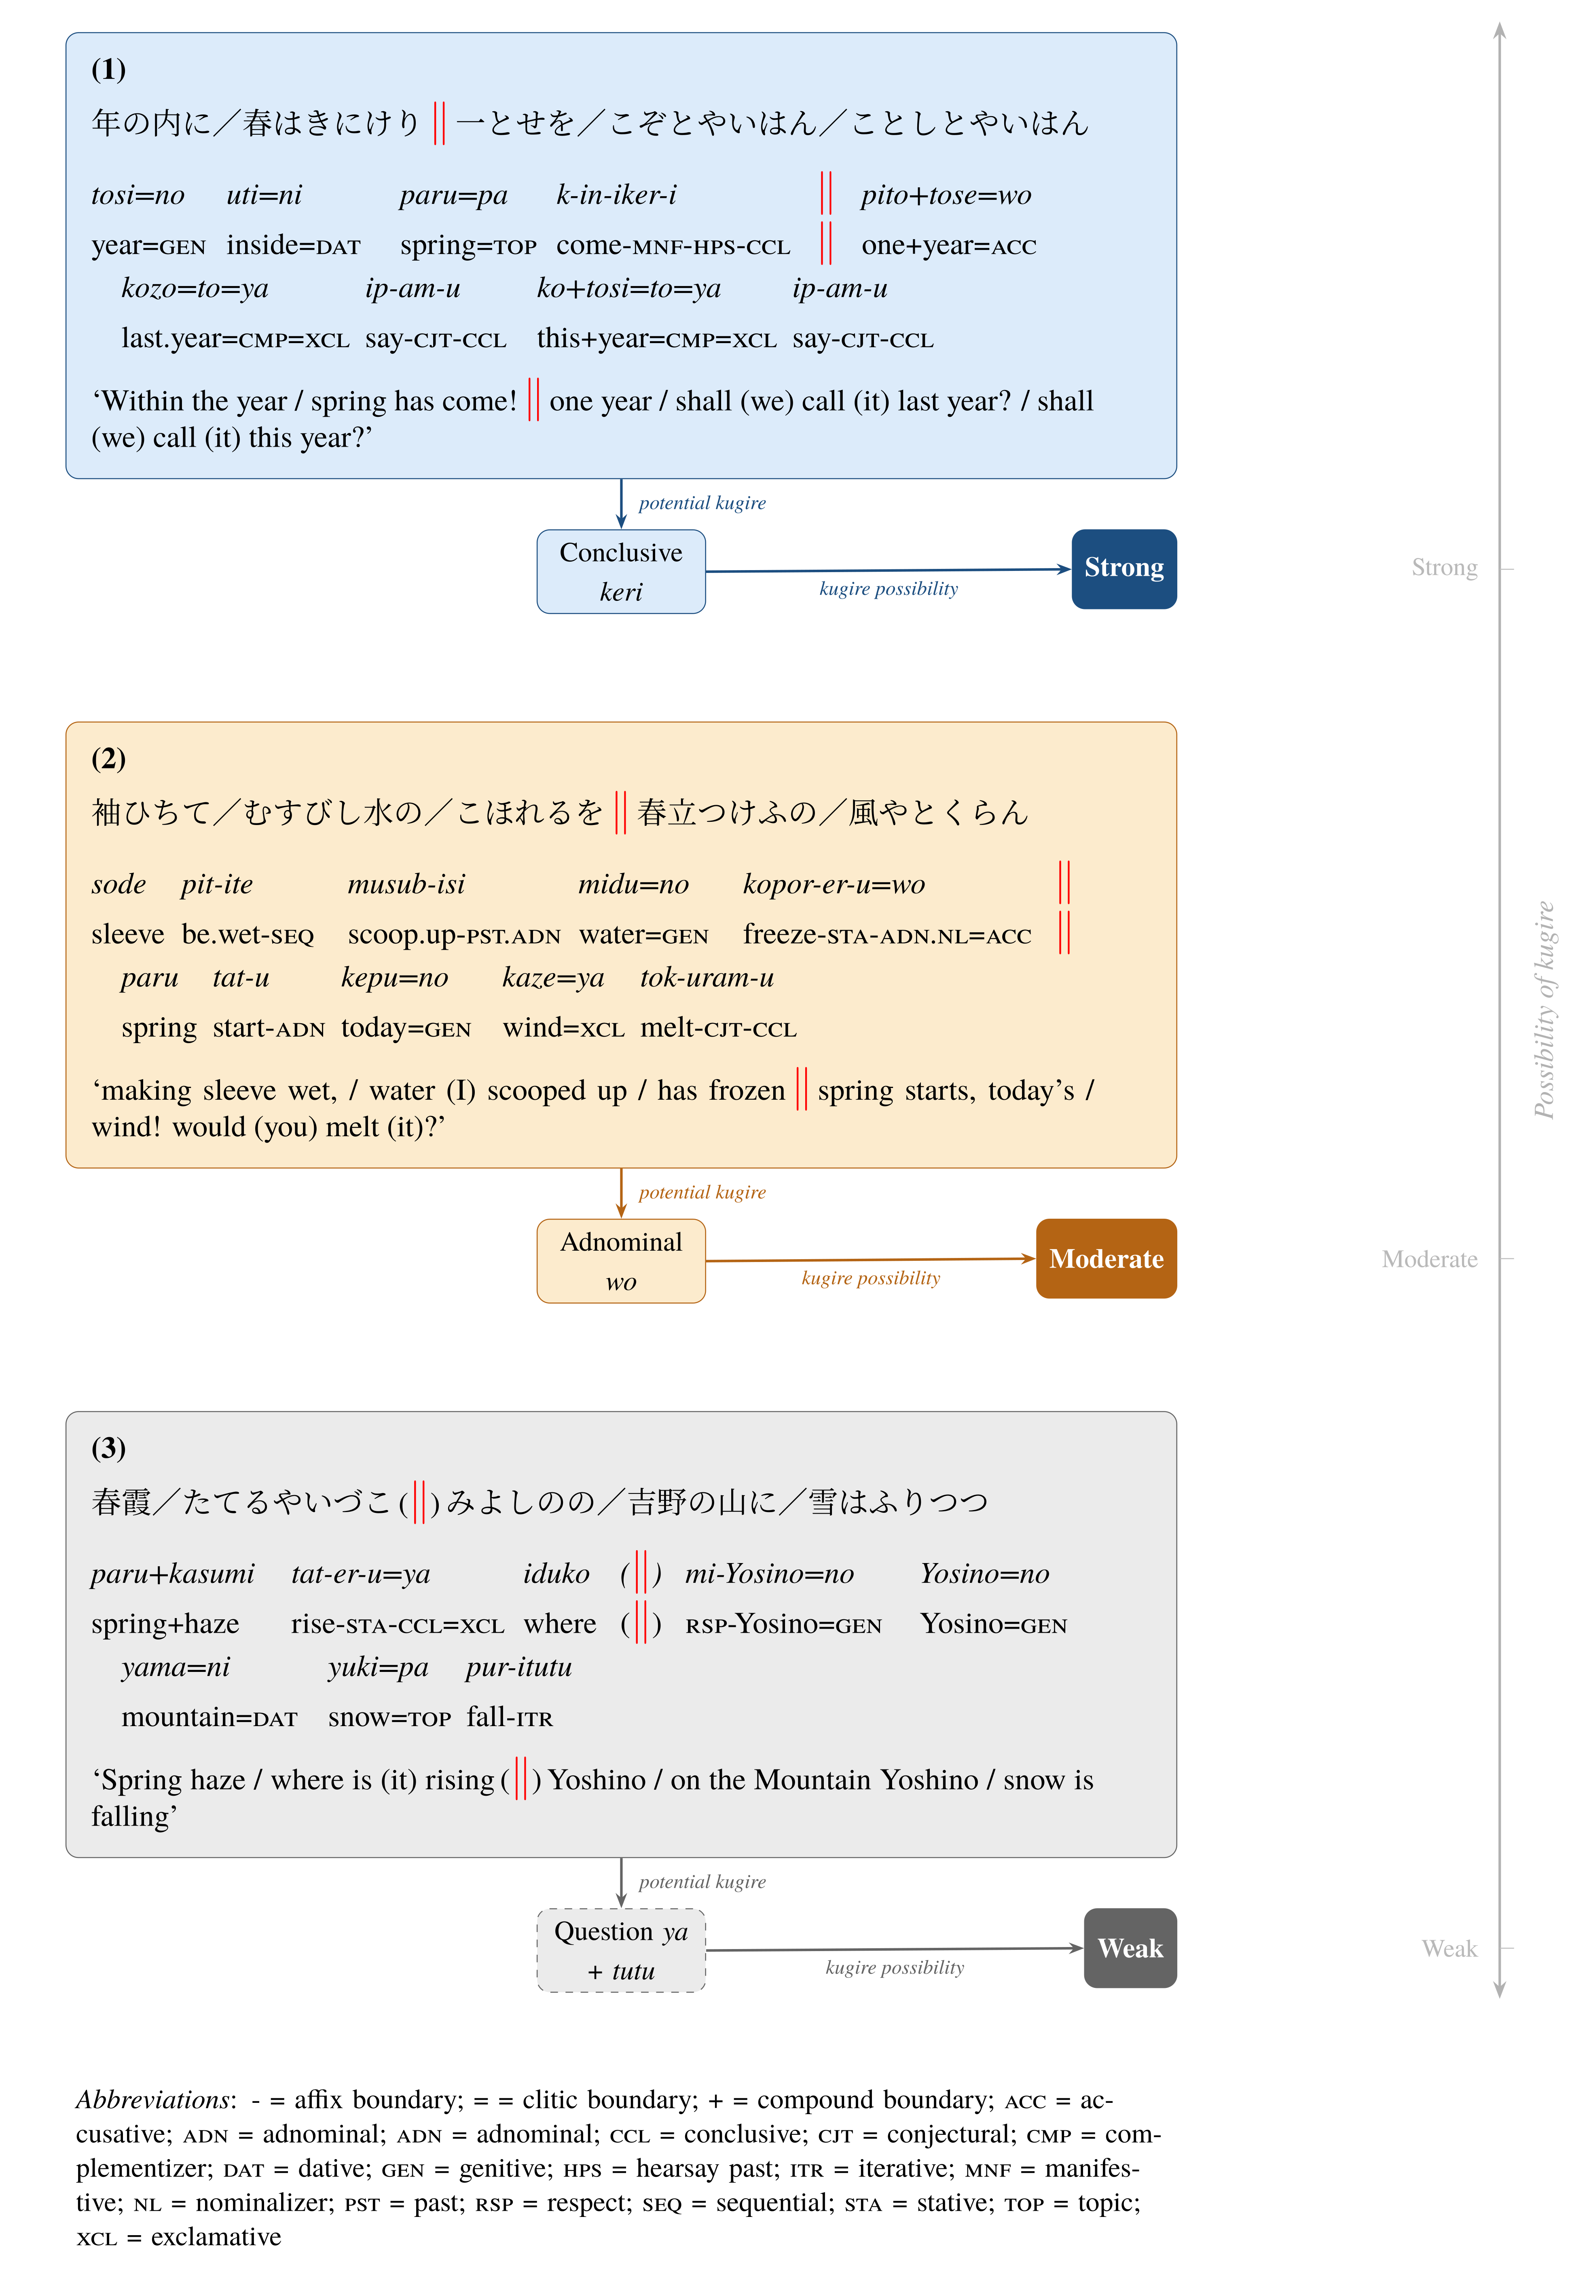
Fig. 3 Examples of strong (1), moderate (2), and weak (3) rule-based kugire candidates
Moderate candidates are phrases where the copula or information structure suggests a break, though not conclusively. In the second poem of the Kokinwakashu, the segments before and after wo are syntactically connected, yet the former presents a scene while the latter offers a conjectural statement about it — a shift that may indicate a break (Fig.3-(2)).
Weak candidates are phrases where a sentence-final particle suggests a break, but the surrounding segments remain semantically interdependent. In the third poem of the Kokinwakashu, the question particle in the second segment may suggest a break, yet the following segment answers that question — semantic interdependence that makes the break uncertain (Fig.3-(3)).

4.2 LLM-assisted translation-based kugire suggestion
We also use a large language model (LLM) to suggest candidate kugire positions from the explanatory translation of (Kaneko, 1933) as encoded by (Yamamoto et al., 2024b). Where the rule-based approach draws on morphological and grammatical features, the LLM-assisted translation-based approach draws on the contemporary Japanese translation, capturing breaks rooted in the translator's reading rather than grammatical form alone.
The LLM is qwen2.5, served locally via Ollama. The model receives the five segments of the original poem and the corresponding explanatory translation, and outputs a JSON object with three fields: alignment (step 1), breaks (step 2), and positions (the resulting candidate indices).
The prompt instructs the model to align segments to the translation, detect sentence boundaries in the translation, and map them back to segment positions — mirroring the workflow of a human annotator using a translation as reference. Three few-shot examples from real Kokinwakashu poems demonstrate this chain, covering no-kugire, second-segment, and fourth-segment cases. Valid positions from the JSON output are recorded independently of rule-based results, e.g., <k n="2" source="kaneko"/>.
In practice, translation-based suggestions require frequent correction by the annotator. The tool reduces input effort but does not replace human judgement. More capable LLMs may improve suggestion quality in future work.

5 Conculusion
This project produced a TEI/XML dataset prototype of kugire annotations for the Kokinwakashu, derived from a lexically extended base and informed by both rule-based and LLM-assisted translation-based methods. The dataset preserves multiple interpretations of kugire, supporting analysis of the relationship between waka structure and interpretive diversity.

References
Enter your references here:
Asaoka Sumiaki 浅岡純朗. (2008). Waka ni Okeru Bun no Kosei: Heian Waka no Tenkanki ni Kansuru Ichi Kosatsu/Sentence Structure in Waka: A Study on the Transitional Period of Heian Waka [和歌における文の構成―平安和歌の転換期に関する一考察―]. Nishogakusha Daigaku Jinbun Ronsoˉ/ Nishogakusha University Journal of Humanities, 81, pp. 130–40.
Asaoka Sumiaki 浅岡純朗. (2007). Waka no Kugire ni Kansuru Ichi Kosatsu: Atarashii Nintei Kijun Shian no Koso/A Study on Kugire in Waka: Toward a New Proposal for Recognition Criteria [和歌の句切れに関する一考察 : 新しい認定基準私案の構想]. Nishogakusha Daigaku Jinbun Ronsoˉ/Nishogakusha University Journal of Humanities, 78, pp. 113–22.
Hodošček, B. and Yamamoto, H. (2022). Development of Datasets of the Hachidaishū and Tools for the Understanding of the Characteristics and Historical Evolution of Classical Japanese Poetic Vocabulary. In Digital Humanities 2022 Conference Abstracts. Tokyo, Japan.
Ikuura Hiroyuki 幾浦裕之, Nagasaki Kiyonori 永崎研宣 and Kato Yumie 加藤弓枝. (2023). Chokusen Wakashu no Kozo-ka to Teiji Shuho ni Kansuru Kokoromi: Karoku Ninenhon Kokinwakashu wo Jirei to shite/An Attempt at Structuring and Presenting Imperial Waka Anthologies: The Karoku Second-Year Manuscript of the Kokinwakashu as a Case Study [勅撰和歌集の構造化と提示手法に関する試み ―嘉禄二年本『古今和歌集』を事例として―]. In Proceedings of JINMONCOM 2023. Information Processing Society of Japan, pp. 183–90.
Kami Hiroyuki 紙宏行. (1985). Shin-Kokin ni Okeru Sankugire no Hyogen Kozo/The Expressive Structure of Third-Line Breaks in the Shin-Kokinshū [新古今における三句切れの表現構造]. Bunkyo Daigaku Joshi Tandai-bu Kenkyu Kiyo/Bunkyo University Women’s College Bulletin, 29, pp. 10–23.
Kaneko Motoomi 金子元臣. (1933). Kokinwakashu Hyoshaku: Showa Shimban/An Annotated Kokinwakashu: The New Showa Edition [古今和歌集評釈: 昭和新版]. Tokyo: Meijishoin.
Yamamoto, H., Hodošček, B. and Chen, X. (2024a). Hachidaishu Part-of-Speech Dataset. 10.5281/zenodo.13940187.
Yamamoto, H., Hodošček, B. and Chen, X. (2024b). Kokinwakashu Hyoshaku by Motoomi Kaneko Translation Sentence Vocabulary Dataset. 10.5281/zenodo.13942707.
Zisk, M. (2023). Glossing Glosses: Methods for Transcribing and Glossing Japanese Kundoku Texts. In Cinato, F.Lahaussois, A.and Whitman, J.B. (eds), Glossing Practice, Comparative Perspectives. Lexington Books, pp. 47–82.

Finished editing your document?
- MAKE SURE TO SAVE THIS FILE UNDER A NEW FILE NAME!
- Go back to the DHConValidator to upload & convert your file and check the output.

Click HERE to return to the DH ConValidator.

E.g., https://github.com/atuko315/program-to-divide-31-syllable-Japanese-poem. Access on 2026/6/29.

