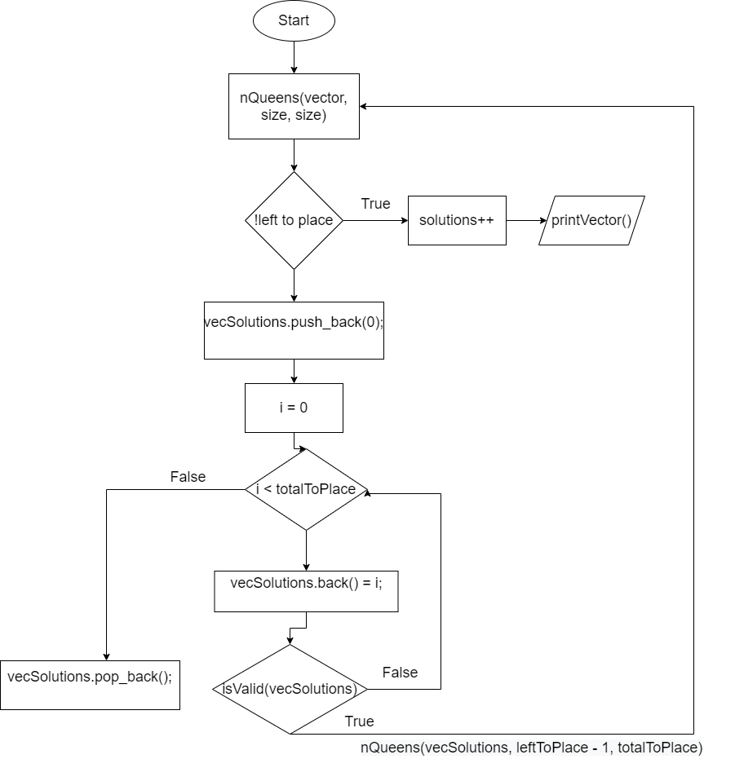

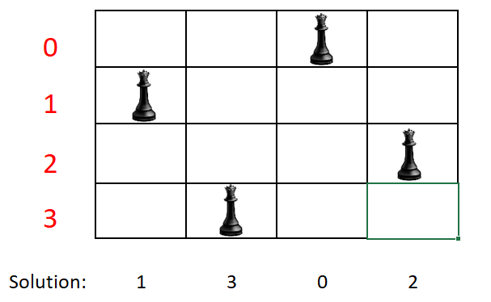

Source: [https://pastebin.com/kSS0kqjy](https://pastebin.com/hV3xJDA2)