EDA Results - Wind Data Project

Histogram of SMP
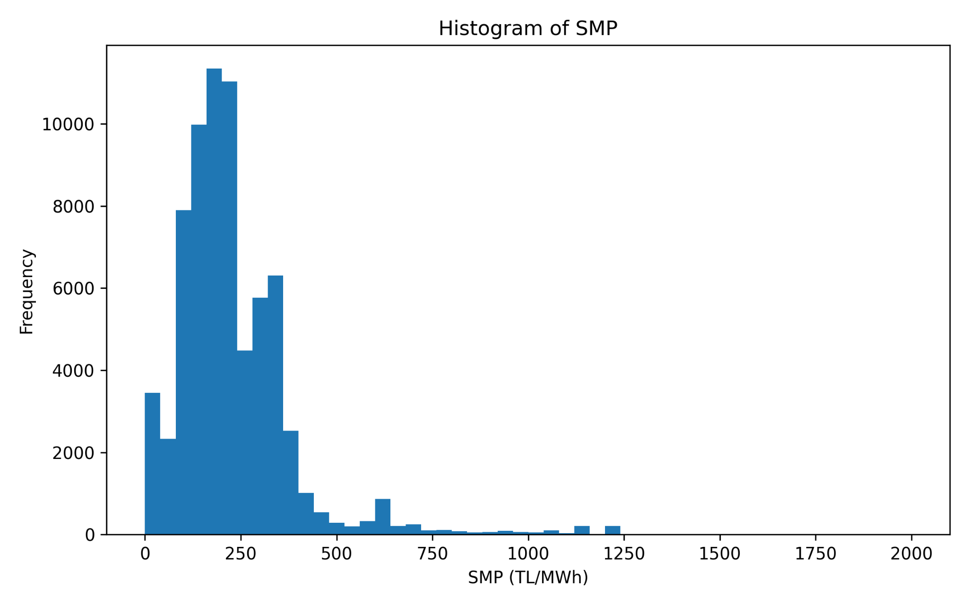

MCP vs SMP Scatter Plot
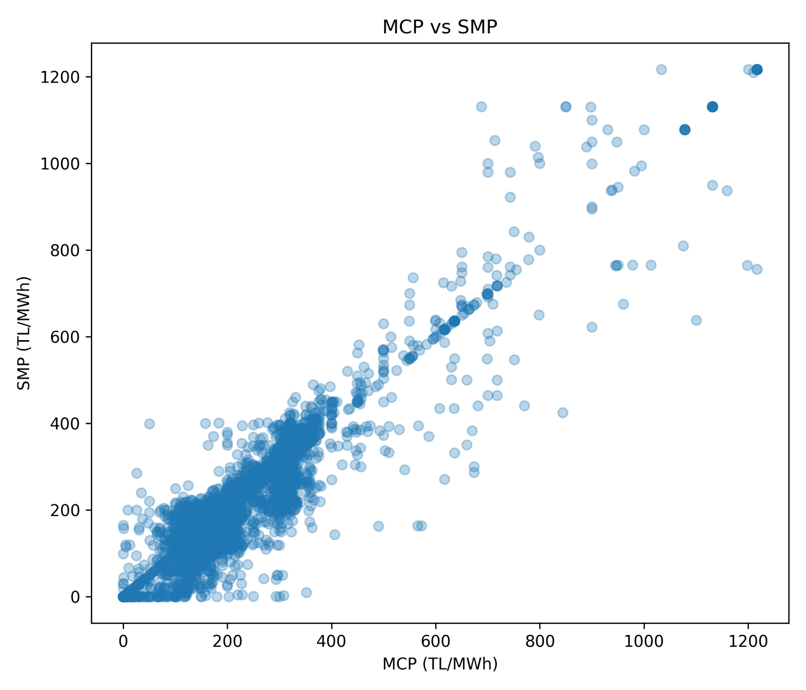

Average SMP by Time Group
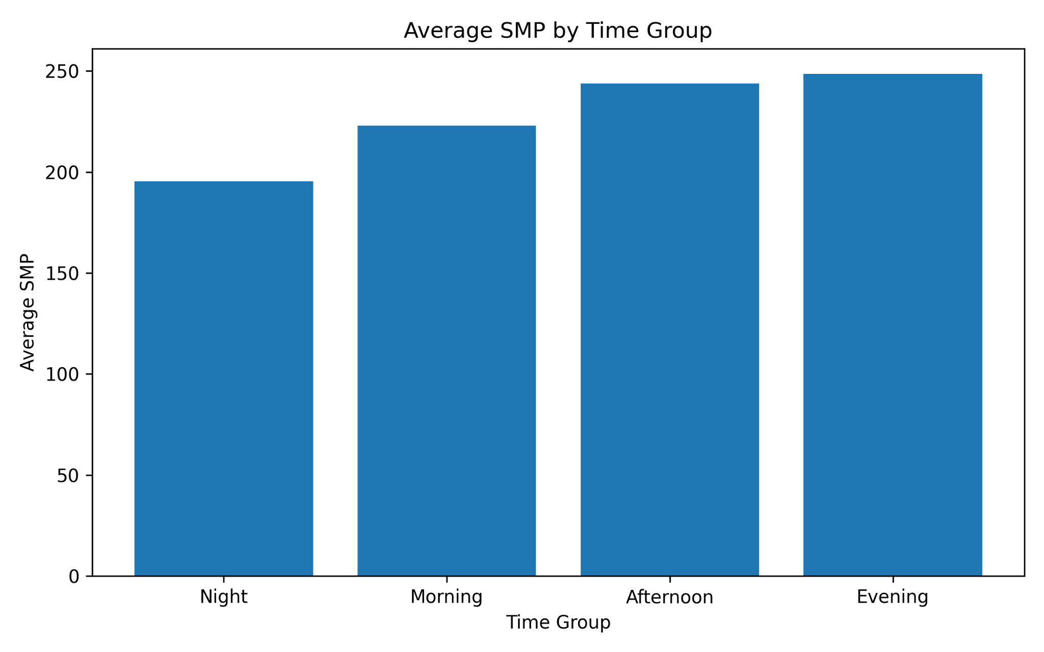

Average SMP by Month
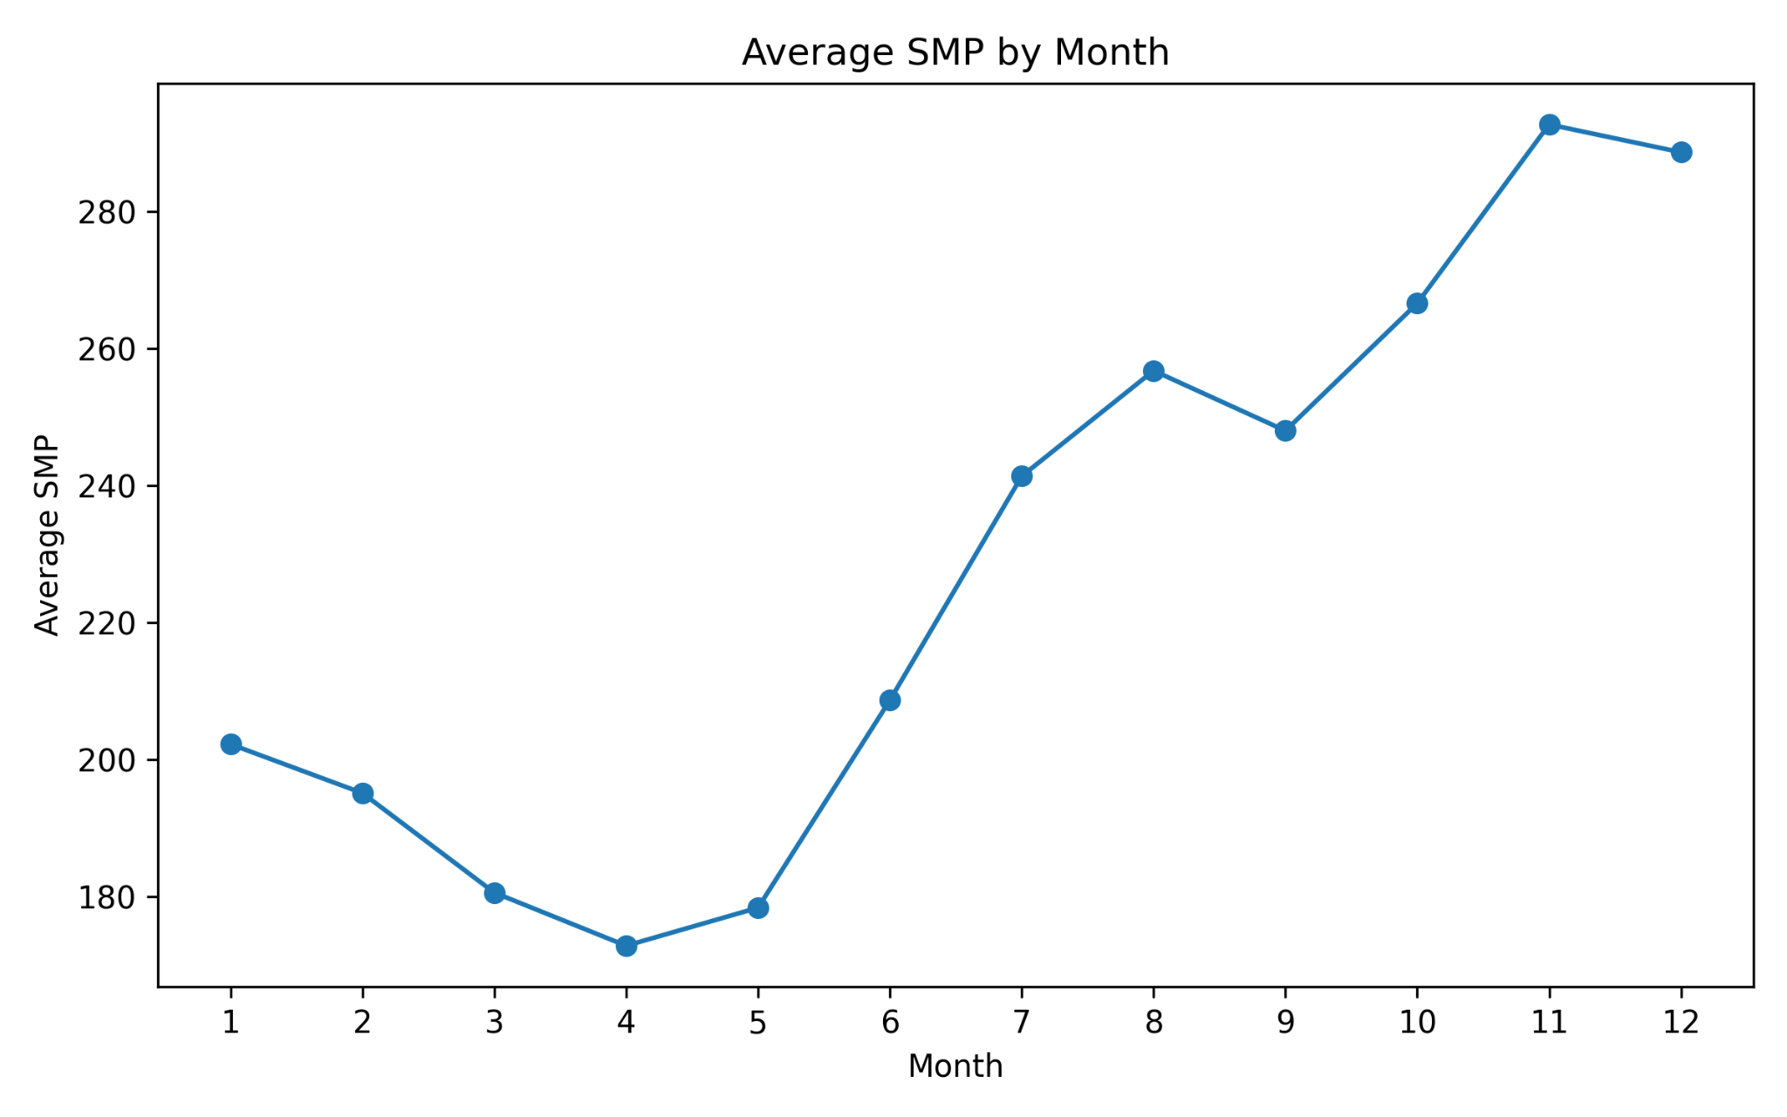

Average MCP by Month
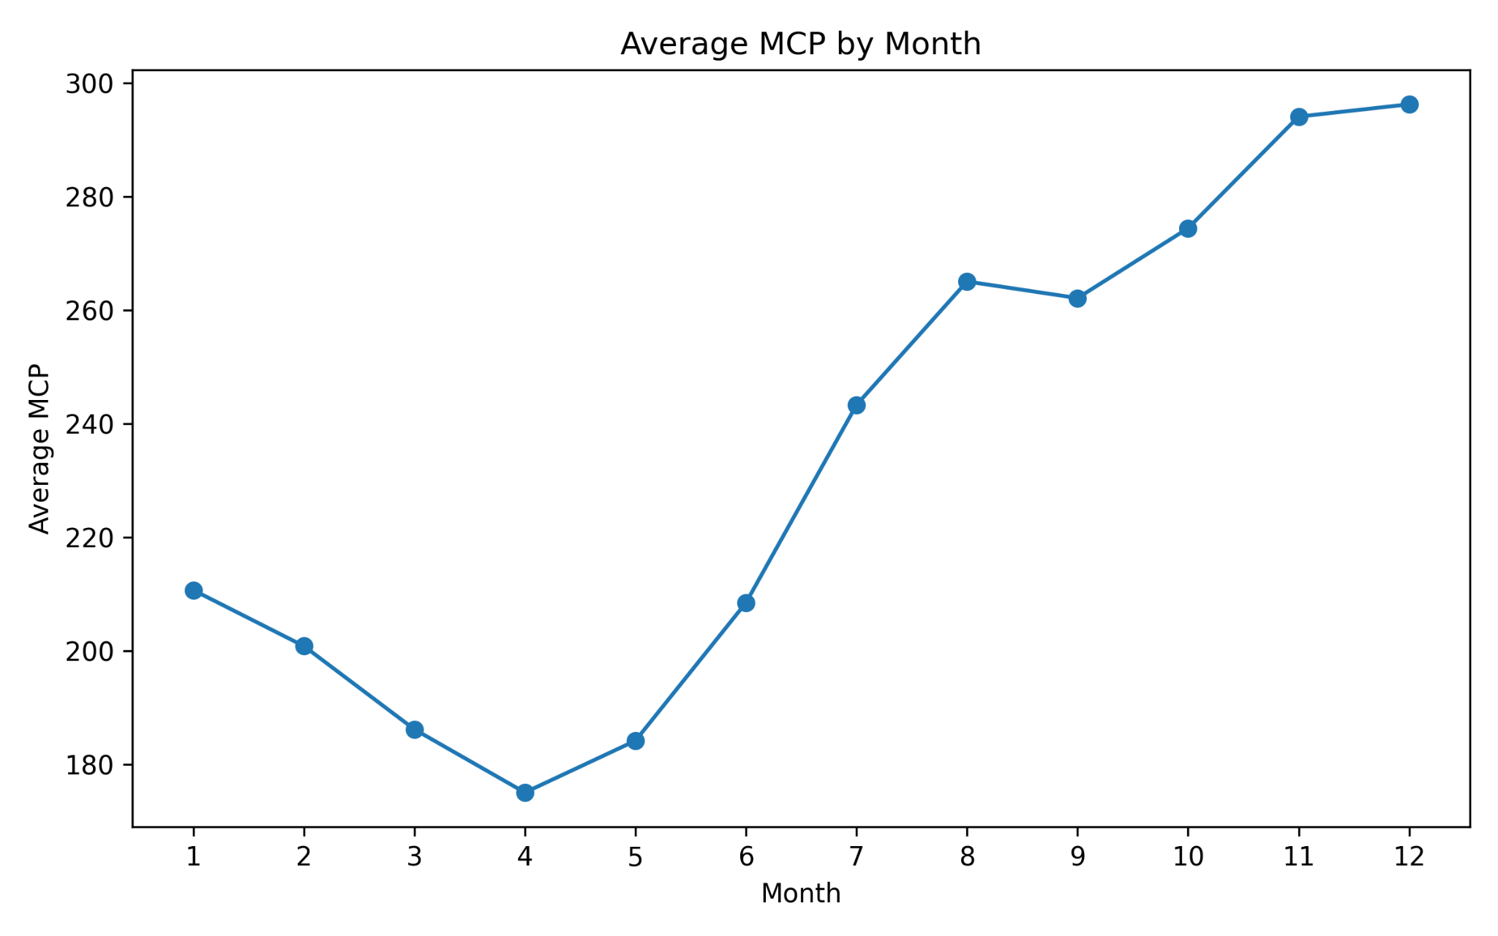

Histogram of SMP (Duplicate)


Histogram of MCP
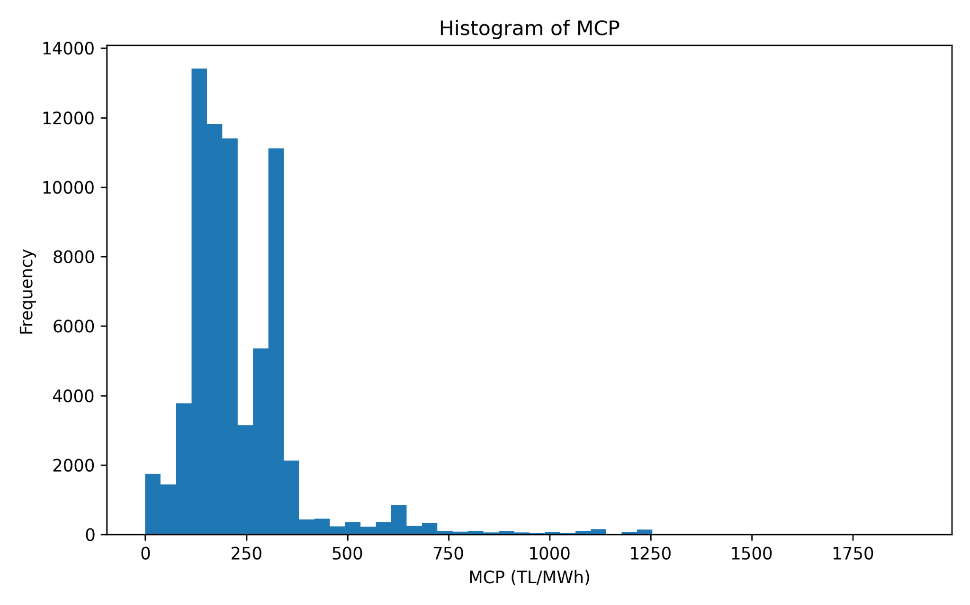

MCP-SMP Correlation by Time Group
