Niki Café Food Order & Payment App

Project 1

SE 321/305 – Software Specification and Design

Term Project Design Document

İdil Sanem Gürsoy

Bartu Nurgün

Yağız Efe Varlı

Esra Kamalak

Özgür İmer

December 27, 2024

1. Introduction

In today's fast-paced world, convenience is key. Niki Café, a popular campus restaurant, faces a recurring issue: long lines and extended wait times during peak hours. This situation inconveniences both customers and staff, highlighting the need for a streamlined solution. Niki Café Food Order & Payment App aims to address this by offering a user-friendly mobile platform where customers can browse the menu, customize orders, and make cashless payments efficiently. By leveraging technology, this project seeks to improve the dining experience and operational efficiency.

1. Problem Definition

Niki Café’s reputation as a campus favorite brings with it a significant challenge: long queues and service delays during busy hours. Customers frequently experience issues such as:

* Prolonged waiting times due to the inability to pre-order food.
* Lack of real-time updates on order status, leading to uncertainty.
* Limited payment options, causing inefficiencies at checkout.
* Absence of promotions or loyalty rewards to enhance the customer experience.

For employees, the pressure of managing high demand often leads to operational inefficiencies, affecting service quality and staff morale. The reliance on traditional methods to handle orders and payments exacerbates these issues, creating a significant obstacle in service delivery.

To address these pain points, the Niki Café Food Order & Payment App will incorporate features such as pre-ordering, real-time order tracking, multiple cashless payment options, and personalized promotions. These enhancements will not only improve customer satisfaction but also enable staff to manage operations more effectively.

3. Proposed System Design

3.1. Requirements

**Functional Requirements**

1. Users must have access to both email and password-based sign-up and sign-in options. Additionally, the system should allow students to sign in using their student.
2. A dashboard for restaurant staff to manage orders, menu, and more should be provided.
3. A page displaying available food and drink items will be accessible to users, featuring images, prices, and descriptions of each item to enhance the browsing experience. Additionally, the system will provide detailed information about ingredients and allergen warnings for each menu item to promote safe consumption.
4. Users will have the ability to save their favorite food and drink items for quick access during future orders.
5. A shopping cart should be available for customers to view selected food and drink items.
6. Users should have the option to cancel their orders if needed, with the system providing a reason for the cancellation, such as "Item out of stock" or "Order canceled by user," to enhance transparency and improve user experience.
7. Users will be able to track the status of their orders in real-time, receiving updates on whether their order is being prepared, out for delivery, or has been delivered.
8. Users will have the ability to view their order history and reorder items easily from previous purchases, streamlining the ordering process for repeat customers.
9. Users will be able to rate their orders after receiving them, providing feedback and enabling the restaurant to improve service and offerings based on customer reviews.
10. The system will provide users with a feature to view available tables in the café and place orders by scanning QR codes located at their tables, allowing them to see which tables are vacant, make informed decisions about where to sit, and quickly access the menu for dine-in or takeout options.

**Non-Functional Requirements**

1. The system is going to include a scalable database with sufficient storage capacity to securely store and manage all application data, including user information, order history, and menu details.
2. The system should offer language options in both Turkish and English.
3. System availability will be restricted to specific hours to allow for daily stock checks and updates to be entered into the system, ensuring accurate inventory management before the next day’s operations.
4. Pages will load within a maximum of 3 seconds to ensure a smooth user experience, and user input should be processed within 1 second to provide quick and responsive interactions throughout the application.
5. The system will integrate a 3D payment authorization API to ensure secure and reliable transaction processing for users.
6. Support must be provided for the current versions of both Android and iOS platforms.

3.2. Activity Diagrams

3.4.1. Activity Diagram 1: Users must have access to both email and password-based sign-up and sign-in options. Additionally, the system should allow students to sign in using their student.

diyagram, metin, tasarım içeren bir resim

Açıklama otomatik olarak oluşturuldu

3.2.2. Activity Diagram 2: A dashboard for restaurant staff to manage orders, menu, and more should be provided.

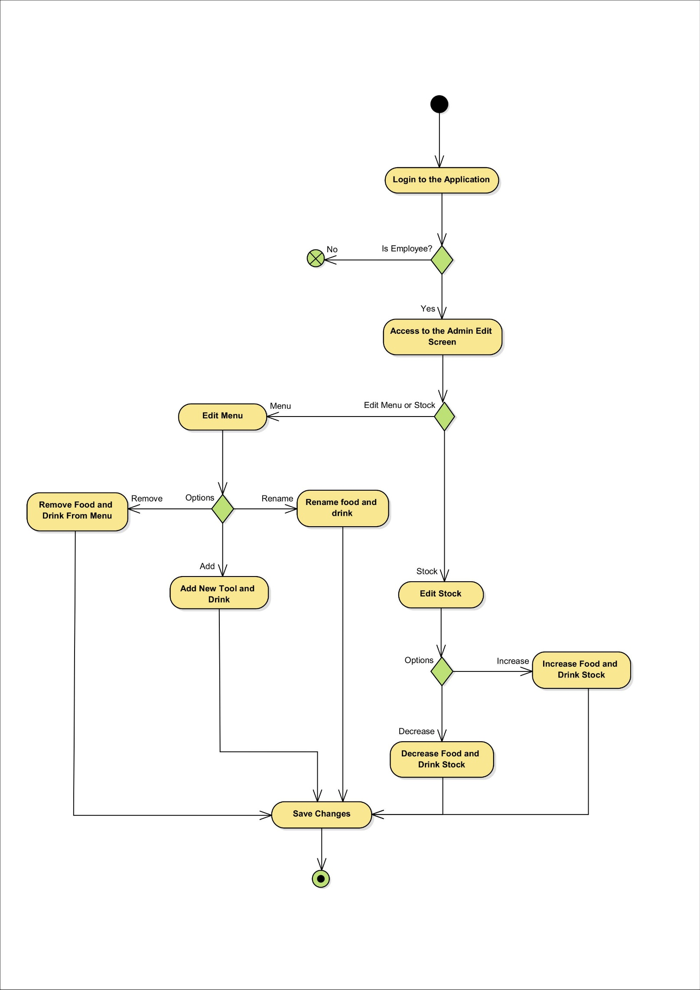

3.2.3. Activity Diagram 3: A page displaying available food and drink items will be accessible to users, featuring images, prices, and descriptions of each item to enhance the browsing experience. Additionally, the system will provide detailed information about ingredients and allergen warnings for each menu item to promote safe consumption.

tasarım içeren bir resim

Açıklama otomatik olarak orta güvenilirlik düzeyiyle oluşturuldu

3.2.4. Activity Diagram 4: Users will have the ability to save their favorite food and drink items for quick access during future orders.

diyagram, ekran görüntüsü, metin, çizgi içeren bir resim

Açıklama otomatik olarak oluşturuldu

3.2.5. Activity Diagram 5: A shopping cart should be available for customers to view selected food and drink items.

tasarım içeren bir resim

Açıklama otomatik olarak düşük güvenilirlik düzeyiyle oluşturuldu

3.2.6. Activity Diagram 6: Users should have the option to cancel their orders if needed, with the system providing a reason for the cancellation, such as "Item out of stock" or "Order canceled by user," to enhance transparency and improve user experience.

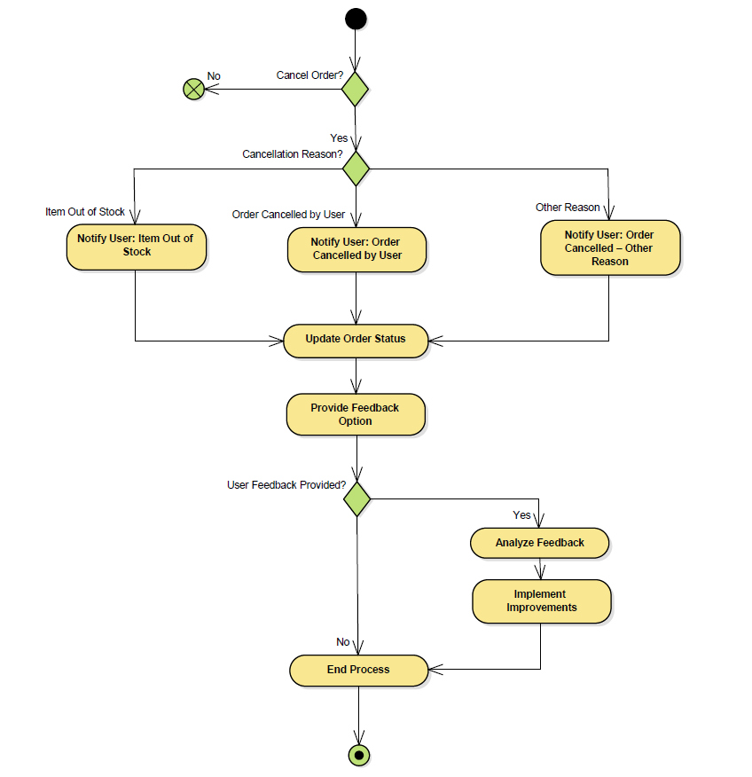

3.2.7. Activity Diagram 7: Users will be able to track the status of their orders in real-time, receiving updates on whether their order is being prepared, out for delivery, or has been delivered.

metin, diyagram, ekran görüntüsü, tasarım içeren bir resim

Açıklama otomatik olarak oluşturuldu

3.2.8. Activity Diagram 8: Users will have the ability to view their order history and reorder items easily from previous purchases, streamlining the ordering process for repeat customers.

metin, ekran görüntüsü, diyagram, çizgi içeren bir resim

Açıklama otomatik olarak oluşturuldu

3.2.9. Activity Diagram 9: Users will be able to rate their orders after receiving them, providing feedback and enabling the restaurant to improve service and offerings based on customer reviews.

diyagram, tasarım içeren bir resim

Açıklama otomatik olarak oluşturuldu

3.2.10. Activity Diagram 10: The system will provide users with a feature to view available tables in the café and place orders by scanning QR codes located at their tables, allowing them to see which tables are vacant, make informed decisions about where to sit, and quickly access the menu for dine-in or takeout options.

diyagram, ekran görüntüsü, tasarım içeren bir resim

Açıklama otomatik olarak oluşturuldu

3.3. Context Model

çizim, taslak, diyagram, metin içeren bir resim

Açıklama otomatik olarak oluşturuldu

3.4. Data Flow Diagrams

3.4.1. DFD Level 0

diyagram, daire, çizim, taslak içeren bir resim

Açıklama otomatik olarak oluşturuldu

3.4.2. DFD Level 1

3.4.2.1 DFD Level 1.1 – Order

diyagram, metin, daire, çizgi içeren bir resim

Açıklama otomatik olarak oluşturuldu

3.4.2.2 DFD Level 1.2 – Payment

diyagram, metin, çizgi, daire içeren bir resim

Açıklama otomatik olarak oluşturuldu

3.4.2.3 DFD Level 1.3 – Meal Preparation

metin, diyagram, daire, plan içeren bir resim

Açıklama otomatik olarak oluşturuldu

3.5. Use Cases

3.5.1. Actors

metin, diyagram, çizgi, ekran görüntüsü içeren bir resim

Açıklama otomatik olarak oluşturuldu

3.5.2. Use Case Diagrams

metin, diyagram, ekran görüntüsü, çizgi içeren bir resim

Açıklama otomatik olarak oluşturuldu

3.6. Class Diagram

metin, diyagram, plan, teknik çizim içeren bir resim

Açıklama otomatik olarak oluşturuldu

3.7. E/R Diagram

taslak, diyagram, çizim, tasarım içeren bir resim

Açıklama otomatik olarak oluşturuldu

3.8. Sequence Diagrams

3.8.1. Sequence Diagram 1: Add to Cart

metin, diyagram, ekran görüntüsü, çizgi içeren bir resim

Açıklama otomatik olarak oluşturuldu

3.8.2. Sequence Diagram 2: Manage Menu

metin, ekran görüntüsü, diyagram, çizgi içeren bir resim

Açıklama otomatik olarak oluşturuldu

3.8.3. Sequence Diagram 3: Manage Stock

metin, diyagram, ekran görüntüsü, çizgi içeren bir resim

Açıklama otomatik olarak oluşturuldu

3.8.4. Sequence Diagram 4: Place Order

metin, diyagram, çizgi, paralel içeren bir resim

Açıklama otomatik olarak oluşturuldu

3.8.5. Sequence Diagram 5: Process Payment

metin, diyagram, çizgi, paralel içeren bir resim

Açıklama otomatik olarak oluşturuldu

3.9. Communication Diagrams

3.9.1. Communication Diagram 1: Add to Cart

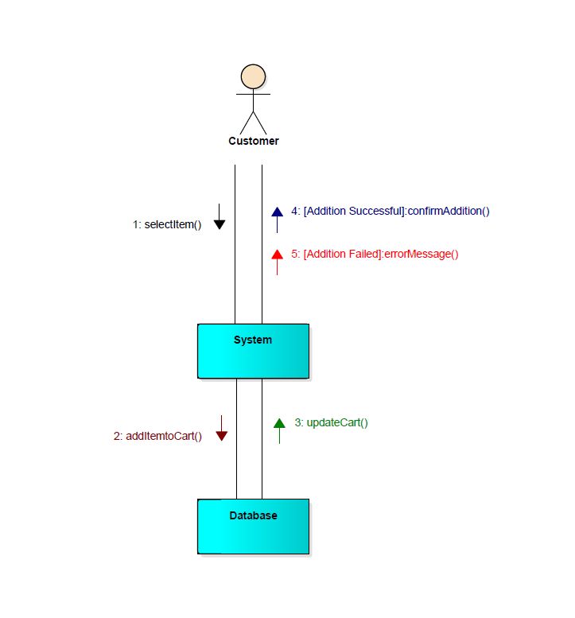

3.9.2. Communication Diagram 2: Manage Menu

ekran görüntüsü, metin, diyagram, çizgi içeren bir resim

Açıklama otomatik olarak oluşturuldu

3.9.3. Communication Diagram 3: Manage Stock

metin, çizgi, yazı tipi, diyagram içeren bir resim

Açıklama otomatik olarak oluşturuldu

3.9.4. Communication Diagram 4: Place Order

metin, ekran görüntüsü, diyagram, tasarım içeren bir resim

Açıklama otomatik olarak oluşturuldu

3.9.5. Communication Diagram 5: Process Payment

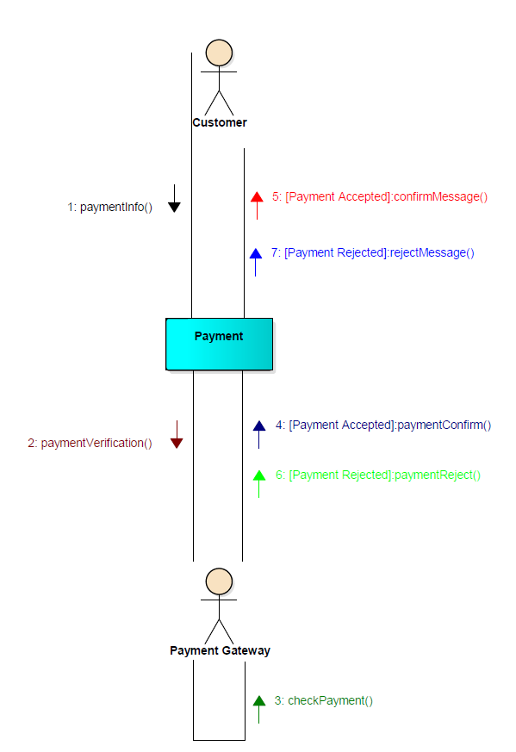

4. Conclusion

The Niki Café Food Order & Payment App offers a straightforward solution to the challenges of long lines and service inefficiencies. By streamlining the ordering and payment processes, it reduces wait times and enhances the overall dining experience. This innovative approach ensures customer satisfaction while optimizing operations at Niki Café, setting a new standard for campus dining. Additionally, the app’s features promote customer loyalty through personalized promotions and provide valuable data insights for better decision-making. By integrating technology into its services, Niki Café demonstrates its commitment to improving customer experiences and operational excellence, paving the way for future innovations in campus dining.