

|  |  |
| --- | --- |
| Meeting Report No: 2 | Meeting Date: 20/11/2024 |
| Meeting Place: Whatsapp Video Call | Meeting Hour: 21.30-22.30 |

|  |  |
| --- | --- |
| Project Name | Niki Café Food Order and Payment App |
| Project Number | 1 |

|  |  |  |
| --- | --- | --- |
|  | Name & Surname | Signature |
| Meeting Director | Bartu Nurgün |  |
| Meeting Reporter | İdil Sanem Gürsoy |  |

|  |  |  |  |
| --- | --- | --- | --- |
|  | Name & Surname | Department | e-mail |
| 1 | İdil Sanem Gürsoy | Software Engineering | idilsgursoy@gmail.com |
| 2 | Özgür İmer | Software Engineering | ozgur.imer01@gmail.com |
| 3 | Bartu Nurgün | Software Engineering | bartunurgun.2@gmail.com |
| 4 | Yağız Efe Varlı | Software Engineering | yagizefe53@hotmail.com |
| 5 | Esra Kamalak | Software Engineering | esra.kmlk.2008@gmail.com |



Agenda Points

|  |
| --- |
| 1 An overview of the project’s main requirements and objectives is provided as a refresher. |
| 2 The use case diagram is reviewed to ensure it aligns with project objectives. |
| 3 The context diagram illustrating system interactions and boundaries is analyzed. |
| 4 The Data Flow Diagram (DFD Level 0) is examined to validate main processes and data flows. |
| 5 Feedback on the diagrams is collected to ensure alignment with project goals. |
| 6 Updates or revisions required for the diagrams are identified and assigned. |
| 7 Next steps in the project's development process are determined and planned. |
| 8 Any questions or clarifications regarding the diagrams are addressed. |
|  |



Decisions

|  |  |  |  |
| --- | --- | --- | --- |
| No | Which jobs to be done? | Who to do? | When to do? |
| 1 | Feedback gathered during the meeting is analyzed and documented to guide necessary updates to the diagrams. | Özgür, Yağız, Esra | 21.11.2024 |
| 2 | The use case diagram will be optimized based on the feedback provided during the review. | İdil, Yağız | 22.11.2024 – 24.11.2024 |
| 3 | Adjustments to the context diagram will be made to better reflect system boundaries and interactions. | Bartu, Esra | 22.11.2024 – 24.11.2024 |
| 4 | Revisions to the DFD Level 0 diagram will be implemented to address identified gaps or inconsistencies. | Bartu, İdil | 22.11.2024 – 24.11.2024 |
| 5 | All updated diagrams and related decisions will be reviewed collectively to ensure alignment with project goals and stakeholder expectations. | All Team Members | 25.11.2024 |

**metin, yazı tipi, logo, grafik içeren bir resim

Açıklama otomatik olarak oluşturuldu**

**Use Case Diagram**

metin, diyagram, ekran görüntüsü, çizgi içeren bir resim

Açıklama otomatik olarak oluşturuldu

**metin, yazı tipi, logo, grafik içeren bir resim

Açıklama otomatik olarak oluşturuldu**

**Context Diagram**

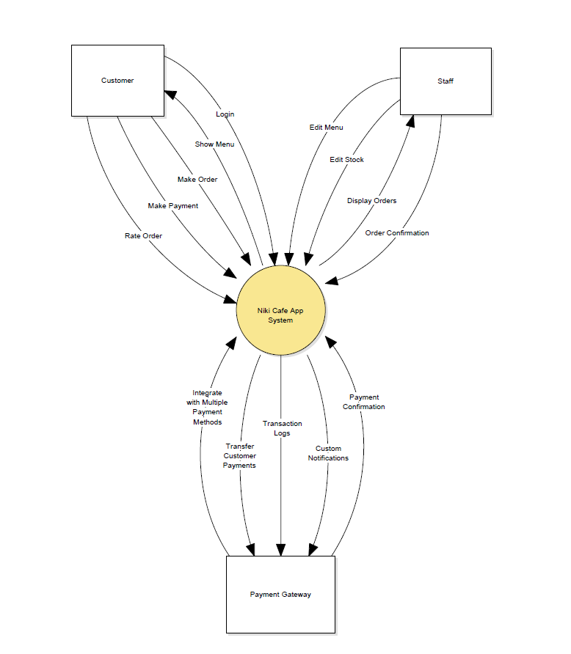

**metin, yazı tipi, logo, grafik içeren bir resim

Açıklama otomatik olarak oluşturuldu**

**Dfd Level 0 Diagram**

**diyagram, daire, çizim, taslak içeren bir resim

Açıklama otomatik olarak oluşturuldu**



|  |
| --- |
| **Plans for the Next Meeting** |
| • Finalizing the review of all diagrams to ensure accuracy and consistency.  • Implementing any remaining adjustments based on feedback.  • Conducting a comprehensive final check of all diagrams and related documentation.  • Preparing the finalized diagrams for presentation or submission. |



|  |
| --- |
| **Meeting Photo** |
| **insan yüzü, kişi, şahıs, gülümsemek, gülüş, giyim içeren bir resim  Açıklama otomatik olarak oluşturuldu** |