**Laporan Implementasi Basis Data I**

**Kelompok A05**

Topik: SIASISTEN

Alamat repository online: <https://github.com/idiotme/tadsab.git>

# \i D:/KULIAH/V/Basdat/tadsab/CreateTable.sql

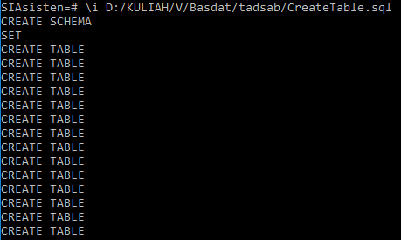

\d

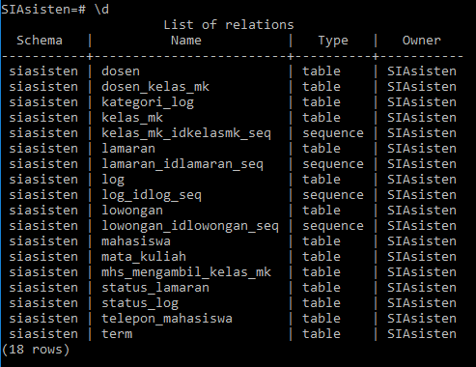

\d MATA_KULIAH

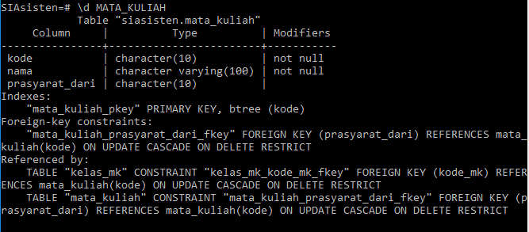

\d TERM

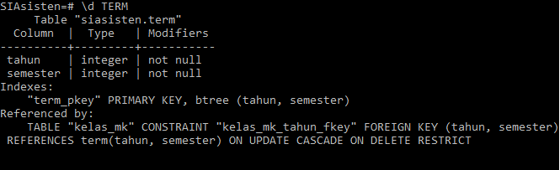

\d KELAS_MK

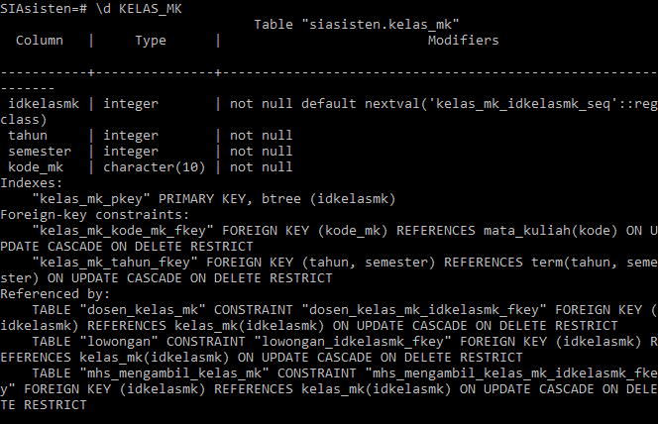

\d DOSEN

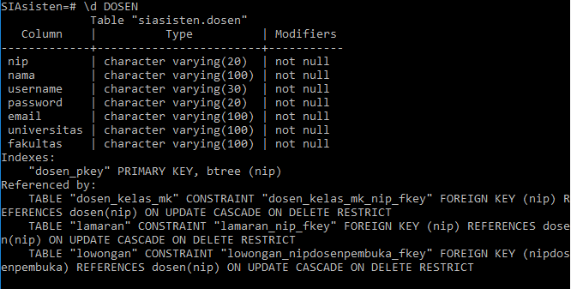

\d MAHASISWA

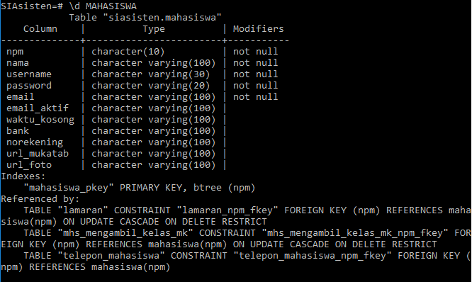

\d TELEPON_MAHASISWA

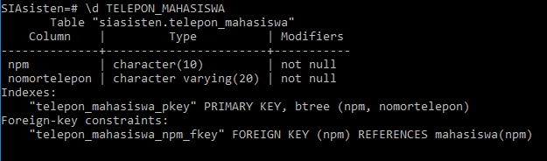

\d MHS_MENGAMBIL_KELAS_MK

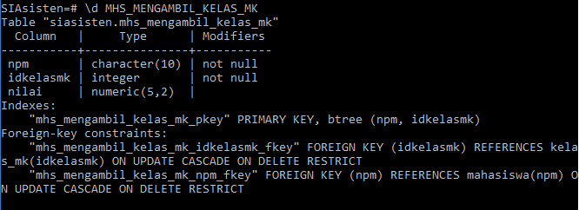

\d DOSEN_KELAS_MK

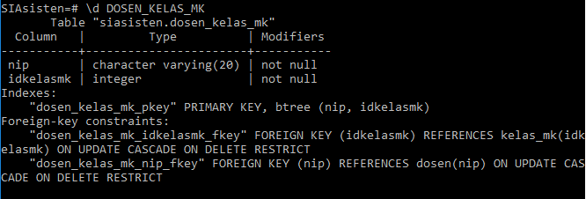

\d LOWONGAN

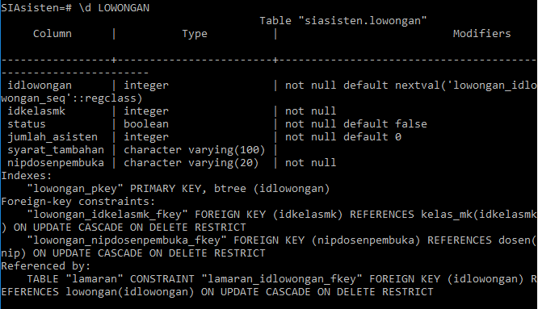

\d STATUS_LAMARAN

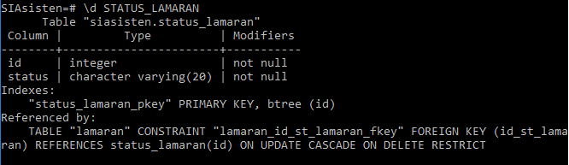

\d LAMARAN

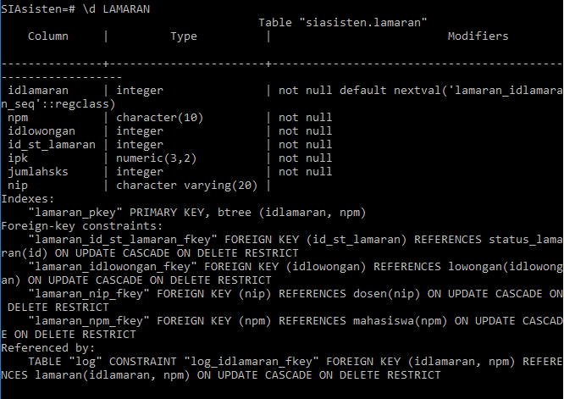

\d STATUS_LOG

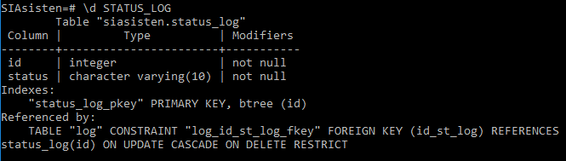

\d KATEGORI_LOG

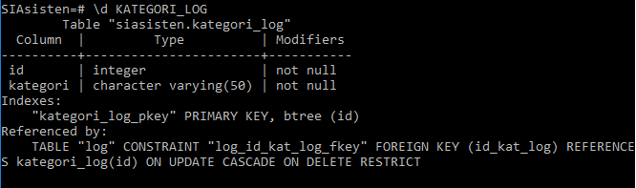

\d LOG

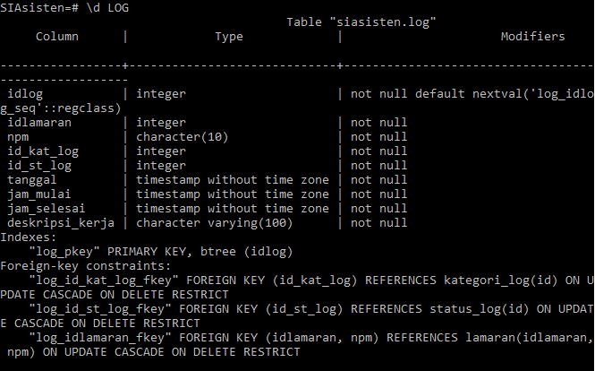

INSERT MATA_KULIAH

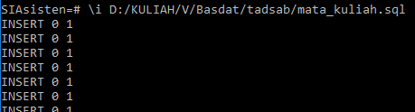

SELECT * FROM MATA_KULIAH;

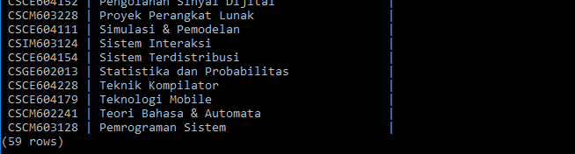

INSERT TERM

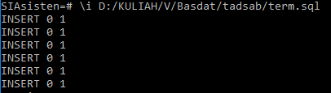

SELECT * FROM TERM;

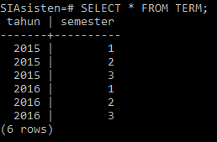

INSERT KELAS_MK

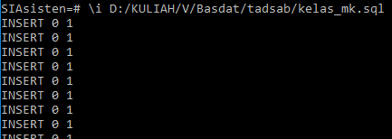

SELECT * FROM KELAS_MK;

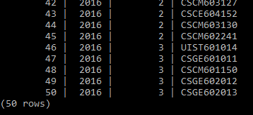

INSERT DOSEN

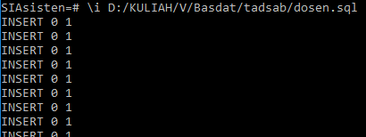

SELECT * FROM DOSEN;

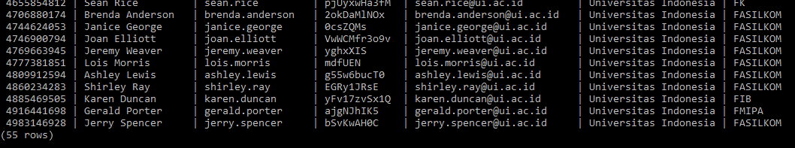

INSERT MAHASISWA

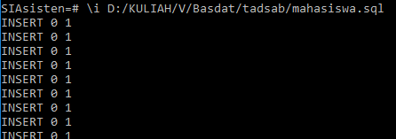

SELECT * FROM MAHASISWA;

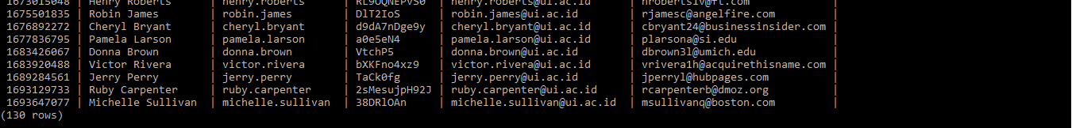

INSERT TELEPON_MAHASISWA

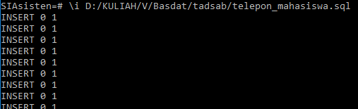

SELECT * FROM TELEPON_MAHASISWA;

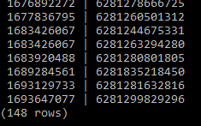

INSERT MHS_MENGAMBIL_KELAS_MK

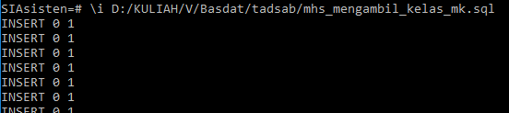

SELECT * FROM MHS_MENGAMBIL_KELAS_MK;

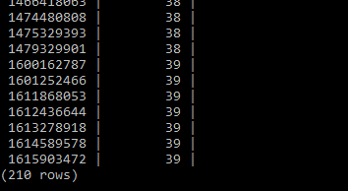

INSERT DOSEN_KELAS_MK

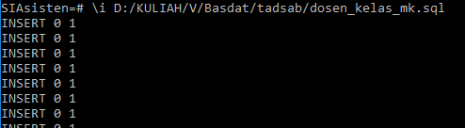

SELECT * FROM DOSEN_KELAS_MK;

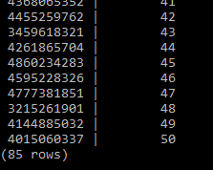

INSERT LOWONGAN

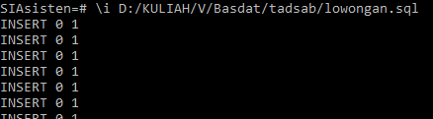

SELECT * FROM LOWONGAN;

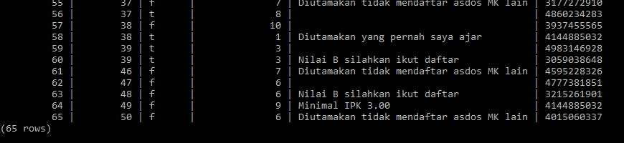

INSERT STATUS_LAMARAN

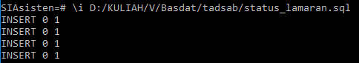

SELECT * FROM STATUS_LAMARAN;

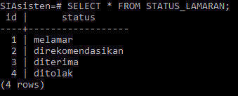

INSERT LAMARAN

SELECT * FROM LAMARAN;

INSERT STATUS_LOG

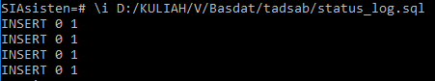

SELECT * FROM STATUS_LOG;

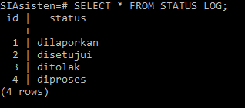

INSERT KATEGORI_LOG

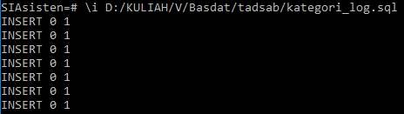

SELECT * FROM KATEGORI_LOG;

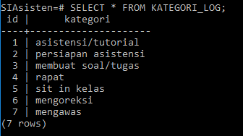

SELECT * FROM LOG;

Kontribusi setiap anggota kelompok:

|  |  |  |  |
| --- | --- | --- | --- |
| NPM | Nama | Deskripsi Tugas | Kontribusi |
| 1406565764 | Meitya Dianti | Men-generate data acak (6 table) |  |
| 1406566924 | Imanda Minara Putri | Men-generate data acak (8 table) |  |
| 1406572385 | Firda Dhea Sauzan | - | 0% |
| 1406577064 | Muthia Nabila | Membuat script DDL untuk create domain, create table (14 table) |  |