**Lab IV –** Prototype User Manual



For Current ITS

CS 411W

Prepared by: Red Team

Date: 12-13-2012

Version 2.0

Table of Contents

1. Introduction 4

2. Getting Started 6

2.1 User Registration 6

2.2 SMS Registration 7

2.3 User Login 7

3.0 HRT GUI 8

3.1 Alerts Management 8

3.2 System Monitoring 10

3.3 Events Management 11

3.4 Advertisement Management 14

3.5 Ridership Trend Report 16

3.6 Train Data Report 18

3.7 User Management 20

3.7.1 User self-management 20

3.7.2 Administrator user management 20

4.0 Business GUI 22

4.1 Service Alerts 22

4.2 Events Administration 23

4.3 Advertisement Campaign Management 26

4.4 System Overview 28

4.5 Ridership Trend Report 29

5.0 Rider GUI 31

5.1 Service Alerts 31

5.2 System Monitoring 32

5.3 Local Events/Attractions 32

5.4 Google Maps Directions 34

5.5 Ridership Trend Report 34

6.0 Test Harness (Akeem Edwards & Dean Maye) 36

7.0 Error Messages (Dean Maye) 36

8.0 Glossary of Terms 36

# List of Figures

Figure 1. Alerts Management 8

Figure 2. Alert Creation 9

Figure 3. Alert Closed 9

Figure 4. System Overview Map 10

Figure 5. Events Administration 11

Figure 6. New Event Created 12

Figure 7. Event Details 12

Figure 8. Editing Events 13

Figure 9. Event Update 13

Figure 10. Closing an Event 14

Figure 11. Advertisement Management 14

Figure 12. Edit Advertisement 15

Figure 13. Advertisement Details 15

Figure 14. Ridership Trend Report 16

Figure 15. Custom Report 17

Figure 16. Train Data Report 18

Figure 17. Custom Report 19

Figure 18. Service Alerts 22

Figure 19. Alert Sign-up 22

Figure 20. Events Administration 23

Figure 21. New Event Created 24

Figure 22. Event Details 24

Figure 23. Editing Events 25

Figure 24. Event Update 25

Figure 25. Closing an Event 26

Figure 26. Advertisement Management 26

Figure 27. Edit Advertisement 27

Figure 28. Advertisement Details 27

Figure 29. System Overview Map 28

Figure 30. Ridership Trend Report 29

Figure 31. Custom Report 30

Figure 32. Service Alerts 31

Figure 33. Alert Sign-up 31

Figure 34. System Overview Map 32

Figure 35. Local Events/Attractions 33

Figure 36. Event Details 34

Figure 37. Ridership Trend Report 35

Figure 38. Custom Report 36

# Introduction

Transit authorities around the country face a multitude of problems when beginning to implement a light rail system to service their host populations. Not the least of these is accurate, real-time communication between the rider, the local businesses that surround the light rail, and the transit authorities themselves. Unfortunately, when planning these systems, often the cost associated with them leaves certain features unfinished or completely left out. In the case of Hampton Roads Transit (HRT) and The Tide, there is no way for riders to accurately know the following: where the trains are relative to them, how occupied the trains are, and any potential problems along the rail line that may impact their travel.

HRT also has no way to accurately track where the trains are, even in downtown Norfolk, a densely populated area. If a train de-rails, human operators have to manually call in the event, which then is relayed to the control center located near Norfolk State University (Messina, 2011). There is no way for those affected by the derailment to automatically reroute themselves to their destination using HRT’s other services, such as the busses. HRT has no way to accurately size their deployment of trains with their existing system, which results in wasted man hours and potentially under/over provisioning of trains.

The local businesses along the line wish to attract potential customers who ride the light rail, but have no way to target the riders in a meaningful way. This results in a loss of riders who are frustrated about a lack of information on what this new transportation service could offer to them. The current level of functionality of The Tide leads to a loss of revenue for HRT who has to constantly justify their light rail project to the local tax paying populace. It is also a loss in potential revenues for the local businesses along the rail line (SIR 2011). This indicates potential problems when it comes to expansion of the rail line into neighboring Virginia Beach, whose main motivator for doing so would be in the benefits the rail line could have to its local businesses and large naval population. These benefits include an alternative to the already overburdened highway system, and boosts to the local economy.

The Current ITS prototype has been developed with this in mind. It connects the riders, HRT administration, and local businesses with easy to use interfaces, allowing for the free flow of information between them. Current ITS will empower riders of HRT’s light rail system “The Tide” by providing an interactive solution to their information shortage. Riders will be able to see, in real time, the relative occupancy of trains that are active and their positions. Riders will receive information about delays or alerts that may affect their travel, and can submit feedback to HRT admins through a web form. In addition, the rider will be able to view advertisements and events submitted by local business owners, in order to take advantage of the local offerings near the light rail.

But, it’s not all about the riders. HRT administration will have a portal to view metrics and control their system. They have the ability control user access, adding and removing users and administrator. With the System Overview, they will have a birds-eye view of all activity on the rail. This includes ETA of trains to stops, current positions of trains, and occupancy values. They will have granular control over reporting of embarks and disembarks on a stop by stop basis, ontime performance of trains and control over system-wide alerts. This historical data is kept in a database to help trend out future values, allowing HRT to plan more efficiently.

The local business owners get an interface to upload and advertise their shops or events, giving relevancy to travel on the light rail. They also have a basic view of historical ridership levels on the stop they are associated with. These features will help bring the light rail into the community, which in turn, drives up interest in funding the expansion of The Tide. A 7-11 located next to the Newtown Road Stop has already begun reporting higher profits simply due to proximity – imagine what advertising directly on The Tide could do.

# Getting Started

To begin using the Current ITS prototype, open a web browser on an internet connected computer and enter <https://odin.cs.odu.edu:8080> into the address bar. Once completed, the main page of the Current ITS application will be displayed. The main page shows all of the components that provide information for light rail riders. User login or registration is not required for this page. To access the application as a transit authority or a business user, registration is required.

# User Registration

Registration is required for users to make changes within the Current ITS system. Only transit authority and business users are authorized to input information into the application. The following steps are a guide for registering to use the application:

**Step 1:** Click on the word “Register” located on the left-hand side of the screen in the Login section of the main page.

**Step 2:** Enter the desired username, name, email address, password, and account type in the appropriate text boxes.

**Step 3:** Click “submit” when completed.

**Step 4:** Check email for account approval email. Upon receipt, account is activated and ready for use.

# SMS Registration

The Current ITS application is designed to send an SMS (Short Messaging Service) message to registered users. The Alerts Module will send an SMS message when an alert applicable to the rider is entered into the system. Conduct the following steps to register a phone to receive SMS messages:

**Step 1:** Navigate to the Current ITS homepage.

**Step 2:** Enter mobile phone number into the text box in the Service Alerts section.

**Step 3:** Select the appropriate mobile carrier.

**Step 4:** Click “Sign Up” to submit the number.

# User Login

The user login feature allows access to the modification portions of Current ITS. It is a one-factor authentication requiring a username and password. The following steps provide the guidance for logging onto the system.

**Step 1:** Navigate to the Current ITS homepage.

**Step 2:** Enter username and password in the text fields in the lower portion of the left-side application window.

**Step 3:** Click the “Login” button.

**Step 4:** A welcome message will appear upon successful authentication.

# 3.0 HRT GUI

## 3.1 Alerts Management

The Alerts Management module will allow you to view, create or remove alerts to notify all riders/business/operators with access to Current ITS. Upon logging into the web application as a transit authority user, click the Alerts link in the left Navigation panel to view the module (Figure X).

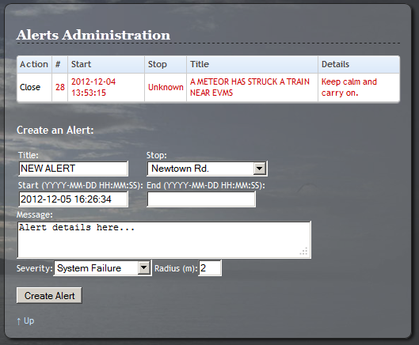

Figure 1. Alerts Management

In the Alerts module, you will see a list of ongoing events (whether entered in using the form or system-generated) along with their estimated Start/Stop time and a description of the alert. There are also options to create an alert, which will enter it into the system and notify all users who have registered to receive service alerts. Simply enter a Title, select an affected stop, a start time, end time (leave blank if unknown), brief message description, a severity level, and radius (in miles) of the affected area. To finish, press the Create Alert button and you will see a confirmation pop-up indicating the alert was created (Figure X). Press OK to return to the Alerts module and you will see the new alert. All registered users of Current ITS should receive a message confirmation with 5-10 minutes.

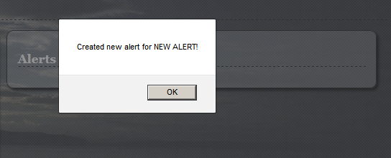

Figure 2. Alert Creation

Ending an alert is just as intuitive. In the list of events above the Create Event form, there is a Close link next to each ongoing alert. Click this to close the alert and you will be presented with a confirmation pop-up that the alert has been closed (Figure X). Press OK to return to the Alerts module.

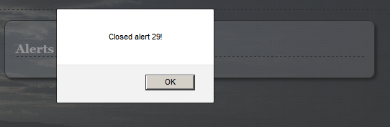

Figure 3. Alert Closed

## 3.2 System Monitoring

The System Monitoring module allows you the power of knowing the status of every vehicle in operation, occupancy, stop information and more. To begin, login as a transit authority user to the web application and click Overview in the left Navigation panel. You will see a view similar to Figure X.

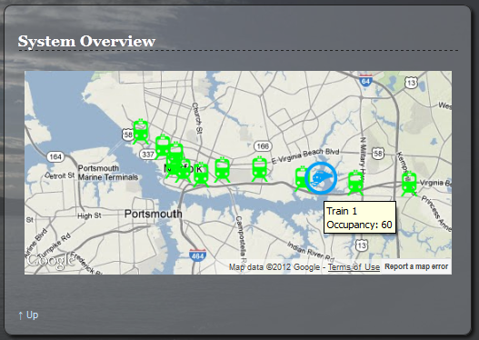

Figure 4. System Overview Map

A map is displayed depicting the entire light rail system. Green markers denote stations along the routes, while circular train markers indicate the location of train vehicles in operation. You can zoom in or out by scrolling the mouse wheel up or down, or pan by clicking and dragging on the map. To get details, such as occupancy or estimate times of arrival (ETAs), simply hold your mouse cursor over the marker. The map will automatically update every few seconds.

## 3.3 Events Management

The Events module allows you to view, edit, or create events to keep light rail commuters in the loop on what’s happening near your system. This includes events which you can create, as well as events being organized by businesses registered with Current ITS. To begin, login as a transit authority user and click Events in the Navigation panel on the left of the web interface (Figure X).

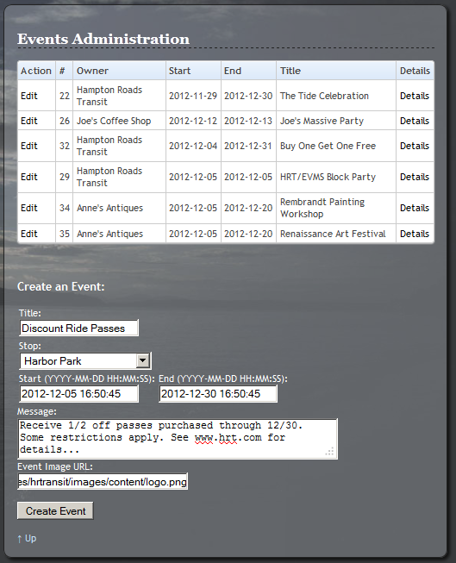

Figure 5. Events Administration

In the Events module, you will see a list of your events as well as the events for all businesses registered with Current ITS. Below this list, there are fields to create a new event. To do this, simply fill in a Title, Stop, Start and End times, a brief Message, and a URL for an image to be displayed along with the event. Upon filling out these fields, press Create Event and you will receive a confirmation pop-up (Figure X).

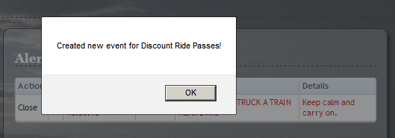

Figure 6. New Event Created

Next to each event in the list, there is an Edit link which can be pressed to edit the particular event. There is also a details link which will take you to the specific details of the event. Press the Details link next to any event to see more information such as the time/location and other relevant details (Figure X).

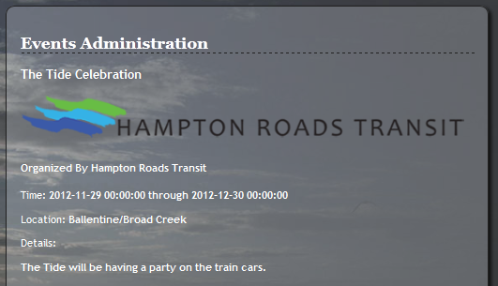

Figure 7. Event Details

To edit an event that already exists, press the Edit button next to it in the events list. You will be presented with a view similar to the one depicted in Figure X. On this form, you can edit any details as needed to keep everyone informed of changes in plans.

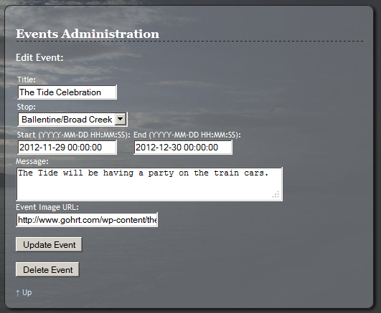

Figure 8. Editing Events

If you are finished with updating the event, press the Update Event button to make the changes immediately. You will receive a confirmation pop-up that the event was updated (Figure X). Press OK to return to the Events list.

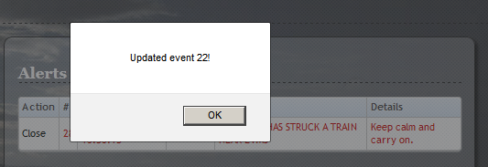

Figure 9. Event Update

We understand that there may be a need to delete events which have been created yourself or by other businesses who have registered with Current ITS. To delete the event, you may press the Delete Event button, and a confirmation dialog will appear (Figure X). Click OK to return to the Events list.

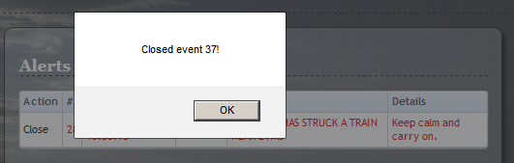

Figure 10. Closing an Event

## 3.4 Advertisement Management

The Advertisement Management module will allow users to view, edit, create, and close advertisements being run on Current ITS. Upon logging into the web application as a transit authority user, click the Advertise link in the left Navigation Panel to view the module (Figure 1).

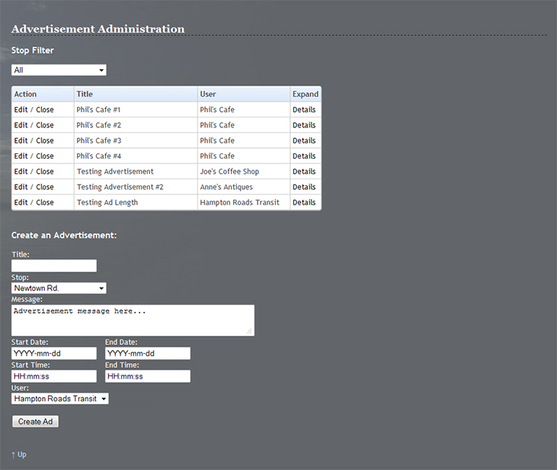

Figure 11. Advertisement Management

In the Advertisement Management module, the first option you will see is the Stop Filter. This is used by selecting a stop from the dropdown list, which will refresh the page and filter the list to show the advertisements for a specific stop. Leaving the dropdown set to “All” will display all of the advertisements currently active on the system.

The first column, Action, on the advertisement listing presents the user with two options: Edit and Close. Clicking the Close link will simply set the advertisement to inactive, thus removing it from the list of ads. The edit option will bring up a new section (Figure 2) which will present the user with six textbox objects (Title, Message, Start Date, End Date, Start Time, and End Time) and two dropdown menus (Stop and User). These fields will be populated with the data from the selected advertisement and can be edited. After making any desired changes, the Edit Ad button should be selected to submit the changes to the advertisement and return to the main layout.

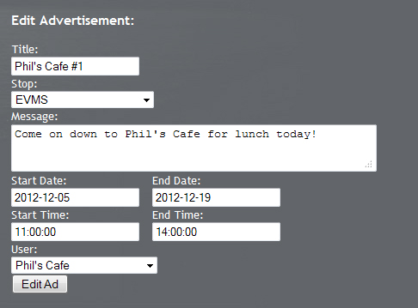

Figure 12. Edit Advertisement

The other option on the main advertisement listing is a clickable link with the word Details. Clicking this link will open another section on the interface (Figure 3), which will list the following information for the selected advertisement: Title, Message, User, Stop, Start Date, End Date, Start Time, and End Time.

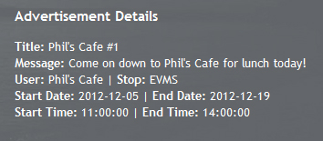

Figure 13. Advertisement Details

The final section of the Advertisement Management module is the “Create an Advertisement” form (Figure 1). This section is similar to the Edit Advertisement section but instead of prepopulated fields this section will allow a user to create a new advertisement from scratch. The section consists of six textbox objects (Title, Message, Start Date, End Date, Start Time, and End Time) and two dropdown menus (Stop and User). Note that the Start Time and End Time will control the timing for during which hours the ad is displayed every day, while the Start and End Date will control how many total days for which the ad is displayed. All of these fields are mandatory and once filled in, the user will click Create Ad in order to create the new advertisement.

## 3.5 Ridership Trend Report

The Ridership Trend Report module will allow HRT to view reports for the number of Departures and Arrivals at a given stop. The Default Report will display five entries with an interval of approximately one hour, centered on the current time. The first option on the page (Figure x) is the Stop Filter, which modifies the stop for which the Default Report will generate values. The Default Report itself is relatively straight forward, featuring three columns: Date/Time, Departures, and Arrivals. As an HRT level user, Departures and Arrivals will display an exact number for each column, generated by the Decision Engine.

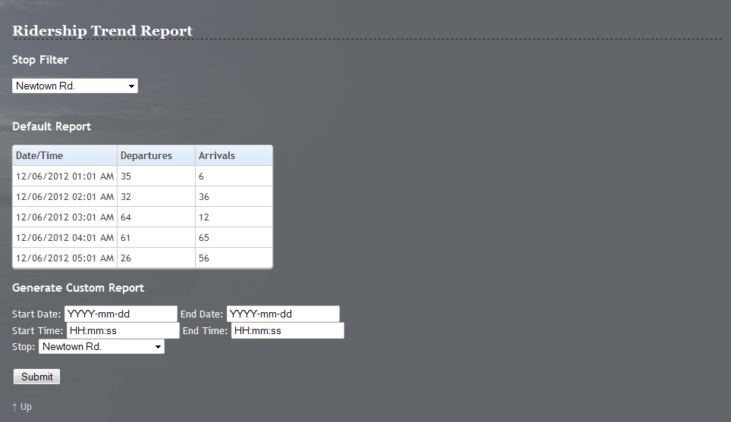

Figure 14. Ridership Trend Report

To generate a Custom Report, a user must input five fields: Start Date, End Date, Start Time, End Time, and Stop. The Start Time and End Time values will control the interval for which the report generates value on each day, while Start Date and End Date control how many total days will be displayed. Note that the report will adjust the time difference between each request, resulting in more detail for a smaller request window and an overview for larger requests. The dropdown menu for Stop will simply set the stop for which to display the report.

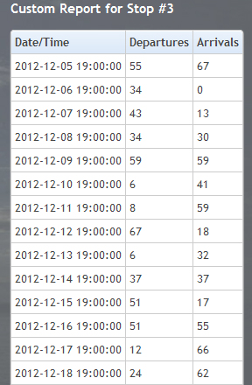

Figure 15. Custom Report

Once all of the fields are complete, the user must click Submit in order to generate the new report. The page will refresh and replace the Default Report with the Custom Report, using the same format as described in the start of this section (Figure x). If the user wishes to generate another report, the form is still displayed beneath the Custom Report section.

## 3.6 Train Data Report

The Train Data Report module will allow HRT users to view details about the On-Time Performance of The Tide. The functionality and layout (Figure 1) is very similar to the previously described Ridership Trend Report module that you may have already read about in the previous section. The first function you will find is the Train Selector which allows the user to pick a train from the dropdown menu to be displayed on the Default Report. The Default Report consists of four columns: Date, Stop ID, Arrival Variance, and Departure Variance. Date and Stop ID will simply be the relevant data for the row’s request, while Arrival Variance and Departure Variance will be calculated by the Decision Engine to show whether a train was late, early, or on time.

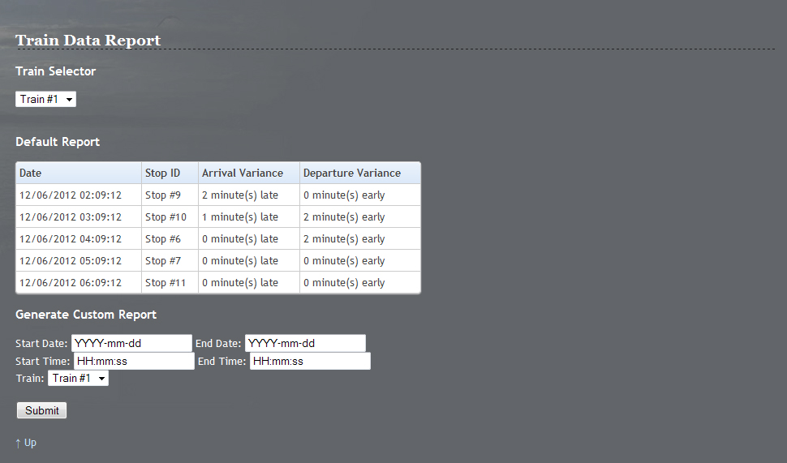

Figure 16. Train Data Report

To generate a Custom Report, a user must input five fields: Start Date, End Date, Start Time, End Time, and Train. The Start Time and End Time values will control the interval for which the report generates value on each day, while Start Date and End Date control how many total days will be displayed. Note that the report will adjust the time difference between each request, resulting in more detail for a smaller request window and an overview for larger requests. The dropdown menu for Train will simply set the train for which to display the report.



Figure 17. Custom Report

Once all of the fields are complete, the user must click Submit in order to generate the new report. The page will refresh and replace the Default Report with the Custom Report, using the same format as described in the start of this section (Figure x). If the user wishes to generate another report, the form is still displayed beneath the Custom Report section.



# User Management

The user management module is designed to allow changes to the individual user accounts. All registered users have access to the basic functions of the module. They are able to make changes to their individual accounts. Administrators have the ability to make changes to any account within the system. This guide will first discuss the user’s capability followed by the administrators.

# User self-management

The user will have the capability to modify their given name, password, and email address. The function will be displayed on the bottom of the Current ITS web page. To change personal information the user will need to do the following:

**Step 1:** Login to the application from the Current ITS home page.

**Step 2:** Scroll to the bottom of the screen where their information is displayed.

**Step 3:** Modify available information in the text fields.

**Step 4:** Click on the “Update” button to submit changes.

# Administrator user management

The administrator has additional options than the ones mentioned above. The administrator has the capability to change other users’ information. This can be done by the following procedure:

**Step 1:** Login to the application with an account that has administrator privileges from the Current ITS home page.

**Step 2:** Scroll to the bottom of the screen where the user information is displayed.

**Step 3:** Select the user to be modified in the dropdown menu.

**Step 4:** Modify available information in the text fields.

**Step 4:** Click on the “Update” button to submit changes.

(This space intentionally left blank.)

# 4.0 Business GUI

## 4.1 Service Alerts

The Alerts module will allow registered businesses to view alerts regarding service outages and important information from Current ITS. Click the Alerts link in the left Navigation panel to view the module (Figure X).

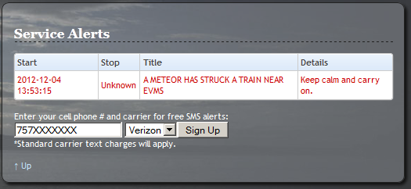

Figure 18. Service Alerts

In the Alerts module, they will see a list of ongoing events (whether entered in by an HRT administrator or system-generated) along with their estimated Start/Stop time and a description of the alert. To register for automatic alerts, they enter their 10-digit mobile telephone number and select their cell phone carrier and press Sign Up. A confirmation dialog will be displayed indicating they were subscribed. Press OK to return to the Alerts module (Figure X). They should receive a message confirmation with 5-10 minutes of an alert being created from now on. To unsubscribe, the business user simply replies STOP to the SMS they receive.

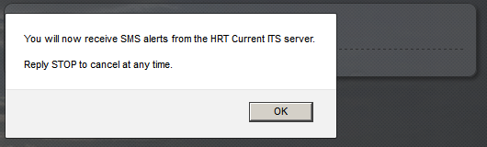

Figure 19. Alert Sign-up

## 4.2 Events Administration

The Events module allows business users the ability to view, edit, or create events to keep light rail commuters in the loop on what’s happening with their organization. To begin, they need to login as a business user and click Events in the Navigation panel on the left of the web interface (Figure X).

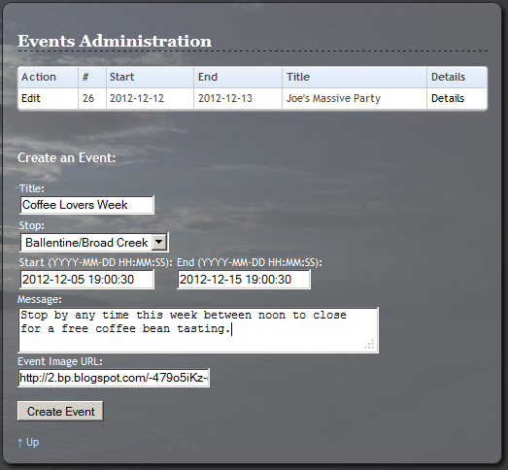

Figure 20. Events Administration

In the Events module, they will see a list of their events registered with Current ITS. Below this list, there are fields to create a new event. To do this, the business user simply fills in a Title, Stop, Start and End times, a brief Message, and a URL for an image to be displayed along with the event. Upon filling out these fields, they press Create Event and will receive a confirmation pop-up (Figure X). Pressing OK returns to the Events module

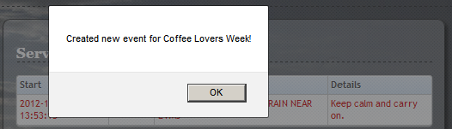

Figure 21. New Event Created

Next to each event in the list, there is an Edit link which can be pressed to edit the particular event. There is also a details link which will take them to the specific details of the event. They just press the Details link next to any event to see more information such as the time/location and other relevant details (Figure X).

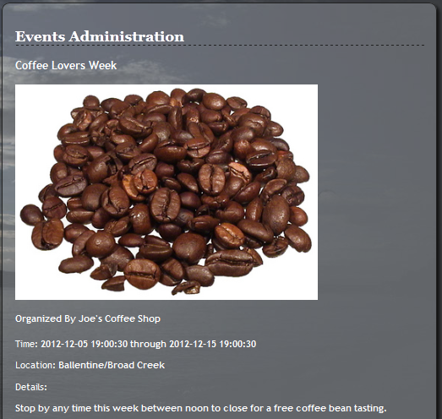

Figure 22. Event Details

To edit an event that already exists, press the Edit button next to it in the events list. They will be presented with a view similar to the one depicted in Figure X. On this form, the business can edit any details as needed to keep everyone interested informed of changes in plans.

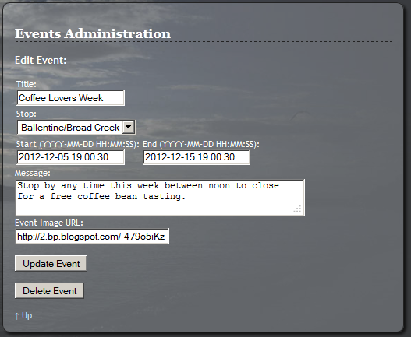

Figure 23. Editing Events

If they are finished with updating the event, the user must press the Update Event button to make the changes immediately. They will receive a confirmation pop-up that the event was updated (Figure X). Then the user just needs to press OK to return to the Events list.



Figure 24. Event Update

We understand that there may be a need to delete events which the business has created. To delete the event, they may press the Delete Event button, and a confirmation dialog will appear (Figure X). Then, click OK to return to the Events list.



Figure 25. Closing an Event

## 4.3 Advertisement Campaign Management

The Advertisement Campaign Management module will allow business users to view, edit, create, and close advertisements that have been created by their account. Upon logging into the web application as a transit authority user, click the Advertise link in the left Navigation Panel to view the module (Figure 1).

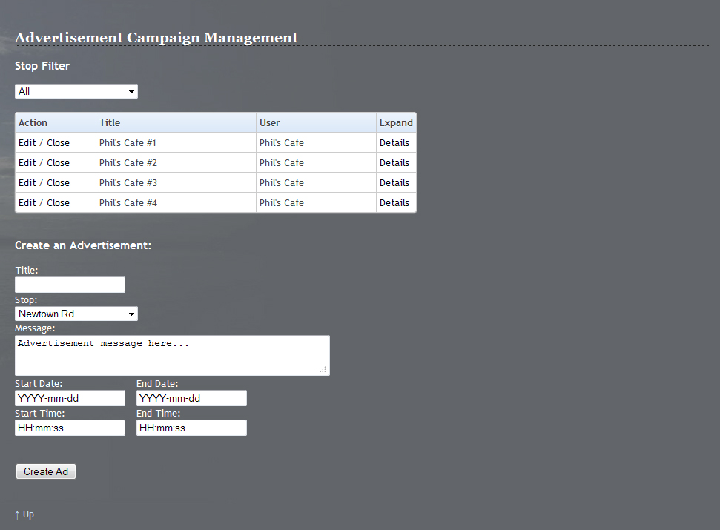

Figure 26. Advertisement Management

In the Advertisement Management module, the first option you will see is the Stop Filter. This is used by selecting a stop from the dropdown list, which will refresh the page and filter the list to show the advertisements for a specific stop. Leaving the dropdown set to “All” will display all of the advertisements currently active on the system.

The first column, Action, on the advertisement listing presents the user with two options: Edit and Close. Clicking the Close link will simply set the advertisement to inactive, thus removing it from the list of ads. The edit option will bring up a new section (Figure 2) which will present the user with six textbox objects (Title, Message, Start Date, End Date, Start Time, and End Time) and one dropdown menus (Stop). These fields will be populated with the data from the selected advertisement and can be edited. After making any desired changes, the Edit Ad button should be selected to submit the changes to the advertisement and return to the main layout.

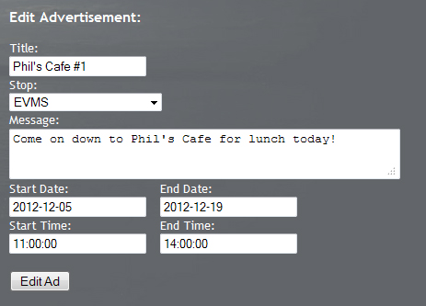

Figure 27. Edit Advertisement

The other option on the main advertisement listing is a clickable link with the word Details. Clicking this link will open another section on the interface (Figure 3), which will list the following information for the selected advertisement: Title, Message, Stop, Start Date, End Date, Start Time, and End Time.

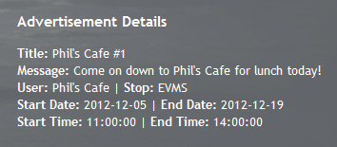

Figure 28. Advertisement Details

The final section of the Advertisement Management module is the “Create an Advertisement” form (Figure 1). This section is similar to the Edit Advertisement section but instead of prepopulated fields this section will allow a user to create a new advertisement from scratch. The section consists of six textbox objects (Title, Message, Start Date, End Date, Start Time, and End Time) and one dropdown menus (Stop). Note that the Start Time and End Time will control the timing for during which hours the ad is displayed every day, while the Start and End Date will control how many total days for which the ad is displayed. All of these fields are mandatory and once filled in, the user will click Create Ad in order to create the new advertisement.

## 4.4 System Overview

The System Overview module allows businesses the power of knowing the status of every vehicle in operation, vacancy, stop information and more. To begin, they visit the web application and click Overview in the left Navigation panel. They will see a view similar to Figure X.

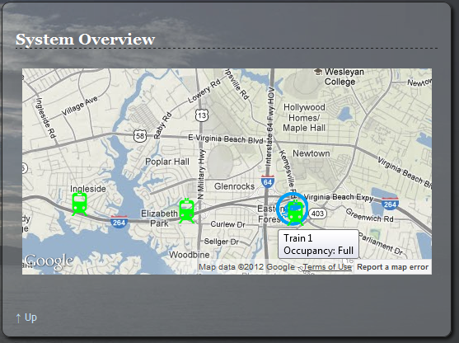

Figure 29. System Overview Map

A map is displayed depicting the entire light rail system. Green markers denote stations along the routes, while circular train markers indicate the location of train vehicles in operation. They may zoom in or out by scrolling the mouse wheel up or down (just as in the administration view), or pan by clicking and dragging on the map. To get details, such as vacancy (full or vacant) or estimate times of arrival (ETAs), they simply hold down the mouse cursor over the marker. The map will automatically update every few seconds.

## 4.5 Ridership Trend Report

The Ridership Trend Report module will allow business users to view reports for the number of Departures and Arrivals at a given stop. The Default Report will display five entries with an interval of approximately one hour, centered on the current time. The first option on the page (Figure x) is the Stop Filter, which modifies the stop for which the Default Report will generate values. The Default Report itself is relatively straight forward, featuring three columns: Date/Time, Departures, and Arrivals. As a business level user, Departures and Arrivals will display High, Medium, or Low for each column, based on the numbers generated by the Decision Engine.

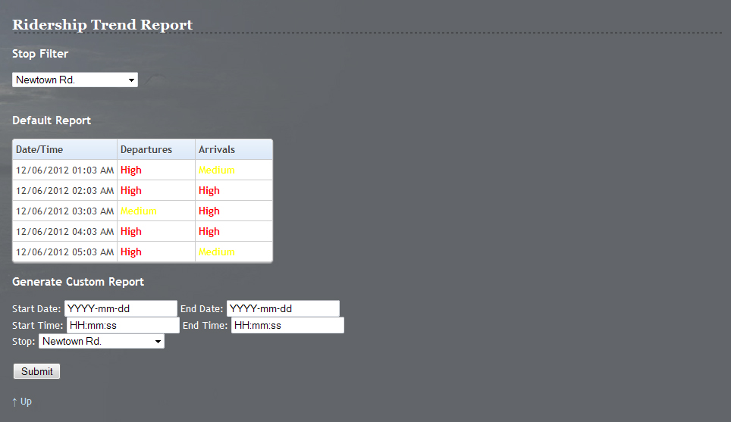

Figure 30. Ridership Trend Report

To generate a Custom Report, a user must input five fields: Start Date, End Date, Start Time, End Time, and Stop. The Start Time and End Time values will control the interval for which the report generates value on each day, while Start Date and End Date control how many total days will be displayed. Note that the report will adjust the time difference between each request, resulting in more detail for a smaller request window and an overview for larger requests. The dropdown menu for Stop will simply set the stop for which to display the report.

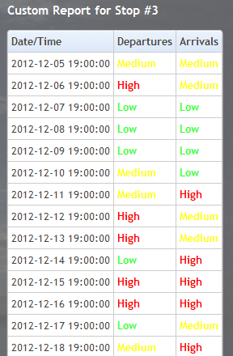

Figure 31. Custom Report

Once all of the fields are complete, the user must click Submit in order to generate the new report. The page will refresh and replace the Default Report with the Custom Report, using the same format as described in the start of this section (Figure x). If the user wishes to generate another report, the form is still displayed beneath the Custom Report section.

## 5.0 Rider GUI

## 5.1 Service Alerts

The Alerts module will allow any light rail commuters and potential passengers to view alerts regarding service outages and important information from Current ITS. Click the Alerts link in the left Navigation panel to view the module (Figure X).



Figure 32. Service Alerts

In the Alerts module, they will see a list of ongoing events (whether entered in by an HRT administrator or system-generated) along with their estimated Start/Stop time and a description of the alert. To register for automatic alerts, they enter their 10-digit mobile telephone number and select their cell phone carrier and press Sign Up. A confirmation dialog will be displayed indicating the rider was subscribed. Then they press OK to return to the Alerts module (Figure X). They should receive a message confirmation with 5-10 minutes of an alert being created from now on. To unsubscribe, the user simply replies STOP to the SMS they receive.



Figure 33. Alert Sign-up

## 5.2 System Monitoring

The System Overview module allows light rail patrons the power of knowing the status of every vehicle in operation, vacancy, stop information and more. To begin, they visit the web application and click Overview in the left Navigation panel. They will see a view similar to Figure X.



Figure 34. System Overview Map

A map is displayed depicting the entire light rail system. Green markers denote stations along the routes, while circular train markers indicate the location of train vehicles in operation. Users can zoom in or out by scrolling the mouse wheel up or down, or pan by clicking and dragging on the map. To get details, such as vacancy or estimate times of arrival (ETAs), they simply hold down the mouse cursor over the marker. The map will automatically update every few seconds.

## 5.3 Local Events/Attractions

The Events module allows keep light rail commuters the ability to view events stay in the loop on what’s happening near light rail stops. To begin, they need click Events in the Navigation panel on the left of the web interface (Figure X).

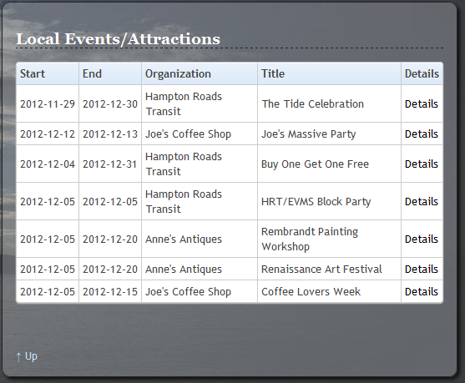

Figure 35. Local Events/Attractions

In the Events module, they will see a list of events registered with Current ITS. There is also a details link which will take them to the specific details of the event. They just have to press the Details link next to any event to see more information such as the time/location and other relevant details (Figure X).

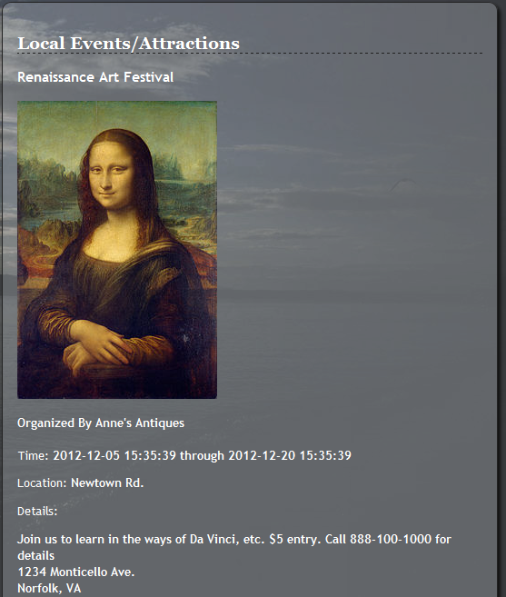

Figure 36. Event Details

## 5.4 Google Maps Directions

## 5.5 Ridership Trend Report

The Ridership Trend Report module will allow riders to view reports for the number of Departures and Arrivals at a given stop. The Default Report will display five entries with an interval of approximately one hour, centered on the current time. The first option on the page (Figure x) is the Stop Filter, which modifies the stop for which the Default Report will generate values. The Default Report itself is relatively straight forward, featuring three columns: Date/Time, Departures, and Arrivals. As a rider level user, Departures and Arrivals will display High, Medium, or Low for each column, based on the numbers generated by the Decision Engine.



Figure 37. Ridership Trend Report

To generate a Custom Report, a user must input five fields: Start Date, End Date, Start Time, End Time, and Stop. The Start Time and End Time values will control the interval for which the report generates value on each day, while Start Date and End Date control how many total days will be displayed. Note that the report will adjust the time difference between each request, resulting in more detail for a smaller request window and an overview for larger requests. The dropdown menu for Stop will simply set the stop for which to display the report.



Figure 38. Custom Report

Once all of the fields are complete, the user must click Submit in order to generate the new report. The page will refresh and replace the Default Report with the Custom Report, using the same format as described in the start of this section (Figure x). If the user wishes to generate another report, the form is still displayed beneath the Custom Report section.

## 6.0 Test Harness (Akeem Edwards & Dean Maye)

## 7.0 Error Messages (Dean Maye)

Current ITS also features instant error messages to aid a user as they navigate the website. These error messages are generated if the user attempts to submit forms which have incorrect input. Section 4.1 of this document details how a user would sign up for Service Alerts. Two distinct error messages can be generated by this module; if a user were to try to submit a blank text box they would be issued the message: “Please a valid 10 digit mobile number”, and if a user were to attempt to submit a phone number already in the database they would be issued the message: “Our records indicate that you are already subscribed. Reply STOP to cancel at any time”. Two error messages can be generated by the feedback module. If a user were to attempt to submit the form with the name field blank the message would be: “Your name was not entered!” and if a user were to attempt to submit the form with the comment field blank the message would be: “Comment field is required!”

## 8.0 Glossary of Terms