Nathan Lutz

CS330 Fall 12

Prof Zeil

Potential Class:

Order, mail-order facility, mof staff, products, stock, warehouses, packing slip, customer, invoice, shipping date, charges, price, shipping and handling costs, sales taxes.

Potential Responsibilities

Received(order), check(order,inventory), divide(order), sending(packing slip, warehouse), tells(warehouse, products), ship (products, customer), prepares(invoice,order), indicating(products,shipping_date,charges)mailed(invoice,customer)

CRC Cards

|  |  |
| --- | --- |
| Orders | |
| Specifies Products | Customer  Mail-order facility |

|  |  |
| --- | --- |
| Warehouse | |
| Manages Inventory  Receives Packing Slip  Ships Product to Customer  Has Products, Inventory | Mail-order facility  Customer |

|  |  |
| --- | --- |
| Inventory | |
| Products in Warehouse | Warehouse |

|  |  |
| --- | --- |
| Product | |
| Has Price | Inventory |

|  |  |
| --- | --- |
| Customer | |
| Place an Order  Receive shipped Products  Receive Invoice | Mail-order facility  Warehouse  Order |

|  |  |
| --- | --- |
| Mail-order Facility | |
| Receive Order from Customer  Check Order against Warehouse Inventory  Divide Order amongst Warehouse  Send Packing Slip to Warehouse  Prepare Invoice  Send Invoice to Customer | Order  Warehouse  Packing Slip  Customer  Invoice |

|  |  |
| --- | --- |
| Packing Slip | |
| Tell warehouse which products to ship to the Customer | Warehouse  Mail-order Facility |

|  |  |
| --- | --- |
| Invoice | |
| Has Products to be shipped, Product’s price, expected shipping date, shipping and handling cost, sales tax | Customer  Mail-order Facility  Product |

UML Diagrams

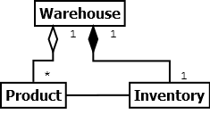

This diagram illustrates that Warehouses maintain 1 inventory, and have many Products which are accounted for in the Inventory.

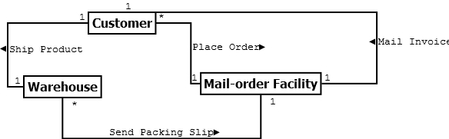

This diagram illustrates that how 1 customer places an order, which prompts the Mail-order Facility to send a packing slip to the warehouse, in order for it to ship the ordered product, in addition to mailing an Invoice back to the Customer.

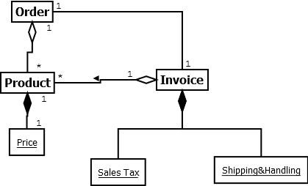

This diagram illustrates how one Order is associated with one Invoice, and many Products, each of which have a Price. The Invoice is associated with potentially many Products, each of which having a Price. The Invoice also contains the Sales Tax and Shipping & Handling cost.