* + 1. **Decision Engine** (**Nathan Lutz**)
       1. **Ridership Trend Report**:

Provide an interface for the Web Application Engine to request a ridership report on the past.

Provide the ability to identify a date range to include:

Date(MM-DD-YYYY)

Time range (HH:MM:SS)

Provide the ability to identify a stop ID as an integer

Specified must be used to query the “Occupancy” table for number of departures and arrivals.

Provide output to Ridership Trend Report function in the form of non-negative integers.

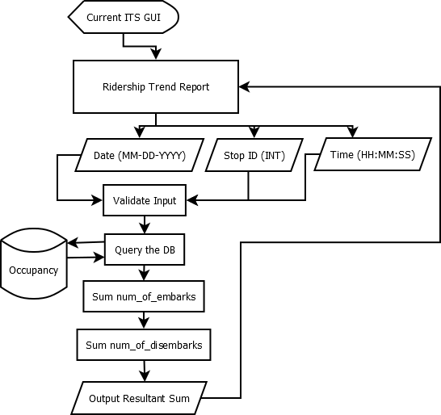

Figure 1. Ridership Trend Report Logic Flow

* + - 1. **Ridership Trend Analysis:**

Provide an interface for the Web Application Engine to request a ridership trend report on future dates.

Provide the ability to identify a date range as specified in 3.1.2.1.i

Provide the ability to identify a stop ID as specified in 3.1.2.1.ii

Specified must be used to query the Current ITS database for number of departures and arrivals from past dates during the specified time range.

Provide the ability to model the values of departures and arrivals for the future date range.

These queried values will be averaged using a “moving average” technique.

Provide output to Ridership Trend Report function in the form of non-negative integers.

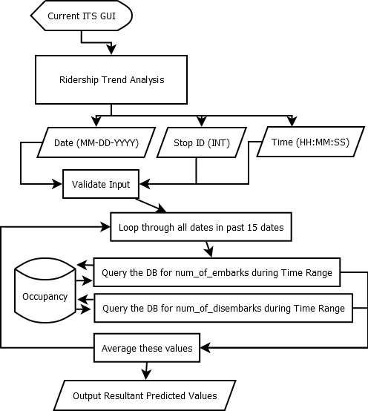

Figure 2. Ridership Trend Analysis

* + - 1. **Delay Impact Calculator**

Provide an interface for the Web Application Engine to request a Delay Impact report. Provide the ability to query the Current ITS database for the most recent simulated GPS location value of active trains.

Provide the ability to identify a GPS coordinate to include:

* Precede South latitudes and West longitudes with a minus sign.
* Latitudes range from -90 to 90.
* Longitudes range from -180 to 180.

Provide the ability to query the Current ITS database “GPS” table for past simulated arrival times at the station during the date and time range. 3.1.1.6

Provide the ability to compare those values to the HRT schedule, and return the average variance.

Provide the ability to query the Current ITS database for any active alerts and their severity level.

Specified must be used in its calculation of delay.

Provide the ability to compare the expected value of time-to-arrival from the calculated variance and current GPS position to the HRT schedule.

Provide output to (Delay Impact Module) function in the form of a time value.

* + - 1. **Ontime Performance Reporting**

Provide an interface for the Web Application Engine to request a Delay Impact report.

Provide the ability to identify a date range as specified in 3.1.2.1.i

Provide the ability to identify a stop ID as specified in 3.1.2.1.ii

Specified must be used to query the Current ITS database “GPS” and “STOPS” table for past simulated arrival times at the station.

Provide the ability to compare those values to the HRT schedule.

Provide output to Train Data Report function the average variance, in the form of a time value.