* + 1. **Decision Engine** (**Nathan Lutz**)
       1. **Ridership Trend Analysis**:

Provide an interface for the Web Application Engine to request a ridership report on the past.

Provide the ability to identify a date range to include:

Date(YYYY-MM-DD)

Time range (HH:MM:SS)

Provide the ability to identify a stop ID as an integer

Provide the ability to determine whether the date specified is a future or past date.

Provide the ability to connect to the Current ITS mysql database.

Provide the ability to follow logic beginning in requirement 3.1.2.v.a if the date is in the past.

Values specified in 3.1.2.1.i must be used to query the “Occupancy” table for number of departures and arrivals. (3.1.1.7)

Provide output to Ridership Trend Report function in the form of non-negative integers. (3.1.4.6)

Provide the ability to follow logic beginning in 3.1.2.1.vi.a if the date is in the future.

Specified must be used to query the “Occupancy” table for number of departures and arrivals from past dates during the specified time range. (3.1.1.7)

Provide the ability to average the number of departures and arrivals that occurred during the time range specified on each date in the past up to 15 days.

Provide the ability to query the “adverts” table for events that occur during the date & time range specified.

Provide the ability to follow logic beginning in requirement 3.1.2.1.vi.f if an event is found.

Provide the ability to store the following values for comparison:

Name

Stop ID

Category

Start date

End Date

Start Time

End Time

Provide the ability to query the “adverts” table for events that have occurred using the values stored in 3.1.2.1.vi.f.i-vii

Provide the ability to follow logic beginning in requirement 3.1.2.1.vi.i if an event is found.

Provide the ability to determine the variance between the set of averages found in 3.1.2.1.vi.c and the embark/disembark values during the time of the event found in 3.1.2.1.vi.g

Provide the ability to apply the variance found in 3.1.2.1.vi.i to the set of averages in 3.1.2.1.vi.c.

Provide output to Ridership Trend Report function in the form of non-negative integers. (3.1.4.6)

* + - 1. **Delay Impact Calculator**

Provide an interface for the Web Application Engine to request a Delay Impact report. Provide the ability to query the Current ITS database for the most recent simulated GPS location value of active trains.

Provide the ability to identify a GPS coordinate to include:

* Precede South latitudes and West longitudes with a minus sign.
* Latitudes range from -90 to 90.
* Longitudes range from -180 to 180.

Provide the ability to identify a date as specified in 3.1.2.1.i.a

Provide the ability to query the “trains” table for active trains during the date specified in 3.1.2.2.ii.

Provide the ability to query the Current ITS database “GPS” table for past simulated arrival times at the station during the date. (3.1.1.11)

Provide the ability to query the “schedule” table. (3.1.1.9)

Provide the ability to compare the values specified in 3.1.2.2.iv and 3.1.2.2.v and store the average variance.

Provide the ability to query the “alerts” table for any active alerts and their severity level. (3.1.1.8)

Specified must be used in its calculation of delay using the following categories and associated Delay intervals.

* 1 – Local Warning – No Delay
* 2 – Local Problem – 10 Min Delay
* 3 – System Warning – 20 Min Delay
* 4 – System Problem – 30 Min Delay
* 5 – System Failure – 50 Min Delay
* 6 – System Shutdown - Interpreted as full stop of trains.

Provide the ability to apply the delay interval to the average variance stored in 3.1.2.2.vi

Provide the ability to compare the expected value of time-to-arrival between the calculated variance and current GPS position to the HRT schedule.

Provide output to Train Data Report module in the form of a time value. (3.1.4.7)

* + - 1. **Ontime Performance Reporting**

Provide an interface for the Web Application Engine to request a Delay Impact report.

Provide the ability to identify a date range as specified in 3.1.2.1.i

Provide the ability to identify a stop ID as specified in 3.1.2.1.ii

Specified must be used to query the Current ITS database “GPS” and “STOPS” table for past simulated arrival times at the station. (3.1.1.11) (3.1.1.5)

Provide the ability to query the “schedule” table. (3.1.1.9)

Provide the ability to compare the values specified in 3.1.2.3.iii and 3.1.2.3.iv and return the variance.

Provide output to Train Data Report module the average variance, in the form of a time value. (3.1.4.7)

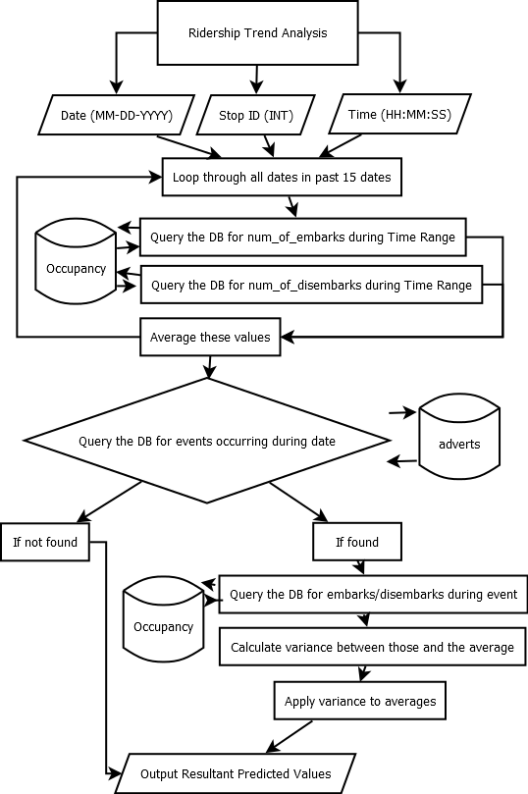

Figure 1. Ridership Trend Analysis