Blue Nile Cycle — From Nominated to Funded
One-page Oversight Body runbook · the system enforces this order, so it is also the order of work · 15 July 2026
1. Triage the register
Where: Partners (sidebar) — the Partners console
- Collect Partner Information Forms for the 22 name-only orgs and drop them on "Import PIFs" (each becomes a full record automatically), or park those orgs for a later round.
- Chase the two PIFs with no readable bank section (Al Takafol, Soblasaw) and re-import.
- Settle the 6 possible duplicate name-pairs before endorsements attach to the wrong record.
2. Register and approve endorsers
Where: Share /proximate/endorse/register with community members; approve under Endorsers (sidebar)
- Real community members from Kurmuk / Geisan / Damazin self-register (locality + conflict-of-interest self-disclosure).
- The OB reviews each pending endorser against their disclosed COI signals and approves or rejects with a reason.
- This is the round’s long pole — it is outreach work, not software work. Start it first.
3. Collect 2 endorsements per partner
Where: Each partner’s page — endorsers answer 3 questions at the bottom
- Is the group real? Do you trust them with money? Would communities accept aid from them? (voice notes supported).
- Conflict-of-interest is checked automatically at submit; a partner needs 2 COI-clear endorsements to progress. Nothing else can bypass this gate.
4. Due-diligence clearance + payment route
Where: Same partner page — evidence panels and Disbursement methods
- Review what is already there: sanctions screen (all 62 ran clear on import), sam.gov screenshots, media-verification verdict.
- Easiest first cohort: the 9 partners with a positive social footprint. No-footprint verdicts are normal for small CBOs — one extra check, not a rejection.
- Then "Add method" (bank / hawala / mobile money — the bank details are in each partner’s PIF on the same page) and run bank verification. Disbursement stays blocked until this is done.
5. Appoint the panel
Where: Rounds & disbursements → Blue Nile Cycle — Panel roster
- Move the 5 candidates (Hamdan, Ibrahim Saeed, Nahla Elbedry, Zahra Haidar, Shaima Ahmed) from candidate → vetted → appointed.
6. Fund the round and record disbursements
Where: Grants from donors (allocation) → All disbursements → Record a disbursement
- The Blue Nile round has no donor allocation yet — link a donor grant to it first.
- Each disbursement picks the partner’s verified route, sets a report window (default 14 days) and the ISF-gate attestation; amounts above $10k automatically require extra co-signatures.
- The partner gets a WhatsApp-friendly token link to report back — no login needed.
Suggested first wave: run the 9 positive-footprint partners through steps 3–6 end to end before scaling to all 62. Every partner page shows a "why blocked" banner telling you the exact missing step.
Visual guide — where each step lives
Live production screenshots, taken as the Oversight Body seat on 15 July 2026. The partner shown in step 3/4 is a demo record — no real bank data appears here.
Step 1 — Partners console — triage, "Import PIFs", "Nominate partner", status filters
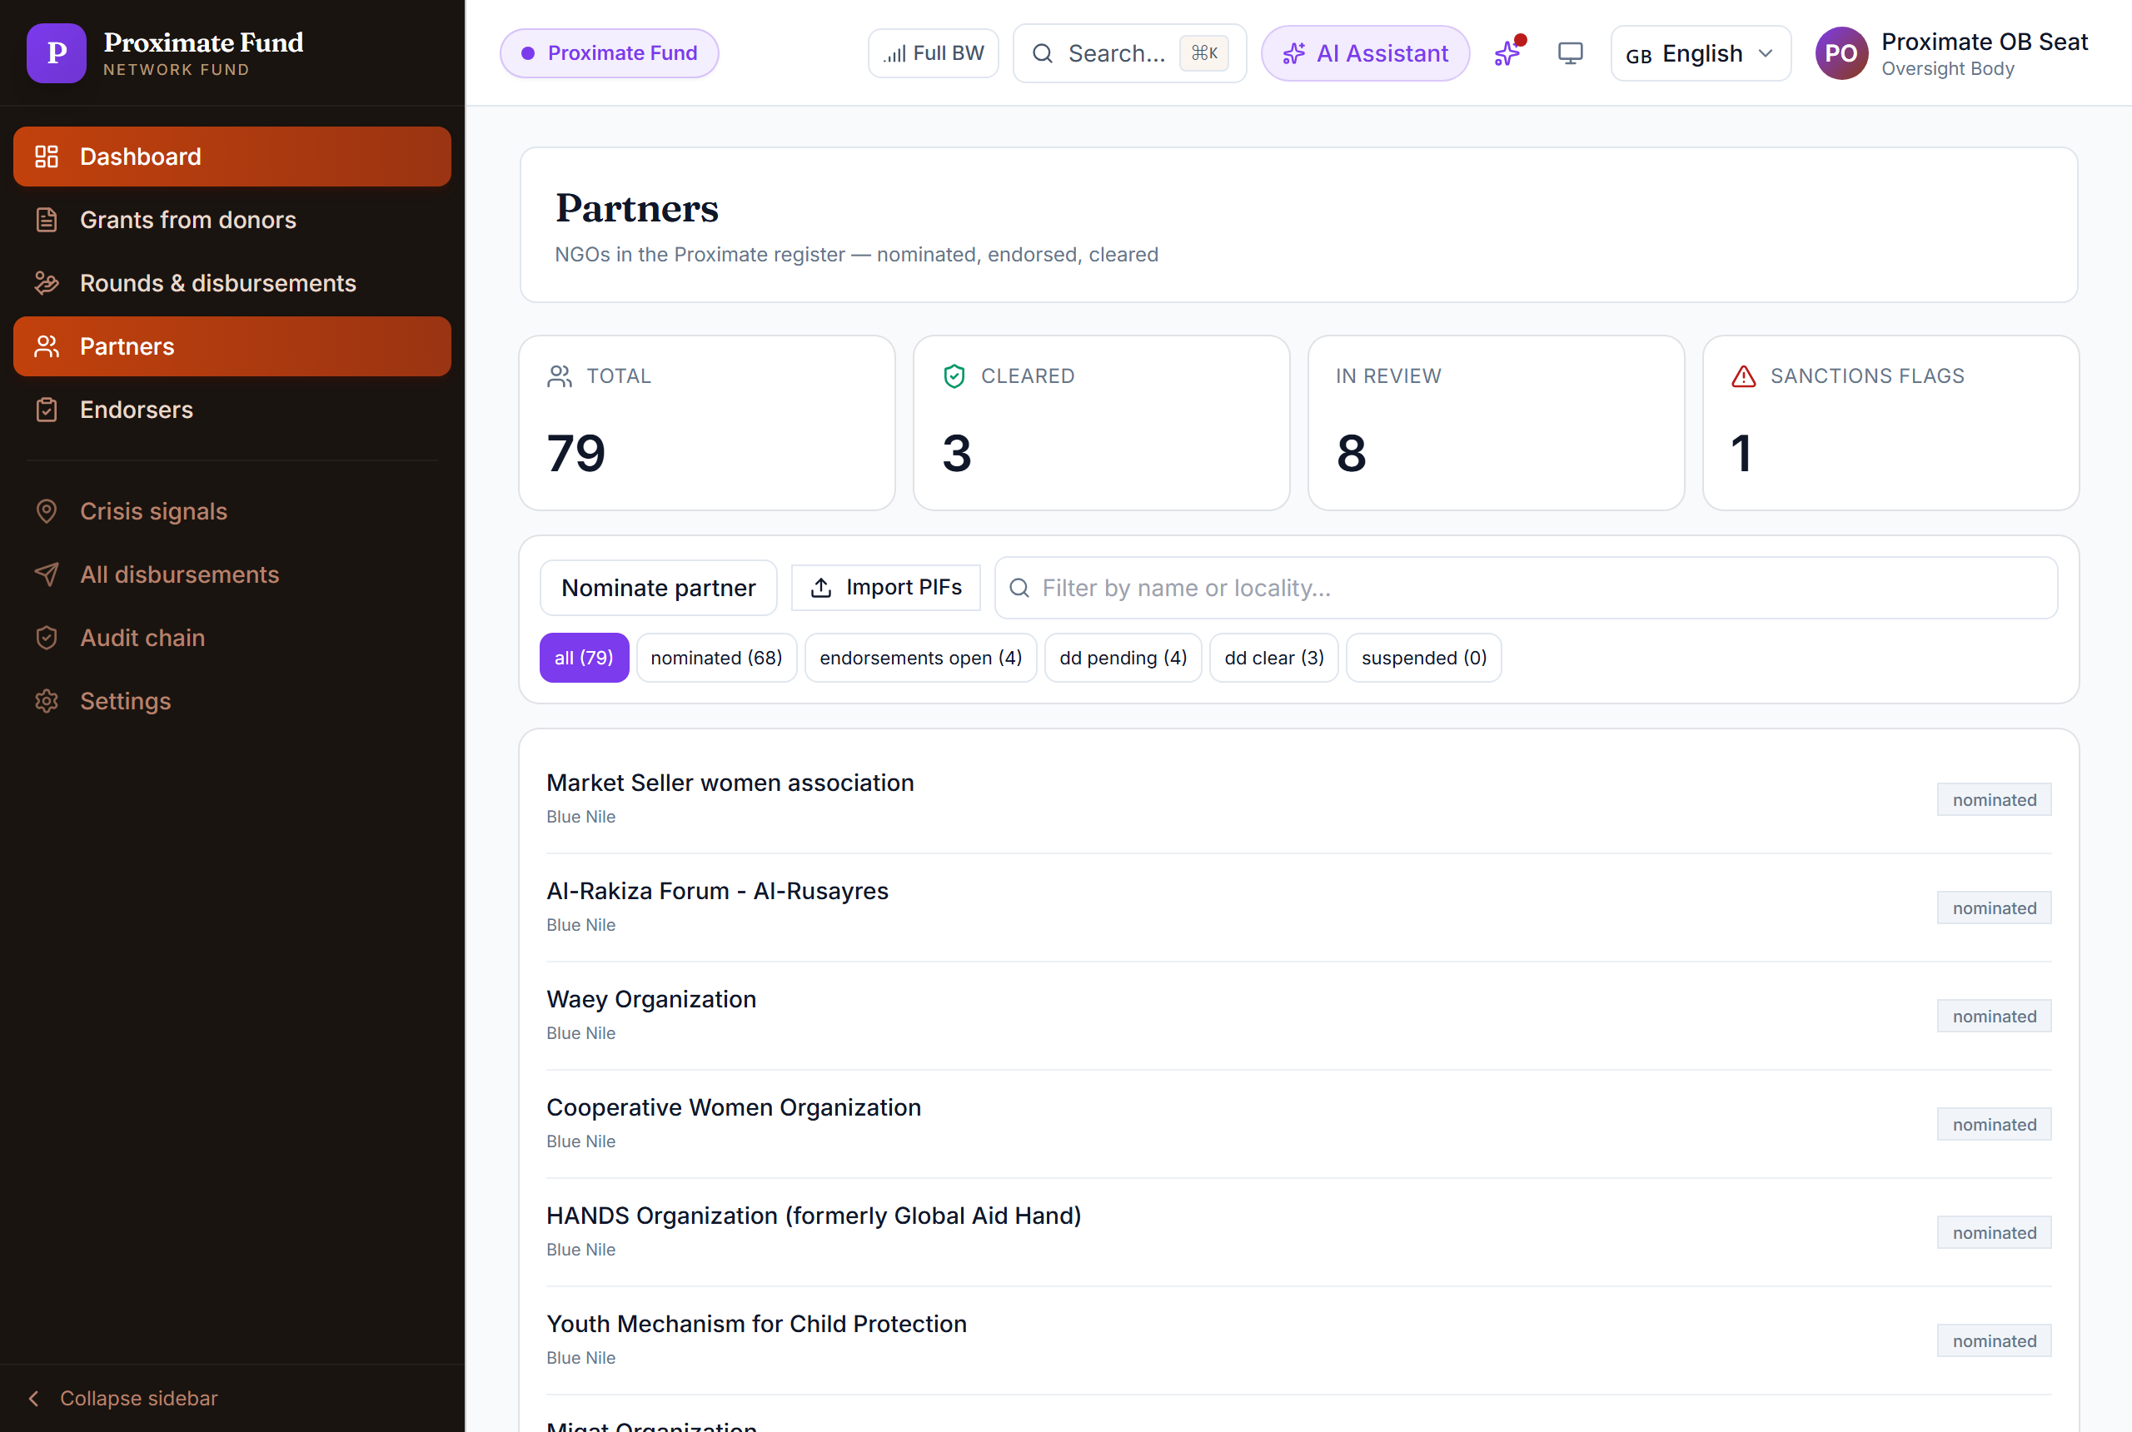
Step 2 — Endorser self-registration (share this link) …
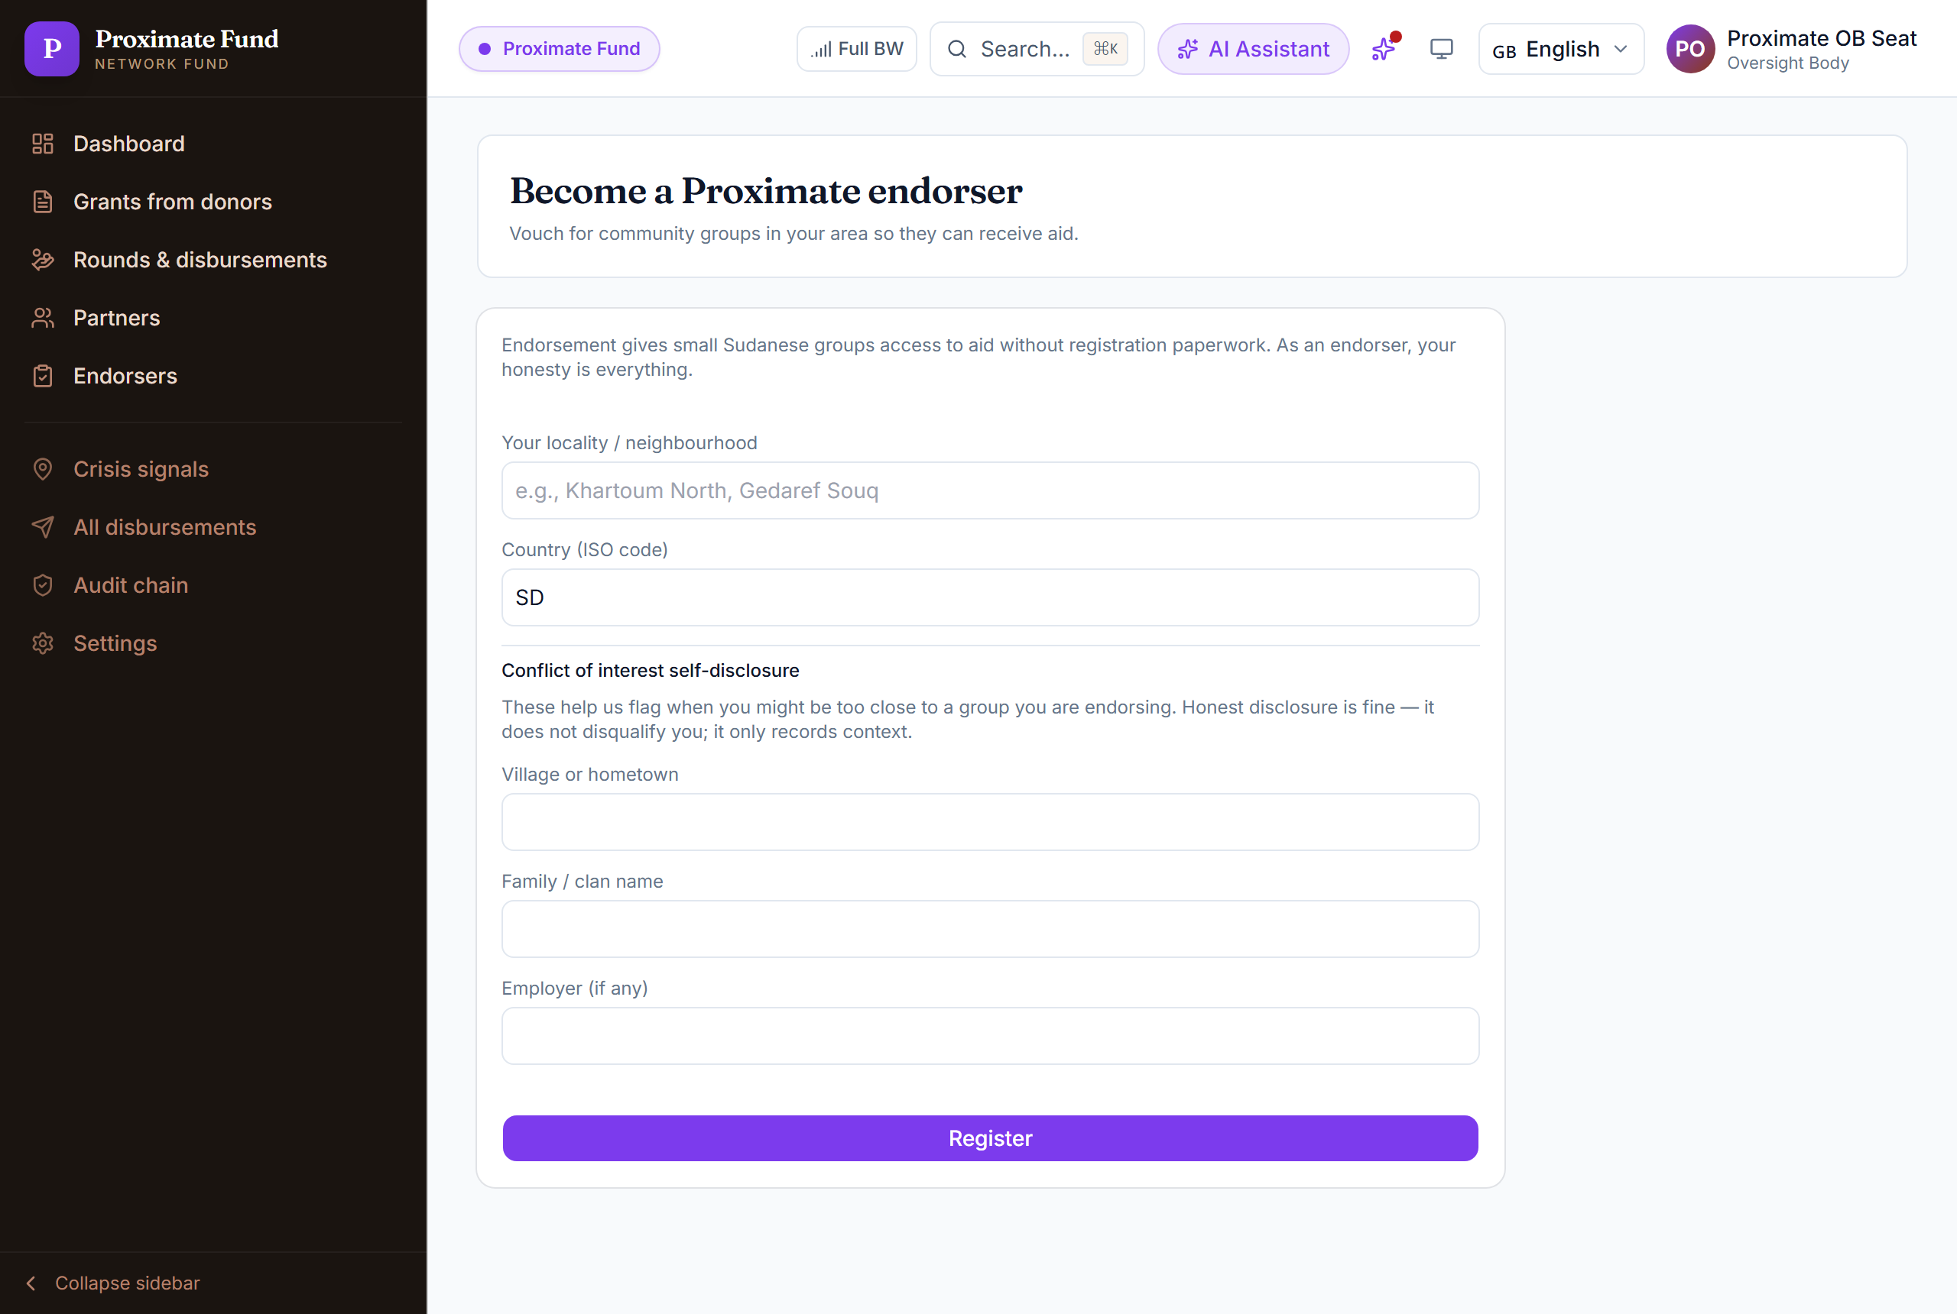
Step 2 — … and the OB approval queue under "Endorsers"
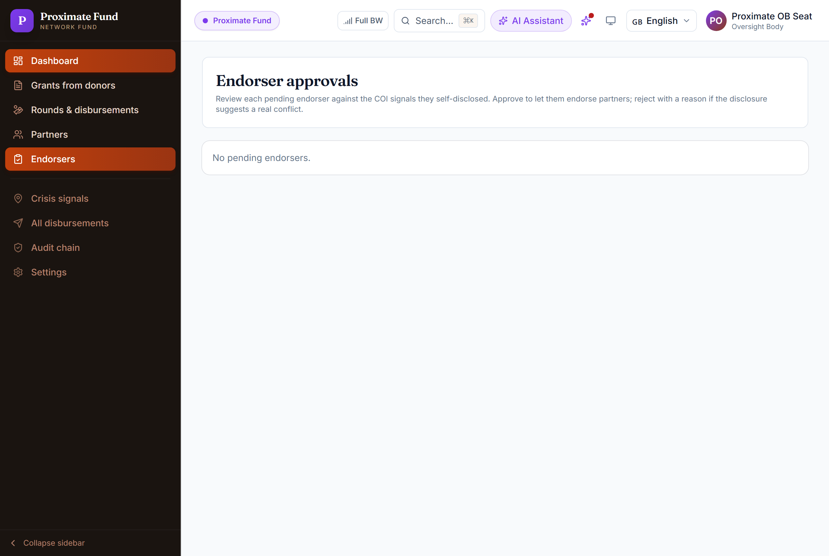
Step 3+4 — Partner page — endorsements, disbursement methods ("Add method" + verified badge), media verification ("Record check"), due-diligence evidence upload
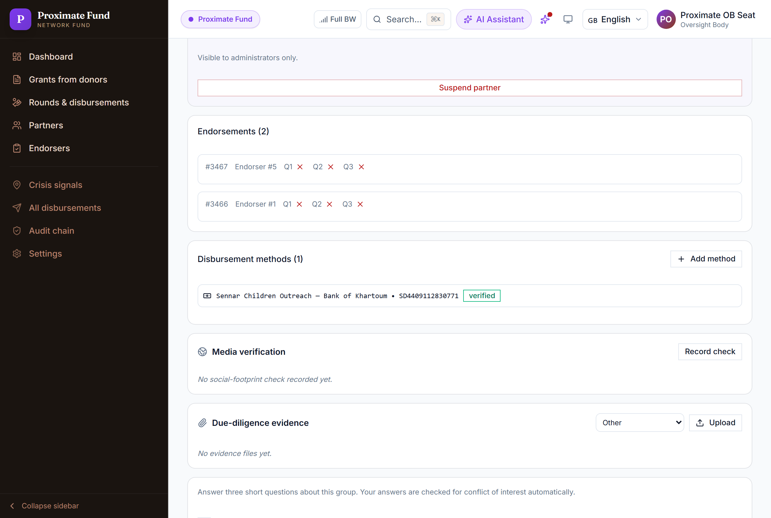
Step 5 — Blue Nile round page — evidence pack and Panel roster with the 5 candidates
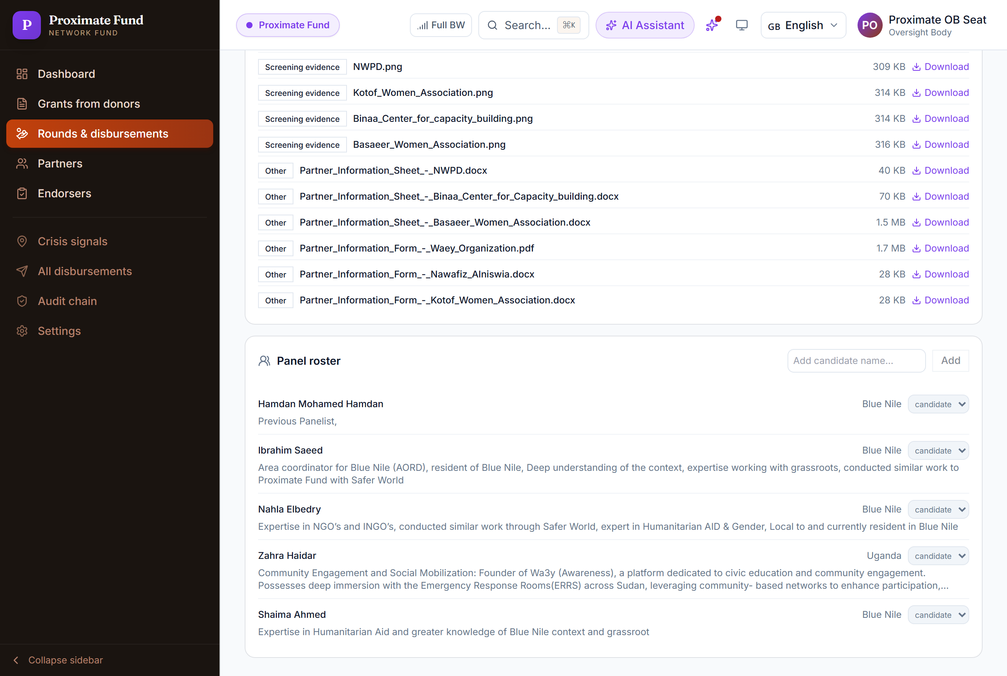
Step 6 — "Record a disbursement" — partner, round, amount, report window, ISF-gate attestation
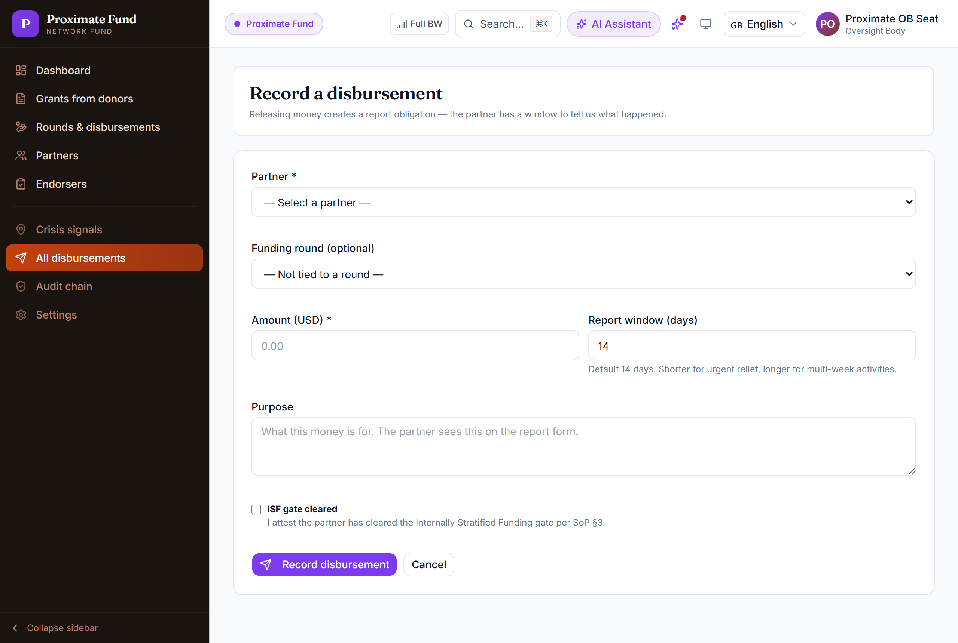
Prepared by the engineering team · production build fae8d2eba · every action above is recorded on the tamper-evident audit chain.

