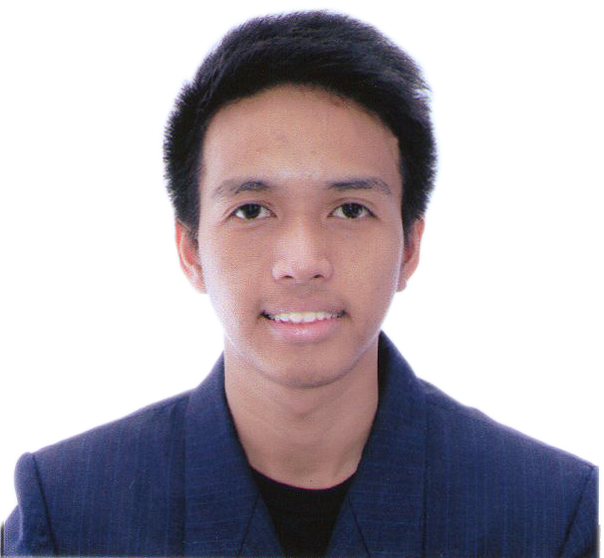

EDISON L. GARCIA

430 Gen. Luna St. Guinayang San Mateo, Rizal
Mobile No.: 09176044432
Email address: edison72791@yahoo.com

Objective: Seeking for a job position that I can contribute my various skills and proficiencies in the field of Information Technology and to be able to engage myself in a good learning environment as I want to be a quality employee.

Proficiency and Skills

Project Management Skills
- Excellent in coordinating among team members
- Possesses good leadership and motivation skills
- Process and detail oriented

IT Proficiency
- Excellent in Microsoft Office applications (Word, Excel, PowerPoint, Access, Publisher, Visio)
- Have a good knowledge in Graphic Designs using Adobe Photoshop, Adobe InDesign
- Have a good knowledge in Web Development using HTML, CSS, jQuery, Php and Wordpress, MySQL
- Have a good knowledge in Web Framework using Bootstrap and CodeIgniter
- Have a good knowledge in Video Editing using Adobe Premiere, Avid Media Composer, Apple iMovie
- Have a good knowledge in assembling of PCs, Software & Hardware Troubleshooting & Installation and Servicing Technique
- Well-informed in using Xampp,Sublime Text and Dreamweaver
- Experience in project management and collaboration tools like SVN, YouTrack and Basecamp

Work Experiences

Programmer
Personal Collection Direct Selling
December 2016 – Present

Creating websites using HTML, CSS, Php (Codeigniter Framework) and Wordpress. Hands on Day-to-Day Web Development: Managing website contents and resolving web issues. Handling client’s calls and meetings, and participating with client’s project discussions. Collaborating with project discussions and development within or with the other team.

Graphic Artist
Department of Health Region IV-A CaLaBaRZon
September 2015 – November 2016

Design tarpaulins, streamers, brochures, flyers, and posters to communicate public health issues following the DOH HPCS standard protocol as and when required. Consult HEPOs/Program Managers on layout/technical component of layout design. Improve/edit photos. Layout, design and create animations on power point.

Front-End Developer
iGen Dev Center, Inc.
May 2013 - September 2014

Creating websites using HTML, CSS, jQuery, .Net and Php. Hands on Day-to-Day Web Development: Managing website contents and resolving web issues. Handling client’s calls and meetings, and participating with client’s project discussions. Collaborating with project discussions and development within or with the other team.

Student Trainee (On-the-job-Trainee)
ABS-CBN Broadcasting Corporation
June 2011 - September 2011

Systems support in the Central Equipment Room of the I-Post Production Department Engineering Division

Educational Background

College Bachelor of Science in Information and Communications Technology
AMA East Rizal University,
Antipolo, Rizal
2008-2013 (Graduated)

High School Nuestra Señora de Aranzazu Parochial School,
Guitnangbayan, San Mateo, Rizal
2004-2008
Elementary Nuestra Señora de Aranzazu Parochial School,
Guitnangbayan, San Mateo, Rizal
1998-2004

Projects

Personal Collection
- https://personalcollection.com.ph
Developed and implemented web pages using Wordpress.
- https://policies.personalcollection.com.ph (Lan-Based)
Developed and implemented web pages using Wordpress.
- Personal Collection Tickets Dashboard per Department
Developed using PHP CodeIgniter Web Framework
- PC Sagot Kita - March Panalo Sagot-Kita Promo Quiz
Developed using PHP Joomla Framework
- PC Code Generator
Developed using PHP CodeIgniter Web Framework

Speechpower
http://speechpower.ph/
Developed and implemented web pages using Wordpress.

Ginebra San Miguel Website
http://ginebrasanmiguel.com/
Developed and implemented web pages using HTML, CSS and jQuery. Responsible for the website design and improvement. In-charge of testing including checking of errors and browser compatibility. Hands-on day to day web development.

San Miguel Brewery Inc. Website
http://sanmiguelbrewery.com.ph/
Responsible for the website design and improvement. In-charge of testing including checking of errors and browser compatibility. Hands-on day to day web development.

San Miguel Yamamura Packaging Corporation (SMYPC) Website
http://sympc.com/
Responsible for the website design and improvement. In-charge of testing including checking of errors and browser compatibility. Hands-on day to day web development.

San Miguel 7107 Celebrations Website
Responsible for the website design and improvement. In-charge of testing including checking of errors and browser compatibility. Hands-on day to day web development.

Barbara Wilson Website
http://www.barbarawilson.org/
Responsible for the website design and improvement. In-charge of testing including checking of errors and browser compatibility. Hands-on day to day web development.

Dolphy Clean Up Game Application
Responsible for the bug fixing of the application. Testing including error checking and device

