I had troubles setting up the scaffolding, especially in the init part of tailwind, so in the end I had to make postcss.config.js and tailwind.config.js manually. I also had to use the tailwind client thus making it too big for github, so I archived them into a RAR.

But yeah after installing all the needed parts, you just have to use “npm run dev” or “npm run build”, then open the local which will be shown in your console.

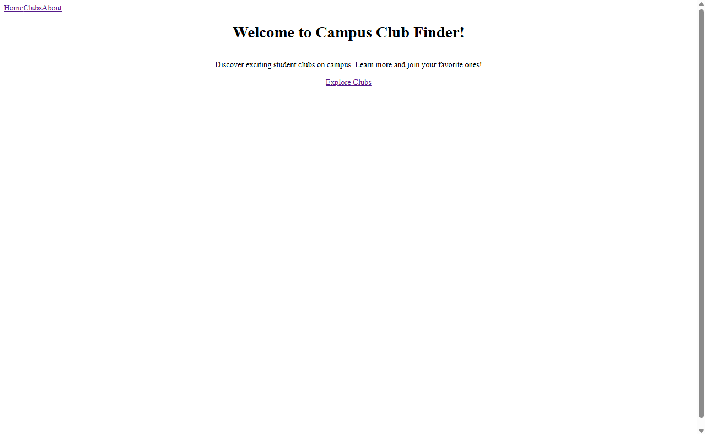you will be greeted with this very plain home page, in which you can navigate to clubs, about, or back to home again on the top left, while you can go straight to “clubs” from explore clubs in the middle.

If you decide to click the clubs, you’ll be directed into this clubs page 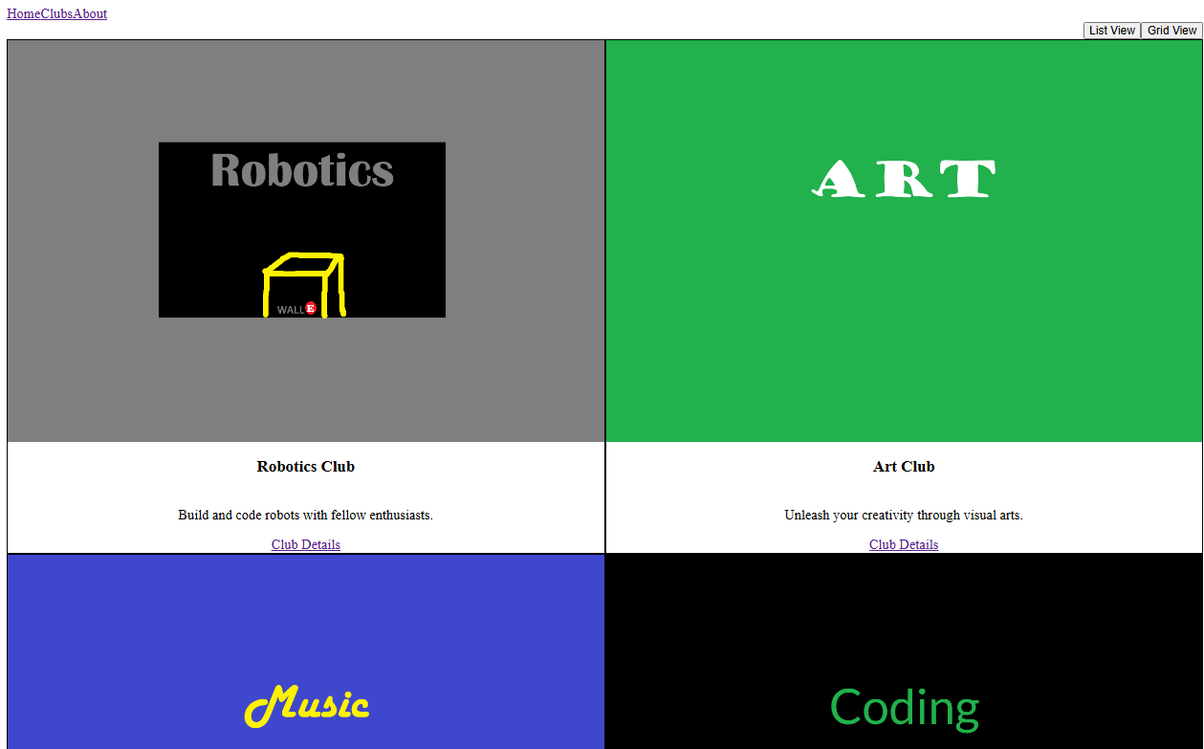in which you can change between grid and list view

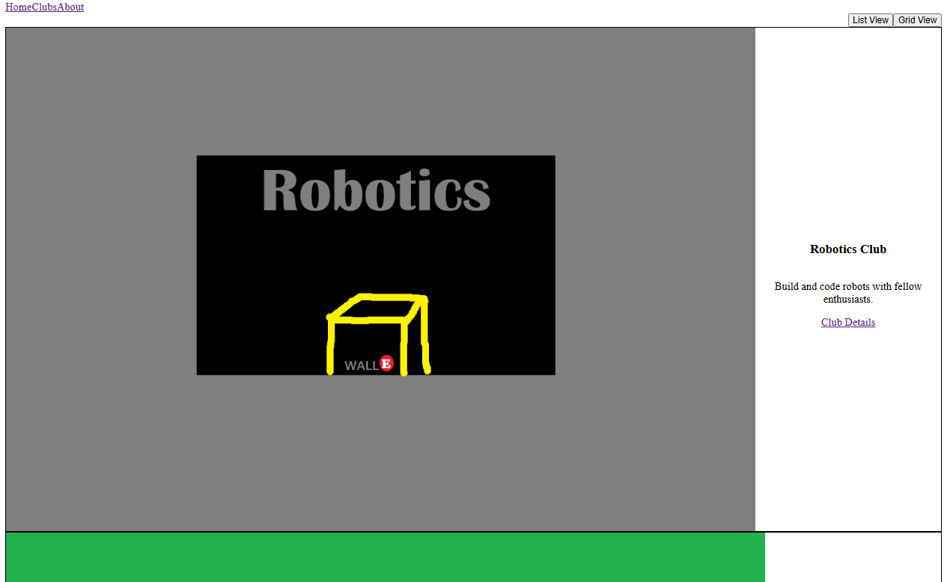

If you click the club details, you’ll be redirected into this page 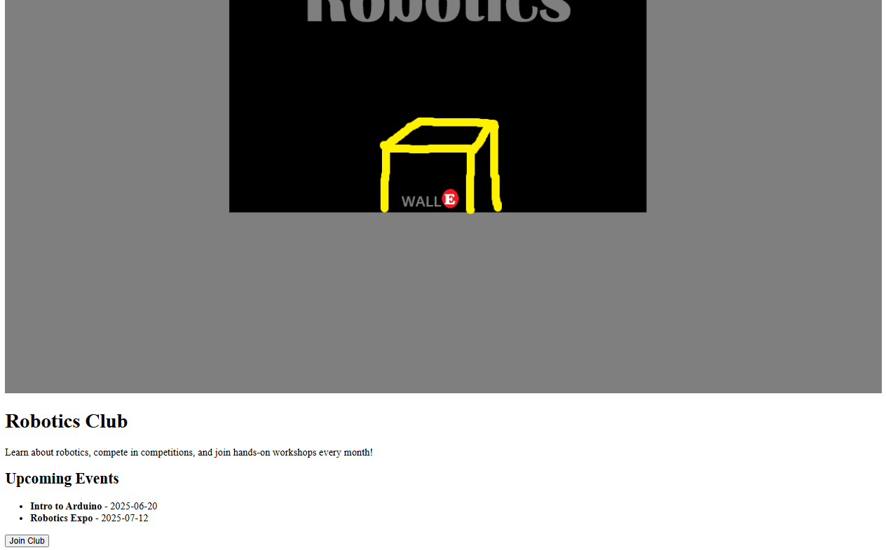

(the nav part above is cut because the picture is too big, but it’s still there)

You can join the club though only locally here.

and here’s what you’ll see if you press about.

And that’s about it. The documentation ends here.