ADVANCED UNIX UTILITY SUITE
A Project Based Learning Report Submitted in partial fulfilment of the requirements for the
award of the degree
of
Bachelor of Technology
in The Department of Computer Science Engineering
Operating Systems and System Programming – 25CS2104E

Submitted by

- 2610030236 – I D K Vamsie
- 2510030261 – K Sai Srinath
- 2510030041 – V Keerthana
- 2510030228 – K Akhila

Under the guidance of Dr. Srinivas Malladi


Department of Computer Science Engineering
Koneru Lakshmaiah Education Foundation, Aziz Nagar
OCTOBER - 2026

ABSTRACT
The Advanced Unix Utility Suite is a comprehensive, modular command-line toolkit developed in C99 to demonstrate, explore, and analyze fundamental Linux/UNIX operating system concepts through direct interaction with POSIX system calls, standard system interfaces, and Linux kernel-exposed information. The primary objective of this project is to bridge the gap between theoretical operating system concepts and practical system-level implementation by providing an integrated environment in which users can execute commands, observe operating system behavior, and understand the internal working of essential system programming mechanisms.
The toolkit combines six major subsystems: System Information (system_info), Process Management (process_manager), File System Management (file_system), Inter-Process Communication and Signals (ipc), Memory Analysis (memory), and Concurrency and Synchronization (concurrency). Each subsystem is implemented using a modular architecture that separates function declarations in header files (.h) from implementation logic in source files (.c), improving code organization, maintainability, reusability, and extensibility.
The System Information module retrieves operating system and system configuration details using interfaces such as uname() and sysconf(). The Process Management module demonstrates process creation, execution, and parent-child synchronization through mechanisms such as fork(), exec(), and wait()/waitpid(). The File System module explores low-level file operations and metadata inspection using open(), read(), write(), close(), and stat(), providing insight into file descriptors and file access. The IPC and Signals module demonstrates communication between processes through anonymous pipes and illustrates asynchronous event notification using sigaction() and kill().
The Memory Analysis module examines process memory statistics and virtual memory mappings by accessing Linux /proc interfaces, including /proc/self/status and /proc/self/maps. The Concurrency module explores multithreaded execution using POSIX threads, shared data, mutex locks, and thread synchronization, illustrating how mutual exclusion helps prevent race conditions during concurrent updates.
A key feature of the suite is its interactive terminal interface, which integrates the individual utilities into a unified command-driven environment. Each demonstration provides readable output and explicit [INTERNAL WORKING] explanations that help users connect the executed command with the underlying system interface and its observable effects. This approach supports practical understanding of process lifecycle management, file descriptor operations, inter-process data transfer, signal delivery, virtual memory organization, and synchronization of shared resources. The project also incorporates a modular Makefile-based build system using GCC, enabling the source files to be compiled and linked consistently in a Linux environment or Windows Subsystem for Linux (WSL). A companion visual dashboard presents the major system-programming modules and their associated commands and APIs, providing an additional overview of the toolkit's functionality.
Overall, the Advanced Unix Utility Suite serves as an educational and experimental platform for studying Linux system programming through modular implementation, command execution, and observable results. By integrating multiple operating system concepts into a single application, the project improves the accessibility of system-level learning, encourages structured experimentation, and provides a foundation for future enhancements such as automated testing, extended process and memory analysis, improved error handling, and deeper visualization of operating system behavior. The suite operates in user space and demonstrates selected Linux/POSIX facilities rather than modifying or implementing the operating system kernel itself.

LIST OF TABLES
Table 1: AUUS_new2 Core Subsystems and Responsibilities
Table 2: POSIX System Calls Utilized Across Modules
Table 3: Functional Test Cases and Subsystem Commands
Table 4: Verification Summary of Expected vs. Actual Telemetry

TABLE OF CONTENTS
Introduction
Methodology & Architecture
Subsystem Implementation & Experiments
Results & Telemetry Verification
Conclusion and Future Work References

1. INTRODUCTION
Operating systems concepts such as process control blocks, virtual address space paging, file descriptor tables, pipe buffers, and mutex synchronization are traditionally taught as static textbook theory. Standard command-line utilities hide kernel transitions, and low-level race conditions or memory layouts are notoriously difficult to diagnose from standard terminal output.

To bridge this pedagogical gap, Advanced Unix Utility Suite (AUUS_new2) was developed as a menu-driven, modular command-line toolkit in C99. AUUS_new2 exposes raw Linux kernel behavior through direct system calls without any third-party dependencies, offering real-time [INTERNAL WORKING] telemetry traces that reveal exact system state changes.

Objectives
- System Discovery: Query kernel release, architecture, and online CPU cores via uname() and sysconf().
- Process Management: Demonstrate process cloning (fork()), binary overlay (execlp()), and parent-child synchronization (waitpid()).
- Virtual File System (VFS): Inspect inode metadata using stat() and manipulate file descriptors via open(), read(), and close().
- IPC & Signals: Establish unidirectional byte streams using anonymous pipe() and install reliable signal handlers using sigaction() and kill().
- Memory Inspection: Parse /proc/self/status and /proc/self/maps to reveal virtual memory segmentation (Text, Data, BSS, Heap, Stack, RSS).
- Concurrency & Mutex Lab: Spawn POSIX threads (pthreads) and enforce mutual exclusion with mutexes to prevent race conditions on shared counters.
- Modular C Engineering: Adhere strictly to C99 standards with clean modular separation between header interfaces and implementation logic.

2. METHODOLOGY & ARCHITECTURE
follows a strict modular architecture. A central REPL dispatcher (main.c) routes user commands to specialized subsystem modules, each defined by a clean interface header (.h) and an implementation file
.
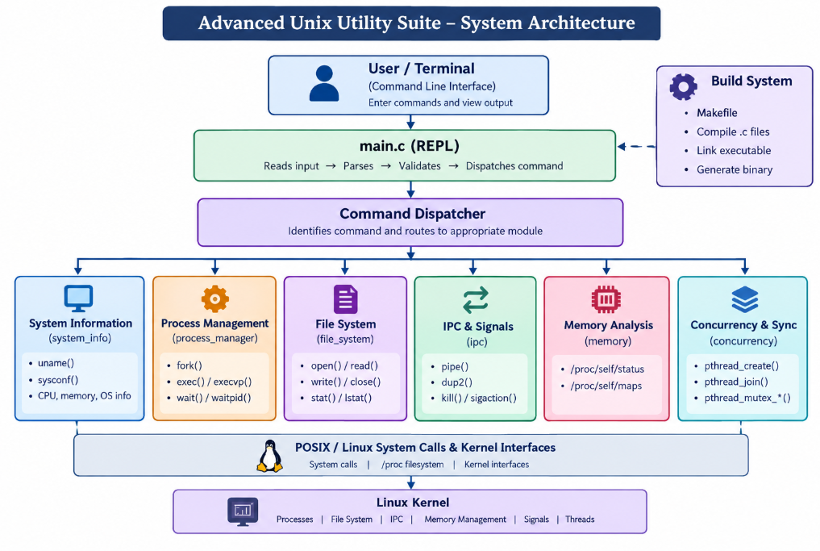

2.1 Project Subsystems and Responsibilities
Module | Primary Responsibility | Associated POSIX APIs
system_info.c | Queries kernel release, node name, CPU count, and memory page size. | uname(), sysconf()
process_manager.c | Manages process lifecycle, cloning, execution overlay, and exit status reaped via waitpid(). | fork(), execlp(), waitpid(), getpid(), getppid()
file_system.c | Performs stream I/O, atomic file creation (O_CREAT | O_EXCL), and inode metadata retrieval (stat()). | open(), read(), close(), stat()
ipc.c | Implements unidirectional kernel pipe streaming and asynchronous signal handling. | pipe(), sigaction(), kill()
memory.c | Parses /proc/self/status and /proc/self/maps for virtual memory and RSS analysis. | /proc/self, sysconf()
concurrency.c | Spawns worker threads and demonstrates race condition prevention using mutexes. | pthread_create(), pthread_mutex_lock(), pthread_mutex_unlock()

2.2 Execution Flow
- The user launches ./unixsuite to start the interactive terminal REPL.
- The user enters a command (e.g., system-info, processes, ipc-demo, thread-demo).
- main.c dispatches the command to the corresponding module.
- The module executes the native POSIX system calls and outputs formatted results alongside detailed [INTERNAL WORKING] telemetry traces.

3. SUBSYSTEM IMPLEMENTATION & EXPERIMENTS

3.1 Module 1: Kernel Discovery & VFS
The system information subsystem queries active Linux kernel parameters. uname(&info) populates kernel release, node name, version, and machine architecture. sysconf(_SC_NPROCESSORS_ONLN) retrieves active online CPU cores, and sysconf(_SC_PAGESIZE) determines the hardware memory page size (4096 bytes).

The Virtual File System (VFS) module utilizes stat() to inspect inode metadata (file size, octal permissions 0644, UID/GID) and open() with O_CREAT | O_EXCL to allocate file descriptors.

3.2 Module 2: Process Management (fork-exec-wait)
The process manager demonstrates the complete process lifecycle through three fundamental system calls:

- fork(): Clones the calling process, creating an identical child process with an isolated address space.
- execlp(): Overlays the child's text and data segments with a new binary program (e.g., echo).
- waitpid(): Blocks the parent until the child terminates, capturing exit status via WEXITSTATUS to prevent zombie processes.

3.3 Module 4: IPC & Signals
Inter-Process Communication uses anonymous pipe(pipefd) to establish a unidirectional ring buffer in kernel memory (pipefd[0] for reading, pipefd[1] for writing). Data flows directly between parent and child address spaces with zero disk I/O. Unused descriptor ends are closed so readers properly detect EOF.

For asynchronous events, sigaction() installs a reliable signal handler for SIGUSR1 with explicit mask flags. kill(pid, SIGUSR1) dispatches a software interrupt, and an atomic flag pattern (static volatile sig_atomic_t) safely records signal delivery.

3.4 Module 5: Virtual Memory & /proc Telemetry
The memory module inspects x86_64 virtual address space layout (Text, Data, BSS, Heap, Stack, and shared memory mappings) by parsing /proc/self/status and /proc/self/maps. It reports total virtual memory (VmSize), resident set size (VmRSS), and peak consumption (VmPeak).

3.5 Module 6: Concurrency & Mutex Synchronization
To demonstrate race conditions, the concurrency module spawns 2 worker threads, each incrementing a shared global counter 100,000 times (expected total: 200,000).

- Without Mutex: Unsynchronized read-modify-write instructions interleave on CPU registers, resulting in lost increments (~140,000 to 170,000).
- With Mutex: pthread_mutex_lock() and pthread_mutex_unlock() enforce mutual exclusion, consistently yielding the exact total of 200,000 with 100% data integrity.

4. RESULTS & TELEMETRY VERIFICATION

4.1 System Calls Utilized
System Call | Purpose in AUUS_new2 | Module
uname() | Retrieves kernel release and machine architecture | system_info.c
sysconf() | Queries online processor count and page size | system_info.c, memory.c
fork() | Clones process for execution lifecycle demo | process_manager.c
execlp() | Overlays process image with target program | process_manager.c
waitpid() | Synchronizes parent and reaps child exit status | process_manager.c
stat() | Inspects file inode metadata and permissions | file_system.c
open() / read() / close() | Manages VFS file descriptors and byte streams | file_system.c
pipe() | Creates kernel buffer for parent-child IPC | ipc.c
sigaction() / kill() | Installs signal handler and dispatches software interrupt | ipc.c
pthread_create() / pthread_mutex_*() | Manages worker threads and mutual exclusion | concurrency.c

4.2 Functional Test Cases
Test Command | Target Operation | Expected Telemetry & Result
system-info | Kernel discovery | Reports Linux kernel version, 16 CPU cores, 4096B page size
processes | Process lifecycle | Clones child, runs binary overlay, reaps exit status 0
file-info | VFS inspection | Reports file size and octal permissions via stat()
read-file | Stream reading | Outputs byte stream from target file descriptor
create-file | Atomic creation | Allocates lowest available integer FD using O_CREAT
ipc-demo | Pipe streaming | Transmits 39-byte payload across kernel pipe buffer
signal-demo | Signal handling | Dispatches SIGUSR1, verifies custom handler execution
memory-info | Virtual memory | Parses /proc/self/status for VmSize and VmRSS
thread-demo | Concurrency | Counter reaches exactly 200,000 using mutex synchronization

4.3 Visual Dashboard & Architecture Integration
Below is the integrated architecture interface captured from the AUUS visual lab environment:

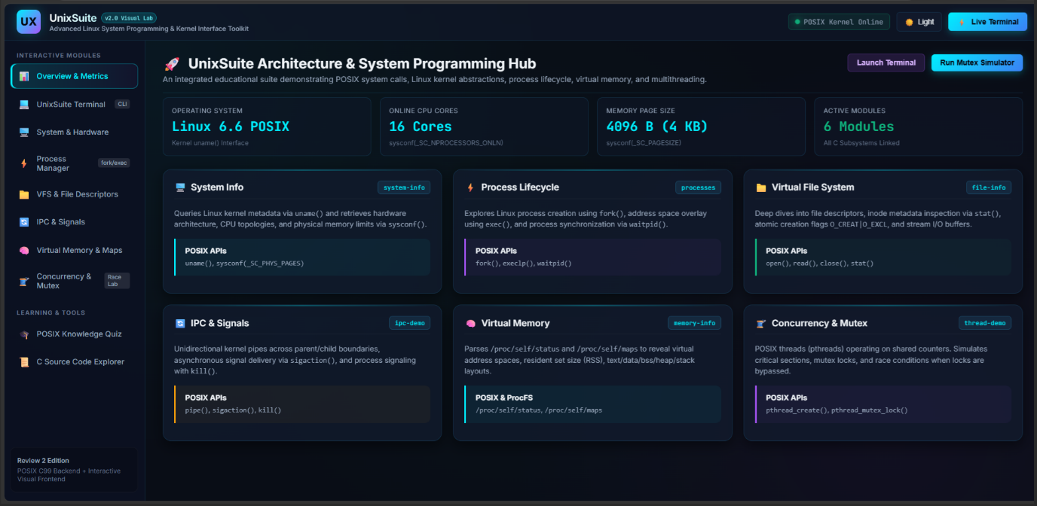

5. CONCLUSION AND FUTURE WORK

Conclusion
Advanced Unix Utility Suite successfully bridges the gap between operating systems theory and practical Linux system programming. By combining six core subsystems into a single interactive command-line application, the project provides transparent, observable telemetry for complex kernel operations including process cloning, file descriptors, anonymous pipes, signal handlers, /proc memory inspection, and mutex-synchronized multithreading.

Future Work
Future iterations of AUUS can incorporate advanced asynchronous I/O (epoll), shared memory IPC segments (shm_open), real-time CPU scheduling priority adjustments (sched_setscheduler), and extended containerization telemetry (cgroups inspection) to further enrich the educational platform.

REFERENCES
[1] The Open Group, POSIX Base Specifications, process, file, pipe, thread and signal interfaces.
[2] GNU C Library documentation, process creation, program execution, file descriptors and signal handling.
[3] Linux manual pages: fork(2), execlp(3), waitpid(2), pipe(2), stat(2), sigaction(2), pthread_create(3).
[4] AUUS_new2 Review 2 Project Documentation, Architecture, Telemetry Traces, and Concurrency Lab Results.

