Solution Pseudo code
magnitude, angle <= exponentialScale(Sensor.Readings)
if magnitude > threshold:
if(angle > 0)
Actuator.setSpeeds(MAX, ẟ*MAX)
else
Actuator.setSpeeds(ẟ*MAX, MAX)

#define ẟ: // diffusion speed function of aggregate obstacle angle

Steering Intensity
The ẟ(α) function is chosen such that it takes the obstacle aggregate angle [0:π] and maps it to [-1:1].
In Figure.1, for example, ẟ returns a negative coefficient to the right wheel, since the diffusion angle is smaller than 90°. Figure.2 shows how ẟ dictates the wheel velocity with respect to α using:
where:

Steering Direction
Without exponential scaling, a far obstacle is accounted for in the same manner an awfully close one would, causing the bot to panic and get stuck in some cases. With exponential scaling, movement is nice and steady as can be seen in the supplementary video. The scaling function used is:

Testing
Various configuration files were used in testing this method where the number of obstacles and bots were tweaked. The results deemed this modification to be necessary.

Discussion
- ẟ(α) is necessary in prioritizing avoiding obstacles ahead over those at the rear since the bot explores forward.
- Exponential scaling is necessary in prioritizing dangerously near obstacles over far ones.
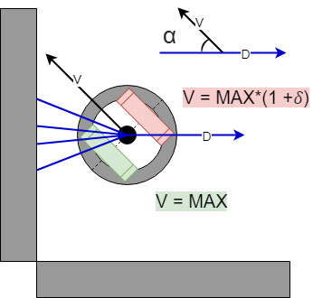Figure 1: Diffusion angle visual

A possible improvement may involve using a polynomial approximation of ẟ(α) and exponential scaling functions if they turn out to be CPU intensive for the bot embedded system.
Also a different ẟ(α) may be considered if stationary object obstacles are configured to move around, since a bot entrusts rear moving bots to turn if in fact they are moving towards it. Possible ẟ(α) variations may be found in Figure.2.
But in our case, only bots can move, so we chose c = 0.

The modified files: https://github.com/idkwtimdoin/Diffbot_results

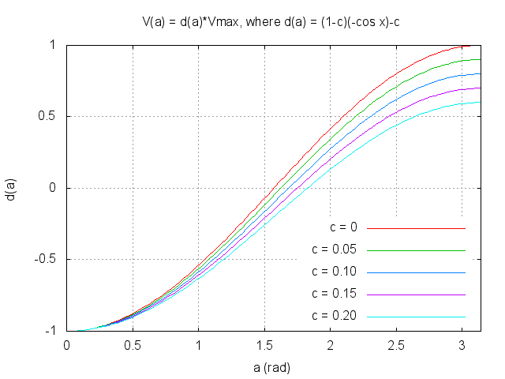Figure 2: Considerable ẟ(α) variations in case of moving objects and moving bots

