WizDorm
Idle Magic School

Architecture Overview
A Visual Guide to the Codebase

Version 1.0 — March 2026

Table of Contents

1. The Big Picture
WizDorm is an idle management game built in Unity 6. The player manages a wizard school dormitory: welcoming students, assigning them to rooms, collecting tuition fees, upgrading facilities, and expanding to new floors. The game is based on a "My Perfect Hotel" codebase by GorodiskiGames, which you are re-theming into the wizard school world.
At its heart, the architecture follows a layered design. Each layer only depends on the ones below it, keeping the codebase modular and manageable. The diagram below shows these layers and the key components in each.
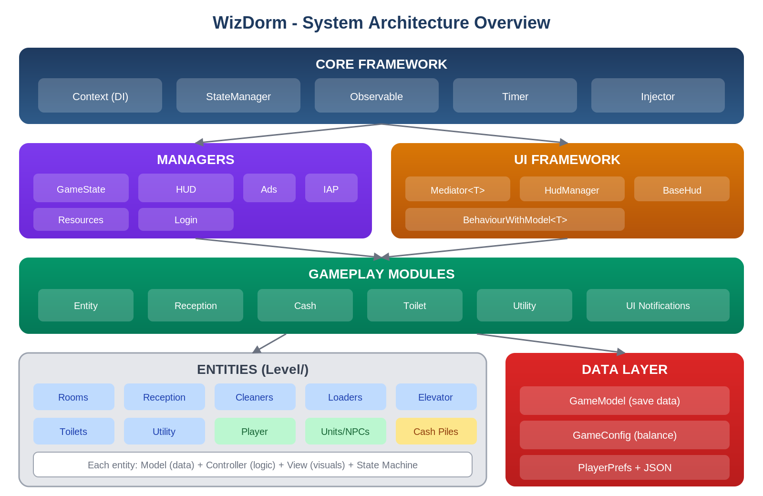
Figure 1 — System Architecture Overview

1.1 Layers Explained
Starting from the top:
- Core Framework — the foundation everything else sits on. Includes the dependency injection container, state machine engine, observable data pattern, and the timer tick system. Nothing in this layer knows about hotels, rooms, or wizards.
- Managers — game-wide services that live for the entire application lifecycle. They handle ads, in-app purchases, UI panel management, asset loading, and login streaks. Managers are registered in the DI container at boot.
- UI Framework — a Mediator pattern that separates visual UI (Views) from game logic (Mediators). Views are pure Unity MonoBehaviours; Mediators are plain C# classes with injected services.
- Gameplay Modules — self-contained feature systems (Cash, Entity, Reception, Toilet, Utility). Each module owns one slice of gameplay and is initialized during the Play state.
- Entities — the actual game objects: rooms, reception desk, cleaners, loaders, elevators, player, NPCs. Each entity is a trio of Model (data), Controller (logic + state machine), and View (visuals).
- Data Layer — persistence (GameModel + PlayerPrefs/JSON) and configuration (ScriptableObject configs that hold all balance numbers).

2. How the Game Boots
When you press Play in Unity, a single MonoBehaviour called GameStartBehaviour kicks off the entire system. It creates the DI container, registers all managers, and enters the first game state. From there, a three-phase state machine brings the game to life.
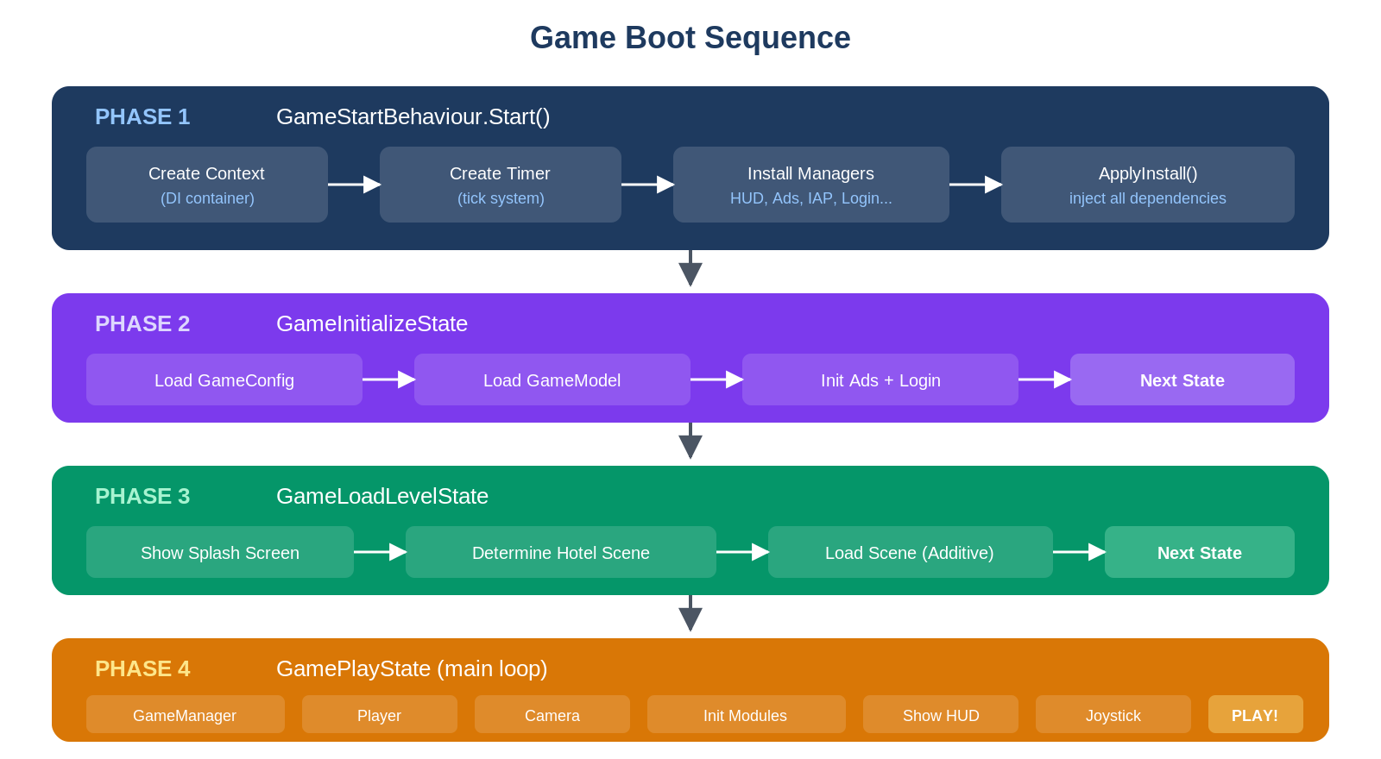
Figure 2 — Boot Sequence

2.1 Phase by Phase
Phase 1 (GameStartBehaviour) creates the root Context, Timer, and Injector. It then installs all managers (HUD, Ads, IAP, Login, Resources) and calls ApplyInstall() to inject dependencies into every registered object. Finally, it enters the first state.
Phase 2 (GameInitializeState) loads the GameConfig from the Resources folder, creates or loads the GameModel (saved progress), and initializes the ads and login systems. It then immediately transitions to the next state.
Phase 3 (GameLoadLevelState) shows a splash screen, figures out which hotel/dorm scene to load based on saved progress, and loads it additively (on top of the persistent Gameplay scene). When loading completes, it transitions to the final state.
Phase 4 (GamePlayState) is where the action happens. It creates the GameManager, spawns the player character, points the camera, initializes all gameplay modules in order, shows the HUD, and enables the joystick. From here, the game runs its idle loop.
💡 Key insight: The three scenes work together: Gameplay.unity is persistent (camera, UI, joystick), while Hotel1/Hotel2 scenes are loaded additively and swapped when the player moves to a new dorm.

3. Dependency Injection
Rather than passing references manually between dozens of classes, the project uses a custom, lightweight dependency injection system. It has three pieces: a Context (the container), an Injector (the wiring tool), and an [Inject] attribute (the marker).
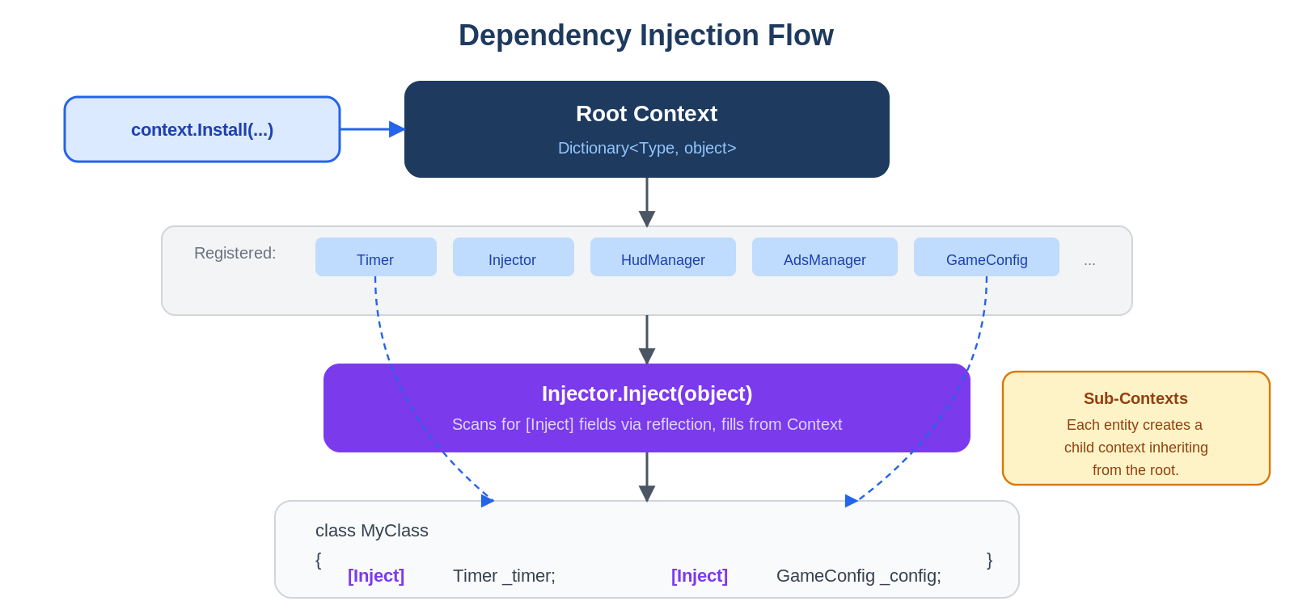
Figure 3 — Dependency Injection Flow

3.1 How It Works
The Context is essentially a dictionary mapping types to object instances. When you call context.Install(timer, hudManager, adsManager), each object gets stored by its concrete type. Later, any class can call context.Get<Timer>() to retrieve it.
The Injector uses C# reflection to scan a class for fields marked with [Inject]. For each such field, it looks up the field's type in the Context and fills it in. Results are cached by type so the reflection cost only happens once per class.
Sub-Contexts are a powerful pattern used heavily by entity controllers. Each entity creates a child Context that inherits everything from the parent (root) but can add entity-specific services. This way, a room's state machine can inject the room's controller without affecting any other room.
⚠️ Watch out: Services are registered by concrete type, not interface. If you register a FakeAdsProxy but something requests BaseAdsProxy, it won't find it. Use InstallByType() for interface-based registration.

4. The Entity System
Entities are the building blocks of the game world. Every interactive object — rooms, reception desk, cleaners, loaders, elevators, toilets, and the utility room — follows the same structural pattern. This consistency makes it straightforward to add new entity types.
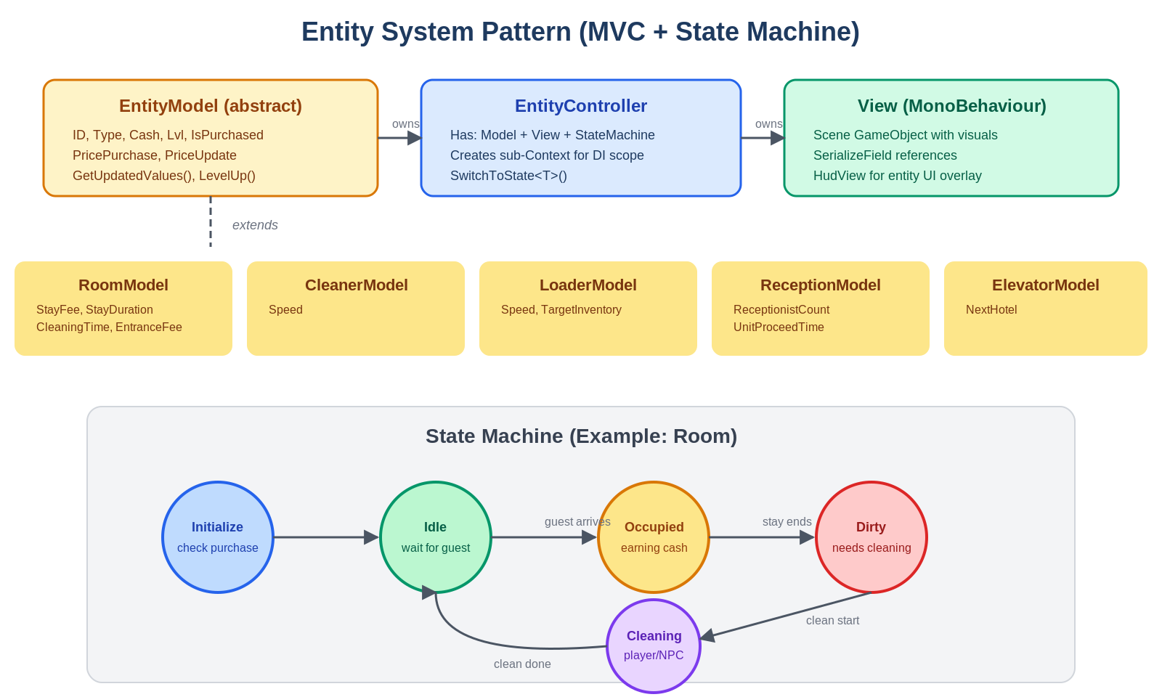
Figure 4 — Entity Pattern (MVC + State Machine)

4.1 The Trio: Model, Controller, View
Each entity consists of three parts:
- Model — a data class extending EntityModel (which extends Observable). Holds the entity's ID, level, cash, purchase state, and entity-specific properties. Calling SetChanged() notifies the UI to update.
- Controller — the brain. Creates a sub-Context for scoped DI, owns a StateManager, loads saved data, binds the model to the view's HUD, and starts the state machine.
- View — a MonoBehaviour on a scene GameObject. Has SerializeField references to child objects (walls, doors, HUD overlay, items). Knows nothing about game logic.

4.2 State Machines
Every entity controller owns a generic StateManager that drives its behavior. States are self-contained classes with Initialize() (setup) and Dispose() (cleanup). When a controller calls SwitchToState<NewState>(), the old state is disposed, the new state gets its [Inject] dependencies filled, and Initialize() runs.
The Room state machine, shown in the diagram, is a good example of the typical lifecycle: Initialize → Idle (waiting) → Occupied (earning cash) → Dirty (needs cleaning) → Cleaning → back to Idle. Each entity type defines its own set of states appropriate to its role.

4.3 ScriptableObject Configs
Every entity type has a config ScriptableObject that contains all balance data — prices, durations, earnings per level, visual variants. These live in the Resources folder and are loaded at runtime. To tweak game balance, you edit configs in the Unity Inspector; no code changes needed.
Each config includes a LvlConfig struct array. When an entity levels up, it reads the next entry from this array to get updated values (price, speed, earnings, etc.).

5. The Idle Game Loop
This is the core of the game — the loop that generates revenue and keeps the player engaged. Understanding this cycle is key to designing any new WizDorm features.
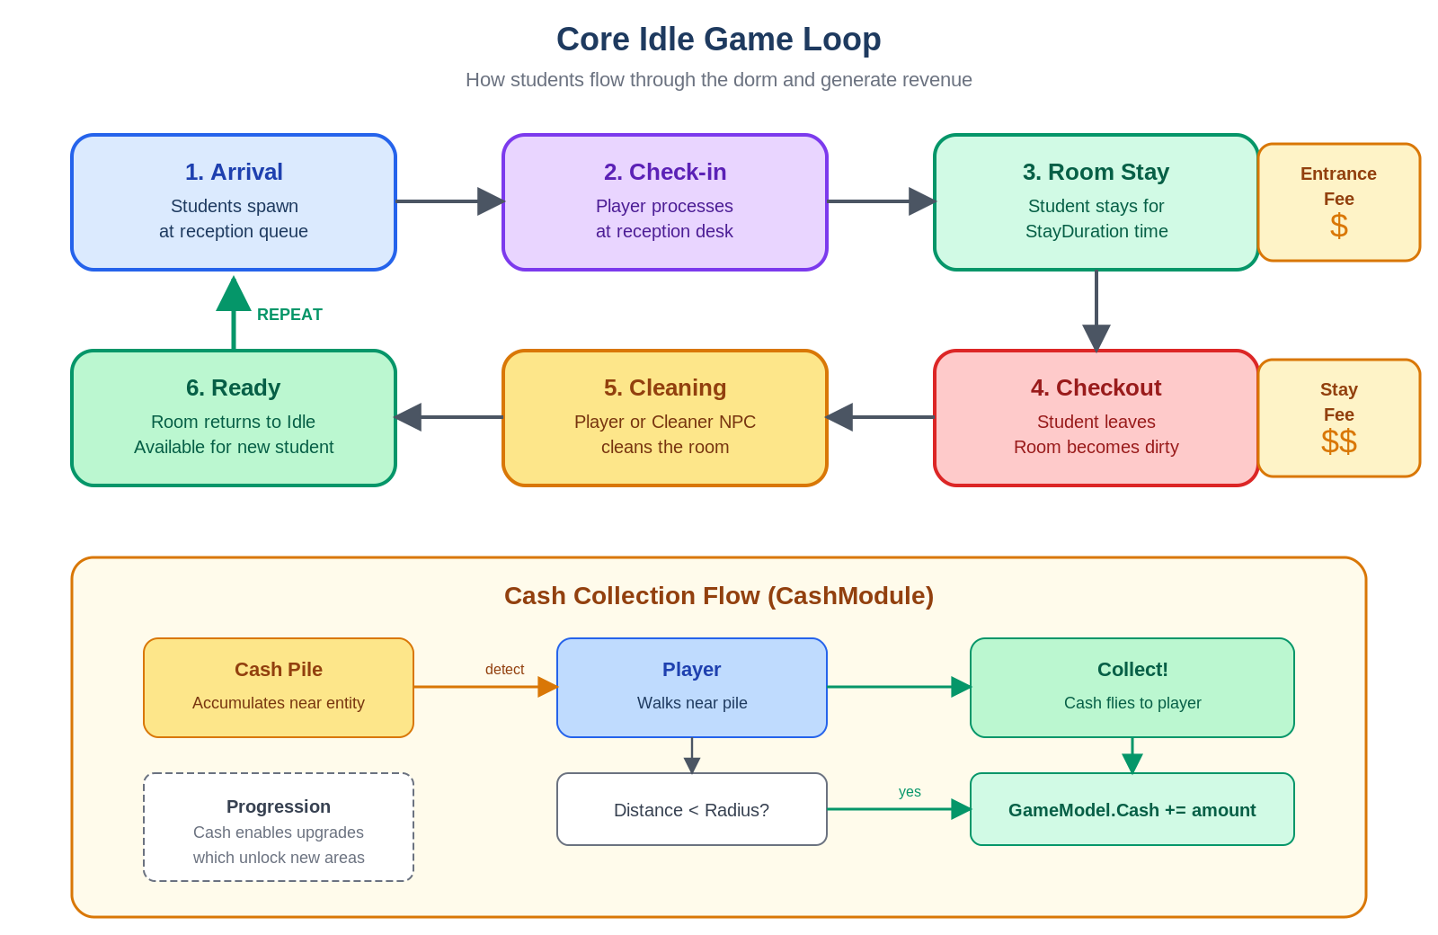
Figure 5 — Core Idle Game Loop

5.1 The Revenue Cycle
Students arrive at the reception desk and join a queue. When the player (or a receptionist NPC) processes them, an entrance fee is earned. The student is then assigned to an available room and stays for a duration determined by the room's level. When the stay ends, a stay fee is earned and the student leaves.
The room is now dirty and must be cleaned — either by the player walking over to it or by a cleaner NPC. Once cleaned, the room returns to the Idle state and can accept a new student. This cycle repeats endlessly, generating passive income.

5.2 Cash Collection
Earned cash doesn't go directly to the player's balance. Instead, it accumulates in visual cash piles near each entity. The CashModule runs a per-frame check: when the player walks within a configurable radius of a pile, the cash animates flying toward the player and gets added to GameModel.Cash.
This design creates a satisfying tactile loop — the player physically moves around the dorm collecting money, even though the earnings happen automatically.

5.3 Progression
Cash fuels progression. Players spend cash to upgrade rooms (higher earnings), purchase new areas (more rooms), hire staff (cleaner NPCs, loaders), and eventually unlock the elevator to the next dorm floor. Each upgrade adjusts the entity's model via its LvlConfig, making the cycle faster and more profitable.

6. UI Framework
The UI system uses a Mediator pattern that separates visual UI components from game logic. This makes it easy to re-skin the UI or change logic independently.
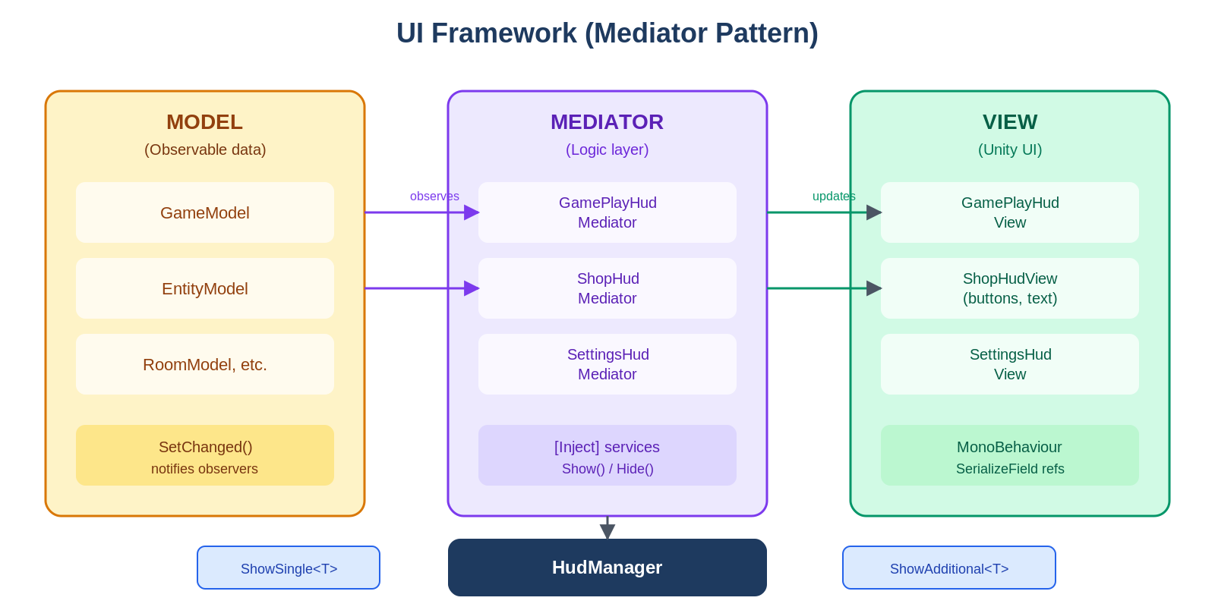
Figure 6 — UI Mediator Pattern

6.1 Three Layers
The Model layer contains Observable data classes (GameModel, EntityModel). When data changes and SetChanged() is called, all subscribed observers are notified automatically.
The View layer contains Unity MonoBehaviours with SerializeField references to buttons, text labels, images, and progress bars. Views know how to display things but have no game logic.
The Mediator sits between them. It gets game services injected via [Inject], subscribes to model changes, and updates the view accordingly. When the user taps a button, the mediator handles the action.

6.2 HudManager
The HudManager controls which UI panels are visible. It supports two modes:
- ShowSingle<T>() — shows one panel at a time (for full-screen menus like Shop or Settings). The previous single panel is hidden automatically.
- ShowAdditional<T>() — stacks multiple panels (for overlays like the gameplay HUD, purchase buttons, notifications). Multiple additional panels can coexist.
Both methods automatically create the mediator instance, inject its dependencies, find the matching view in the scene, and call Show().

6.3 BehaviourWithModel<T>
For entity-level UI (the small HUD overlays that show an entity's level and cash), views extend BehaviourWithModel<T>. When you assign a model to the view, it automatically subscribes as an observer. The abstract OnModelChanged() method fires immediately and on every subsequent data change, keeping the UI perfectly in sync without manual polling.

7. Data Persistence
The game stores all player progress using Unity's PlayerPrefs system with JSON serialization. There is no database or cloud save — everything lives on the device.
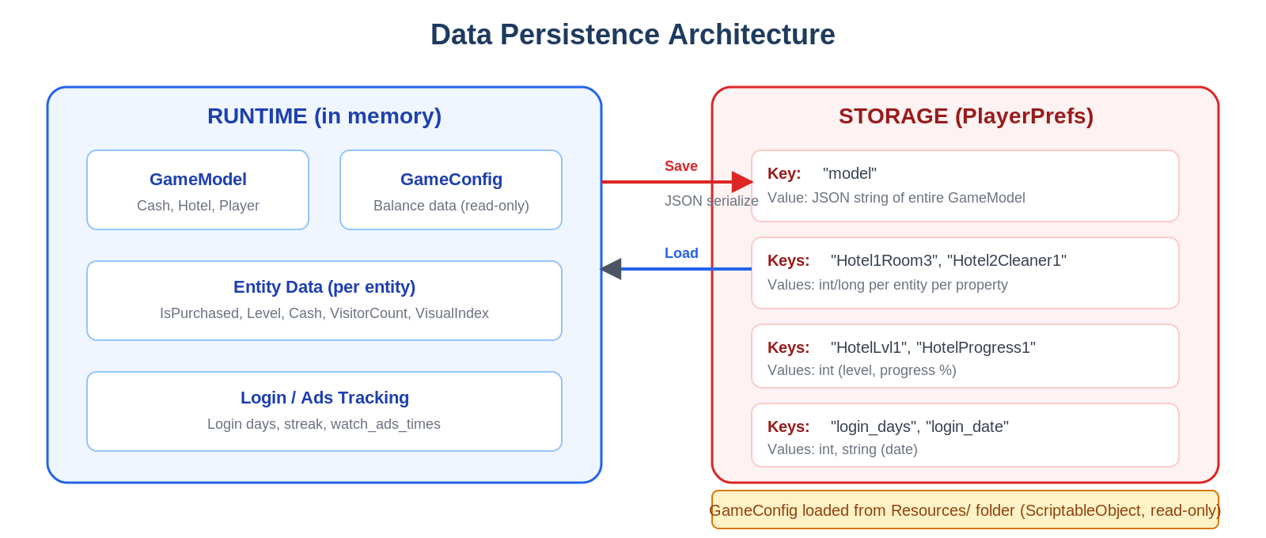
Figure 7 — Data Persistence Architecture

7.1 What Gets Saved
- GameModel — the main save object. Serialized as a single JSON string under the key "model". Contains: Cash, Hotel index, Player selection, NoAds flag, Inventory list, Joystick visibility.
- Per-entity data — stored as individual PlayerPrefs entries with composite keys like "Hotel1Room3". Each entity stores: IsPurchased (bool), Level (int), Cash (long), VisitorCount (int), VisualIndex (int).
- Hotel progress — stored per hotel under keys like "HotelLvl1" and "HotelProgress1".
- Login tracking — login_days (streak count), login_date (last login), watch_ads_times (rewarded ad count).

7.2 Configuration (Read-Only)
All game balance data lives in ScriptableObject configs loaded from the Resources folder. These are authored in the Unity Inspector and read at runtime — never modified by the game. The main GameConfig holds global settings (default cash, interaction radii, walk speeds), while entity-specific configs (RoomConfig, CleanerConfig, etc.) define per-level progression curves.
⚠️ Limitation: PlayerPrefs is wiped on app reinstall. If you plan to add cloud saves for WizDorm, you will need to refactor GameModel's Load/Save methods to use an alternative backend while keeping the same data shape.

8. Architecture Decisions at a Glance
This section summarizes the key architectural choices made in the codebase and their trade-offs. Knowing these will help you make informed decisions as you build WizDorm.

Decision | Pros | Cons / Risks
Custom DI (not Zenject) | Lightweight, no package dependency, easy to understand | No interface binding, no scoped lifetimes, reflection cost on first inject
State machines everywhere | Clean separation of behavior, easy to debug, self-documenting | Many small state classes to manage, boilerplate per entity type
Observable pattern | Reactive UI updates, no polling, decoupled model/view | Must remember to call SetChanged(), risk of notification loops
Custom Timer (not Unity Time) | Centralized tick events, TimeScale control, platform-safe | Extra indirection, TickCount overflow after ~25 days
PlayerPrefs + JSON | Simple, no dependencies, works everywhere | No encryption, wiped on reinstall, no cloud sync, size limits
ScriptableObject configs | Designer-friendly, hot-reloadable, version-controllable | No runtime modification, must remember to create assets
Additive scene loading | Persistent UI scene + swappable level scenes | Must manage scene lifecycle carefully, cross-scene references are fragile
Mediator UI pattern | Logic/view separation, testable mediators, swappable views | Extra layer of abstraction, must pair mediator with view type correctly

End of Architecture Overview

