Designing Prompt Engineering Strategies in Building a LLM-based System for a Cognitive Behavioral Therapy-Based System
Isaac Dicayanan† $​^{1}$, Nash Luis Maramag† $​^{1}$, Alliyah Bianca Maunahan† $​^{1}$ Raine Miguel Villaver† $​^{1}$, and Judith Azcarraga
Abstract

Mental health challenges among students highlight the need for accessible and effective support systems, as many face barriers such as cost and limited access to professional services. AI-powered chatbots offer a potential alternative, but existing systems often exhibit inconsistent responses, limited personalization, and ethical concerns. This study develops a self-help chatbot grounded in Cognitive Behavioral Therapy and examines how structured prompt engineering techniques influence response quality within an eight-intent linear framework. Four prompting strategies were systematically applied and evaluated across different stages of the therapy process using internal testing, comparison with a baseline model, user surveys, and assessment by licensed therapists. Results indicate that no single strategy performs optimally across all stages: structure-oriented techniques are more effective for early cognitive identification, while persona-based prompting improves empathy and emotional validation in later stages. These findings informed a hybrid prompting approach that reduced conversational steps and achieved higher ratings in structure, usefulness, and therapeutic alignment. Overall, the results demonstrate that structured prompt design can significantly improve the coherence, efficiency, and perceived therapeutic value of chatbot-based interventions without requiring model fine-tuning, supporting their potential as accessible mental health support tools for students.

1 Introduction
Mental health, defined as the ability to handle life stressors and contribute effectively to one’s community (chengti2018?), has become a growing concern among students facing academic, social, and relational pressures. Despite the availability of counseling services, many individuals continue to experience barriers to support, including financial constraints and limited accessibility. Cognitive Behavioral Therapy (CBT) is a well-established intervention that helps individuals identify and manage negative thought patterns, and its structured, stage-by-stage approach makes it particularly suitable for digital delivery (denecke2021?). This sequential nature allows CBT processes to be translated into guided conversational flows, making it compatible with chatbot-based systems, although concerns remain regarding accessibility, ethical risks, and over-reliance on self-guided tools.
To improve access to mental health support, AI-powered chatbots have emerged as a promising solution, offering immediate, text-based interaction. Prior studies demonstrate that chatbots can assist with conditions such as depression and anxiety (casu2024?), but challenges persist in maintaining user engagement and delivering personalized responses (limpanopparat2024?). Recent advancements in large language models (LLMs), such as ChatGPT, have enabled more natural and context-aware interactions. However, existing systems still face limitations in handling complex cases, maintaining conversational consistency, and sustaining coherent dialogue across interactions (vuyyuru2024?; aleem2024?; lee2024a?). Earlier chatbot implementations, including Philobot and Wysa, successfully incorporated CBT techniques but relied heavily on predefined or scripted interactions (liu2022?; beatty2022?), while more recent approaches attempt to introduce flexibility through prompting and machine learning integration (indumini2024?). Despite these developments, issues related to engagement, personalization, and therapeutic depth remain.
These limitations highlight the importance of prompt engineering in shaping chatbot behavior. Studies show that carefully designed prompts can improve response reliability, coherence, and task performance in language models (chen2023?; vatsal2024?; yu2024?; white2023?). In mental health contexts, where emotional sensitivity and contextual appropriateness are critical, the way instructions are structured significantly affects the quality of responses. Rather than relying on model fine-tuning or rigid scripting, prompt engineering offers a scalable approach to improving chatbot performance by guiding how the model interprets and responds to user input.
This study develops Pebbles, a CBT-based mental health support chatbot powered by a large language model (LLM), designed to guide users through structured therapeutic conversations in a text-based, self-help format. Pebbles uses a module-driven conversational framework and investigates four prompt engineering techniques: Few-Shot Prompting, Chain-of-Thought Prompting, Persona-Based Prompting, and Plan-and-Solve Prompting. These techniques are applied across different stages of CBT to guide Pebbles in identifying cognitive distortions, supporting cognitive restructuring, suggesting behavioral strategies, and maintaining empathetic and contextually relevant dialogue. The system is designed as a text-based support tool for individuals experiencing mild to moderate stress, anxiety, or negative thought patterns, and is not intended to diagnose mental health conditions or replace professional therapy. It operates solely through prompt engineering without model fine-tuning, maintaining short-term conversational context to support continuity within individual sessions.
The study evaluates how each prompting technique influences the chatbot’s ability to understand user concerns, deliver structured CBT-based interventions, and enhance overall user experience. Performance is assessed through a combination of internal testing, user-based surveys across two evaluation rounds, and expert assessment by licensed therapists, focusing on CBT accuracy, empathic tone, and clinical value. By addressing key limitations in engagement, consistency, and personalization, this work contributes to ongoing research on prompt engineering and highlights its potential to enhance AI-driven mental health support systems.
This study presents the design, implementation, and evaluation of a CBT-based mental health chatbot using a large language model. Prompt engineering techniques—few-shot, chain-of-thought, persona-based, and plan-and-solve—are applied to guide structured, therapy-oriented interactions. The system design and evaluation approach are informed by prior work on CBT chatbot architectures (indumini2024?), with considerations for modularity, controlled testing, and ethical deployment.

2 Methodology

2.1 Software Design and Implementation
The chatbot is developed in TypeScript using Node.js and integrates OpenAI GPT-4.1 (initially GPT-4o-mini) with a temperature of 0.2 for response consistency. The system follows a monorepo architecture consisting of a web application and a standalone CBT engine.

2.1.1 Technology Stack
The frontend is built with Next.js and React, enabling direct server-side LLM calls through server actions. TailwindCSS and ShadcnUI are used for styling and UI components.
The CBT engine (@rainev/cogni) is implemented in TypeScript and integrates with LangChain for model abstraction and structured output handling, with validation enforced through Zod schemas.
Client-side state is managed using Zustand with persistent storage via localStorage to maintain session continuity without server-side session management.
The system uses pnpm workspaces, Vitest for testing, and ESLint for code quality, targeting Node.js 20+.

2.1.2 Implementation Choices
Session data, including message history and CBT state, is stored locally to preserve user privacy while simplifying system design, at the cost of device-bound sessions.
A serverless architecture is used, where LLM calls are executed through Next.js server actions, enabling secure API usage and simplified deployment on Vercel.
Prompt techniques are implemented through a centralized registry, allowing dynamic selection of prompts based on CBT stage without modifying core logic.
All LLM outputs are validated against predefined schemas to ensure structured and reliable responses.

2.2 Repository and Deployment Structure
The system is organized as a monorepo containing a web application and a reusable CBT engine. The web layer handles user interaction, while the engine manages CBT logic, prompt construction, and analytics. Shared scripts ensure consistent build, testing, and deployment workflows. The repository structure and component organization are shown in Fig. 1 and Fig. 2.

2.2.1 High-Level Pipeline Overview
Each user message is processed through a structured pipeline prioritizing safety and CBT compliance. Crisis risk is evaluated before any response generation, while non-crisis interactions follow an eight-intent CBT cycle with controlled transitions. The overall processing flow is depicted in Fig. 3.

2.2.2 Web Application Layer (apps/web)
The web application provides two interfaces: /chat for standard use and /chat-test for evaluation with additional analytics. User inputs are routed through server actions that enforce safety checks before invoking the CBT engine. The interaction flow is shown in Fig. 4.

2.2.3 Core Engine Layer
The CBT engine orchestrates four main processes per interaction: cognitive distortion classification, prompt assembly, structured response generation, and intent transition computation. It is model-agnostic and supports interchangeable LLM backends.
For non-crisis inputs, the system performs distortion classification using a structured prompt-based approach, returning the distortion type, confidence, and rationale. Outputs are validated through schema enforcement to ensure consistency. The orchestration process is shown in Fig. 5.

2.2.4 Safety Gate and Crisis Handling
All messages first pass through a crisis detection module that classifies risk into predefined categories and levels. Low-risk inputs proceed to CBT processing, while medium- and high-risk cases trigger predefined, human-reviewed crisis responses. This ensures that no generative output is produced in high-risk scenarios. The crisis routing mechanism is shown in Fig. 6.

2.2.5 CBT Intent Routing and Flow Control
The system implements an eight-stage CBT cycle managed by a finite state machine. Transitions are determined through a structured evaluation process, advancing only when confidence thresholds are met; otherwise, the current stage is maintained. After completing the cycle, the system resets to allow repeated use. The intent flow is outlined in Fig. 7.

2.2.6 Prompting Architecture and Technique Registry
Each session is assigned a single prompting technique to ensure consistency during evaluation. Techniques include default, persona-based, few-shot, chain-of-thought, plan-and-solve, and a hybrid configuration.
Prompts are retrieved dynamically from a centralized registry based on the current CBT stage and selected technique, enabling modular and extensible prompt management.

2.2.7 Session Recording, Analytics, and Visual Outputs
Each interaction generates structured records containing intent, inputs, outputs, classifications, and timestamps. These are used to compute analytics such as mood changes, distortion patterns, intent progression, and session summaries. Visual and textual outputs derived from these analytics are shown in Fig. 8.

2.2.8 Data Export and Administrative Controls
The system supports user-initiated export of session data via email, packaged as structured JSON files for analysis. This ensures that data sharing remains explicit and user-controlled. The export process is illustrated in Fig. 9.

2.3 Prompt Testing
Goal. Prompt testing was conducted to evaluate and refine four prompt engineering techniques across the chatbot’s CBT conversational flow. Instead of deploying multiple chatbot versions, the study identifies the most effective technique for each CBT intent, recognizing that different stages require distinct conversational behaviors.
Due to time and resource constraints, full-scale evaluation with users and clinicians across all techniques was not feasible. A controlled internal testing approach was adopted to enable systematic comparison under consistent conditions.
Rationale. Standardized conversational scenarios were developed and reused across all prompt conditions to ensure consistency. This controlled input method minimizes variability in user phrasing, allowing differences in responses to be attributed primarily to the prompting technique. It also supports reproducibility across trials.

2.3.1 Design of Prompt Testing
Testing Approach. The testing employed a scenario-based evaluation method using structured conversational scripts. Four distinct scenarios representing emotional situations were developed. Each scenario was tested across all four prompt engineering techniques to allow direct comparison of responses under similar conditions.
Testing Environment. Testing was conducted in a controlled simulation using a fixed model configuration. This ensured that observed differences in performance were attributable to prompt design rather than external variables.
Evaluation. The prompt effectiveness was assessed using qualitative criteria grounded in CBT communication principles and conversational AI research. The primary criterion was how well each response aligned with the therapeutic objective of the corresponding CBT intent. Specifically, responses were evaluated for their relevance to the user's input, clarity and coherence, ability to guide cognitive reflection, emotional appropriateness, and maintenance of conversational flow.

2.4 Testing and Final Prompt Lineup
The system employs a hybrid configuration in which each intent is paired with the technique that demonstrated the best performance during evaluation. The final prompt techniques used reflect the varying cognitive and conversational demands of each intent in the CBT framework.
Across prompt testing, different techniques demonstrated strengths at specific stages of the CBT process, reflecting the varying cognitive and conversational demands of each intent. Few-shot prompting was most effective for early-stage situation identification by providing strong contextual grounding and structured guidance, as seen in responses such as, “We’re at Step 1, where we pinpoint the specific situation that set things off.” Plan-and-Solve prompting showed the highest precision in isolating automatic thoughts, often prompting directly with cognitively focused questions like, “What was the first thought that went through your mind?”
As the interaction progressed into reflective and restructuring stages, Persona-based prompting—augmented with Chain-of-Thought for mood assessment—consistently produced more empathetic and context-aware responses. This is reflected in Pebbles’ phrasing, such as, “Let’s take a closer look at this thought together,” and later, “What feels like a fairer or kinder way to see your situation now?” These responses demonstrate a shift toward emotional validation and guided reflection.
In contrast, structure-oriented techniques produced more direct but less relational responses, highlighting the trade-off between precision and empathy across prompting strategies.
Based on these observations, a hybrid configuration was adopted, with the selected prompting techniques for each CBT intent summarized in Table 1.

2.5 Limitations of Prompt Testing
While the prompt testing process provided valuable insights for informing the final prompt configuration, several limitations should be acknowledged. First, the evaluation was conducted internally by the research team rather than by independent assessors, introducing the possibility of researcher bias in evaluating response quality. Second, the standardized scenarios used for testing represent a limited range of user experiences and emotional contexts. Third, since all testing was conducted using a single model configuration, the findings reflect the behavior of this specific model. Fourth, prompt testing evaluated individual turns and stage-level performance, but did not systematically assess multi-turn coherence or full-session behavior across all techniques.

2.6 Data Collection
Data collection for this study involved three primary sources: structured user testing sessions with the developed chatbot application, expert evaluation by mental health professionals, and structured survey instruments.

2.6.1 User Testing and Evaluation
To evaluate the effectiveness of each prompt engineering technique, this study implemented a structured assessment strategy grounded in both expert evaluation and end-user feedback. The chatbot variant with the finalized prompt techniques and a version of the chatbot that has no prompt techniques involved will be tested by selected student participants, aged 20-22. The testing environment will be monitored by the researchers.
Participants included in the testing were limited to individuals not currently experiencing severe psychological distress or crisis situations. After completing their sessions, student testers filled out a post-session questionnaire via Google Forms, composed of 4 key sections: Background of the User, Experience with Pebbles the chatbot, Comparison between the chatbot and RawGPT, and Future Use. The questionnaire was informed by established usability and user experience evaluation frameworks, particularly the System Usability Scale by John Brooke (brooke95?). The questions were based on a 5-point Likert scale (1 = Strongly Disagree to 5 = Strongly Agree) but also included open-ended questions that allowed users to express their thoughts through their own words.

2.6.2 Therapist Evaluation
To ensure the chatbot's responses align with therapeutic standards, scripted session transcripts have been independently reviewed by professional therapists. Their evaluation will focus on how well the chatbot reflects key principles of CBT, particularly its ability to generate responses that are psychologically meaningful, accurate, supportive, and appropriate for a therapeutic setting. Unlike the user testing, where structured questionnaires were used, therapist evaluations were conducted through live interviews, enabling real-time, in-depth feedback.

2.6.3 Objective Performance Metrics
To complement subjective user feedback and expert evaluation, this study incorporates an objective performance metric derived from session logs. Intent Transition Speed: The average number of conversational turns required for the chatbot to advance from one CBT intent to the next. This metric reflects the efficiency of the prompt configuration in guiding users through each stage, with fewer turns suggesting clearer and more effective guidance. This will be compared against Raw GPT to establish a baseline.

2.7 Ethical Safeguards and Data Privacy
The system incorporates safeguards to ensure responsible use and prevent harm. It does not provide medical diagnoses, clinical treatment, or crisis counseling. In cases of severe distress, users are directed to seek support from licensed professionals or appropriate services.
To minimize potential discomfort during testing, participants followed predefined scenarios rather than sharing personal experiences. Participation was voluntary, and participants could withdraw at any time.
The system adheres to data privacy principles aligned with the Philippine Data Privacy Act of 2012 (Republic Act 10173). No personally identifiable information is collected beyond what is necessary for functionality, and all data used for evaluation is anonymized and handled solely for academic purposes. A data privacy disclaimer is presented prior to system use. The chatbot operates under OpenAI’s non-commercial research use policy.

3 Results and Discussion
The development and evaluation of Pebbles proceeded through a series of iterative phases, each informed by the results of the previous one. This included multiple rounds of internal prompt testing, user evaluation, expert review, and prompt refinement. Table 2 provides an overview of the full development timeline, summarizing the key phases, the changes implemented in each, and the outcomes that motivated subsequent revisions. The sections that follow discuss each phase in detail.

3.1 User Testing
Fifteen participants from diverse academic backgrounds evaluated the system in an online setting. Each participant interacted with two chatbot versions: Pebbles, which uses structured prompt engineering, and Raw GPT, which operates without prompt guidance. Participants discussed the same scenario across both systems, typically involving academic stress, interpersonal conflict, or anxiety-related concerns.
Most participants reported no prior experience with mental health support systems, and familiarity with Cognitive Behavioral Therapy (CBT) varied widely, indicating a heterogeneous baseline.
Overall, Pebbles was positively received based on responses based on responses from the post-session questionnaire informed by usability evaluation frameworks. The instrument combined 5-point Likert scale items with open-ended questions, allowing both quantitative assessment and qualitative insights. Participants reported that the structured, step-by-step approach helped them better understand their thoughts, reflect more clearly, and generate more balanced perspectives. The system was generally described as easy to follow, with clear guidance at each stage and a coherent conversational flow. Its tone was perceived as supportive and empathetic, contributing to user comfort during interaction.
Despite these strengths, several limitations were identified. Some participants noted repetitive phrasing, particularly in validation statements, which reduced conversational naturalness. Others observed that the chatbot occasionally progressed to the next CBT stage despite incomplete or ambiguous responses, suggesting limitations in intent validation and transition control. Additionally, while the chatbot was generally perceived as empathetic, some responses were described as slightly robotic, indicating room for improvement in linguistic variation and personalization.
Comparative evaluation showed a consistent preference for Pebbles over Raw GPT across multiple dimensions, including structure, clarity, emotional support, CBT adherence, and depth of reflection. Participants highlighted that Pebbles provided more guided and meaningful interactions, whereas Raw GPT responses were perceived as less structured and less therapeutically aligned. All participants expressed a preference for Pebbles.
Qualitative feedback further emphasized the value of the system’s structured approach, with participants describing it as focused, approachable, and helpful for reflection. However, repetition and occasional rigidity in conversational flow were recurring concerns. Despite these issues, user acceptance remained high, with over 90% indicating willingness to reuse or recommend the system.
Objective performance was assessed using intent transition speed, defined as the number of conversational turns required to progress between CBT stages. Pebbles consistently required fewer turns across all intents compared to Raw GPT. The largest improvements were observed in automatic thought identification and evidence-gathering stages, suggesting that structured prompting reduced conversational looping and improved efficiency. However, faster transitions may also reflect stricter prompting constraints, which could contribute to the observed rigidity in some interactions.

3.2 Therapist Evaluation
In the next testing phase, two professionals within the field of therapy evaluated the chatbot through reviewing a scripted conversation and some session excerpts from the previous user testing. The testing was conducted in an online interview setup, allowing them more freedom in expressing their thoughts and opinions.

3.2.1 CBT Fidelity and Adherence
The eight-step structure was described as clear, clinically appropriate, and reflective of session-based psychological practice. One evaluator noted that “the steps 1–8 were accomplished, and described the overall flow as “really close to real therapeutic practice. One therapist remarked that the chatbot “maayos ung pagka-guide niya sa patient (it guides the client well), and that it captures the essence of how therapists restructure thinking.
Despite the overall positive evaluation, several structural limitations were identified. The chatbot was described as occasionally too suggestive, at times drawing conclusions more quickly than a therapist would. In particular, Step 3 was identified as an area where the chatbot “connects the dots too quickly, whereas ideally, “the patient should be the one to realize.

3.2.2 Empathy and Therapeutic Presence
Both therapists evaluated the chatbot's empathic quality positively. When asked whether the responses felt empathic, one therapist noted that the chatbot appropriately validates user responses, emphasizing that validation is central to therapeutic communication. Neither therapist identified significant emotional flatness in tone. Importantly, one evaluator stated that a client would “100% feel heard based on the chatbot extquotesingles responses.

3.2.3 Clinical Risk and Ethical Concerns
Both therapists reported no immediate ethical violations in the chatbot's responses. A primary concern involved emotional readiness for CBT. One therapist emphasized that CBT requires a degree of rational reflection and cognitive engagement. If a client is highly emotionally distressed, they may not be capable of engaging in structured cognitive work.
Despite these concerns, the tool was not deemed inherently inappropriate. With proper safeguards, both evaluators expressed that the chatbot could be recommended as a self-help tool and as a therapy supplement. However, it was not endorsed as a replacement for professional care in high-risk or crisis situations.

3.2.4 Evaluation of Summary Feature
The chatbot's summary output was strongly endorsed. Therapists appreciated its ability to clearly identify key issues, capture restructuring outcomes, and present information in a structured format. One therapist emphasized that it successfully summarizes “the gist of the interaction. The structured layout was viewed as helpful for reviewing the progression of thoughts and restructuring steps in a clear and organized manner. One suggested minor addition included timestamps to show when the client sent each response.

3.2.5 Overall Evaluation & Recommendations
The system was viewed as a potentially valuable support tool that can gather relevant contextual information, guide initial restructuring, and produce structured summaries that therapists can later review. This was described as both cost-effective and efficient.
The most significant limitation identified was the lack of session continuity. Therapists emphasized that real CBT involves revisiting previous discussions and building on prior sessions. The inability to “pick up where it left off was described as a critical gap.

3.3 Prompt Rework
Following the therapists' evaluation and analysis of user feedback from the first testing phase, the majority of the required refinements were identified within the chatbot's prompt configuration rather than its structural CBT framework or application architecture.
Feedback indicated that responses occasionally felt repetitive, overly structured, or insufficiently contextualized when transitioning between steps. Some users noted that the chatbot could appear mechanical in tone and that certain stages progressed too quickly without adequate elaboration. Therapists also highlighted concerns regarding pacing, guided discovery versus suggestion, emotional readiness checks, and the need for clearer contextual explanations of each CBT step.
To address these concerns, several adjustments were implemented. The chatbot's initial greeting was revised from a casual opening (“hey) to a more formal introductory message. Crisis helplines were also updated and cross-checked for accuracy. The prompt instructions underwent iterative refinement to improve conversational quality, focusing on emphasizing a more natural and less mechanical tone, providing clearer contextual explanations for each CBT step, reducing repetitive validation phrasing, and strengthening guided questioning. A checkpoint mechanism was incorporated within Intent I6 where it extquotesingles instructed to give the user a recap of the conversation.
Three rounds of retesting were conducted following these modifications.

3.3.1 First Rework Phase
The first retesting phase involved prompt adjustments only. However, this initial attempt at prompt rework did not produce the improvements hoped for. While certain issues were addressed, the tone remained somewhat mechanical. An attempt to enforce contextual explanations at every stage unintentionally increased repetitive phrasing, highlighting the sensitivity of prompt-level tuning. The GPT-4o-mini model demonstrated a tendency to over-prioritize newly introduced instructions at the expense of previously functioning prompt constraints, producing responses that followed structural requirements mechanically while failing to maintain variation in tone and phrasing.

3.3.2 Second Rework Phase
The most significant modification in the second phase was the transition from GPT-4o-mini to GPT-4o. GPT-4o was selected due to its documented improvements in instruction adherence, contextual reasoning, and response reliability. Following the upgrade, noticeable improvements were observed in conversational fluidity, reduced structural rigidity, and better integration of contextual instructions without excessive repetition. However, this improvement came with increased token consumption per prompt, which is acknowledged as a trade-off between performance and cost.

3.3.3 Third Rework Phase
This phase focused primarily on resolving technical issues related to delayed or misaligned responses. Continued testing following the model change revealed that the system was skipping Intent 8 in every conversation. The CogniEngine.respond function was updated to evaluate the intent transition prior to generating the chatbot's reply. Prompt selection was also modified to reference nextIntent instead of the current intent. These backend refinements significantly improved consistency between conversational flow, intent tracking, and stage progression.

3.4 User Retesting
A follow-up evaluation was conducted with 10 participants from the original cohort to assess the effectiveness of the revised system. Participants interacted with the updated version and compared it directly with the previous iteration.
Overall, responses indicated clear improvement in user experience. All ratings fell within the upper range, with most participants reporting noticeable or significant improvements. Comparative feedback showed a consistent preference for the updated version across all evaluated dimensions, with no participants rating the previous version as superior. The strongest improvements were observed in clarity, structure, and overall preference, while gains in emotional support and CBT adherence were also evident.
However, improvements in conversational naturalness were less consistent, with some participants perceiving minimal difference between versions. This suggests that while structural and functional refinements were effective, enhancements in linguistic variation and human-like interaction remain an area for further development.
Qualitative feedback reinforced these findings. Participants highlighted improved structure, clearer guidance, and more coherent conversational flow. The revised system was described as easier to follow, with more explicit explanations of CBT steps and more relevant summaries and coping strategies.
Despite these improvements, several limitations remain. Some participants noted that responses could be simplified further and made more natural. Others suggested strengthening safety features, including more visible disclaimers emphasizing that the system is not a substitute for professional support.
User acceptance remained high, with the majority of participants indicating willingness to reuse and recommend the system. These findings suggest that the revisions improved usability and perceived effectiveness, while also highlighting ongoing trade-offs between structure and conversational naturalness.

3.5 Final Expert Evaluation
After these results, an additional evaluation phase with another expert was conducted. To minimize potential bias and ensure a more objective assessment, a different therapist from the initial two evaluators was selected. The final expert evaluation focused on assessing the chatbot's alignment with CBT principles, particularly in terms of conversational structure, intent flow, and therapeutic appropriateness.
The expert's feedback highlighted the importance of maintaining coherent progress across CBT stages. As the expert described, “there is a flow therapists use in real therapy practice, suggesting that preserving this sequence supports the overall structure of the interaction. The expert advised against skipping the mood rating step, noting that “tasks like evaluating evidence may be more challenging for some clients, particularly younger students. In relation to conversational flexibility, the expert noted that it's easier to move between steps in real conversations and acknowledges the limitations of chatbots when it comes to this.
Finally, the expert emphasized the importance of grounding coping strategies in the user's own experiences: “you have to ask what they usually do when they feel low, which allows coping strategies to emerge in a more personalized and contextually relevant manner.
Overall, the findings indicate that the chatbot demonstrates strong alignment with the structured nature of CBT, while also exploring opportunities to enhance the conversational naturalness and user-centered engagement.

3.6 Final Prompt Rework
One of the implementations for prompt refinement was adjusting the chatbot's responses to make the interaction feel more natural and human-like. Expert reviewers noted that in a natural therapeutic setting, practitioners do provide context for their approach, but they typically do so in a more subtle and integrated manner rather than stating it explicitly.
To address this, the prompts were revised to express the intent of each step rather than explicitly stating the step itself. Below is an example of how the typical response was structured before these changes were made:
Pebbles: I'm sorry to hear that you're feeling this way. To give you some context, we're starting with Step 1: Situation Identification. This step is about pinpointing a specific situation or event that might be contributing to how you're feeling.
An additional indicator in the prompts was added to prevent it from explicitly calling it a step. Below is an excerpt from the prompt for Intent 1:
At the start of the conversation, explain what Step 1: Situation Identification (I1) is in detail and why it's important to go through to give context to the user. However, do not explicitly state that we are in that particular step. Stick closely to the principle of this step. Do not explain step 1 again in further messages.
With these changes, instead of labeling the stages, the chatbot now uses reflective questions and supportive language that naturally guide the user toward the same cognitive objectives:
Pebbles: I'm here to listen. Sometimes, it helps to focus on a specific situation or event that has been particularly upsetting. This can make it easier for us to understand what's going on and work through it together. Could you share a recent moment or event that stands out as especially upsetting for you?
Another change was the repositioning of the conversation summary from Intent 6 to the final step. Additionally, the coping strategy prompt was revised to encourage the user to reflect on their own coping strategies.
A limitation acknowledged in making this change is that the final intent is designed for closure, meaning it cannot generate a follow-up response without looping back to the initial intent. As a result, a compromise was adopted by designing the response to be reflective—prompting the user to consider their own coping strategies while still encouraging personal insight.

4 Discussion
This study examined how structured prompt engineering influences the performance of a CBT-based mental health chatbot. By combining internal prompt testing, user evaluation, and expert review, the findings demonstrate that prompt design plays a critical role in shaping both the therapeutic quality and usability of AI-driven mental health support systems.

4.1 Prompt Engineering as a Design Mechanism
A key finding is that no single prompting technique was optimal across all CBT stages. Instead, effectiveness depended on the cognitive and emotional demands of each intent. Structure-oriented techniques, such as Few-Shot and Plan-and-Solve prompting, performed better in early stages requiring clarity and cognitive precision, while Persona-based prompting was more effective in later stages requiring empathy, reflection, and emotional validation.
This supports prior work suggesting that prompt engineering can significantly influence response quality and task alignment in large language models (chen2023?; vatsal2024?), and extends it by demonstrating that prompt effectiveness is context-dependent within multi-stage therapeutic interactions. The resulting hybrid configuration highlights prompt engineering as a modular design mechanism rather than a single static optimization.

4.2 Efficiency and Conversational Control
Objective evaluation showed that the structured prompting configuration reduced the number of conversational turns required to progress through CBT stages compared to a baseline model. This suggests that explicit prompt constraints can improve conversational efficiency and reduce ambiguity in user guidance.
However, this efficiency introduces a trade-off. While structured prompting improved progression and reduced conversational looping, it also contributed to perceived rigidity in some interactions. Users noted occasional premature transitions and repetitive phrasing, indicating that increased control may come at the expense of conversational flexibility. This reflects a broader tension in conversational AI between guidance and adaptability.

4.3 Therapeutic Value and User Perception
User and expert evaluations indicate that the system was generally perceived as supportive, structured, and therapeutically meaningful. Participants reported improved clarity of thought, increased reflection, and high levels of acceptance, while therapists confirmed alignment with CBT principles and potential utility as a self-help tool.
These findings are consistent with prior studies on CBT-based chatbots (casu2024?; limpanopparat2024?), but extend them by showing that improvements in therapeutic quality can be achieved through prompt engineering alone, without model fine-tuning. This highlights the accessibility of prompt-based approaches for rapid development and deployment.

4.4 Limitations and Constraints
Several limitations affect the interpretation of these results. Prompt evaluation was conducted internally rather than through fully randomized user testing across all techniques, which may introduce bias. The use of standardized scenarios, while necessary for control, limits ecological validity and may not fully capture real-world conversational variability.
Additionally, the system relies on a fixed model configuration, and findings may not generalize across different model versions or settings. Evaluation focused primarily on stage-level performance rather than full-session coherence, leaving longer-term conversational dynamics underexplored. Finally, while users reported positive experiences, some limitations in naturalness, repetition, and pacing highlight areas where prompt engineering alone may not fully address conversational nuance.

4.5 Implications and Future Directions
The findings suggest that prompt engineering can serve as a practical and scalable approach for improving AI-driven mental health tools, particularly in structured therapeutic contexts such as CBT. Rather than relying solely on model improvements, future systems may benefit from adaptive prompting strategies that dynamically adjust to user state, emotional readiness, and conversational context.
Future work should explore non-linear CBT flows, allowing users to revisit earlier stages, as well as more robust intent validation to prevent premature transitions. Expanding evaluation to more diverse user populations and incorporating longitudinal testing would improve generalizability and better capture real-world usage patterns.
Additionally, integrating multimodal elements such as visual CBT aids and enhancing safety mechanisms—such as clearer escalation pathways or user-controlled interruption features—may further improve usability and trust. Closer collaboration with mental health professionals throughout system design is also recommended to ensure clinical relevance and ethical alignment.
Overall, this study advances current understanding by demonstrating that prompt engineering is not merely a technical adjustment, but a central design factor in shaping the effectiveness, safety, and user experience of conversational mental health systems.
99
S. Ahmed, S. Khurshid, M. Imran, M. S. Siddiqui, S. Hina, and M. Ahmed, “Analysis of mental health counseling conversation using natural language processing," Journal of Computer Science, vol. 20, no. 3, pp. 303–309, 2024.
M. Aleem, I. Zahoor, and M. Naseem, “Towards culturally adaptive large language models in mental health: Using ChatGPT as a case study," in Proc. Int. Conf., pp. 240–247, 2024.
C. Beatty, T. Malik, S. Meheli, and C. Sinha, “Evaluating the therapeutic alliance with a free-text CBT conversational agent (Wysa): A mixed-methods study," Frontiers in Digital Health, vol. 4, 2022.
L. Brocki, G. C. Dyer, A. Gładka, and N. C. Chung, “Deep learning mental health dialogue system," arXiv preprint arXiv:2301.09412, 2023.
J. Brooke. “SUS: A quick and dirty usability scale. Usability Eval. " Ind.. 189., 1995
T. Brown et al., “Language models are few-shot learners," in Advances in Neural Information Processing Systems, 2020.
F. Campbell et al., “Factors that influence mental health of university and college students in the UK: A systematic review," BMC Public Health, vol. 22, no. 1, 2022.
M. Casu, S. Triscari, S. Battiato, L. Guarnera, and P. Caponnetto, “AI chatbots for mental health: A scoping review of effectiveness, feasibility, and applications," Applied Sciences, vol. 14, no. 13, p. 5889, 2024.
B. Chen, Z. Zhang, N. Langrené, and S. Zhu, “Unleashing the potential of prompt engineering in large language models: A comprehensive review," arXiv preprint arXiv:2310.14735, 2023.
C. Cheng et al., “PAL: Persona-augmented emotional support conversation generation," arXiv preprint arXiv:2212.09235, 2022.
S. Chengti, “Understanding mental health and well-being," International Journal of Indian Psychology, vol. 6, no. 5, 2018.
K. Denecke, N. Schmid, and S. Nüssli, “Implementation of cognitive behavioral therapy in e-mental health apps: Literature review," Journal of Medical Internet Research, vol. 24, no. 3, p. e27791, 2021.
A. Indumini, K. Kulathilake, and D. Hettiarachchi, “Implementing cognitive behavioral therapy in chatbots to reduce students' exam stress using ChatGPT," in Proc. 8th SLAAI-ICAI, 2024.
T. Khot, H. Trivedi, M. Finlayson, Y. Fu, K. Richardson, P. Clark, and A. Sabharwal, “Decomposed prompting: A modular approach for solving complex tasks," arXiv preprint arXiv:2210.02406, 2022.
Kim et al., “Persona is a double-edged sword: Enhancing the zero-shot reasoning by ensembling the role-playing and neutral prompts," 2023.
A. Lee, S. Moon, M. Jhon, J.-W. Kim, D.-K. Kim, J. E. Kim, K. Park, and E. Jeon, “Comparative study on the performance of LLM-based psychological counseling chatbots via prompt engineering techniques," in Proc. IEEE BIBM, pp. 7080–7082, 2024.
Y.-K. Lee, I.-J. Lee, M.-J. Shin, Beseoyeon, and S. Hahn, “Enhancing empathic reasoning of large language models based on psychotherapy models for AI-assisted social support," Korean Journal of Cognitive Science, vol. 35, no. 1, pp. 23–48, 2024.
S. Limpanopparat, E. Gibson, and A. Harris, “User engagement, attitudes, and the effectiveness of chatbots as a mental health intervention: A systematic review," Computers in Human Behavior Artificial Humans, vol. 2, no. 2, 2024.
I. Liu, W. Chen, Q. Ge, D. Song, and S. Ni, “Enhancing psychological resilience with chatbot-based cognitive behavior therapy: A randomized control pilot study," in Chinese CHI, pp. 216–221, 2022.
M. Mani, D. J. Kavanagh, L. Hides, and S. R. Stoyanov, “Review and evaluation of mindfulness-based iPhone apps," JMIR Mhealth and Uhealth, vol. 3, no. 3, p. e82, 2015.
M. Nakao, K. Shirotsuki, and N. Sugaya, “Cognitive-behavioral therapy for management of mental health and stress-related disorders: Recent advances in techniques and technologies," BioPsychoSocial Medicine, vol. 15, no. 1, 2021.
J. Nie et al., “LLM-based conversational AI therapist for daily functioning screening and psychotherapeutic intervention via everyday smart devices," arXiv preprint arXiv:2403.10779, 2024.
D. Park, G. An, C. Kamyod, and C. G. Kim, “A study on performance improvement of prompt engineering for generative AI with a large language model," Journal of Web Engineering, pp. 1187–1206, 2024.
B. G. Shapero, J. Greenberg, P. Pedrelli, M. de Jong, and G. Desbordes, “Mindfulness-based interventions in psychiatry," Focus, vol. 16, no. 1, pp. 32–39, 2018.
J. Shin, C. Tang, T. Mohati, M. Nayebi, S. Wang, and H. Hemmati, “Prompt engineering or fine-tuning: An empirical assessment of LLMs for code," in Proc. MSR, 2025.
S. Vatsal and H. Dubey, “A survey of prompt engineering methods in large language models for different NLP tasks," arXiv preprint arXiv:2407.12994, 2024.
A. Vuyyuru, T. L. Praveena, A. Sharma, M. Yelagandula, and S. Nelli, “Mental health therapist chatbot using NLP," in Proc. ICAIQSA, 2024.
L. Wang, W. Xu, Y. Lan, Z. Hu, Y. Lan, R. K.-W. Lee, and E.-P. Lim, “Plan-and-solve prompting: Improving zero-shot chain-of-thought reasoning by large language models," arXiv preprint arXiv:2305.04091, 2023.
L. Wang et al., “Evaluating generative AI in mental health: A systematic review of capabilities and limitations," JMIR Mental Health, 2024.
J. Wei et al., “Chain-of-thought prompting elicits reasoning in large language models," arXiv preprint arXiv:2201.11903, 2022.
J. White et al., “A prompt pattern catalog to enhance prompt engineering with ChatGPT," arXiv preprint arXiv:2302.11382, 2023.
H. Yu and S. McGuinness, “An experimental study of integrating fine-tuned large language models and prompts for enhancing mental health support chatbot system," Journal of Medical Artificial Intelligence, vol. 7, p. 16, 2024.
Z. Zhu, J. Wang, and G. Pu, “Chatbot usage intention analysis: In uencing factors among students," Frontiers in Psychology, 2022.

Figure captions
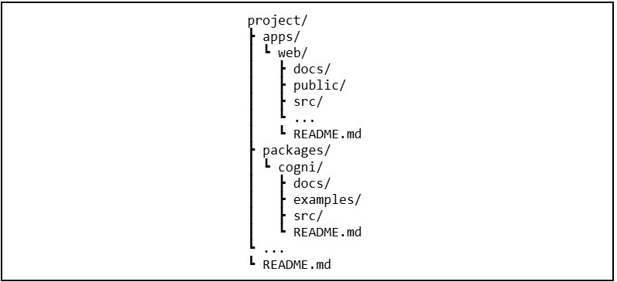
Repository structure of the monorepo.
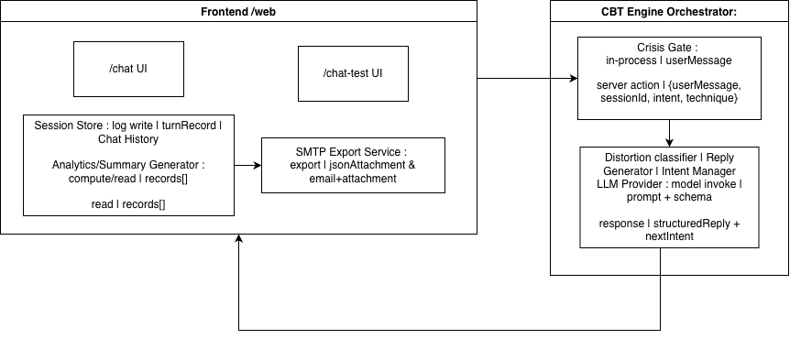
Repository component placement, showing the organization of major system components within the monorepo.
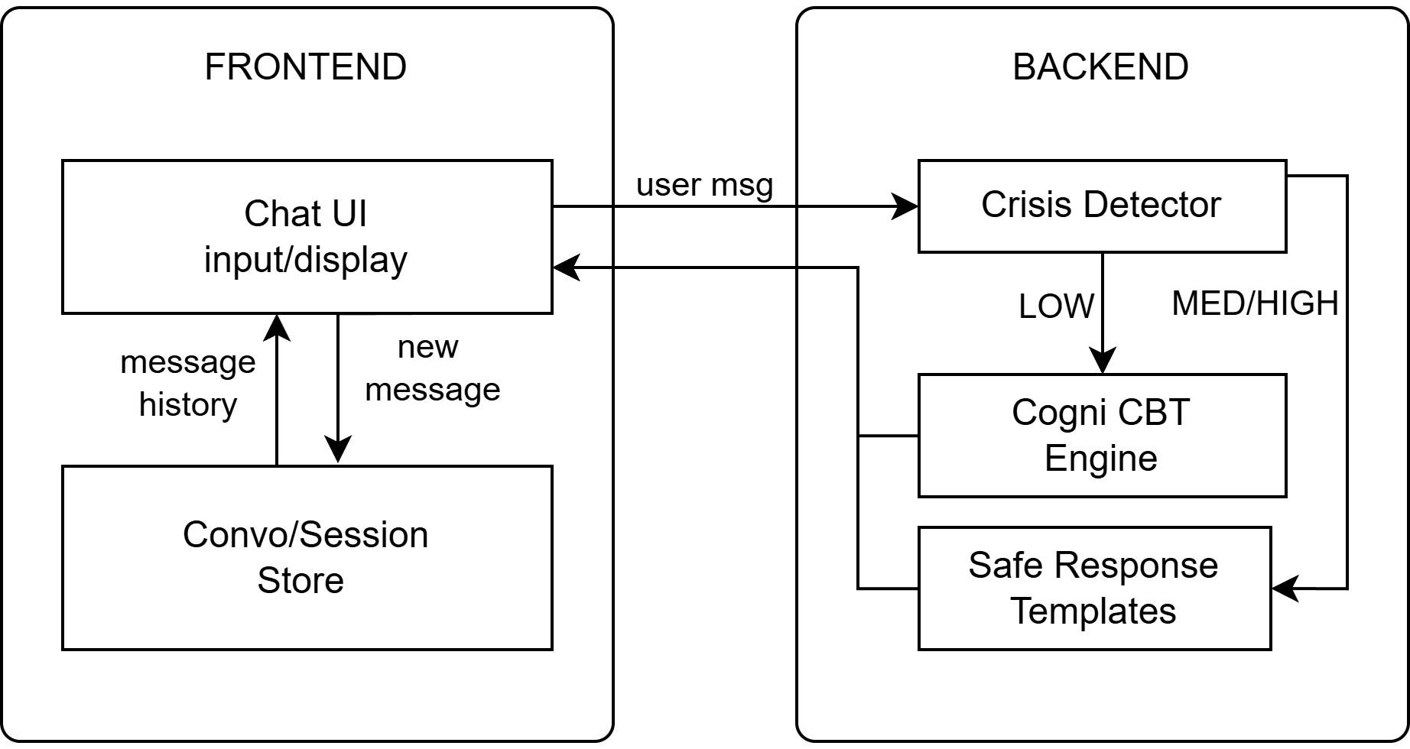
End-to-End Pipeline. Illustrates the full runtime flow for a single user turn.
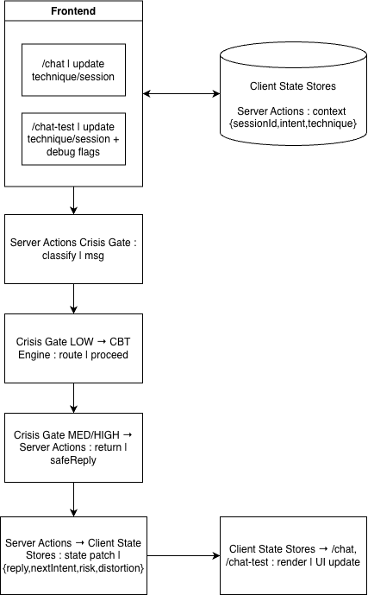
Web App Interaction Flow: UI → Server Action → Safety Gate → Engine → UI Update
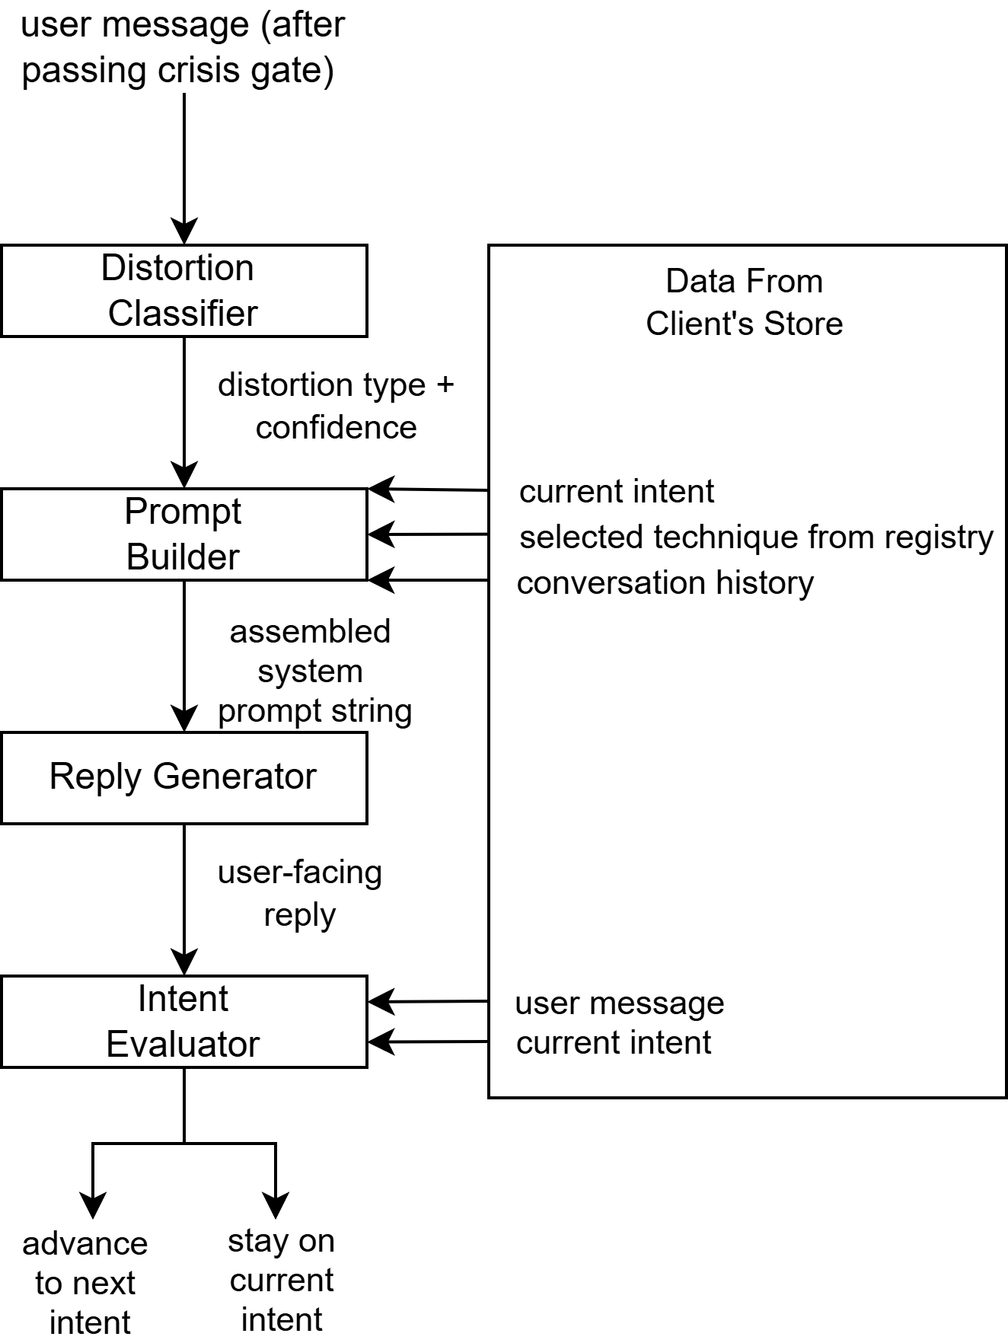
Internal Engine Orchestration. Details the internal sequence of the CBT engine for non-crisis turns.
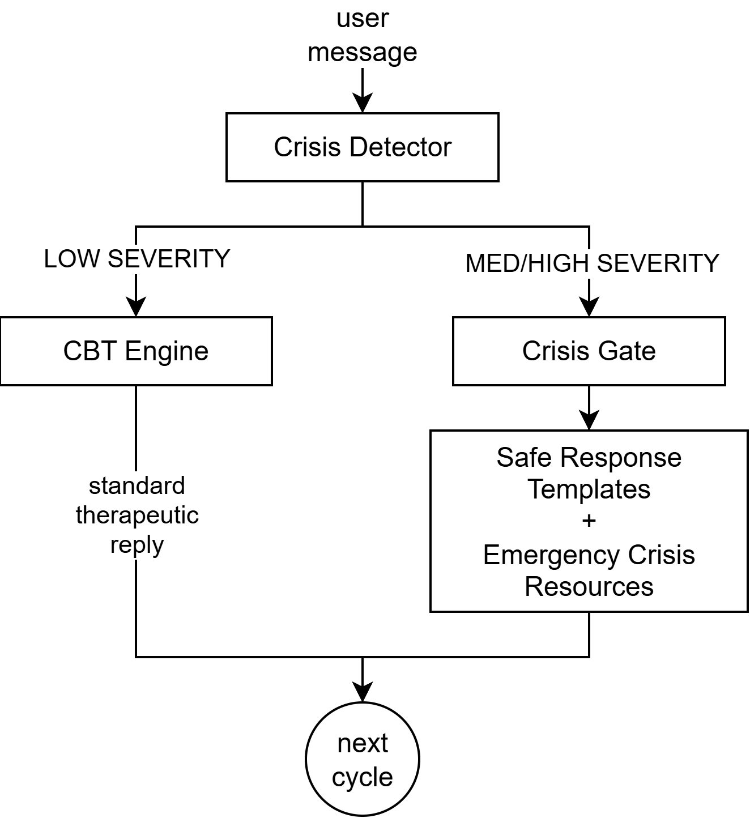
Figure 4.5: Crisis Gate Decision Flow. Focuses on the crisis gate mechanism that enforces safety-first routing.
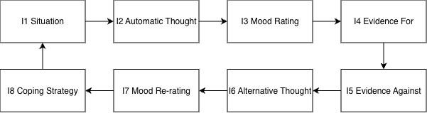
Intent State Machine. Illustrates the finite-state machine governing the eight CBT intents.
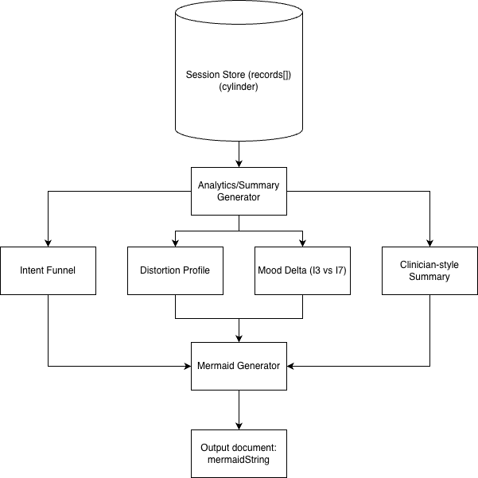
Session Analytics Outputs: Mood Delta, Distortion Profile, Intent Funnel, and Mermaid Session Flowchart.
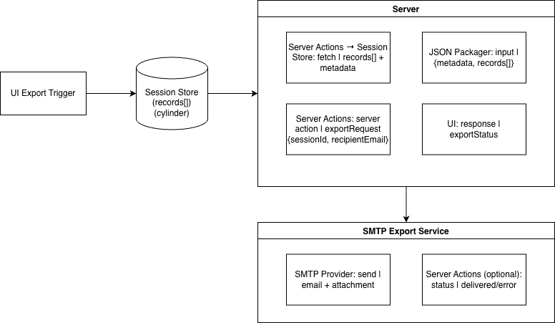
Session Export Flow: User Trigger $→$ JSON Packaging $→$ SMTP Send.
Final prompt lineup selected for each CBT intent after internal prompt testing.
Intent | Technique | Rationale
I1 | Few-Shot | Provided the strongest contextual grounding, clear CBT framing, and effective elicitation of the triggering situation.
I2 | Plan-and-Solve | Showed the highest cognitive precision in identifying automatic thoughts and distinguishing beliefs from emotions.
I3 | Persona + Chain-of-Thought | Balanced empathy and structure, enabling smooth and coherent mood rating.
I4 | Persona-Based | Best supported reflective evidence gathering while maintaining emotional safety.
I5 | Persona-Based | Encouraged balanced thinking and counter-evidence exploration without reducing user agency.
I6 | Persona-Based | Most effective in guiding users toward realistic and self-compassionate alternative thoughts.
I7 | Persona-Based | Maintained emotional continuity and supported reflective mood re-rating.
I8 | Persona-Based | Produced the most context-aware and personalized coping strategies.
Overview of system development and evaluation phases.
# | Phase | Description | Changes Made | Outcome / Motivation for Next Phase
Table 2 continued.
# | Phase | Description | Changes Made | Outcome / Motivation for Next Phase
1 | Initial System Development | Chatbot built with GPT-4o-mini at temperature 0.2; four prompt techniques implemented across all 8 CBT intents. | Module-driven CBT engine, centralized prompt registry, safety gate, and session analytics established. | Functional baseline established; internal prompt testing conducted to select best technique per intent.
2 | Prompt Testing | Internal evaluation of all four techniques across 8 CBT intents using standardized scenarios. | Hybrid configuration selected: Few-Shot (I1), Plan-and-Solve (I2), Persona + CoT (I3), Persona-Based (I4–I8). | Hybrid lineup finalized; system deployed for first round of user testing.
3 | First User Testing | 15 student participants evaluated Pebbles and Raw GPT across structured CBT sessions. | No system changes; post-session questionnaires administered. | Positive reception; issues identified with repetitive phrasing, mechanical tone, and premature intent transitions.
4 | First Therapist Evaluation | Two licensed therapists reviewed scripted transcripts and session excerpts via online interview. | No system changes; qualitative feedback collected. | Confirmed CBT fidelity; raised concerns about pacing, guided discovery, and emotional readiness checks.
5 | First Prompt Rework | Prompt-level adjustments to address mechanical tone and repetition. | Added contextual explanations per step; revised greeting; updated crisis helplines. | Limited improvement — GPT-4o-mini over-prioritized new instructions, causing rigidity and repetitive structure.
6 | Model Upgrade + Second Rework | Upgraded model from GPT-4o-mini to GPT-4o; prompts re-tuned for improved naturalness. | Model replaced; prompt instructions refined to leverage improved instruction adherence. | Significant gains in fluency and coherence; however, Intent 8 was found to be consistently skipped.
7 | Third Rework (Bug Fix) | Resolved Intent 8 skipping caused by misaligned intent transition logic. | CogniEngine.respond updated to evaluate intent transition before response generation; prompt selection switched to reference nextIntent. | Intent flow restored; system re-deployed for second round of user testing.
8 | Second User Testing | 10 returning participants compared the old and new versions of the system. | No system changes; comparison questionnaire administered. | All participants preferred the updated version; improvements confirmed in clarity, structure, and helpfulness.
9 | Final Expert Evaluation | A third therapist assessed CBT alignment and conversational structure. | No system changes; qualitative feedback collected. | Recommended grounding coping strategies in user experience; advised against skipping the mood rating step.
10 | Final Prompt Rework | Refined prompts to improve naturalness and remove explicit CBT step labels from responses. | Step labels removed; summary repositioned to final intent; coping strategy prompt revised to encourage user-led reflection. | Final system version produced more natural, human-like therapeutic interactions.

