PERSONAL INFORMATION | Iaroslav Domin
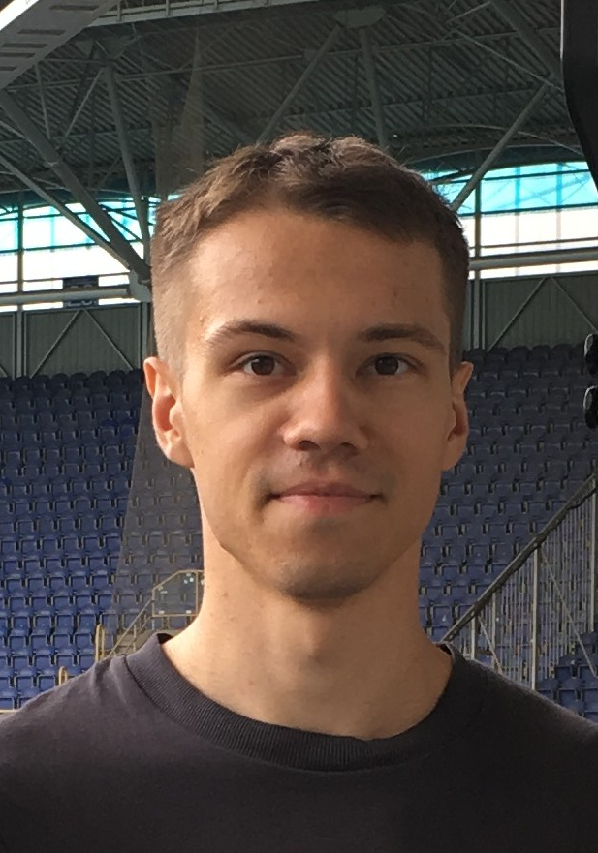 | Ukraine, Kharkiv, Lebedinskaya str. 1, ap. 29, index: 61001
 |  +380 67 425 35 36

ya.domin@gmail.com

Skype ya.domin

idmn.me; github.com/idmn
 | Sex Male | Date of birth 28/07/1993 | Nationality Ukrainian

WORK EXPERIENCE

Nov 2019 – Ongoing | Data Scientist
Nov 2019 – Ongoing | Adatype; adatype.ai
Nov 2019 – Ongoing | ▪ development of data analysis algorithms  ▪ creation of interactive visualisation tools (R Shiny)  ▪ creation of statistical reports  ▪ database management (google bigquery)  ▪ reading scientific publications on data analysis; creating summary reports of publications; implementing algorithms from publications

Jul 2015 – Nov 2019 | Clinical Statistical Programmer/Analyst
Jul 2015 – Nov 2019 | Intego Group, LLC; intego-group.com
Jul 2015 – Nov 2019 | ▪ creation of various statistical outputs (interactive visualizations, static graphs, tables, listings)  ▪ creation of analysis datasets (CDISC ADAM)  ▪ writing specifications for analysis datasets (CDISC ADAM)  ▪ quality control of datasets and statistical outputs  ▪ prepared and held an internal course on R programming  ▪ conference participation: Roche Regional SPA Conference (Welwyn, 2019)

EDUCATION AND TRAINING

Sep 2014 – Jun 2015 | Clinical SAS Programming and Statistical Analysis
Sep 2014 – Jun 2015 | Intego Group, LLC, Ukraine
Sep 2014 – Jun 2015 | ▪ SAS programming  ▪ CDISC standards  ▪ Creation of CDISC datasets (SDTM/ADAM) and statistical outputs  ▪ Clinical programmer working process

Sep 2014 – Jun 2015 | Master's degree in applied mathematics: Mathematician (applied mathematics), Researcher (area of computational mathematics)
Sep 2014 – Jun 2015 | V. N. Karazin National University (Kharkiv, Ukraine)
Sep 2014 – Jun 2015 | ▪ Statistics  ▪ Mathematical Modeling  ▪ Numerical Methods  ▪ Complex Analysis

Sep 2010 – Jun 2014 | Bachelor's degree in applied mathematics
Sep 2010 – Jun 2014 | V. N. Karazin National University (Kharkiv, Ukraine)
Sep 2010 – Jun 2014 | ▪ Probability Theory, Statistics, Random Processes  ▪ Programming, Algorithms and Data Structures, Databases  ▪ Calculus, Functional Analysis  ▪ Linear Algebra, Geometry  ▪ Differential Equations, Differential Geometry  ▪ Complex Analysis  ▪ Computational Methods

PERSONAL SKILLS

Mother tongue(s) | Russian, Ukrainian
Other language(s) | UNDERSTANDING |  | SPEAKING |  | WRITING
Other language(s) | Listening | Reading | Spoken interaction | Spoken production
English | C1 | C1 | B2 | B2 | B2
 | IELTS: 7.0 (C1) (2017)

Communication skills | ▪ good communication skills gained through my experience of working in an international team

Job-related skills | Working as a clinical statistical programmer and as a data scientist:  ▪ Programming languages: R - excellent, SAS – good  ▪ data wrangling  ▪ data visualization, including interactive visualizations, using Shiny and other R packages  ▪ machine learning algorithms (incl. DNNs)  ▪ R packages development  ▪ git/github  ▪ good knowledge of CDISC standards, understanding of drug development process  ▪ Google Bigquery

Other skills | ▪ Web scraping (pet data analysis projects in R, hosted on github)  ▪ Python (ML-stack, limited experience)  ▪ javascript (entry-level)

ADDITIONAL INFORMATION

Honours and awards | ▪ International Mathematics Competition for University Students: 2011 – II-nd prize.  ▪ All-Ukrainian Mathematics Olympiad for University Students: 2011, 2012 – III-rd prize; 2014, 2015 –  II-nd prize.  ▪ All-Ukrainian Mathematics Olympiad among Schoolchildren: 2010 – III-rd prize.

