Regional model validation record
Field | Entry and completion guidance
Region | South China Sea | LME_036 | Regional workbook
Catch source | Sea Around Us; 1950–2019; total catch = landings + discards. Region | Catch ZIP | Taxon catch  Snapshot documented 3 Sep 2026;
Selected article | Cheung, Wai Lung (2007). Vulnerability of marine fishes to fishing: from global overview to the northern South China Sea. UBC doctoral thesis. DOI 10.14288/1.0074894 | Thesis PDF | Paper folder
Other known articles | • Pauly & Christensen (1993). Stratified models of large marine ecosystems: application to the South China Sea. Local record  • Pitcher et al. (2000). Marine Reserves and the Restoration of Fisheries and Marine Ecosystems in the South China Sea. Local record  • Lin, Chen & Lin (2020). Trophic model of a deep-sea ecosystem with methane seeps in the South China Sea. Local record | DOI  • Zhang et al. (2022). Effects of ocean warming and fishing on the coral reef ecosystem: A case study of Xisha Islands, South China Sea. Local record | DOI  • Jiang et al. (2023). A preliminary model of the mangrove ecosystem of Dongzhaigang Bay, Hainan, (China) based on Ecopath and Ecospace. Local record | DOI  • Feng et al. (2026). Ecosystem characteristics and ecological carrying capacity of a subtropical marine ranch in the pearl river estuary: an ecopath modeling approach. Local record | DOI
Selected model | 36_1_South_China_Sea_SCS-2007_Northern_South_China_Sea_(2000s)  Selected, 2000s northern shelf; 38 source groups. Folder | JSON | Saved runtime.
Selection rationale | Article – ?  Model – newer model (2000 vs 1970)
Model extraction | source reconstruction report  - several internal conflicts within the paper. Full conflict report.  - Diet Sums – only rounding errors.  max error = 0.0011, group 33 (Pelagic sharks and rays).  - GS not reported; defaulted to 0.2 for all consumer groups, 0 for producers/detritus/import groups  - BA not reported; auto completed through LIM  - state comparison.
SPPR calculation | Removed groups from calculation:  - seabirds (TE<0.1%, TL=3.4, sppr_TE=3.75M, sppr_GE=21K)  - other mammals (TE<0.1%, TL=3.9, sppr_TE=800K, sppr_GE=13K)  - Pinnipeds (TE<0.1%, TL=4.1, sppr_TE=340K, sppr_GE=3400)  - Marine Turtles (TE<1%, TL=3, sppr_TE=20K, sppr_GE=724)

Field | Entry and completion guidance
GE diagnostics | no negative source columns.  rho_living = 0.3209187537609611; b = 0.00408138212364339.  Detritus pool 38 Detritus: SPPR = 1.007782936216668.
TE diagnostics | no negative source columns.  rho_living = 0.6163296517365333;  Detritus pool 38 Detritus: SPPR = 0.995222499887902.
Taxon to group mapping
Catch coverage
Geographic fit | A. Region covered by study: Not determined.  B. Study area covered by region: Not determined.  A = 100 × area(R ∩ S)/area(R); B = 100 × area(R ∩ S)/area(S). R has an LME polygon; S lacks a verified digital/georeferenced shelf boundary. The removed legacy approximation and broad bounds are insufficient. New geographic evidence note; source images at end.
Temporal fit | Model period: 2000s (no verified single model year). Fixed coefficients and stage weights are applied to catch years 1950–2019, including the 2019 reference. They do not reconstruct annual ecosystems and transfer a northern-shelf model to whole-LME catch.
Other
Open issues and next action | [MANUAL — Researcher: open issue and consequence]  [Researcher: next action / priority]  [Researcher: relevant .md report hyperlink, if available]
Review and reproducibility | [MANUAL — Researcher name: ___ | review date: ___]  [Researcher: review decision and limitations]  [Researcher: reviewed input/version and configuration]  [Researcher: reproducibility evidence/report hyperlink]

Geographic evidence screenshots
Region R and selected model study area S. Insert source images when available; the two percentages in the table require documented spatial evidence, not visual estimation.

Region area
Target region boundary
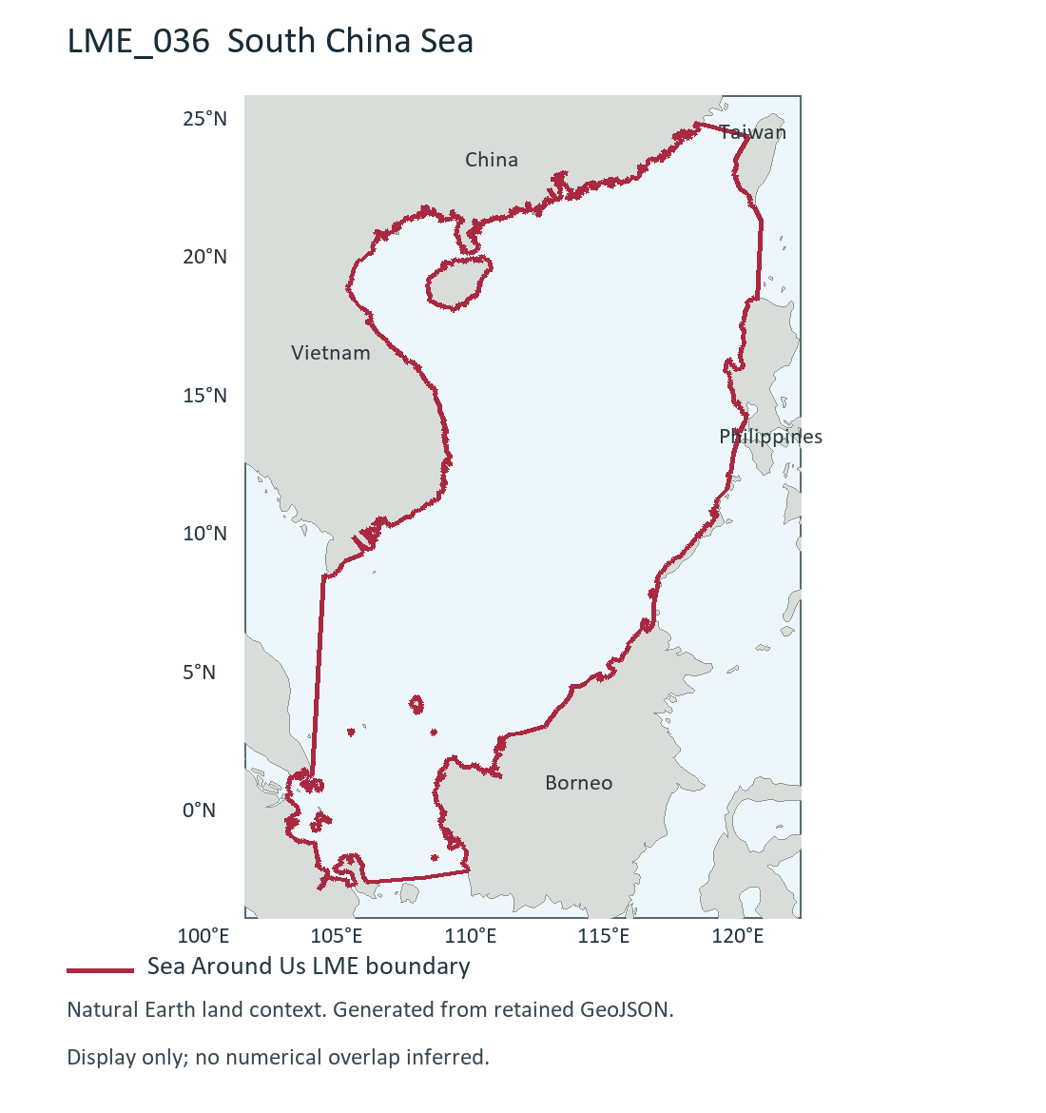
LME_036 South China Sea (R). Generated during this test from retained Sea Around Us boundary; dataset release/date not recorded. Source and display method | Image.

Study area in the article
Study boundary for the selected model
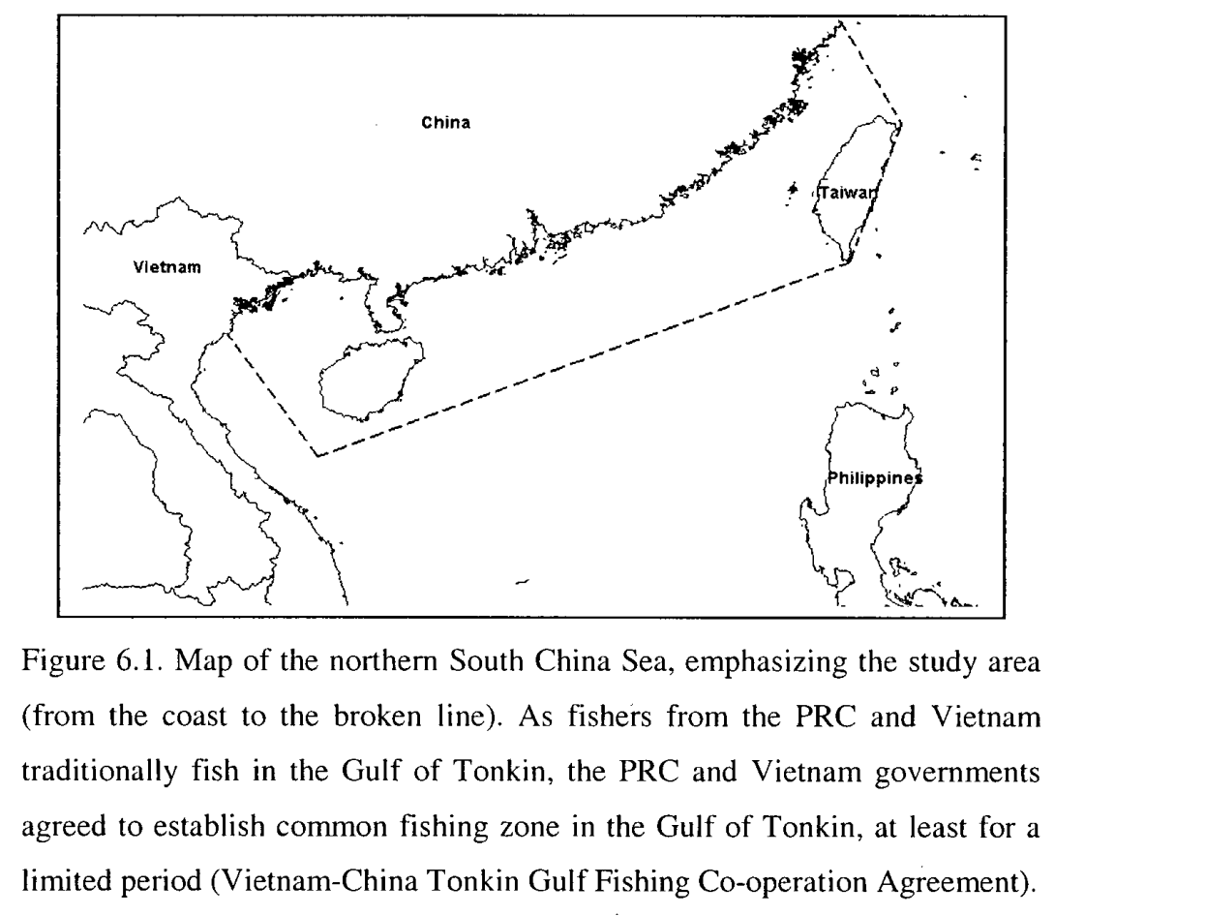
Cheung (2007), Figure 6.1, printed p.170 / PDF p.185. Northern South China Sea shelf (S), 2000s selected model; coast to broken line. Source PDF | DOI | Image.
The source figure is available; it is shown for geographic context and does not establish either numerical overlap percentage.

