South China Sea model validation
Validation record for the selected 2000s northern South China Sea model. The linked Excel appendix lists all 374 taxa, with mapping confidence and assumptions. Estimates remain provisional.
Field | Entry
Region | South China Sea | LME_036 | Regional workbook
Catch source | Sea Around Us; 1950–2019; source contains landings, discards and total catch. Region | Catch ZIP | Taxon catch  Snapshot documented 3 Sep 2026;  Assessment: 2019 landings, as recorded in Overview / Settings. Total catch includes landings + discards.
Selected article | Cheung, Wai Lung (2007). Vulnerability of marine fishes to fishing: from global overview to the northern South China Sea. UBC doctoral thesis. DOI 10.14288/1.0074894 | Thesis PDF | Paper folder
Other known articles | • Pauly & Christensen (1993). Stratified models of large marine ecosystems: application to the South China Sea. Local record  • Pitcher et al. (2000). Marine Reserves and the Restoration of Fisheries and Marine Ecosystems in the South China Sea. Local record  • Lin, Chen & Lin (2020). Trophic model of a deep-sea ecosystem with methane seeps in the South China Sea. Local record | DOI  • Zhang et al. (2022). Effects of ocean warming and fishing on the coral reef ecosystem: A case study of Xisha Islands, South China Sea. Local record | DOI  • Jiang et al. (2023). A preliminary model of the mangrove ecosystem of Dongzhaigang Bay, Hainan, (China) based on Ecopath and Ecospace. Local record | DOI  • Feng et al. (2026). Ecosystem characteristics and ecological carrying capacity of a subtropical marine ranch in the pearl river estuary: an ecopath modeling approach. Local record | DOI
Selected model | 36_1_South_China_Sea_SCS-2007_Northern_South_China_Sea_(2000s)  Selected, 2000s northern shelf; 38 source groups. Folder | JSON | Saved runtime.
Other models from the same article | Northern South China Sea (1970s): same northern shelf and 38 source groups; earlier biomass, mortality and catch parameterization with adult-heavy stages. Kept separately from the selected 2000s model.
Selection rationale | Article – ?  Model – newer model (2000 vs 1970)
Model extraction | source reconstruction report  - several internal conflicts within the paper. Full conflict report.  - Diet Sums – only rounding errors.  max error = 0.0011, group 33 (Pelagic sharks and rays).  - GS not reported; defaulted to 0.2 for all consumer groups, 0 for producers/detritus/import groups  - BA not reported; auto completed through LIM  - state comparison.
SPPR calculation | Removed groups from calculation:  - seabirds (TE<0.1%, TL=3.4, sppr_TE=3.75M, sppr_GE=21K)  - other mammals (TE<0.1%, TL=3.9, sppr_TE=800K, sppr_GE=13K)  - Pinnipeds (TE<0.1%, TL=4.1, sppr_TE=340K, sppr_GE=3400)  - Marine Turtles (TE<1%, TL=3, sppr_TE=20K, sppr_GE=724)

Field | Entry
GE diagnostics | no negative SPPR entries across the basal-source columns.  rho_living = 0.3209187537609611; b = 0.00408138212364339.  Detritus (38): SPPR = 1.007782936216668.
TE diagnostics | no negative SPPR entries across the basal-source columns.  rho_living = 0.6163296517365333.  Detritus (38): SPPR = 0.995222499887902.
Geographic fit | A. Region covered by study: approximately 15–25%.  B. Study area covered by region: approximately 90–100%.
Temporal fit | Model period: 2000s (no verified single model year). Fixed coefficients and stage weights are applied to catch years 1950–2019, including the 2019 reference. They do not reconstruct annual ecosystems and transfer a northern-shelf model to whole-LME catch.
Other | - Diagnostics were run before groups removal.
Open issues and next action | - Test how much SPPR and PPR values change when using the 1970 model.  - Add article selection reason when we review other articles
Review and reproducibility | Researcher name: Ido Carmel | review date: 30/09/2026

Taxon mapping and coverage
Reference: 2019 landings, excluding discards. All sources, all taxa and groups;
There are 38 source groups plus one computational import and 374 catch taxa.
Simple-chain PPR totals 837,452,937.79 t C in 2019.
The 34 taxa that lack an assigned trophic level have zero landings that year and therefore contribute zero PPR.
Simple-chain PPR is calculated with the simple trophic chain method.
Excel taxon appendix and Sources contains all taxa, sorted by unrounded PPR, and allocation values and assumptions.
Overall confidence | Taxa | Catch percentage | PPR percentage
High | 126 | 34.5975% | 31.0269%
Medium | 120 | 28.4361% | 33.4649%
Low | 108 | 24.4003% | 30.6822%
Very low | 20 | 12.5661% | 4.8260%
Unresolved | 0 | 0.0000% | 0.0000%

The summary uses the weaker required membership or allocation confidence. The following tables show each component separately.
Group assignment rules
Plain-language rule | Confidence | PPR percentage
The taxon fits an unambiguous documented group definition | High | 30.8962%
The assignment has incomplete or conflicting size habitat or stage evidence | Low | 30.6822%
The source explicitly assigns the taxon to the model group | High | 14.8040%
Ecology and catch classification support an assumed group assignment | Medium | 10.7450%
Taxonomy, ecology and model definitions establish an assumed set of eligible groups | Medium | 8.0236%
A broad catch label is approximated by compatible named and residual groups | Very low | 4.0110%
The closest represented ecological group is used despite a habitat or source-definition mismatch | Very low | 0.8150%
A verified synonym links the catch taxon to explicit source membership | High | 0.0230%
Membership sources: Cheung group definitions; adopted regional mapping and evidence. Taxonomic authorities and ecological limitations are described on the Excel Sources sheet.
Allocation and mapping uncertainty
Plain-language rule | Confidence | PPR percentage
Model catch proportions supply an assumed allocation across eligible groups | Medium | 64.7287%
The taxon is assigned to one group and needs no split | High | 35.2713%
Each percentage is the known simple-chain PPR associated with taxa using that rule.
All 374 catch taxa have an assigned group: 100% of 2019 landings and known simple-chain PPR are mapped. Unresolved taxa: none. This includes 20 Very low assignments covering 12.5661% of landings and 4.8260% of known simple-chain PPR; their exact taxa, weights and reasons are flagged in the Excel appendix.
Very low decisions
Affected taxa | Why confidence is very low
Unidentified marine fish, finfish, groundfish and pelagic fish; Perciformes; Chondrichthyes (6 taxa) | Unknown species mixtures are approximated by compatible named and residual fish pools. Any chimaera component uses shark/ray analogues.
Miscellaneous aquatic invertebrates (1 taxon) | Demersal invertebrate pools approximate an unknown mixture; cephalopod habitat is mixed.
Billfishes (9 taxa); Lampris guttatus; Lepidocybium flavobrunneum (11 taxa) | Large pelagic groups substitute for absent oceanic/deep-water compartments; source stage boundaries are weak transfers.
Ruvettus pretiosus; Gadiformes (2 taxa) | The single benthopelagic pool is a habitat analogue; depth and source pool aggregation remain uncertain.
Whole model-pool catch proportions are assumed representative of regional taxon catches across 1950–2019 and all catch bases. These are not observed target-catch mixtures. Another 108 taxa retain Low confidence because of membership or stage-definition limitations.
Allocation sources: selected model catch and biomass fields; adopted candidate decisions and calculations. Prior stage assumptions and their source conflicts remain in the regional Allocation assumptions ledger.
High mapping coverage does not establish model validity. The northern shelf model is extrapolated to the wider region; the diagnostic and source-matrix limitations above remain.

Geographic evidence screenshots
R is LME036; S is the northern shelf coast-to-broken-line area in Cheung Figure 6.1. The grid and shared coastal landmarks support the approximate ranges above.

Region area
Target region boundary
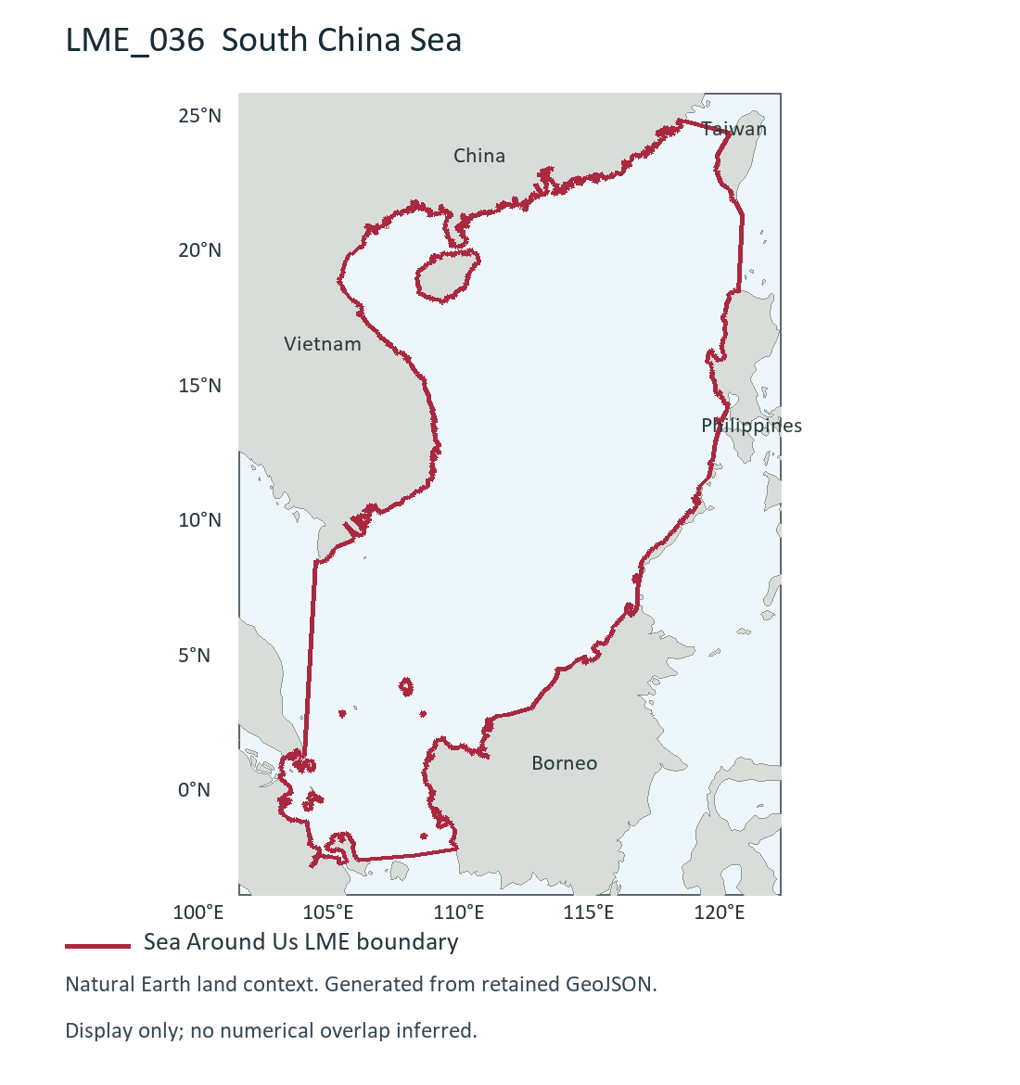
LME_036 South China Sea (R). Retained researcher figure drawn from Sea Around Us boundary; dataset release/date not recorded. Source and display method | Image.

Study area in the article
Study boundary for the selected model
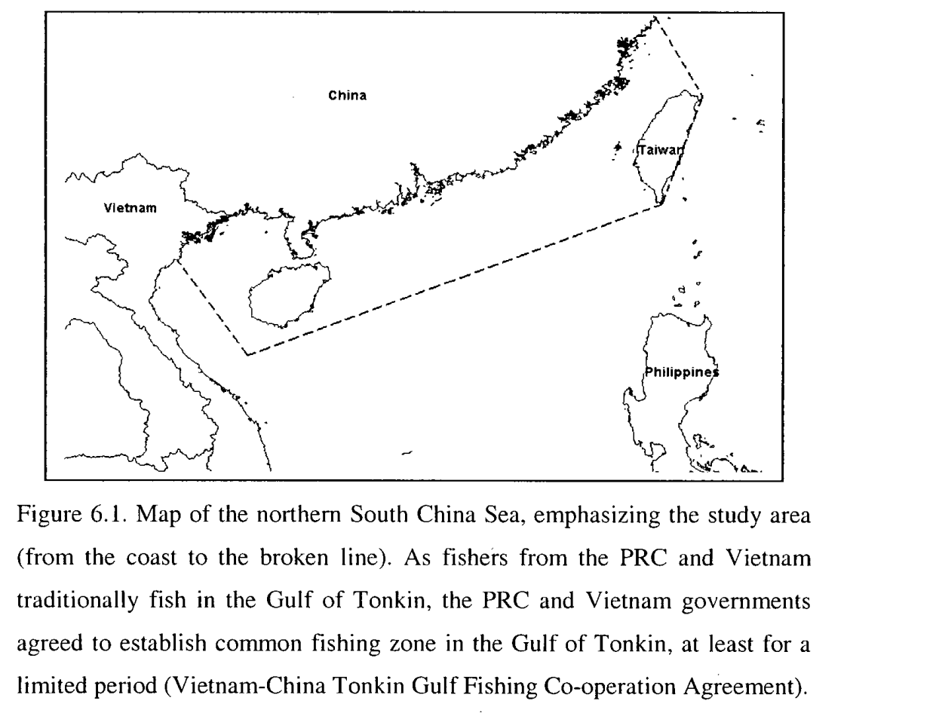
Cheung (2007), Figure 6.1, printed p.170 / PDF p.185. Northern South China Sea shelf (S), 2000s selected model; coast to broken line. Source PDF | DOI | Image.
Visual estimates transfer geographic landmarks between maps; raw screenshot pixel areas were not compared. Boundary interpretation near Taiwan and differing map scales limit precision.

