East China Sea model validation
Field | Entry
Region | East China Sea, LME_047; Sea Around Us target boundary. Regional workbook
Catch source | Sea Around Us v50.1, 1950–2019. Reference: 2019 landings, including reported and unreported retained catch; discards separate. Raw catch | Taxon/TL source
Selected article | Xu, Song, Wang, Xie, Huang, Li, Zheng & Lin (2022), Estimating the Impact of a Seasonal Fishing Moratorium on the East China Sea Ecosystem From 1997 to 2018. Frontiers in Marine Science 9, 865645; DOI 10.3389/fmars.2022.865645. Main paper | Publisher supplement | Paper folder
Other known articles | Li & Zhang (2012), A trophic model of the East China Sea and its possible application. Helgoland Marine Research; DOI 10.1007/s10152-011-0278-7. Publisher supplement retained; focal main PDF unavailable. Cheng et al. (2009), Changes in the ecosystem structure of the East China Sea 1969–2000; known inventory source unavailable. Li supplement | Other source inventory
Selected model | 47_2_East_China_Sea_(2018); static M2018, autumn 2018/spring 2019 survey data. 24 ecological groups plus synthetic diet_import (25). Figure 1 shows a localized shelf study area; exact modeled boundary/area is unstated. Selected JSON | Saved computational workbook
Other models from the same article | 47_1_East_China_Sea_(1997) remains a separate, unselected counterpart, using the 1997–2000 resource survey and different parameter/diet state. Ecosim M2018 SFM/no-SFM scenarios are simulations, not alternative static M2018 source exports. 1997 JSON
Selection rationale | Article: ? (separate article-choice reason unrecorded). Model: “2018 preferred; 1997 retained separately. Model coefficients held fixed across catch years.” This recorded recency preference does not establish whole-LME spatial suitability. Recorded rationale
Model extraction | - Diet Sums – only rounding errors.  - GS not reported; default runtime values are filled.  - BA not reported; auto completed through LIM  - Model catch is assumed to be 0 due to conflicts of table S4 with the main paper. If catch from this table is allocated to BA, there are no SPPR changes. If it is instead allocated to M0, new_GE changes by 2.5% and new_TE changes by 45%.
GE diagnostics | OK:  - model catch defaults to zero.  No negative SPPR entries across the basal-source columns.  rho_living = 0.69  b = 0.20  Detritus (24): SPPR = 1.41  Sppr calculation is balanced (inflow=outflow).
TE diagnostics | WARN:  - model catch defaults to zero.  - Sharks (22) and Marine mammals (23) have EE = 0 (and TE=0).  No negative SPPR entries across the basal-source columns.  rho_living = 0.78  Detritus (24): SPPR = 0.72  Sppr calculation is balanced (inflow=outflow).  SPPR is zero for Sharks (22) and Marine mammals (23) (routed back to detritus).
SPPR calculation | Removed groups from calculation:  - Marine mammals (GE=0.10%, EE=0, TL=3.9, sppr_TE=0, sppr_GE=25K)  Kept sharks in PPR calculations even though TE=SPPR_TE=0 because sharks sppr is routed back to detritus in this case.
Geographic fit | A. Region covered by study: approximately 10–15%.  B. Study area covered by region: approximately 90–100%.
Temporal fit | Static M2018 coefficients and catch/biomass proxy splits are transferred across 1950–2019. Reference 2019 overlaps the spring survey, but fixed guild composition does not represent observed change across years, fleets or catch bases.
Other
Open issues and next action | - Test how much SPPR and PPR values change when using the 1997 model.  - Perform sensitivity test for sharks in PPR
Review and reproducibility | Researcher name: Ido Carmel | review date: 01/10/2026  MODEL VALIDATED
Taxon mapping and coverage
Reference: 2019 landings; all exact catch labels, including unidentified and zero-catch records; no taxon or group filter.
24 ecological source groups (+1 computational import); 276 catch labels.
Simple-chain PPR totals 370,210,805.58 t C in 2019.
22 labels lack a saved classic coefficient/TL; all have zero 2019 landings and zero annual PPR. Unavailable TL remains ?, not zero.
Method: simple trophic chain.
Full taxon mapping appendix and descriptive Sources sheet
Overall confidence | Taxa (n) | Catch (%) | Simple-chain PPR (%)
High | 49 | 33% | 54%
Medium | 185 | 53% | 41%
Low | 16 | 0.049% | 0.20%
Very low | 26 | 14% | 4.8%
Unresolved | 0 | 0% | 0%
The summary uses the weaker required membership or allocation confidence. The following tables show each component separately.
Group assignment rules
Plain-language rule | Confidence | PPR percentage
Exact source member in one group or a documented author union. | High | 53%
Habitat and feeding support an inferred guild. | Medium | 20%
Unlisted taxon extends documented source representatives. | Medium | 17%
Source members support an inferred family/order group set. | Medium | 3.2%
Broad reporting label uses a plausible pooled mixture of unknown composition. | Very low | 2.7%
Closest represented analogue retains material habitat, feeding or taxonomic mismatch. | Very low | 2.1%
Verified taxon fits the explicit Bivalves or Cnidaria pool. | High | 1.2%
Partial ecological fit retains size, habitat or competing-pool uncertainty. | Low | 0.20%
Verified synonym connects the catch label to a source member. | High | 0.12%
Older ECS lobster evidence transfers to focal Crabs. | Medium | 0.0029%
Membership evidence: focal Table S1 and all taxon decisions. Representative lists are not exhaustive family definitions. Bony residuals exclude dedicated cartilage but retain eligible mixed guilds and named fish groups.
Allocation weight rules
Plain-language rule | Confidence | PPR percentage
One reviewed source group; no numerical split. | High | 93%
Complete positive 2018 source catch proportions proxy the taxon mixture across years and bases. | Medium | 2.1%
Complete M2018 group biomass proportions proxy composition after source catch is incomplete or censored. | Medium | 4.9%
Weights and assumptions: 12 split labels use complete positive 2018 Table S4 catch proportions; 15 use M2018 biomass after incomplete or censored source catch. Both have Medium allocation confidence. S4 is M1997 Ecosim calibration data, not a native M2018 catch vector. Whole-guild proxies are transferred across years, areas, fleets and catch bases. Allocation evidence | Historical donor reconstruction
Each rule percentage is the independent simple-chain PPR associated with taxa using that rule.
Unresolved taxa: none. The 26 Very low decisions cover 14.1427% of landings and 4.8247% of simple-chain PPR. The same cohort contributes 14.17% of GE, 12.25% of TE and 13.74% of With Egestion PPR under the reference controls. Method-specific contributions

Very low decisions
Affected taxa | Why confidence is very low
Marine fishes not identified; Marine finfishes not identified | Unknown bony-fish composition is approximated by eleven named and residual fish groups; the Benthivores coefficient also pools rays. Biomass weights assume caught-mass composition and remain fixed across years, fleets and catch bases.
Gadus macrocephalus | Pacific cod is absent from the source membership and reaches the northern ECS margin. Benthivores/piscivores supplies only a weak demersal feeding analogue.
Oncorhynchus; Salmonidae | The model has no anadromous or subarctic fish compartment. Northern-margin salmon catch is placed in Planktivores/piscivores by a weak feeding analogy.
Miscellaneous marine crustaceans | The unknown crustacean mixture is approximated by Benthic Crustaceans, Crabs and Shrimps. Excluding crustacean members of Zooplankton is a landed benthos/nekton assumption; biomass proportions are transferred across years and catch bases.
Planiliza haematocheilus; Mugil cephalus; Mugilidae | Mullets graze microalgae and detritus, but the model has no herbivore or detritivore fish pool. Benthivores is a weak bottom-feeding analogue with a diet mismatch.
Gastropoda; Turbo cornutus; Haliotidae; Haliotis; Rapana | Mollusks is explicitly composed of bivalves. Gastropod grazing or predation is absent; the shelled benthic-mollusc connection supports only a weak analogue.
Miscellaneous aquatic invertebrates | Unknown residual composition is approximated by eight benthic/nekton invertebrate pools. Excluding actual animal members of Zooplankton is an ecological assumption; fixed biomass weights are not observed caught-mass proportions.
Gadidae | The unlisted northern family uses weak cod and pollock feeding analogues in two mixed guilds. Source calibration catch proportions proxy this family mixture and are transferred across years and catch bases.
Chondrichthyes | Sharks and the ray-bearing Benthivores pool approximate the class, but chimaeras are absent and Benthivores also pools bony fish. Fixed biomass proportions do not measure cartilage catch composition.
Perciformes | The historical reporting order has unknown composition across ten guilds, some containing non-perciform members. Modern taxonomy does not resolve the reporting mixture; fixed biomass weights proxy composition.
Gadus chalcogrammus | Northern-margin pollock is absent from the source membership. Planktivores/piscivores supplies only a weak midwater feeding analogue.
Mola mola | Planktivores supplies a weak zooplankton-feeding connection, but large oceanic sunfish, deep excursions and gelatinous-prey specialization are poorly represented.
Kyphosidae; Chanos chanos | The fish guilds lack herbivory and detritivory. Omnivores is a weak mixed-feeding analogue for grazing sea chubs and milkfish.
Mollusca | The unknown mixture combines bivalves, gastropods and cephalopods. Gastropods lack an explicit compartment and borrow the bivalve coefficient; fixed biomass weights proxy the mixture.
Scaridae | Omnivores offers a weak coastal mixed-feeding connection. Reef scraping and obligate grazing differ strongly from this shelf guild; no source parrotfish membership is claimed.
Marine pelagic fishes not identified | Unknown pelagic composition uses seven named and mixed fish guilds whose coefficients also contain demersal members. The benthopelagic boundary and fixed calibration-catch composition proxy remain uncertain.
Rhincodon typus | The Sharks pool represents a predatory source shark. Whale-shark plankton filtering is a material mismatch, so the taxonomic connection is only a weak analogue.

Geographic evidence screenshots
R is the full East China Sea LME target. S reconstructs the blue hatch in Figure 1, whose caption calls it the study area. Methods identify the M2018 joint autumn 2018/spring 2019 survey but supply no separate explicit model boundary or area. Coverage therefore describes this study footprint, with model-domain representativeness unresolved. Native graticule calibration preserves the offshore gap, western bends and southern/northeastern boundary; eight water controls pass.

Region area
East China Sea target region
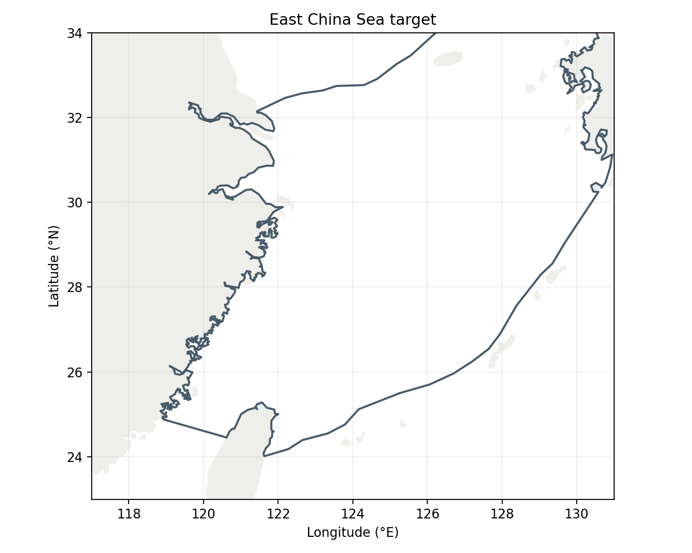
Sea Around Us LME 47 target R: 779,590 km². Target boundary | Map image

Study area in the article
Original East China Sea study area — Figure 1
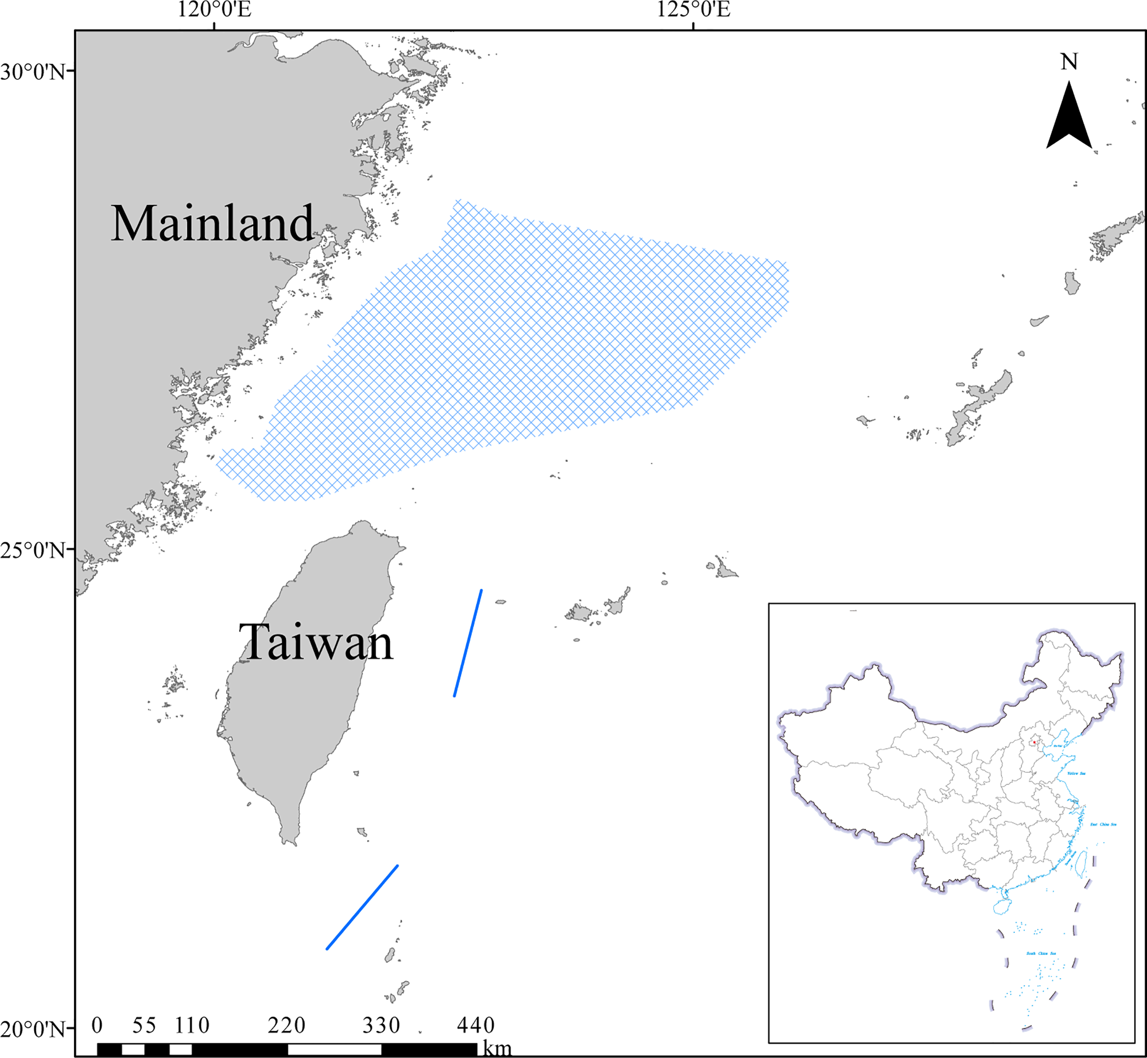
Xu et al. 2022 Figure 1, PDF 3: “The study area in the East China Sea.” §2.2, PDF 4: M2018 uses the joint ECS survey in autumn 2018 and spring 2019. The generic regional description supplies context, not a whole-LME native model boundary. Original figure | Methods | Geographic assessment
Approximate marine study area 106,097 km²; A≈13.61%, B≈100.00%. Descriptive ranges 10–15% and 90–100% reflect trace, registration and coastline uncertainty. Natural Earth ne_50m means 1:50 million scale, not 50 metres. Coverage is not a PPR multiplier. Reconstructed footprint
