Regional model validation record
Field | Entry
Region | Papua New Guinea, EEZ_598. Regional review completed; figures integrated. Regional workbook
Catch source | Sea Around Us regional catch, 1950–2019; landings reference year 2019. Exact Papua New Guinea reporting unit, including unidentified categories; historical download retained. Catch inputs | Workbook catch
Selected article | Allain, V.; Nicol, S.; Essington, T.; Okey, T.; Olson, B.; Kirby, D. (2007). An Ecopath with Ecosim model of the Western and Central Pacific Ocean warm pool pelagic ecosystem. WCPFC-SC3-EB SWG/IP-8. DOI: not recorded. Source PDF | WCPFC article | Paper folder
Other known articles | Griffiths, S.P.; Allain, V.; Hoyle, S.D.; Lawson, T.A.; Nicol, S.J. (2019). Just a FAD? Ecosystem impacts of tuna purse-seine fishing associated with fish aggregating devices in the western Pacific Warm Pool Province. 2005 source and pooled experiment retained for investigation; not selected. DOI 10.1111/fog.12389 | Retained article
Selected model | 941_20070101_WCPO_Warm_Pool_Option1_(mixed_periods); mixed source periods. Final 31 ecological groups plus one computational import. Pelagic study domain 110–180°E, 15°S–15°N. Selected JSON | Model folder | Loaded state
Other models from the same article | Initial 24-group WCPO warm-pool model and final 31-group source model, both mixed periods and the same broad domain; final adds stages and forage detail. The adopted D_fixed_M0 option1 is an extraction/parameter variant of the final model. Three Ecosim perturbations are scenarios, not distinct Ecopath inputs. Initial model | Final source
Selection rationale | Article: ? — comparative article-selection reason is unrecorded. Model: the recorded selection adopts D_fixed_M0 to preserve juvenile other-mortality flows and improve juvenile production consistency. It remains a surrogate; Griffiths 2019 is deferred for investigation. Recorded rationale
Model extraction | Initial/final table scope is distinguished. Accepted Small BET/YFT P/B and EE differ from the paper. Source YFT/piscivorous diet sums 0.998/1.002 are normalized by the retained loader. GS exceptions are retained; missing BA is derived for 24 groups. Missing baby/forage catch becomes runtime zero, not observed source zero; detritus EE is forced to 1 and synthetic import is added. Native stanza dynamics are not reproduced. Source and runtime review | Transformation ledger  Retained departures and evidence limits: model notes
SPPR calculation | [MANUAL — Researcher: calculation choices and reasons]  [Excluded groups, scope and relevant values; other adjustments]

Field | Entry
GE diagnostics | No negative SPPR entries across the basal-source columns. rho_living = 0.54676655; b = 0.63691435; Detritus (31) SPPR = 2.58026100.
TE diagnostics | No negative SPPR entries across the basal-source columns. rho_living = 0.82430628; Detritus (31) SPPR = 0.25250886.
Geographic fit | Approximate A: 100% of the Papua New Guinea EEZ lies in the reported study rectangle. B: about 8.9–10.4% of the study area lies in this EEZ; the range reflects the published-area versus land-excluded coordinate-domain denominator. Broad pelagic overlap does not resolve coastal/reef-fish representativeness. Boundary estimate
Temporal fit | Mixed source inputs: skipjack/forage 1993–2002, yellowfin/bigeye/bycatch 1995–2004 and diet 2001–2007; 2005–2006 assessment editions are not model years. Fixed ecosystem coefficients and composition proxies are transferred across 1950–2019; the 2019 estimate is not an annual ecosystem reconstruction.
Other | The accepted variant retains overall WARN and strict mass balance false (adult BET production residual ≈0.728%); PP-budget status is OK. Original source/native-model validity and author confirmation remain unestablished. Geographic coverage and nonnegative coefficients do not resolve these limitations. Exact diagnostic evidence
Open issues and next action | [Researcher: open issues and next actions]
Review and reproducibility | Researcher name: [name] | review date: [date]
Taxon mapping and coverage
Reference: 2019 landings; all catch labels and source-group scope, including zero catch and unidentified categories.
31 source ecological groups (+1 computational import); 102 catch labels.
Simple-chain PPR totals 140,786,408.80 t C in 2019.
47 labels lack a saved TL/coefficient. All have zero 2019 landings and therefore zero annual contribution; their missing inputs remain unknown.
Method: independent simple trophic chain using saved classic taxon coefficients.
Taxon mapping appendix and descriptive Sources sheet
Overall confidence | Taxa | Catch percentage | PPR percentage
High | 2 | 0.0571% | 0.0542%
Medium | 33 | 92.2048% | 98.4226%
Low | 15 | 2.1487% | 0.3040%
Very low | 47 | 5.2643% | 1.2169%
Unresolved | 5 | 0.3251% | 0.0022%
The summary uses the weaker required membership or allocation confidence. The following tables show each component separately.
Group assignment rules
Plain-language rule | Confidence | PPR percentage
Explicit final source membership in the group or stage union. | High | 97.2962%
Supported candidate set requires an explicit membership inference. | Medium | 0.9015%
Weak usable taxonomic/functional analogue; habitat/stage mismatch. | Very low | 0.8126%
Broad catch label uses an assumed represented-pool composition. | Very low | 0.4043%
Source lineage partly fits the habitat or stage definition. | Low | 0.3040%
Documented family identity fits the complete source group set. | High | 0.1934%
Verified historical/current synonym fits the named source stages. | High | 0.0767%
Supported ecological extension for an unlisted pelagic piscivore. | Medium | 0.0090%
No meaningful taxonomic/feeding guild or usable analogue. | Unresolved | 0.0022%
Related small-pelagic taxa extend final listed representatives. | Medium | 0.0000%
Membership evidence: final source definitions and taxonomic/ecological review
Allocation weight rules
Plain-language rule | Confidence | PPR percentage
Historical source landings proportions supply an assumed regional composition; genuine zeros and the accepted infant exception are explicit. | Medium | 98.0894%
Incomplete raw source catch rejects the catch proxy; complete biomass proportions assume regional composition/catchability. | Medium | 1.8120%
One eligible group receives the entire taxon; this adds no allocation uncertainty. | High | 0.0964%
No eligible compartment supplies a numerical allocation. | Unresolved | 0.0022%
Each percentage is the simple-chain PPR associated with taxa using that rule. Weights and assumptions: candidate/catch/biomass evidence
Unresolved: Bivalvia, Pinctada, Tridacna gigas, Echinodermata and Holothuriidae lack a meaningful feeding/taxonomic guild. Bivalvia and Pinctada have positive 2019 catch; the other three have zero. Their combined catch is 0.3251% and simple-chain PPR is 0.0022%. Very low: 47 exact broad-category or coastal, invertebrate and unlisted-tuna analogues are flagged in the appendix; 5.2643% of landings and 1.2169% of simple-chain PPR. Numerical model coverage is 99.6749%; coverage does not establish representativeness. The two residual marine-fish labels now use all 17 source-defined bony-fish pools, including named tuna and billfish stages. Dedicated sharks are excluded; mixed bathyal pools remain an uncertain whole-biomass proxy. Missing source exports require complete biomass allocation (W9, Medium); residual composition and transfer remain Very low. Independent simple-chain confidence shares above are unchanged; model-method contributions are recalculated. Reporting scope evidence

Geographic evidence screenshots
Target region R and selected model study area S. Approximate WGS84 boundary comparison with consistent land exclusion; the reported model area gives an alternate B denominator.

Region area
Papua New Guinea EEZ_598
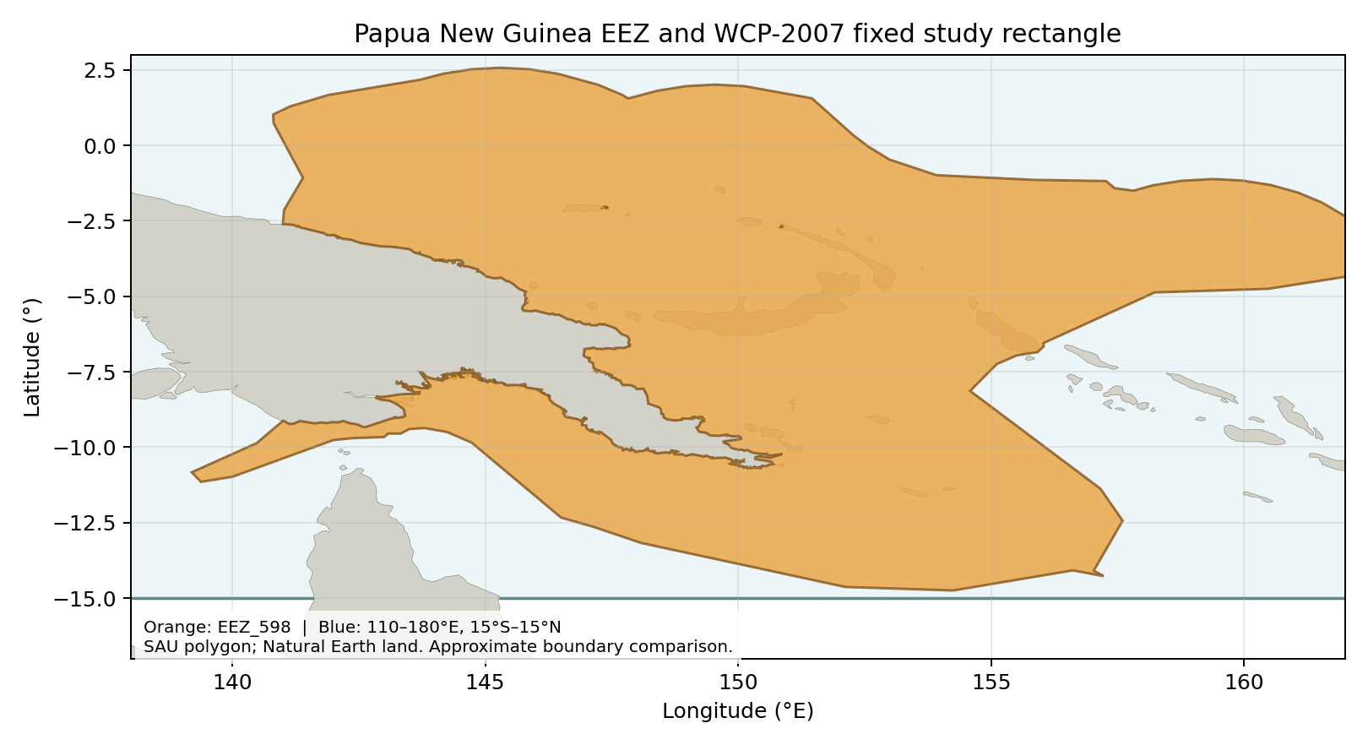
Papua New Guinea EEZ boundary: repaired repository Sea Around Us polygon; Natural Earth 1:50m land. Boundary source | Image

Study area in the article
Study rectangle from Allain et al. (2007), Section 2.2 PDF7
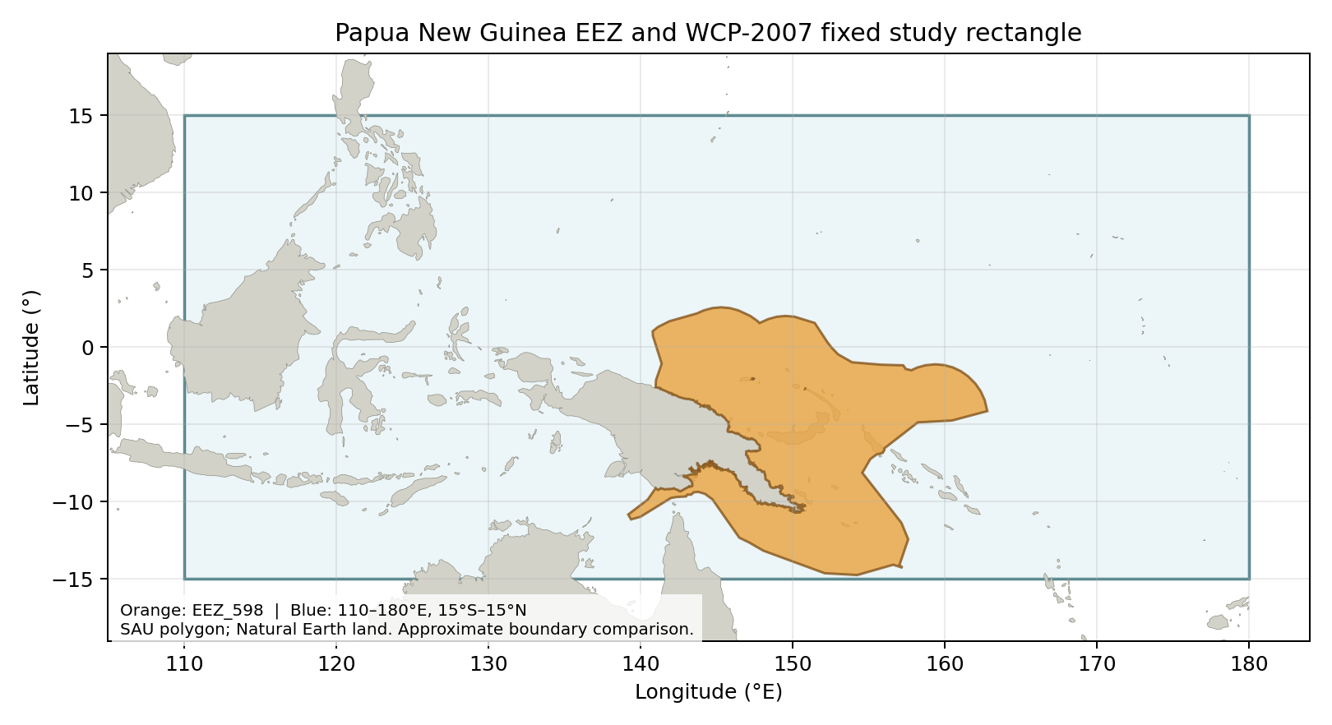
Reported bounds: 110–180°E, 15°S–15°N; reconstructed study boundary. Figure 1 PDF3 shows the broader warm-pool/cold-tongue context. Source PDF7 | Source Figure 1 | Image
