California Current model validation
Field | Entry
Region | California Current, LME_003  Regional workbook
Catch source | Sea Around Us reconstructed catches, 1950–2019. Reference: 2019 landings, excluding discards; frozen regional extract.  SAU California Current | Regional catch
Selected article | Koehn et al. (2016). Developing a high taxonomic resolution food web model to assess the functional role of forage fish in the California Current ecosystem. Ecological Modelling 335, 87–100.  DOI | Source PDF | Paper and supplements
Other known articles | Field (2004) and Ruzicka et al. (2007) are earlier California Current models cited by the selected article. Their smaller northern domains are the white dotted area in Figure 1; they are source context, not alternative selected parameterizations.  Selected source discussion
Selected model | CAL-2016_California_Current_2000-2014. Source baseline combines 2000–2014 information; 93 source groups (92 living, one detritus) plus one synthetic runtime diet_import group. Published model area: 302,000 km².  Canonical source | Selected solved input | Model folder
Other models from the same article | The author archive supplies one central parameter set and Monte Carlo realizations of parameter uncertainty. These are not separate geographic or temporal baseline models; this review uses only the recorded central selected input.
Selection rationale | Article — High taxonomic resolution and explicit forage-fish groups; main paper, Appendix B and author parameter/diet archive provide reconstructable source evidence.  Model — The recorded user selection is the audited author-equation B/EE solution, with canonical source and computational runtime retained as distinct roles.
Model extraction | All 93 author Yield fields are explicit and match canonical export and loaded group catch; zero juvenile yields are model uncaught assumptions. Source Table 1 audit checks 837 cells with no differences. Canonical 26 unknown B and 67 unknown EE are preserved; selected source-equation solution has residual 2.84×10⁻¹⁴. Runtime consumer GS=0.2, sole-detritus routing/EE=1 and import bookkeeping are accepted extensions, not article measurements; diets and source parameters are not normalized or repaired.  Source extraction audit | Catch provenance | Protected inputs  Retained departures and evidence limits: model notes
SPPR calculation | [MANUAL — Researcher: calculation choices and reasons]  [Excluded groups, scope and relevant values; other adjustments]

Field | Entry
GE diagnostics | WARN. Full 94-recipient × 3-source matrix has no negative or nonfinite entries. rho_living=0.454504269; b=0.185834010. Detritus (93) SPPR=1.513603626. Source balance and primary-production accounting pass; 21 zero-EE groups, accepted GS/detritus extensions and near-zero effective efficiencies remain limitations.  Exact direct returns and all axes
TE diagnostics | WARN. Full matrix has no negative or nonfinite entries. rho_living=0.562095966; b=0 by this method convention. Detritus (93) SPPR=1.132196143. EE-fix follows the selected convention; zero EE and near-zero trophic efficiencies remain. No solver rerun or parameter repair was made.  Direct TE return | Full matrix
Geographic fit | A. Region covered by study: approximately 8–13%.  B. Study area covered by region: approximately 60–90%.  These are rounded approximate ranges from source bounds, the current marine polygon and published area, not measured overlap or statistical intervals.  Independent A/B assessment
Temporal fit | Source information spans 2000–2014; reference catch is 2019, five years after the latest source year. Fixed model coefficients and fixed composition proxies are applied across 1950–2019 and catch bases; annual ecosystem or juvenile/adult composition is not reconstructed.
Other | With Egestion retains WARN; rho_living=0.363603415, b=0.200920643 and Detritus (93) SPPR=1.592796611; its full matrix has no negative/nonfinite entries. All 349 labels are assigned, but 190 Very low labels account for 37.3786% of landings and 19.3913% of independent simple-chain PPR. Coastal herbivore/detritivore analogues retain serious feeding-pathway mismatch; full label assignment does not establish production eligibility.  Feeding-role and competitor review | Evidence index  Very low mappings contribute 55.12% of GE, 60.23% of TE and 52.41% of With Egestion PPR; these shares differ from the independent simple-chain coverage summary. Method-specific exposure
Open issues and next action | [Researcher: open issues and next actions]
Review and reproducibility | Researcher name: [name] | review date: [date]
Taxon mapping and coverage
Reference: 2019 landings. Independent all-taxon simple-chain estimate; all source support, all labels and no group filter.
93 source groups plus one synthetic runtime import; 349 catch taxa.
Simple-chain PPR totals 107,146,622.596 t C in 2019.
72 labels lack a classic TL/coefficient; all have zero reference-year landings and contribute zero PPR. No positive-catch contribution is unknown.
Simple-chain PPR uses the saved fixed taxon coefficients of the simple trophic chain method; landings × coefficient / 9 once, in tonnes C.
All-taxon Excel appendix | Descriptive Sources sheet
Overall confidence | Taxa (n) | Catch (%) | Simple-chain PPR (%)
High | 75 | 27.8318% | 11.2119%
Medium | 67 | 33.9652% | 69.1983%
Low | 17 | 0.8244% | 0.1985%
Very low | 190 | 37.3786% | 19.3913%
Unresolved | 0 | 0.0000% | 0.0000%
Sum | 349 | 100.0000% | 100.0000%
The summary uses the weaker required membership or allocation confidence. The following tables show each component separately.
Group assignment rules
Evidence: Every taxon and candidate | Source quantities and weight assumptions
Plain-language rule | Confidence | PPR percentage
Explicitly listed source member of the group or stage pair | High | 78.1640%
Closest practical taxonomic or ecological analogue for an absent compartment | Very low | 11.5950%
Broad reporting composition approximated by named and residual pools | Very low | 7.7962%
Unambiguous documented taxonomic group fit | High | 1.9801%
Taxonomic extension from source-listed representatives | Medium | 0.2658%
Assumed group set supported by source members and taxonomy | Medium | 0.1938%
Partial or conflicting ecological fit among plausible pools | Low | 0.0047%
Verified synonym of an explicitly listed source member | High | 0.0003%
Supported ecological extension of the source-defined group | Medium | 0.0000%
Allocation weight rules
Evidence: Every taxon and candidate | Source quantities and weight assumptions
Plain-language rule | Confidence | PPR percentage
Complete selected-model caught-mass proportions as a fixed composition proxy | Medium | 76.7518%
One group receives the complete catch; no split uncertainty | High | 23.0539%
Preserved regional identified-catch donor composition; reporting-population applicability uncertain | Low | 0.1943%
Each rule percentage is the share of independent simple-chain PPR associated with taxa using that rule.
Unresolved taxa: none. Very low approximation does not mean source membership: 190 labels rely on broad reporting composition or a closest practical analogue. All zero catches and zero-weight candidate stages remain in the linked evidence. Provider maximum-length categories do not establish caught stage; complete author Yield provides W4, while prior identified-catch donor proportions remain W5 Low. The four broad bony-fish labels now include all 40 eligible source groups, including named pelagics and genuine zero-catch stages. Juvenile sablefish and lingcod (group 31) remain in the pelagic set; adult sablefish (group 45) does not. Complete author Yield supplies assumed catch proportions. Complete candidate evidence

Geographic evidence screenshots
Target R is the current marine LME boundary. S is a coarse coastal-corridor reconstruction. Its 232,510 km² area differs from the published 302,000 km²: holding reconstructed overlap fixed gives B 77.81% or 59.91%, respectively. These are distinct denominator scenarios; exact 2000 m GIS is unavailable.

Region area
Target region boundary
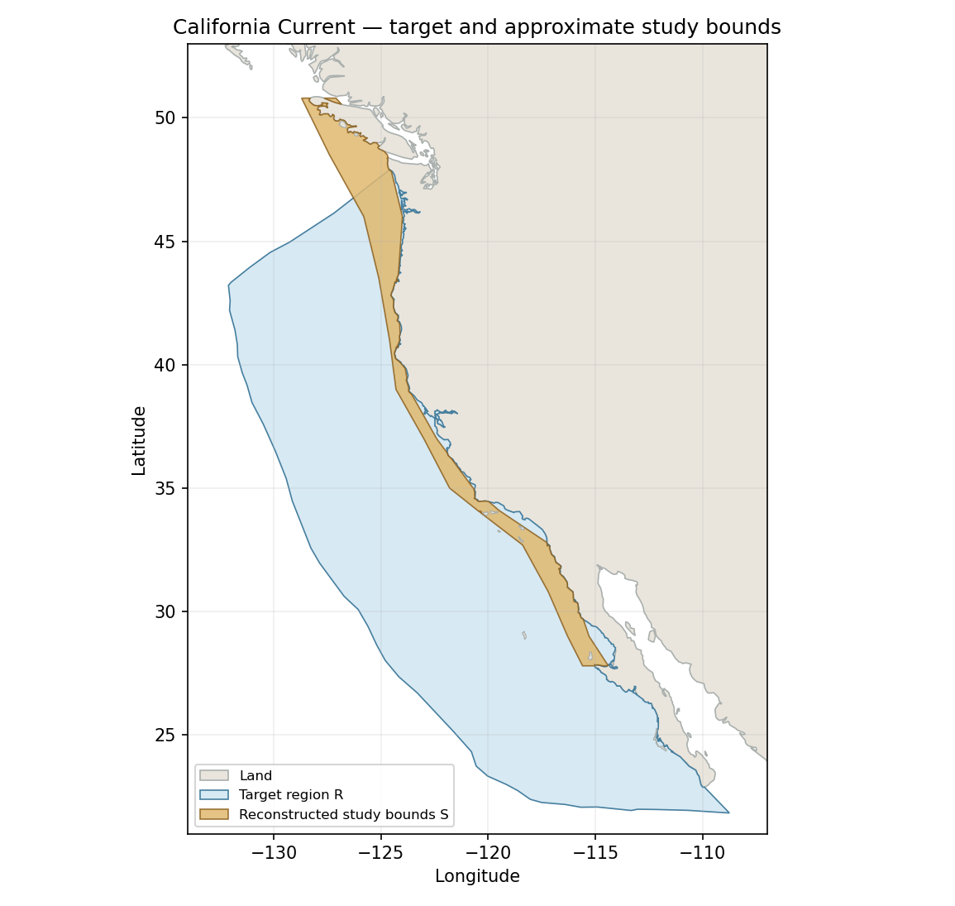
California Current LME_003. Current repaired SAU marine boundary with reconstructed source bounds; this image is our reconstruction, not an article figure. Boundary source | Reconstructed GeoJSON

Study area in the article
Study boundary for the selected model
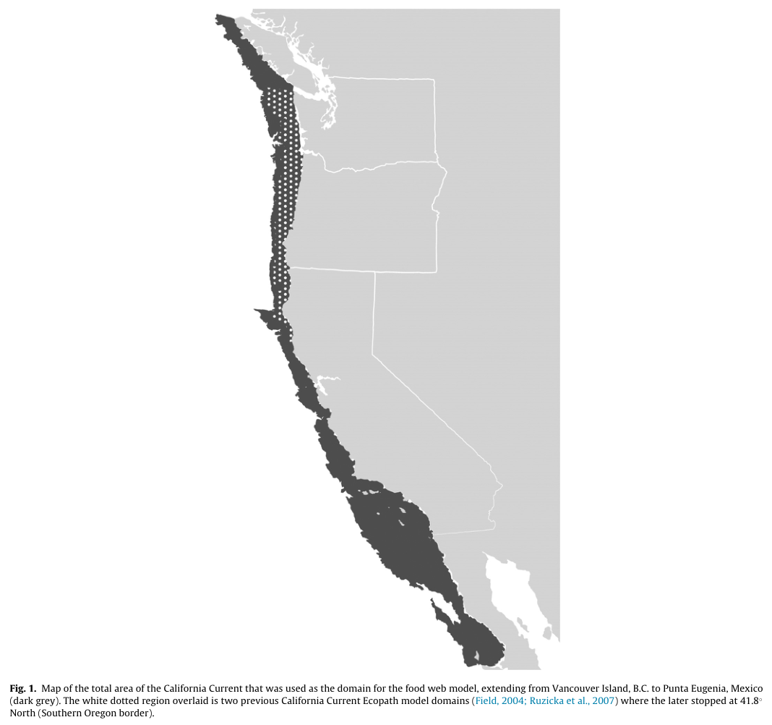
Koehn et al. (2016), Figure 1, PDF p. 5 / printed p. 91. Dark shading denotes the selected model; white dots denote earlier models. Caption/prose state northern Vancouver Island to Punta Eugenia. Shading appears farther south; explicit bounds govern the reconstruction. The inherited target-envelope footprint conflicts with this subregional study. Original PDF

