Humboldt Current model validation
Field | Entry
Region | Humboldt Current, LME_013; Sea Around Us target boundary includes southern Patagonia. Regional workbook
Catch source | Sea Around Us catch series 1950–2019; reference: 2019 landings. All 218 exact labels, including zero catch and unidentified categories. Catch inputs | Regional catch
Selected article | Neira, Arancibia, Barros, Arriagada, Alarcón & Gatica (2026). Analysing ecosystem and demersal stocks dynamics in the Chilean Patagonia system (41°28.6′S–57°S) from 1980 to 2020 using food web modelling. Progress in Oceanography 241, 103631. Source PDF | DOI
Other known articles | Chiaverano et al. (2018), Large jellyfish and forage fishes as energy pathways in the Northern Humboldt Current System. DOI 10.1016/j.pocean.2018.04.009. Northern 1995–1998 alternatives fail all three saved methods. Other article
Selected model | 13_1_Chilean_Patagonia_(1980); one static 1980 Ecopath model, 15 source ecological groups plus synthetic diet_import. Chilean Patagonia channels, fjords and adjacent open waters, approximately 290,000 km². Canonical JSON | Model folder
Other models from the same article | No other complete static parameterization identified in this article. The 1980–2020 Ecosim series, fishing scenarios and sensitivity runs are dynamic outputs, not additional static input models. Source inventory
Selection rationale | Article - ?  Model - User selected this available non-failing WARN alternative after comparison with Northern Humboldt 1995–1998 (GE, TE and With Egestion FAIL). Spatial suitability remains a serious limitation; model selection does not establish regional applicability.
Model extraction | Partial paper reconstruction. Supplementary S1–S7 are now retained; calibration and pedigree tables add no species-membership inventory. Canonical Sea-lion diet sum 1.002 is preserved; accepted runtime normalizes it at tolerance 0.001, infers BA and supplies GS, detritus/routing, missing-catch and import defaults. Printed rounded biomass and undocumented source BA remain distinct from accepted inputs. Extraction report | Source/runtime review
GE diagnostics | WARN: source reconstruction and accepted runtime transformations remain limitations.  No negative SPPR entries across the basal-source columns.  rho_living = 0.3579  b = 0.0210  Detritus (15): SPPR = 1.0453  Strict mass balance passes in the accepted runtime.
TE diagnostics | WARN: source reconstruction and accepted runtime transformations remain limitations.  No negative SPPR entries across the basal-source columns.  rho_living = 0.5423  Detritus (15): SPPR = 0.9937  Strict mass balance passes in the accepted runtime.
SPPR calculation | [MANUAL — Researcher: calculation choices and reasons]  [Excluded groups, scope and relevant values; other adjustments]
Geographic fit | Approximate A. Region covered by study: 7.0–11%.  Approximate B. Study covered by region: 60–95%. Boundary assessment
Temporal fit | Static 1980 ecosystem applied to catch years 1950–2019; the 2019 reference is 39 years later. Fixed coefficients and composition proxies do not reconstruct annual ecosystem changes. Publication in 2026 does not make the 1980 model contemporary.
Other | With Egestion also retains WARN: rho_living = 0.2863; b = 0.0213; Detritus (15) SPPR = 1.0509. Strict mass balance passes. Skates source EE cannot be interpreted without missing BA. Full matrices and diagnostics
Open issues and next action | [Researcher: open issues and next actions]
Review and reproducibility | Researcher name: [name] | review date: [date]
Taxon mapping and coverage
Reference: 2019 landings; all catch labels, zero catch and unidentified categories; no group filter.
15 source ecological groups (+1 computational import); 218 catch labels.
Simple-chain PPR totals 277,099,551.43 t C in 2019.
34 labels lack a saved classic coefficient/TL; all have zero 2019 landings and therefore zero annual PPR. Unavailable TL remains ?, not zero.
Method: simple trophic chain.
Taxon mapping appendix and descriptive Sources sheet
Overall confidence | Taxa (n) | Catch (%) | Simple-chain PPR (%)
High | 69 | 80% | 19%
Medium | 26 | 3.3% | 20%
Low | 6 | 0.031% | 0.014%
Very low | 117 | 17% | 60%
Unresolved | 0 | 0% | 0%
Overall confidence uses the weaker required membership or allocation component.
Group assignment rules
Plain-language rule | Confidence | PPR percentage
Closest represented taxonomic or ecological analogue; mismatches remain. | Very low | 54%
Explicit named source membership or combined source stages. | High | 13%
Supported ecological assignment with an explicit source or reporting inference. | Medium | 12%
Supported extension from listed related source taxa. | Medium | 8.4%
Unambiguous fit to an explicit source definition. | High | 6.6%
Broad-category approximation over compatible represented pools. | Very low | 6.5%
Regional reporting and ecology support an assumed eligible group set. | Medium | 0.16%
Partial ecological fit or conflicting regional habitat/reporting evidence. | Low | 0.014%
Verified synonym or spelling of a source-listed taxon. | High | 0.00015%
Membership evidence: exact source definitions, historical taxonomy and regional reporting scope. source definitions, taxonomy and all 16 candidate decisions Current reassessment
Allocation weight rules
Plain-language rule | Confidence | PPR percentage
One reviewed group; no numerical split. | High | 99%
Incomplete source catches rejected; complete model biomass proportions with composition and catchability assumptions. | Medium | 1.3%
Complete historical source-model catch proportions; composition transfer assumed. | Medium | 0.074%
Weights and assumptions: Hoki retains the historical source landings split; other complete catch proxies and biomass fallbacks remain fixed across years and bases. Their precision does not establish observed composition. Weights and evidence Reviewed allocations
Each percentage is the independent simple-chain PPR associated with taxa using that rule.
Unresolved taxa: none. The 117 Very low decisions account for 16.6361% of landings and 60.4104% of simple-chain PPR. Dosidicus gigas alone contributes 38.8770%. Squid and unrepresented fish/ray compartments remain consequential analogues. Full mapping coverage does not establish ecological validity. Reporting scope evidence

Very low decisions
Affected taxa | Why confidence is very low
Dosidicus gigas | Large oceanic predatory squid uses Small pelagic fish as a weak active-nekton analogue. Squid taxonomy, body size and feeding differ from the source’s small/medium pelagic fish pool; the selected model has no cephalopod group.
Acanthocybium solandri; Allothunnus fallai; Coryphaena; Coryphaena hippurus; Elagatis bipinnulata; Fistularia corneta; Istiompax indica; Istiophoridae; Istiophorus platypterus; Kajikia audax; Katsuwonus pelamis; Scomberomorus sierra; Scombridae; Scombroidei; Tetrapturus; Tetrapturus angustirostris; Thunnus alalunga; Thunnus albacares | Small pelagic fish is the only explicitly pelagic fish pool. Large oceanic predators and broad-family labels extend beyond its small/medium source definition; size, feeding and composition are uncertain.
Thunnus maccoyii; Thunnus obesus; Thunnus orientalis; Xiphias gladius | Small pelagic fish is the only explicitly pelagic fish pool. Large oceanic predators and broad-family labels extend beyond its small/medium source definition; size, feeding and composition are uncertain.
Aplodactylus punctatus; Beryx splendens; Bothidae; Caranx; Caranx lugubris; Caulolatilus; Caulolatilus princeps; Chirodactylus variegatus; Cilus gilberti; Cynoglossidae; Cynoscion analis; Diapterus peruvianus; Diplectrum pacificum; Dissostichus eleginoides; Epinephelus; Graus nigra | Other demersal fish is specifically a Seriolella pool. Unlisted demersal, reef and benthopelagic fish use a weak bottom-associated analogue, with taxonomic, depth, size or habitat mismatch.
Haemulidae; Heteropriacanthus cruentatus; Hippocampus; Hippoglossina macrops; Isacia conceptionis; Labrisomus philippii; Malacanthidae; Monacanthidae; Mugil cephalus; Nemadactylus; Ophichthus; Paralabrax; Paralabrax humeralis; Paralichthyidae; Paralichthys; Paralichthys microps | Other demersal fish is specifically a Seriolella pool. Unlisted demersal, reef and benthopelagic fish use a weak bottom-associated analogue, with taxonomic, depth, size or habitat mismatch.
Paralonchurus peruanus; Parapsettus panamensis; Pinguipes chilensis; Pleuronectiformes; Polydactylus approximans; Prionotus stephanophrys; Prolatilus jugularis; Ruvettus pretiosus; Sciaenidae; Scorpaena histrio; Sebastidae; Seriola; Seriola lalandi; Seriola rivoliana; Serranidae; Stellifer minor | Other demersal fish is specifically a Seriolella pool. Unlisted demersal, reef and benthopelagic fish use a weak bottom-associated analogue, with taxonomic, depth, size or habitat mismatch.
Trichiuridae; Trichiurus lepturus | Other demersal fish is specifically a Seriolella pool. Unlisted demersal, reef and benthopelagic fish use a weak bottom-associated analogue, with taxonomic, depth, size or habitat mismatch.
Alopias; Alopias vulpinus; Batoidea; Carcharhinus falciformis; Carcharhinus longimanus; Chondrichthyes; Deania calceus; Galeorhinus galeus; Hexanchus griseus; Isurus; Isurus oxyrinchus; Lamna nasus; Mustelus; Myliobatidae | Skates contains the named Dipturus/Zearaja chilensis stock. Sharks, other rays and chimaeras share cartilaginous taxonomy but differ in feeding, form and habitat; broad-label composition is unknown.
Prionace glauca; Rhinoptera steindachneri; Sphyrna zygaena; Squalus acanthias | Skates contains the named Dipturus/Zearaja chilensis stock. Sharks, other rays and chimaeras share cartilaginous taxonomy but differ in feeding, form and habitat; broad-label composition is unknown.
Marine fishes not identified | Verified bony-fish reporting scope excludes Skates, but composition across named and pooled fish groups and unrepresented taxa remains unknown. 1980 model biomass proportions replace incomplete source catches, assuming regional composition and catchability across years and catch bases.
Elasmobranchii | The shark/ray/skate reporting category excludes chimaeras. Skates supplies only a weak analogue for its unknown mixture, with feeding, form and habitat differences.
Doryteuthis gahi | Shelf squid uses Small pelagic fish as a partial active-nekton analogue. It is not a source-listed fish; taxonomy, feeding and shelf/demersal movements differ.
Mollusca | Unknown mollusc composition mixes benthic members with pelagic squid, which uses only a weak fish analogue. 1980 model biomass proportions replace incomplete source catches, assuming regional composition and catchability across years and catch bases.
Marine pelagic fishes not identified | The reporting category is bony fish; Small pelagic fish is the only explicitly pelagic pool. Unknown mixture and unrepresented large predators make the assumed composition uncertain.
Lampris guttatus; Lepidocybium flavobrunneum | Unrepresented deep-water fish use the pelagic fish pool as a weak analogue. Lampris is pelagic; Lepidocybium also uses slopes and near-bottom waters. Size, depth and feeding differ from the source pool.
Perciformes | Historical fisheries scope is broader than modern orders. Brama-like pelagic and Seriolella-like demersal pools approximate an unknown mixture. 1980 model biomass proportions replace incomplete source catches, assuming regional composition and catchability across years and catch bases.
Actinopterygii | Ray-finned fish have unknown composition across named and pooled bony-fish groups; Skates is excluded. 1980 model biomass proportions replace incomplete source catches, assuming regional composition and catchability across years and catch bases.
Chrysaora plocamia | Macrozooplankton explicitly represents euphausiids. The jellyfish shares a pelagic invertebrate role but differs in body size, gelatinous composition and feeding.
Marine finfishes not identified | Verified bony-fish reporting scope excludes Skates, but composition across named and pooled fish groups and unrepresented taxa remains unknown. 1980 model biomass proportions replace incomplete source catches, assuming regional composition and catchability across years and catch bases.
Marine groundfishes not identified | Bony groundfish have unknown composition across named and pooled demersal groups. Skates and explicitly pelagic Small pelagic fish are excluded. 1980 model biomass proportions replace incomplete source catches, assuming regional composition and catchability across years and catch bases.
Scorpaeniformes | Historical fisheries scope differs from modern orders. Other demersal fish supplies a weak demersal analogue rather than explicit source membership.
Teuthida | The historical squid label has unknown species and size composition. Small pelagic fish is a partial active-nekton surrogate with taxonomic, size and feeding mismatch.
Carangidae | Unknown family composition spans pelagic and bottom/reef-associated fish. The Seriolella-defined demersal pool is an analogue. Complete model biomass proportions supply an assumed regional composition proxy.
Coelorinchus chilensis | The focal model has no grenadier group. The Hoki union offers a weak morphology/habitat analogue with different biology. Historical Hoki catch proportions divide surrogate coefficients; they do not measure grenadier stage composition.
Gadiformes | Unknown cod-like species composition and unrepresented grenadiers require a broad-category approximation. Complete source catches for Hoki, blue whiting and Southern hake supply proxy weights; they do not establish regional composition.
Galaxias maculatus | This diadromous fish has marine planktonic larvae/juveniles and freshwater adults. Small pelagic fish supplies a weak marine-life-phase analogue. The caught-stage mixture is unknown and the provider’s large-reef tag conflicts with primary evidence.
Hoplostethus atlanticus | Primary evidence describes deep seamount/bottom-associated aggregations, often beyond 800 m. The Seriolella-defined Other demersal fish group is a weak depth/habitat analogue. A bathypelagic provider tag does not establish small-pelagic membership.
Larimus pacificus | Regional primary evidence places Pacific drum over coastal bottoms at 40–60 m and in demersal/coastal catches. Retain a weak Seriolella-pool analogue; taxonomy differs. These observations override the provider’s simplified small-pelagic tag.
Macrouridae | Unknown grenadier composition has no named focal pool. Hoki morphology/habitat provides a weak broad-category analogue. Transferred Hoki catch weights are not observed grenadier ages.
Mobula birostris | Pelagic zooplankton feeding provides a closer ecological connection to the pelagic fish pool than to benthic predatory Skates. Giant body size, cartilaginous taxonomy and life history remain outside the source’s small/medium fish scope.
Rajiformes | Historical provider/FAO reporting includes skates, rays, stingrays and mantas. It does not establish a modern skate-only composition. The specifically named Skates stock remains a weak broad-category analogue.
Salilota australis | Primary regional evidence describes a southern benthopelagic gadiform in demersal fisheries. Southern hake supplies a weak unsplit predator analogue. The source does not name Salilota, and its ecology differs from the source Hoki/blue-whiting alternatives.
Selene peruviana | Primary regional evidence describes sandy-bottom demersal habitat at 1–50 m and sizes up to 85 cm. The Seriolella-defined pool remains a weak analogue. The provider’s small-pelagic tag cannot define exclusive ecological membership.
Thyrsites atun | Chile diet observations and the primary catalogue support shelf/midwater schooling and pelagic prey. Small pelagic fish is retained as a weak food-web analogue; observed large size and bottom association remain mismatches.

Geographic evidence screenshots
Target R and study S use geographic coordinates. The reviewed source-map reconstruction is distinct from the inherited rectangular article footprint, which conflicts with the stated study bounds and marine domain.

Region area
Humboldt LME_013 target and study location
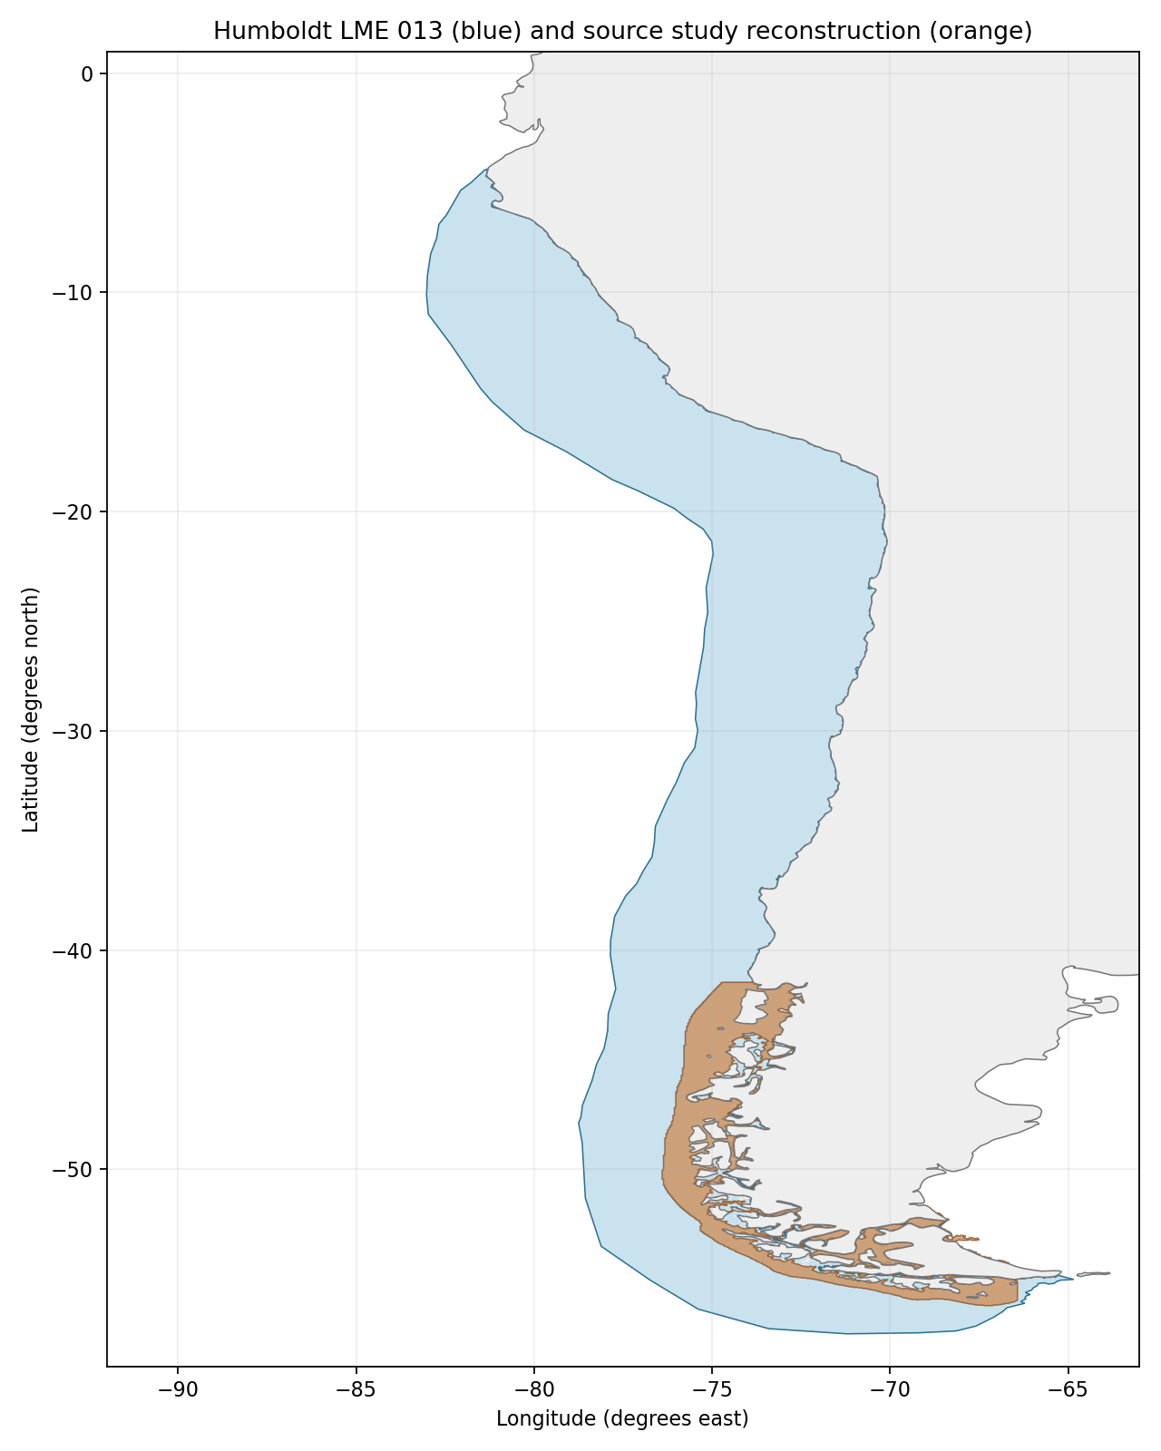
Sea Around Us target R: 2,560,136 km², including southern Patagonia. Blue = R; orange = source reconstruction. Target boundary | Image

Study area in the article
Approximate source-domain reconstruction
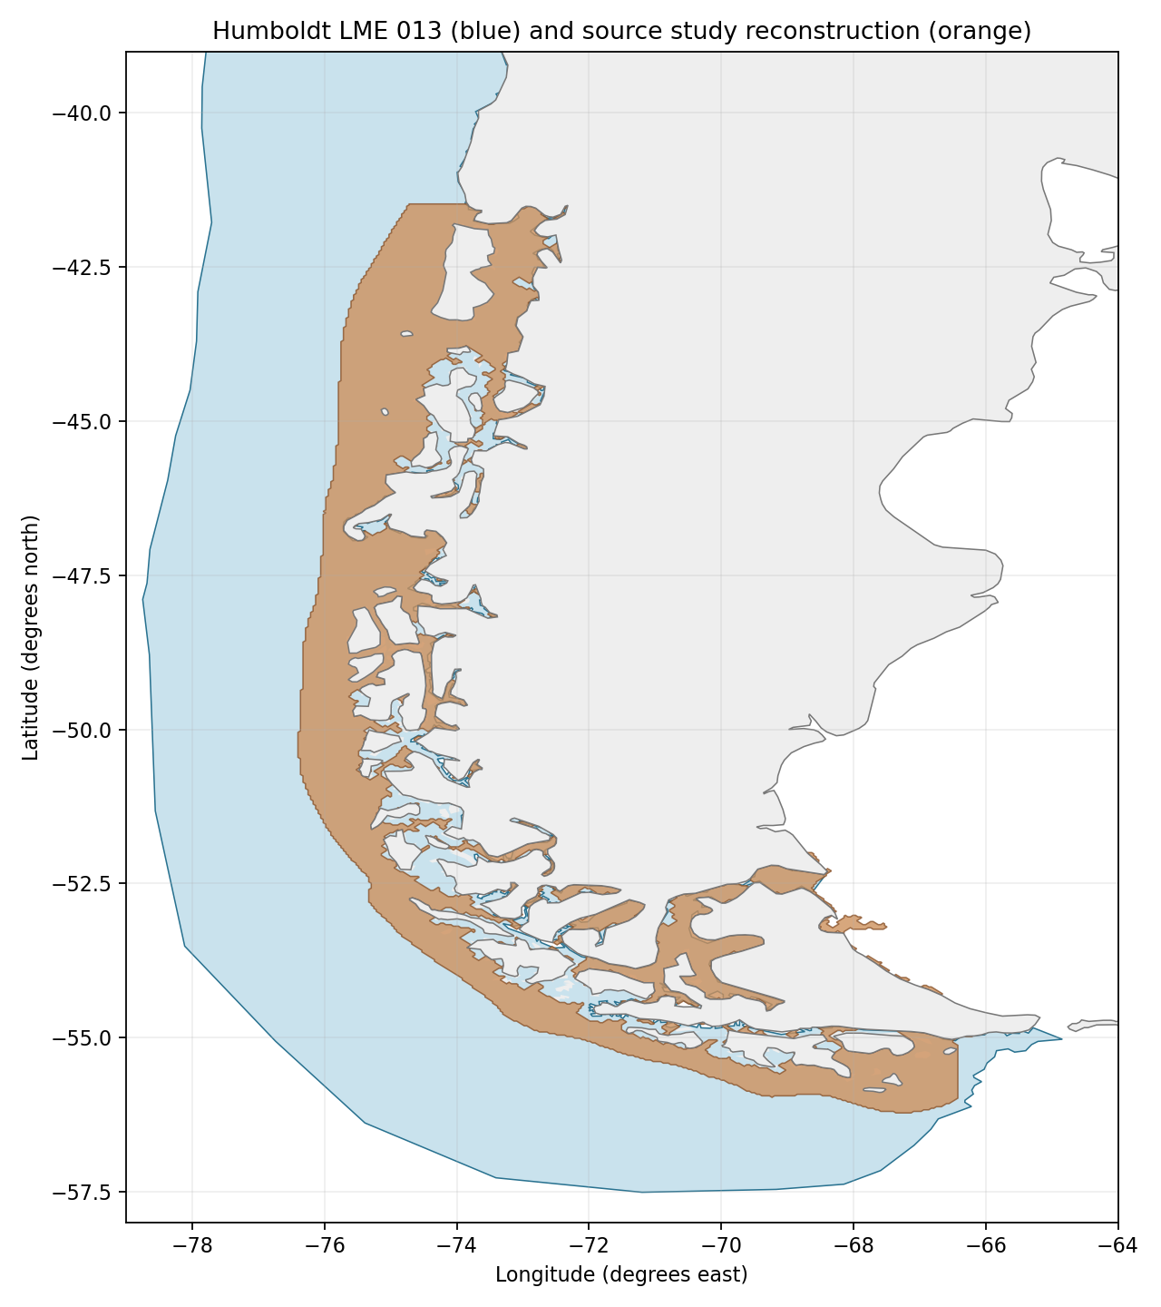
Source S: Methods/PDF4 and Figure 1/PDF2 give 41°28.6′S–57°S, fjords/channels and open water to 35 nautical miles offshore; reported 290,000 km². Image shading trace gives 194,166 km², overlap 183,217 km²; A 7.1565%, B 94.3611% using traced S, B 63.1783% using reported S. Approximate 3–4 km image/coastline resolution and unresolved inner fjords drive the 7–11% / 60–95% sensitivity brackets. The 35-nmi distance is not a fixed longitude offset. Source map | Source bounds | Portable reconstruction
Original source study map: Figure 1 (PDF2), retained below. The abstract/highlights say 55°S, while title, Methods and map indicate 57°S; the latter are used with the discrepancy disclosed. The old −76° to −72°, 41.5°–55°S rectangle includes land and misses the southern/eastern domain.