Northern Humboldt candidate model validation
Field | Entry
Region | Humboldt Current, LME_013. Candidate evaluation of the northern Peruvian food web.  Regional workbook
Catch source | Sea Around Us, 1950–2019; confidence reference: 2019 landings. All 218 exact labels, including zero catch and unidentified categories.  Catch and classic inputs | Reference arithmetic
Candidate article | Chiaverano et al. (2018). Evaluating the role of large jellyfish and forage fishes as energy pathways, and their interplay with fisheries, in the Northern Humboldt Current System. Progress in Oceanography 164, 28–36. DOI 10.1016/j.pocean.2018.04.009.  Source PDF | DOI
Other known articles | Neira et al. (2026), Chilean Patagonia 1980–2020 food-web modelling, DOI 10.1016/j.pocean.2025.103631. Its static 1980 model remains selected. Tam et al. (2008), Northern Humboldt trophic linkages under La Niña and El Niño, is a predecessor; its stocks cannot replace this model without a verified crosswalk.  Selected-model review
Candidate model | HUM2018 resolved native supplement candidate, 1995–1998. 39 ecological stocks plus two source fleet nodes, over 165,000 km² at 4°S–16°S and up to 111 km offshore. The paper counts 36 living groups and three detritus pools. Anchovy eggs (36) are a nonfeeding pool in the supplement, giving four operational detritus pools in this translation. The runtime adds one synthetic diet_import source.  Canonical source JSON | Computational input
Other models from the same article | The aggregated baseline has 24 ecological groups plus one pooled fishery node (25 source nodes), over the same area and period. It merges source groups and uses rounded printed values. Full detailed detritus/fleet routing is retained only in the resolved version. The four structural scenarios alter jellyfish consumption, forage-fish consumption or fishing rates; they are separate scenarios, not replacement static baselines.
Selection rationale | Article - Requested candidate review to test the local source evidence and its applicability to Northern Humboldt catches.  Model - Prioritize the resolved supplement because its distinct taxa, hake stages, two fleets and detailed diets/routing permit a more faithful audit than the aggregated alternative. The active selection remains Chilean Patagonia 1980.
Model extraction | The PDF, XLS supplement and Word figures/tables are present and verified; historical unavailable-file metadata is obsolete. Printed Chrysaora plocamia (7) diet sums to 1.045 and is preserved in canonical JSON and imports; runtime normalization is separate. Gelatinous zooplankton (6) source biomass and P/B imply production 0.00530 t/km²/year, far below its predation demand. Sardine landings are 5.6513425 in the supplement but 1.4 in the paper’s stated balanced baseline. Neither conflict has a supported numerical repair. GS is derived from source assimilation efficiency; explicit living BA=0 follows the stated steady state. Runtime detritus EE is forced to one and pool BA is derived. Internal fishery discards are retained in source evidence but their returned-flow ancestry is unsupported in the SPPR translation. The runtime loader also replaces eight native detritus-fate cells with pool self-identity; the exact changes remain explicit.  Fresh reconstruction audit | Source conflicts | Loader matrix changes
GE diagnostics | FAIL: source production and strict SPPR balance fail.  Negative SPPR by source and recipient: Benthic detritus (39): Benthic detritus (39), Leatherback turtle (35), Green sea turtle (34), Cetaceans (33), Pinnipeds (32), Seabirds (31), Chondrichthyans (30), Catfish (29), Sea robin (28), Medium sciaenids (27), Medium demersal fish (26), Conger (25), Butter fishes (24), Benthic elasmobranchs (23), Small demersal fish (22), Flatfish (21), Large hake (20), Medium hake (19), Small hake (18), Other large pelagic fish (17), Chub mackerel (16), Horse mackerel (15), Other small pelagic fish (14), Other cephalopods (13), Jumbo squid (12), Mesopelagic fish (11), Anchovy (10), Sardine (9), Macrobenthos (8), Chrysaora plocamia (7), Gelatinous zooplankton (6), Macrozooplankton (5), Mesozooplankton (4), Microzooplankton (3); Pelagic detritus (38): Pelagic detritus (38); Anchovy eggs (36): Anchovy eggs (36), Leatherback turtle (35), Green sea turtle (34), Cetaceans (33), Pinnipeds (32), Seabirds (31), Chondrichthyans (30), Catfish (29), Medium sciaenids (27), Medium demersal fish (26), Conger (25), Butter fishes (24), Benthic elasmobranchs (23), Flatfish (21), Large hake (20), Medium hake (19), Small hake (18), Other large pelagic fish (17), Chub mackerel (16), Horse mackerel (15), Jumbo squid (12), Anchovy (10), Sardine (9), Chrysaora plocamia (7).  rho_living = 0.7000  b = 1.5918; recycling does not converge.  Detritus SPPR: Anchovy eggs (36) = -3.0709; Fishery offal (37) = 0.0000; Pelagic detritus (38) = -1.1262; Benthic detritus (39) = -4.4980.  Strict model balance and SPPR balance both fail. PP gap 5.5%.  Full GE return | Labeled GE matrix
TE diagnostics | FAIL: source production and strict SPPR balance fail.  No negative SPPR entries across the basal-source columns.  rho_living = 0.7316  Detritus SPPR: Anchovy eggs (36) = 0.0000; Fishery offal (37) = 0.0000; Pelagic detritus (38) = 0.3043; Benthic detritus (39) = 0.0000.  Strict model balance and SPPR balance both fail. PP gap 9.4%.  The engine cannot recredit EE=0 losses with four operational detritus pools.  Full TE return | Labeled TE matrix
SPPR calculation | [Researcher calculation choices and notes]
Geographic fit | Approximate A. Region covered by study: 6.0–8.0%.  Approximate B. Study covered by region: 90–100%. The northern shelf domain leaves most of this LME outside the model.  Boundary assessment
Temporal fit | Static 1995–1998 baseline applied to catch years 1950–2019; 2019 is 21–24 years later. Fixed coefficients and source catch/biomass allocations do not represent annual ecosystem or catch-composition changes. Publication year 2018 is separate from model period.
Other | With Egestion also FAIL: rho_living = 0.5600; b = 1.1098; PP gap 7.3%. Its negative source–recipient set matches GE. Candidate arithmetic is retained with scientific ineligibility flags; no candidate output is adopted. This model is unsuitable for validated regional PPR until the consequential source conflicts and unsupported native flows are resolved. The selected Chilean Patagonia model retains WARN and a different, southern geographic limitation.  Full direct report | Candidate calculations
Open issues and next action
Review and reproducibility | Researcher name: [name] | review date: [dd/mm/yyyy]

Taxon mapping and coverage
Reference: 2019 landings; all recorded labels, all model groups and no taxon exclusions.
39 source ecological groups plus two fleet records and one computational import; 218 catch taxa.
Simple-chain PPR totals 277,099,551.43 t C in 2019.
34 labels lack classic TL/coefficient inputs; all have zero 2019 landings and contribute zero annual PPR. Their coefficients remain unavailable.
Method: independent simple trophic chain using the saved regional coefficients.
Excel taxon appendix | Descriptive Sources sheet
Overall confidence | Taxa (n) | Catch (%) | Simple-chain PPR (%)
High | 70 | 87% | 71%
Medium | 104 | 9.4% | 24%
Low | 17 | 0.24% | 0.26%
Very low | 27 | 3.2% | 4.9%
Unresolved | 0 | 0% | 0%
Overall confidence uses the weaker required membership or allocation component.

Group assignment rules
Plain-language rule | Confidence | PPR percentage
Explicit inclusion of the taxon in the source model | High | 71%
Supported extension from the source’s listed representative taxa | Medium | 7.3%
Source membership connected through a verified synonym or documented spelling correction | High | 6.7%
Supported ecological assignment requiring a group-boundary interpretation | Medium | 6.6%
Closest represented ecological or taxonomic analogue | Very low | 3.3%
Assumed eligible group set supported by taxonomy and ecology | Medium | 3.2%
Approximation of a broad reporting category across plausible model pools | Very low | 1.6%
Partial or competing ecological fit | Low | 0.26%
Unambiguous fit to a documented taxonomic or ecological group | High | 0.15%
Membership evidence: exact supplement group definitions, source taxonomic lists and authoritative synonym/habitat records. Complete mapping evidence

Allocation weight rules
Plain-language rule | Confidence | PPR percentage
One group; no allocation split required | High | 86%
Allocation proportional to native source-model landings | Medium | 14%
Complete source-model biomass fallback after unusable landings | Medium | 0.046%
Weights use measured composition only when applicable. The source-model landings proxy is used before biomass; assumed proportions are fixed across catch years, with stage, fishery and geographic transfers recorded. Allocation evidence
Each percentage is the independent simple-chain PPR associated with taxa using that rule.
Unresolved taxa: none. 27 Very low decisions account for 3.2% of catch and 4.9% of independent simple-chain PPR.

Very low decisions
Affected taxa | Why confidence is very low
Actinopterygii; Gadiformes; Marine finfishes not identified; Marine fishes not identified; Marine groundfishes not identified; Marine pelagic fishes not identified; Perciformes; Scorpaeniformes | Broad fish reporting labels have unknown composition across named and residual pools, historical taxonomic scope, and potentially unrepresented deep-water members; native landings approximate their mixtures.
Batoidea; Chondrichthyes; Elasmobranchii; Myliobatidae | Broad/historical cartilaginous labels cross benthic and water-column pools with unrepresented chimaera or filter-feeding ray components.
Callorhinchus callorynchus | Benthic chimaera uses an elasmobranch analogue across the Holocephali/Elasmobranchii boundary.
Decapoda; Malacostraca; Miscellaneous marine crustaceans | Benthic/pelagic mixture uses macrozooplankton/benthos biomass because native landings are zero; a 2–20 mm size mismatch remains.
Dissostichus eleginoides; Hoplostethus atlanticus | Deep, cold-water fishes use a medium-demersal analogue with population, depth and size mismatches.
Galatheidae; Grimothea monodon | Squat lobsters lack a source pool; macrozooplankton/benthos biomass weights retain the 2–20 mm size mismatch.
Galaxias maculatus | Amphidromous galaxiid lacks a corresponding source population; a coastal small-fish analogue is assumed.
Macruronus magellanicus; Merluccius australis; Merluccius gayi; Micromesistius australis | Non-Peruvian hake/cod-like fishes use Peruvian hake groups; species, southern ecology and size boundaries differ, and native stage landings are transferred.
Mobula birostris | Pelagic filter-feeding manta uses the closest chondrichthyan pool despite the source apex-predator correspondence.
Ophichthus | Snake eel mapped to unnamed conger pool despite taxonomic identity differing from the regional congrio interpretation.

Geographic evidence
The study covers a northern coastal shelf segment of the target LME. The shaded source boundary was traced approximately against its graticule; reported area and traced area differ, so the A/B ranges express boundary uncertainty.

Region area
Target region boundary
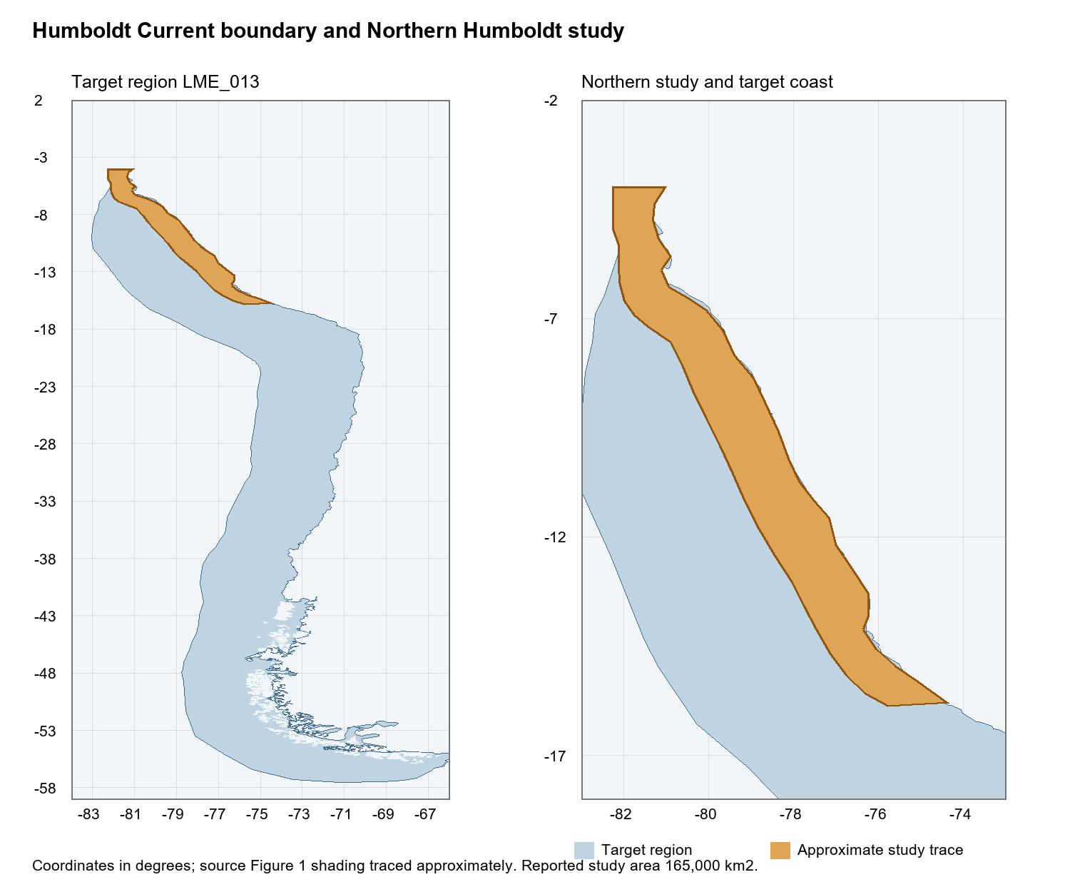
Humboldt Current LME_013 Sea Around Us boundary and approximate study trace in common geographic coordinates. Boundary evidence

Study area in the article
Study boundary for the selected model
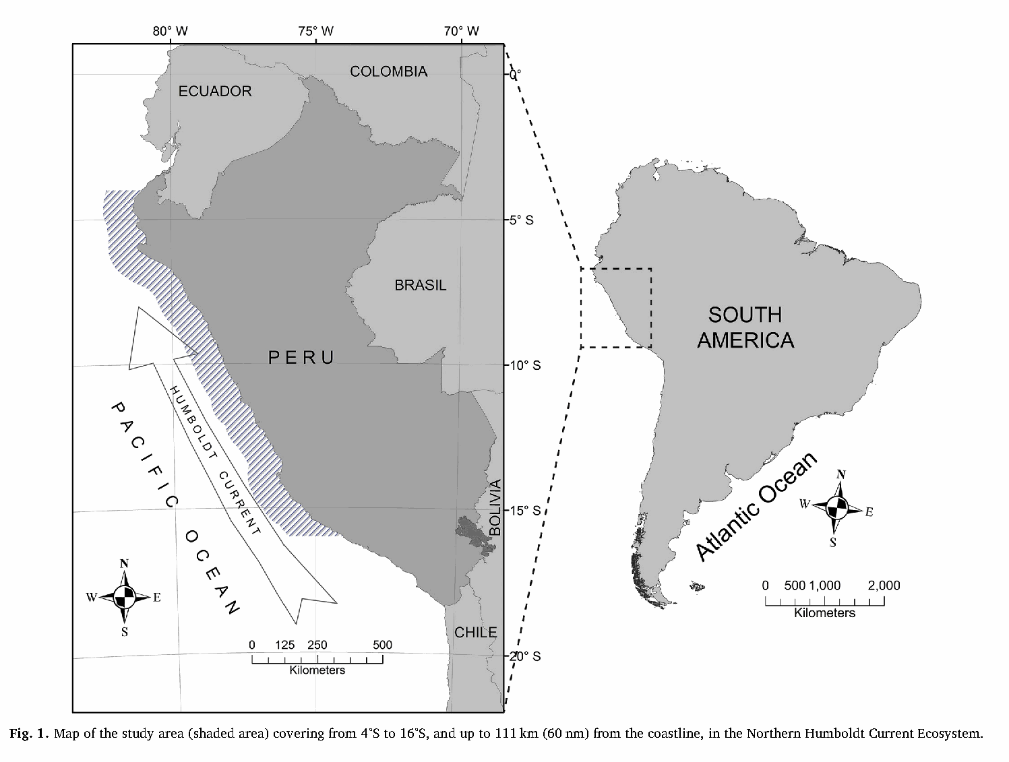
Chiaverano et al. (2018), original Figure 1, PDF page 2 / printed page 29. Hatching marks the 4°S–16°S coastal domain, up to 111 km offshore. Source PDF

