Regional model validation record
Field | Entry
Region | Humboldt Current, LME_013; Sea Around Us target boundary includes southern Patagonia. Regional workbook
Catch source | Sea Around Us catch series 1950–2019; reference: 2019 landings. All 218 exact labels, including zero catch and unidentified categories. Catch inputs | Regional catch
Selected article | Neira, Arancibia, Barros, Arriagada, Alarcón & Gatica (2026). Analysing ecosystem and demersal stocks dynamics in the Chilean Patagonia system (41°28.6′S–57°S) from 1980 to 2020 using food web modelling. Progress in Oceanography 241, 103631. Source PDF | DOI
Other known articles | Chiaverano et al. (2018), Large jellyfish and forage fishes as energy pathways in the Northern Humboldt Current System. DOI 10.1016/j.pocean.2018.04.009. Northern 1995–1998 alternatives fail all three saved methods. Other article
Selected model | 13_1_Chilean_Patagonia_(1980); one static 1980 Ecopath model, 15 source ecological groups plus synthetic diet_import. Chilean Patagonia channels, fjords and adjacent open waters, approximately 290,000 km². Canonical JSON | Model folder
Other models from the same article | No other complete static parameterization identified in this article. The 1980–2020 Ecosim series, fishing scenarios and sensitivity runs are dynamic outputs, not additional static input models. Source inventory
Selection rationale | User selected this available non-failing WARN alternative after comparison with Northern Humboldt 1995–1998 (GE, TE and With Egestion FAIL). Spatial suitability remains a serious limitation; model selection does not establish regional applicability.
Model extraction | Partial paper reconstruction. Referenced supplements S1–S7 are absent from the retained source set. Canonical Sea-lion diet sum 1.002 is preserved; accepted runtime normalizes it at tolerance 0.001, infers BA and supplies GS, detritus/routing, missing-catch and import defaults. Printed rounded biomass and undocumented source BA remain distinct from accepted inputs. Extraction report | Source/runtime review
SPPR calculation | [MANUAL — Researcher: calculation choices and reasons]  [Excluded groups, scope and relevant values; other adjustments]

Field | Entry
GE diagnostics | No negative or non-finite entries in all 48 source–recipient SPPR values, including unfished groups. rho_living=0.35789474; b=0.02104338; Detritus(15) SPPR=1.04526035. Overall WARN.
TE diagnostics | No negative or non-finite entries in all 48 source–recipient SPPR values, including unfished groups. rho_living=0.54226475; b=0.00000000; Detritus(15) SPPR=0.99371192. Overall WARN.
Geographic fit | Approximate A: 7–11% of the target region is covered by the study. B: 60–95% of the study is covered by the region. Different denominators; low-confidence reconstruction, not statistical intervals. Boundary assessment
Temporal fit | Static 1980 ecosystem applied to catch years 1950–2019; the 2019 reference is 39 years later. Fixed coefficients and composition proxies do not reconstruct annual ecosystem changes. Publication in 2026 does not make the 1980 model contemporary.
Other | With Egestion: no negative or non-finite entries across all 48 source–recipient values; rho_living=0.28631579; b=0.02128150; Detritus SPPR=1.05089804. All three computational balances pass in the accepted transformed runtime, but input/source concerns retain WARN. Skates source EE cannot be interpreted without missing BA; no scientific parameters changed. Full matrices and diagnostics
Open issues and next action | [Researcher: open issues and next actions]
Review and reproducibility | Researcher name: [name] | review date: [date]
Taxon mapping and coverage
Reference: 2019 landings; all catch labels, zero catch and unidentified categories; no group filter.
15 source ecological groups (+1 computational import); 218 catch labels.
Simple-chain PPR totals 277,099,551.43 t C; total catch 7,166,264.97 t.
34 labels lack a saved classic coefficient/TL; all have zero 2019 landings and therefore zero annual PPR. Unavailable TL remains ?, not zero.
Method: independent simple trophic chain, saved classic wet-weight coefficient × catch / 9 once.
Taxon mapping appendix and descriptive Sources sheet
Overall confidence | Taxa | Catch percentage | PPR percentage
High | 66 | 69.6458% | 12.8861%
Medium | 31 | 13.5477% | 26.8951%
Low | 0 | 0.0000% | 0.0000%
Very low | 121 | 16.8066% | 60.2188%
Unresolved | 0 | 0.0000% | 0.0000%
The summary uses the weaker required membership or allocation confidence. The following tables show each component separately.
Group assignment rules
Plain-language rule | Confidence | PPR percentage
M11: Closest represented taxonomic or ecological analogue; mismatches explicit. | Very low | 55.8164%
M5: Small/medium pelagic ecological extension from named source representatives. | Medium | 18.3892%
M1: Explicit named source membership or combined source stages. | High | 12.8071%
M4: Congeneric or related-source taxonomic extension. | Medium | 8.3729%
M10: Broad-category approximation over compatible represented guilds. | Very low | 4.4024%
M3: Explicit operative Benthos definition and bottom-associated reporting scope. | High | 0.1534%
M9: Broad label with a supported but composition-dependent candidate set. | Medium | 0.0585%
M2: Verified spelling/synonym of a named source taxon. | High | 0.0002%
Membership evidence: source definitions, taxonomy and all 16 candidate decisions
Allocation weight rules
Plain-language rule | Confidence | PPR percentage
W1: One reviewed group; no numerical split. | High | 98.6323%
W9: Missing candidate catches prevent complete catch proxy; complete model biomass fallback. | Medium | 1.2932%
W4: Historical source landings split for Hoki <3/≥3 years. | Medium | 0.0745%
Each percentage uses the same complete classic-PPR denominator. Hoki weights 0.006/0.062 and 0.056/0.062 transfer 1980 landings composition to the region. No compatible regional age-catch mass was found. Other multi-group labels use complete candidate biomass because missing source catch is not a genuine zero. Weights and evidence
Unresolved: none. Very low: 121 labels represent 16.8066% of landings and 60.2188% of classic PPR. Dosidicus gigas contributes 9.8012% / 38.8770%, Doryteuthis gahi 0.1608% / 0.0732%, Teuthida zero / zero. Their group 6 active-nekton analogy is partial; source small/medium fish, Seriolella-defined group 7 and named demersal predators differ in taxonomy, size and habitat. Sharks/rays, other demersal fish and broad unknowns also use explicit weak analogues or assumed represented pools. Coverage alone does not establish ecological validity. Residual marine fish reporting is restricted to source bony-fish pools; Skates is excluded from the fish, finfish and groundfish labels. Composition remains Very low and incomplete source catch requires biomass allocation. Reporting scope evidence

Geographic evidence screenshots
Target R and study S use geographic coordinates. The reviewed source-map reconstruction is distinct from the inherited rectangular article footprint, which conflicts with the stated study bounds and marine domain.

Region area
Humboldt LME_013 target and study location
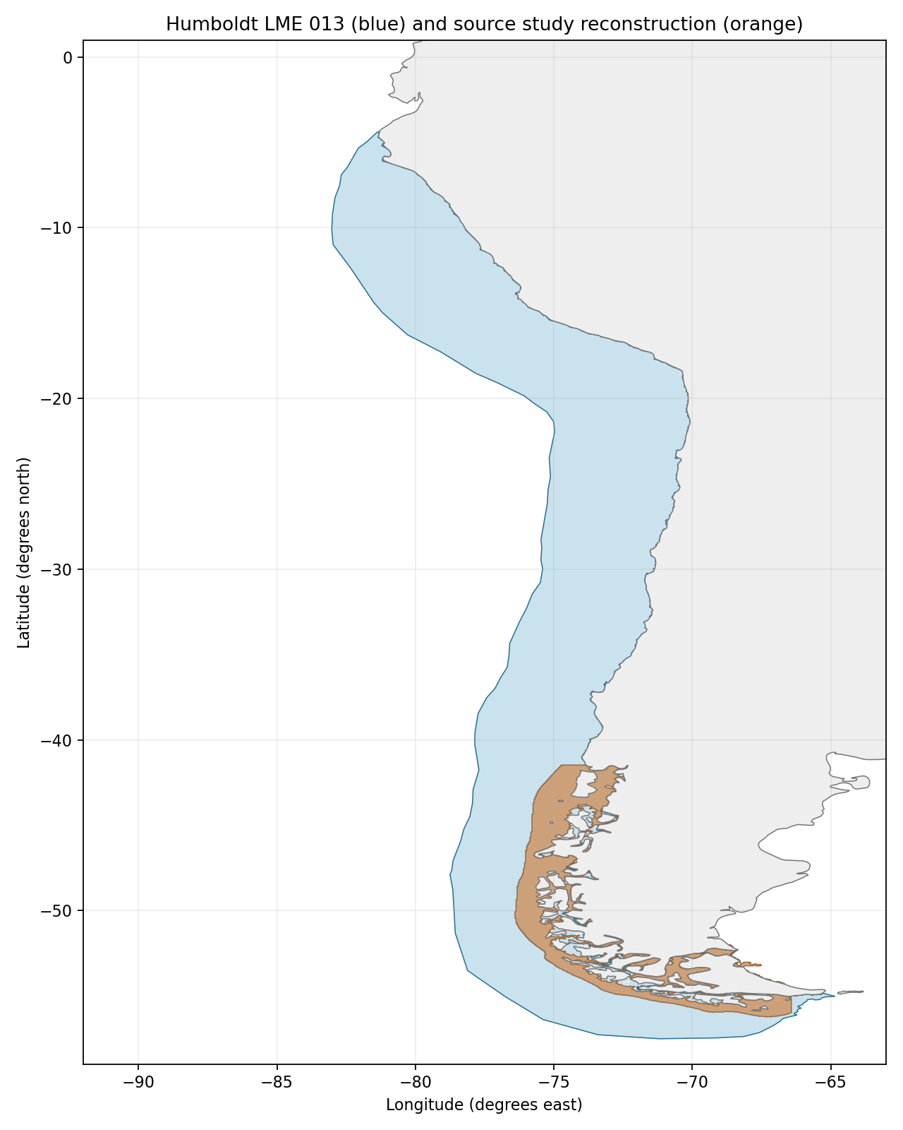
Sea Around Us target R: 2,560,136 km², including southern Patagonia. Blue = R; orange = source reconstruction. Target boundary | Image

Study area in the article
Approximate source-domain reconstruction
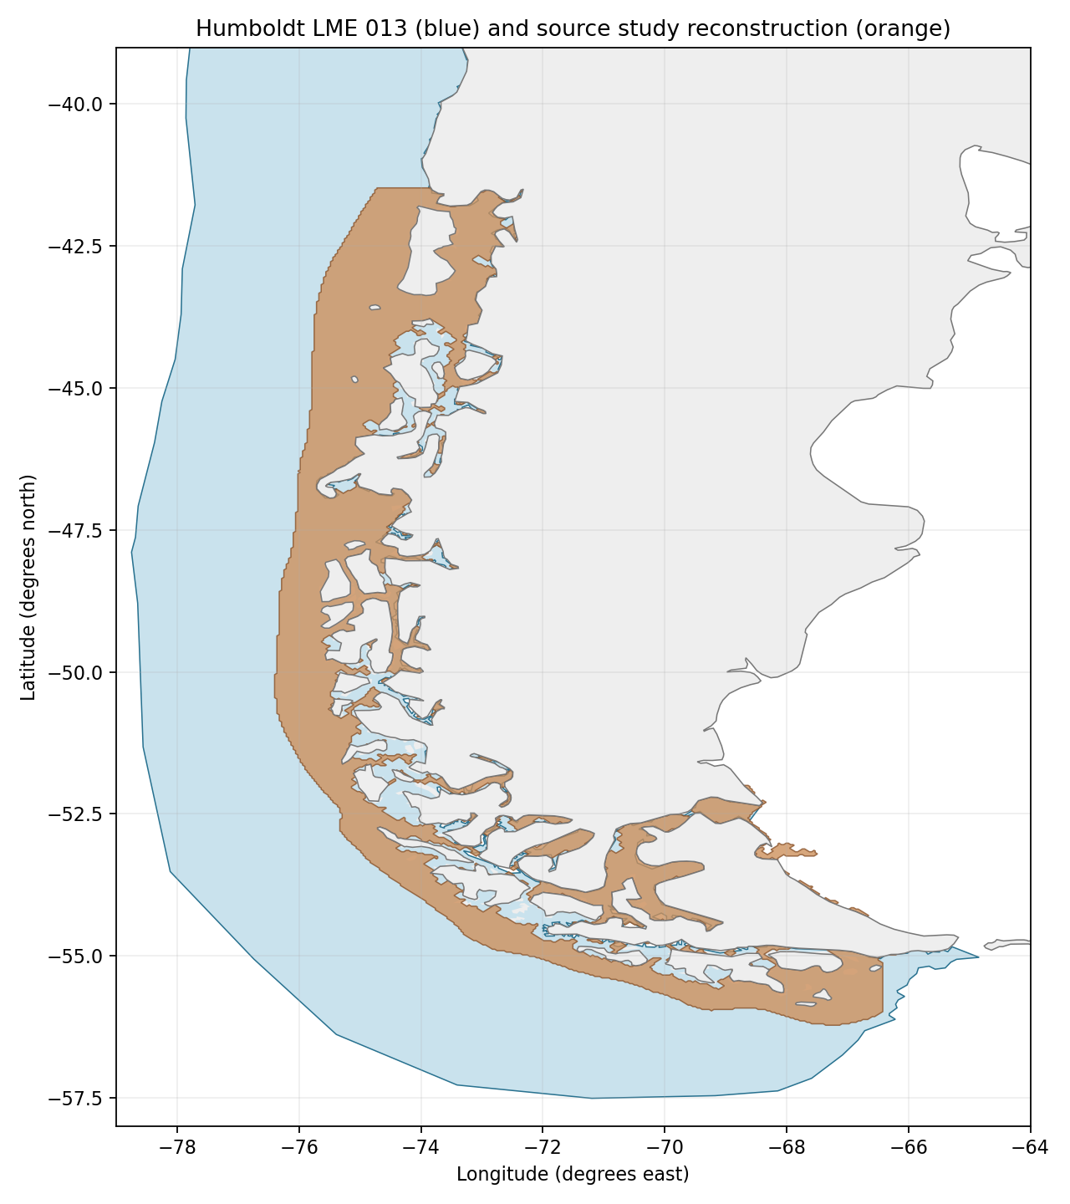
Source S: Methods/PDF4 and Figure 1/PDF2 give 41°28.6′S–57°S, fjords/channels and open water to 35 nautical miles offshore; reported 290,000 km². Image shading trace gives 194,166 km², overlap 183,217 km²; A 7.1565%, B 94.3611% using traced S, B 63.1783% using reported S. Approximate 3–4 km image/coastline resolution and unresolved inner fjords drive the 7–11% / 60–95% sensitivity brackets. The 35-nmi distance is not a fixed longitude offset. Source map | Source bounds | Portable reconstruction
Original source study map: Figure 1 (PDF2), retained below. The abstract/highlights say 55°S, while title, Methods and map indicate 57°S; the latter are used with the discrepancy disclosed. The old −76° to −72°, 41.5°–55°S rectangle includes land and misses the southern/eastern domain.